Commodity product markup language

Version 6 Release 4.1 (v6.4.1)

Created by EFET

# Copyright Notice

Copyright © EFET 2017. All Rights Reserved.

This document and translations of it may be copied and furnished to others, and derivative works that comment on or otherwise explain it or assist in its implementation may be prepared, copied, published and distributed, in whole or in part, without restriction of any kind, provided that the above copyright notice and this paragraph are included on all such copies and derivative works. However, this document itself may not be modified in any way, such as by removing the copyright notice or references to EFET except as required to translate it into languages other than English.

The limited permissions granted above are perpetual and will not be revoked by EFET or its successors.

## Disclaimer

This document and the information contained herein are provided on an “as is” basis.

EFET DISCLAIMS ALL WARRANTIES, EXPRESS OR IMPLIED, INCLUDING BUT NOT LIMITED TO ANY WARRANTY THAT THE USE OF THE INFORMATION HEREIN WILL NOT INFRINGE ANY RIGHTS OR ANY IMPLIED WARRANTIES OF MERCHANTABILITY OR FITNESS FOR A PARTICULAR PURPOSE.

EFET reserve the right to publish clarifications from time to time to this standard. Clarifications will not materially change the standard but will resolve ambiguities and correct any errors that may be discovered after publication. Such clarifications must take the form of a separate addendum to the main document and will be published in the same location as the standard.

# Content

1 Copyright Notice 2

1.1 Disclaimer 2

2 Content 3

3 Introduction to CpML 4

4 About this Document 5

4.1 Revision History 5

4.2 Purpose and Scope 6

4.3 Target Audience 6

4.4 Additional Information 7

4.5 Conventions 7

4.5.1 Use of Modal Verbs 7

4.5.2 Typographical Conventions 8

4.5.3 Notation of Schema 8

4.5.4 Information on Field Usage 9

4.5.5 Information on Field Occurrence 9

4.6 CPMLDocument IDs 9

5 CpMLDocument Schema Reference 11

5.1 CpMLDocument Root 11

5.2 Confirmation 11

5.3 Reporting 12

5.3.1 DoddFrank 12

5.3.2 ODRF 16

5.3.3 Europe 16

5.3.4 Switzerland 31

5.4 TradeConfirmation (CNF) 44

5.5 BrokerConfirmation (BCN) 65

5.6 GenericConfirmation (GNF) 83

5.7 IRSTradeDetails (IRT) 86

5.8 ETDTradeDetails (ETD) 94

5.9 FXTradeDetails (FXT) 98

5.10 Additional Business Rules 104

5.10.1 Examples for ‘TimeIntervalQuantities’ 109

6 StrategyConfirmation (SCN) Schema Reference 110

7 Description of CpML Field Names 111

7.1 A–D 111

7.2 E–L 117

7.3 M–R 121

7.4 S–Z 126

8 Description of CpML Field Types 131

8.1 A-D 131

8.2 E–L 138

8.3 M–R 142

8.4 S–Z 145

# Introduction to CpML

The Commodities product Mark-up Language (CpML) is the commodity trading industry standard that enables the representation of trades and other related information in a standardized way. The standard is widely used for electronic confirmation of Over-The-Counter (OTC) trades and for regulatory reporting in Europe.

CpML defines the data format that is used by the following processes:

* eCM (electronic Confirmation Matching)
* eRR (electronic Regulatory Reporting)
* eXRP (eXchange-Related Processes)

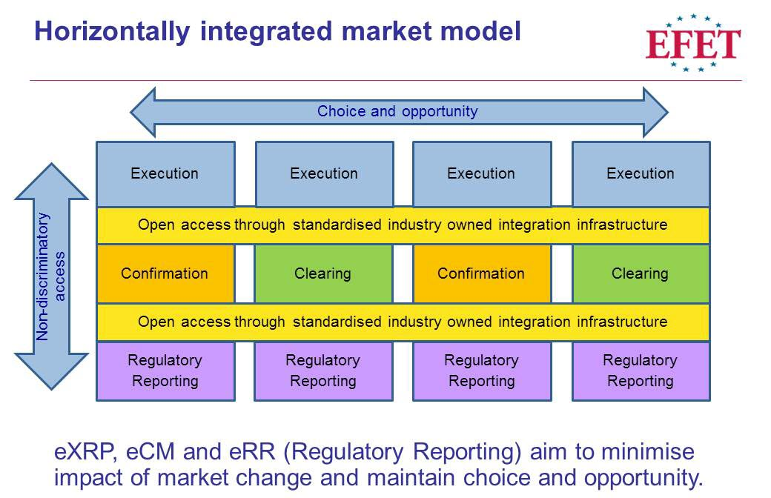

The CpML standard itself is process-neutral. The data structure is defined using XML schemas (XSD). Market participants deliver XML documents that base on these schemas and are called CpMLDocuments. For each process, there is a different standard that defines how the data is processed and which CPML structures are used.

# About this Document

## Revision History

|  |  |  |  |
| --- | --- | --- | --- |
| **Version** | **Date** | **Changes** | **Author of changes** |
| 4.1 | April 2012 | Alignment with GTRfC FpML Message Specification v1.7.  Addition of Physical Oil, Bullion.  Enhancement of Physical Electricity and Coal to account for US products. | EFET |
| 4.2 | October 2012 | Alignment with GTRfC FpML Message Specification v1.7.3.1  Addition of strategies, cross asset class products and introduced the ‘Generic Confirmation’ for non-standard products. | EFET |
| 4.2d | October 2012 | Addition of Cancellation document. | EFET |
| 4.2e | November 2012 | Clarifications to the CpMLReportingEnvelope | EFET |
| 4.2f | December 2012 | Implementation clarifications and minor adjustments to business rules for Calculation Periods | EFET |
| 4.2g | January 2013 |  | EFET |
| 4.2g | December 2013 |  | CpML Technical Committee |
| 5.1 | November 2013 |  | CpML Technical Committee |
| 5.2 | February 2014 |  | CpML Technical Committee |
| 5.3 | November 2015 | REMIT Phase 1 and ESMA Level 2 | CpML Technical Committee |
| 6.1 | January 2016 | Requirements from users  Versioning amended to be in line with CpML Organisation versioning | CpML Technical Committee |
| 6.2 | February 2016 | Changes for REMIT Phase 2 | CpML Technical Committee |
| 6.3 | March-July 2016 | Consistency check between schema and CpML description. Overview of changes:   * Alignment of document structure with schema structure, i.e. sections added or removed, tables merged, order of fields adapted. * Usage types corrected. * Names and descriptions corrected. * Missing fields, field types and value types added. * Redundant tables and sections removed. * Key/Info column removed. * Process-specific information removed. * Consistent terminology and spelling of terms. * Rules for modal verbs added and modal verbs corrected. * payload document = transaction details section * envelope = regulatory details * Conventions to explain document usage added. |  |
| 6.4 | February 2017 | * Additional time stamp fields to compensate for DLS issues * ‘EURegulatoryDetails/Formula­ProductInformation/Underlying’ changed to mandatory * New units of measure added for quantities * Amended for EMIR RTS/ITS * Removed ERR-specific rules and enrichment information |  |
| 6.4.1 | April 2017 | Minor corrections:   * Value “O” for ‘ActionType’ removed. * Length of ‘ClassificationOfProductType’ set to “255”. * Value “OT” for ‘EProduct1CodeType’ removed. * Value “SB” for ‘EProduct2CodeType’ added. * Type “ContractTypeType” added to chapter 8. * Type “LoadDeliveryIntervalType” changed from hours only to hours:minutes (e.g. 08:00). |  |

## Purpose and Scope

This document contains the specification of the CpML standard. The CpML standard defines the vocabulary for exchanging standardized messages for commodity trading and reporting processes.

The CpML specification corresponds to the underlying XML schemas, which implement this specification. The XML schemas define the data structures and rules for the following document types:

1. CpMLDocument: Market participants generate messages with trade information in a standardized format, the so-called CpMLDocument.
2. StrategyConfirmation: Combines fundamental transaction types in order to describe a trading strategy.

The CpML specification defines a generic vocabulary that can be applied to different business processes. Process-relevant information is described in the corresponding process specifications, for example, the eCM standard.

## Target Audience

This document is for business analysts and IT professionals in the commodity trading business who want to provide standardized trade information in the CpML format for post-trade data processing.

For example, this can be:

* Software engineers and data architects who implement CPML interfaces
* Business analysts who develop process interfaces

The following knowledge is assumed:

* Familiarity with the terms and processes used in the commodity trading industry
* Know-how regarding the structure and functionality of XML schemas

## Additional Information

This section lists web sites or documents with additional information related to the CpML standard.

|  |  |  |
| --- | --- | --- |
| **Ref ID** | **Description** | **Source** |
|  | List of codes specific to EFET and CPML, for example, broker codes | <http://www.efet.org/Standardisation/Static-data> |
|  | Esma register of Regulated Markets | <http://registers.esma.europa.eu/publication/searchRegister?core=esma_registers_mifid_rma> |
|  | Home page of CpML standard | <http://cpml.org> |
|  | Incoterm rules, published by the Internation Chamber of Commerce | <http://www.iccwbo.org/incoterms/id3042/index.html> |
|  | Full list of BSC (Balancing and Settlement Code) signatories | <https://www.elexon.co.uk/bsc-related-documents/bsc-signatories-qualified-persons> |
|  | Coal quality specifications as listed in SCoTA | <http://www.globalcoal.com/scota/scotaSpecs.cfm> |
|  | FpML® (Financial products Markup Language) web site | [www.fpml.org](http://www.fpml.org) |
|  | EIC codes published by ENTSO-E | <https://www.entsoe.eu/data/energy-identification-codes-eic/eic-documentation/Pages/default.aspx> |
|  | Acer Transaction Reporting User Manual | <https://www.acer-remit.eu/portal/public-documentation> |
|  |  |  |
|  |  |  |

## Conventions

### Use of Modal Verbs

For compliance with the CPML standard, implementers need to be able to distinguish between mandatory requirements, recommendations and permissions, as well as possibilities and capabilities. This is supported by the following rules for using modal verbs.

The key words “must”, “must not”, “required”, “should”, “should not”, “recommended”, “may” and “optional” in this document are to be interpreted as follows:

|  |  |
| --- | --- |
| **Key word** | **Description** |
| Must | Indicates an absolute requirement. Requirements must be followed strictly in order to conform to the standard. Deviations are not allowed.  Alternative expression: required, is mandatory |
| Must not | Indicates an absolute prohibition. This phrase means that the provision must not be used in any implementation of the CPML standard.  Alternative expression: must be omitted |
| Should | Indicates a recommendation. Among several possibilities, one is recommended as particularly suitable, without mentioning or excluding others. There may exist valid reasons in particular circumstances to ignore a particular item, but the full implications must be understood and carefully weighed before choosing a different course.  Alternative expression: recommended |
| May | Indicates a permission. This word means that an item is truly optional within the limits of CPML. One data supplier may choose to include the item because a particular transaction requires it or because the data supplier feels that it enhances the document while another data supplier may omit the same item.  Alternative expression: optional |
| Should not | This phrase means that there may exist valid reasons in particular circumstances when the particular behavior is acceptable or even useful, but the full implications should be understood and the case carefully weighed before implementing any behavior described with this label.  Alternative expression: “not recommended” |

### Typographical Conventions

This documentation uses the following typographical conventions:

* ‘AgentID’: single quotation marks are used to indicate field names.
* “trader”: double quotation marks are used to indicate field values.
* Reporting/Europe: Slashes are used to indicate paths or nested nodes within the schema, for example, ….
* TotalVolumeUnit: Field names and values as well as attributes are consistently written with camel case spelling, as in the schema. There are no spaces between words and each new word starts with an uppercase letter.

### Notation of Schema

The CpMLDocument schema reference in section 5 is a flat representation of the tree structure in the corresponding XSD schema.

For each main node in the schema, there is a separate section with a table that contains the sections and fields in that node. The fields are listed in the same order as in the schema.

Subsections are indicated with a gray background. The start and end of each section is clearly indicated. Subsections are nested within each others.

For each field, you find information about the usage type, see section 4.5.4, and the business rules. These rules determine the dependencies on other fields or values, where applicable.

Fields and value types are reused in different locations of the schema. Therefore, the general field descriptions and value type descriptions are described in separate sections in alphabetical, see sections 7 and 8.

### Information on Field Usage

Information on mandatory or optional use of a field is specified in column “Usage”:

* **O = Optional**. These fields are logically optional and not required by business rules. The information may be present in the CpMLDocument.
* **C = Conditional**. These fields are logically conditional, meaning the field must be provided if and only if the specified conditions are met.
* **M = Mandatory**. Mandatory fields are logically required and must always be present, unless the parent field may be omitted.
* **M+C = Mandatory with condition**. Fields with this condition are logically required. According to the business rules, specific values must be set if the specified conditions are met.
* **M+CH = Mandatory, but part of a choice**. One of the fields in an XSD choice section must be provided. Thus, all fields within the choice are marked as mandatory in the schema.

### Information on Field Occurrence

If nothing else is stated for a field, the following rules apply with regard to the minimum or maximum occurrence of the field:

* Conditional or optional fields: (0-1)  
  These fields can be absent or occur exactly once within the given context.
* Mandatory fields: (1-1)  
  These fields must occur exactly once within the given context.

In all other cases, the allowed number of repetitions is clearly indicated. Examples: (0-n) or (1‑4).

## CPMLDocument IDs

To provide a common syntax for CPMLDocuments that is comprehensible and maintains uniqueness, the ID in the ‘DocumentID’ field must be unique. It is recommended to use the following syntax:

1. Document type abbreviation (e.g. “CNF” for TradeConfirmation)
2. Date code (8 characters, in yyyymmdd format)
3. Locally and daily unique transaction identifier of the sender
4. @
5. Sender identification, i.e. domain name or party code of the sender

Examples:

* CNF_20040610_1234567890@electrabel.com
* CAN_20040610_1234567890@11XELECTRABEL—Z

**Important:** The document ID must not exceed a total length of 50 characters.

**Important:** Once created, the document ID must not be changed any more. To retransmit information about the same transaction, the version ID must be changed instead.

# CpMLDocument Schema Reference

The CpMLDocument extends the basic trade description structure of CpML to include support for reporting of regulatory, transaction and position data on a per-jurisdiction basis. The CpMLDocument comprises one specific section with regulatory details per reporting regime. In addition to the regulatory sections, the CpMLDocument includes one or more transaction details sections, for example, with Trade Confirmation or Broker Confirmation information, and other supporting information such as images of paper confirmations or other binary files.

Each CpMLDocument contains information about exactly one transaction and is not used to combine information from multiple transactions.

**Note:** For more information about the notation of the schema, see section 4.5.3.

## CpMLDocument Root

At root level, a CpMLDocument can have the following sections:

* Confirmation (optional), see section 5.2
* Reporting, see section 5.3
* One of:
  + TradeConfirmation, see section 5.4
  + BrokerConfirmation, see section 5.5
  + Generic Confirmation, see section 5.6
  + IRSTradeDetails, see section 5.7
  + ETDTradeDetails, see section 5.8
  + FXTradeDetails, see section 5.9

## Confirmation

|  |  |  |  |  |
| --- | --- | --- | --- | --- |
| **Name** | **Usage** | **Type** | **Business Rule** | |
| CpMLDocument/Confirmation: optional section  This section is currently not in use. | | | | |
| ServiceMode | M | ServiceMode | |  |
| End of **Confirmation** | | | | |

## 