**Problem Statement:**

Home Credit is an organization that serves the unbanked population with access to loans. Such individuals that do not have a built-up credit score have a challenging time securing loans from financial institutions.

[Home Credit](http://www.homecredit.net/) strives to broaden financial inclusion for the unbanked population by providing a positive and safe borrowing experience. In order to make sure this underserved population has a positive loan experience; Home Credit makes use of a variety of alternative data--including telco and transactional information--to predict their clients' repayment abilities

*So, problem statement would be predicting how likely each applicant is of repaying a loan?*

**Dataset Description:**

There are seven data sets that are at the disposal of Home Credit:

**Application_train.csv** - this is the principal table and presents all the application information. There is a single row per application, which has a unique identifier.

**previous_application.csv** - this file presents previous applications for people in the sample through Home Credit. There is a row per each application.

**installments_payments.csv** - this is the repayment history on loans given out through Home Credit for people in the sample. Each row is a made or missed payment.

**bureau.csv** - credit information from other financial institutions that were reported to Home Credit. Each row represents a credit that was given to an individual in the sample.

**bureau_balance.csv** - monthly information per credit, per loan for users in the sample..

**POS_CASH_balance.csv** - like bureau_balance.csv, this data set is the internal version of the previous monthly breakdown of balances for consumer credit and cash loans that were taken out through Home Credit.

**credit_card_calance.csv** - each row in this data set represents a monthly balance of credit cards that were issued to applicants in the sample through Home Credit.

**Links between the Data sets:**

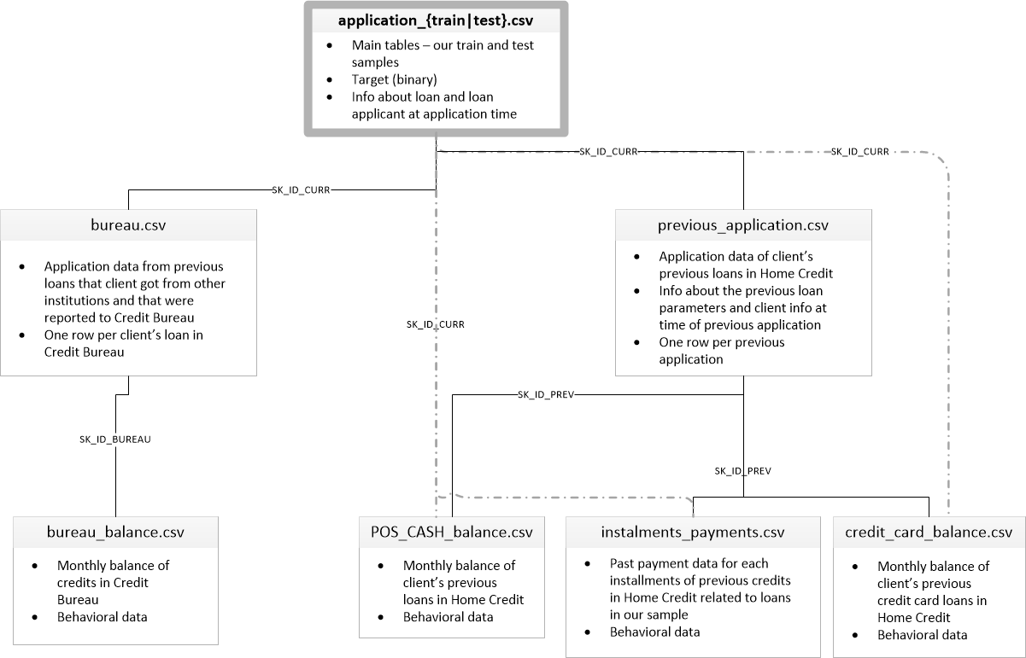

**Data Wrangling and Cleaning:**

1. **bureau_balance.csv :**

* Analyzed dataset with few rows & identified categorical column
* “STATUS ” column being used to denote “**Status of Credit Bureau loan during the month (active, closed, DPD0-30,… [C means closed, X means status unknown, 0 means no DPD, 1 means maximal did during month between 1-30, 2 means DPD 31-60,… 5 means DPD 120+ or sold or written off ] )**” which typically denotes on which month Paid , Not paid , closed . This column dropped & instead dummy variables created for Numerical Conversion.
* Then it summing based on ‘**SK_ID_BUREAU**’ , which will be representing ‘**Month_Balance_Count’ .** Also, we are dropping **‘MONTHS_BALANCE’** original column
* Grouped Data set is ready for Merge

1. **bureau.csv**

* Transforming Categorical variables to Numerical variables & Dropping actual columns
* Merging with **bureau_balance** dataset based on ‘**SK_ID_BUREAU’**
* Now Merged Data set is ready

1. **credit_card_balance.csv**

* It has Each month credit record
* Transforming Categorical variables to Numerical variables & Dropping actual columns
* Step 2: Creating new unique DFfor **'SK_ID_PREV'** & **'SK_ID_CURR'**
* Dropping **‘'SK_ID_CURR'’** from **credit_card_balance** data frame**.**
* Grouping DF based on **‘SK_ID_PREV’ –** Summing past Installement payment information and grouping by previous ID.
* Merging with Step 2 DF, based on **'SK_ID_PREV'**
* So it has unique **'SK_ID_PREV'** & **'SK_ID_CURR'** with all data’s Mergedtogether

1. **previous_application.csv**

* Transforming Categorical variables to Numerical variables & Dropping actual columns

1. **POS_CASH_BALANCE.csv**

**-** Transforming Categorical variables to Numerical variables & Dropping actual columns

**F) installments_payments.csv**

* Transforming Categorical variables to Numerical variables & Dropping actual columns
* Dropping **‘'SK_ID_CURR'’** from **installments_payments** data frame**.**
* New Variable Created to know whether Payment Made on date or Late
* Grouping DF based on **‘SK_ID_PREV’ –** Summing past Installement payment information and grouping by previous ID.
* Merging with Step 2 DF, based on **'SK_ID_PREV'** from **credit_card_balance.csv**
* So, it has unique **'SK_ID_PREV'** & **'SK_ID_CURR'** with all data’s Mergedtogether

**General Merging Strategy:**

* Dropping **‘'SK_ID_CURR'’** from **installments_payments,** **pos_cash_balance,** **cc_balance**  data frame**.**
* **previous_application** & **installments_payments** Merged based on **‘SK_ID_PREV’**
* Above Merged to **cc_balance** based on **‘SK_ID_PREV’**
* 1-1 Mapping enabled for **'SK_ID_PREV'** & **'SK_ID_CURR’.** Then Merged with above 4 data set
* So Right side of above Image is completely Merged.
* All Previous Data is Grouped By **‘SK_ID_CURR’** then dropped **‘SK_ID_PREV’,** to merge with training data set
* Merged Previous Data sets & bureau grouped datasets with training data set through ‘**SK_ID_CURR’**
* All data sets Merged with Training Data set. Merging Process completed.

**Missing Variables Handling:**

* There are 283 columns with missing variables out of 339 columns in the data frame.
* Above 35 % Missing variables columns dropped as it is not going to impact predictions.
* np.isfinite() Method being used to drop few rows from the data set which depends on ‘late’ & ‘closed’ Which is being referred from Missing variable % table . which shares same % of missing values.
* **‘OCCUPATION_TYPE’** is important feature though it has 31 % of missing values, so NAN marked as Unemployment
* Rest of below 10 % missing variables being filled with wither 0 or Mean, based on feature reference from excel.

After Handling Missing variables, data set stored to CSV as a single Merged data set .

**Outlier Handling:**

* Have not gone through complete data set columns, so looked at few important columns
* DOB has not any outliers
* Days Employed has outlier, it’s been handling after divided by -365 then > 0’s will be marked & masked as 0.
* Could see few outliers in ‘**AMT_INCOME_TOTAL’** it’ been handled by 3 standard deviations of the mean.

**Application_train.csv – Preparation:**

* Identified categorial variables
* Transforming Categorical variables to Numerical variables & Dropping actual columns.
* Replaced all negative values to 0
* X_train & y_train identified for feature selection
* Training set and validation set are split in following percentages: 66.66% : 33.33%.
* Top 10 features identified based on ‘**mutual_info_classif’**