Average Othello User Manual

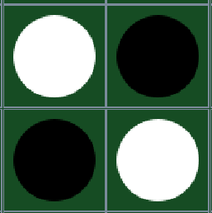

Henry Dyer

Luis Garcia

Jonathan Kneice

Tony Nguyen

Contents

**Set up/Installation** **3**

**How to Play… Become a master of Othello/Reversi** **4**

**Ruleset Differences of Othello and Reversi** **7**

**Traversing through the menus** **8**

**Tips/Tricks** **15**

**Things that were not included in the final product** **15**

**Future Plans** **16**

# 

# Set up/Installation

The usage of this software requires computer that supports Windows and Mac. The software requires a monitor, mouse, and keyboard. The user would need to have Java installed, specifically, JDK 16.0.2 or higher.

# How to Play… Become a master of Othello/Reversi

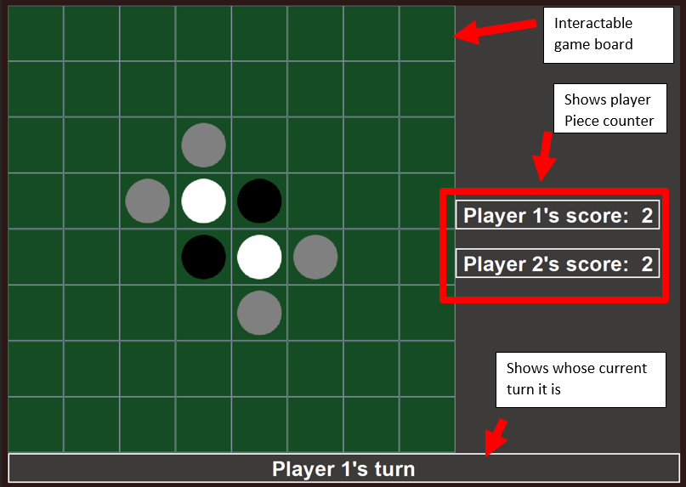

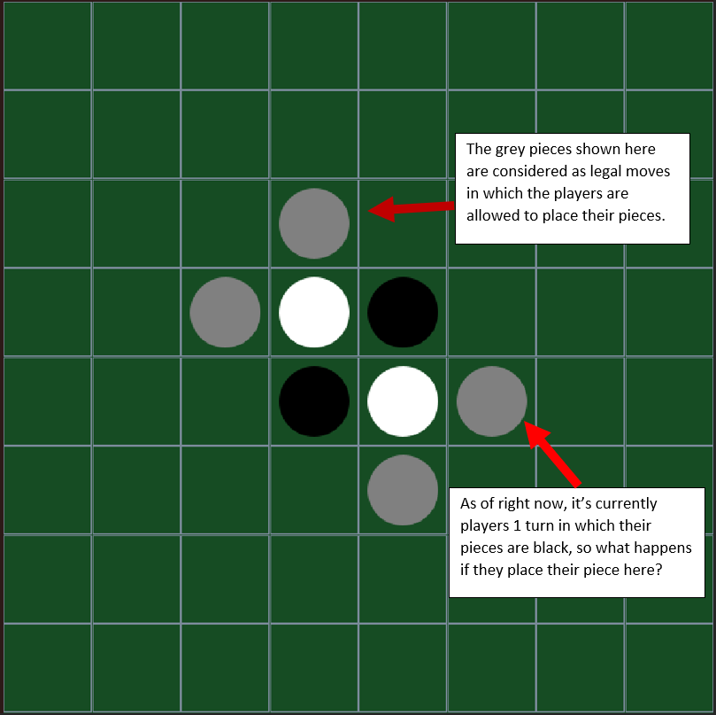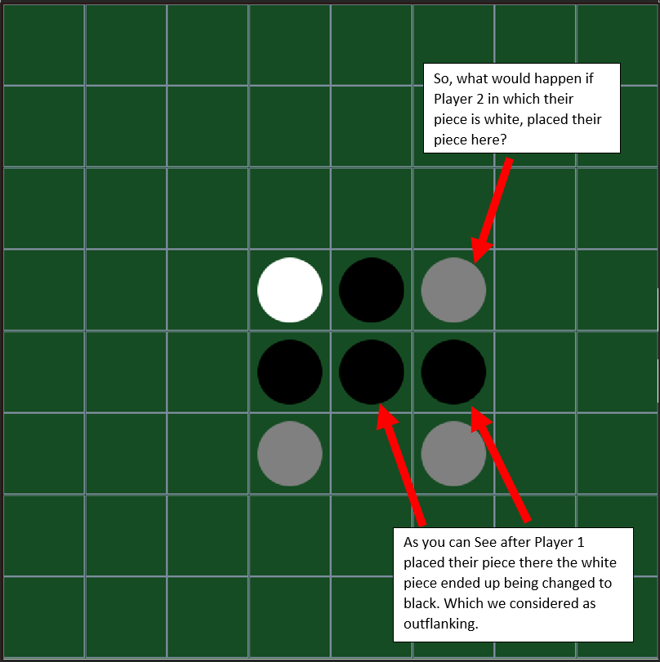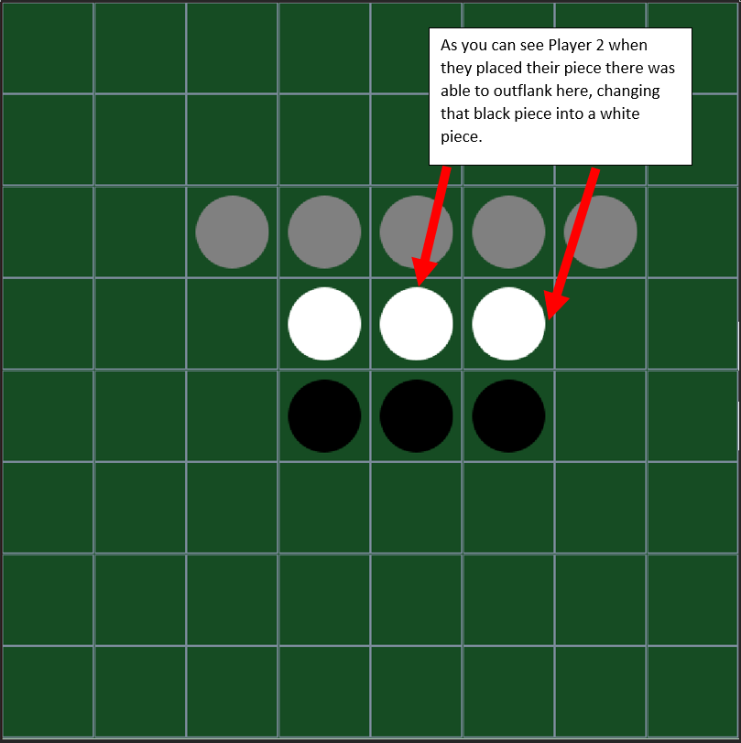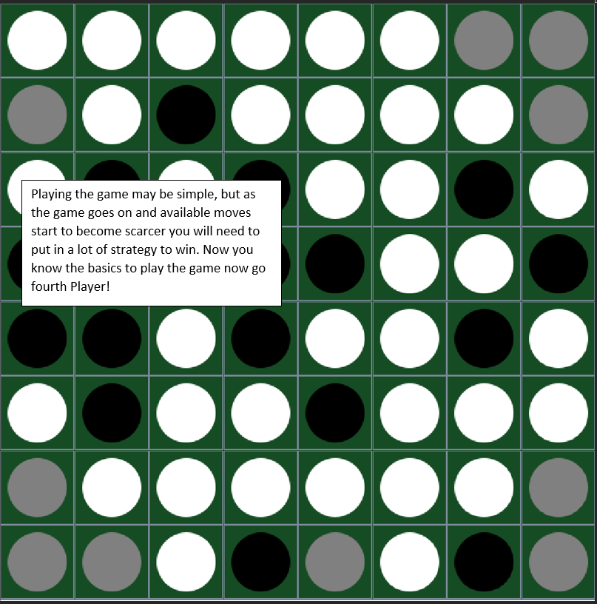

The concept of Othello is simple. Each player uses pieces of a different color–by default, player one uses black pieces, and player two uses white pieces. The objective of the game is to place the pieces and to claim as much of the board as they can by outflanking other pieces. On a player’s turn, that player places a piece that would outflank one or more of the opponent’s pieces. All of those outflanked pieces are then flipped over and become pieces belonging to the current player, adding to their score. Each player alternates turns playing pieces in this way until the board is full, or neither player is able to make a move. The player with the most pieces at the end of the game wins.

# Ruleset Differences of Othello and Reversi

Othello and Reversi may be similar in design and gameplay. However, there are two key differences explained below.

| Othello | Reversi |
| --- | --- |
| Skips players turn if no legal places are available. | Ends game, if no legal places available |
| Four pieces are placed in the middle during the preparation of the game. | Four pieces placed in the middle during the preparation of the game are optional and are decided by the User/Host. |

# 

# Traversing through the menus

Main Menu

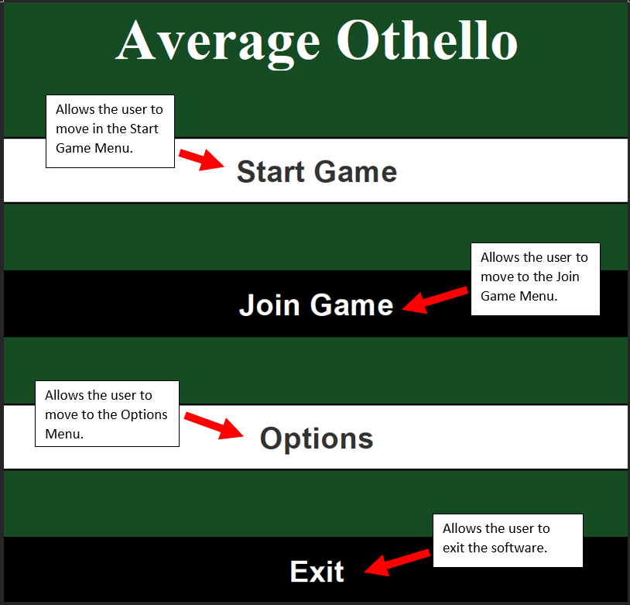

Start Game Menu

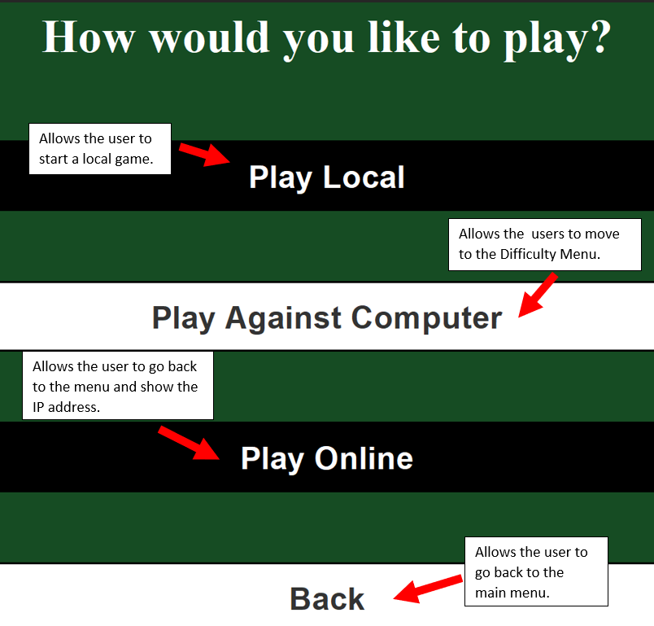

Play Online Menu

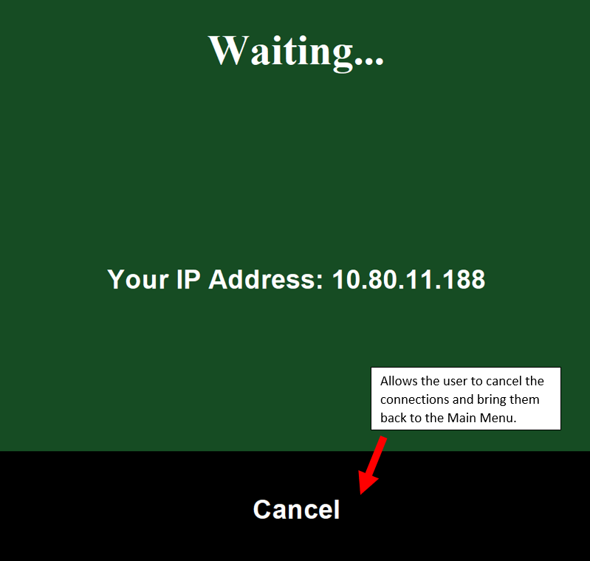

Join Game Menu

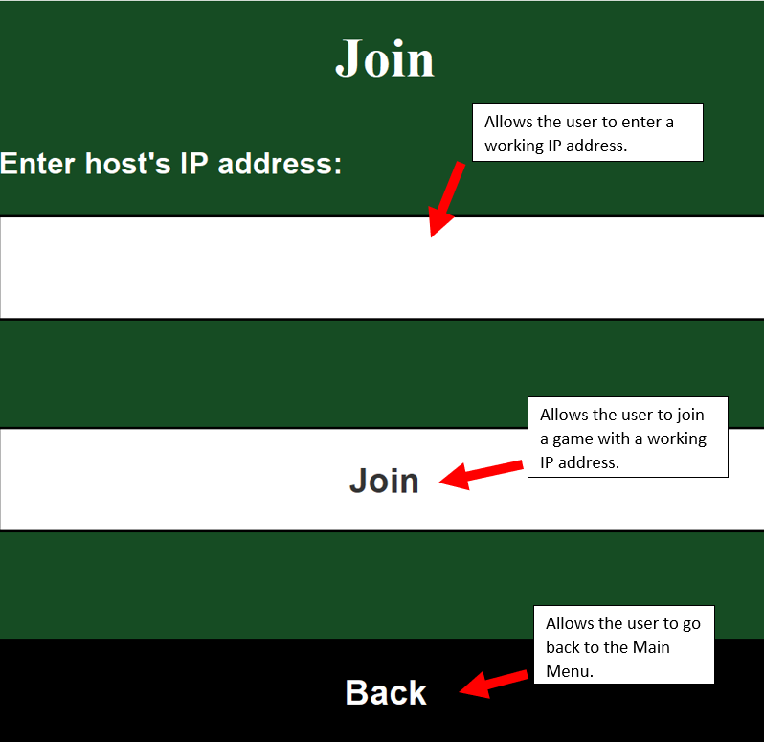

Options Menu

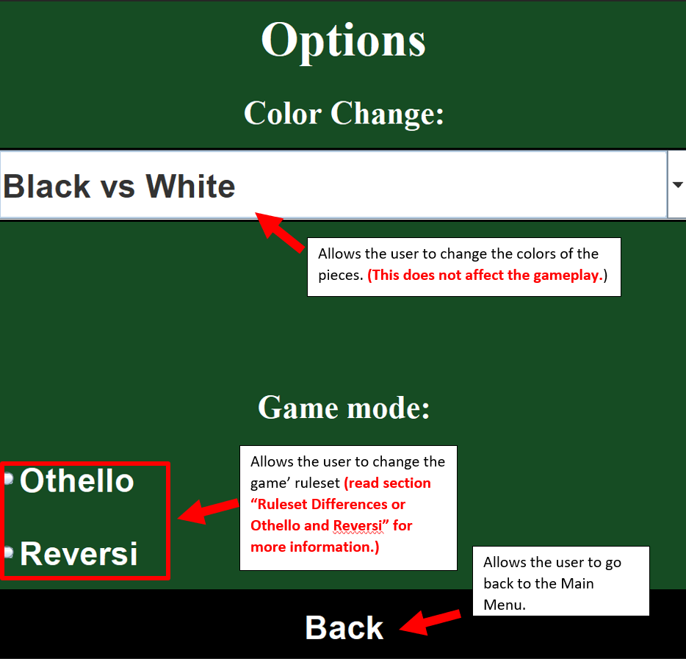

Difficulty Menu

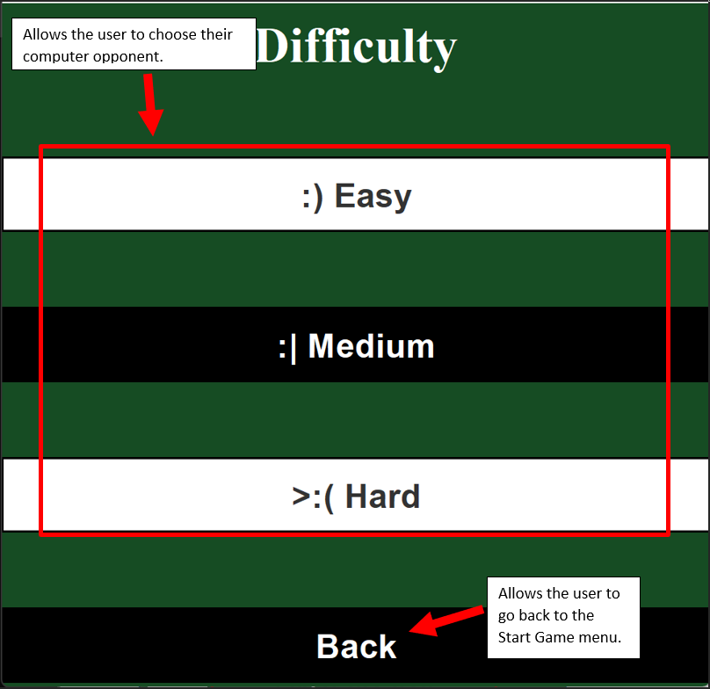

Game Over Menu

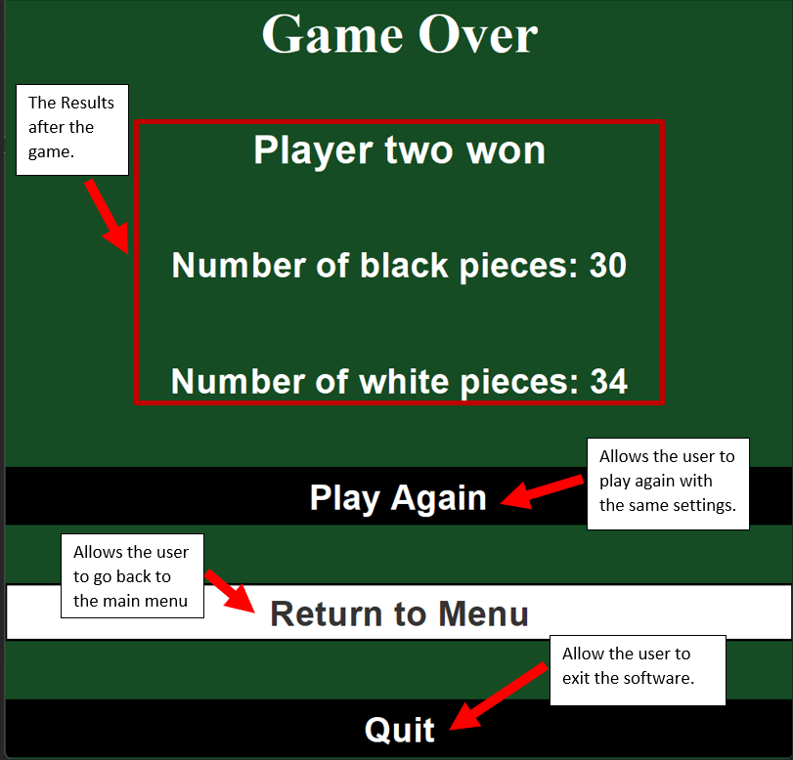

# 

# Tips/Tricks

* Try to think multiple turns ahead. Sometimes, what seems like a good move now may backfire later.
* Capturing the edges of the board will make your win much easier, so take the corners!
* Avoid placing pieces that give your opponent a bridge to the corners. This area is considered the “danger zone”

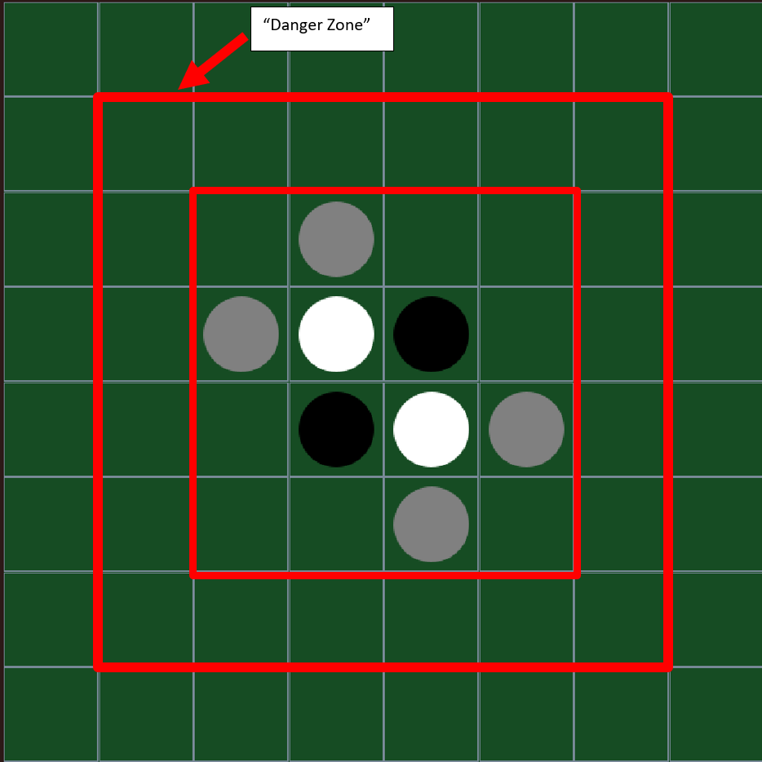

* Stay at the center of the board, then move to the edges.
* Avoid the walls unless you're able to capture the edges/corners.
* Again, think ahead and give yourself an advantage and give your opponent less options to make moves or win.
* Taking less pieces during early games will help you gain more/better options later in the game. Prioritize strategic placement over claiming lots of pieces early in the game.
* Be aggressive and force your opponent to play near the corners/edges for you to take them.

# Things that were not included in the final product

* Settings where it is possible to change different game ruleset from Othello and Reversi
* Timer during gameplay where a turn should last for 25 seconds otherwise the player's turn will switch

# 

# Future Plans

* Instructions on how to play the game available as a menu within the game
* Alternate modes for Othello and Reversi

# 