MGMT 58200 Final Project

Implementing a database for Vinayaga Steels

## **Group 2**:

## Girish Sharma

## Keerthana Nemili

## Payal Pandya

## Thannir Malai Annamalai Kumar

## Udyog Pati

# **Background**

***Client: Vinayaga Steels***

***Business Description:***The Indian steel industry has 3 main manufacturers – SAIL, JSW, Tata. The big dealers in each city/state stock hot rolled, cold rolled steel sheets etc. in bulk from these manufacturers. Big scale industries directly source these materials from dealers, whereas small scale and medium scale industries can’t pay upfront and expect credit-based payment source from middlemen merchants. Vinayaga steels operates in this merchant space providing steel sheets for credit.

Vinayaga Steels is an iron and steel merchant operating in the middleman space of the Steel industry supply chain. It was founded in 1993 by Mr. Kumar A and located in the heart of Manchester of South India “Coimbatore”, a city known for the steel foundries and small and medium scale businesses in general. Vinayaga Steels started off with just selling iron and steel sheets. But then it expanded its product portfolio by selling steel pipings, rod etc. under a different brand “Vinayaga Pipes”.

***Current Scenario:***The company records data as manual written bills and online electronic bills, but there is no organized database or structure to record the data. The major entities are: Dealer, Customer, PurchaseBill, SalesBill, Product, and Transportation.

## **Dataset Description:** The database created consists of 5 tables (Entities).

**PurchaseBill:** Contains records of bills made when Vinayaga Steels purchased steel sheets from the dealer

**SalesBill:** Contains records of bills made when Vinayaga Steels sold the purchased steel sheets to the customer

**Dealer:** Contains list of dealers from whom Vinayaga Steels purchased steels sheets

**Customer:** Contains list of customers to whom Vinayaga Steels sold steels sheets

**Transportation:** Contains list of vehicles which transported steel sheets from dealer/to customer

|  |  |
| --- | --- |
| Table Name: **PurchaseBill** Attributes / Columns:   * Purchase_BillNo * Product_HSN_Code * Purchase_Date * Dealer_TIN * Vehicle_No * Product_Name * SGST * Price_per_kg * Quantity_kg * Category * Product_Value * Category_Code * CGST * Dimension * Net_Value | Table Name: **SalesBill** Attributes / Columns:   * Sales_BillNo * Product_HSN_Code * Delivery_Date * Mode_of_Bill * Product_Name * Dimension * Category * Category_Code * Price_per_kg * Quantity_kg * Product_Value * SGST * CGST * Net_Value * Customer_TIN * Vehicle_No |
| TableName: **Customer** Attributes / Columns:   * Customer_TIN * Customer_Name * Country * State_Code * Address_Line_1 * Address_Line_2 * City * State * Pincode | Table Name: **Dealer** Attributes / Columns:   * Dealer_TIN (Primary Key) * Dealer_Name * Email * Country * State_Code * Phone_No * Address_Line_1 * Address_Line_2 * City * State * Pincode |
| Table Name: **Transportation**  Attributes / Columns:   * Vehicle No * Driver_Name * Vehicle_Type * Driver_License_No |  |

## **Project Objective:**

Design and implement a database for Vinayaga steels to improvise the current data capturing mechanism and efficiently record, manage and store data which will set a base for them build on and take data driven decisions.

## **Conceptual Data Modelling:**

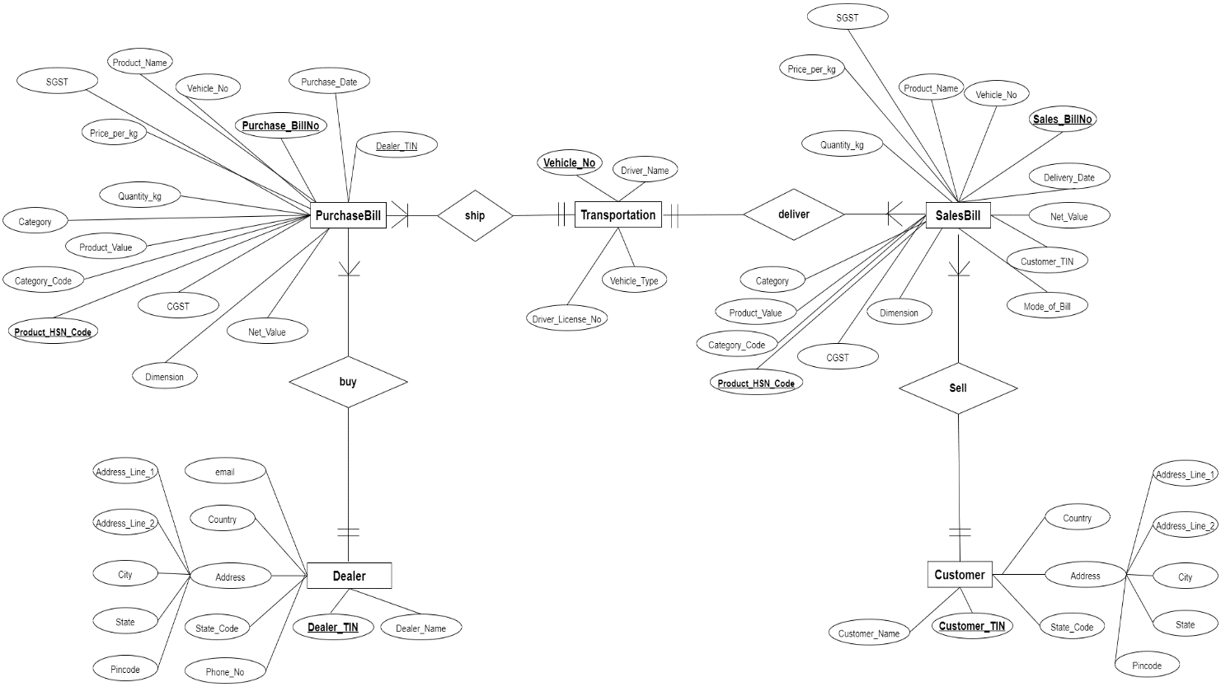

Cardinality of Tables.

* Each dealer can have one or many purchase bills.
* Each purchase Bill has only one dealer
* Each purchase Bill is associated with only one means of transportation(vehicle).
* Each transportation(vehicle) can have one or more purchase bills.
* Each sales bill is associated with only one means of transportation(vehicle).
* Each transportation(vehicle) can have one or more sales bills.
* Each sales bill is associated with only one customer.
* Each customer can have on or more sales bills.

## **Relational Data Modelling:**

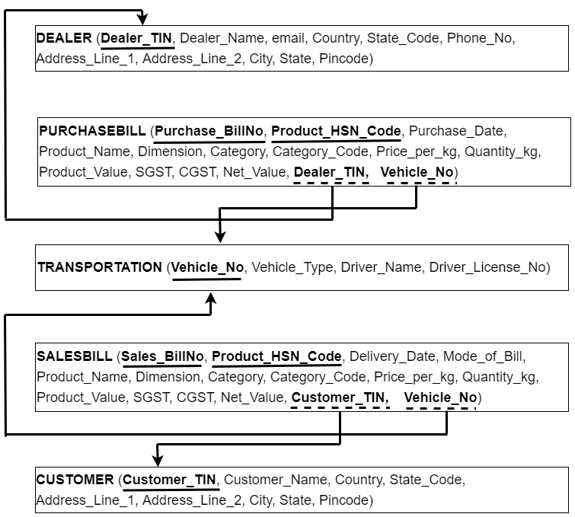

## **Data Model & Design Choices:**

The billing information was being recorded as manual bills; our objective was to create a SQL Database for the company that could be easily used to gain managerial insights. After gathering data into Excel, and preparing the ER-diagram and Relational Schema, we started with normalising.

Taking a first look at the data, we realised that Dealers and Customers have a composite attribute for Address, so to achieve 1-NF, we decomposed this attribute into separate columns for Address_Line1, Address_Line2, City, State and PIN.

We inspected each table to figure out the functional dependencies first, followed by identifying partial and transitive dependencies. Below reported are our findings –

***DEALER:***

Dealer_TIN -> Dealer_Name, email, Country, State_Code, Phone_No, Address_Line_1, Address_Line_2, City, State, Pincode

**No partial or transitive dependencies identified!** We therefore kept this table as is.

***CUSTOMER:***

CUSTOMER -> Customer_TIN, Customer_Name, Country, State_Code, Address_Line_1, Address_Line_2, City, State, Pincode

No partial or transitive dependencies identified! We therefore kept this table as is.

***PURCHASEBILL:***

Purchase_BillNo, Product_HSN_Code -> Price_per_kg, Quantity_kg, Product_Value, SGST, CGST, Net_Value, Dealer_TIN, Vehicle_No

Purchase_BillNo -> Purchase_Date : PARTIAL DEPENDENCY

Product_HSN_Code -> Product_Name, Dimension, Category, Category_Code : PARTIAL DEPENDENCY

Category_Code -> Category : TRANSITIVE DEPENDENCY

***TRANSPORTATION:***

Vehicle_No -> Vehicle_Type, Driver_Name, Driver_License_No

Driver_License_No -> Driver_Name : TRANSITIVE DEPENDENCY

**SALESBILL**

Sales_BillNo , Product_HSN_Code -> Price_per_kg, Quantity_kg, Product_Value, SGST, CGST, Net_Value, Customer_TIN, Vehicle_No

Product_HSN_Code -> Purchase_Date, Product_Name, Dimension, Category, Category_Code : PARTIAL DEPENDENCY

Category_Code -> Category: TRANSITIVE DEPENDENCY

Sales_BillNo -> Mode_of_Bill, Delivery_Date : PARTIAL DEPENDENCY

For each attribute listed above in the primary key, in their respective tables, that is involved in partial dependency, we created a new table. Primary key in old table becomes primary key of new table as well. All attributes that are partial dependent on that attribute are also be moved to the new table.

We then tackled the transitive dependencies, to take our tables to a 3-NF. For each transitive dependency, we created a new table with non-key determinant, and non-key dependant attributes. Primary key of new table is the non-key determinant from original table and removed non-key dependant from original table.

We finally ended up with the below Normalised Relational Schema. Our database now consists of 10 relations. Here, our common relation between Sales and Purchase is a Product which has information about dimensions and category.

*Note: In our case, Price_per_kg is dependent on both Bill number and product number and is not unique to just product.*

## **Appendix:**

SQL Queries and Results

1. Top 3 products purchased the most overall.

1. Total Categories purchased or Sold by Vinayaga Steels.

1. Which Product was most sold under each category.

1. Total Dealers.

1. Average Purchase Value, Total Purchase Value, Number of Bills at dealer level.

1. Best and worst price by dealers for each category across months.

1. Vinayaga Steels Profit Per Month.

1. Which vehicle type was used mostly for supply chain.

1. Which vehicle was mostly used for supply chain.

1. Total Customers.

1. Average Purchase Value, Total Purchase Value, Number of Bills at Customer level.

1. Average State and Central Government Tax.

1. Number of bills in each type.

1. Average sales value for each bill type.

1. Which customer made highest number of bills in EWay and normal type.

