Ansible training 2020.1014 / updated 2022.0420 / 2026.0418

DevOps with Ansible: Introduction to Playbooks & Testing

Ad hoc commands and key based logins:
Not full blown playbook, not saved for later

origin # ssh-keygen
ssh-add path/id_rsa

origin # lxc-attach -m adhoc # servername

adhoc # mkdir /root/.ssh
/root/.ssh/authorized_keys ## add contents of id_rsa.pub on ssh’ing pc

origin # ssh root@adhoc # ok, using key

origin # ansible all -i hosts -m ping -u root ## adhoc commands

/etc/ansible/hosts

You can specify a different inventory file at the command line using the -i <path> option

[group name]
10.0.0.1
ip addresses can appear in more than 1 group

NOTE ansible.cfg # can have overrides in CURDIR as well as
~/.ansible.cfg - overrides in home dir

HOWTO Make directories - p.62 - $ ansible-galaxy collection init ansible.default

Playbooks

---
gather_facts needs Python installed; facts are not available from ad-hoc command runs

authorized_key module

ansible-playbook bootstrap.yml -k -K -l hosts # query ssh password and sudo password

TODO "Mastering ansible 4th edition" p.28 - free strategy, speed up per-node exec

ignore_errors: true
^ p.226

failed_when: <conditions>
^ p.231

p.201 convert to lowercase, search/replace

YAML

yaml files starts with a list
--- # start
… # end

colon: must be followed by space

multiple lines - use pipe |
scalar: |
line1
line2
line3

folded: >
line1
line2 is part of line1
line3 is part of line2

drive: ‘c:’

Boolean values like “yes” or “True” MUST USE QUOTES

Use quotes on “2.0” numbers to prevent conv to floating point number!

Variables

vars should consist of letters, numbers, and underscores – no dashes or dots

arrays:

record:
field1: one
field2: two

A specific field can then be referenced from dictionary with bracket or dot notation:

record[‘field1’] OR record.field1

You can assign vars to hosts in inventory
[west]
host1 http_port=8080
host2 http_port=3000

You can assign vars to a group of hosts

[west]
host1
host2

west:
hosts:
host1:
host2:
vars:
proxy.west.local

Tasks and plays

notify: # is kind of an error trap
- restart nginx

handlers:
- name: restart nginx
service:
name: nginx
state: restarted

Ansible conditions and loops

- name: install python pkg on debian and centos
hosts: devservers
gather_facts: true
tasks:
- name: install python debian
# debug: var=ansible_facts # dump
apt:
name: python-dev
when: ansible_facts[‘distribution’] == “Ubuntu”
- name: install python centos
yum:
name: python-devel
when: ansible_facts[‘distribution’] == “CentOS”

Ansible loops

- name: add users
hosts: webservers
tasks:
- name: addusers
user:
name: “{{ item }}”
state: present
groups: “staff”
loop:
- testuser1
- testuser2
- testuser3

YAMLLint

Can do all files in dir with arg “.”

Ansible Tests

Compile - with different python versions

Sanity = static code analysis (standards/requirements adhered to)

Integration = test functionality of modules

Unit - applied against individual parts of codebase

# ansible-test sanity --list-test

# ansible-test sanity --test compile

Git pull requests

# git clone http/.git ansible-pr-test

cd ansible-pr-test

# git checkout -b pullrequestnumber devel # newbranchname
# git pull htps:/ansible.git github-release-anon-access

Q: variables are merged by default to the specific host before a play is run and Ansible overwrites variables by default. Variables defined at which level have the highest priority?
vars defined at HOST have the highest priority

=================================================================

2020.1014 DevOps with Ansible: Working with Ansible Features

Ansible Vault = encryption for files

# ansible-vault create/decrypt/edit/encrypt/view vaultfile.yml

# ansible-vault encrypt bootstrap.yml
$ [asks for password]

# ansible-vault create file.yml ## launches editor

Ansible Modules

Discrete units of code invoked at commandline or used in playbook/task

task/library plugins are NOT ansible plugins

Modules - some modules do not take args

# ansible webservers -m ping -u root -i hosts

# ansible webservers -m service -a “name=nginx state=restarted” -u root -i hosts ## -a = args

# ansible webservers -m shell -a “sleep 2s && reboot & executable=/bin/bash” -u root -i hosts

playbook- yaml syntax = complex arguments

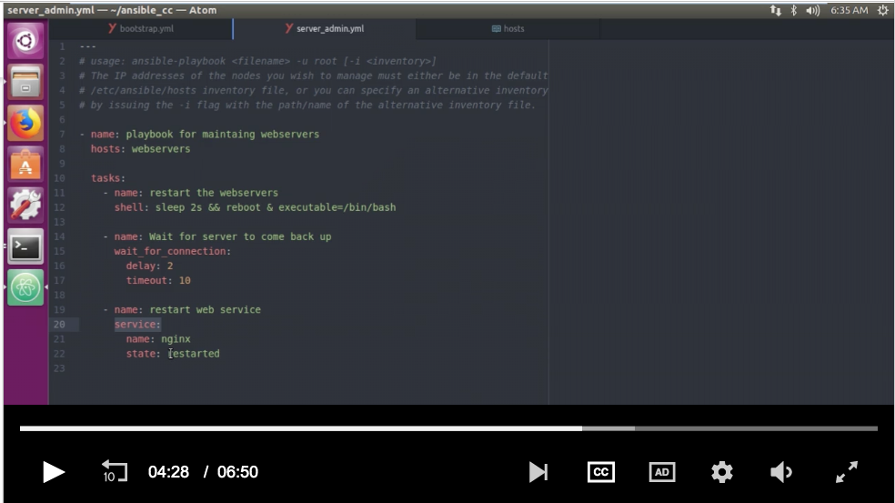
All ansible modules return JSON data

idempotent = module should have no additional effect if called >1x with same parms, and make no changes if current state = desired final state

# ansible-doc service ## doc on service module
# ansible-doc -l ## list all

Ansible commands modules

command, raw, shell

raw = pretty much same as ssh ## when python is not installed

# ansible webservers -m raw -a “test -e /usr/bin/python || (apt-get update && apt-get install -y python)” -u root -i hosts

command module (default when running adhoc) bypasses the shell, no env vars, can only exec binaries that exist on dest, no redirection

# ansible webservers -a “who -r” -o -u root -i hosts

shell module - native functionality, redirection supported, env vars

# ansible webservers -m shell -a “ps -aux > ps.out” -u root -i hosts

Ansible plugins

extensible - create plugin and drop in folder, inside role, or put in ansible.cfg directory source

action plugins are frontend plugins for ansible modules
can exec actions on master host before calling actions for modules
work in combo with modules to do things for tasks
exec auto in BG

lookup plugins can be used anywhere templating can be used in ansible
e.g. inside a play, vars file, inside jinja2

inventory plugins - allow specify various data sources to compile hosts inventory
may need to be whitelisted in .cfg

hosts
[[
web1 ansible_host=10.0.0.1
ntp1 ansible_host=10.0.0.2
db1 ansible_host=10.0.0.3
]]

inventory.yml:
[[
plugin: constructed
strict: False
groups:
webservers: inventory_hostname.startswith(‘web’)
test: “’test’ in (ec2_tags|list)”
multi_group: (group_names|intersection([‘alpha’, ‘beta’]))|length >= 2
]]

# ansible-inventory -i hosts -i inventory.yml --list ## long dump

# ansible-inventory -i hosts -i inventory.yml --graph ## shortlist

# ansible webservers -m ping -i hosts -i inventory.yml -u root

Ansible Filters

filters are based on jinja2 templating engine

used inside {braces}

allows us to add custome filters

filters exec on Controller to manip local data (kinda like Linux pipelining)

tasks:
- name: random mac
debug: msg=”{{ ‘40:2c:1a’ | random_mac }}”

doc - filters is under working with plugins

debug: msg=”{{ ‘htp:/longurl’ | urlsplit(‘hostname’) }}” # parse hostname from url

# ansible-playbook filter.yml -u root -i hosts

Ansible Patterns

which hosts to manage

# ansible webservers:dbservers -m ping -u root -i hosts ## do both kinds

# ansible webservers[0] ## 1st server in list

# ansible “dbservers:&staging” # intersection db server also in staging group

:colon is OR
!bang is NOT

# ansible-playbook patterns.yml -u root -i hosts

regexp patterns start with ~tilde
hosts: ~(web|db)servers

Command line tools

# ansible 10.0.0.1 -m ping -u root -i hosts ## ip must be in hosts file

# ansible-config view

# ansible-console all -u root ## interactive repetitive console
$ ping

# ansible-doc -l -t lookup ## list lookup-type plugins

# ansible-inventory -i hosts --list | --graph

# ansible-playbook pingme.yml -u root -i hosts

ansible pull = pull playbooks from VCS repo like git
setup remote copy of ansible on each node, run via cron, update playbook source via repo – inverts push arch into pull arch (scaling potential)

ansible vault

Network scaling automation w/ Ansible Tower

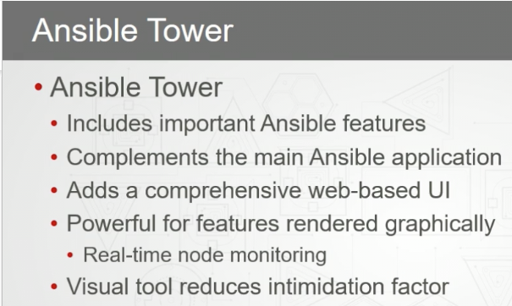

- Role based access control (LDAP / AD)

- Simplified portal view

- Job scheduling

- Dashboard

- REST API

- Cloud integration

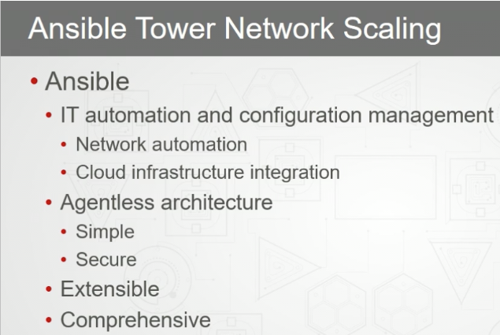

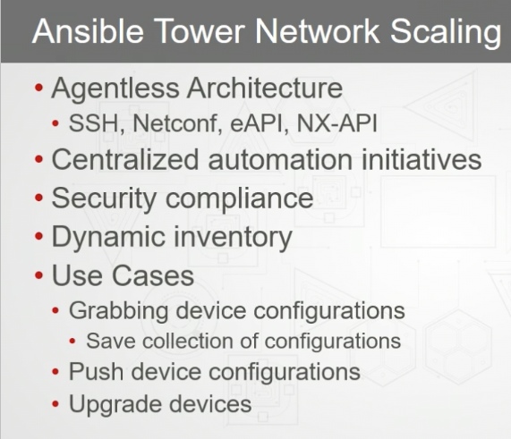

Installing Ansible Tower

- install on standalone VM or cloud instance, don’t colocate w/ other apps

- RAM requirements based on # of hosts to manage, 4GB / 100 forks

- umask 022 is required in /etc/profile

ansible tower quick installation guide // free trial - up to 10 nodes, does not expire

ec2 and vagrant supported

setup.sh

Tower Administration

Normal - R/W limited to Roles

Auditors inherit R/o for all objects in tower

Admin - g0dx0r

Teams - hierarchical, can have different permissions

The Ansible variable named qa_passed is defined as True in an Ansible playbook. Which of these debug commands will indicate the variable type as a debug message?
debug: msg="{{ qa_passed | type_debug }}"
Correct answer.
Selected

The JOB STATUS graph on the Dashboard allows you to filter activity based on which values?
Job Type
Period

