|  |  |  |  |  |  |  |  |  |  |  |  |
| --- | --- | --- | --- | --- | --- | --- | --- | --- | --- | --- | --- |
|  |  |  | | |  |  |  | | 09/05/2024 | | |
|  |  |  | | |  |  |  | | Date | | |
| **RE-ADMISSION SLIP** | | | | | | | | | | | |
| This is to certifies that, | | ABADIANO , IVY M. | | | | | | a ***RETURNEE*** student, fulfilled all | | | |
| necessary requirements and formalities and is hereby granted a permission to resume his/her studies in | | | | | | | | | | | |
| **Samar State University -** | | | Paranas Campus | . | | | | | | | for |
| the Academic Year **2023 - 2024**, **Second Semester.** | | | | | | | | | | | |
|  |  |  | | |  |  |  | |  |  | |
|  |  |  | | |  |  |  | |  |  | |
| Program: | Bachelor of Elementary Education | | | | | | | | | | |



**MAE V. CAÑAL, RGC, RPm, RPsy**

*Director, Student Welfare and Development Services*

Website: www.ssu.edu.ph

*WURI Fourth Industrial Revolution | Rank 1 in the Philippines and in the World (2022 & 2023)*

*Rated 3 Stars | QS Ratings System for Excellence (2022)*

*Energy Efficiency Excellence Awardee (2022)*

*ASEAN Icons Awardee (2022)*

*Gawad Yamang Isip Awardee (2022)*

*1st Philippine Higher Education Internationalization Awardee (2021)*

*PQA | Level 2 | Recognition for Proficiency in Quality Management (2020)*

*Top Patent Filer (2009-2019)*

*PRIME-HRM (2018)*

Contact us: (055) 530-0629 | [info@ssu.edu.ph](mailto:info@ssu.edu.ph)

Follow us on @ssucatbalogan

Page 1 of 1

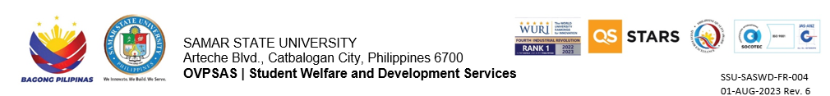

|  |  |  |  |  |  |  |  |  |  |  |  |
| --- | --- | --- | --- | --- | --- | --- | --- | --- | --- | --- | --- |
|  |  |  | | |  |  |  | | 09/05/2024 | | |
|  |  |  | | |  |  |  | | Date | | |
| **RE-ADMISSION SLIP** | | | | | | | | | | | |
| This is to certifies that, | | ABADIANO , IVY M. | | | | | | a ***RETURNEE*** student, fulfilled all | | | |
| necessary requirements and formalities and is hereby granted a permission to resume his/her studies in | | | | | | | | | | | |
| **Samar State University -** | | | Paranas Campus |  | | | | | | | for |
| the Academic Year **2023 - 2024**, **Second Semester.** | | | | | | | | | | | |
|  |  |  | | |  |  |  | |  |  | |
|  |  |  | | |  |  |  | |  |  | |
| Program: | Bachelor of Elementary Education | | | | | | | | | | |



**MAE V. CAÑAL, RGC, RPm, RPsy**

*Director, Student Welfare and Development Services*

Received by: ___________________________________

Date: _________________________________________