BAUTISTA, KEANA FRANCHESKA M. 2ECE-E

**PROBLEM 1**

**pd.merge**

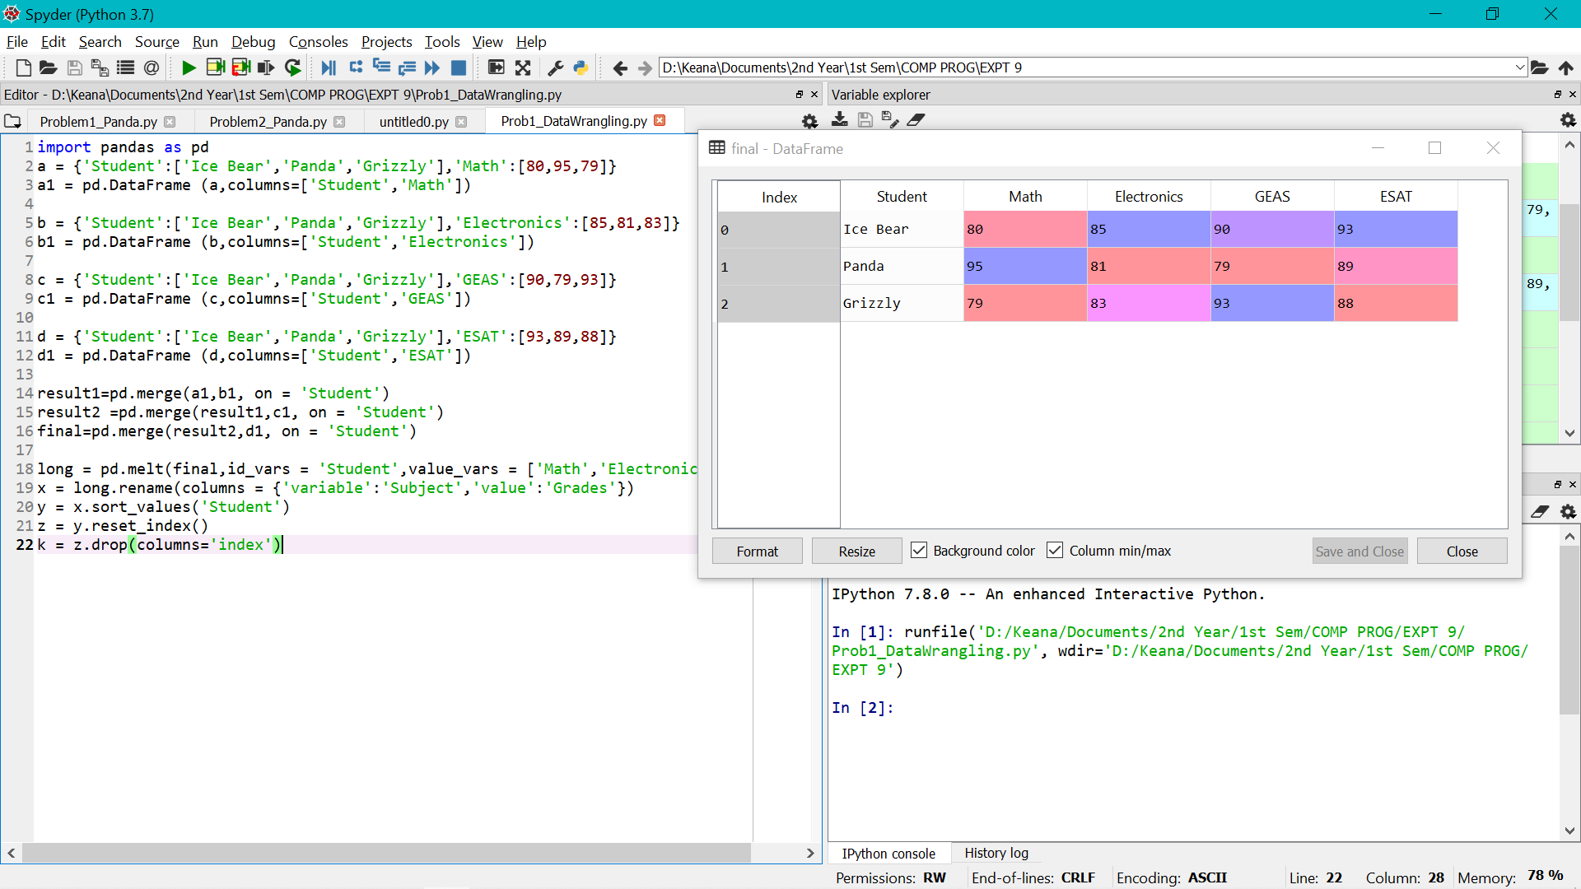

***long format***

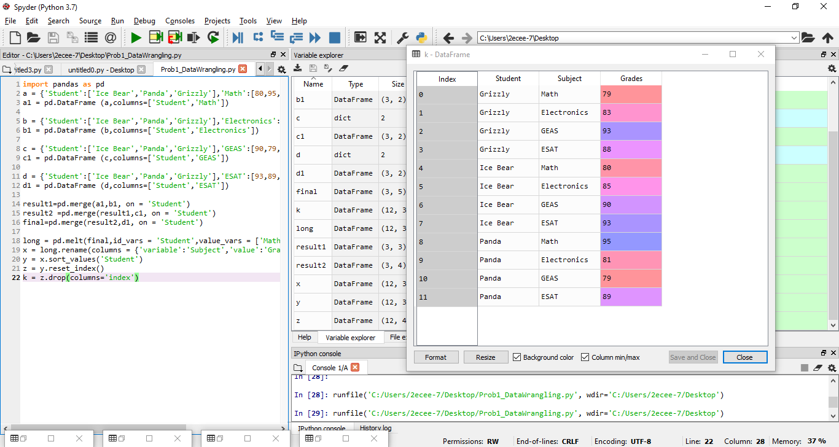

**PROBLEM 2**

