LINK 3 2d

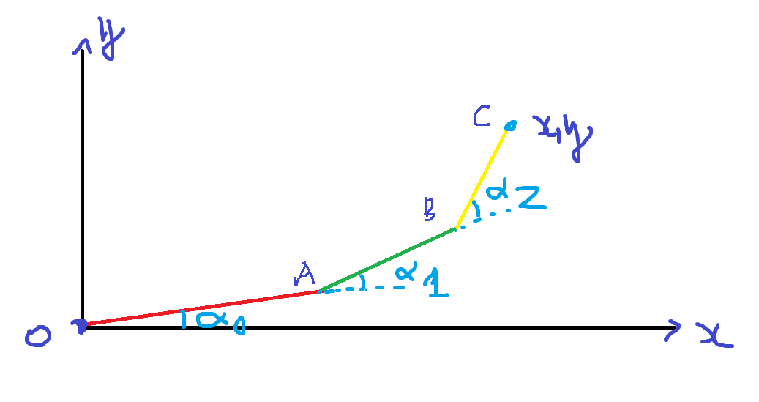

$$R_{A}=\left[\begin{matrix}cosα & -sinα & 0 \\ sinα & cosα & 0 \\ 0 & 0 & 1\end{matrix}\right]$$

$$T_{A}=\left[\begin{matrix}1 & 0 & A \\ 0 & 1 & 0 \\ 0 & 0 & 1\end{matrix}\right]$$

$$R_{B}=\left[\begin{matrix}cosβ & -sinβ & 0 \\ sinβ & cosβ & 0 \\ 0 & 0 & 1\end{matrix}\right]$$

$$T_{B}=\left[\begin{matrix}1 & 0 & B \\ 0 & 1 & 0 \\ 0 & 0 & 1\end{matrix}\right]$$

$$R_{C}=\left[\begin{matrix}cosγ & -sinγ & 0 \\ sinγ & cosγ & 0 \\ 0 & 0 & 1\end{matrix}\right]$$

$$T_{C}=\left[\begin{matrix}1 & 0 & C \\ 0 & 1 & 0 \\ 0 & 0 & 1\end{matrix}\right]$$

$$R_{A}.T_{A}=\left[\begin{matrix}cosα & -sinα & 0 \\ sinα & cosα & 0 \\ 0 & 0 & 1\end{matrix}\right].\left[\begin{matrix}1 & 0 & A \\ 0 & 1 & 0 \\ 0 & 0 & 1\end{matrix}\right]=\left[\begin{matrix}cosα & -sinα & A.cosα \\ sinα & cosα & A.sinα \\ 0 & 0 & 1\end{matrix}\right]$$

$$R_{A}.T_{A}.R_{B}=\left[\begin{matrix}cosα & -sinα & A.cosα \\ sinα & cosα & A.sinα \\ 0 & 0 & 1\end{matrix}\right].\left[\begin{matrix}cosβ & -sinβ & 0 \\ sinβ & cosβ & 0 \\ 0 & 0 & 1\end{matrix}\right]=\left[\begin{matrix}cosα.cosβ-sinα.sinβ & -cosα.sinβ-sinα.cosβ & A.cosα \\ sinα.cosβ+cosα.sinβ & -sinα.sinβ+cosα.cosβ & A.sinα \\ 0 & 0 & 1\end{matrix}\right]=\left[\begin{matrix}\cos\left(α+β\right) & -\sin\left(α+β\right) & A.cosα \\ \sin\left(α+β\right) & \cos\left(α+β\right) & A.sinα \\ 0 & 0 & 1\end{matrix}\right]$$

$$\underline{a}=\left[\begin{matrix}A.cosα \\ A.sinα\end{matrix}\right]$$

$$R_{A}.T_{A}.R_{B}.T_{B}=\left[\begin{matrix}cos⁡(α+β) & -sin⁡(α+β) & A.cosα \\ sin⁡(α+β) & cos⁡(α+β) & A.sinα \\ 0 & 0 & 1\end{matrix}\right].\left[\begin{matrix}1 & 0 & B \\ 0 & 1 & 0 \\ 0 & 0 & 1\end{matrix}\right]=\left[\begin{matrix}cos⁡(α+β) & -sin⁡(α+β) & B.\cos\left(α+β\right)+A.cosα \\ sin⁡(α+β) & cos⁡(α+β) & B.\sin\left(α+β\right)+A.sinα \\ 0 & 0 & 1\end{matrix}\right]$$

$$\underline{b}=\left[\begin{matrix}B.\cos\left(α+β\right)+A.cosα \\ B.\sin\left(α+β\right)+A.sinα\end{matrix}\right]$$

$$R_{A}.T_{A}.R_{B}.T_{B}.R_{c}=\left[\begin{matrix}\cos\left(α+β\right) & -\sin\left(α+β\right) & B.\cos\left(α+β\right)+A.cosα \\ \sin\left(α+β\right) & \cos\left(α+β\right) & B.\sin\left(α+β\right)+A.sinα \\ 0 & 0 & 1\end{matrix}\right]. \left[\begin{matrix}cosγ & -sinγ & 0 \\ sinγ & cosγ & 0 \\ 0 & 0 & 1\end{matrix}\right]=\left[\begin{matrix}\cos\left(α+β\right).cosγ-\sin\left(α+β\right).sinγ & -\cos\left(α+β\right).sinγ-\sin\left(α+β\right).cosγ & B.\cos\left(α+β\right)+A.cosα \\ \sin\left(α+β\right).cosγ+\cos\left(α+β\right).sinγ & -sin\left(α+β\right).sinγ+\cos\left(α+β\right).cosγ & B.\sin\left(α+β\right)+A.sinα \\ 0 & 0 & 1\end{matrix}\right]=\left[\begin{matrix}\cos\left(α+β+γ\right) & -\sin\left(α+β+γ\right). & B.\cos\left(α+β\right)+A.cosα \\ \sin\left(α+β+γ\right). & \cos\left(α+β+γ\right) & B.\sin\left(α+β\right)+A.sinα \\ 0 & 0 & 1\end{matrix}\right]$$

$$R_{A}.T_{A}.R_{B}.T_{B}.R_{c}.T_{C}=\left[\begin{matrix}\cos\left(α+β+γ\right) & -\sin\left(α+β+γ\right). & B.\cos\left(α+β\right)+A.cosα \\ \sin\left(α+β+γ\right). & \cos\left(α+β+γ\right) & B.\sin\left(α+β\right)+A.sin \\ 0 & 0 & 1\end{matrix}\right].\left[\begin{matrix}1 & 0 & C \\ 0 & 1 & 0 \\ 0 & 0 & 1\end{matrix}\right]=\left[\begin{matrix}\cos\left(α+β+γ\right) & -\sin\left(α+β+γ\right). & C.\cos\left(α+β+γ\right)+B.\cos\left(α+β\right)+A.cosα \\ \sin\left(α+β+γ\right). & \cos\left(α+β+γ\right) & C.\sin\left(α+β+γ\right)+B.\sin\left(α+β\right)+A.sinα \\ 0 & 0 & 1\end{matrix}\right]$$

$$\underline{c}=\left[\begin{matrix}C.\cos\left(α+β+γ\right)+B.\cos\left(α+β\right)+A.cosα \\ C.\sin\left(α+β+γ\right)+B.\sin\left(α+β\right)+A.sinα\end{matrix}\right]$$

Forward kinematics: Set $α,β,γ$ find $\underline{c}$

Invert kinematics : ??

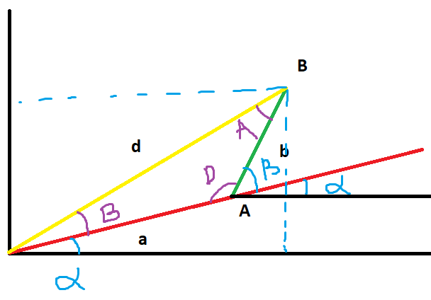

$$\frac{\sin{A}}{a}=\frac{\sin{B}}{b}=\frac{\sin{D}}{d}$$

$$d^{2}={x_{B}}^{2}+{y_{B}}^{2}$$

$$d^{2}=a^{2}+b^{2}-2.a.b.\cos\left( 180-β\right)$$

$${x_{B}}^{2}+{y_{B}}^{2}=a^{2}+b^{2}+2.a.b.\cos\left( β\right)$$

$$\cos{β}=\frac{{x_{B}}^{2}+{y_{B}}^{2}-a^{2}-b^{2}}{2.a.b}→β=arccos⁡\left(\frac{{x_{B}}^{2}+{y_{B}}^{2}-a^{2}-b^{2}}{2.a.b}\right)$$

$$\sin{β}=±\sqrt{1-\cos^{2}{β}}$$

$$θ=arctan\frac{y}{x}$$

$$\frac{sinA}{a}=\frac{sinB}{b}=\frac{\sin{D}}{d}=\frac{sin\left(π-β\right)}{d}=\frac{sinβ}{d}→sinA=\frac{a.sinβ}{d}$$

$$A=arcsin\left(\frac{a.sinβ}{d}\right)$$

$$⍺=arctan\frac{y}{x}-arcsin\left(\frac{a.sinβ}{d}\right)$$