**3. Topics to Investigate**

**Focus of the Statistical Investigation**

**Guiding Question #2:** Has youth employment in Saskatchewan decreased since the announcement of a minimum wage increase in July 2024?

**Background/ Context**

The relationship between minimum wage and youth employment is highly contested within the field of economics. Classical economic theory suggests that increases to minimum wage have a negative impact on youth employment. This theory suggests that when employers are required to pay a higher minimum wage, they will be more likely to reduce their number of employees. The negative impact of minimum wage increases is thought to be felt most strongly by youth who, as relatively inexperienced workers, are more likely to earn minimum wage.

In July 2024, the government of Saskatchewan announced an increase to the minimum wage from $14 per hour to $15 per hour. According to classical economic theory, this announced increase in minimum wage should have led to a decrease in youth employment. We tested this prediction by testing whether the proportion of youth who were employed after the announcement of the minimum wage increase is less than the proportion of youth who were employed before the announcement.

**4. Statistical Methods**

**Guiding Question #2:** Has youth employment in Saskatchewan decreased since the announcement of a minimum wage increase in July 2024?

**Hypotheses**

For our second guiding question, we explored whether youth employment in Saskatchewan decreased since the announcement of a minimum wage increase. For this question, our variable of interest is youth employment. As the data set records information at the individual level, employment is a categorical variable. In the data set, any one individual can be classified as employed (at work), employed (absent from work), unemployed, and not in the labour force. As a result of the categorical nature of this variable, the statistic of interest was the proportion of youth who were employed. For this exploration, we tested the following statistical hypothesis:

$$H_{0}:p_{employSKpost}-p_{employSKpre}≥0$$

$$H_{A}:p_{employSKpost}-p_{employSKpre}<0$$

We also conducted the same test on Alberta for the same period. The minimum wage in Alberta has been constant at $15 for this period. As a result, we did not expect to see a difference in the proportion of youth who are employed in the post and pre minimum wage announcement time frame. However, we conducted the test on Alberta as a form of comparison to see if there was similar trend in Alberta as in Saskatchewan. If there was a similar change in both provinces, then any change in employment was likely due to economic factors outside of the change in minimum wage.

$$H_{0}:p_{employABpost}-p_{employABpre}≥0$$

$$H_{A}:p_{employABpost}-p_{employABpre}<0$$

It is important to note that for Alberta, pre and post treatment simply refers to the same time period as Saskatchewan's pre and post treatment. As minimum wage remained steady for the entire period, there is no treatment condition for Alberta.

In testing both hypotheses, we used a value of $α= 0.05$.

In our analysis, we defined youth as aged 15 to 24 years. We defined the pre-treatment period as July 2023 to June 2024 and the post-treatment period as July 2024 to June 2025. This allowed us to study a full 12 months before and after the announcement of the minimum wage increase. We decided to define the pre and post treatment period based on the date of the announcement of the minimum wage increase rather than the date where the minimum wage came into effect. We made this decision based on the idea that employers would seek to reduce their number of employees *before* the increased minimum wage came into effect. We defined employed as employed and present at work or as employed and absent from work during the time of survey.

**Condition Checking**

To test the difference in proportion of youth who are employed pre and post treatment, we conducted a proportion test which relies on the normal distribution. For such a test to be appropriate, all samples must meet the following conditions: $np ≥10$ and $n\left(1-p\right)≥10$.

The results for the condition checks are below:

|  |  |  |
| --- | --- | --- |
| **sample** | $$np$$ | $$n\left(1-p\right)$$ |
| Saskatchewan pre-treatment | 5472 | 4798 |
| Saskatchewan post-treatment | 6079 | 5457 |
| Alberta pre-treatment | 7263 | 6902 |
| Alberta post-treatment | 7419 | 7033 |

As a result, the necessary conditions were met to conduct a difference of proportions test for both Saskatchewan and Alberta.

**5. Results**

**Visualization**

To helps us get a sense of whether youth employment decreased in the year before and year after Saskatchewan's announcement of a minimum wage increase, we plotted a side-by-side proportion bar graph for youth employment for both the pre- and post-announcement period in both provinces.

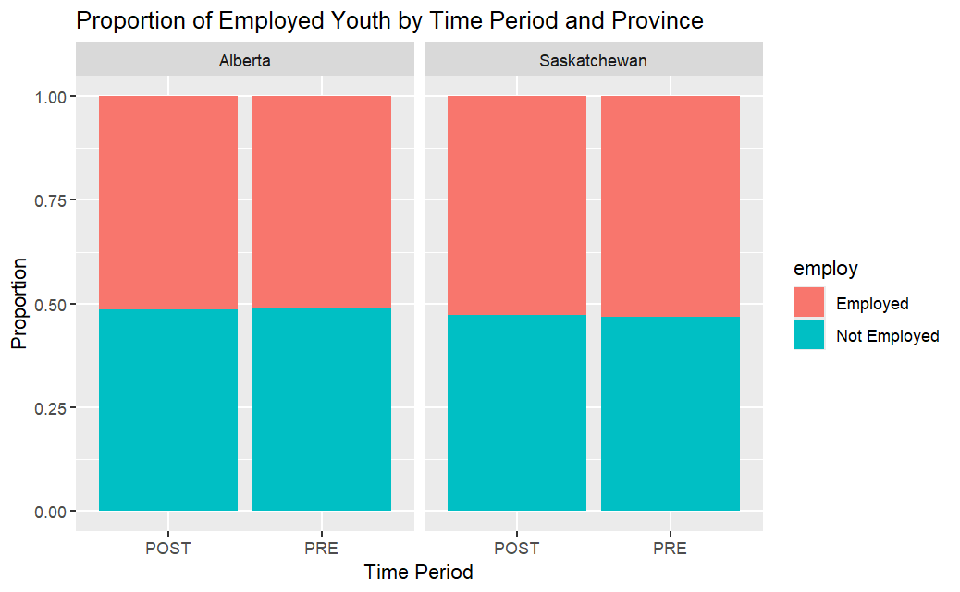

The above visualization shows the proportion of youth who were employed at the time surveyed. Pink represents the proportion of youth who are employed, and blue represents the proportion of youth who are unemployed. POST represents the 12 months after the announcement of the minimum wage increase and PRE represents the 12 months before the announcement.

For both Alberta and Saskatchewan, the proportion of youth who are employed appears to be very similar for the pre- and post-announcement time periods. From this visualization it seems unlikely that there is evidence of a statistically significant decrease in youth employment for either province. Comparing the two provinces in the visualization, Saskatchewan appears to have a slightly higher youth employment rate than Alberta.

**Proportion Tests**

First, we calculated the sample difference in proportions for youth employment for between the post- and pre-announcement time periods in Saskatchewan. The difference in the sample proportion for youth employment in Saskatchewan was calculated to be about -0.0059. In other words, youth employment decreased by 0.59 percentage points after the announcement of the increase in minimum wage in those sampled in the survey.

Next, a proportion test was used to see whether this difference represents statistically significant evidence of a decrease in proportion. In conducting the proportion test, we calculated the p-value. The p-value represents the probability of getting another two samples of the same size with a difference of proportion that is less than or equal to the difference in proportion we found, given that there is no actual difference in the population proportions. This probability can be stated as:

From above, the observed value of the test statistic is $z_{obsv}≈-0.8645$, and the p-value for this test is 0.1937. This means that if there is no actual difference in proportions, the probability of getting another two samples with a difference in proportion of less than or equal to the difference in proportion we found is 0.1937. This p-value is greater than our stated value of $α= 0.05$. As $p-value > α$, we fail to reject the null hypothesis. Therefore, we do not have statistically significant evidence of a decrease in youth employment in Saskatchewan after the announcement of an increase in minimum wage.

To further investigate the difference in proportions in youth employment before and after the announcement of a minimum wage increase, we calculated the 95% confidence interval for .

From above, the 95% confidence interval is:

$$-0.0191≤p_{empSKpost}-p_{empSKpre}≤0.0074$$

This confidence interval tells us that we can be 95% confident that the true difference in population proportion for Saskatchewan before and after the announcement of a minimum wage increase is -0.0191 and 0.0074. In other words, if we were to repeat this study many times, the confidence interval we would create would capture the true difference in population proportion 95% of the time. Since the above confidence interval captures the value of 0, we cannot be 95% confident that there has been a decrease in the true proportion of youth who are employed after the announcement of a minimum wage increase in Saskatchewan.

As a comparison, we conducted the same test for the same period for Alberta. The minimum wage remained constant in Alberta during this period, so we did not expect to see a difference in the proportion of youth who are employed in the post and pre-treatment time frame. In this test, post and pre-treatment simply refers to the same period as pre and post treatment in Saskatchewan. Again, we started by calculating the sample difference in proportions for youth employment in Alberta for the post and pre-treatment period. The difference in the sample proportion for youth employment in Alberta was about -0.0006. In other words, youth employment decreased by 0.06 percentage points during the same period as the post and pre-treatment period in Saskatchewan.

A proportion test was used to see whether this difference represents statistically significant evidence of a decrease in proportion.

From the above calculations, the value of the test statistic is $z_{obsv}≈-0.1035$. The p-value for the test is 0.5412. This p-value is greater than our stated value of $α= 0.05$. As a result, $p-value > α$, and we fail to reject the null hypothesis. Therefore, we do not have statistically significant evidence of decrease in youth employment in this period.

To further investigate whether there has been a decrease in youth employment in this period, we will calculate the 95% confidence interval for .

From above, the 95% confidence interval is:

$$-0.0110≤p_{empABpost}-p_{empABpre}≤0.0122$$

As a result, we can be 95% confident that the true difference in population proportion for youth employment in Alberta in this time is between -0.0110 and 0.0122. This confidence interval captures the value of 0. Therefore, we cannot be 95% confident that there has been a decrease in the true proportion of youth who are employed during this period in Alberta.

**6. Conclusion and Future Work**

**Interpretation of Results**

For the proportion test for Saskatchewan, the p-value for the test was 0.1937. Since 0.1937 is greater than our stated value of $α= 0.05$, we failed to reject the null hypothesis. As a result, we could not conclude that there was a statistically significant decrease in youth employment in Saskatchewan after the announcement of an increase in minimum wage. As a result, our findings do not appear to support the economic theory that increases to minimum wage have a negative impact on youth employment. There was a slight decrease in the observed sample proportion for youth employment in Saskatchewan after the announcement of an increase in minimum wage. However, this decrease was not found to be statistically significant. Additionally, we could not be 95% confident that there was a true population decrease in youth employment during this period.

As a comparison, we also conducted the same test for Alberta. For this test the p-value was 0.5412. Since 0.5412 is greater than our stated value of $α= 0.05$, we again failed to reject the null hypothesis. As a result, we could not conclude that there was a statistically significant decrease in youth employment in Alberta during the same time as the post and pre treatment in Saskatchewan. Similar to what was observed for Saskatchewan, a slight decrease was observed in the sample proportion for youth employment in Alberta in the same period. Again, this decrease was not found to be statistically significant. It appears that youth employment levels followed a similar trend in both Alberta and Saskatchewan in the period studied. As Alberta's minimum wage was constant during this period, this suggests that the observed trends in youth employment were likely a result of economic outside of the changes to minimum wage.

**Limitations**

While our findings do not support the classical economic theory that increases in minimum wage have negative impacts on youth employment, it is important to be aware of the limitations of our study. Our study only examined one instance of an increase to minimum wage in one jurisdiction. As a result, we should be cautious in generalizing these results to the impacts of increases to minimum wage in other time periods and locations. Additionally, this proportion test did not control for other variables that could have impacted youth employment in the period. It is possible that other economic factors may have contributed to or mitigated the impacts of the increased minimum wage on youth employment in Saskatchewan.

**Recommendations and Future Directions**

To further examine the impacts of minimum wage other studies should be conducted for other instances of minimum wage increases including both in Canada and elsewhere. If similar trends are discovered for other instances of minimum wage increases, then it may be possible to generalize our findings. Additional statistical methods that control for other variables that could contribute to change in employment levels should also be explored.

**Appendices**

**Data Preparation**

To aid in the analysis of comparing Alberta and Saskatchewan pre- and post-treatment, we created four separate data frames: Saskatchewan pre-treatment, Saskatchewan post-treatment, Alberta pre-treatment, and Alberta post-treatment.

**Data Visualization**

**Condition Checking**

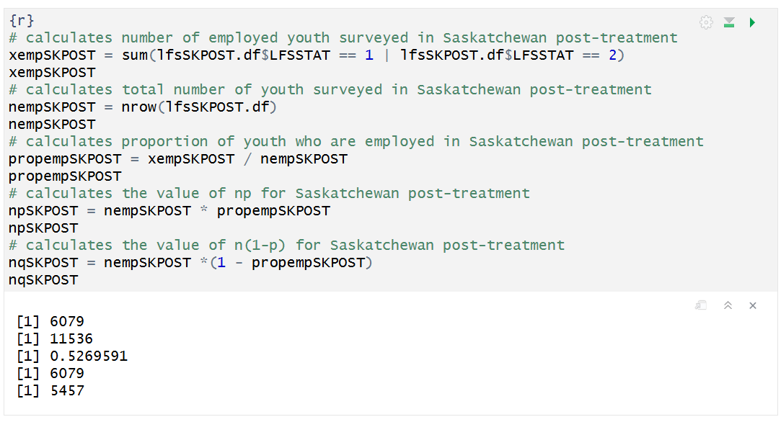

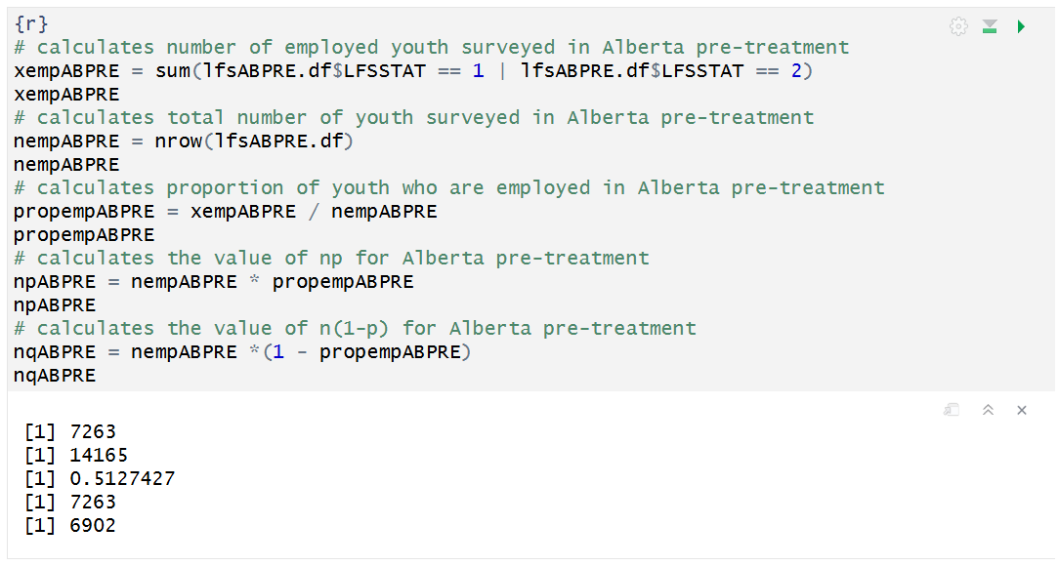

**Data Analysis**

