212 Design Project Part B
The following circuit will be used in the following document with LM741 op amps:
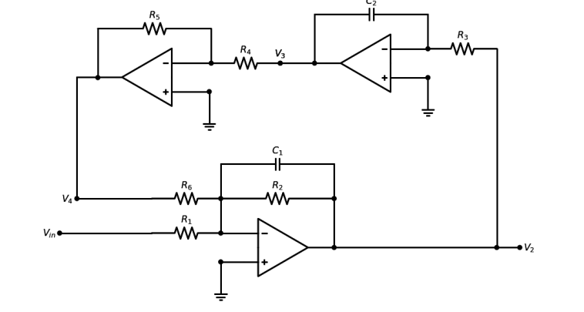
Figure 1: Bandpass filter circuit
After building the circuit in LTSpice, with the previous values calculated in part A. The following circuit in figure 2 is as shown.
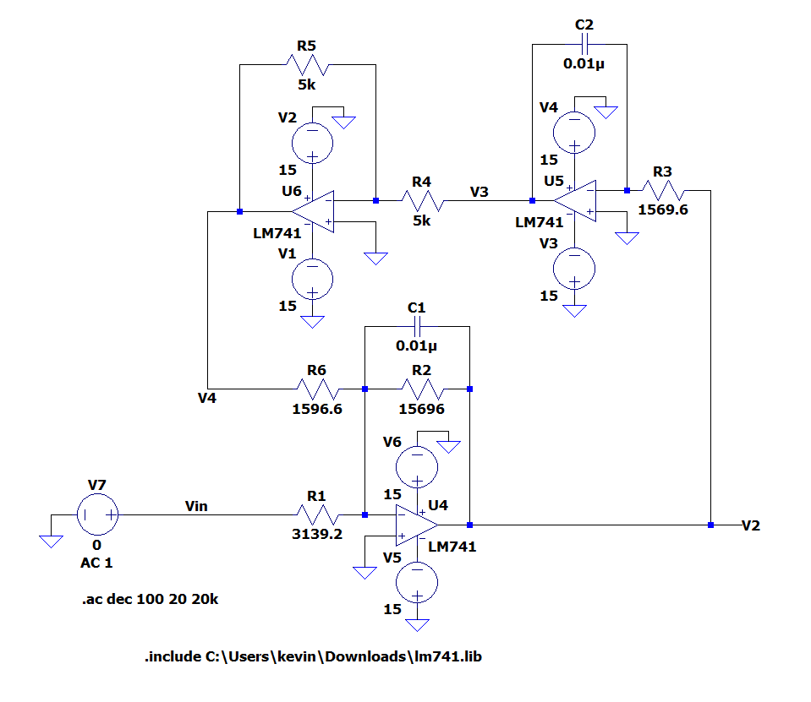
Figure 2: LTSpice bandpass filter circuit with LM471 Op amp
Next, an AC analysis simulation with a source of 1V and the response is plotted from 20 Hz to 20 kHz. The following figures shows the bandwidth and center frequency on Bode plots.
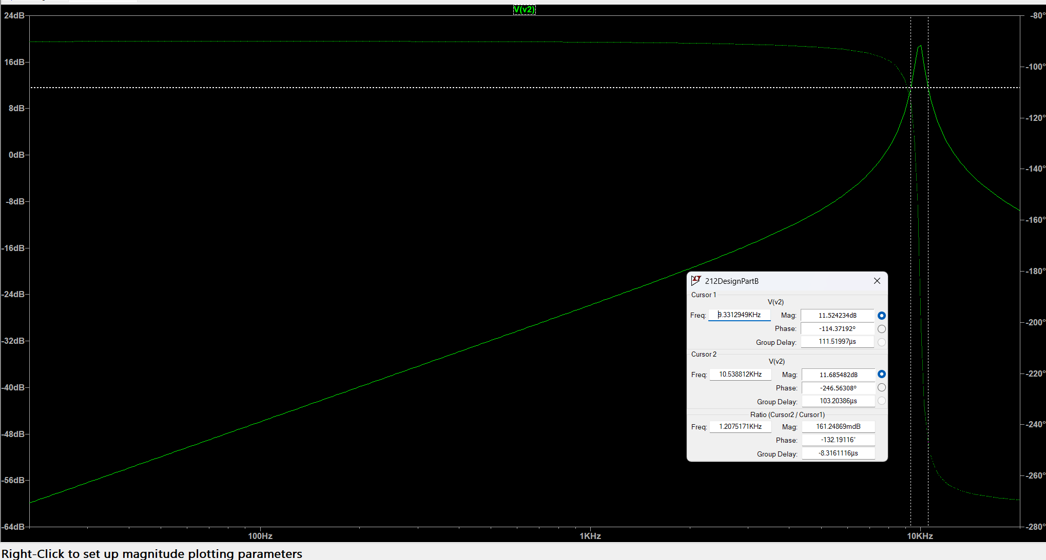
Figure 3: Bode plot of $V_{2}$ of the circuit shown in figure 2 with cursors at $f_{c1}$and $f_{c2}$
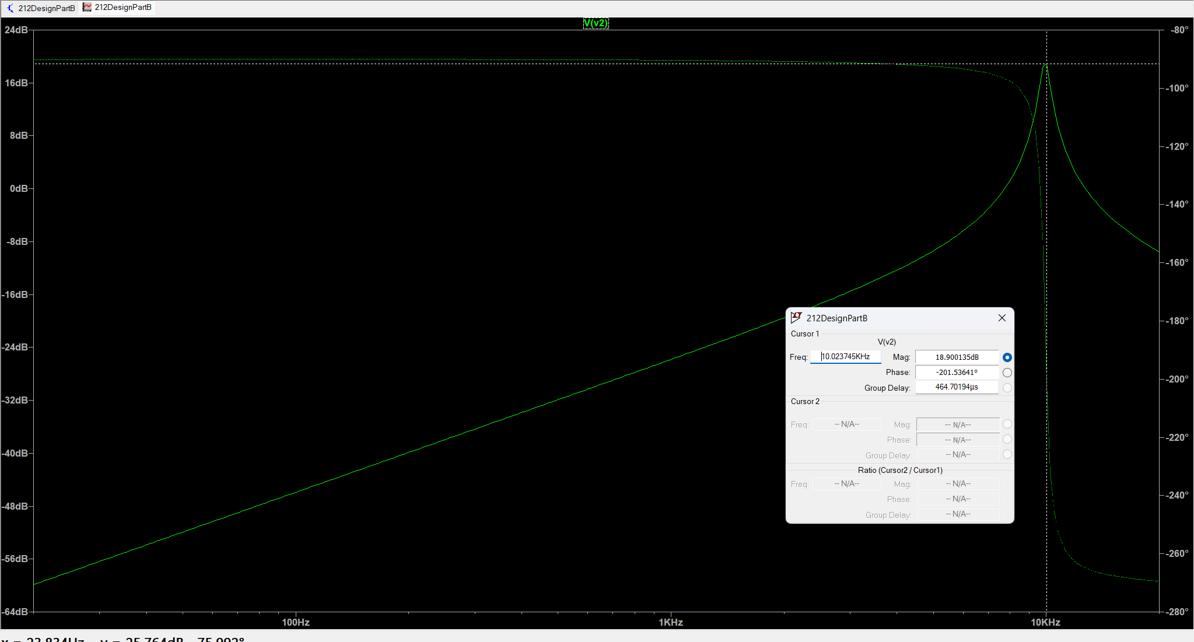
Figure 4: Bode plot of $V_{2}$ of the circuit shown in figure 2 with cursor at $f_{0}$

From figure 3 and figure 4, the following values can be sorted in a data table with comparison of MatLab values founded in part A. Where the frequency from Matlab is converted from radians to Hertz using the equation
$$f=\frac{ω}{2π}$$
Table 1 LTSpice (LM471) vs MatLab values frequency and magnitudes
 | LTSpice Frequency (Hz) | LTSpice Magnitude (dB) | MatLab Frequency (Hz) | MatLab  Magnitude (dB)
$$f_{0}$$ | 10024 | 18.9 | 10,138 | 13.9
$$f_{c1}$$ | 9,265 | 10.7 | 9,628 | 10.8
$$f_{c1}$$ | 10,615 | 10.9 | 10,663 | 10.9
$$β=(f_{c2}-f_{c2})$$ | 1,350 |  | 1,035
Using the data collected from figures 3 and 4, the bandwidth has a difference values comparing the LTSpice and Matlab of 315 Hz, which is a 30% difference. The bandwidth is not what is expected, this is due to the LM471 op amp and the how the LTSpice simulations run. However, the center frequency has a difference of 5 dB which is a 36% error. The difference in magnitudes and frequency is due to the slew rate where it is defined as the maximum rate of change of its output voltage. The significance slew rate has on the LM471 op amp is at higher frequencies (e.j. 10140Hz), the LM471 op amp cannot respond fast enough compared to an ideal op amp. This in return reduces the bandpass filter gain as seen in figure 3 and figure 4. To see if this is present in the “ideal” op-amp, the UniversalOpAmp2 from LTSpice will be used to explore further.
The following exploration will be using the universal op amp 2 as it yields results closer to the simulation from Matlab.
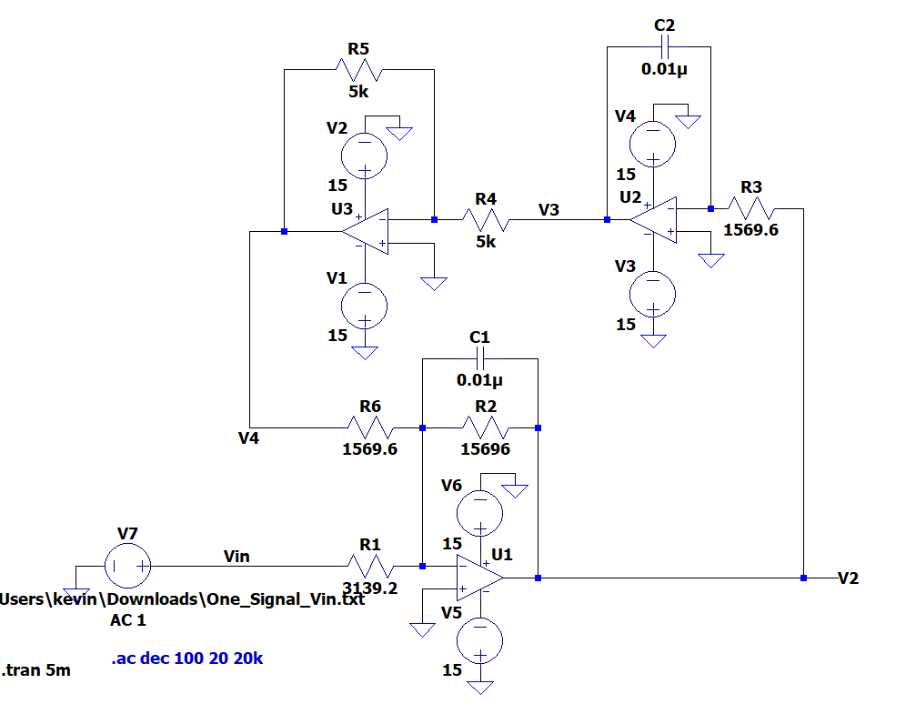
Figure 5: LTSpice bandpass filter circuit with UniversalOpAmp2

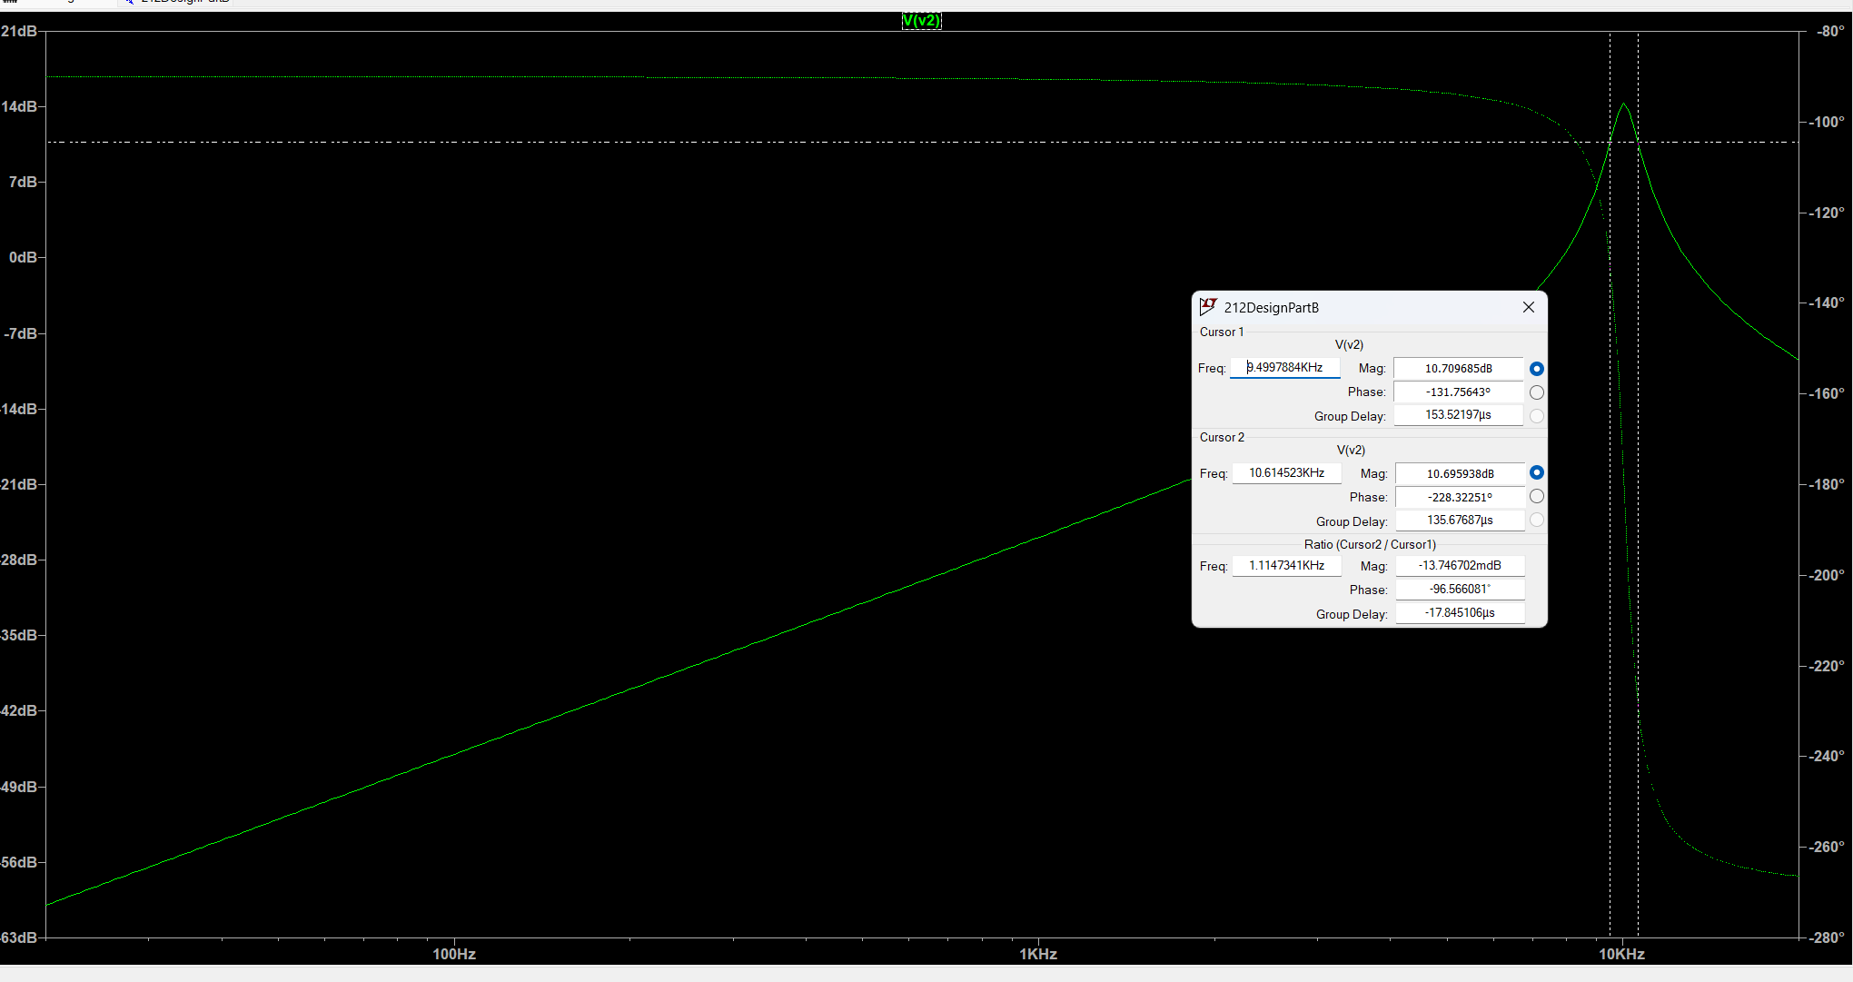
Figure 6: Bode plot of $V_{2}$ of the circuit shown in figure 5 with cursors at $f_{c1}$and $f_{c2}$
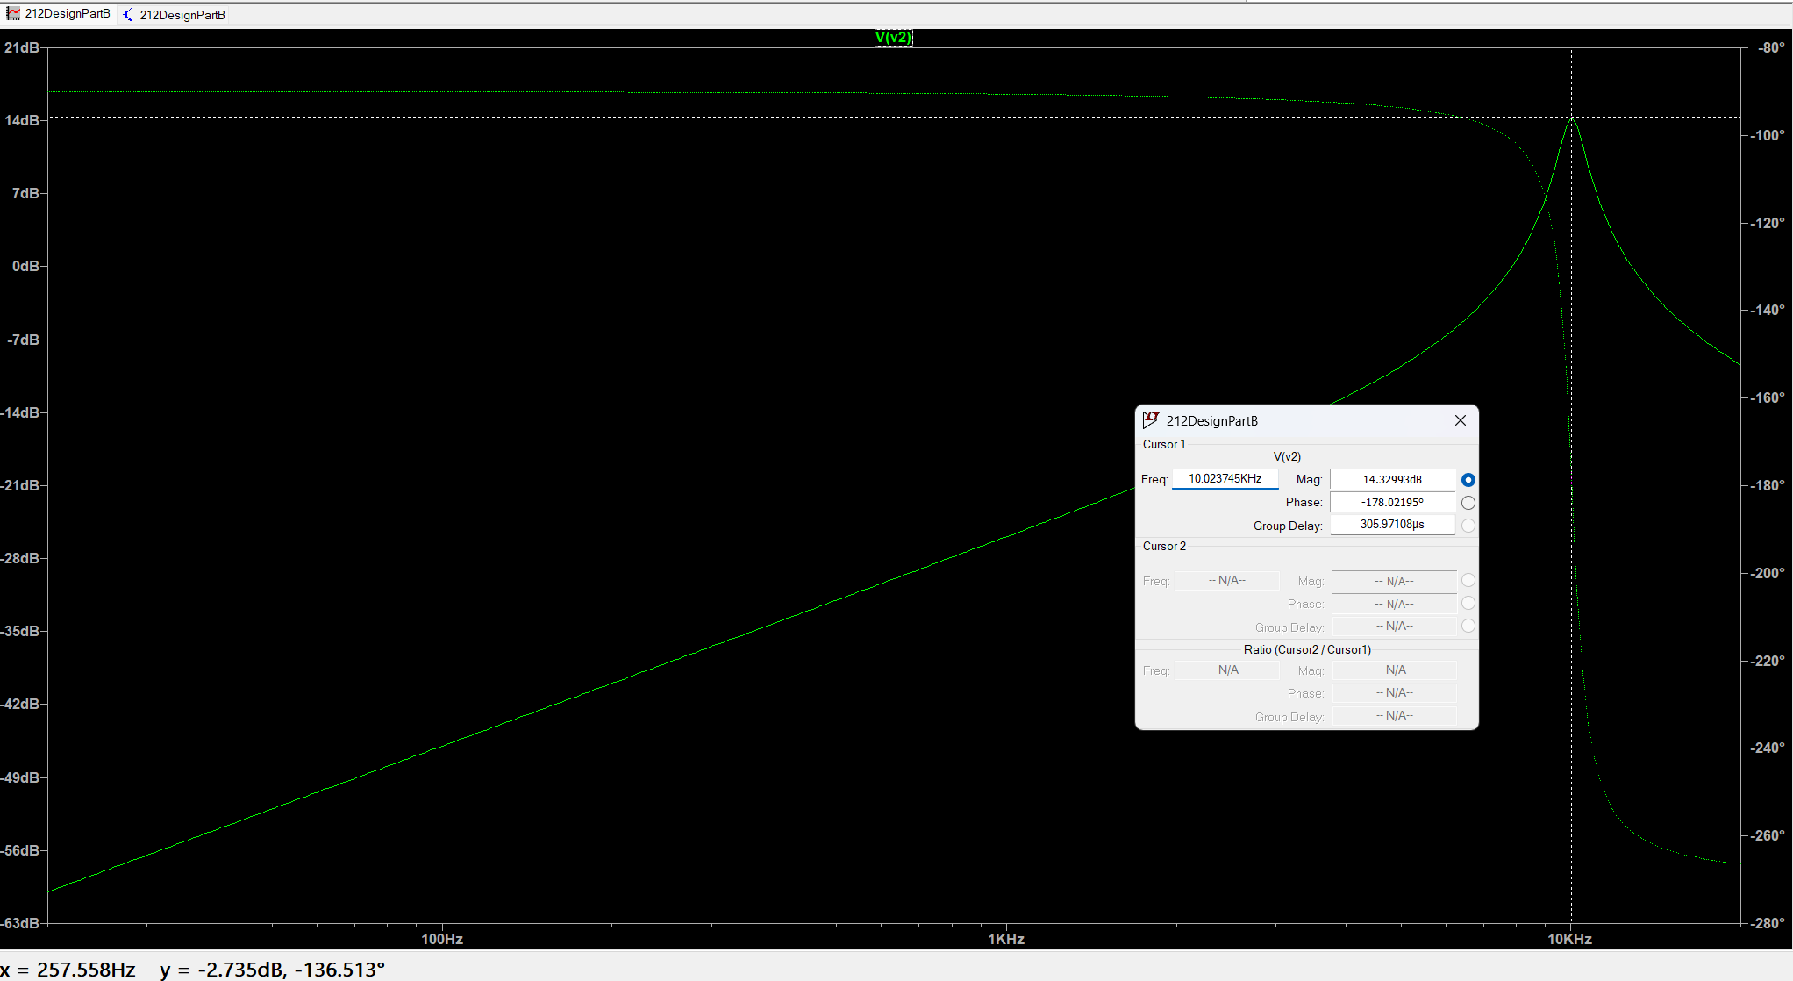
Figure 7: Bode plot of $V_{2}$ of the circuit shown in figure 5 with cursor at $f_{0}$

Table 2 LTSpice (Universal Op amp2) vs MatLab values frequency and magnitudes
 | LTSpice Frequency (Hz) | LTSpice Magnitude (dB) | MatLab Frequency (Hz) | MatLab  Magnitude (dB)
$$f_{0}$$ | 10024 | 14.3 | 10,138 | 13.9
$$f_{c1}$$ | 9,500 | 10.7 | 9,628 | 10.8
$$f_{c1}$$ | 10,615 | 10.9 | 10,663 | 10.9
$$β=(f_{c2}-f_{c2})$$ | 1,115 |  | 1,035
Using the data collected from figures 6 and 7, the bandwidth has a difference values comparing the LTSpice and Matlab of 80 Hz, which is a 7.7% percentage error. The difference in bandwidths is lower than the LM471 as well as the center frequency. The center frequency percentage error is 2.9% compared to the LM471 percentage error of 36%. The universal op amp more closely represents the matlab values in terms of frequency and magnitudes. The “ideal” UniversalOpAmp2 simulated in LTSpice are more what is expected.
One_Signal_Vin.txt is downloaded
Next a noise will be used in the bandpass filter. A Matlab Function is used to generate a noise based on the 10,140Hz center frequency. The results are extracted under the file ‘One_Signal_Vin.txt’ and is put as the voltage source shown in figure 8.

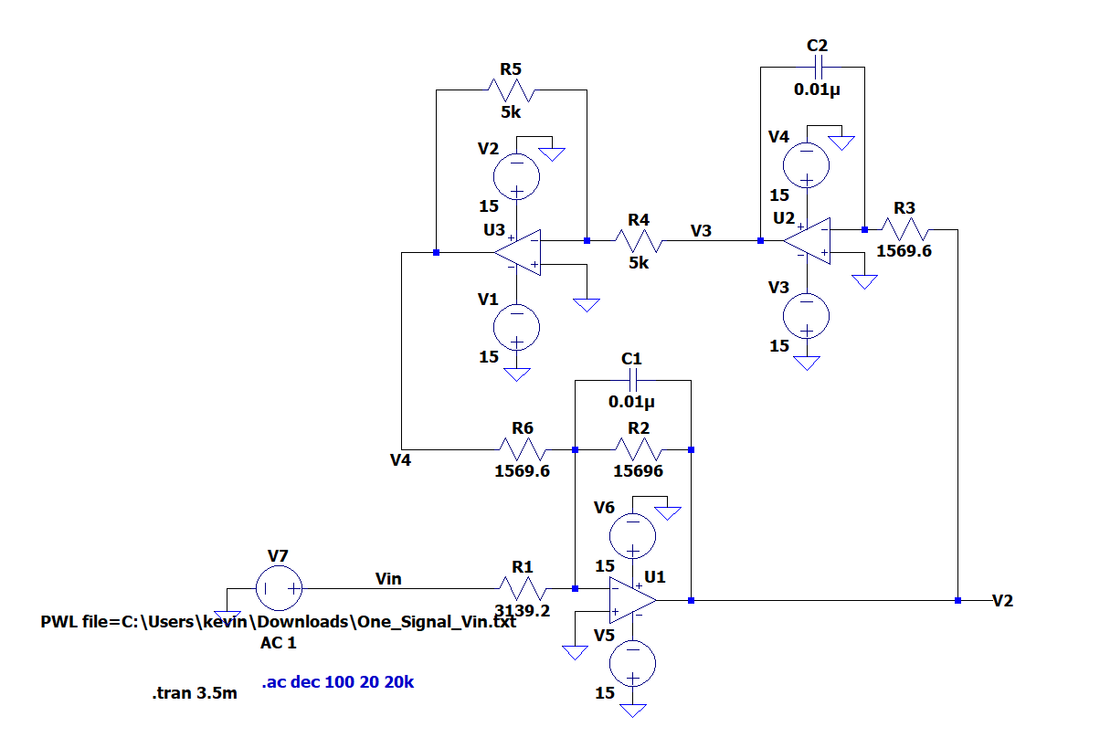
Figure 8: LTSpice Bandpass filter circuit with noise file generated from Matlab
The noise will now be applied to the circuit
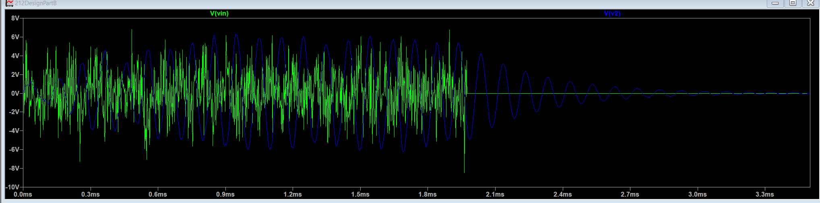
Figure 9: LTSpice plot of Noise signal as input source and output
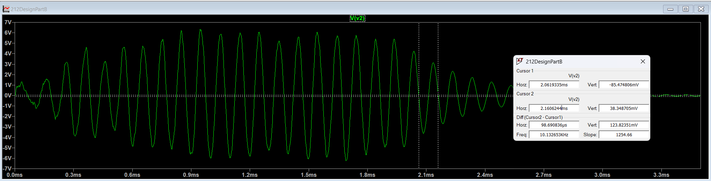
Figure 10: LTSpice plot of Noisey signal output with cursors for 1 period
Figure 9 represents the green jagged lines as the noise generated from the Matlab function. Where the center frequency should be 10,140Hz, the blue oscillating wave is the output of $V_{2}$. Measuring $V_{2}$ by itself can be used to find period of: 98.7 µs and the center frequency is found by the equation
$$f_{0}=\frac{1}{T_{0}}$$
Where the simulated center frequency is 10,131.7 Hz which is a 0.08% percent error which closely matches the actual center frequency of 10,140 Hz. The bandpass filter with the UniversalOpAmp2 bandpass filter verifies the circuit works as well as behaving as a high quality factor bandpass filter

