**Requirements:**

1. A user should be able to see a screen where they can click a button to be able to register and log in.
2. The login requires a username and password and they must be correct to successfully log in
3. The registration button shows the user a screen where they can input required information
4. The user can retrieve his password if he answers the security question
5. Once logged in the customer should be able to:
   1. Search the flight database for flights based on criteria
   2. Have the ability to book a flight
   3. Have the ability to unbook a flight
   4. Be unable to book flights that conflict with one another
   5. Be unable to book a flight if it is full
6. In addition to the above an admin should be able to add, update, or delete flights
7. Users should be able to logout
8. Users should be able to return to the main menu

**Tables**

|  |  |  |
| --- | --- | --- |
| Registration |  |  |
| CustomerID | INT Primary key Auto_increment |  |
| firstName | varchar (50) |  |
| lastName | varchar (50) |  |
| address  City | varchar (50)  varchar (50) |  |
| zip | numeric (5) |  |
| state | varchar (30) |  |
| username | varchar (30) |  |
| password | varchar (30) |  |
| email | varchar (30) |  |
| SSN | numeric (9) |  |
| securityQuestion | varchar (100) |  |
| securityAnwser | varchar (100) |  |
| admin | Boolean |  |
| FlightID | numeric (4) | fk |
| Flights |  |  |
| FlightID | INT Primary key Auto_increment |  |
| departureCity | varchar (50) |  |
| arrivalCity | varchar (50) |  |
| departureTime | Date |  |
| arrivalTime | Date |  |
| airplaneid | numeric (4) | fk |
|  |  |  |
|  |  |  |
|  |  |  |
| Airplane |  |  |
| airplaneid | INT Primary key Auto_increment |  |
| maxCapacity | numeric (100) |  |
| currentCapacity | numeric (100) |  |

bookedFlight

bookedID PK

Airplaneid fk

Customerid fk

UML

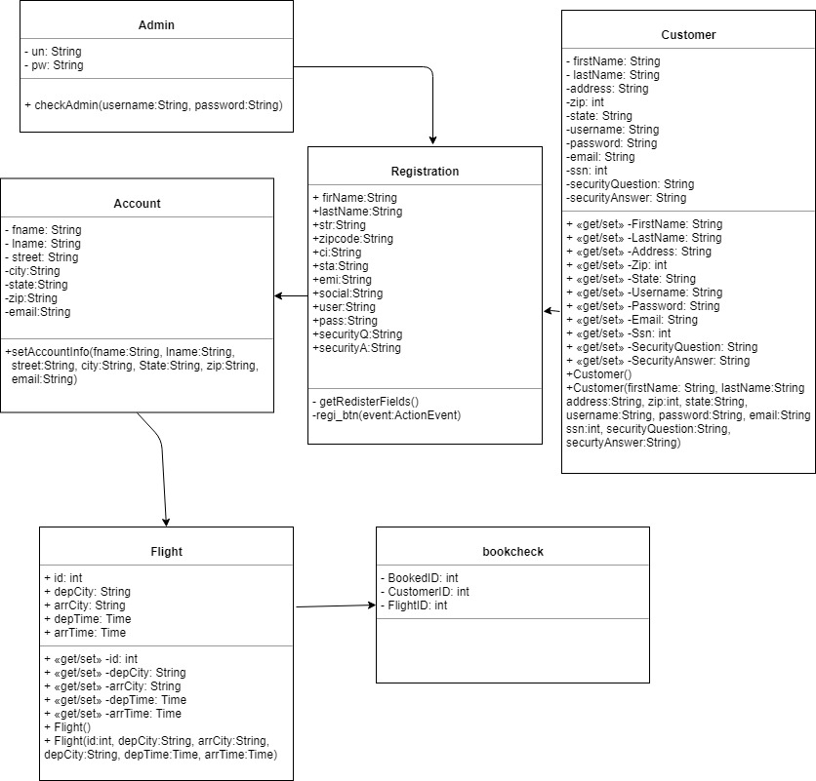

**Project Flow**

The Airways booking project starts with the title, airplane logo, and two buttons (login and Register. The register button directs the user to the registration menu. This page allows the user to register for the project. Once the correct information is inputted, the user clicks on the register button and all the information is inserted into AirwaysData (Database). The user is immediately directed to the main menu. Once the user has an account they can click the “log in” button. There are three buttons for the log in menu, “sign in”, “forgot password”, and “Back to Main menu”. “Back to Main menu” takes the user back to the main menu. Forgot password button takes the user to the retrieve forgotten password menu. Here the user can enter their username then get their security question by pressing “Get security Question”. This button displays the question and then the user can enter the security answer into the text box. If the answer is correct then the correct password is displayed for the user. Then the user can click on the login button or the main menu button. Back at the log in page the user should enter their username and password, then click sign in. The system checks if the username, password, and if the user is an admin. If not a admin the user is taken to the account information page. This page allows the user to go to the book a flight page. This page allows the user to search by the flightID and then book the flight using the button “book”. If admin then the user is taken to the admin information page. The admin page allows the admin to add, delete, and update flights.