Mobile Robot Simultaneous Localization and Mapping in Static Environments

Sefton Bennett, Clara Nieto-Wire, Jorge O. Peche, Marios Timotheou, Diana Vasili-Acevedo,

The City College of New York of the City University of New York
School of Engineering, Department of Electrical Engineering

Abstract

This paper presents a first stage in the solution for both, mapping and localization of a mobile robot on a simple static environment. Several algorithms have been developed based on the occupancy grid technique, which provides a robust and unified approach to a variety of problems in spatial robot perception and navigation for mobile robots. One of the most successful approaches consists on two occupancy grids. One grid models the static parts of the environment, and the other one contains information about static landmarks detected in the environment. The union of the two grid maps would provide a description of the static environment and provides the robot with localization. The most important procedure within this approach is the recollection of data, which is significantly simplified by the use of a simulation tool such as PLAYER/STAGE. The results of different simulations are shown as well as a detailed explanation of how to install and use this powerful tool which contributes for an easier mapping and localization process.

1. Introduction

For autonomous mobile robots, the ability to function and interact with an unknown environment is of key importance. For this reason mapping has been an extremely active research area in robotics and artificial intelligence for at least two decades.
Robotic mapping addresses the problem of acquiring spatial models of physical environments through mobile robots and it is important for several reasons. Primarily, an accurate model of a robot's surrounding environment enables it to complete many complex tasks more quickly and reliably than without such a model. Another advantage of map building is that it potentially provides a good framework for integrating information from many different sensors, from many different positions and directions, into a single knowledge source, from which complex plans can be created.
Using the Simultaneous Localization and Map-Building (SLAM) method, a map is build as the robot navigates an environment, while a localization routine runs in parallel, continually updating and correcting the robot’s estimated pose. SLAM allows robots to operate in an environment without a priori knowledge of a map and without access to independent position information; it makes a robot truly autonomous.
The approach used as a main reference for this paper is the on-line algorithm introduced in Wolf and Sukhatme (2003), and is divided into two parts: mapping of static environments, and robot localization. These two tasks are combined, allowing the robot to perform simultaneous localization and mapping.
The mapping algorithm uses the occupancy grid technique introduced in Elfes (1986, 1989). This approach is capable of detecting stationary objects in the environment and representing them on a map. To achieve this, an occupancy grid map is maintained to represent occupancy probabilities, which correspond to the static parts of the environment. Consequently, a complete description of the static environment is acquired.
This paper is organized as follows. In sections II and III, the basic theory of the occupancy grid approach and the SLAM method are shortly resumed for a better understanding of the overall project. Section IV presents a general explanation of the Player/Stage software as a simulation tool. The results and conclusions of the project are shown in section V.

2. Occupancy Grid Approach

Occupancy grid maps have become a dominant paradigm for environment modeling in mobile robotics and have been have been built using sonar sensors, laser range finders, and stereo vision. They represent environments by fine-grained, metric grids of variables that reflect the occupancy of the environment. Once acquired, they enable various key functions necessary for mobile robot navigation, such as localization, path planning, collision avoidance, and people finding.
This technique employs a multidimensional representation of space into cells, where each cell stores a probabilistic estimate of its state [2].
Since a robot can only obtain information about its environment through its sensors, a spatial world model from sensor data is best modeled as an estimation theory problem. To interpret the data obtained from a given sensing device a stochastic sensor model is used, defined by a probability density function of the form p(r/z), where r is the reading obtained from the sensor and z is the true parameter space range value in the map. This density function is subsequently used in a Bayesian estimation procedure to determine the occupancy grid cell state probabilities as shown in Fig. 1. Finally, it is possible to obtain a deterministic world model, using optimal estimators such as the maximum a posteriori (MAP) decision rule to assign discrete states to the cells, labeling them occupied, empty, or unknown.

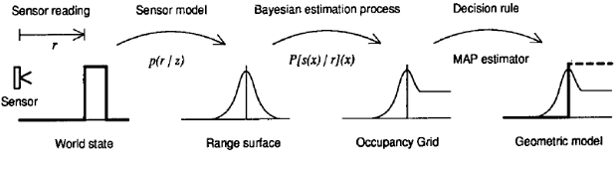

Figure 1. Estimating the occupancy grid.

The sequential updating formulation of Bayes' theorem is use to allow the incremental composition of sensory data and determine the cell occupancy probabilities. For two sensors S₁ and S₂, it is required to use the corresponding sensor models p₁(r/z) and p₂(r/z). As a result, multiple sensors operating independently can update the same occupancy grid.
In some applications there is a need to assign a state to each cell on the occupancy grid; occupied, empty or unknown. In order to do this it is useful to define an unknown band around a threshold value and utilize the maximum posteriori decision rule.
Fig. 2. shows one possible way of using occupancy grids in mobile robot mapping. In this case the data acquired from a single sensor reading is called a sensor view. Various sensor views taken at the same robot position can be used to obtain a local sensor map. Sensor fusion of the separate local sensor maps yields a robot view, which encloses all the information recovered from a single sensing position. As the robot moves through its environment the different robot views, from multiple locations are integrated into a global map of the environment [2].

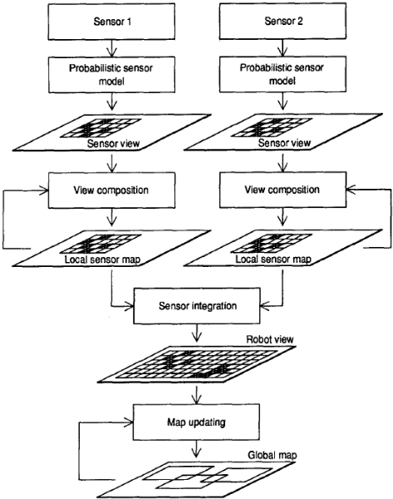

Figure 2. Framework for occupancy-grid-based robot mapping.

3. Simultaneous localization and mapping

The Simultaneous Localization and Mapping (SLAM) requires a mobile robot to autonomously explore the environment with its on-board sensors, gain knowledge about it, interpret the scene, build an appropriate map and localize itself relative to this map [8]. Thus the main advantage of SLAM is that it eliminates the need for artificial infrastructures or a priori topological knowledge of the environment.
Several approaches have been proposed to address the SLAM problem; these approaches assume one of three main theories. The most popular of these is the Kalman filter based approach, which is very popular because it provides a recursive solution to the navigation problem and a means of computing consistent estimates for the uncertainty in vehicle and map landmark locations.
A second theory used to solve the SLAM problem is to avoid the need for absolute position estimates and for precise measures of uncertainty, and instead to employ more qualitative knowledge of the relative location of landmarks and vehicle to build maps and guide motion.
The third theory, takes away with rigorous Kalman filter or statistical formalism while retaining a numerical or computational approach to the navigation and SLAM problem. Such approaches include the use of iconic landmark matching, global map registration, bounded regions and other measures to describe uncertainty.
Nevertheless, an estimation-theoretic or Kalman filter based approach has a major advantage, which is that it is possible to study the evolution and the uncertainty in the map and vehicle location. A proof of existence and convergence for a solution of the SLAM problem within a formal framework also covers the widest possible range of navigation problems and implies that solutions to the problem using other approaches are possible [9].

4. The Player/Stage Software

4.1 Description

The Player/Stage Project provides open-source tools that simplify controller development, particularly for multiple-robot and sensor network systems (MRS). For many applications, particularly in MRS, Player/Stage offers a combination of transparency, flexibility and speed that makes it one of the most useful robot development environments available [7].
The project provides the Player robot device server and the Stage multiple robot simulator, plus supporting tools and libraries. Running on a robot, Player provides a simple interface to the robot’s sensors and actuators over a network. Client control programs communicate with Player over a TCP socket, reading data from sensors, writing commands to actuators, and configuring devices on the fly. Player supports a variety of robot hardware and provides implementations of sensing and control algorithms, such as landmark tracking and probabilistic localization.
Stage provides a population of simulated robots and sensors operating in a two-dimensional bitmapped environment.
The devices are accessed through Player, as if they were real hardware. Stage can simulate tens or hundreds of robots on a desktop PC, and controllers commonly work similarly on simulated and real robots.
Player and Stage run on many UNIX-like platforms, are released as Free Software under the GNU General Public License [5] and are maintained by the authors at: http://playerstage.sf.net.
Because Player’s external interface is simply a TCP socket, client programs can be written in any programming language that provides socket support, such as C, C++, Tcl, Python, Java, and Common LISP. This brings neutrality to the platform and more importantly, the socket abstraction allows that regardless of the physical location of the robotic devices, a client program can take control over them from any machine to which there is network connectivity.
Stage simulates a population of mobile robots, sensors and environmental objects. Its purposes are to enable rapid development of controllers that will eventually drive real robots, enable robot experiments without access to the real hardware and environments and to enable wondering experiments with devices that do not exist yet. Stage enables experiments with large populations of robots that would be prohibitively expensive to buy and maintain.
Player makes it very easy for clients to read data from and send commands to any device on the network, as well as send arbitrary messages to one another. Stage allows for convenient and rapid evaluation of many clients.

5. Results and Conclusions

The goal of this paper was to survey major concepts utilized in the algorithm introduced in Wolf and Sukhatme (2003) and generally, in the field of robotic mapping. We believe that the theory described in this document is a representative example of the state of the art in robotic simultaneous mapping and localization, specifically in the area of indoor navigation of static environments. Overall, with the introduction of tools like the Player/Stage project the researchers in robot mapping and localization are optimistic.

Trough the development of this project we were able to install the Player/Stage software and become familiar with it, understanding the different structures and files that need to be utilized in order to run a simulation. We acquired a basic knowledge of how Player and Stage are related and studied several examples included with the project.
We were able to modify those examples, comprehending how to include one or more robots in a simulation and how to incorporate the different sensors and actuators that are provided. In addition, we perform numerous simulations and collect data related to them for future interpretation. Fig.3. shows a simulation of one Pioneer 2-DX robot in a simple static environment.

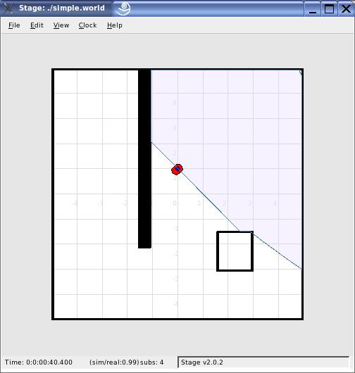
(a)

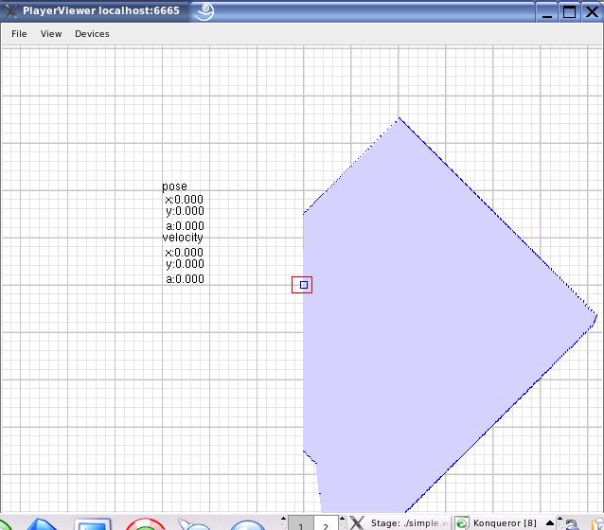
(b)

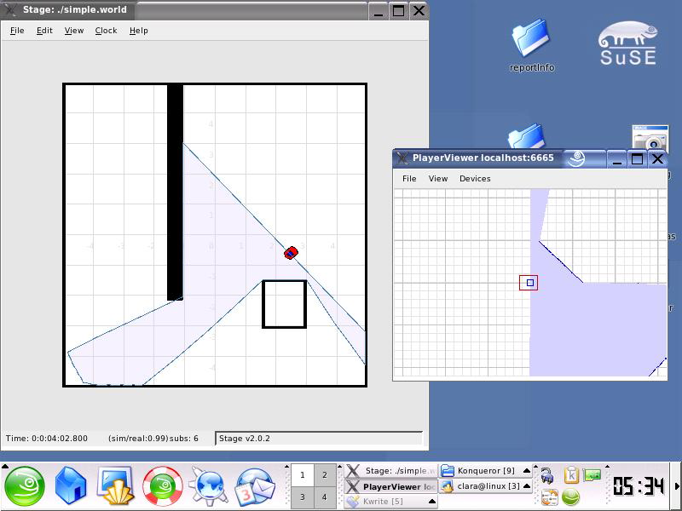
(c)

Figure 3. Simulation using Player/Stage. (a) Stage window, (b) Egocentric perspective, (c) General screen view.

Our main achievement is a Player/Stage Beginners Manual, where we explain in detailed all the needed steps to install the project and perform different simulations using this powerful tool

6. References

[1] Wolf, D. and Sukhatme, G. 2005. Simultaneous localization and mapping in dynamic environments. In Autonomous Robots 19, 53-65,2005
[2] Elfes, A. 1989. Using occupancy grids for mobile robot perception and navigation. In Computer, 12(6):26-57
[3] Thrun, S. 2003. Learning occupancy grid maps with forward sensor models. Autonomous Robots, 15:111-127, 2003.
[4] Thrun, S. 2002. Robotic Mapping: a survey. In G. Lakemeyer and B. Nebel, editors, Exploring Artificial Intelligence in the New Millenium. Morgan Kaufmann.
[5] Vaughan R., Howard A., Gerkey B. 2003. Stage Version 1.3.3 User Manual, (compatible with Player 1.4rc2).
[6] Vaughan R., Howard A., Gerkey B. 2004. Player Version 1.50 User Manual
[7] Vaughan R., Howard A., Gerkey B. 2003. The Player/Stage Project: Tools for Multi-Robot and Distributed Sensor Systems. In Proceedings of the 11th International Conference on Advanced Robotics (ICAR 2003), pages 317-323, Coimbra, Portugal.
[8] Martinelli A., Svensson A., Tomatis N. and Siegwart R. 2004. SLAM Based on Quantities Invariant of the Robot’s Configuration. In Swiss Federal Institute of Technology Lausanne (EPFL), CH-1015 Lausanne, Switzerland.

[9] Dissanayake G., Newman P., Clark S., Durrant-Whyte H.F. and Csorba M. 2001. A Solution to the Simultaneous Localization and Map Building (SLAM) Problem. In IEEE Transactions on Robotics and Automation, Vol. 17, Nº. 3,

