CS4600 Design Document
By Nicholas L. Cox
February 2012
Binaural Playback System

To create my binaural (two-ear), lifelike stereo algorithms I intend to use some equations refered to as Interaural Time Difference (ITD) and Interaural Level Difference (ILD) which will map a sound from a single point to the two ears of the listener. The ITD equation can be just a simple hyperbolic elipse function, or as I hope to find with my dummy head recordings a function that will take into account the curvature and formability of a natural head. One of the following simple equations might work:
ITD = ( D * sin θ ) / V See Figure 1
ITD = (D / V)2 * sin θ See Figure 2
Where D is the distance between the ears, θ is the angle of the sound relative to the forward vector of the listener, V is the speed of sound, and ITD is the time difference between the two ears.

The programming environment I'll be using is the open audio library OpenAL in C++, this will give me easy access to audio playback manipulation in the form of time delays and volume changes that I can send to each ear individually.

I'll also be using the open graphics library OpenGL to draw an environment in which a person can move around and see the objects that are making sound. I have a code base already that allows me to easily make shapes of any kind and move them around however I need. Initially I'll just make a simple shape that will move in a smooth circle around the camera to demonstrate the binaural affect. Then I'll make the more ellaborate environment with multiple sound sources that move in random paths so the listener can try to find the sources just by listening.

Figure 1.
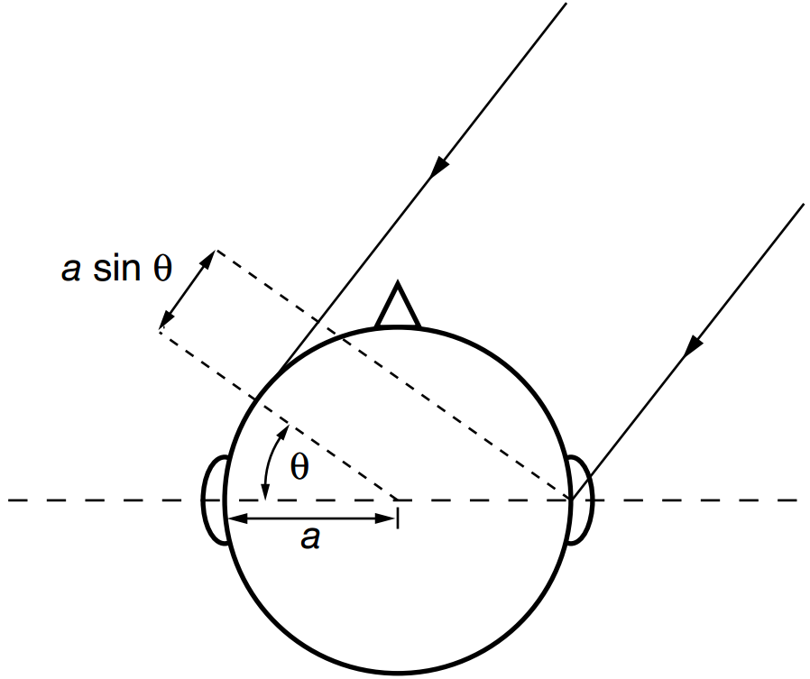

Figure 2.

