K-fold Factor Analysis - Lebenon Students

April 05, 2021

Table of Contents

# Fold and Sample Summary

**# of folds:** 10

**# of variables:** 21

**# of observations:** 8027

**Maximum # of factors extracted:** 4

# Model Fit Summary

**Fit across folds by factor model**

| factors | df | chisq | | cfi | | rmsea | |
| --- | --- | --- | --- | --- | --- | --- | --- |
| mean | range | mean | range | mean | range |
| 1 | 189 | 652.42 | 555.18 - 749.88 | 0.98 | 0.98 - 0.99 | 0.06 | 0.05 - 0.06 |
| 2 | 188 | 391.78 | 349.07 - 442.29 | 0.99 | 0.99 - 0.99 | 0.04 | 0.03 - 0.04 |
| 3 | 186 | 331.66 | 282.34 - 382.37 | 0.99 | 0.99 - 1.00 | 0.03 | 0.03 - 0.04 |
| 4 | 183 | 311.37 | 268.35 - 347.98 | 0.99 | 0.99 - 1.00 | 0.03 | 0.02 - 0.03 |

**Best model in each fold by fit index**

| fold | chisq | cfi | rmsea |
| --- | --- | --- | --- |
| 1 | 4 | 4 | 4 |
| 1 | 4 | 4 | 4 |
| 1 | 4 | 4 | 4 |
| 1 | 4 | 4 | 4 |
| 1 | 3 | 3 | 3 |
| 1 | 4 | 4 | 4 |
| 1 | 4 | 4 | 4 |
| 1 | 4 | 4 | 4 |
| 1 | 4 | 4 | 4 |
| 1 | 4 | 4 | 4 |

# Model Structures

## Factors: 1

### Across Folds Measures

**Standardized Loading Across Folds**

| variable | mean | min | max |
| --- | --- | --- | --- |
| a1101x | 0.69 | 0.61 | 0.78 |
| a1102x | 0.58 | 0.51 | 0.64 |
| a1103x | 0.63 | 0.58 | 0.66 |
| a1104x | 0.74 | 0.70 | 0.78 |
| a1105x | 0.47 | 0.43 | 0.55 |
| a1106x | 0.70 | 0.67 | 0.72 |
| a1107x | 0.77 | 0.74 | 0.79 |
| a1108x | 0.76 | 0.72 | 0.79 |
| a1109x | 0.62 | 0.59 | 0.66 |
| a1110x | 0.67 | 0.62 | 0.71 |
| a1111x | 0.70 | 0.64 | 0.75 |
| a1112x | 0.48 | 0.42 | 0.54 |
| a1113x | 0.66 | 0.62 | 0.69 |
| a1114x | 0.80 | 0.77 | 0.83 |
| a1115x | 0.75 | 0.70 | 0.80 |
| a1116x | 0.78 | 0.75 | 0.82 |
| a1117x | 0.85 | 0.82 | 0.88 |
| a1118x | 0.32 | 0.21 | 0.39 |
| a1119x | 0.84 | 0.81 | 0.86 |
| a1120x | 0.34 | 0.24 | 0.40 |
| a1121x | 0.48 | 0.41 | 0.53 |

**Mean Scale Reliabilities**

| type | f1 |
| --- | --- |
| alpha | 0.94 |
| omega_h | 0.92 |

### Within Fold Information

**Factor Structure Option 1**

**In Folds: 1, 2, 3, 4, 5, 6, 7, 8, 9, 10**

f1 =~ a1101x + a1102x + a1103x + a1104x + a1105x + a1106x + a1107x + a1108x + a1109x + a1110x + a1111x + a1112x + a1113x + a1114x + a1115x + a1116x + a1117x + a1118x + a1119x + a1120x + a1121x

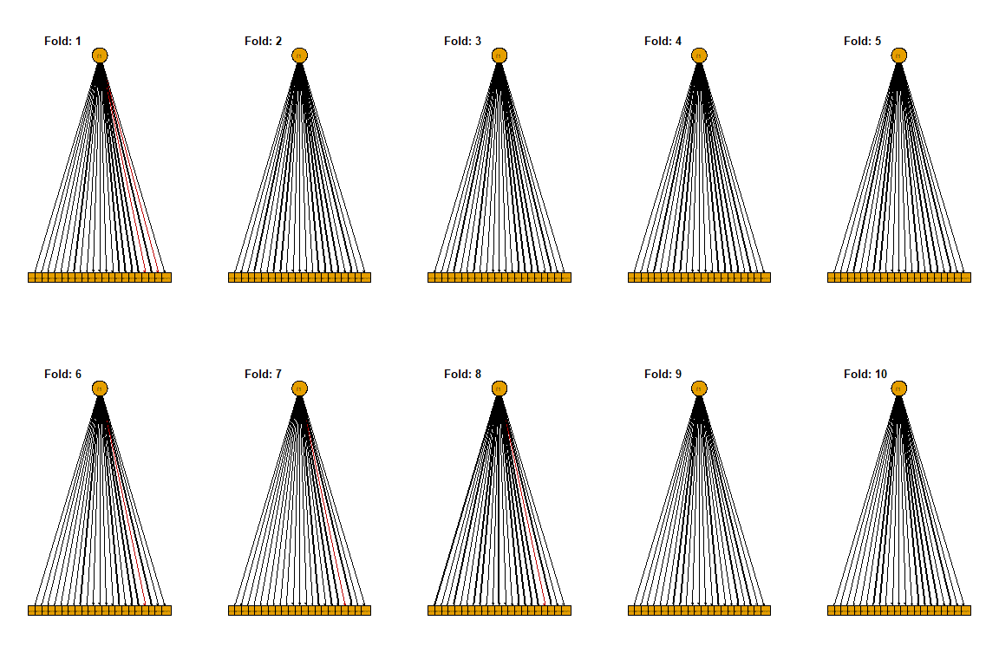

## Factors: 2

### Across Folds Measures

**Standardized Loading Across Folds**

| variable | mean | min | max |
| --- | --- | --- | --- |
| a1101x | 0.69 | 0.61 | 0.78 |
| a1102x | 0.58 | 0.52 | 0.64 |
| a1103x | 0.64 | 0.58 | 0.67 |
| a1104x | 0.75 | 0.70 | 0.78 |
| a1105x | 0.47 | 0.43 | 0.55 |
| a1106x | 0.71 | 0.67 | 0.73 |
| a1107x | 0.77 | 0.74 | 0.79 |
| a1108x | 0.76 | 0.72 | 0.80 |
| a1109x | 0.63 | 0.60 | 0.67 |
| a1110x | 0.67 | 0.62 | 0.71 |
| a1111x | 0.71 | 0.64 | 0.75 |
| a1112x | 0.48 | 0.43 | 0.54 |
| a1113x | 0.66 | 0.62 | 0.69 |
| a1114x | 0.79 | 0.77 | 0.83 |
| a1115x | 0.75 | 0.70 | 0.81 |
| a1116x | 0.78 | 0.76 | 0.83 |
| a1117x | 0.83 | 0.80 | 0.86 |
| a1118x | 0.50 | 0.33 | 0.59 |
| a1119x | 0.82 | 0.80 | 0.85 |
| a1120x | 0.57 | 0.45 | 0.70 |
| a1121x | 0.85 | 0.75 | 0.92 |

**Mean Factor Correlations**

|  | f1 | f2 |
| --- | --- | --- |
| f1 | 1.00 |  |
| f2 | 0.52 | 1.00 |

**Mean Scale Reliabilities**

| type | f1 | f2 |
| --- | --- | --- |
| alpha | 0.94 | 0.70 |
| omega_h | 0.92 | 0.58 |

### Within Fold Information

**Factor Structure Option 1**

**In Folds: 1, 2, 3, 4, 5, 6, 7, 8, 9, 10**

f1 =~ a1101x + a1102x + a1103x + a1104x + a1105x + a1106x + a1107x + a1108x + a1109x + a1110x + a1111x + a1112x + a1113x + a1114x + a1115x + a1116x + a1117x + a1119x

f2 =~ a1118x + a1120x + a1121x

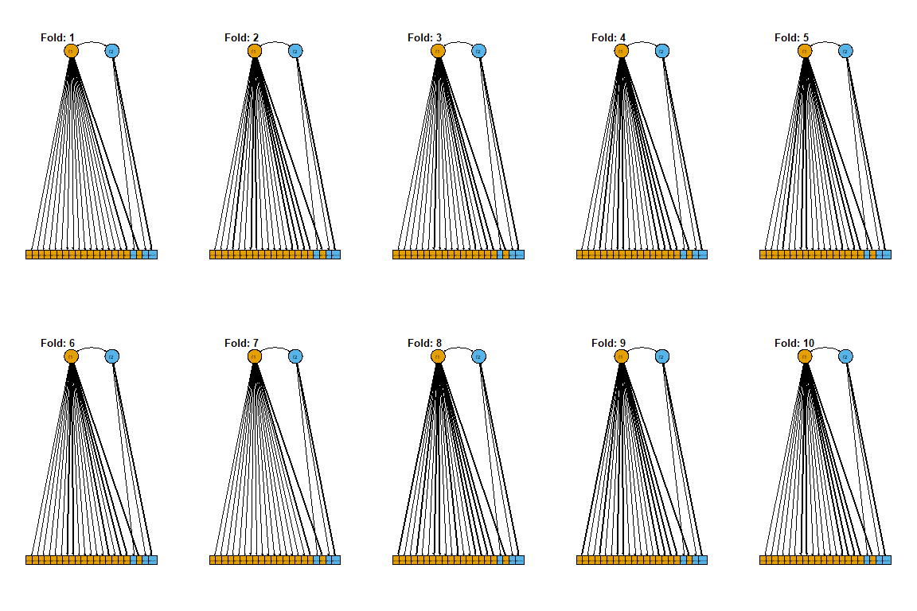

## Factors: 3

### Across Folds Measures

**Standardized Loading Across Folds**

| variable | mean | min | max |
| --- | --- | --- | --- |
| a1101x | 0.70 | 0.60 | 0.79 |
| a1102x | 0.59 | 0.52 | 0.66 |
| a1103x | 0.65 | 0.60 | 0.68 |
| a1104x | 0.76 | 0.71 | 0.80 |
| a1105x | 0.49 | 0.45 | 0.57 |
| a1106x | 0.71 | 0.68 | 0.74 |
| a1107x | 0.78 | 0.75 | 0.81 |
| a1108x | 0.77 | 0.72 | 0.80 |
| a1109x | 0.63 | 0.60 | 0.67 |
| a1110x | 0.70 | 0.65 | 0.74 |
| a1111x | 0.75 | 0.68 | 0.80 |
| a1112x | 0.49 | 0.43 | 0.55 |
| a1113x | 0.70 | 0.66 | 0.74 |
| a1114x | 0.80 | 0.77 | 0.83 |
| a1115x | 0.76 | 0.72 | 0.81 |
| a1116x | 0.79 | 0.76 | 0.83 |
| a1117x | 0.87 | 0.83 | 0.89 |
| a1118x | 0.55 | 0.40 | 0.63 |
| a1119x | 0.86 | 0.83 | 0.88 |
| a1120x | 0.59 | 0.47 | 0.71 |
| a1121x | 0.86 | 0.77 | 0.93 |

**Mean Factor Correlations**

|  | f1 | f2 | f3 |
| --- | --- | --- | --- |
| f1 | 1.00 |  |  |
| f2 | 0.48 | 1.00 |  |
| f3 | 0.90 | 0.53 | 1.00 |

**Mean Scale Reliabilities**

| type | f1 | f2 | f3 |
| --- | --- | --- | --- |
| alpha | 0.92 | 0.70 | 0.86 |
| omega_h | 0.88 | 0.57 | 0.82 |

### Within Fold Information

**Factor Structure Option 1**

**In Folds: 1, 2, 3, 4, 5, 6, 7, 8, 9, 10**

f1 =~ a1101x + a1102x + a1103x + a1104x + a1106x + a1107x + a1108x + a1109x + a1114x + a1115x + a1116x

f2 =~ a1118x + a1120x + a1121x

f3 =~ a1105x + a1110x + a1111x + a1112x + a1113x + a1117x + a1119x

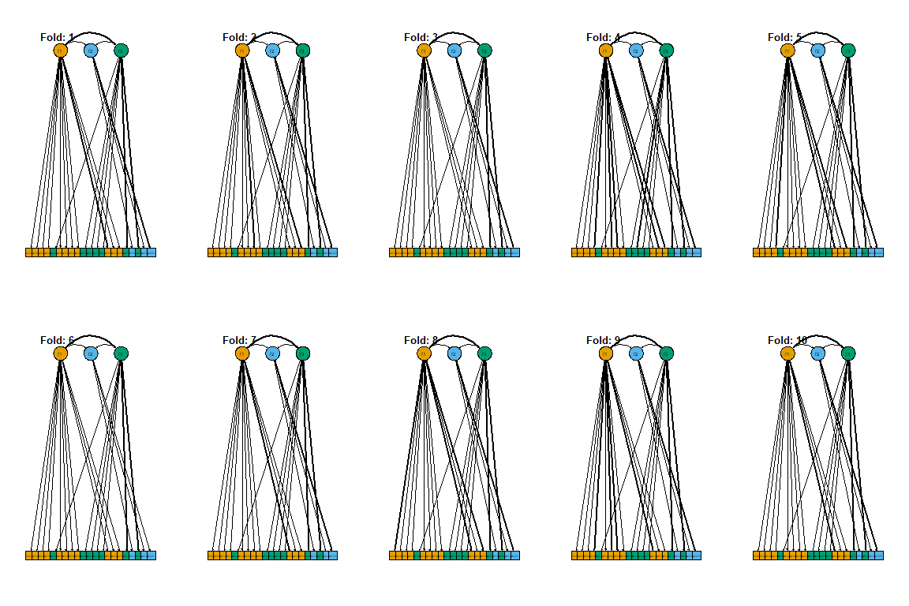

## Factors: 4

### Across Folds Measures

**Standardized Loading Across Folds**

| variable | mean | min | max |
| --- | --- | --- | --- |
| a1101x | 0.71 | 0.61 | 0.79 |
| a1102x | 0.59 | 0.53 | 0.66 |
| a1103x | 0.65 | 0.60 | 0.68 |
| a1104x | 0.77 | 0.72 | 0.81 |
| a1105x | 0.48 | 0.44 | 0.57 |
| a1106x | 0.72 | 0.68 | 0.75 |
| a1107x | 0.79 | 0.75 | 0.82 |
| a1108x | 0.78 | 0.74 | 0.81 |
| a1109x | 0.64 | 0.61 | 0.68 |
| a1110x | 0.70 | 0.65 | 0.75 |
| a1111x | 0.74 | 0.68 | 0.80 |
| a1112x | 0.48 | 0.43 | 0.55 |
| a1113x | 0.70 | 0.66 | 0.74 |
| a1114x | 0.81 | 0.78 | 0.83 |
| a1115x | 0.81 | 0.75 | 0.87 |
| a1116x | 0.85 | 0.81 | 0.89 |
| a1117x | 0.87 | 0.83 | 0.89 |
| a1118x | 0.53 | 0.37 | 0.61 |
| a1119x | 0.86 | 0.84 | 0.88 |
| a1120x | 0.57 | 0.44 | 0.68 |
| a1121x | 0.84 | 0.74 | 0.91 |

**Mean Factor Correlations**

|  | f1 | f2 | f3 | f4 |
| --- | --- | --- | --- | --- |
| f1 | 1.00 |  |  |  |
| f2 | 0.88 | 1.00 |  |  |
| f3 | 0.49 | 0.49 | 1.00 |  |
| f4 | 0.88 | 0.87 | 0.53 | 1.00 |

**Mean Scale Reliabilities**

| type | f1 | f2 | f3 | f4 |
| --- | --- | --- | --- | --- |
| alpha | 0.90 | 0.81 | 0.70 | 0.87 |
| omega_h | 0.85 | 0.74 | 0.58 | 0.82 |

### Within Fold Information

**Factor Structure Option 1**

**In Folds: 1, 2, 6, 7, 8, 9**

f1 =~ a1101x + a1102x + a1103x + a1104x + a1105x + a1106x + a1107x + a1108x + a1109x + a1114x

f2 =~ a1115x + a1116x

f3 =~ a1118x + a1120x + a1121x

f4 =~ a1110x + a1111x + a1112x + a1113x + a1117x + a1119x

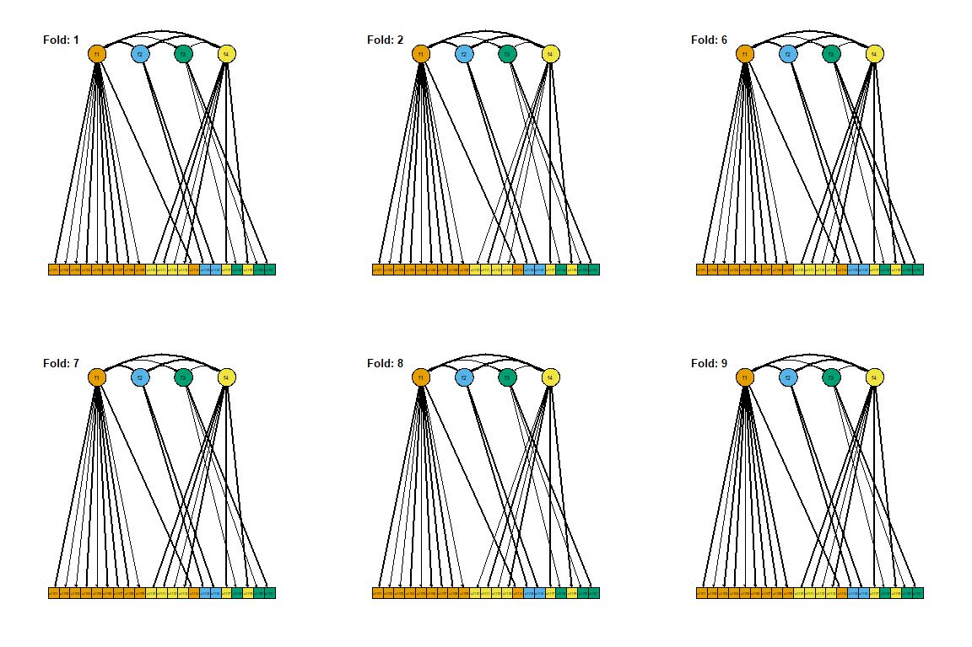

**Factor Structure Option 2**

**In Folds: 3, 4, 10**

f1 =~ a1101x + a1102x + a1103x + a1104x + a1106x + a1107x + a1108x + a1109x + a1114x

f2 =~ a1115x + a1116x

f3 =~ a1118x + a1120x + a1121x

f4 =~ a1105x + a1110x + a1111x + a1112x + a1113x + a1117x + a1119x

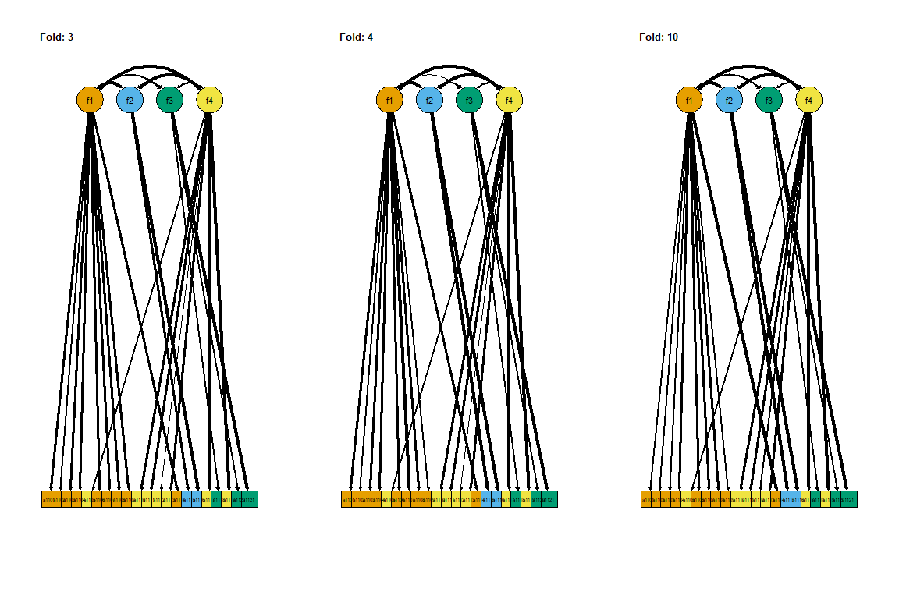

**Factor Structure Option 3**

**In Folds: 5**

f1 =~ a1101x + a1102x + a1103x + a1104x + a1106x + a1107x + a1108x + a1109x

f2 =~ a1115x + a1116x

f3 =~ a1118x + a1120x + a1121x

f4 =~ a1105x + a1110x + a1111x + a1112x + a1113x + a1114x + a1117x + a1119x

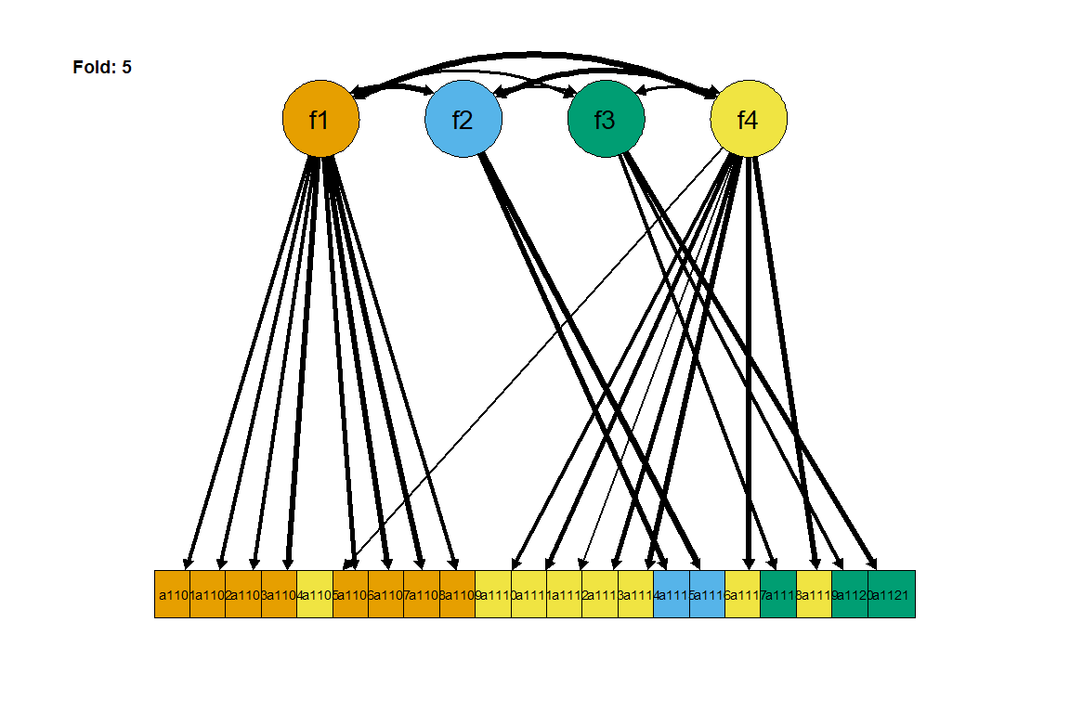

# Appendix - Within Fold Model Fit

| fold | 1-factor | | | | 2-factor | | | | 3-factor | | | | 4-factor | | | |
| --- | --- | --- | --- | --- | --- | --- | --- | --- | --- | --- | --- | --- | --- | --- | --- | --- |
| df | chisq | cfi | rmsea | df | chisq | cfi | rmsea | df | chisq | cfi | rmsea | df | chisq | cfi | rmsea |
| 1 | 189.00 | 675.05 | 0.98 | 0.06 | 188.00 | 437.12 | 0.99 | 0.04 | 186.00 | 370.10 | 0.99 | 0.04 | 183.00 | 345.11 | 0.99 | 0.03 |
| 2 | 189.00 | 614.05 | 0.99 | 0.05 | 188.00 | 351.41 | 0.99 | 0.03 | 186.00 | 299.92 | 1.00 | 0.03 | 183.00 | 284.14 | 1.00 | 0.03 |
| 3 | 189.00 | 675.16 | 0.98 | 0.06 | 188.00 | 374.15 | 0.99 | 0.04 | 186.00 | 332.41 | 0.99 | 0.03 | 183.00 | 289.26 | 1.00 | 0.03 |
| 4 | 189.00 | 749.88 | 0.98 | 0.06 | 188.00 | 393.66 | 0.99 | 0.04 | 186.00 | 307.90 | 1.00 | 0.03 | 183.00 | 281.19 | 1.00 | 0.03 |
| 5 | 189.00 | 639.37 | 0.99 | 0.05 | 188.00 | 362.20 | 0.99 | 0.03 | 186.00 | 299.48 | 1.00 | 0.03 | 183.00 | 317.08 | 1.00 | 0.03 |
| 6 | 189.00 | 612.00 | 0.98 | 0.05 | 188.00 | 349.07 | 0.99 | 0.03 | 186.00 | 282.34 | 1.00 | 0.03 | 183.00 | 268.35 | 1.00 | 0.02 |
| 7 | 189.00 | 640.62 | 0.98 | 0.05 | 188.00 | 416.62 | 0.99 | 0.04 | 186.00 | 382.37 | 0.99 | 0.04 | 183.00 | 347.11 | 0.99 | 0.03 |
| 8 | 189.00 | 684.52 | 0.98 | 0.06 | 188.00 | 442.29 | 0.99 | 0.04 | 186.00 | 373.57 | 0.99 | 0.04 | 183.00 | 347.98 | 0.99 | 0.03 |
| 9 | 189.00 | 678.37 | 0.98 | 0.06 | 188.00 | 402.74 | 0.99 | 0.04 | 186.00 | 345.44 | 0.99 | 0.03 | 183.00 | 325.14 | 0.99 | 0.03 |
| 10 | 189.00 | 555.18 | 0.99 | 0.05 | 188.00 | 388.49 | 0.99 | 0.04 | 186.00 | 323.07 | 0.99 | 0.03 | 183.00 | 308.38 | 0.99 | 0.03 |
| Mean | 189.00 | 652.42 | 0.98 | 0.06 | 188.00 | 391.78 | 0.99 | 0.04 | 186.00 | 331.66 | 0.99 | 0.03 | 183.00 | 311.37 | 0.99 | 0.03 |