Screenshots:

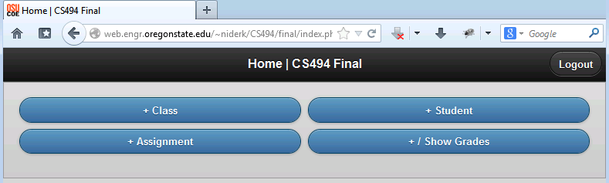

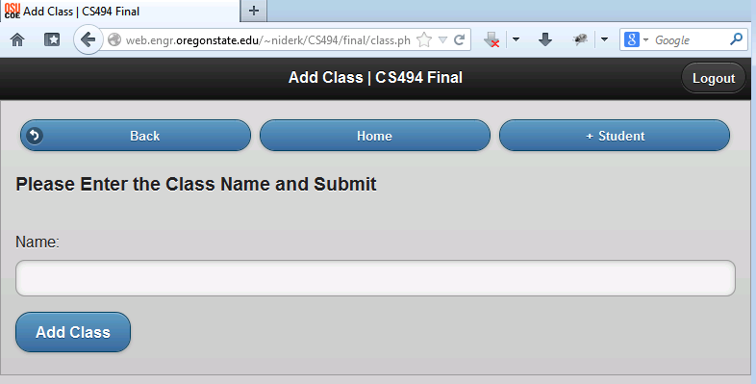

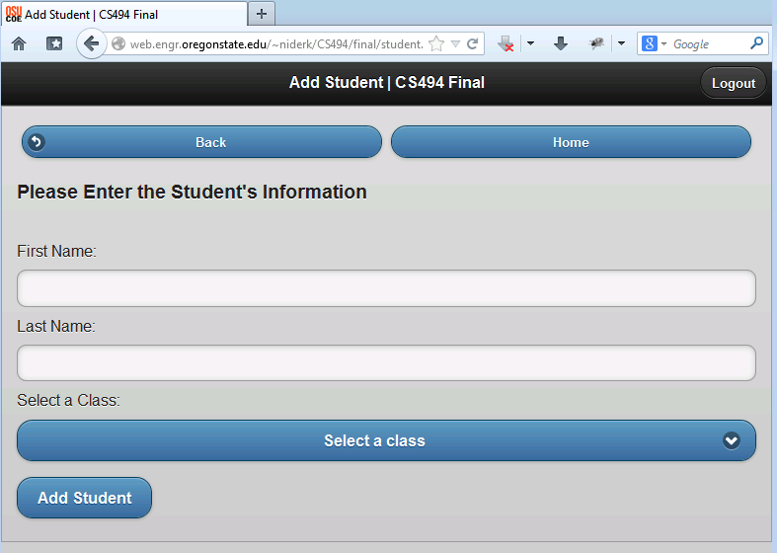

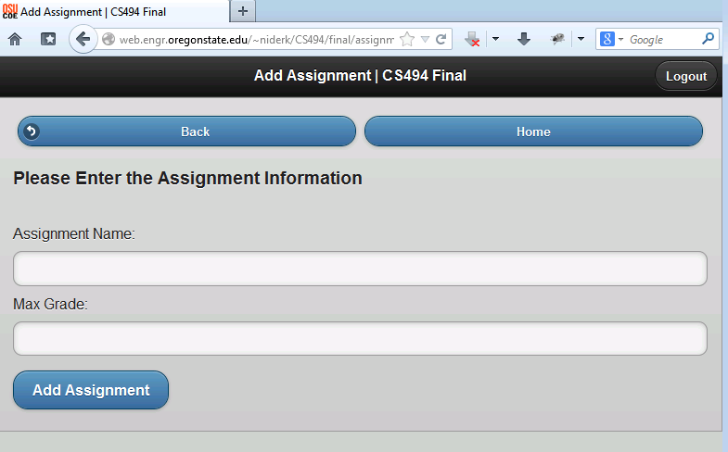

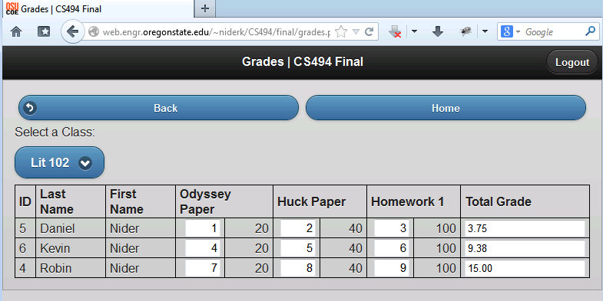

AJAX:

assignment.php:  
Echo from add_assignment.php is placed into the “error” div below.

<div data-theme="a" id="error"> </div>

<div data-theme="a">

<form id="addForm" method="post" action="add_assignment.php" data-ajax="false">

<h3>Please Enter the Assignment Information</h3><br>

<div><label for="assignmentName">Assignment Name:</label><input type="text" id="assignmentName" name="assignmentName" required /></div>

<div><label for="max_grade">Max Grade:</label><input type="number" id="max_grade" name="max_grade" required /></div>

<div class="ui-block-a"><input type="submit" value="Add Assignment"/></div>

</form>

**add_assignment.php:**

if(!$name && $max_grade) echo "Need to enter assignment name and max grade";

else {

//check for class existence

//src: http://stackoverflow.com/questions/14439009/php-check-existance-of-record-in-the-database-before-insertion

$params = array(':name' => $name, ':user' => $user);

$query = $pdo->prepare("SELECT COUNT(*) FROM assignments WHERE name=:name AND user=:user");

if (!($query->execute($params))) { echo "Query failed"; exit(); }

if ($query->fetchColumn() != 0) { echo "Assignment already exists"; exit(); }

$params = array(':name' => $name, ':max_grade' => $max_grade, ':user' => $user);

$stmt = $pdo->prepare("INSERT INTO assignments(name, max_grade, user) values(:name,:max_grade,:user)");

if (!$stmt->execute($params)){ echo "Execute failed"; exit(); }

echo "Assignment ". $name ." added";

# Cool Feature

I implemented PDO for all my SQL queries including checking logins, and adding and retrieving info to an from the database.

Validation:

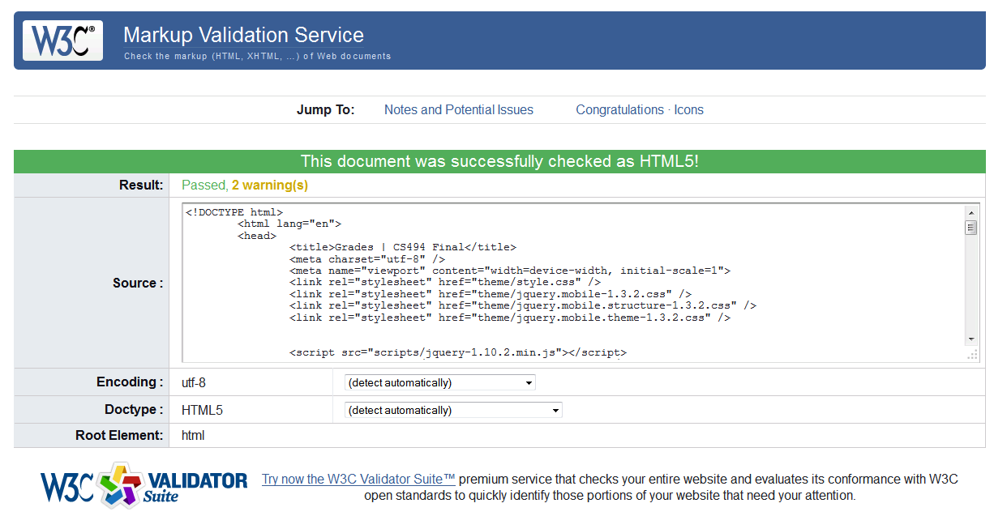

PHP files working:

