# RF Amplifier

|  |  |  |  |
| --- | --- | --- | --- |
| Spincore PA10W | 10– 75 MHz | $ 1845,00 |  |
| Spincore PA15W | 4 – 100 MHz | $ 2085,00 |  |
| CPC Amps 0.7T300M | 1 – 30 MHz |  |  |
| Tomco BT00250-AlphaS | 0.1 – 30 MHz |  |  |
| Barthel RFPA-1/50-250 | 1 – 50 MHz |  |  |

# TR Switch

Mini-Circuits ZYSWA-2-50DR

NMR-Service Transcoupler 14 – 30 Mhz

SpinCore: λ/4 cable and diodes

# Filters

SIF-21.4+ Lumped LC Band Pass Filter, 18 – 25 MHz, 50 Ohm

SLP-50+ Lumped LC Low Pass Filter, DC – 48 MHz, 50 Ohm

# Pre amps

MiniCircuits ZFL-500LN

Miteq AU-1467

# SpinCore NMR Probe

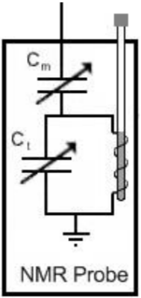

Cm: Non-Magnetic trimmer 1.5 – 19 pF with 20pF in series

Ct: Non-Magnetic trimmer 1.5 – 19 pF with 30pF in series

Coil inductance: 11.4µH (15,24mm length and 11mm diameter)

# SpinCore setup

