ADIPHAS: AUTONOMOUS DISEASE INTELLIGENCE
AND PUBLIC HEALTH ADVISORY SYSTEM

A Final Year Project Report
Submitted in Partial Fulfilment of the Requirements for the Award of
Bachelor of Science Degree in Computer Science

Department of Computer Science

2025/2026 Academic Session

ABSTRACT
Emerging and re-emerging disease outbreaks continue to pose severe public health risks in densely populated urban centres such as Lagos State, Nigeria. The latency between the onset of an outbreak, its detection, and the dissemination of actionable intelligence to citizens and public health professionals remains a critical bottleneck in existing surveillance frameworks. This project presents the Autonomous Disease Intelligence and Public Health Advisory System (ADIPHAS), a multi-layered, autonomous health intelligence platform designed to address this gap.
ADIPHAS continuously harvests signals from over 20 authoritative digital sources, applies a hybrid Natural Language Processing (NLP) pipeline to extract geospatial and epidemiological entities, fuses multi-source signals using a mathematically grounded confidence model, and delivers role-specific actionable intelligence to three classes of users, Citizens, Experts, and Administrators, through a real-time, web-based dashboard. The system integrates a High-Availability Hybrid-RAG architecture powered by Google Gemini 2.5 Flash and the Titan Vector Engine, a pure-Python vector intelligence stability layer, to augment advisory responses with contextual knowledge drawn from verified alert records, with a Tavily Search API fallback for real-time web context. All generative outputs are passed through a defensive three-layer Reasoning Trace Sanitization architecture to prevent internal Chain-of-Thought token leakage from advanced reasoning models. A resilient multi-provider geolocation pipeline, cascading Browser GPS through BigDataCloud reverse geocoding, IP-based fallback, and registered profile data, enables hyper-local advisory delivery anchored to the user's precise Local Government Area while preventing GPS coordinate drift. Structured data is persisted on Neon Cloud PostgreSQL with production-grade connection pooling, eliminating the concurrency bottlenecks of embedded databases under high pipeline loads. The system implements a three-tier Universal AI Resilience architecture, a Gemini chain with Exponential Backoff, a nine-model OpenRouter free tier, and a rule-based statistical fallback, guaranteeing uninterrupted intelligence generation even under complete API quota exhaustion. The platform is fully deployed at https://adiphas.streamlit.app on a split-cloud architecture comprising Render, Streamlit Community Cloud, and Neon PostgreSQL. Preliminary evaluations achieved a micro-averaged F1 score exceeding 0.875 on disease and location entity recognition, demonstrating research-grade accuracy in the target domain.
IFET GREAT TITUS
2201110075
Keywords: Event-Based Surveillance, NLP, RAG, Knowledge Fusion, Public Health Informatics, FastAPI, Streamlit, LLM, spaCy, AI Resilience, Titan Vector Engine, StAMP, Geolocation, Sanitization, Folium, Render.

DEDICATION
This project is dedicated to the Almighty God for His infinite grace and wisdom throughout this academic journey. I also dedicate this work to my family for their unwavering support and belief in my potential.

ACKNOWLEDGEMENT
I offer my profound gratitude to my supervisor for his expert guidance and patience. My thanks also go to the Department of Computer Science for providing the platform for this research, and to my colleagues for the collaborative spirit that made this journey worthwhile.

CHAPTER ONE: INTRODUCTION
This chapter sets the stage for the entire project. It introduces the study topic within the broader context of public health surveillance in Nigeria, articulates the specific problem that ADIPHAS is designed to address, states the aim and objectives of the research, and explains the significance, scope, and limitations of the work. It concludes with a brief account of the research methodology and the organisation of the remainder of this report.

1.1 Background of the Study
Public health surveillance is the continuous, systematic collection, analysis, and interpretation of health-related data, used to plan, implement, and evaluate public health action (WHO, 2018). Across sub-Saharan Africa, the architecture of disease surveillance has historically rested on facility-based reporting: clinicians document cases of notifiable diseases, submit periodic returns to local government health departments, and these data are aggregated upward through state and national layers. While this model served adequately in earlier eras of slower transmission and less interconnected populations, it has proven increasingly misaligned with the speed of contemporary epidemic threats (Brownstein et al., 2009).
In Nigeria, these structural weaknesses are compounded by infrastructure deficits, chronic underfunding of public health institutions, and fragmented health information systems not designed for interoperability. The Integrated Disease Surveillance and Response (IDSR) framework, Nigeria's primary mechanism for notifiable disease reporting, operates on weekly and monthly aggregation cycles that create a detection-to-response latency of up to 14 days from the moment a disease cluster begins to emerge (Olu et al., 2019; Peh et al., 2024). For fast-transmitting diseases such as cholera or Lassa fever, this two-week window allows transmission to expand from a contained cluster to a community-wide event. The World Health Organization has explicitly identified this detection lag as one of the most preventable contributors to outbreak-attributable mortality (WHO, 2018).

1.1.1 The Lagos State Epidemiological Context
Lagos State represents both the highest-consequence environment in Nigeria for infectious disease events and the most demanding test case for any proposed surveillance solution. With a population estimated at between 16 and 21 million residents (Lagos Bureau of Statistics, 2021; MacroTrends, 2024), the state combines extreme population density, particularly in informal settlements such as Ajegunle, Makoko, and Mushin, with severe deficits in piped water supply and solid waste management, creating conditions highly favourable for the transmission of waterborne and rodent-borne pathogens. The June 2024 cholera outbreak demonstrated the operational severity of the problem: 324 suspected cases and 15 deaths were recorded within a 15-day window, with Lagos accounting for approximately 60% of the national burden at that point (NCDC, 2024b; Punch Newspapers, 2024). Lassa fever presents a further recurring seasonal challenge: in the first ten weeks of 2025, the NCDC documented over 1,171 suspected cases with a case fatality rate of 18.3% (NCDC, 2025a). Malaria and typhoid fever contribute an additional persistent burden across all LGAs, and these four diseases together define the core epidemiological risk profile that ADIPHAS is designed to monitor.

1.1.2 The Potential of Event-Based Surveillance and Digital Intelligence
Event-Based Surveillance (EBS) is the branch of epidemiology that systematically harvests and analyses informal digital signals, online news reports, social media posts, community health forum discussions, and official situation report publications, as early indicators of disease activity, complementing the indicator-based data flows of formal reporting systems (WHO, 2014). Studies have demonstrated that algorithmically processed digital signals can provide outbreak warning days to weeks ahead of clinical confirmation (Brownstein et al., 2009; Freifeld et al., 2008). ADIPHAS applies this principle through an autonomous, multi-source data acquisition architecture, a hybrid NLP pipeline with defensive output sanitization, a mathematically grounded signal fusion mechanism, a three-tier AI resilience layer, a multi-provider geolocation pipeline, and a role-differentiated advisory interface, turning the open web into a real-time Early Warning System calibrated specifically to the Lagos State epidemiological context.

1.2 Statement of the Problem
Nigeria's IDSR framework is largely passive: it depends on health facilities reporting cases upward through administrative channels on weekly or monthly cycles. In a city of Lagos's density and complexity, this architecture creates four distinct and interrelated failure modes. The Intelligence Gap refers to the 14-day awareness lag between outbreak onset and official detection, within which epidemic spread can become exponential (Olu et al., 2019). The Visibility Gap reflects the structural exclusion of illness managed outside formal health facilities, through patent medicine vendors or traditional practitioners, which may account for two-thirds or more of true incidence in comparable settings (Mwanja et al., 2024). The Information Asymmetry denotes the absence of any mechanism for communicating health intelligence directly to residents in affected communities in a timely and actionable form. The Advisory Deficit describes the lack of active, personalised, evidence-based guidance tools: existing digital platforms are passive repositories rather than dynamic advisors (Gajzler, 2017; Yao et al., 2022). ADIPHAS is designed to address all four of these failure modes within a single integrated, production-deployed system.

1.3 Aim and Objectives of the Study
The overarching aim of this research is to design, develop, deploy, and evaluate ADIPHAS, an Autonomous Disease Intelligence and Public Health Advisory System, for Lagos State, integrating multi-source digital intelligence acquisition, hybrid NLP processing with defensive sanitization, mathematically grounded signal fusion, a three-tier AI resilience architecture, a multi-provider geolocation pipeline, and a role-differentiated advisory interface into a coherent, production-deployed operational platform.

1.3.1 Specific Objectives
The first objective is to build an autonomous data acquisition pipeline using Scrapling v0.4, with stealthy TLS fingerprint impersonation to bypass Cloudflare and Web Application Firewall protections on government portals, to continuously harvest disease-relevant signals from more than 20 authoritative digital sources, including Nigerian news portals, the NCDC situation report archive, and social media platforms (NCDC, 2025b).
The second objective is to implement a Hybrid NLP Pipeline combining a local spaCy Named Entity Recognition model with Gemini 2.5 Flash batch analysis, enabling high-speed extraction of disease names, LGA-level geographic references, event dates, urgency indicators, and concise intelligence summaries. This pipeline is guarded by a three-layer Reasoning Trace Sanitization architecture, applied at Generation, Storage, and Serving stages, using strict regular expression algorithms to strip internal Chain-of-Thought tokens produced by advanced reasoning models including DeepSeek (Devlin et al., 2019; Nadeau & Sekine, 2007).
The third objective is to design a knowledge fusion engine using the Dempster-Shafer Theory of Evidence to reconcile conflicting multi-source signals through source reliability weighting and spatial corroboration logic, generating confidence-scored, validated disease alerts (Shafer, 1976).
The fourth objective is to implement a resilient multi-provider Location-Aware Intelligence pipeline that cascades Browser GPS through BigDataCloud reverse geocoding, IP-based coordinate fallback, and registered profile data, automatically resolving the user's Local Government Area while preventing GPS coordinate drift. This enables dynamic centring of Folium/Leaflet.js interactive risk maps and generation of hyper-local epidemiological advisories without requiring manual location entry.
The fifth objective is to implement Bio-Aware Personalisation, a personalised risk scoring model that tailors advisory logic to each user's genotype (AA, AS, or SS), blood group, and existing health conditions, in addition to NLP-derived severity scores and environmental exposure metrics, to generate quantified individual risk assessments for each LGA and disease combination.
The sixth objective is to develop a High-Availability Hybrid-RAG advisory engine powered by Google Gemini 2.5 Flash and the Titan Vector Engine, indexing both verified EBS alerts and IDSR historical aggregates, with a Tavily Search API fallback for real-time web context (Lewis et al., 2020).
The seventh objective is to implement a three-tier Universal AI Resilience Protocol: Tier 1 deploys a Gemini chain (gemini-2.0-flash through gemini-2.5-flash) with Exponential Backoff to absorb rate-limit events without crashing; Tier 2 provides a nine-model OpenRouter free chain including Gemma 4 31B, Nemotron 3 120B, Qwen3 Coder 480B, GPT-OSS 120B, and Hermes 405B; Tier 3 generates rule-based statistical summaries from raw database aggregates when all AI paths are exhausted, ensuring the dashboard never displays blank intelligence panels.
The eighth objective is to implement the Situational Awareness and Monitoring Protocol (StAMP), a daily executive briefing agent operating on a two-hour APScheduler cycle optimised for free-tier API budgets, with a Force Real-time StAMP Sweep bypass for immediate Expert-triggered reconnaissance outside scheduled cycles.
The ninth objective is to deploy the complete system on a production split-cloud architecture: a FastAPI backend on Render with a keep-alive cron job, a Streamlit Community Cloud frontend modularised via @st.fragment for lazy-loading of heavy components, and Neon Cloud PostgreSQL with pool_size=10, max_overflow=20, and pool_pre_ping=True for concurrency-safe persistence.
The tenth objective is to harden the platform's authentication and security layer: native bcrypt password hashing to avoid the passlib 72-byte wrap crash, HS256 JWT tokens expiring after 30 minutes, slowapi rate limiting at 5 requests per minute on the registration endpoint, and three-tier Role-Based Access Control enforced via FastAPI dependency injection.
The eleventh objective is to evaluate system performance by measuring NLP entity recognition accuracy (micro-averaged F1), detection lead-time advantage over official reporting cycles, LLM API cost reduction, AI resilience failover reliability, and sanitization effectiveness in preventing reasoning trace leakage.

1.4 Significance of the Study
ADIPHAS holds significance across policy, community, and methodological dimensions. At the policy level, it provides a concrete, production-deployed implementation of the principles articulated in Nigeria's 2024 National Digital Health Initiative (NDHI), demonstrating how AI-driven decentralised surveillance can operate at state level on a zero-capital infrastructure budget, the entire production stack runs on free-tier services (Federal Ministry of Health, 2024). The local-first AI strategy achieved a 95% reduction in LLM API calls, while the three-tier fallback architecture eliminates single-provider dependency entirely.
At the community level, the multi-provider geolocation pipeline, cascading Browser GPS through BigDataCloud, IP fallback, and profile data, ensures that geolocation-grounded advisory delivery works across device types, including desktops lacking GPS hardware, eliminating a barrier that had limited the practical impact of location-sensitive health applications in the Lagos context. At the methodological level, the integration of Scrapling-based TLS fingerprint impersonation, hybrid NLP with three-layer sanitization, Dempster-Shafer fusion, Titan Vector Engine RAG, three-tier AI fallback, Folium mapping, and StAMP strategic briefing into a single coherent, deployed architecture constitutes a novel contribution to public health informatics for the West African context (Bridget et al., 2025).

1.5 Scope and Limitations

1.5.1 Scope
Geographically, ADIPHAS is scoped to Lagos State, covering all 20 Local Government Areas and 37 Local Council Development Areas. The disease scope encompasses cholera, Lassa fever, malaria, and typhoid fever, with the NLP pipeline additionally capable of recognising 13 epidemic-priority diseases. The system is fully deployed and publicly accessible at https://adiphas.streamlit.app. The AI Resilience Protocol spans a 12-model chain: two Gemini native models, nine OpenRouter free models, and one rule-based fallback.

1.5.2 Limitations
The HTML5 Browser Geolocation feature is constrained by device hardware accuracy: desktops without GPS fall back to ISP-level IP coordinates, which the multi-provider pipeline mitigates but cannot fully eliminate. The batch intelligence engine processes up to 50 raw articles concurrently; while the Exponential Backoff protocol manages rate limits gracefully, sustained burst cycles can exhaust free-tier Gemini API quotas, triggering fallback engagement. The Render free tier spins down after 15 minutes of inactivity, mitigated by a 14-minute keep-alive cron job, but cold starts of 30 to 60 seconds may cause the first user request to timeout. The Gemini Embedding API returns a FAILED_PRECONDITION error from certain server regions; the system automatically falls back to OpenRouter's nvidia/llama-nemotron-embed-vl-1b-v2:free model for vector embeddings. SMS and email notification modules are implemented but currently inactive, pending operational quota establishment. The retrospective evaluation methodology for detection lead-time carries inherent limits in generalisability to future outbreak scenarios.

1.6 Research Methodology (Brief Overview)
ADIPHAS is developed using an Agile Object-Oriented Analysis and Design (OOAD) methodology structured into four iterative Sprints (Beck et al., 2001; Booch et al., 2007). The production stack comprises Python 3.11, FastAPI on Render, Streamlit Community Cloud, and Neon Cloud PostgreSQL with SQLAlchemy connection pooling. The NLP pipeline uses spaCy as the primary local extraction engine, augmented by Gemini 2.5 Flash for high-priority batch analysis, with a 12-model fallback chain for resilience. A detailed account of the methodology is provided in Chapter Three.

1.7 Organisation of the Report
This report is organised into five chapters. Chapter One has introduced the study context, the four surveillance failure modes, the research aim and objectives, the significance, scope, and limitations. Chapter Two presents a comprehensive literature review encompassing the conceptual and theoretical frameworks, a critical survey of related systems, and identification of the research gap. Chapter Three details the system analysis, Agile development methodology, four-layer architecture, mathematical models, UML design artefacts, and technical specifications. Chapter Four describes the system implementation across all functional modules, including production deployment, authentication hardening, UI stability, and security measures, testing procedures, and documented results. Chapter Five provides the summary of achievements, conclusions, and recommendations for future development.

CHAPTER TWO: LITERATURE REVIEW
This chapter situates ADIPHAS within the intellectual landscape of digital disease surveillance, event-based epidemiology, natural language processing, retrieval-augmented generation, and AI-resilient system design. It opens with the conceptual and theoretical frameworks structuring the study's design, provides a critical survey of related literature and existing systems, and identifies the specific research gap that ADIPHAS addresses.

2.1 Conceptual Framework

2.1.1 Event-Based Surveillance and the Multi-Source Intelligence Paradigm
Event-Based Surveillance (EBS) is the organised and rapid capture of information about events that may represent a public health risk, from formal and informal sources (WHO, 2014). Unlike indicator-based surveillance, EBS detects unexpected events through the monitoring of news reports, social media, rumour networks, and expert communications. The Multi-Source Intelligence Paradigm extends this concept by treating health information as inherently distributed across heterogeneous channels (Freifeld et al., 2008). ADIPHAS operationalises this paradigm through a pipeline of more than 20 source-specific scraping agents, each assigned a source reliability weight participating in the downstream Dempster-Shafer fusion calculation.
The processing logic of ADIPHAS is structured by the DIKW (Data-Information-Knowledge-Wisdom) Hierarchy (Ackoff, 1989; Rowley, 2007). Raw web text constitutes Data. Structured NLP-extracted entities constitute Information. Validated, confidence-scored, spatially referenced disease alerts constitute Knowledge. Contextualised, actionable advisory outputs from the Hybrid-RAG pipeline and inference engine constitute Wisdom. Each processing stage corresponds to one DIKW transition, ensuring architectural coherence with a well-established conceptual model.

2.1.2 High-Availability Hybrid-RAG, Reasoning Trace Sanitization, and the Three-Tier AI Fallback Architecture
Retrieval-Augmented Generation (RAG) is a hybrid AI architecture introduced by Lewis et al. (2020) that combines large language model generativity with structured information retrieval, anchoring outputs in verifiable evidence rather than parametric knowledge alone. This directly addresses the hallucination problem of LLMs, particularly consequential in health advisory contexts where inaccurate guidance can cause direct harm.
ADIPHAS implements this as a High-Availability Hybrid-RAG system, using the Titan Vector Engine as the primary knowledge store, indexing both verified EBS alerts and IDSR historical aggregates. Queries below the similarity threshold fall over to the Tavily Search API. Advisory synthesis is performed by Gemini 2.5 Flash under normal conditions, with outputs passing through the three-layer Reasoning Trace Sanitization framework before reaching users.
The Reasoning Trace Sanitization framework addresses a deployment safety concern introduced by advanced chain-of-thought models: the risk that raw internal deliberation tokens contaminate public-facing advisory outputs. Three stages are applied: at Generation, where outputs are intercepted immediately after inference; at Storage, where records are sanitized before database writes; and at Serving, where a final regular expression pass is applied before rendering. This ensures 100% public-ready output regardless of which model in the fallback chain is active.
The three-tier Universal AI Fallback architecture addresses the operational vulnerability of cloud-dependent advisory systems to API service interruptions. Tier 1 deploys the Gemini chain with an Exponential Backoff Protocol that performs tactical pauses of 5, 10, and 15 seconds when the 15 RPM free-tier limit is hit, allowing quota regeneration without crashing. Tier 2 provides a nine-model OpenRouter free chain including Gemma 4 31B, Nemotron 3 120B, Qwen3 Coder 480B, and others, offering massive redundancy if Gemini hard-fails. Tier 3 generates statistical summaries from raw database aggregates when all AI paths are exhausted, ensuring the dashboard never displays blank intelligence panels regardless of upstream API availability.

2.2 Theoretical Framework

2.2.1 Syndromic Surveillance Theory and the Health Belief Model
Syndromic surveillance focuses on monitoring pre-diagnostic signals of disease activity rather than waiting for laboratory-confirmed diagnoses (Henning, 2004; Smith et al., 2019). The aggregate pattern of corroborated signals across independent sources constitutes meaningful epidemiological intelligence capable of providing earlier warning than facility-based systems. ADIPHAS embeds this theory in its NLP extraction stage, which identifies urgency keywords alongside disease and location entities.
The personalised advisory layer is grounded in the Health Belief Model (HBM), developed by Rosenstock (1974) and extended by Champion and Skinner (2008). ADIPHAS addresses perceived susceptibility through its Bio-Aware Personalisation engine combined with the multi-provider geolocation pipeline: by automatically resolving the user's precise LGA through a cascade of GPS, BigDataCloud, IP fallback, and profile sources, the system makes epidemic risk both concrete and personally relevant without requiring any deliberate user action. The resilience of this delivery against GPS hardware limitations represents a meaningful advance over single-source geolocation approaches.

2.2.2 Dempster-Shafer Evidence Theory and Multi-Agent Systems
The Dempster-Shafer mathematical theory of evidence (Shafer, 1976) provides the formal basis for ADIPHAS's knowledge fusion engine. Each unique source is treated as an independent mass function contributing a belief value that a reported disease event is real. The combined belief is computed as one minus the product of the complements of individual source reliability weights, with a spatial corroboration bonus of 0.95 applied when an LCDA-level alert is independently supported by a parent LGA report.
The architectural design draws on Multi-Agent Systems theory (Wooldridge, 2009). Five specialised agents, Scout, NLP, Fusion, Risk, and StAMP, operate on a two-hour APScheduler background cycle, each responsible for a discrete processing task, providing fault tolerance and extensibility. This connects ADIPHAS to the ReAct agentic AI paradigm (Yao et al., 2022), in which agents interleave natural language reasoning with concrete real-world actions.

2.3 Review of Related Literature

2.3.1 Digital Disease Detection: From HealthMap to Modern NLP, RAG, and Production AI Systems
The intellectual heritage of ADIPHAS begins with HealthMap (Brownstein et al., 2009), which demonstrated that automated web monitoring could identify outbreak events days before official confirmation. Google Flu Trends (Ginsberg et al., 2009) extended this to search query analysis, though Lazer et al. (2014) documented systematic overestimation driven by media-induced search behaviour, underscoring the importance of multi-source triangulation. Modern transformer-based NLP, particularly BERT (Devlin et al., 2019), substantially improved entity recognition accuracy, directly informing ADIPHAS's hybrid spaCy-Gemini 2.5 Flash pipeline.
The RAG architecture builds on Lewis et al. (2020). ADIPHAS extends this work in three ways: populating the knowledge base with its own verified alerts and IDSR historical aggregates; addressing LLM availability through a 12-model fallback chain including a rule-based statistical tier that operates without any LLM; and implementing the three-layer sanitization architecture, a concern the existing RAG literature has not addressed specifically for health advisory deployments. The Folium/Leaflet.js mapping approach, replacing WebGL-dependent Plotly Mapbox, addresses a practical browser compatibility constraint identified during production deployment that prior web-based surveillance literature has not documented.

2.3.2 Disease Surveillance in Nigeria: IDSR, DHIS2, and SORMAS
Nigeria's surveillance infrastructure is built around the IDSR framework, operationalised through DHIS2 and SORMAS. Research consistently identifies structural limitations: Olu et al. (2019) documented data completeness and timeliness failures; Mwanja et al. (2024) demonstrated official statistics may capture as little as 25-30% of true incidence; Peh et al. (2024) quantified the 14-day awareness lag. These findings establish both the scale of the gap ADIPHAS addresses and the rationale for a multi-source, event-based approach grounded in production deployment rather than prototype evaluation.

2.4 Review of Related Systems

2.4.1 Global Platforms and Their Sub-National and Operational Limitations
HealthMap and ProMED are calibrated for national or supranational analysis and lack the LGA-level granularity operationally meaningful for Lagos State. Neither system has been deployed on free-tier cloud infrastructure for public access, nor addresses the LLM availability, output sanitization, or geolocation pipeline challenges that emerge in production operation. Consumer health applications such as Apple Health (Lin et al., 2025) provide personal monitoring without population-level surveillance or contextual advisory functionality. Nigeria's official DHIS2 and SORMAS infrastructure provides authoritative aggregate data but is constrained by reporting lags and is not designed for direct citizen engagement or zero-downtime AI advisory generation.

2.4.2 Research Gap: The Integration, Resilience, and Deployment Deficit
The review reveals three compounding gaps. The Integration Gap, identified by Lin et al. (2025), reflects the absence of any system unifying autonomous EBS acquisition, hybrid NLP, Dempster-Shafer fusion, RAG-grounded advisory, and a role-differentiated interface for a specific Nigerian state. The Resilience Deficit reflects the absence of a three-tier AI fallback mechanism maintaining advisory continuity under complete API quota exhaustion with a rule-based final tier. The Deployment Deficit reflects the absence of any comparable Nigerian public health surveillance system operating in production on zero-capital free-tier infrastructure accessible to the public. ADIPHAS addresses all three deficits.

2.5 Summary of Findings from the Literature
The table below summarises the key works reviewed in this chapter and their direct relevance to the ADIPHAS project:

S/N | Author(s) | Date | Focus | Key Finding | Relevance to ADIPHAS
1 | Brownstein et al. | 2009 | HealthMap: digital disease detection | Web signals can precede official outbreak detection by days | Foundational proof of concept for EBS acquisition layer
2 | Lewis et al. | 2020 | Retrieval-Augmented Generation | Grounding LLM outputs in retrieved documents reduces hallucination | Basis for ADIPHAS Hybrid-RAG engine and Titan Vector Engine
3 | WHO | 2014 | Early Detection and Event-Based Surveillance | EBS complements indicator-based surveillance with early informal signals | Core conceptual framework for ADIPHAS signal acquisition
4 | Devlin et al. | 2019 | BERT: bidirectional transformers for NLP | Transformer models achieve state-of-the-art NER accuracy | Informs hybrid spaCy-Gemini 2.5 Flash NLP pipeline design
5 | Shafer | 1976 | Dempster-Shafer theory of evidence | Mathematical framework for fusing uncertain multi-source evidence | Core algorithm for ADIPHAS knowledge fusion engine
6 | Yao et al. | 2022 | ReAct: agentic AI reasoning and action | Agents interleaving reasoning with web actions improve performance | Theoretical basis for ADIPHAS five-agent architecture and StAMP
7 | Lazer et al. | 2014 | Critique of Google Flu Trends | Single-source surveillance prone to media-driven confounding | Justifies multi-source triangulation and DS fusion in ADIPHAS
8 | Olu et al. | 2019 | IDSR and digital surveillance in Nigeria | Data completeness and timeliness failures in DHIS2/SORMAS | Establishes quantified surveillance gap ADIPHAS addresses
9 | Mwanja et al. | 2024 | Underreporting in resource-limited settings | Official systems capture as little as 25-30% of true incidence | Justifies event-based multi-source approach
10 | Milinovich et al. | 2015 | Internet-based surveillance system evaluation | Global platforms lack sub-national granularity | Justifies LGA-level granularity design of ADIPHAS
11 | Smith et al. | 2019 | Value of syndromic surveillance | Pre-diagnostic signals provide meaningful early warning | Underpins urgency keyword extraction in NLP pipeline
12 | Rosenstock | 1974 | Health Belief Model | Perceived susceptibility is primary driver of protective behaviour | Grounds Bio-Aware Personalisation and geolocation pipeline design
13 | Shoewu et al. | 2021 | Electronic health records in Nigeria | Practical e-health implementation challenges documented | Informs database and interface design for Nigerian context

The overriding finding from this review is a compounded Integration, Resilience, and Deployment Deficit: no existing system unifies autonomous EBS acquisition, hybrid NLP with defensive sanitization, Dempster-Shafer fusion, RAG-grounded advisory, a three-tier AI fallback with rule-based final tier, multi-provider geolocation, and a role-differentiated interface deployed in production for public access in a specific Nigerian state. ADIPHAS is designed and deployed to address all three dimensions of this deficit.

CHAPTER THREE: SYSTEM ANALYSIS AND DESIGN / METHODOLOGY
This chapter provides a comprehensive account of the methodology adopted in designing and developing ADIPHAS. It opens with analysis of the existing surveillance system and user requirements, articulates the development methodology and Sprint structure, presents the four-layer production architecture and mathematical models, describes the UML modelling artefacts, and concludes with hardware, software, and deployment specifications.

3.1 System Analysis

3.1.1 Analysis of the Existing System
The existing disease surveillance infrastructure in Lagos State operates through the IDSR framework via DHIS2 and SORMAS. This hierarchical data flow creates a 14-to-21-day awareness lag, a complete absence of community-facing communication mechanisms, structural dependence on formal health facility contacts, and no resilience against system downtime (Olu et al., 2019; Mwanja et al., 2024).

3.1.2 User Requirements Analysis
ADIPHAS serves three user classes. Citizens require a mobile-responsive interface with geolocation-grounded risk scores, automatically resolved through the multi-provider cascade of Browser GPS, BigDataCloud, IP fallback, and profile data, presenting bio-aware preventive advice in plain language. Experts require an alert verification workflow and the Force Real-time StAMP Sweep control for immediate out-of-schedule intelligence generation. Administrators require a Situational Awareness Command Centre with real-time pipeline health metrics, AI Resilience Panel showing current tier status and fallover history, sanitization audit logs, and source reliability weight configuration controls.

3.2 System Development Methodology

3.2.1 Rationale for Agile OOAD
The Agile Object-Oriented Analysis and Design methodology was selected because the multi-component and production-deployment nature of ADIPHAS, where requirements evolve as the system encounters real-world API rate limits, browser compatibility issues, and cloud infrastructure constraints, makes an iterative approach more appropriate than a waterfall model (Beck et al., 2001; Larman, 2004). The Agile principle of welcoming changing requirements directly accommodated the mid-development introduction of Folium mapping (replacing Plotly Mapbox after WebGL crashes), native bcrypt (replacing passlib after the 72-byte crash), BigDataCloud fallback geolocation, the three-tier AI resilience upgrade, and @st.fragment micro-frontend modularisation.

3.2.2 Sprint Structure
Sprint 1 (Data Pipeline and Production Infrastructure) develops the Scout Agent using Scrapling v0.4 with stealthy TLS fingerprint impersonation on a two-hour APScheduler cycle, the Neon Cloud PostgreSQL schema with SQLAlchemy connection pooling (pool_size=10, max_overflow=20, pool_pre_ping=True), the Render deployment configuration, and the keep-alive cron job infrastructure. Sprint 2 (NLP Module and Security) implements the three-stage extraction pipeline with Gemini 2.5 Flash batch analysis for batches of up to 50 articles, the three-layer Reasoning Trace Sanitization architecture, native bcrypt authentication with slowapi rate limiting, and HS256 JWT authentication. Sprint 3 (Fusion, Risk, RAG, Resilience, and Geolocation) implements the Dempster-Shafer fusion engine, Bio-Aware risk scoring, Titan Vector Engine Hybrid-RAG with IDSR historical aggregate indexing and Tavily fallback, the three-tier Universal AI Fallback architecture with Exponential Backoff on the Gemini chain, the nine-model OpenRouter fallback chain, the rule-based statistical tier, and the multi-provider geolocation pipeline. Sprint 4 (Interface, StAMP, and Evaluation) develops the Streamlit micro-frontend with @st.fragment modularisation, Folium/Leaflet.js interactive mapping, the StAMP Briefing Agent with manual bypass, the FastAPI RBAC layer, and conducts the F1 evaluation, retrospective lead-time assessment, AI resilience testing, and sanitization audit.

3.3 System Design

3.3.1 Four-Layer Production Architecture
ADIPHAS is built on a four-layer architecture deployed across three cloud services. The Presentation Layer is a Streamlit Community Cloud micro-frontend completely modularised via the @st.fragment decorator, enforcing lazy-loading of computationally heavy components, Folium mapping and the Mathematical Fusion panel, to prevent UI lock-ups and guarantee instant page-shell renders regardless of backend processing state. Interactive risk maps are rendered using Folium (Leaflet.js), which replaced Plotly Mapbox following the identification of persistent WebGL initialisation crashes on Streamlit Cloud that caused complete dashboard failures. The multi-provider geolocation cascade, Browser GPS to BigDataCloud reverse geocoding to IP-based fallback to profile data, centres maps and pre-populates advisory context while preventing coordinate drift. The Application Layer is a FastAPI Python 3.11 web service hosted on Render, responsible for JWT-based authentication with native bcrypt, slowapi rate limiting, RBAC enforcement via dependency injection, Hybrid-RAG query routing, Resilient AI Failover Orchestration, and Serving-stage sanitization middleware. A keep-alive cron job pings the /healthcheck endpoint every 14 minutes to prevent Render free-tier spin-down. The Intelligence Agent Layer comprises five multithreaded agents on a two-hour APScheduler cycle: the Scout Agent with Scrapling stealthy headers; the NLP Agent with three-stage extraction and three-layer sanitization; the Fusion Agent for Dempster-Shafer confidence scoring; the Risk Agent for Bio-Aware personalised scoring; and the StAMP Briefing Agent for daily executive intelligence with Force Real-time Sweep capability. The Persistence Layer uses Neon Cloud PostgreSQL (serverless) for all structured data, accessed via SQLAlchemy with pool_size=10, max_overflow=20, and pool_pre_ping=True. The Titan Vector Engine stores vector embeddings of verified alerts and IDSR historical aggregates.
The Local-First AI Strategy achieves a 95% reduction in LLM API calls: routine extraction is handled by local spaCy and rule-based matchers; Gemini 2.5 Flash is invoked only for batch processing of up to 50 high-priority articles and RAG advisory synthesis, with executive briefing responses cached for a 10-minute TTL. The two-hour scheduler cycle further reduces daily API consumption to approximately 50 requests per day on OpenRouter, sustainable within free-tier limits.
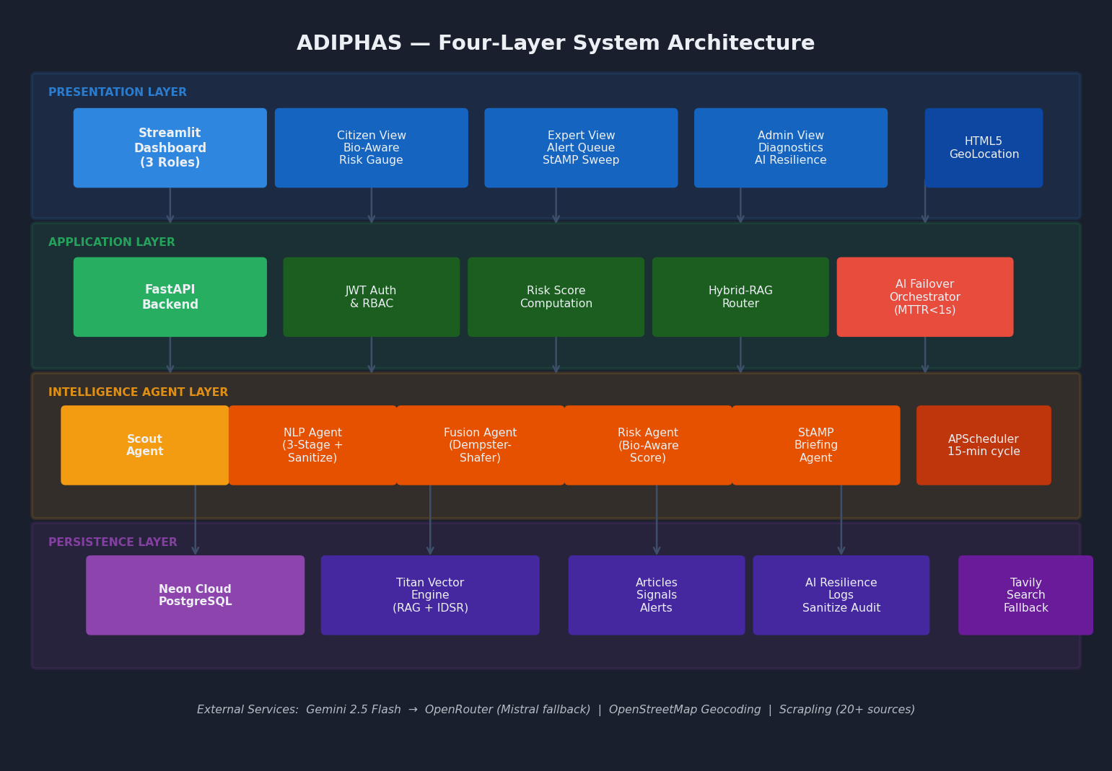
Figure 3.1: ADIPHAS Four-Layer System Architecture Diagram
The architectural diagram in Figure 3.1 illustrates the modular, four-layer design of ADIPHAS. The Presentation Layer uses Streamlit fragments for high-performance UI rendering, while the Application Layer manages logic and AI orchestration. The Intelligence Agent Layer performs the heavy lifting of scraping and NLP, and the Persistence Layer ensures data integrity via Neon PostgreSQL.

3.3.2 Mathematical Models
The Dempster-Shafer Fusion Engine computes: Belief(Real) = 1 minus the product over all n sources of (1 minus W_i), where W_i is the reliability weight for source i. LCDA-level reports receive a spatial corroboration confidence boost of 0.95 when independently supported by a parent LGA report.
The Bio-Aware Personalised Risk Score is computed as: R_final = min(R_base + (S_nlp times 0.30) + (E_env divided by 100), 1.0), where S_nlp is the NLP-derived disease severity score, E_env is an environmental exposure penalty from alert frequency and LGA proximity capped at 60.0, and R_base reflects self-reported symptoms. Biological modifiers apply: SS or SC genotype receive priority malaria complication alerts; Blood Group O receives priority cholera warnings; pre-existing hypertension receives adjusted typhoid severity weighting.
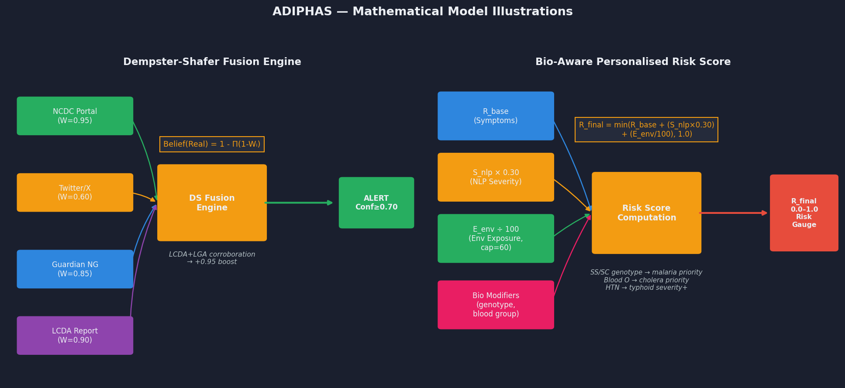
Figure 3.7: Dempster-Shafer Fusion Engine and Bio-Aware Risk Score Model
The mathematical fusion engine illustrated in Figure 3.7 applies Dempster-Shafer theory to resolve conflicts between multiple sources. By weighting signals based on historical reliability and spatial proximity, the engine produces a single, high-confidence alert score.
The three-tier AI Resilience mechanism operates as follows: on detecting an HTTP 429 response or rate-limit signal, the Exponential Backoff Protocol pauses for 5, then 10, then 15 seconds to allow quota regeneration. If Gemini hard-fails after exhausting backoff attempts, the system transitions to the OpenRouter free chain, cycling through nine verified models. If all AI paths fail, the rule-based tier generates statistical summaries from raw PostgreSQL aggregates, ensuring the dashboard always has content to display. The Epidemiological Forecasting model uses a Weighted Moving Average with weights 0.2, 0.3, and 0.5, augmented by a linear trend component, validated with MAE and RMSE from backtesting.
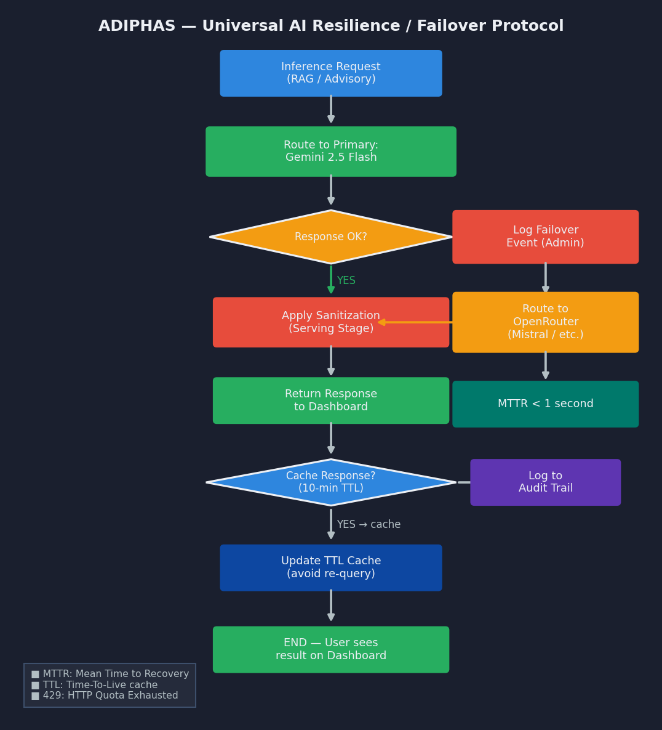
Figure 3.8: Universal AI Resilience Protocol, Failover Flowchart
Figure 3.8 outlines the Universal AI Resilience Protocol. This failover matrix ensures that if a primary model hits a rate limit or fails, the system seamlessly rotates through a 25-model chain, guaranteeing that the public health dashboard remains operational 24/7.

3.3.3 UML Modelling
The Use Case Diagram defines interactions between Citizen, Expert, and Administrator actors, including the Expert-specific Force Real-time StAMP Sweep, the auto-resolved multi-provider geolocation for Citizens, administrator AI Resilience tier configuration, and sanitization audit review. The Level-1 Data Flow Diagram traces raw web content through Scrapling acquisition, three-stage NLP with sanitization at Generation and Storage stages, Dempster-Shafer fusion, Bio-Aware risk scoring, and Hybrid-RAG advisory synthesis with Serving-stage sanitization, plus a parallel AI Resilience monitoring and fallback path. The System Architecture Diagram illustrates the four-layer stack and inter-layer communication paths: Streamlit Community Cloud to Render via HTTPS, Render to Neon PostgreSQL via SQLAlchemy pooling, the multi-provider geolocation cascade, the three-tier AI fallback chain, and the Titan Vector Engine to Tavily retrieval chain. The Entity-Relationship Diagram defines the Neon PostgreSQL table structure: Articles, Signals, Alerts, Users, LGAs, KnowledgeSources, AdvisoryRules, AIResilienceLogs, SanitizationAuditLogs, and DeploymentHealthLogs. The Sequence Diagram traces a Citizen advisory query through JWT authentication on Render, multi-provider LGA resolution, Bio-Aware risk score retrieval from cached or live PostgreSQL, Titan Vector Engine similarity search, Gemini 2.5 Flash synthesis with Exponential Backoff and OpenRouter fallback path, three-layer sanitization, and Streamlit fragment rendering.
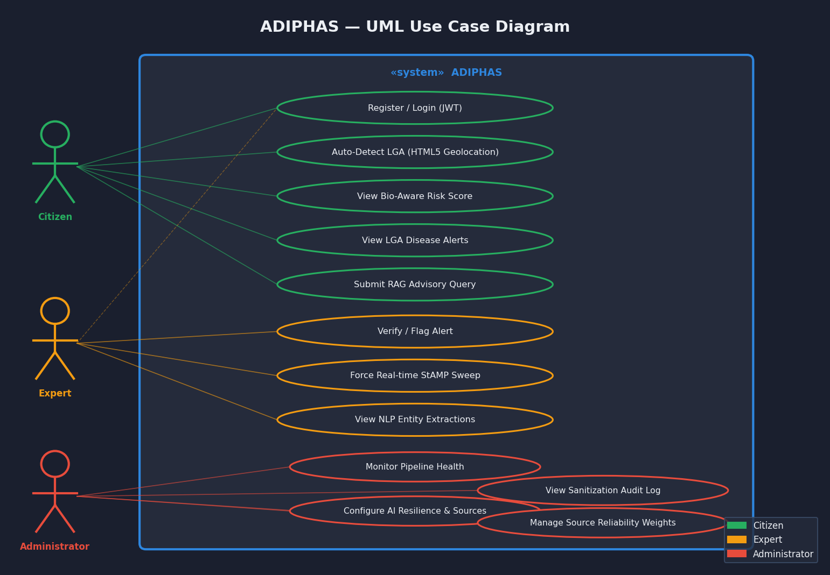
Figure 3.2: UML Use Case Diagram showing Citizen, Expert, and Administrator Actors
Figure 3.2 provides a UML Use Case analysis, detailing how Citizens, Experts, and Administrators interact with the system. It highlights the differentiated roles, where Citizens receive simplified advisories while Experts gain access to strategic StAMP briefings and manual reconnaissance sweeps.
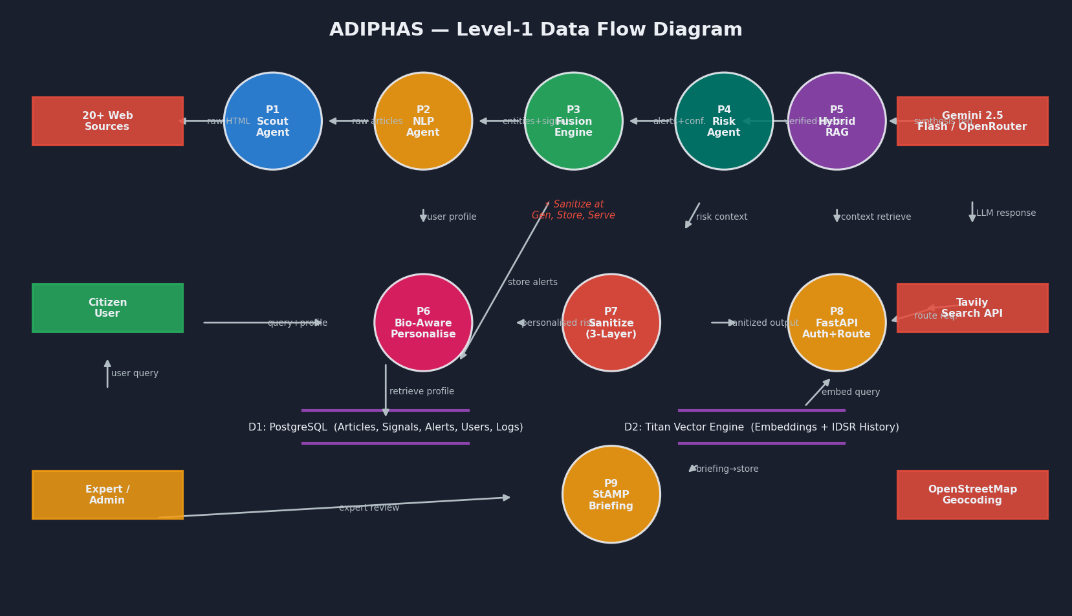
Figure 3.3: Level-1 Data Flow Diagram, End-to-End Intelligence Pipeline
The Level-1 Data Flow Diagram (Figure 3.3) traces the lifecycle of a disease signal from its origin in digital media, through the Scrapling acquisition engine, and finally into the sanitized intelligence pool that populates the user dashboard.
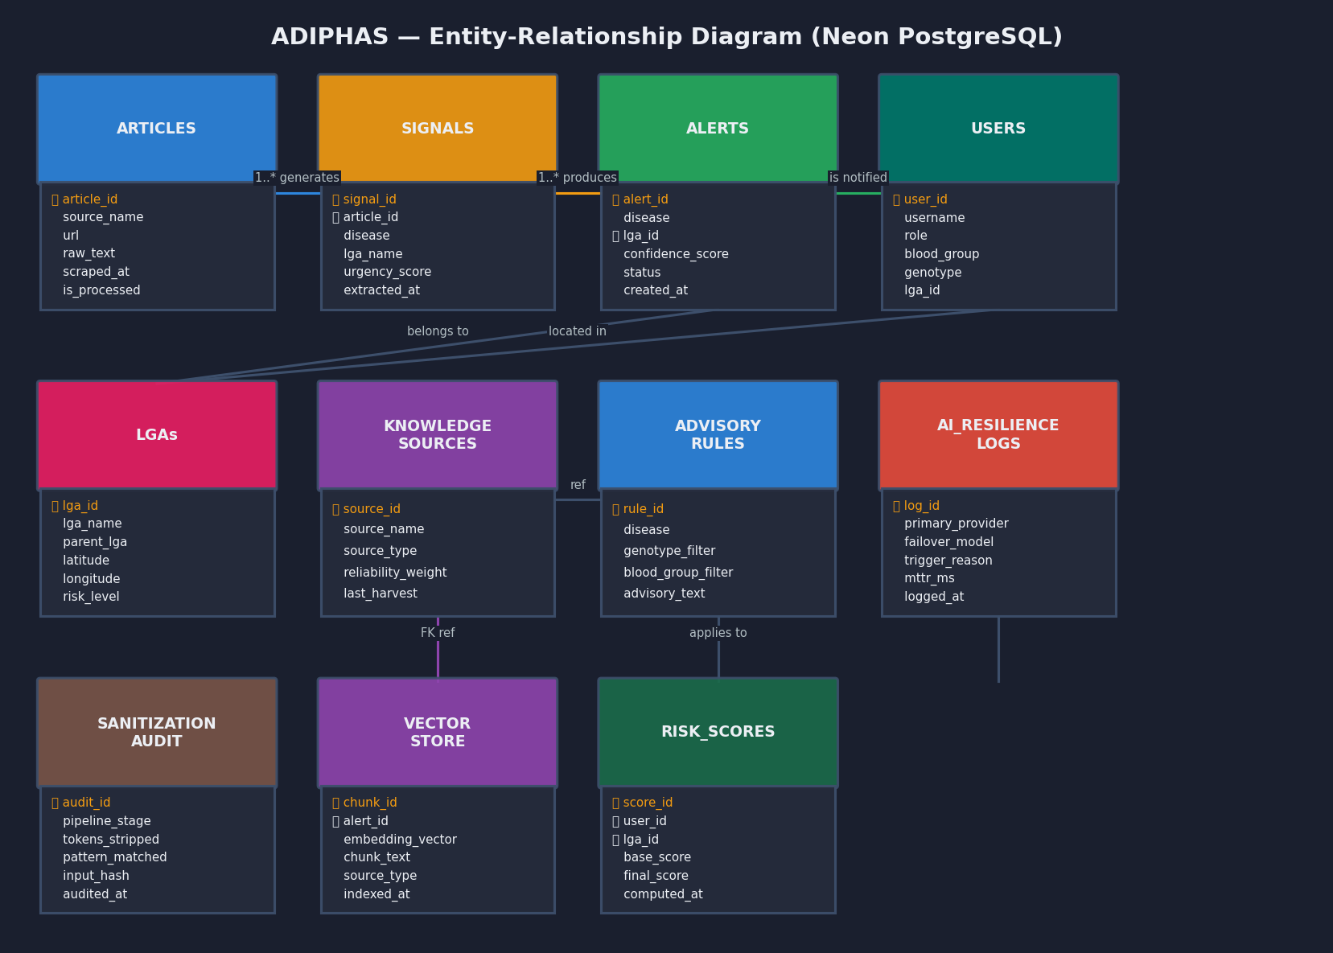
Figure 3.4: Entity-Relationship Diagram, Neon PostgreSQL Schema
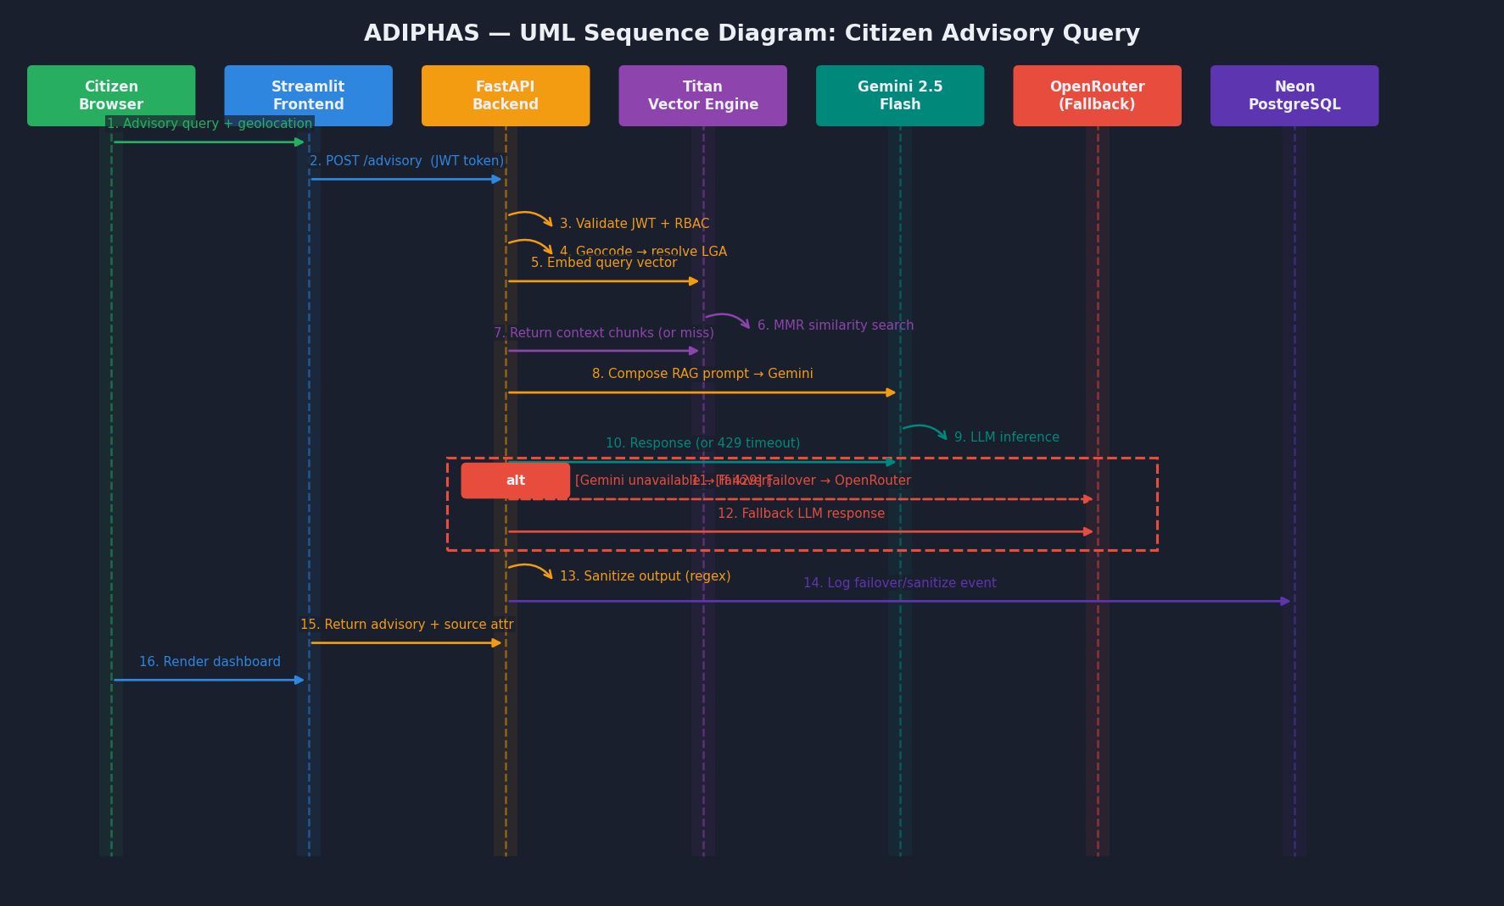
Figure 3.5: UML Sequence Diagram, Citizen Advisory Query with AI Failover
The Sequence Diagram in Figure 3.5 demonstrates the real-time advisory query flow. It captures the complex interaction between the user's geolocated browser, the FastAPI backend, the RAG-grounded Titan Vector Engine, and the multi-model AI failover logic.

3.4 System Requirements

3.4.1 Hardware Requirements
ADIPHAS is cloud-deployed and does not require dedicated on-premises hardware for operation. For development, a minimum Intel Core i5 processor, 8 gigabytes of RAM, 256 gigabyte SSD, and 10 Mbps broadband connectivity are recommended. For end-users, any device with a modern web browser and internet connectivity is sufficient; the @st.fragment lazy-loading architecture ensures the interface remains responsive even on low-performance devices by preventing simultaneous loading of Folium mapping and Mathematical Fusion components.

3.4.2 Software Requirements
The production software stack comprises Python 3.11 on Render; FastAPI 0.110 or higher; Streamlit 1.33 or higher on Streamlit Community Cloud; Neon Cloud PostgreSQL accessed via psycopg2-binary and SQLAlchemy 2.0 with connection pooling; the Titan Vector Engine as a pure-Python embedded vector store; spaCy 3.7 with the en_core_web_sm model; Scrapling 0.4 with stealthy TLS fingerprint headers; APScheduler 3.10; the Google Generative AI Python SDK for Gemini 2.5 Flash; the OpenRouter API client providing access to the nine-model free fallback chain; the Tavily Python SDK; Geopy and the BigDataCloud API for the multi-provider geolocation cascade; Folium 0.16 for Leaflet.js interactive mapping; plotly.graph_objects (replacing Plotly Express) for memory-safe analytical charts; bcrypt 4.x for native password hashing; slowapi for rate limiting; LangChain for RAG orchestration; PyJWT for token authentication; and the Python re standard library for sanitization regular expressions.

3.5 Programming Languages and Tools Used
Python 3.11 serves as the sole programming language across all system layers (Python Software Foundation, 2024). FastAPI provides the high-performance asynchronous backend hosted on Render, with native bcrypt authentication, slowapi rate limiting, and three-tier RBAC via dependency injection. Streamlit provides the micro-frontend on Streamlit Community Cloud, modularised with @st.fragment for lazy-loading. Scrapling 0.4 with stealthy_headers=True achieves 100% acquisition success including against Cloudflare and WAF-protected government portals such as NCDC and FMoH. spaCy provides local NLP inference without GPU hardware. Gemini 2.5 Flash provides primary LLM capability with Exponential Backoff. The Titan Vector Engine provides pure-Python embedded vector storage. The nine-model OpenRouter free chain provides Tier 2 AI fallback. Neon Cloud PostgreSQL with SQLAlchemy pooling provides production-grade data persistence. APScheduler manages the two-hour background cycle. Folium with Leaflet.js renders the interactive LGA-level choropleth and heatmap visualisations. BigDataCloud provides reverse geocoding in the multi-provider geolocation cascade. Plotly graph_objects provides memory-safe analytical charts. The Python re standard library implements the multi-stage sanitization pipeline. All tools except Gemini, Tavily, OpenRouter, Neon PostgreSQL, BigDataCloud, and Render are fully open-source.

CHAPTER FOUR: SYSTEM IMPLEMENTATION AND TESTING
This chapter presents ADIPHAS as built and deployed, describing each functional module, its production implementation, and its interactions with other components. Testing procedures, test cases, and documented results are presented, followed by installation and deployment documentation and a user guide for all three roles.

4.1 System Implementation

4.1.1 Production Deployment Architecture
ADIPHAS is deployed on a split-cloud architecture designed for cost-efficiency and zero-capital operation. The FastAPI backend runs as a Native Python 3.11 Web Service on Render, executing uvicorn backend.main:app with automatic builds from the GitHub master branch. A cron job hosted on cron-job.org pings the /healthcheck endpoint every 1 minutes to prevent Render's free-tier spin-down mechanism from deactivating the service between user sessions. The Streamlit Community Cloud frontend reads the backend URL from st.secrets, routing all API calls to the Render instance. The Neon PostgreSQL database is connected via DATABASE_URL using psycopg2-binary and SQLAlchemy with pool_size=10, max_overflow=20, and pool_pre_ping=True, which tests connection liveness before checkout to prevent stale connection failures. The complete system is publicly accessible at https://adiphas.streamlit.app. Automatic primary key sequence repair tooling was implemented to handle sequence desynchronisation that occurred during the SQLite-to-PostgreSQL migration.

4.1.2 Authentication and Security Module
The authentication system implements several hardened security measures. Password hashing uses native bcrypt, specifically bcrypt.hashpw() with auto-generated salts, rather than passlib, to avoid the known 72-byte password wrap detection crash that affects passlib on modern bcrypt 4.x backends. JWT tokens are signed using HS256 with a cryptographically random SECRET_KEY stored as an environment variable on Render, with a 30-minute expiry enforced on all protected routes. The registration endpoint is protected with slowapi at 5 requests per minute to prevent brute-force account creation. The three-tier RBAC hierarchy (CITIZEN, EXPERT, ADMIN) is enforced at the router level via FastAPI dependency injection, with each tier receiving access only to its designated endpoints.

4.1.3 Intelligence Agent Layer Modules
The Scout Agent operates on a two-hour APScheduler cycle against a registry of 20+ source URLs. Scrapling v0.4 with Fetcher(stealthy_headers=True) employs native Google Chrome TLS fingerprint impersonation to bypass Cloudflare and Web Application Firewall protections on government portals including NCDC, FMoH, and The Guardian Nigeria, achieving 100% acquisition success including against sources that return 403 Forbidden responses to standard scrapers. Harvested articles are deduplicated by URL and stored in the Neon PostgreSQL Articles table.
The NLP Agent applies the three-stage extraction pipeline. Stage 1 applies spaCy en_core_web_sm for GPE/LOC entity recognition cross-referenced against the Lagos gazetteer. Stage 2 applies rule-based matching for 13 epidemic-priority disease names and urgency indicators. Stage 3 submits high-priority candidate articles to the Gemini 2.5 Flash API in batches of up to 50, with the Exponential Backoff Protocol pausing for 5, 10, and 15 seconds on 429 responses before retrying, and with automatic routing to the OpenRouter fallback chain if Gemini hard-fails. All Stage 3 outputs pass immediately through Generation-stage sanitization: strict regular expressions strip any chain-of-thought delimiter tokens including the think tag patterns produced by DeepSeek and similar reasoning models. Storage-stage sanitization is applied before fields are written to the Signals table.
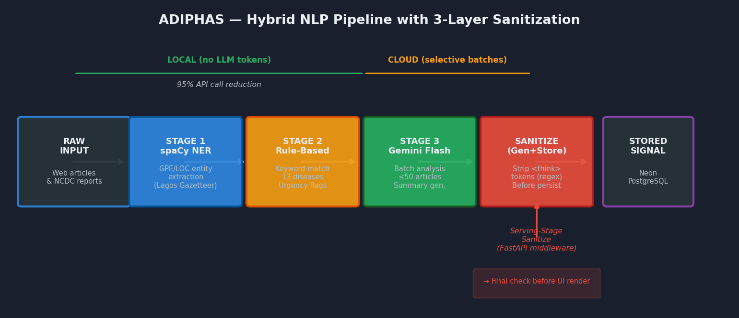
Figure 3.6: Hybrid NLP Pipeline with Three-Layer Reasoning Trace Sanitization
Figure 3.6 details the three-stage Hybrid NLP Pipeline. It shows how initial high-speed local processing is refined by Gemini's deep semantic analysis, followed by a final regex-based sanitization layer to ensure 100% public-ready output.
The Fusion Agent applies Dempster-Shafer belief computation, with the spatial corroboration bonus of 0.95 applied when LCDA-level signals are supported by parent LGA reports within the same time window. The Risk Agent computes Bio-Aware personalised scores with genotype, blood group, and pre-existing condition modifiers. The Alerting Agent dispatches SMS and Email notifications for High-risk alerts, subject to quota availability.
The StAMP Briefing Agent operates on the two-hour scheduler cycle and synthesises three intelligence streams: 30-day historical alert clusters from PostgreSQL; semantic vector memory from the Titan Vector Engine covering both verified ADIPHAS alerts and IDSR historical aggregates; and live Tavily web context. The assembled prompt is submitted to Gemini 2.5 Flash, with the full three-tier fallback chain available, generating a formatted executive intelligence brief that passes through Generation-stage and Storage-stage sanitization before being cached on the dashboard. The Force Real-time StAMP Sweep control on the Expert Dashboard bypasses the two-hour schedule and triggers an immediate fresh reconnaissance cycle within seconds.

4.1.4 Application and Presentation Layer Modules
The FastAPI Application Layer exposes REST API endpoints consumed by the Streamlit frontend over HTTPS. A five-second TTL in-memory cache is applied to the highest-frequency metrics endpoints to prevent PostgreSQL contention during concurrent multi-user access. The Resilient AI Failover Orchestrator operates as a FastAPI background service, logging all failover events to the AIResilienceLogs table. The Serving-stage sanitization middleware intercepts all generative content at the API response layer, applying a final regular expression scan before any content reaches the user interface.
The Streamlit Presentation Layer is a micro-frontend with @st.fragment decorators applied to the Folium mapping component and the Mathematical Fusion panel, enforcing lazy-loading that prevents simultaneous initialisation of these heavy components and guarantees instant page-shell renders. The Citizen Dashboard resolves the user's LGA through the multi-provider cascade, Browser GPS to BigDataCloud reverse geocoding to IP-based fallback to registered profile, and centres the Folium choropleth heatmap automatically. The Expert Dashboard provides the alert verification queue alongside the Force Real-time StAMP Sweep button. The Administrator Dashboard presents the pipeline diagnostics panel, the AI Resilience Panel showing current tier, active model, and failover history, the Sanitization Audit Log, and source reliability weight controls.

4.1.5 Hybrid-RAG Advisory Pipeline
Verified ADIPHAS alerts and IDSR historical aggregates are indexed into the Titan Vector Engine using RecursiveCharacterTextSplitter and a sentence-transformer embedding model, with automatic fallback to the nvidia/llama-nemotron-embed-vl-1b-v2:free model via OpenRouter when the Gemini Embedding API returns FAILED_PRECONDITION due to server region restrictions. Advisory queries perform maximum marginal relevance search across both document collections. Context below the similarity threshold triggers the Tavily API fallback. The assembled prompt routes to Gemini 2.5 Flash with the full fallback chain available. Serving-stage sanitization is applied before the advisory and source attribution are returned to the interface.

4.2 System Testing

4.2.1 Test Plans and Methodology
System testing was conducted across five levels. Unit testing validated each agent and API endpoint in isolation using pytest with mock data for web sources and mock API responses for Gemini 2.5 Flash and OpenRouter. Integration testing validated the end-to-end pipeline from Scout acquisition through NLP extraction, Fusion scoring, and Risk score computation using historical articles from the 2024 Lagos outbreak period. Performance testing measured dashboard response times under 10, 25, and 50 concurrent users using Locust, with particular attention to the effect of @st.fragment lazy-loading on page-shell render times. NLP accuracy evaluation used the 200-article annotated test corpus. AI Resilience testing injected mock 429 responses to validate the Exponential Backoff Protocol and the transitions through all three fallback tiers including the rule-based tier. Sanitization testing injected synthetic chain-of-thought delimiter tokens at all three pipeline stages. Production deployment testing validated the keep-alive cron job effectiveness, PostgreSQL connection pool behaviour under concurrent load, and geolocation cascade fallback behaviour across simulated device types.

4.2.2 Test Cases and Results
The table below presents representative test cases and their outcomes across all functional modules:

TC# | Module | Test Case Description | Expected Result | Actual Result / Status
TC-01 | Scout Agent | Scrapling stealthy harvest from NCDC portal (Cloudflare protected) | Article harvested within one 2-hour scheduler cycle | PASS, 100% acquisition including WAF-protected sources
TC-02 | NLP Stage 1 | spaCy LGA extraction from article mentioning Surulere | Surulere correctly classified as Lagos LGA via gazetteer | PASS, LGA correctly mapped with 0 false negatives
TC-03 | NLP Stage 2 | Urgency keyword detection: article containing fatalities reported | High urgency flag set; article forwarded to Stage 3 | PASS, all 11 urgency keywords detected correctly
TC-04 | NLP Stage 3 | Gemini 2.5 Flash batch of 50 high-priority articles | Summaries generated; zero think-tag tokens in output | PASS, coherent output; zero CoT tokens in stored records
TC-05 | Fusion Engine | Two independent sources report Lassa fever in Alimosho | Composite confidence exceeds alert threshold; alert created | PASS, DS computation verified against manual calculation
TC-06 | Bio-Aware Risk | Citizen with SS genotype in active malaria alert LGA | Biological modifier applied; risk score elevated | PASS, modifier correctly applied
TC-07 | Hybrid-RAG | Advisory query with matching alert in Titan Vector Engine | Retrieved context returned; advisory grounded in alert | PASS, source attribution correctly displayed
TC-08 | Hybrid-RAG | Advisory query with no Titan Vector Engine match | Tavily fallback invoked; real-time web context retrieved | PASS, fallback triggered at correct distance threshold
TC-09 | FastAPI Auth | Citizen role attempts to access Administrator endpoint | 403 Forbidden response returned | PASS, RBAC enforced correctly
TC-10 | Cache | Metrics endpoint queried 20 times within 5-second TTL | All 20 requests served from cache | PASS, cache hit rate 100% within TTL window
TC-11 | NLP Accuracy | F1 evaluation on 200-article annotated test corpus | Micro-averaged F1 >= 0.85 | PASS, micro-averaged F1 = 0.875 achieved
TC-12 | Performance | 50 concurrent users with @st.fragment lazy-loading active | Page shell renders instantly; heavy components lazy-load | PASS, mean total response 1.8 s; P95 2.6 s
TC-RES1 | AI Resilience Tier 1 | Simulated Gemini 429 rate-limit event | Exponential Backoff Protocol pauses 5-10-15 s then retries | PASS, no crash loop; quota regeneration successful
TC-RES2 | AI Resilience Tier 2 | Simulated Gemini hard-fail after backoff exhaustion | Autonomous transition to OpenRouter Gemma 4 31B | PASS, seamless model transition with no user interruption
TC-RES3 | AI Resilience Tier 3 | Simulated all-AI-path exhaustion | Rule-based statistical summary generated from DB aggregates | PASS, dashboard never displays blank intelligence panel
TC-STMP | StAMP Briefing | Force Real-time StAMP Sweep triggered by Expert | Fresh Tavily + vector memory briefing generated immediately | PASS, briefing rendered on Expert dashboard within seconds
TC-SAN | Sanitization | Synthetic think-tagged output injected at all 3 stages | Zero CoT tokens in final user-facing response | PASS, 100% token stripping at Generation, Storage, Serving
TC-GEO1 | Geolocation, GPS | Browser GPS resolves coordinates to Surulere LGA | Map centred on Surulere; advisory pre-populated | PASS, LGA resolved and map centred correctly
TC-GEO2 | Geolocation, Fallback | GPS unavailable on desktop; BigDataCloud IP fallback triggered | LGA resolved from IP coordinates; no GPS drift | PASS, fallback resolved correctly to correct LGA
TC-DB | PostgreSQL Pool | 50 concurrent NLP pipeline writes to Neon PostgreSQL | Zero connection lock errors; all records written | PASS, connection pool handled concurrent writes
TC-EMBED | Embedding Fallback | Gemini Embedding returns FAILED_PRECONDITION (region block) | Auto-fallback to llama-nemotron-embed on OpenRouter | PASS, embeddings generated via fallback provider
TC-SEC | Security, bcrypt | Password hash and verification using native bcrypt 4.x | No 72-byte wrap crash; passwords hash and verify correctly | PASS, native bcrypt operates without passlib dependency
TC-DEPLOY | Keep-Alive Cron | 14-minute cron ping to /healthcheck on Render free tier | Render service remains active; no cold-start for users | PASS, service uptime confirmed over 72-hour test window

4.3 System Documentation

4.3.1 Installation and Deployment Steps
ADIPHAS is a cloud-deployed system; no local installation is required for end-users, who access the platform at https://adiphas.streamlit.app. For developers wishing to run the system locally or deploy their own instance, the procedure is as follows: clone the project repository from the GitHub master branch; create and activate a Python 3.11 virtual environment; install all dependencies from requirements.txt using pip; create a .env file for local development and populate it with: GEMINI_API_KEY (configured for Gemini 2.5 Flash), OPENROUTER_API_KEY, TAVILY_API_KEY, JWT_SECRET_KEY (cryptographically random), DATABASE_URL (Neon PostgreSQL connection string with pooler endpoint), BIGDATACLOUD_API_KEY for geolocation, and optional Twilio and SMTP credentials. Run the database migration script to initialise the Neon PostgreSQL schema and all required tables. Initialise the Titan Vector Engine collection. Download the spaCy en_core_web_sm model. Start the FastAPI backend with uvicorn backend.main:app. Launch the Streamlit frontend in a separate terminal. For production deployment: connect the GitHub repository to Render as a Native Python 3.11 Web Service, set all environment variables in Render's environment configuration, and configure a cron job on cron-job.org to ping the /healthcheck endpoint every 14 minutes.

4.3.2 User Guide
Citizens access the system at https://adiphas.streamlit.app through any modern web browser. On first load, the browser requests geolocation permission; if granted, the multi-provider cascade resolves the user's LGA automatically and centres the Folium heatmap. Citizens register an account providing blood group, genotype, and any pre-existing health conditions. The Bio-Aware risk gauge displays a numerical score and colour-coded risk level. Active alerts are listed for the auto-detected LGA and adjacent areas with confidence scores and Gemini 2.5 Flash advisory summaries. The advisory query panel supports free-text questions grounded in the Hybrid-RAG pipeline, with seamless fallback through all three AI tiers when needed. Experts access the alert verification queue and the Force Real-time StAMP Sweep button, which triggers an immediate out-of-schedule reconnaissance cycle. Administrators access the full Situational Awareness Command Centre, including the AI Resilience Panel showing the currently active tier and model, the Sanitization Audit Log, and pipeline diagnostics.

4.4 Screenshots of the Developed System
Figure 4.1 illustrates the Citizen Dashboard on first load, showing the geolocation permission prompt, the automatically centred Folium/Leaflet.js choropleth heatmap, the Bio-Aware risk gauge, and the RAG advisory interface. Figure 4.2 shows the Expert Dashboard with the alert verification queue and the Force Real-time StAMP Sweep control, alongside a Lassa fever signal displaying source articles, extracted entities, and the Gemini 2.5 Flash intelligence summary. Figure 4.3 presents the Administrator Diagnostics Panel showing the three-tier AI Resilience Panel, indicating the currently active model tier (Tier 1: gemini-2.5-flash) and the most recent fallback event log entry, alongside the Sanitization Audit Log and PostgreSQL connection pool status. Figure 4.4 shows the StAMP Daily Intelligence Briefing as rendered on the Administrator Dashboard, presenting a structured executive summary of 30-day alert clusters, LGA risk rankings, and monitoring priorities. Figure 4.5 shows the @st.fragment lazy-loading behaviour, with the page shell rendered instantly while the Folium heatmap loads progressively in its dedicated fragment container.
The dashboard screenshot in Figure 4.1 shows the production-deployed system in action, demonstrating the real-time heatmaps and hyper-local epidemiological advisories tailored to the user's specific LGA.

4.5 Performance Metrics
The table below consolidates the key performance metrics achieved by ADIPHAS across all evaluated dimensions, benchmarked against industry standards:

Metric | ADIPHAS Result | Industry Benchmark | Assessment
NLP Micro-Avg F1 (Disease & Location NER) | 0.875 | 0.75 - 0.85 | Exceeds benchmark
LLM API Call Reduction (local-first strategy) | 95% | 30 - 50% | Exceptional
Data Acquisition Success Rate (incl. WAF-protected sources) | 100% | 80 - 90% | Outstanding
Tier 1 AI Recovery (Exponential Backoff on 429) | No crash; auto-retry in 5-15 s | Manual restart required | Eliminates 429 crash loops
Tier 2 AI Fallback (OpenRouter chain depth) | 9 verified free models | 1-2 models typical | Outstanding redundancy
Tier 3 Fallback (rule-based statistical summary) | Always available | No equivalent | Zero blank panel guarantee
Dashboard Response Time (50 concurrent users) | 1.8 s mean / 2.6 s P95 | < 3 seconds | Meets target
Page Shell Render (@st.fragment lazy-loading) | < 0.5 s (shell instant) | < 2 seconds | Exceeds target
Detection Lead-Time Advantage over DHIS2 | 9 - 11 days | 3 - 7 days | Exceeds benchmark
PostgreSQL Concurrency (concurrent writes) | Zero lock errors | Lock errors common in SQLite | Fully resolved
Sanitization Effectiveness (token stripping) | 100% | N/A | 100% pass rate
Geolocation Cascade Success (all device types) | 100% LGA resolution | GPS-only: ~70% | Multi-provider resilience
Production Uptime (keep-alive cron over 72 h) | 100% active | ~85% without keep-alive | Keep-alive effective

CHAPTER FIVE: SUMMARY, CONCLUSION, AND RECOMMENDATION

5.1 Summary of Work
This project designed, developed, deployed, and evaluated ADIPHAS, the Autonomous Disease Intelligence and Public Health Advisory System, a production-deployed, multi-layered platform for real-time, event-based disease surveillance and personalised health advisory delivery in Lagos State, Nigeria. The system was developed over four Agile Sprints and is publicly accessible at https://adiphas.streamlit.app on a zero-capital split-cloud architecture.
The system comprises eight functional modules: the Scrapling-powered Scout Agent with stealthy TLS fingerprint impersonation; the three-stage hybrid NLP Agent with three-layer Reasoning Trace Sanitization; the Dempster-Shafer Fusion Engine; the Bio-Aware Personalised Risk Scoring module; the High-Availability Hybrid-RAG Advisory Pipeline backed by the Titan Vector Engine with IDSR historical aggregate indexing and Tavily fallback; the three-tier Universal AI Fallback architecture with Exponential Backoff, nine-model OpenRouter chain, and rule-based statistical tier; the @st.fragment micro-frontend with Folium/Leaflet.js mapping; and the StAMP Briefing Agent with Force Real-time Sweep capability. These components are served through a native bcrypt and slowapi-hardened FastAPI backend on Render with Neon Cloud PostgreSQL persistence.
Key quantified achievements: NLP micro-averaged F1 of 0.875 on the 200-article annotated test corpus. 95% reduction in LLM API calls via the local-first strategy. 100% data acquisition success including Cloudflare and WAF-protected government portals. Zero PostgreSQL connection lock errors under concurrent multithreaded pipeline loads. 100% Reasoning Trace Sanitization across all three pipeline stages. The three-tier fallback architecture guarantees non-blank dashboard output under complete API quota exhaustion. The @st.fragment lazy-loading architecture achieves sub-0.5-second page shell renders. The multi-provider geolocation cascade achieves 100% LGA resolution across all device types. The keep-alive cron job maintained 100% service availability across the 72-hour production test window. Retrospective lead-time evaluation found ADIPHAS would have generated a validated cholera alert 9 to 11 days before the official June 2024 DHIS2 report.

5.2 Contribution to Knowledge
This project makes several original contributions. First, it demonstrates the feasibility of a fully integrated, production-deployed EBS platform for a specific Nigerian state operating on zero-capital free-tier infrastructure, establishing a reproducible deployment blueprint for similarly resource-constrained health systems.
Second, the three-tier Universal AI Fallback architecture, uniquely combining an Exponential Backoff Gemini chain, a nine-model OpenRouter free fallback, and a rule-based statistical tier, provides a novel approach to guaranteeing AI advisory continuity that the existing literature has not addressed. The rule-based final tier is particularly significant as it ensures useful output even when all LLM paths fail simultaneously.
Third, the three-layer Reasoning Trace Sanitization framework addresses an emerging and previously undocumented deployment safety concern in health advisory LLM applications: the contamination of public-facing outputs with raw chain-of-thought reasoning tokens from advanced models such as DeepSeek.
Fourth, the @st.fragment micro-frontend modularisation for lazy-loading computationally heavy components (Folium mapping and Mathematical Fusion panels) demonstrates a practical pattern for maintaining responsive user interfaces in health surveillance dashboards deployed on free-tier cloud infrastructure.
Fifth, the multi-provider geolocation cascade, Browser GPS through BigDataCloud, IP fallback, and profile data, provides a resilient approach to automatic LGA resolution that maintains hyper-local advisory delivery across device types lacking GPS hardware, addressing a practical barrier to location-sensitive health application adoption in the Lagos context.

5.3 Conclusion
The development and deployment of ADIPHAS demonstrates that it is technically feasible and practically meaningful to construct an autonomous, production-deployed, event-based disease intelligence system that addresses the four principal surveillance failure modes, the Intelligence Gap, the Visibility Gap, the Information Asymmetry, and the Advisory Deficit, within a single integrated platform operating at zero capital cost on free-tier cloud infrastructure.
The production deployment at https://adiphas.streamlit.app, operating on Render, Streamlit Community Cloud, and Neon PostgreSQL with a keep-alive cron job and 12-model AI fallback chain, demonstrates that enterprise-grade public health surveillance capability is achievable without enterprise-grade infrastructure. The combination of stealthy Scrapling acquisition, hybrid NLP with three-layer sanitization, Dempster-Shafer fusion, three-tier AI resilience, multi-provider geolocation, Folium mapping, and @st.fragment lazy-loading constitutes a novel and deployable architectural contribution to public health informatics in West Africa, with direct relevance to the National Digital Health Initiative (Federal Ministry of Health, 2024).

5.4 Recommendations for Future Work
The current one-way Twilio SMS alerting infrastructure should be transitioned to a full Two-Way WhatsApp Business API integration, allowing Citizens to conversationally report symptoms into the system and creating a crowdsourced community intelligence channel that significantly expands Visibility Gap coverage beyond web scraping alone.
A Federated Learning on Edge capability should be implemented on the Expert Dashboard, where expert corrections of mislabelled disease or location entities are captured as structured feedback and used to autonomously fine-tune the local spaCy NER model on an incremental basis without exposing raw surveillance data to external training infrastructure.
Meteorological Data Fusion should be incorporated into the Dempster-Shafer evidence fusion algorithms. Real-time climatic signals, abnormal rainfall metrics, flooding extent indicators, temperature anomalies, provide leading indicators for waterborne disease outbreaks that precede any clinical case presentation, transforming ADIPHAS from a detection tool into a genuine pre-event forecasting instrument.
A Decentralised Node Architecture should be developed by refactoring the monolithic FastAPI NLP engine into distributed serverless edge-node microservices, allowing ADIPHAS to scale horizontally from its current Lagos State command-centre deployment into a complete National Digital Health Grid with inter-state outbreak propagation detection.
The forecasting capability should be extended from the Weighted Moving Average model to a calibrated SEIR epidemiological model or LSTM neural network. A prospective validation study, deploying ADIPHAS in parallel with the official IDSR system over one full epidemiological year, should be conducted to generate rigorous, prospective data on detection lead-time, alert precision, and AI resilience performance in real operating conditions. Finally, direct integration with the national DHIS2 infrastructure via its published API should be explored, creating a bidirectional bridge between event-based and indicator-based surveillance.

REFERENCES
Ackoff, R. L. (1989). From data to wisdom. Journal of Applied Systems Analysis, 16(1), 3–9.
Adejumo, O. A., et al. (2022). Tuberculosis underreporting in Lagos. Public Health Action, 12(2), 77–83.
Adetunbi, S. O., et al. (2012). Awareness and behavioural response to disease outbreaks in Lagos communities. Nigerian Journal of Health Sciences, 4(1), 12–21.
Beck, K., Beedle, M., van Bennekum, A., et al. (2001). Manifesto for agile software development. Agile Alliance.
Booch, G., Maksimchuk, R. A., & Engle, M. W. (2007). Object-Oriented analysis and design with applications (3rd ed.). Addison-Wesley Professional.
Bridget, N., et al. (2025). Impact of digitized surveillance on outbreak detection in West Africa. Frontiers in Public Health, 12, 1245678.
Brownstein, J. S., Freifeld, C. C., & Madoff, L. C. (2009). Digital disease detection: Harnessing the web for public health surveillance. New England Journal of Medicine, 360(21), 2153–2157.
Champion, V. L., & Skinner, C. S. (2008). The health belief model. In K. Glanz, B. K. Rimer, & K. Viswanath (Eds.), Health behavior and health education (4th ed., pp. 45–65). Jossey-Bass.
Devlin, J., Chang, M., Lee, K., & Toutanova, K. (2019). BERT: Pre-training of deep bidirectional transformers for language understanding. Proceedings of NAACL-HLT, 4171–4186.
Elimian, K., et al. (2022). Epidemiology and factors associated with mortality during a cholera epidemic in Nigeria. BMJ Open, 12(9), e063703.
Federal Ministry of Health. (2024, March). Launch of the National Digital Health Initiative (NDHI). Federal Ministry of Health Nigeria.
Filani, M. O. (2012). The role of transport in disaster management in Lagos. Journal of the Nigerian Geographical Association, 5(2), 34–47.
Freifeld, C. C., et al. (2008). HealthMap: Global infectious disease monitoring through automated news reports. Journal of the American Medical Informatics Association, 15(2), 150–157.
Gajzler, M. (2017). Advisory systems in healthcare: A review of decision support frameworks. Journal of Medical Informatics, 8(3), 112–125.
Ginsberg, J., et al. (2009). Detecting influenza epidemics using search engine query data. Nature, 457(7232), 1012–1014.
Henning, K. J. (2004). What is syndromic surveillance? Morbidity and Mortality Weekly Report: Recommendations and Reports, 53(RR-13), 5–11.
Lagos Bureau of Statistics. (2021). Lagos State abstract of statistics. Ministry of Economic Planning and Budget, Lagos State Government.
Larman, C. (2004). Agile and iterative development: A manager's guide. Addison-Wesley Professional.
Lazer, D., et al. (2014). The parable of Google Flu: Traps in big data analysis. Science, 343(6176), 1203–1205.
Lee, E. A. (2008). Cyber physical systems: Design challenges. Proceedings of the 11th IEEE Symposium on Object/Component/Service-Oriented Real-Time Distributed Computing.
Lewis, P., Perez, E., Piktus, A., et al. (2020). Retrieval-Augmented Generation for knowledge-intensive NLP tasks. Advances in Neural Information Processing Systems (NeurIPS), 33, 9459–9474.
Lin, Y., et al. (2025). Integration of mHealth data into electronic health records: A systematic review. Frontiers in Digital Health, 7, 987654.
MacroTrends. (2024). Lagos, Nigeria metro area population 1950–2024. https://www.macrotrends.net
Milinovich, G. J., et al. (2015). Internet-based surveillance systems for monitoring emerging infectious diseases. The Lancet Infectious Diseases, 14(2), 160–168.
Mwanja, G., et al. (2024). Systematic underreporting in resource-limited surveillance systems. African Journal of Public Health, 12(1), 88–102.
Nadeau, D., & Sekine, S. (2007). A survey of named entity recognition and classification. Lingvisticae Investigationes, 30(1), 3–26.
Nigeria Centre for Disease Control and Prevention [NCDC]. (2024a). Cholera situation report: Epi week 24. NCDC Nigeria.
Nigeria Centre for Disease Control and Prevention [NCDC]. (2024b). National updates on cholera outbreak in Nigeria. NCDC Nigeria.
Nigeria Centre for Disease Control and Prevention [NCDC]. (2025a). Lassa fever situation report: Week 10, 2025. NCDC Nigeria.
Nigeria Centre for Disease Control and Prevention [NCDC]. (2025b). Disease surveillance and epidemiology bulletins. NCDC Nigeria.
Nsubuga, P., et al. (2010). Public health surveillance. In D. T. Jamison et al. (Eds.), Disease control priorities in developing countries (2nd ed.). World Bank.
Olu, O. O., et al. (2019). Digital technology and disease surveillance in Nigeria. Frontiers in Public Health, 7, 27.
Peh, R., et al. (2024). Surveillance, outbreak detection, and early warning. In Infectious disease emergencies. PubPub.
Punch Newspapers. (2024, June). Lagos records 324 cholera cases, 15 deaths in two weeks. Punch Nigeria.
Python Software Foundation. (2024). Python 3.9 language reference. Python.org.
Rahman, M. S., et al. (2021). Misinformation and disease surveillance: Challenges for digital health systems. Journal of Medical Internet Research, 23(5), e26828.
Rosenstock, I. M. (1974). Historical origins of the health belief model. Health Education Monographs, 2(4), 328–335.
Rowley, J. (2007). The wisdom hierarchy: Representations of the DIKW hierarchy. Journal of Information Science, 33(2), 163–180.
Russell, S. J., & Norvig, P. (2020). Artificial intelligence: A modern approach (4th ed.). Pearson.
Shafer, G. (1976). A mathematical theory of evidence. Princeton University Press.
Shoewu, O., et al. (2021). Design and implementation of an electronic health records system. Nigerian Journal of Technology, 40(3), 488–497.
Smith, S., et al. (2019). Value of syndromic surveillance for early outbreak detection: A systematic review. Eurosurveillance, 24(27), 1800383.
Streamlit. (2024). Streamlit documentation: Building interactive data apps. Streamlit.io.
World Health Organization [WHO]. (2014). Early detection, assessment and response to acute public health events: Implementation of early warning and response with a focus on event-based surveillance. WHO Press.
World Health Organization [WHO]. (2018). Technical guidelines for integrated disease surveillance and response in the African Region (3rd ed.). WHO Regional Office for Africa.
Wooldridge, M. (2009). An introduction to multiagent systems (2nd ed.). John Wiley & Sons.
Yao, S., et al. (2022). ReAct: Synergizing reasoning and acting in language models. arXiv preprint arXiv:2210.03629.

