ARTIFICIAL INTELLIGENCE ENHANCED JOB PLATFORM: A MACHINE LEARNING APPROACH TO JOB MATCHING AND RECOMMENDATIONS

BY

TANIMOWO, EMMANUEL OLUWADARASIMI 2101110048

A PROJECT SUBMITTED TO THE DEPARTMENT OF COMPUTER AND INFORMATION SCIENCES
FACULTY OF BASIC MEDICAL AND APPLIED SCIENCES, TRINITY UNIVERSITY, YABA,
LAGOS, NIGERIA

IN PARTIAL FULFILMENT OF THE REQUIREMENTS FOR THE AWARD OF THE BACHELOR OF SCIENCE (HONOURS) DEGREE IN COMPUTER SCIENCE

MAY, 2025

CERTIFICATION
This is to certify that this project titled ARTIFICIAL INTELLIGENCE ENHANCED JOB PLATFORM: A MACHINE LEARNING APPROACH TO JOB MATCHING AND
RECOMMENDATIONS is an original work carried out by TANIMOWO, EMMANUEL OLUWADARASIMI (2101110048) in the Department of Computer and Information Sciences, Faculty of Basic Medical and Applied Sciences, Trinity University, Yaba, Lagos State, Nigeria under the supervision of MR. OMOSEBI PAUL ADEOYE. This project has been examined and found acceptable as part of the requirement for the award of Bachelor of Science (B.Sc.) in Computer Science.

Tanimowo Emmanuel Oluwadarasimi DATE
(Student)

Mr. Omosebi Paul Adeoye DATE
(Supervisor)

Dr. Obabueki Omo-Okhirelen DATE
(Head of Department)

DEDICATION
This project is dedicated to God, whose guidance and blessings have been vital to its completion. I am deeply grateful for being my constant source of strength and support throughout this journey. Your grace has propelled me forward, and it is through your divine presence that I have reached this important milestone.

DECLARATION
I, TANIMOWO, EMMANUEL OLUWADARASIMI (2101110048) declare that this project was carried out by me under the supervision of MR. OMOSEBI PAUL ADEOYE Department of Computer and Information Sciences, Faculty of Basic Medical and Applied Sciences, Trinity University, Yaba, Lagos State, Nigeria. I attest that this project has not been presented either wholly or partially for the award of any degree elsewhere. All sources of data and scholarly information used in this project are duly acknowledged.

TANIMOWO, EMMANUEL OLUWADARASIMI .........................................
Signature & Date

ACKNOWLEDGEMENT
I offer my deepest gratitude to the Almighty for His constant grace, protection, provision, and favor throughout my journey at Trinity University. All praise, adoration, and glory are due to Him alone.
To my esteemed supervisor, Mr. P.A. Omosebi, your patience, guidance, and unwavering encouragement have been pivotal to my success. Your belief in me has been a source of inspiration, and I am truly grateful for the invaluable lessons and support you've provided.
I would also like to thank Ag. HOD, Dr. Obabueki Omo-Okhirelen, and all the lecturers who supported me throughout this project. Special thanks go to Mrs. Omirinlewo, Dr. Humphrey, Dr. Ayankoya, Dr Sotunwa for their positive influence on my undergraduate career. It has been a privilege to learn from your expertise.
My heartfelt appreciation goes to my family for their unwavering support, love, and belief in me. You have been the driving force behind my achievements, and I cannot thank you enough for your invaluable contributions throughout my undergraduate years.
Finally, I extend my gratitude to Trinity University for providing a nurturing academic environment and valuable opportunities for growth. To all my friends, I am deeply thankful for the journey we've shared. Your friendship and support have made my university experience both memorable and rewarding. Thank you for being an integral part of this chapter in my life.

TABLE OF CONTENTS

CERTIFICATION i
DEDICATION ii
DECLARATION iii
ACKNOWLEDGEMENT iv
TABLE OF CONTENTS v
LIST OF TABLES ix
LIST OF FIGURES x
ABSTRACT xi
CHAPTER ONE 1
INTRODUCTION 1
  - Background of the Study 1
  - Statement of the Problem 2
  - Aim and Objectives of the Study 2
  - Justification of the Study 2
  - Scope of the Study 3
  - Significance of the Study 4
  - Limitation of the Study 4
  - Definition of Terms 5
CHAPTER TWO 6
LITERATURE REVIEW 6
  - Introduction 6
  - Background of Artificial Intelligence in Job Recruitment 7
    - Evolution of Job Recruitment Platforms 7
    - Machine Learning in Recruitment 8
      - Supervised vs Unsupervised Learning. 9
      - Natural Language Processing in Resume Parsing 10
  - Artificial Intelligence Techniques for Job Matching and Recommendations 11
    - Collaborative Filtering 11
    - Content-Based Filtering 12
    - Hybrid Models 12
  - Job Matching Algorithms 13
    - Decision Trees and Random Forest 14
    - Deep Learning for Job Recommendations 14
    - Strengths and Weakness of Some Common Job Matching Algorithms 14
  - Review of Existing Systems 15
  - Review of Related Works 17
CHAPTER THREE 22
SYSTEM ANALYSIS AND DESIGN 22
  - Introduction 22
  - Requirement Analysis 22
    - Functional Requirements 22
    - Non-Functional Requirements 24
  - Software Development Life Cycle (SDLC) Model Selection 25
    - Comparing Models 25
    - Justification of the Chosen SDLC Model 26
    - The Agile Software Development Process 27
  - System Design 28
    - Block Diagram 29
    - Data Flow Diagram 30
    - Activity Diagram 30
    - Use Case Diagram 33
    - Sequence Diagram 34
    - Class Diagram 38
    - Architectural Diagram 39
CHAPTER FOUR 41
SYSTEM IMPLEMENTATION 41
  - Introduction 41
  - Implementation 41
    - Backend Development 41
    - Frontend Development 42
    - Real-Time Communication 42
    - Automation and Web scraping 42
    - Machine Learning Integration 42
  - System Requirements 42
    - Minimum Hardware Requirements 42
    - Minimum Software Requirements 43
  - Program Modules and Interfaces 45
    - User Management Module 45
    - Jobs Management Module 47
    - Resume Parsing & Job Matching Module 49
    - Job Application & Assessment Module 51
    - Interview Management Module 53
    - Chat Module and Personalized Chatbot 54
    - Multi-Factor Authentication Module 55
  - Performance Metrics 58
    - Recommendation Accuracy Metrics 58
    - Performance Distribution Analysis 59
    - System Performance Insights 59
    - Comparative Performance Benchmarks 60
CHAPTER FIVE 61
SUMMARY, RECOMMENDATION AND CONCLUSION 61
  - Summary of the Study 61
  - Contribution to Knowledge 61
  - Recommendations for Further Study 62
  - Conclusion 62
REFERENCES 63

LIST OF TABLES
Table 2.1: Comparative Insights of AI Techniques for Job Matching and Recommendations 13
Table 2.2: Strengths and Weakness of Some Common Job Matching Algorithms 15
Table 2.3: Summary of Existing Systems 16
Table 2.4: Summary of Reviewed Related Works 20

LIST OF FIGURES
Figure 3.3.3.1: Agile Software Development Process 28
Figure 3.4.1: Block Diagram 29
Figure 3.4.2: Data Flow Diagram 30
Figure 3.4.3: Activity Diagram 31
Figure 3.4.4: Use Case Diagram 34
Figure 3.4.5: Sequence Diagram 36
Figure 3.4.6: Class Diagram 39
Figure 3.4.7: Architectural Diagram 40

ABSTRACT
The rapid evolution of technology has transformed how job seekers and employers interact, with traditional job platforms often struggling to deliver personalized, efficient, and effective job matching services. This project explores the development and implementation of an Artificial Intelligence enhanced Job Platform that leverages large language model intelligence to optimize job matching and recommendations. The system aims to bridge the gap between job seekers and potential employers by analyzing user profiles, job descriptions, and relevant market trends to provide accurate, data-driven job recommendations.
Core functionalities include resume parsing using Natural Language Processing (NLP), keyword extraction, and matching algorithms that align candidates' skills and experiences with job opportunities. The system further integrates intelligent assessment and interview support, alongside a chatbot for seamless user interaction.
Performance evaluation based on over 400 candidate-job match records showed an average matching accuracy of 59.21%, with Precision@50% at 76.11% and F1 score of 114.08%, skill diversity coverage was 73.25% with 57.33% job coverage. These metrics validate the reliability and effectiveness of the AI-enhanced platform in delivering relevant, personalized, and scalable recruitment experiences for job seekers and employers.

Keywords: Artificial Intelligence, Job Platform, Machine Learning, Job Matching, Recommendations, Resume Parsing, Natural Language Processing.

Background of the Study
CHAPTER ONE INTRODUCTION

The job market has evolved significantly over the past decade, with technology playing a critical role in connecting job seekers and employers. Traditional job platforms often rely on keyword-based search engines and manual filtering, which can be inefficient and result in poor matching between candidates and job opportunities (Zhou et al., 2021). As companies demand more specific skills and qualifications, traditional methods struggle to provide personalized recommendations, leading to mismatches, prolonged recruitment processes, and frustration for both employers and job seekers (Tan et al., 2020).
With the rise of artificial intelligence (AI) and machine learning (ML), there has been a transformative shift toward AI-driven platforms that can analyze vast amounts of data, provide personalized job recommendations, and optimize the job matching process (Mihai & Dima, 2022). These AI-powered platforms use advanced algorithms to analyze job seekers' resumes, skillsets, experiences, and preferences, and then match them with job opportunities that align with their profiles. This approach not only improves the accuracy of the matching process but also helps job seekers identify career paths and opportunities that they may not have considered (Khan et al., 2021).
Artificial Intelligence enhanced job platforms go beyond simple keyword matching by leveraging machine learning models, such as natural language processing (NLP) and recommendation algorithms, to process large volumes of structured and unstructured data. NLP techniques are particularly useful in parsing and understanding resume content, job descriptions, and other textual data, enabling a deeper understanding of the qualifications and skills required for specific roles (Chen et al., 2023). This capability allows platforms to offer tailored job recommendations based on a user’s unique profile rather than relying solely on traditional keyword searches.
Moreover, AI-enabled platforms provide additional functionalities such as automated resume parsing, job market analysis, and skill gap identification. These systems continuously learn from user behavior, feedback, and hiring trends to further improve the precision of their recommendations (Rahman et al., 2023). With the integration of machine learning techniques, such as collaborative filtering and content-based filtering, AI-powered platforms can predict job suitability for candidates and employers, thus minimizing mismatches and accelerating the hiring process (Garg & Patel, 2020).
In addition, AI-driven platforms can incorporate intelligent chatbots that assist users by answering queries related to job searches, applications, and profile management (Ahmed & Al-Jabri, 2022). These chatbots leverage context-based learning to provide more personalized interactions, enhancing the user experience and ensuring that users receive timely and relevant guidance throughout the job search process.

By automating many of the labor-intensive aspects of recruitment and providing intelligent insights, Artificial Intelligence enhanced job platforms have the potential to reshape the future of job matching and recruitment, making the process more efficient, personalized, and effective for all parties involved.

Statement of the Problem
Traditional job platforms often fail to provide accurate and personalized job recommendations, relying on basic keyword searches and manual filtering processes. This results in job seekers receiving irrelevant job listings and employers struggling to find suitable candidates. Additionally, the growing complexity of the job market, with evolving skill requirements, exacerbates the mismatch between candidates and available positions. There is a pressing need for an intelligent platform that can leverage machine learning to offer personalized job matching and enhance the efficiency of the recruitment process for both job seekers and employers.
The problem to be addressed by this study is the need to develop and implement an Artificial Intelligence enhanced job platform that is more efficient, accurate, and data-rich, improving job matching, reducing mismatches, and enhancing the overall recruitment experience for both job seekers and employers.

Aim and Objectives of the Study
The main aim of this project is to design, develop, and implement an Artificial Intelligence enhanced job platform that utilizes machine learning techniques for effective job matching and personalized recommendations.
The objectives are:
    - To conduct a comprehensive review of existing job matching algorithms and recruitment platforms, identifying best practices and challenges in the field.
    - To design an intuitive user interface for job seekers and employers, ensuring a seamless experience in job searching and candidate selection.
    - To evaluate the performance and effectiveness of the job platform in providing relevant job recommendations and enhancing the recruitment process.

Justification of the Study
This study is justified by the increasing demand for efficient, accurate, and personalized job matching solutions in today's competitive job market. Traditional job platforms often fall short, providing generic recommendations that do not align with the unique skills and preferences of job seekers, resulting in wasted time and missed opportunities.
The proposed Artificial Intelligence enhanced job platform leverages machine learning

algorithms to deliver tailored job recommendations, addressing the limitations of conventional job search methods. This approach not only improves the user experience for job seekers but also enhances the efficiency of the recruitment process for employers by matching them with the most suitable candidates.
Moreover, the study aims to reduce the time and resources spent on manual filtering and searching for job opportunities, which can be inefficient and error-prone. Research indicates that organizations spend significant amounts on ineffective recruitment methods, with some studies suggesting that poor hiring decisions can cost businesses over $15,000 per bad hire (Costello, 2021). By implementing a smart job matching system, this project can help mitigate these costs and improve hiring outcomes.
Through the development of this Artificial Intelligence enhanced job platform, this study seeks to transform the job search and recruitment landscape, making it more effective, efficient, and aligned with the needs of both job seekers and employers.

Scope of the Study
The scope of this project will encompass the design, development, and implementation of an Artificial Intelligence enhanced job platform that utilizes machine learning techniques for job matching and recommendations. The platform will focus on the following aspects:
- User Experience: Creating an intuitive and user-friendly interface for both job seekers and employers to facilitate seamless interactions.
- Job Matching Algorithm: Developing and integrating advanced machine learning algorithms that analyze candidate profiles and job descriptions to deliver personalized job recommendations.
- Data Collection and Analytics: Implementing robust data collection mechanisms to gather insights on user preferences, job market trends, and skill requirements, enhancing the platform’s recommendations over time.
- Security and Privacy: Ensuring the protection of user data through secure authentication methods and compliance with data protection regulations.
- Integration: Allowing for integration with existing HR management systems and job boards to streamline recruitment processes for employers.
- Feedback Mechanism: Incorporating a feedback system for users to evaluate job matches and platform functionality, enabling continuous improvement.

Significance of the Study
The significance of this study lies in its potential to transform the job recruitment process through the development of an Artificial Intelligence enhanced job platform that utilizes machine learning techniques for job matching and recommendations. By addressing the shortcomings of traditional job platforms, this study aims to create a more efficient and personalized experience for both job seekers and employers.
The proposed platform offers several advantages, including improved accuracy in job matching based on individual skills and preferences, which can significantly reduce the time and effort required to find suitable candidates or job opportunities. Additionally, by leveraging data analytics and machine learning, the platform can adapt to changing job market trends and skill requirements, providing real-time insights that are invaluable for both parties.
This study contributes to the growing body of knowledge in the fields of artificial intelligence and employment technology, promoting the adoption of innovative solutions in recruitment processes. The findings could lead to enhanced job satisfaction for candidates and increased hiring efficiency for employers, ultimately fostering a more dynamic and responsive job market. Moreover, the integration of user feedback mechanisms within the platform can facilitate continuous improvement, ensuring that it remains relevant and effective in meeting the evolving needs of the workforce.

Limitation of the Study
While the development of the Artificial Intelligence enhanced job platform offers promising advancements in job matching and recommendations, several limitations must be acknowledged:
- Data Quality and Availability: The effectiveness of machine learning models heavily relies on the quality and quantity of data. Inaccurate or insufficient data on job seekers' skills and employers' requirements may hinder the platform's ability to provide relevant job matches.
- Algorithmic Bias: Machine learning models can inadvertently perpetuate biases present in training data, leading to unfair job recommendations or candidate evaluations. Ensuring fairness in the recommendations requires careful attention to data diversity and bias mitigation techniques.
- User Privacy Concerns: Collecting and processing personal data for job matching may raise privacy issues. Balancing data utilization with user privacy is crucial and may limit the scope of data collected.
- Technological Barriers: Users with limited access to technology or those who are not tech-savvy may struggle to effectively use the platform, potentially limiting its reach and impact.
- Dynamic Job Market: The fast-evolving nature of job markets and skill requirements poses a challenge for the platform to remain up-to-date with the latest trends and needs, requiring ongoing adjustments to algorithms and data inputs.

- Integration with Existing Systems: Implementing the platform alongside traditional recruitment processes may face resistance from organizations accustomed to existing methods, complicating adoption and integration efforts.

Definition of Terms
- Artificial Intelligence (AI): Computer systems that can think and make decisions like humans do, such as recognizing faces or understanding speech.
- Job Platform: A website or app where people can search for jobs and employers can post job openings (like Indeed or Glassdoor).
- Machine Learning: A subset of artificial intelligence that enables systems to learn from data and improve their performance over time without being explicitly programmed.
- Job Matching: The process of connecting the right job seekers with the right job openings based on their skills and what employers need.
- Recommendations: Suggestions given to users, like "jobs you might like" or "candidates that fit this position," based on their preferences and behavior.
- Resume Parsing: Technology that automatically reads and extracts information from resumes (like name, skills, work experience) and organizes it into a computer-readable format.
- Natural Language Processing (NLP): A field of artificial intelligence focused on the interaction between computers and human language, enabling systems to understand, interpret, and respond to text or voice data.
- User Profile: A collection of information and attributes related to a job seeker or employer, including skills, work experience, and job preferences, used for personalized matching.
- Job Listing: A formal announcement or advertisement detailing job openings, responsibilities, qualifications, and application instructions.
- Candidate Evaluation: The assessment process to determine the suitability of job applicants for specific roles based on their qualifications, skills, and experiences.
- Job Market Trends: Patterns and changes in employment opportunities and requirements, reflecting the evolving landscape of industries and skill demands.

Introduction
CHAPTER TWO LITERATURE REVIEW

The job recruitment landscape has experienced significant changes in recent years, driven by rapid advancements in technology and evolving workforce demands. Traditional recruitment platforms, which rely heavily on keyword-based searches, manual filtering of resumes, and simplistic matching techniques, often fail to provide optimal solutions for both job seekers and employers. These conventional approaches are prone to inefficiencies, resulting in irrelevant job suggestions for candidates and difficulties for employers in identifying the best talent (Singh et al., 2021). The challenges are further exacerbated by the sheer volume of data generated in the modern job market, making it increasingly difficult for traditional systems to manage and process information effectively.
In response to these limitations, the integration of Artificial Intelligence (AI) in job platforms has emerged as a powerful tool, offering the potential to transform recruitment processes. Artificial Intelligence enhanced job platforms leverage machine learning (ML) algorithms, natural language processing (NLP), and recommendation systems to deliver personalized job matches based on a wide range of factors, including skills, experience, preferences, and even soft skills (Chen et al., 2021). These systems have shown remarkable improvements in matching accuracy, reducing the reliance on manual filtering and enhancing the overall user experience for both candidates and recruiters (Zhao et al., 2023).
Recent studies highlight the ability of AI-driven platforms to streamline recruitment processes and eliminate common biases present in traditional systems. For instance, AI tools can focus on the essential skills and qualifications of candidates, offering an objective evaluation that minimizes the influence of gender, age, or race (Liu & Lee, 2022). Furthermore, these platforms can analyze vast datasets, including previous successful matches, to continuously improve their recommendation accuracy (Huang et al., 2020). As a result, AI-powered recruitment platforms have become an increasingly popular solution to overcome the inefficiencies of traditional methods, contributing to more effective hiring processes.
However, the integration of AI into job platforms also brings about challenges and limitations. There are growing concerns regarding the transparency of AI systems, as users often find it difficult to understand how certain recommendations are made. This lack of transparency can lead to mistrust in the systems, particularly when high-stakes decisions like hiring are involved (Gade et al., 2022). Additionally, data privacy issues have emerged as a critical concern, as AI platforms require access to extensive personal data to function effectively. Ensuring compliance with data protection laws, such as the General Data Protection Regulation (GDPR), is paramount to maintaining user trust and safeguarding sensitive information (Patil & Mukherjee, 2023).
This chapter aims to comprehensively review the existing literature on Artificial Intelligence

enhanced job platforms. It explores the background and evolution of these platforms within the context of machine learning, natural language processing, and recommendation systems. Furthermore, the chapter discusses the advantages and benefits of AI-driven platforms, including improved efficiency, reduced bias, and enhanced user experience. It also critically examines the associated challenges, such as transparency, fairness, and data privacy concerns. Through an in-depth analysis of current research, this chapter identifies key findings, gaps in knowledge, and potential areas for future exploration, aiming to provide a thorough understanding of AI's role in transforming modern recruitment platforms.

Background of Artificial Intelligence in Job Recruitment
Before delving into the specifics of Artificial Intelligence driven job recruitment platforms, it's essential to understand the foundational elements that facilitate their effectiveness: artificial intelligence and recruitment strategies. This section sets the stage by exploring these concepts and how they converge to create a transformative hiring landscape.
Artificial intelligence, encompassing machine learning, natural language processing, and data analytics, plays a pivotal role in reshaping recruitment processes. AI technologies enable the analysis of vast amounts of data, allowing organizations to make informed decisions based on historical patterns and candidate profiles. By automating time-consuming tasks such as resume screening and candidate matching, AI significantly enhances the efficiency and accuracy of recruitment efforts (Jha & Chaudhary, 2022).
Recruitment strategies have also evolved, influenced by technological advancements and the changing dynamics of the job market. Traditional methods often relied on passive candidate sourcing and manual evaluation, leading to biases and inefficiencies. The incorporation of AI not only streamlines these processes but also fosters more equitable hiring practices by minimizing human biases in candidate assessment (Avery et al., 2022).
As we delve into the evolution of job recruitment platforms, it becomes clear that technological advancements, particularly in AI, have played a pivotal role in reshaping how organizations attract, evaluate, and hire talent.

Evolution of Job Recruitment Platforms
The evolution of job recruitment platforms has been marked by significant technological advancements and changing workforce dynamics. Traditionally, job recruitment was a labor-intensive process reliant on print advertisements, word-of-mouth referrals, and recruitment agencies. This method often resulted in lengthy hiring cycles and a limited pool of candidates (Feller et al., 2021).

With the advent of the internet in the late 20th century, online job boards emerged, revolutionizing how employers and job seekers connected. Platforms such as Monster and CareerBuilder facilitated easier access to job listings and enabled candidates to submit applications digitally. However, these platforms primarily served as repositories of job postings, often lacking sophisticated algorithms for matching candidates to suitable roles (Rai et al., 2022).
The introduction of social media in the early 2000s further transformed the recruitment landscape. Platforms like LinkedIn allowed professionals to network, showcase their skills, and search for job opportunities in a more interactive and engaging manner. This shift led to a more candidate-centric approach, enabling employers to build talent pipelines and engage with potential hires proactively (Kumar et al., 2023).
In recent years, the integration of artificial intelligence and machine learning into recruitment platforms has further revolutionized the process. Modern platforms leverage AI-driven algorithms to analyze candidate profiles, assess skills, and predict job fit, thereby enhancing the accuracy of matching candidates with job openings. This not only improves the efficiency of the hiring process but also helps to reduce bias and improve diversity within organizations (Sutherland et al., 2021).
As the job market continues to evolve, recruitment platforms are increasingly adopting advanced technologies such as predictive analytics, chatbots, and automated interview scheduling. These innovations enable organizations to streamline their hiring processes, improve candidate experiences, and make data-driven decisions, ultimately leading to better talent acquisition outcomes (Rai et al., 2022).
In summary, the evolution of job recruitment platforms reflects a broader shift towards digitalization and automation, driven by technological advancements and changing employer and candidate expectations. As AI continues to shape this landscape, recruitment platforms will likely become even more sophisticated, catering to the evolving needs of both job seekers and employers.

Machine Learning in Recruitment
Machine Learning (ML), a subset of artificial intelligence (AI), has emerged as a transformative force in the recruitment landscape. By leveraging vast amounts of data and advanced algorithms, machine learning enables organizations to refine their hiring processes, enhance candidate experience, and improve overall recruitment outcomes.
One of the primary applications of machine learning in recruitment is in candidate screening. Traditional methods often involve manual review of resumes, which can be time-consuming and prone to bias. Machine learning algorithms, on the other hand, can analyze resumes and job descriptions to identify the best matches based on specific criteria, such as skills, experience, and

qualifications. This automated screening process not only accelerates the hiring timeline but also reduces the likelihood of human error and bias, ensuring a more objective evaluation of candidates (Lomax & Furlong, 2021).
Moreover, machine learning models can learn from historical hiring data to predict candidate success. By analyzing past hiring decisions, performance metrics, and employee retention rates, these models can identify patterns that indicate a high probability of future success in specific roles. This predictive capability allows recruiters to make more informed decisions, focusing their efforts on candidates who are more likely to thrive within the organization (Yadav & Singh, 2022).
Additionally, machine learning enhances the candidate experience through personalized job recommendations. By analyzing a candidate's profile and their interaction with the platform, machine learning algorithms can suggest job openings that align closely with their skills and interests. This tailored approach not only improves the chances of successful placements but also fosters a more engaging experience for job seekers (Smith & Johnson, 2023).

Supervised vs. Unsupervised Learning
        - Supervised Learning: Supervised learning relies on labeled datasets, meaning that for each input, the desired output is known. In recruitment, this method is particularly effective for predicting outcomes based on historical hiring data. For example, a machine learning model can be trained using data from past job applicants, including their resumes, qualifications, and the eventual hiring decisions. This model can then be used to predict the suitability of new candidates for particular roles. In job recommendation systems, supervised learning models help identify the most relevant matches between candidates and job openings by learning from historical data on successful placements (Zhang & Zhao, 2021). These models can also predict the likelihood of a candidate’s success in a role, offering employers data-driven recommendations that improve hiring outcomes.
        - Unsupervised Learning: In contrast, unsupervised learning deals with datasets that lack labeled outputs. The system is tasked with identifying patterns or groupings within the data without predefined categories. In job recommendation systems, unsupervised learning is often used to cluster similar candidates or roles based on their shared attributes, such as skills, qualifications, or work experience. This enables recruiters to discover hidden patterns and insights in the job market (Gupta & Sharma, 2022). It also aids in segmenting job seekers or employers into clusters, helping platforms offer personalized recommendations. For instance, a system might analyze job descriptions and discover common themes, allowing candidates to receive suggestions that align with emerging trends or industries.

        - Combining Supervised and Unsupervised Learning: The most robust job recommendation systems often combine supervised and unsupervised learning. Initially, unsupervised learning techniques can categorize candidates and job openings into relevant clusters. Following this, supervised learning can predict the probability of a successful job match based on historical hiring data (Lee et al., 2023). This hybrid approach leads to more precise recommendations and better job matching for both candidates and employers.
In summary, supervised learning enhances job recommendation systems by leveraging labeled data to predict outcomes, while unsupervised learning uncovers hidden patterns that improve job-candidate alignment. Together, these techniques optimize recruitment processes by providing accurate, data-driven insights for more effective hiring.

Natural Language Processing (NLP) in Resume Parsing
Natural Language Processing (NLP), a subfield of AI that deals with the interaction between computers and human languages, plays a pivotal role in transforming the recruitment landscape, especially in the area of resume parsing. Resume parsing refers to the process of automatically extracting, organizing, and analyzing information from resumes to match candidates with job opportunities. Traditional methods often involve manually scanning through resumes, which is not only time-consuming but also prone to errors and inconsistencies. NLP, through its ability to understand and process human language, offers a powerful solution to this challenge.

NLP Techniques for Resume Parsing
NLP algorithms analyze resumes by identifying and classifying key components such as candidate names, contact information, education, work experience, skills, and certifications. One of the core tasks in NLP-based resume parsing is entity extraction, where specific pieces of information are pulled from the text. For instance, it can recognize job titles, company names, and the duration of employment, even if this information is presented in varied formats (Shah & Mehta, 2021).
By applying techniques such as tokenization (breaking down text into individual words or phrases) and part-of-speech tagging (assigning word categories like nouns, verbs, or adjectives), NLP models can interpret the structure and meaning of resumes. This allows for better understanding of the candidate’s qualifications and achievements, beyond mere keyword matching. NLP also enables semantic analysis, where the context in which certain skills or experiences are presented is understood, allowing systems to differentiate between relevant and irrelevant information.

Handling Variability and Ambiguity in Resumes
One of the biggest challenges in resume parsing is the variability in how candidates present their information. People often use different terms to describe the same skill or experience. For example, one candidate might list “software developer,” while another might use “programmer,” and a third might specify “backend engineer.” NLP models, through techniques such as word embeddings and synonym recognition, can map these variations to the same concept, ensuring consistency in how resumes are interpreted (Liu et al., 2023).
Moreover, NLP helps resolve ambiguities inherent in natural language. For instance, if a resume includes the phrase “led a project,” NLP can infer the leadership skills involved, even if the exact phrase “leadership” is not mentioned. Such inference capabilities allow recruiters to identify hidden strengths in candidates that might otherwise go unnoticed in keyword-based searches.

Integration of NLP in Job Recommendation Systems
NLP in resume parsing extends beyond merely extracting data. It integrates with job recommendation systems, where parsed resumes are matched with job descriptions based on a deeper understanding of both the candidate's qualifications and the job’s requirements. NLP can assess the degree of compatibility between a resume and a job description by analyzing the semantic relationships between them. This ensures that candidates are not only matched based on technical keywords but also on contextual relevance and experience alignment (Khan & Nguyen, 2022).
Finally, the continuous advancement of NLP models, powered by deep learning architectures like transformers (used in models such as GPT or BERT), ensures that resume parsing becomes increasingly sophisticated and capable of understanding more complex nuances in language, driving better matches between job seekers and employers (Kim & Lee, 2024).

Artificial Intelligence Techniques for Job Matching and Recommendations
In AI-powered recruitment systems, matching job seekers with employers involves utilizing sophisticated algorithms designed to analyze and predict compatibility between candidates and job listings. These techniques aim to streamline the recruitment process by offering personalized recommendations that align with both candidate qualifications and employer requirements. In this section, we will explore the key AI techniques that drive job matching and recommendation systems, such as collaborative filtering, content-based filtering, and hybrid models.

Collaborative Filtering
Collaborative filtering is a widely-used technique in job matching systems, which operates by

predicting job matches based on user behavior, past job applications, and similarities between user profiles. This approach leverages historical data, such as which jobs were applied to or accepted by users with similar skills and interests, to suggest job openings to new candidates. Collaborative filtering can be either user-based or item-based.
- User-Based Collaborative Filtering: This method analyzes the behavior of a particular user in relation to other users with similar profiles or career paths. If users with similar backgrounds frequently apply for a certain type of job, the system will recommend similar roles to the new user.
- Item-Based Collaborative Filtering: This method focuses on the similarities between job listings and compares how frequently users with certain profiles are drawn to specific roles. This technique can help surface job opportunities that a candidate might not have explicitly searched for but would still be relevant based on their profile and behavior.

Content-Based Filtering
Content-based filtering is another critical technique used in recruitment platforms to match candidates with job opportunities by comparing job descriptions to candidate profiles. Unlike collaborative filtering, which focuses on the behaviors of users, content-based filtering directly analyzes the attributes of both job listings and candidates.
This method uses information retrieval techniques to assess factors such as skills, qualifications, and experience outlined in both job postings and candidate resumes. The system then recommends jobs that best fit the candidate's profile, ensuring a more targeted search. Content-based filtering allows for more precise matching, especially for highly specialized roles where specific skills or qualifications are required. It allows platforms to recommend jobs based on a deep understanding of the individual candidate’s background, making it particularly useful for candidates seeking roles that closely match their current expertise.

Hybrid Models
Hybrid models combine both collaborative and content-based filtering to create more effective and personalized job recommendations. These models take advantage of the strengths of each approach: while collaborative filtering leverages user behavior and trends, content-based filtering ensures that the recommendations are based on the core attributes of the jobs and candidates.
Hybrid systems dynamically adjust based on feedback from both job seekers and employers, offering recommendations that not only align with a candidate's qualifications but also take into account what similar users have pursued in the past. This makes hybrid models particularly powerful, as they balance the specificity of content-based filtering with the broader, trend-based insights of collaborative filtering.

- Example: A hybrid model might recommend a software developer position to a candidate because their skills match the job description (content-based filtering), while also considering that users with similar profiles have found success in similar roles (collaborative filtering). This dual approach results in more refined and accurate job matching.
By combining multiple techniques, hybrid models address the limitations of individual algorithms, improving the overall quality of recommendations and ensuring a more satisfying job search experience for users.

Comparative Insights of AI Techniques for Job Matching and Recommendations
The table below offers a detailed comparative analysis of the three primary techniques: Collaborative Filtering, Content-Based Filtering, and Hybrid Models, focusing on their key characteristics such as accuracy, level of personalization, data dependency. By highlighting these aspects, the comparison aims to provide a clearer understanding of how each technique performs in the context of job matching and recommendation systems, and how well-suited they are for dynamic recruitment platforms.

Table 2.1: Comparative Insights of AI Techniques for Job Matching and Recommendations
TECHNIQUE | ACCURACY | PERSONALIZATION | DATA DEPENDENCY
Collaborative Filtering | Moderate to High (depends on user  interaction) | Moderate (based on similar users) | Requires a large amount of historical user data
Content-based Filtering | High (focused on job-candidate  match) | High (tailored to individual profiles) | Requires detailed job and candidate data
Hybrid Models | High (combines strengths of both) | High (balances user behavior and profile-based recommendations) | Requires both user interaction data and detailed job/candidate attributes

Job Matching Algorithms
This section delves into some of the most widely used algorithms for job matching in AI-powered recruitment platforms. These algorithms are crucial for processing large datasets of job seeker profiles and employer requirements, identifying relevant patterns, and delivering accurate

job recommendations.

Decision Trees and Random Forest
Decision tree models are one of the foundational algorithms in machine learning, particularly effective in classification tasks. In job recruitment, decision trees help to break down complex hiring criteria by creating a hierarchical structure of decisions, ultimately classifying candidates based on their skills, experience, and job suitability. A decision tree follows a series of "if-then" statements to categorize applicants, making it transparent and easy to interpret for recruiters.
Building on decision trees, the Random Forest algorithm creates multiple decision trees and aggregates their results for more robust predictions. By considering multiple trees, Random Forest minimizes the risk of overfitting, ensuring better generalization across diverse candidate profiles and job requirements. This makes Random Forest well-suited for job matching tasks where varied input data, such as qualifications, work experience, and skills, need to be considered simultaneously (Smith et al., 2022).

Deep Learning for Job Recommendations
Deep learning has become a powerful tool in job recommendation systems, particularly for its ability to identify complex, non-linear patterns in large datasets. Neural networks, especially deep neural networks (DNNs), can analyze vast amounts of candidate and employer data to provide highly personalized job matches.
In recruitment, deep learning models can capture intricate relationships between job seekers’ skills, experiences, and personal preferences, comparing them to job descriptions and organizational needs. These models excel in processing unstructured data such as resumes, cover letters, and interview transcripts, making them highly effective for personalized job recommendations (Zhao & Li, 2023). Unlike traditional algorithms, deep learning continues to improve as it processes more data, constantly refining its understanding of job-market dynamics.

    - Strengths and Weakness of Some Common Job Matching Algorithms
The table below provides a comprehensive comparative analysis of the most common algorithms: Decision Trees, Random Forest, and Deep Learning used in Artificial Intelligence enhanced job platforms. This comparison highlights key aspects such as strengths, weaknesses, accuracy, level of personalization, and data dependency. By focusing on these characteristics, the analysis offers a clearer understanding of the performance of each algorithm in delivering accurate and personalized job recommendations. Additionally, it provides insights into how each method handles different types of data, offering a guide for their applicability in modern recruitment systems.

Table 2.2: Strengths and Weakness of Some Common Job Matching Algorithms
ALGORITHMS | STRENGTHS | WEAKNESSES
Decision Trees | - Simple and easy to interpret  - Fast to train  - Suitable for small datasets | - Prone to overfitting  - Less effective with complex data
Random Forest | - High accuracy  - Reduces overfitting  - Handles large datasets well | - Computationally intensive  - Less interpretable than single trees
Deep Learning | - Handles complex and unstructured data  - Learns non-linear patterns  - Best for large-scale recruitment | - Requires large datasets  - Black box nature, less interpretable

Review of Existing Systems
In the ever-evolving landscape of job recruitment, various systems have emerged, each seeking to address the complexities of matching candidates with suitable job openings. This section reviews the existing systems used in job recruitment, detailing their functionalities, advantages, and limitations. Understanding these systems is essential for organizations aiming to enhance their recruitment processes through technology.
The traditional recruitment process has relied heavily on manual methods, including paper resumes and in-person interviews. While these methods are familiar, they are often time-consuming and prone to human error. The manual collection of resumes can lead to missed candidates, inconsistencies in evaluation, and delays in hiring decisions (Al-Marri et al., 2019). Furthermore, the inability to efficiently analyze data hampers organizations’ capabilities to identify trends in hiring and applicant performance (Nugroho et al., 2021). The inefficiencies of traditional methods highlight the need for more streamlined approaches.
With the advent of technology, Applicant Tracking Systems (ATS) have emerged as a popular solution to manage recruitment workflows. ATS platforms automate the processes of resume screening, candidate tracking, and communication. They allow recruiters to filter candidates based on specific criteria and store all applicant information in a centralized database (Raghavan et al., 2023). However, despite their advantages, ATS solutions can introduce biases if their algorithms are not carefully designed. Additionally, customization can be limited, making it challenging for organizations with unique recruitment needs.
AI-powered recruitment platforms represent a significant advancement in the field. These systems leverage machine learning algorithms to analyze vast amounts of data and provide personalized job recommendations based on candidates’ profiles, skills, and preferences. AI

recruitment solutions enhance efficiency and can significantly reduce the time-to-hire (Baker et al., 2022). Nevertheless, the use of AI raises concerns about algorithmic bias and fairness, especially if the data used to train these models is not representative of the diverse candidate pool (Choudhury et al., 2021).
Another innovative approach involves video interviewing platforms, which facilitate remote interviews through video technology. These platforms can incorporate features such as automated scheduling, AI-driven analysis of candidate responses, and real-time feedback for interviewers (Singh et al., 2021). While they offer flexibility and convenience, video interviews may not accurately assess candidates' interpersonal skills and could be hindered by technical difficulties. Moreover, candidates may feel uncomfortable in virtual settings, impacting their performance.
Job matching platforms utilize algorithms to align job seekers with job openings by analyzing factors like skills, experience, and preferences. By providing tailored job recommendations, these platforms improve the chances of successful matches (Van Esch et al., 2023). However, the effectiveness of these systems heavily relies on the quality of the data available. Poorly curated data can lead to inaccurate recommendations and a negative user experience.
The review of existing systems in job recruitment reveals a landscape marked by both innovation and challenges. While traditional methods are gradually being replaced by advanced technologies like ATS, AI-powered platforms, and video interviewing tools, organizations must navigate issues related to bias, data quality, and candidate experience. Understanding the strengths and limitations of these systems is crucial for improving recruitment processes and ensuring equitable hiring practices.

Table 2.3: Summary of Existing Systems
SYSTEM | DESCRIPTION | ADVANTAGES | LIMITATIONS | REFERENCES
Traditional Recruitment | Manual processes for resume collection and screening | Familiar, readily available, inexpensive | Time-consuming, prone to errors, limited data analysis | Al-Marri et al. (2019), Nugroho et al. (2021)

Applicant Tracking System (ATS) | Automates resume parsing and candidate tracking | Streamlines recruitment workflow, organizes candidate data | Potential biases, limited customization | Raghavan et al. (2023)
AI-Powered Recruitment | Uses AI for candidate sourcing and matching | Improves efficiency, personalize d recommend ations | Bias in algorithms, data privacy concerns | Baker et al. (2022), Choudhury et al. (2021)
Video Interviewing Platforms | Enables remote interviews via video technology | Convenient, flexible | Technical issues, may not capture interpersonal skills | Singh et al. (2021)
Job Matching Platforms | Matches job seekers with openings based on profiles | Enhanced job match accuracy | Data quality issues, algorithm biases | Van Esch et al. (2023)

Review of Related Works
In recent years, the job recruitment landscape has seen significant advancements, particularly through the incorporation of artificial intelligence (AI) and machine learning techniques. Various studies have explored these technologies to enhance recruitment processes, offering innovative solutions to traditional challenges in candidate selection and job matching. This section reviews several notable works that contribute to the understanding and application of AI in job recruitment.

In recent years, AI and machine learning have significantly transformed job recruitment

landscapes. This section reviews notable works contributing to AI applications in recruitment processes.
Soni Yadav et al. (2024) developed an AI-powered job portal using Jaccard similarity and percentage similarity algorithms for job matching. The platform features resume upload, job search, automated candidate screening, and skill testing modules. Results showed improved matching accuracy, reduced hiring time, and automated recruitment tasks, though potential AI bias remains a concern.

Smith and Brown (2024) created an AI tool that optimizes job descriptions using machine learning analysis of historical posting data. Their research achieved a 30% increase in application rates for optimized postings, but requires ongoing adjustments to align with evolving industry standards.

Nguyen and Patel (2024) developed an AI platform for skill gap analysis, matching candidate skills with job requirements. Organizations using this platform experienced 30% reduction in time-to-hire and improved candidate-job fit, though maintaining updated skill databases remains challenging.

Chen et al. (2024) integrated AI with gamification for recruitment, using interactive games to assess candidate skills and cultural fit. Results showed 40% increased candidate satisfaction and engagement, but careful game design is needed to ensure valid assessments.
Garcia and Liu (2024) examined AI's impact on candidate experience through personalized recruitment pathways. Their system customized communication based on candidate behavior, increasing engagement by 25%, though privacy concerns regarding over-personalization were noted.

Roberts et al. (2024) analyzed AI-driven analytics' impact on hiring decisions using data visualization tools. Findings revealed 30% improvement in hiring decision quality, but warned against over-reliance on visualization at the expense of qualitative factors.

Zhang et al. (2023) investigated AI-driven sentiment analysis in recruitment platforms using NLP techniques to evaluate candidate sentiments in resumes and cover letters. Candidates with positive sentiment scores were 20% more likely to receive interviews, though context understanding challenges persist.

Khan et al. (2023) explored AI's role in improving recruitment diversity through candidate data anonymization algorithms. Results showed 40% increase in diverse candidate shortlisting, but potential loss of valuable contextual information was identified as a limitation.

Thompson et al. (2023) conducted a meta-analysis of AI recruitment tools across industries,

identifying key trends and pitfalls. They emphasized the need for continuous evaluation and ethical consideration management in AI recruitment systems.

Lee et al. (2023) developed a framework incorporating fairness constraints into machine learning models to reduce recruitment bias. Results showed significant reduction in biased outcomes, though implementation complexity and continuous monitoring requirements were noted.

Dr. B. Vani and C. Naveen Kumar (2022) designed "Jobs-3600," a Flutter-based cross-platform job recommendation application using MySQL and PHP. The app provides personalized job matching based on skills and qualifications, effectively reducing recruitment time, though accessibility and internet connectivity limitations exist.

Fang et al. (2022) proposed a deep learning framework combining NLP and CNN for resume analysis and candidate screening. Their method achieved 93% accuracy compared to traditional keyword-based systems, but faced interpretability and training data bias challenges.

Chen et al. (2021) developed a hybrid recommendation model integrating content-based and collaborative filtering techniques. Testing on real-world datasets showed improved user satisfaction rates, though scalability across diverse job markets remains challenging.

Zarrin Tasnim et al. (2020) developed an online job portal using machine learning for profile analysis and job matching. The system featured resume parsing, automated matching, and real-time notifications, improving recruitment efficiency while addressing data privacy and algorithm bias concerns.

Mendez and Bulanadi (2020) created the "Job Matcher" web application using collaborative filtering techniques to analyze user profiles and preferences. The system provides personalized recommendations by comparing similar user profiles, incorporating feedback mechanisms for continuous improvement.

Table 2.4: Summary of Reviewed Related Works

S/  N | Author(s) | Title of  paper | Problem statement | Method used | Results | Contribution | Limitations
1. | Soni Yadav et al. (2024) | AI-Based Job Portal | Slow, inefficient job search | AI/NLP for recommendati ons and parsing | Improved matching, faster hiring | AI  recruitment transformati on | Potential hiring bias
2. | Smith and Brown (2024) | AI Job Description Optimizatio n | Low application rates | Machine Learning analysis of posting data | Application rates increased by 30% for optimized postings | Enhanced job posting effectiveness | Needs ongoing adjustments
3. | Nguyen and Patel (2024) | AI for Skill Gap Analysis | Skills mismatch, long hiring | Platform for skill-job matching | 30% reduction in time-to-hire | Improved candidate-job fit | Database update challenges
4. | Chen et al. (2024) | AI-  Gamified Recruitme nt | Need for engaging recruitment processes | Interactive skill assessment games | 40% increase in satisfaction | Enhanced recruitment engagement | Assessment validity concerns
5. | Garcia and Liu (2024) | Personalized Recruitment | Poor candidate engagement | Customized communicatio n system | 25%  engagement increase | Enhanced personalization | Privacy concerns
6. | Roberts et al. (2024) | AI  Analytics for Hiring | Lack of data-driven decisions | Data visualization tools | 30% better hiring decisions | Improved decision-making | Over-reliance on visualization

7. | Zhang et al. (2023) | Sentiment Analysis in Recruitme nt | Inaccurate sentiment evaluation | NLP for resume sentiment analysis | 20% more interviews for positive scores | Enhanced candidate evaluation | Context misinterpretation
8. | Khan et al. (2023) | AI for Recruitme nt Diversity | Selection bias issues | Data anonymization algorithms | 40% increase in diverse candidates | Promoted diversity | Loss of contextual information
9. | Thompson et al. (2023) | AI  Recruitme nt Tools Meta-Analysis | Lack of comprehensiv e evaluation | Meta-analysis across industries | Identified trends and pitfalls | Recruitment effectiveness insights | Ethical implications
10. | Lee et al. (2023) | Fair AI Recruitme nt | Bias in AI systems | Fairness constraints in ML models | Reduced biased outcomes | Addressed algorithm fairness | Implementation complexity
11. | Dr. B.  Vani1, C. Naveen Kumar (2022) | Jobs-3600 Mobile App | Poor job-candidate matching | Flutter app with MySQL/PHP | Cross-platform job recommendati ons | Simplified digital recruitment | Limited reach, data dependency
12. | Fang et al. (2022) | Deep Learning Screening | Inefficient resume screening | CNN for feature extraction | 93%  screening accuracy | Enhanced screening efficiency | Model interpretability issues
13 | Chen et al. (2021) | Hybrid Job Recommen dations | Limited recommendati on systems | Content-based  +  collaborative filtering | Improved user satisfaction rates | Effective diverse recommendatio ns | Scalability challenges
14. | Tasnim et al. (2020) | Intelligent Job Portal | Manual job search inefficiency | Machine Learning with web crawler, K-means, decision tree | Automated clustering and notifications | Improved job search efficiency | Limited real-world evaluation
15. | Mendez (2020) | Job Matcher Web App | Student-industry job matching | Collaborative filtering with V-Model | Efficient job matching platform | Convenient placement system | Data sparsity issues

Introduction

CHAPTER THREE SYSTEM ANALYSIS AND DESIGN

The rapid advancement of artificial intelligence and machine learning technologies has significantly transformed the way people search for and secure jobs. Traditional job platforms, though effective to a degree, often fail to provide personalized and accurate job recommendations, leaving job seekers overwhelmed with irrelevant listings and employers struggling to identify suitable candidates. The Artificial Intelligence enhanced Job Platform addresses these challenges by leveraging machine learning algorithms to enhance job matching and recommendation accuracy. This platform aims to provide job seekers with tailored job suggestions based on their profiles, experience, skills, and preferences, while helping employers reach candidates who best fit their job requirements.
In this chapter, we analyze the system requirements for the Artificial Intelligence enhanced Job Platform, explore the functional and non-functional needs, and establish the system design framework. The requirements will be mapped out to create a comprehensive understanding of the platform's objectives, user expectations, and performance criteria, guiding the implementation phase of the project.

Requirement Analysis
Requirement analysis is critical to ensure that the Artificial Intelligence enhanced Job Platform meets the needs of both job seekers and employers effectively. This phase identifies the key functionalities, performance criteria, and system behavior needed to develop a robust, user-centered application. The requirements are divided into two main categories: functional requirements, which define what the system should do, and non-functional requirements, which describe the quality and performance of the system.

Functional Requirements
The functional requirements define the key capabilities of the Artificial Intelligence Enhanced Job Platform. These functions are designed to ensure personalized experiences, intelligent job matching, and seamless interaction for all user roles: Candidates, Companies, Panelists, and Administrators. The system integrates machine learning algorithms to enhance recommendation accuracy and user engagement. Key functional requirements include:

User Profile Management:
        - All users (Candidates, Companies, Panelists, and Admins) must be able to register, create, edit, and manage their individual profiles securely.
        - Candidates should be able to provide comprehensive information including work experience, skills, education, certifications, and job preferences.

        - Companies (Employers) must be able to set up organization profiles, post job listings, define candidate search preferences, and manage their recruitment process.
        - Panelists will have access to evaluation and screening tools but do not have access to job application metrics.
        - Administrators must have full access to manage all user accounts and oversee system operations.

Job Recommendation System:
        - A machine learning-powered recommendation engine matches job seekers with suitable openings based on their profile, skills, and preferences.
        - Recommendations are dynamically updated based on new job postings and changes to a candidate’s profile.
        - The system learns over time, improving accuracy and relevance of job suggestions.

Search and Filter Functionality:
        - Both job seekers and employers can use advanced search and filtering tools to narrow down results.
        - Search criteria include location, skills, experience level, job type, salary range, and company attributes.

Job Application and Tracking:
        - Candidates can apply for jobs directly on the platform and monitor their application status in real time.
        - Employers can view all applicants per job, update statuses (e.g., shortlisted, rejected, hired), and communicate with candidates.
        - Companies also have the ability to compare candidates’ side-by-side based on their resumes and profile data to evaluate strengths, weaknesses, and overall fit.

Assessment and Evaluation Tools:
        - Employers can create assessments for candidates, choosing between manual grading and an AI-powered automated grading system.
        - AI can also be used to generate relevant assessment questions based on job descriptions and required skills, or employers can opt to create them manually.
        - Assessment results can be factored into the candidate comparison feature for deeper evaluation.

Notification and Alert System:
        - Users receive real-time updates via email, push notifications, and in-app alerts for new job matches, application status changes, or employer messages.
        - Notifications are tailored based on user role and preferences.

Data Analytics and Insights:
        - Employers gain access to metrics such as job post engagement, applicant demographics, and hiring funnel analytics.
        - Candidates receive insights on profile visibility, application engagement, and AI-powered recommendations to improve job match quality.
        - These insights help all users make data-driven decisions on the platform.

Administrative Dashboard:
        - Admins can monitor overall platform activity, manage user behavior, moderate job postings, and track system performance.
        - They are responsible for maintaining the platform’s security, enforcing usage policies, and generating operational reports.

Non-Functional Requirements
The non-functional requirements describe the quality attributes and performance expectations of the Artificial Intelligence enhanced Job Platform, focusing on aspects like reliability, scalability, usability, and security. Key non-functional requirements include:

Scalability:
        - The platform should be able to handle increasing numbers of users, job postings, and data records without compromising performance.
        - Implement a cloud-based infrastructure that supports horizontal scaling to accommodate user demand.

Performance:
        - The system should deliver responses within a reasonable time frame, especially for critical operations like job recommendations and search functions.
        - Ensure that the average response time for data-intensive operations, such as recommendation generation, remains under 3 seconds.

Usability:
        - Design a user-friendly interface that is intuitive for both job seekers and employers to navigate.

        - Ensure that the platform is accessible on various devices, including desktop, and mobile, with adaptive UI components.

Security:
        - Implement robust security protocols to protect user data, including encryption of sensitive information and secure login mechanisms.
        - Comply with data protection regulations (such as GDPR) to ensure the privacy of users’ personal information.

Reliability and Availability:
        - The platform should maintain high availability, with a target uptime of 99.9%, ensuring consistent access for users.
        - Implement automated backup and disaster recovery systems to prevent data loss and support quick recovery from any incidents.

Maintainability:
        - Structure the codebase with modular design principles, enabling easy maintenance, updates, and future enhancements.
        - Document code, APIs, and workflows to facilitate efficient troubleshooting and onboarding of new developers.

Software Development Life Cycle (SDLC) Model Selection
The development of the Artificial Intelligence enhanced Job Platform requires a structured approach to ensure the project meets the intended requirements, performance standards, and scalability. Selecting an appropriate SDLC model is essential for organizing the development process and aligning team efforts toward delivering a robust and reliable product. This section explores and compares various SDLC models, leading to the selection of the most suitable model for this project. Finally, it provides an overview of the Agile development process, which was chosen to guide the platform's development.

Comparing Models
Various SDLC models are commonly used in software development, each with its advantages and limitations. The following SDLC models were considered for the Artificial Intelligence enhanced Job Platform:
- Waterfall: This linear model emphasizes completing each phase sequentially before moving on to the next. While it is straightforward and simple to understand, the Waterfall model lacks flexibility. Its rigid structure makes it challenging to accommodate changes, making it less suitable for projects that involve evolving requirements or iterative learning, as is the case with AI and

machine learning systems.
- V-Model (Verification and Validation Model): The V-Model adds a testing phase parallel to each development stage, which ensures a thorough validation process. However, like the Waterfall model, it does not adapt well to changing requirements. This limitation would impede the flexibility needed for the iterative testing and tuning required for machine learning algorithms within the Artificial Intelligence enhanced job platform.
- Agile Model: Agile is an iterative model that focuses on incremental development, where features are delivered in small, manageable segments called sprints. This model emphasizes continuous feedback, adaptation to changing requirements, and collaboration between stakeholders and developers. Agile is particularly suited for projects involving complex and evolving requirements, such as machine learning algorithms that must be tuned and optimized over time. Agile’s flexibility and focus on continuous improvement make it ideal for this project.
- Spiral Model: The Spiral model combines iterative and risk-driven approaches, allowing for incremental development while addressing potential risks at each stage. Although the Spiral model is flexible and promotes regular refinement, it is complex and can become costly, especially for smaller teams or limited budgets.

After analyzing these models, the Agile model was selected as the most suitable approach for the Artificial Intelligence enhanced Job Platform, due to its adaptability, iterative nature, and support for continuous feedback.

Justification of the Chosen SDLC Model
The Agile model was chosen for this project due to several factors:
      - Flexibility and Adaptability: Agile allows for adjustments based on user feedback and data insights, crucial for machine learning systems that require iterative tuning and improvements. By enabling rapid response to changing requirements, Agile aligns with the needs of an AI-driven project.
      - Iterative Development: Machine learning models often require several rounds of training, validation, and optimization. Agile’s sprint-based structure supports this iterative development, allowing the team to test, improve, and refine the algorithms over multiple cycles.
      - User-Centric Focus: Agile prioritizes collaboration with end-users and stakeholders, ensuring that the platform is developed with real user needs in mind. This user-centered approach is essential for delivering a job recommendation system that effectively addresses the needs of both job seekers and employers.
      - Continuous Improvement: Agile encourages regular review and adaptation, which is particularly beneficial for a platform that leverages emerging

technologies. Continuous improvement aligns well with the dynamic nature of AI and machine learning, enabling the team to enhance the platform as new advancements arise.
      - Rapid Delivery of Features: The incremental delivery approach allows for the deployment of core functionalities, such as job recommendation algorithms and profile management, while additional features are progressively integrated. This enables users to interact with early versions of the platform, providing feedback that guides further development.

The Agile Software Development Process
The Agile methodology, with its iterative and flexible approach, is well-suited for developing the Artificial Intelligence enhanced Job Platform. By breaking down the development process into smaller, manageable sprints, Agile enables continuous feedback and refinement. Each phase of the Agile process is designed to incorporate user needs and adapt to emerging requirements, essential for the dynamic nature of machine learning projects.
      - Requirements Gathering: The first step involves gathering detailed user requirements through methods such as interviews, surveys, and workshops. This process aims to understand the needs of both job seekers and employers, including their preferences for job recommendations, profile matching, and user experience. Insights from this stage drive the development of personalized, effective recommendation features.
      - Planning: Once requirements are collected, the team creates a backlog of tasks, estimating the time and resources needed for each item. This stage includes forming sprint schedules, setting priorities, and defining sprint goals. Planning ensures that high-priority tasks, such as building core algorithms for matching and recommendation, are addressed first, and keeps development focused and efficient.
      - Development: In each sprint, developers focus on specific tasks, implementing functionalities and presenting working software at the end of each cycle. Initial sprints may cover basic features like user profiles and job listings, while later sprints focus on integrating machine learning models and refining recommendation algorithms. At the end of each sprint, the working software is shared with users and stakeholders, allowing them to see progress and provide feedback.
      - Testing: Rigorous testing is an integral part of Agile development, ensuring that each feature meets functional and performance requirements. Testing includes unit tests, integration tests, and quality assurance to detect and resolve bugs early. Given the platform's reliance on machine learning, testing also involves validating the accuracy and relevance of recommendations to ensure they meet user needs

effectively.
      - Deployment: After receiving stakeholder approval, the software is deployed for user access. This may involve partial deployment of certain features or modules, allowing users to start interacting with the platform while further features are developed. Feedback from live deployment informs future iterations, helping to fine-tune the platform’s performance and user satisfaction.
This iterative Agile process ensures that the Artificial Intelligence enhanced Job Platform remains adaptable and responsive to user feedback. By building incrementally and allowing for adjustments at each stage, Agile facilitates the successful integration of machine learning algorithms and enhances the overall job matching and recommendation experience.
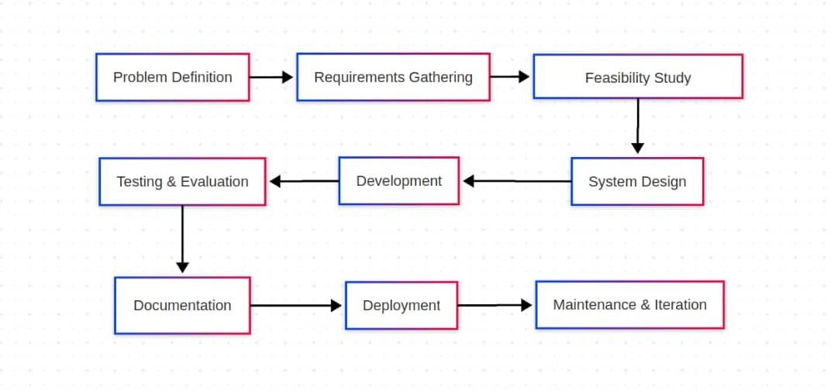
Figure 3.3.3.1: Agile Software Development Process

System Design
The system design for an Artificial Intelligence enhanced job matching and recommendation platform involves building a robust architecture that personalizes job recommendations using machine learning algorithms. This includes selecting suitable technologies for processing user profiles and managing databases, while also ensuring an intuitive, user-friendly interface for job seekers and employers. The design emphasizes scalability, reliability, and security, creating a platform that can adapt to a growing user base while safeguarding sensitive user data. Additionally, careful attention is given to data storage and processing methods, with structured storage for user profiles and job listings, as well as unstructured storage for resumes and job descriptions. The aim is to deliver accurate job matching by analyzing job seeker qualifications and preferences alongside job requirements, providing a seamless experience for users seeking jobs or candidates for open roles. Ultimately, the goal is to create a dependable, efficient system that optimizes job search and recruitment through intelligent automation and tailored recommendations.

Block Diagram
The block diagram below illustrates the major components of the AI-enhanced job matching and recommendation system. The system is divided into several core layers: the User Interface, Application Layer, Generative AI and Matching Engines, and Database Layer, along with integration with external cloud APIs.
The User Interface is built with React and TypeScript, enabling interactive access for candidates, employers, administrators, and panelists.
      - The Application Layer, powered by Django REST Framework, handles user requests, authentication, data validation, and business logic.
      - Within this layer, critical modules such as the Job Matching Engine, Generative AI Engine (for recommendations and chatbot interactions), Assessment System, Notification Module, and Job Scraper work together to deliver dynamic and personalized experiences.
      - A dedicated Chat and Interview System powered by WebSocket facilitates real-time communication between users.
      - The Database Layer uses PostgreSQL to store structured and unstructured data, including user profiles, job listings, applications, assessments, and chat histories.
      - Integration with external cloud services like Gemini AI, Gmail SMTP, and Google Authenticator enhances intelligence, communication, and security.
This modular design promotes scalability, flexibility, and maintainability while ensuring the system can effectively manage complex job-candidate interactions and provide accurate, intelligent job recommendations.
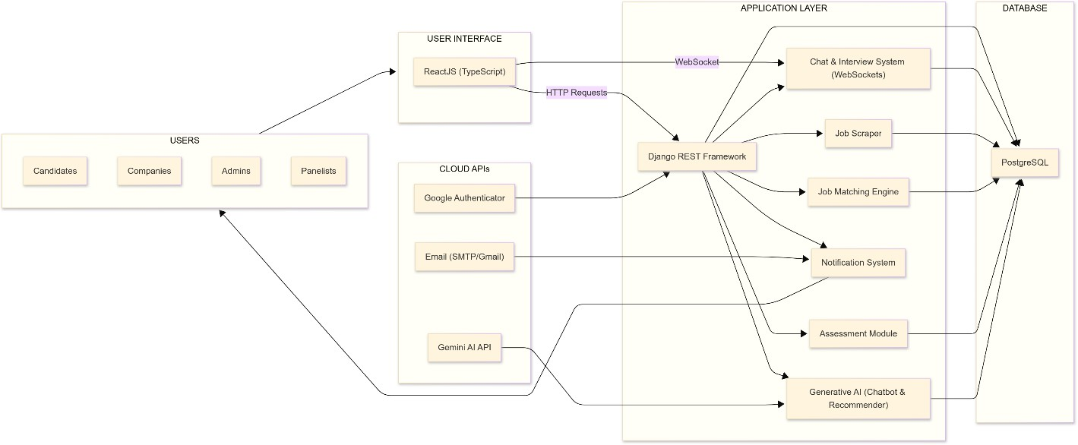

Figure 3.4.1: Block Diagram

    - Data Flow Diagram
The Data Flow Diagram (DFD) illustrates the logical flow of data within the AI-enhanced job matching and recommendation platform. It provides a detailed view of how information moves between external users (candidates, employers, panelists, and administrators), system processes, and internal data entities.
At its core, the system captures user inputs such as profile registrations, job postings, and resume uploads, and processes them through modules like the Job Matching Engine, Resume Parser, and Assessment Engine. Each of these modules communicates with relevant data stores such as the User Profiles, Job Listings, Applications, and Assessment Results entities to retrieve or store data.
The Generative AI Engine and WebSocket-based Chat & Interview module enhance real-time interactivity and recommendation capabilities. Additionally, a Job Scraper Service continuously populates the system with external job listings, while the Notification System ensures timely updates to both candidates and employers.
Administrators interact with the system through a dedicated dashboard, which provides insights and oversight of platform activities. This DFD demonstrates the seamless integration of various functional components to ensure efficient, personalized, and intelligent job matching and recruitment workflows.
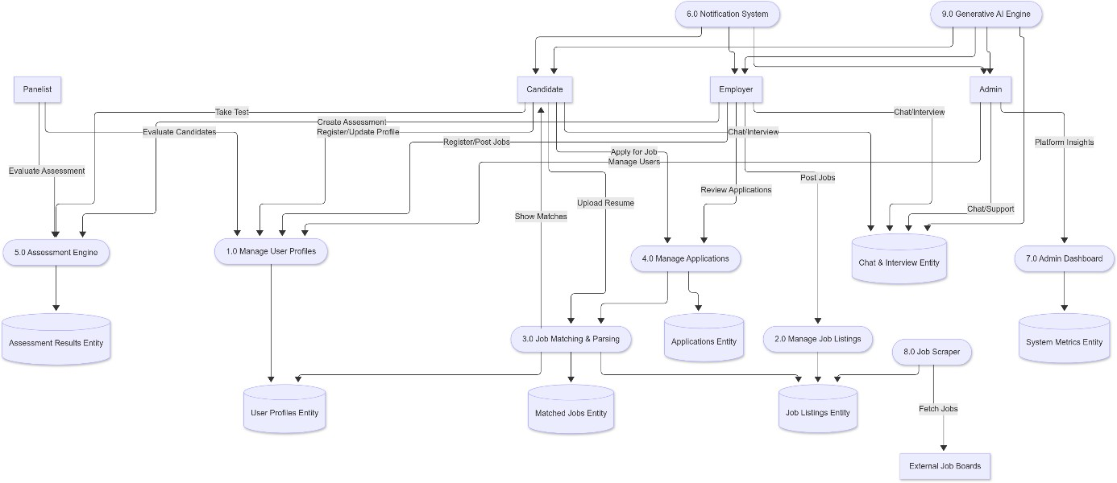

Figure 3.4.2: Data Flow Diagram

Activity Diagram
The Activity Diagram presents a dynamic view of the key workflows and user interactions within the AI-enhanced job matching and recommendation platform. It maps out the sequence of actions performed by users, including candidates, employers, administrators and system components during critical processes such as user registration, profile management, job searching, application submission, assessment completion, and interview scheduling.

This diagram highlights decision points like profile completeness checks, application choices, and assessment requirements, illustrating how the system guides users through each step with appropriate branching paths. It also captures asynchronous activities, such as waiting for employer feedback and real-time communication during interviews, emphasizing the platform’s interactive and user-centric design.
By visualizing these workflows, the Activity Diagram clarifies the flow of control and the orchestration of tasks that collectively enable efficient job matching, seamless application management, and effective communication between stakeholders, ensuring a smooth and intelligent recruitment experience.
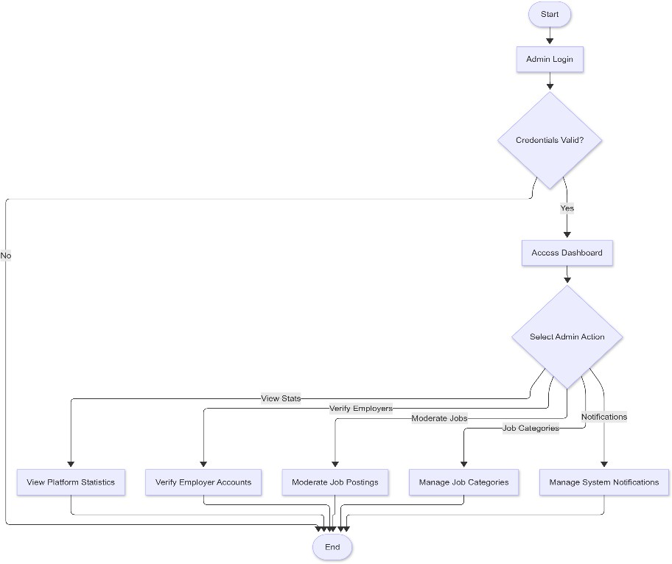

Figure 3.4.3: Admin Activity Diagram

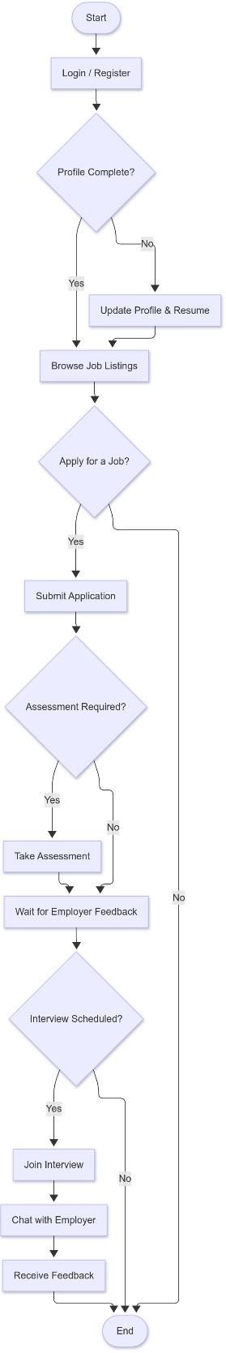

Figure 3.4.3: Candidate Activity Diagram

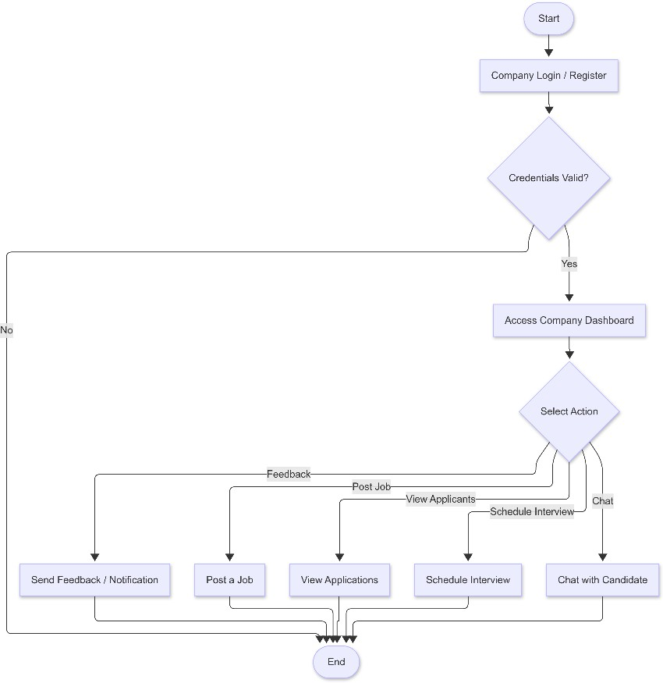

Figure 3.4.3: Company Activity Diagram

Use Case Diagram
The Use Case Diagram is a vital element in system modeling that visually depicts the functional interactions between external users, known as actors, and the internal processes of the system. It establishes the scope of the system by identifying who interacts with it and what functionalities are available to each type of user. The diagram serves as a high-level abstraction that simplifies complex system behaviors into easily understandable relationships.
In this context, the use case diagram represents a structured overview of the system’s expected behavior from the end-users' perspectives. Each actor is defined based on their role in the system and is linked to the specific operations they are authorized to initiate. These actors are placed outside the system boundary, while the system use cases are placed within. The connections between them indicate interactions such as initiating tasks, triggering processes, or receiving outcomes.
The use case diagram helps define the boundaries of the system by explicitly showing what lies within and outside its scope of operations. It ensures that the system design aligns with the users' expectations and functional requirements. Additionally, it lays the foundation for further modeling, including sequence diagrams, activity diagrams, and system design specifications.
By outlining the major user roles and their corresponding system functionalities, the use case diagram provides clarity and structure, enabling all stakeholders, developers, analysts, project managers, and clients to share a common understanding of what the system is designed to do. It acts as a blueprint that guides requirement analysis, validation, and system implementation

throughout the software development lifecycle.

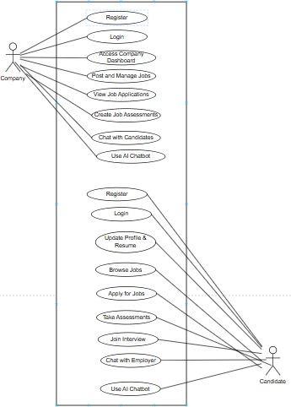

Figure 3.4.4: Company and Candidate Use Case Diagram

Sequence Diagram
The Sequence Diagram is a type of interaction diagram that models the dynamic behavior of a system by showing the sequence of messages exchanged between various objects or components over time. It focuses on how processes operate with one another and in what chronological order, making it especially useful for visualizing the flow of logic within a specific scenario or use case.
In the context of the AI-enhanced job matching and recommendation platform, the sequence diagram provides a step-by-step representation of the interactions between users (such as candidates, companies, admins, and panelists) and the system components. It illustrates how requests are initiated by actors, how the system processes those requests internally, and how responses are returned.
Each diagram typically includes lifelines representing system components or actors, vertical

dashed lines to show their lifespan during the interaction, and horizontal arrows that depict the communication between them. These interactions may include method calls, data exchanges, validations, or asynchronous notifications.
Sequence diagrams are essential for understanding system behavior during runtime, especially in complex workflows such as user registration, job application, interview scheduling, or candidate evaluation. They provide clarity in the sequence of operations and ensure that the logic aligns with the intended functionality of the system.
By using sequence diagrams, developers and analysts can identify potential design issues, optimize communication between components, and ensure proper synchronization in multi-step processes. This contributes to a more robust and efficient system architecture.

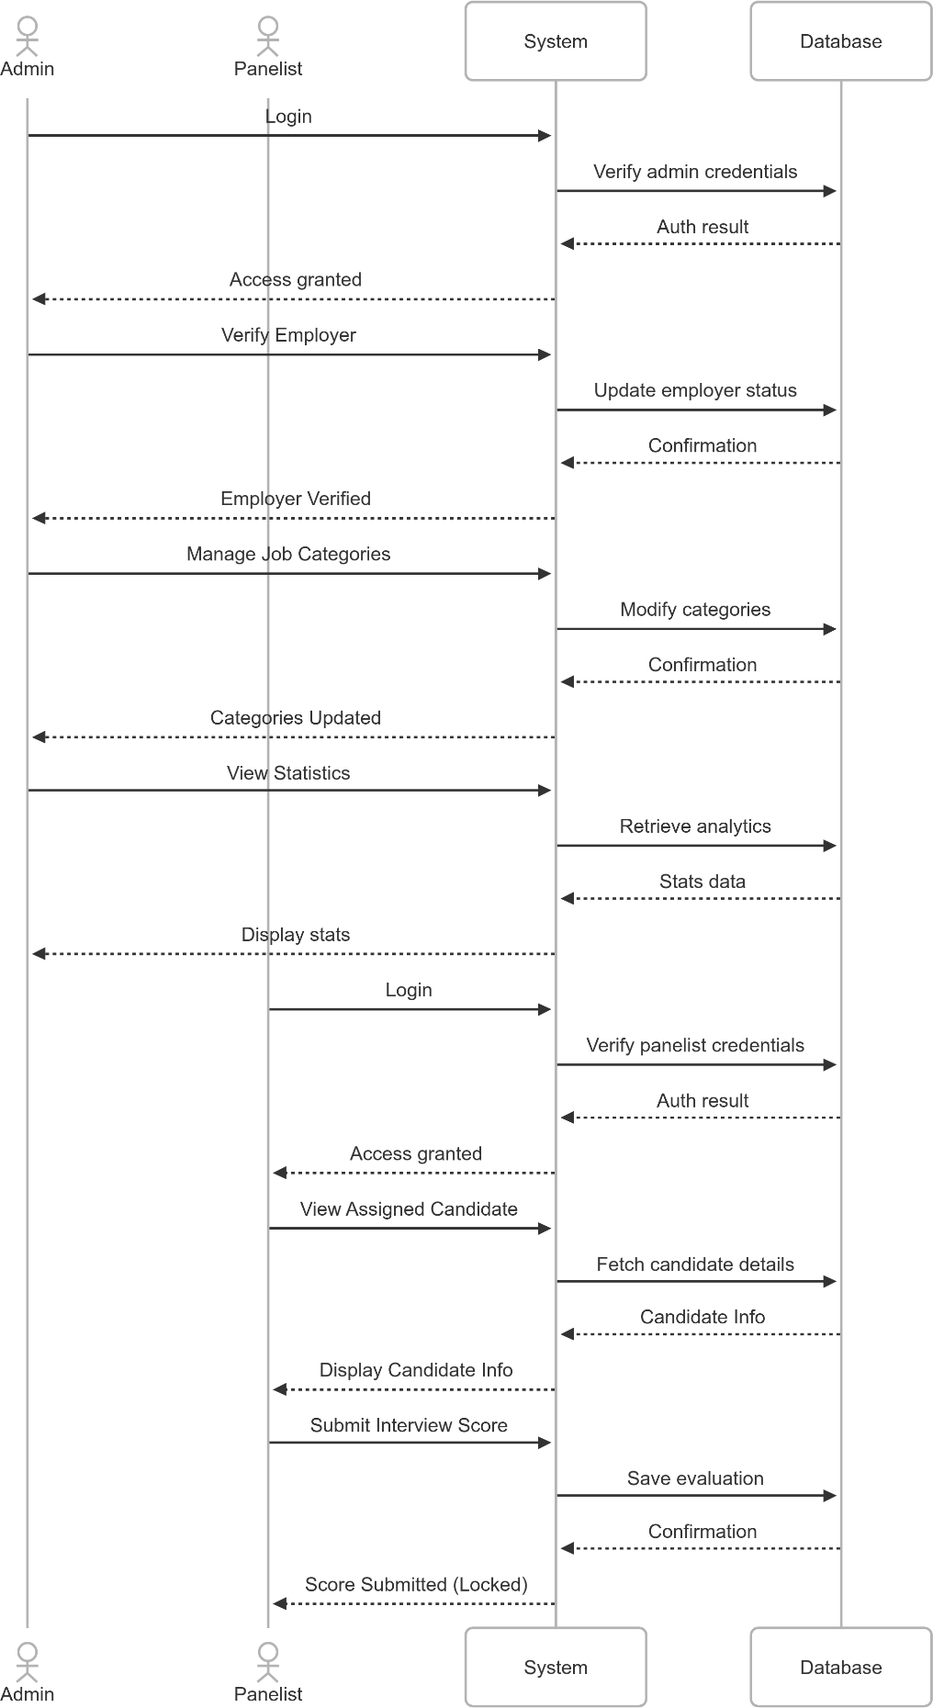

Figure 3.4.5: Sequence Diagram for Admin and Panelist

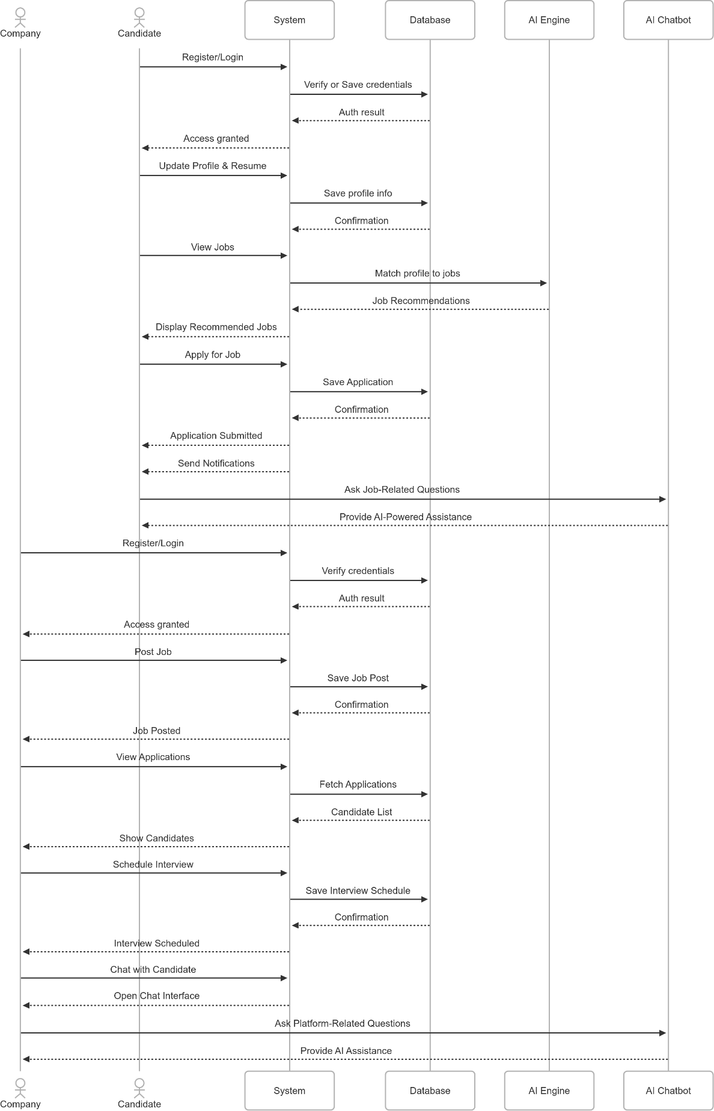

Figure 3.4.5: Sequence Diagram for Company and Candidate

Class Diagram
A class diagram is a fundamental type of static structure diagram in the Unified Modeling Language (UML) that provides a visual representation of the system’s classes, their attributes, operations (methods), and the relationships among the classes. It is primarily used in object-oriented software design to model the conceptual structure of the system before the implementation phase.
Class diagrams help capture the system’s key components by illustrating the system’s classes as well as their internal details, including properties (attributes) and behaviors (methods). Additionally, class diagrams depict various types of relationships between classes, such as associations, inheritances (generalizations), dependencies, and aggregations or compositions, which define how classes interact or depend on one another.
By modeling these elements, class diagrams provide a high-level overview of the system architecture and serve as a blueprint for developers during coding. They help in understanding and analyzing the system’s data and behavior, identifying responsibilities of each class, and establishing clear interfaces between different parts of the system.
In addition to facilitating communication among project stakeholders, class diagrams play a vital role in ensuring that the system’s design aligns with its functional requirements. They also assist in identifying potential design flaws early in the development lifecycle, improving maintainability and scalability.
Overall, class diagrams are an essential tool in the software engineering process, bridging the gap between system requirements and implementation through a clear and comprehensive visual representation of the system’s structure.

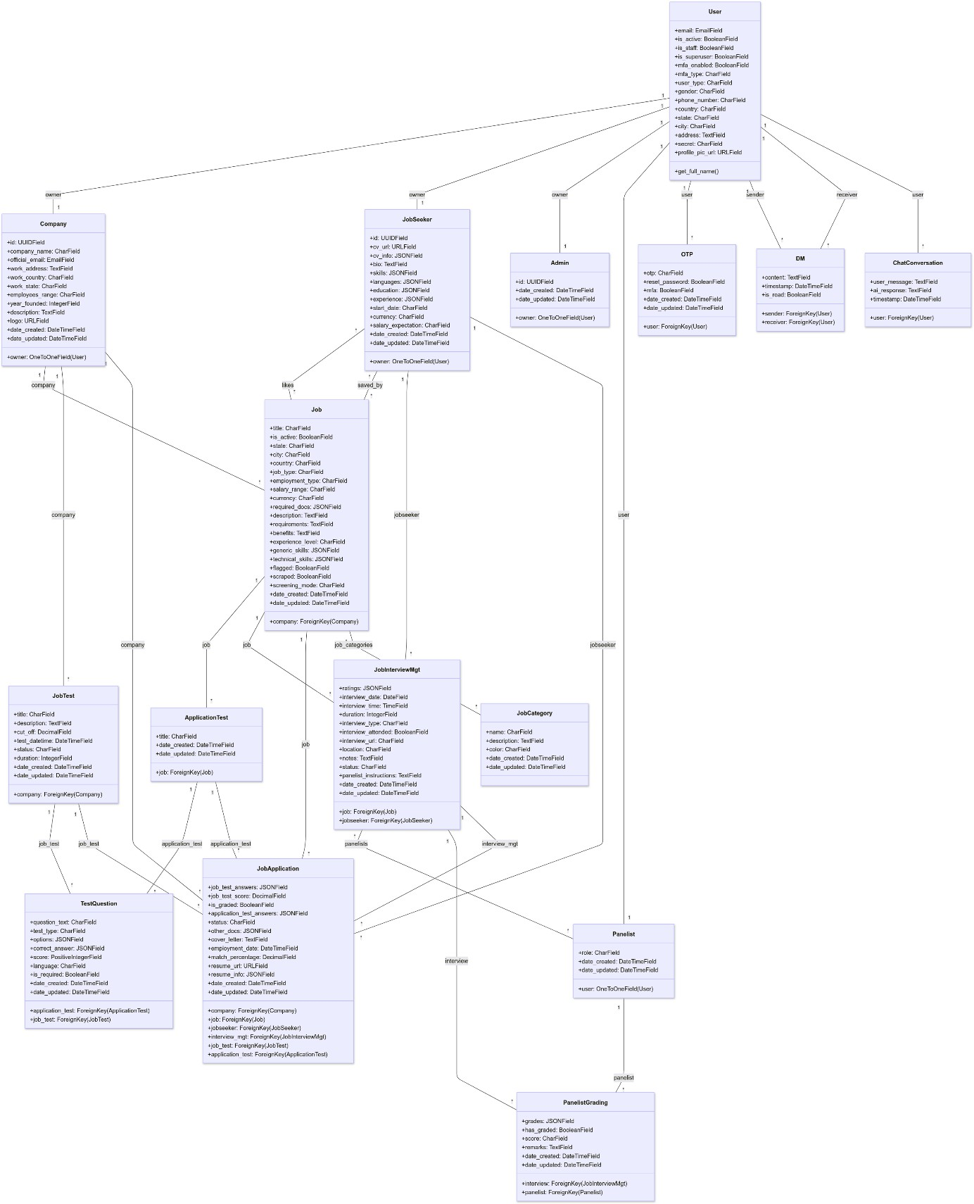

Figure 3.4.6: Class Diagram

Architectural Diagram
This is a high-level visual representation that illustrates the structural design and operational flow of a software system. It provides a comprehensive overview of the system’s components, their responsibilities, interconnections, and the technologies involved in delivering the application's core functionalities.

It showcases how different system layers, including the frontend interface, backend services, AI/ML engine, database, file storage, and security mechanisms collaborate to support a seamless and intelligent job-matching experience.
Each component is depicted as a distinct module, with directional data flows that indicate how information moves across the system. For example, job seekers and employers interact with the platform through a responsive frontend, which communicates with a Django-based RESTful backend via a secure API Gateway. This backend manages user data, job listings, applications, interviews, and interacts with an integrated AI engine that provides smart recommendations and resume analysis.
Supporting systems such as a PostgreSQL relational database, cloud-based file storage (for resumes, tests, and recordings), and WebSocket-based chat infrastructure are also included to ensure data persistence, document management, and real-time communication. The system’s scalability and performance are supported by cloud infrastructure components such as load balancers, auto-scaling groups, and CI/CD pipelines.
Security is enforced through JSON Web Token (JWT), ensuring secure access control for different user roles including candidates, employers, panelists, and administrators. Additionally, an admin dashboard provides analytics and oversight of AI decisions and platform operations.
The architectural diagram plays a critical role in ensuring alignment between technical design and business goals. It serves as a blueprint for developers, architects, DevOps teams, and stakeholders to understand the technical landscape, identify integration points, and maintain consistency throughout the development and deployment lifecycle.
Overall, this diagram promotes scalability, and maintainability, making it an indispensable asset for planning, communication, and execution of a robust AI-driven recruitment platform.
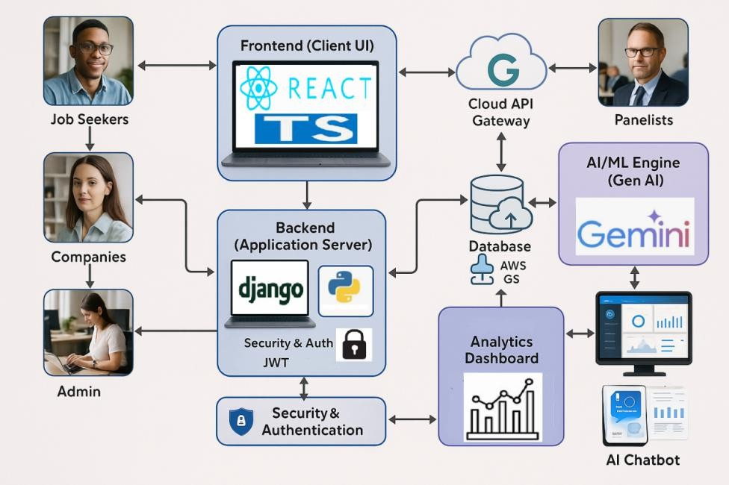
Figure 3.4.7: Architectural Diagram

Introduction

CHAPTER FOUR SYSTEM IMPLEMENTATION

This chapter focuses on the implementation of the Artificial Intelligence enhanced job platform designed to revolutionize job matching and recommendations using machine learning techniques. The system implementation stage translates the design concepts into a fully functional application, integrating various technologies, algorithms, and frameworks to achieve the project objectives. This phase includes the development of core features such as job seeker profile creation, employer job postings, intelligent job matching, and real-time recommendations.
The implementation process involves setting up the backend for data processing and storage, building an intuitive user interface, and incorporating machine learning models for personalized job matching. Special attention is given to ensuring system scalability, security, and performance optimization to handle a growing user base and provide reliable service. Testing and deployment strategies are also implemented during this stage to guarantee a seamless user experience and address potential issues before the platform is made fully operational. This chapter provides an in-depth exploration of the tools and technologies employed in bringing the Artificial Intelligence enhanced job platform to life.

Implementation
The implementation of the Artificial Intelligence enhanced job platform is a combination of powerful backend frameworks, interactive front-end technologies, and efficient task scheduling mechanisms to deliver a robust, user-friendly, and scalable system. Below is an overview of how each technology is integrated into the platform.

Backend Development
The backend of the platform is built using Django, a Python-based web framework known for its scalability and simplicity. Django facilitates the development of secure APIs and supports a robust ORM for interacting with the PostgreSQL database. It handles job seeker and employer profiles, job postings, and machine learning model integration for intelligent job matching.
      - PostgreSQL: A powerful relational database system used to store and retrieve user data, job details, and system logs efficiently. Its advanced querying capabilities enable complex data handling required for personalized recommendations.
      - Celery: Used to manage asynchronous tasks such as sending email notifications, processing large datasets, and executing periodic background tasks.
      - Django APScheduler: Integrated to handle recurring tasks like refreshing recommendation models, sending reminders, or generating system reports.

Frontend Development
The frontend is developed using HTML, CSS, and JavaScript to create a user-friendly and visually appealing interface.
      - HTML structures the web pages, ensuring accessibility and a clear hierarchy.
      - CSS adds styling to enhance user experience, making the platform attractive and responsive across different devices.
      - JavaScript introduces interactivity, allowing users to interact with features such as real-time notifications, dynamic job search filters, and live feedback.

Real-Time Communication
The system incorporates WebSocket to enable real-time communication between the server and users. This is used for delivering instant updates like new job postings, notifications for employer responses, or real-time chat features between job seekers and employers.

Automation and Web scraping
Selenium, a web automation tool, is used to scrape and integrate job postings from external sources. This ensures that job seekers have access to a diverse pool of opportunities while keeping the system content-rich and up-to-date.

Machine Learning Integration
The platform integrates pre-trained machine learning models within the Django framework to match job seekers with relevant roles based on their profiles, skills, and preferences. These models are periodically updated using Celery tasks to ensure recommendations remain accurate and personalized.

System Requirements
The successful implementation and operation of the Artificial Intelligence enhanced Job Platform rely on meeting specific hardware and software requirements. This section outlines the minimum hardware and software specifications necessary for deploying and running the system efficiently.

Minimum Hardware Requirements
To ensure the system operates smoothly, the following minimum hardware requirements should be met:
- Processor: Intel Core i5 or equivalent

  - A multi-core processor with a clock speed of at least 2.0 GHz is required to handle server-side processing, machine learning algorithms, and real-time updates.
  - Recommended: Intel Core i7 or higher for enhanced performance.

Memory (RAM): 4 GB (Minimum)
  - Adequate memory is essential for running web services, database queries, and task scheduling efficiently.
  - Recommended: 8 GB or more for optimal multitasking and performance.
- Storage: 256 GB SSD or HDD
  - An SSD is preferred for faster data access and system responsiveness, particularly for handling database operations and model updates.
  - Recommended: 512 GB SSD or higher.
- Network: Stable internet connection
  - A reliable internet connection is required for real-time notifications, user interactions, and integration with external APIs.

Minimum Software Requirements
To ensure the successful development, deployment, and operation of the AI-enhanced Job Matching and Recommendation Platform, the following software components are essential. These tools have been selected based on their reliability, scalability, and compatibility with modern cloud environments.
- Operating System: The system should be developed and deployed on operating systems that are stable and widely supported. The recommended options include:
  - Windows 10 or later
  - macOS (Monterey or later)
  - Linux distributions (preferably Ubuntu 20.04 LTS or higher)
Linux is particularly suitable for production environments due to its stability, performance, and better compatibility with cloud infrastructure.
- Programming Language: The primary programming language for this platform is Python 3.8 or higher. Python is chosen for its simplicity, large library ecosystem, and powerful capabilities in both web development and artificial intelligence. It also integrates seamlessly with Django and modern AI APIs such as OpenAI or Google’s Gemini.
- Web Framework: The backend of the platform will be built using Django 3.0 or higher.

Django is a secure, scalable, and mature web framework that supports rapid development. It includes built-in features for user authentication, admin management, and a robust ORM for interacting with the database. Combined with Django REST Framework, it enables the creation of secure and modular RESTful APIs.
- Database Management System: The recommended database system is PostgreSQL version 12 or higher. PostgreSQL is an open-source, enterprise-grade relational database known for its robustness, extensibility, and support for complex queries. It is ideal for managing structured data such as job listings, user profiles, applications, interview records, and scoring results.
- Libraries and Dependencies: The platform relies on several critical Python libraries and third-party services to support core features:
  - Django REST Framework: To create and manage RESTful APIs used by the frontend.
  - Celery: To manage asynchronous background tasks such as sending emails, processing large files, or communicating with AI engines.
  - WebSocket (via Django Channels): To enable real-time features like chat, live status updates, and interview scheduling notifications.
  - Selenium and Beautiful Soup: For automated scraping of job postings from third-party job portals.
  - Cloudinary (or AWS S3 / Google Cloud Storage): For storing and serving media files such as resumes, test documents, and interview recordings.
  - OpenAI or Gemini API Clients: For generative AI tasks such as resume parsing, smart job recommendations, candidate scoring, and chatbot functionality.
- Development and Productivity Tools: For effective and streamlined development, the following tools and platforms are recommended:
  - Integrated Development Environment (IDE): Either PyCharm or Visual Studio Code, offering robust support for Django, Python, and frontend development.
  - Version Control System: Git, with repositories hosted on GitHub or GitLab for source code management and team collaboration.
  - Virtual Environment Management: Tools such as Virtualenv or Pipenv to isolate dependencies and manage Python package versions for different environments.
  - Web Browsers: Google Chrome, Mozilla Firefox, or Microsoft Edge should be used for testing and accessing the platform’s frontend interface during development and Quality Assurance.

Program Modules and Interfaces
The system is divided into modular components, each responsible for a specific function within the platform. Key modules include the User Management Module, Job Management Module, Resume Parsing and Matching Module, Application and Interview Management Module, and the AI Recommendation Engine. These modules interact through well-defined interfaces using RESTful APIs, ensuring seamless data flow and integration. The modular structure enhances scalability, maintainability, and enables easy future expansion of the system.

User Management Module
This module manages user authentication, registration, and role-based access control for the four types of users: Job Seekers, Companies, Panelists, and Admins. Each user has a tailored profile dashboard with relevant actions and permissions. Admins can manage all users, approve registrations, and control access across the platform.
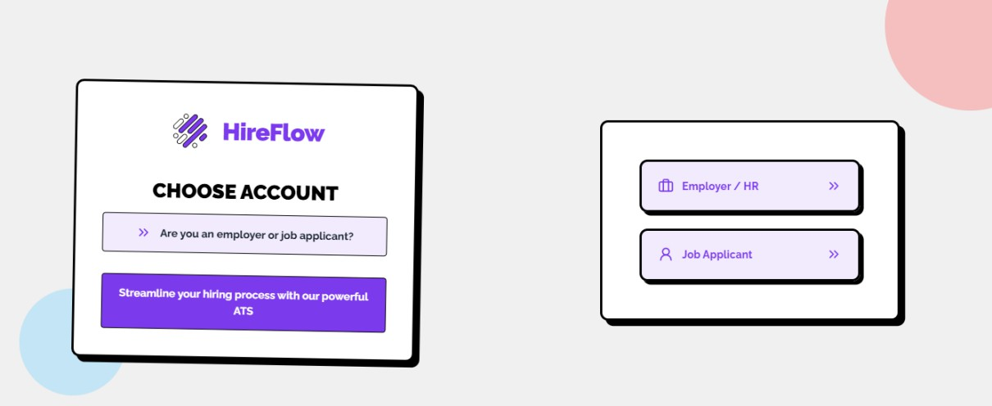
Company and Candidate Registration View
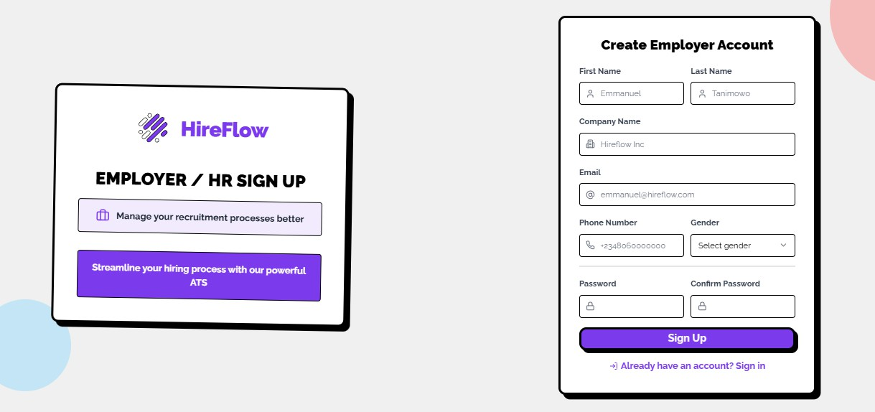
Company Registration Page

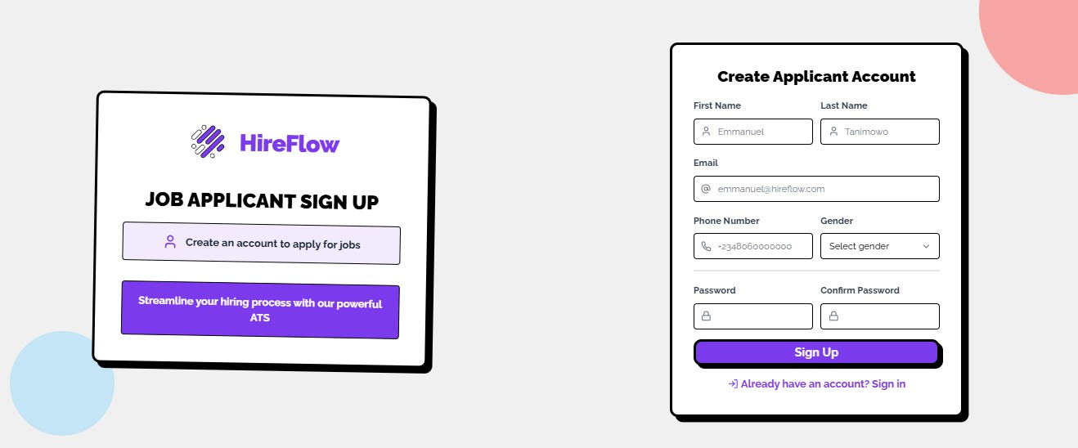
Candidate Registration Pages
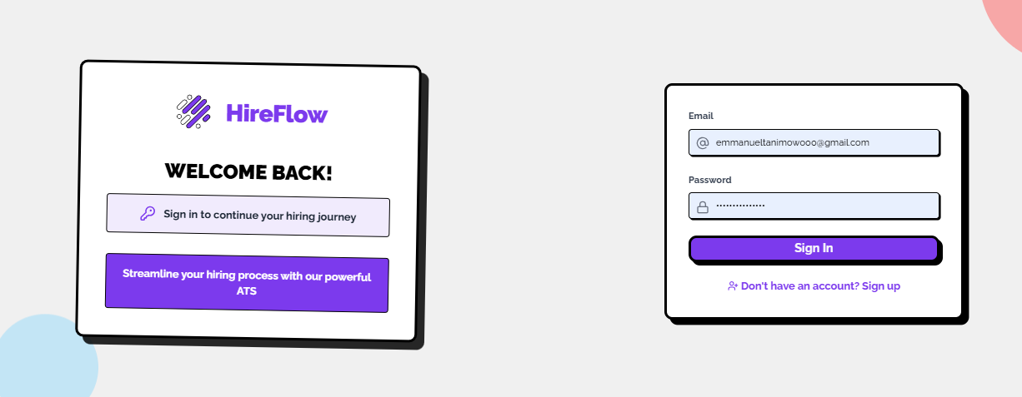
User Login Page
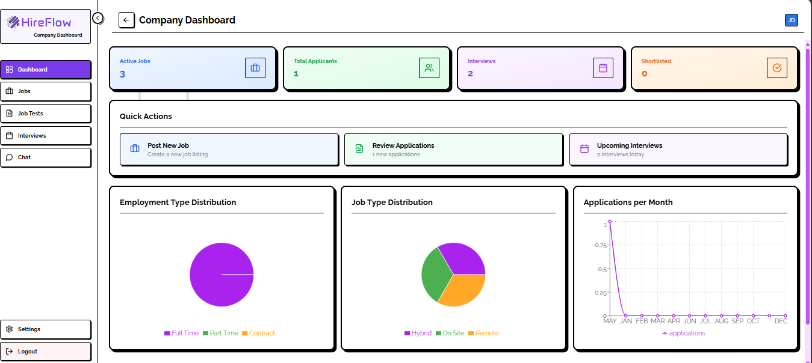
Company Dashboard

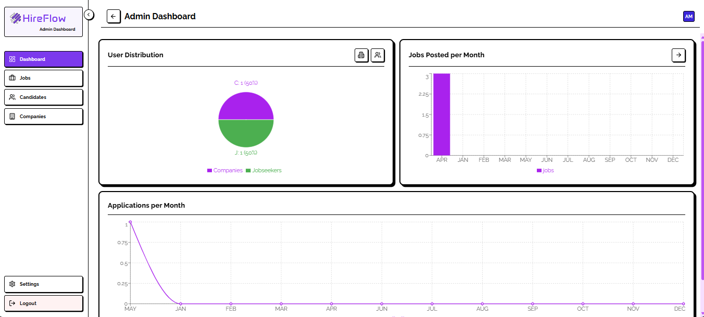
Admin Dashboard
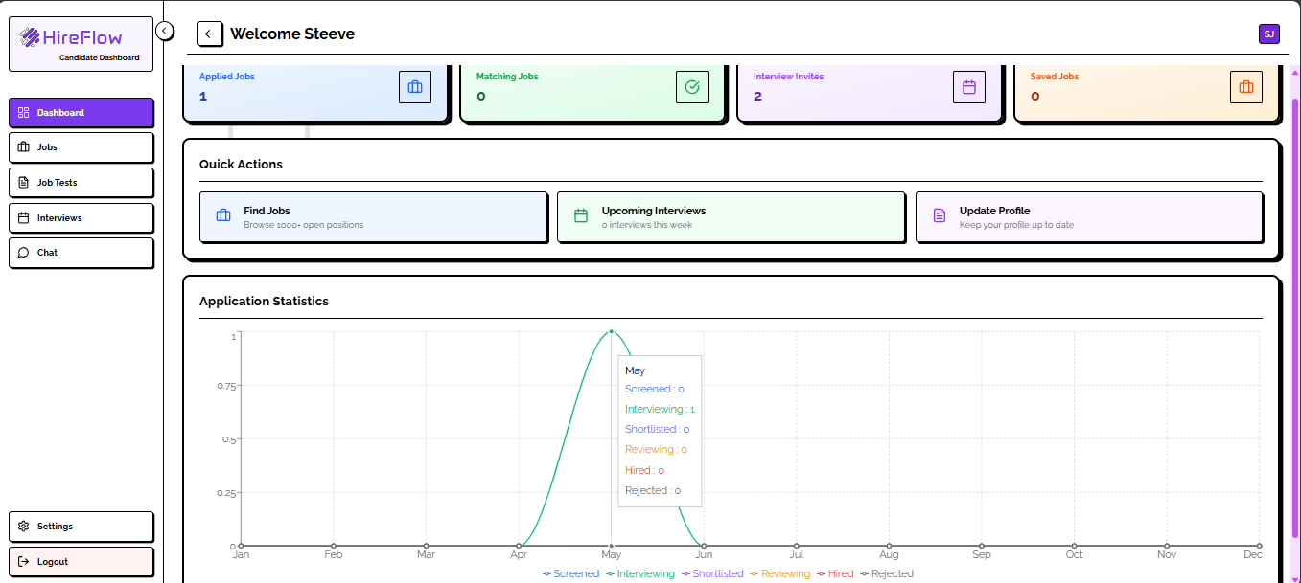
Candidate Dashboard

Jobs Management Module
The Jobs Module allows companies to create, update, and manage job postings. It includes functionality to set required qualifications, skills, and custom assessment tests. Jobs are made available on the job seeker dashboard and linked to AI-based matching for improved visibility to relevant candidates.

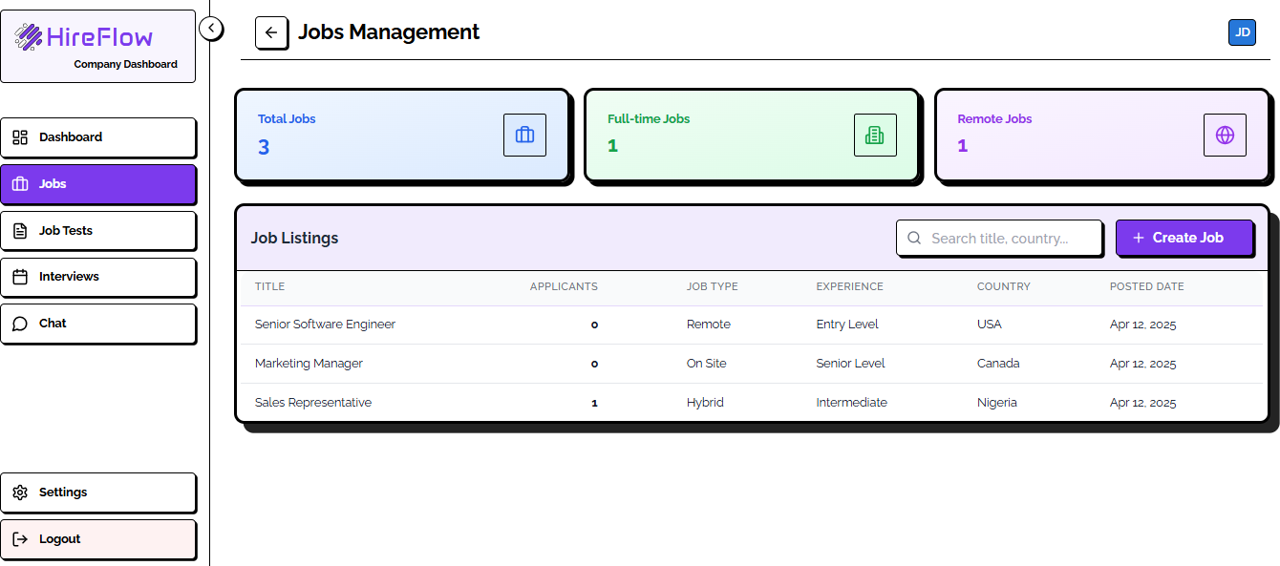
Company Jobs Management
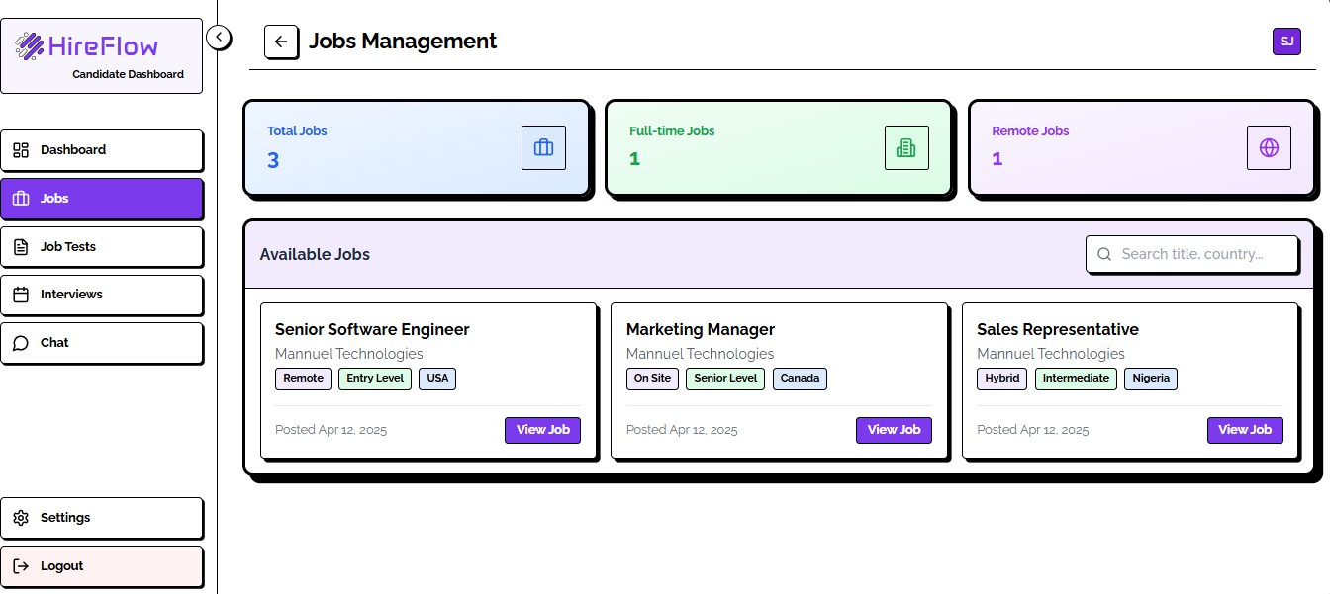
Candidate Jobs Management

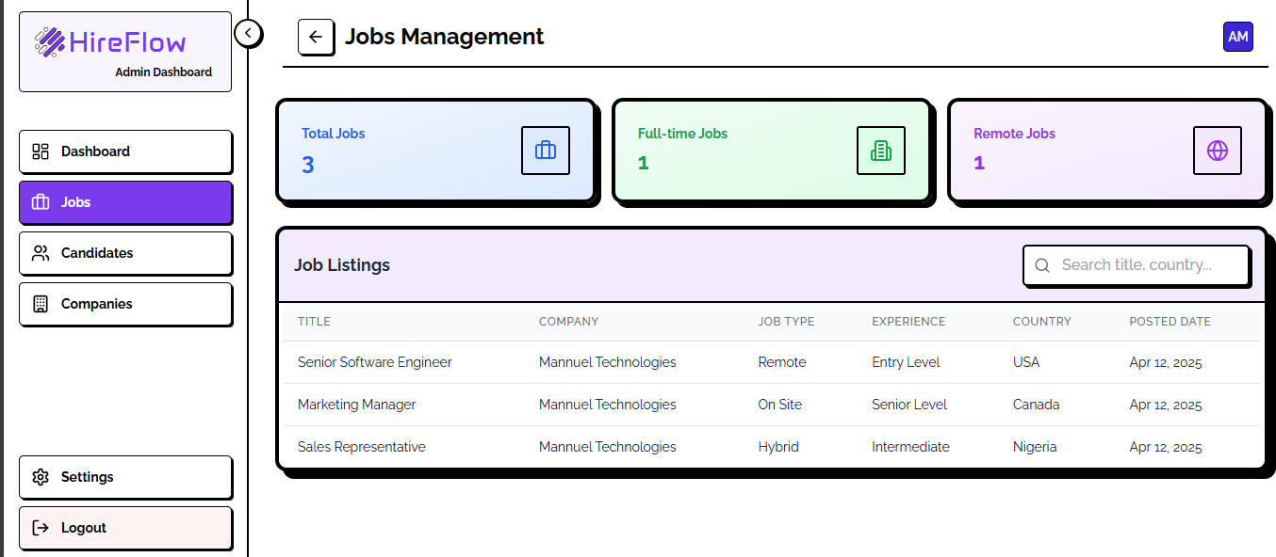
Admin Jobs Management

Resume Parsing & Job Matching Module
This module uses a generative AI engine to parse uploaded resumes and extract structured data such as skills, education, and experience. It then compares this data with job requirements using intelligent algorithms to calculate a match percentage, helping job seekers identify best-fit roles instantly.

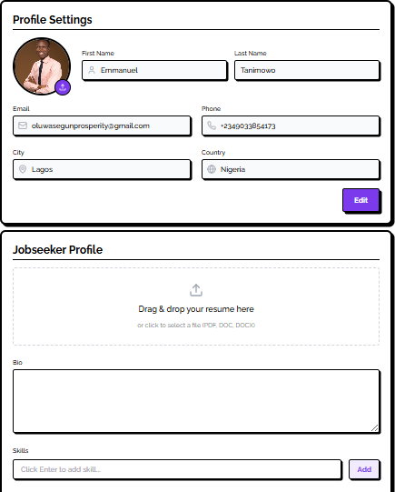
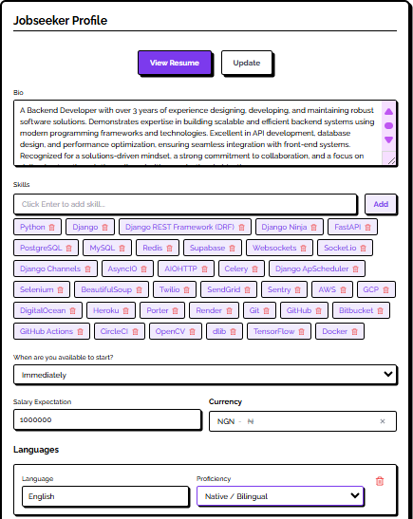
Candidate Resume Parsing

Job Application & Assessment Module
This module enables job seekers to seamlessly apply for available job postings directly from their dashboards. For roles that include an assessment component, the system automatically delivers the relevant test, records user responses, and computes scores in real time.
The progress of each application is tracked through distinct stages, including: Screened, Interviewing, Shortlisted, Reviewing, Hired, and Rejected.
Employers benefit from advanced candidate comparison features. Using data from applicants’ profiles, resumes, assessment results, and other personalized information, companies can evaluate candidates' skills, strengths, and overall suitability for the role, helping to identify the best fit for their job openings.

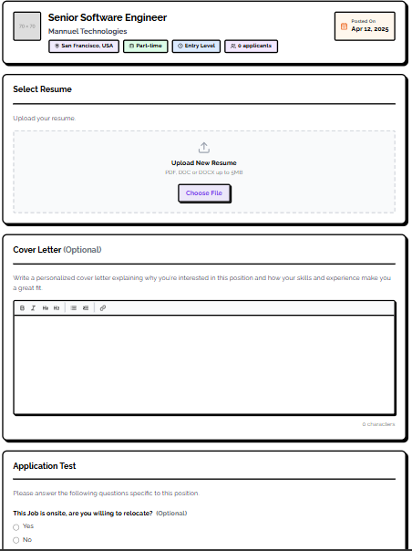
Candidate Job Application Form

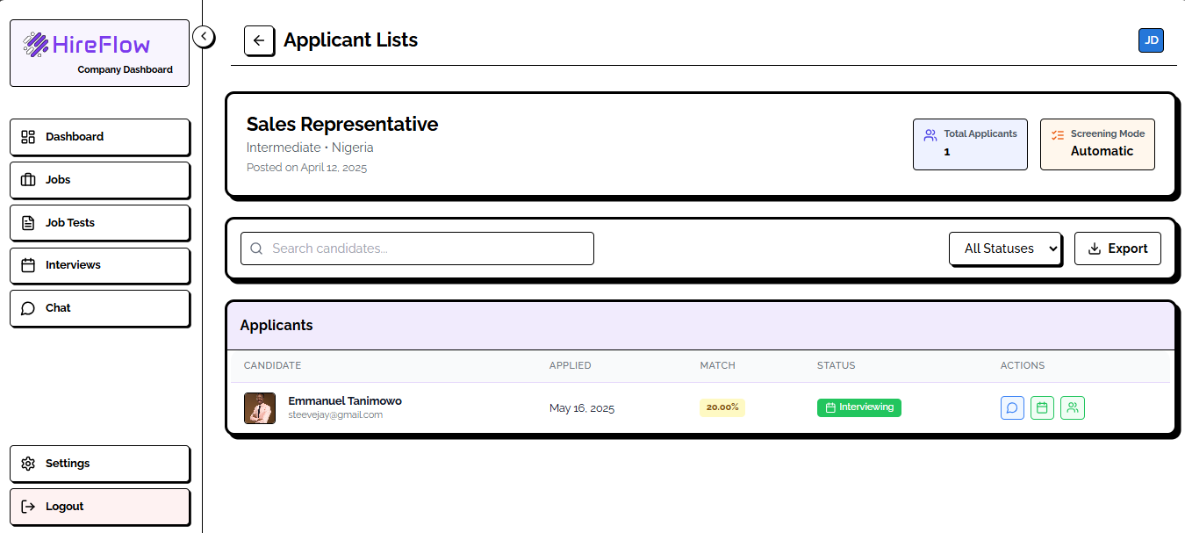
Company Job Applicants List

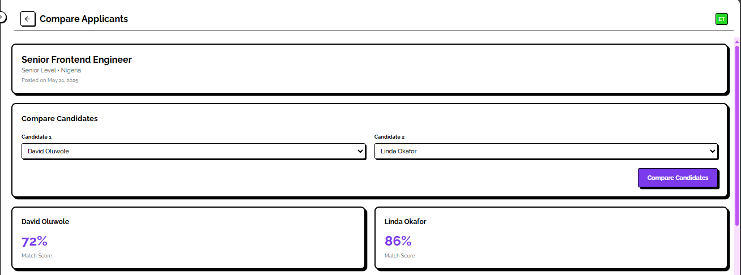
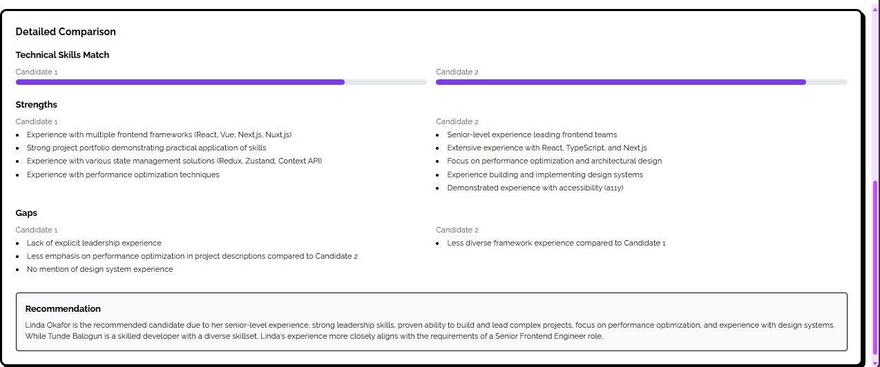

Compare Candidates View

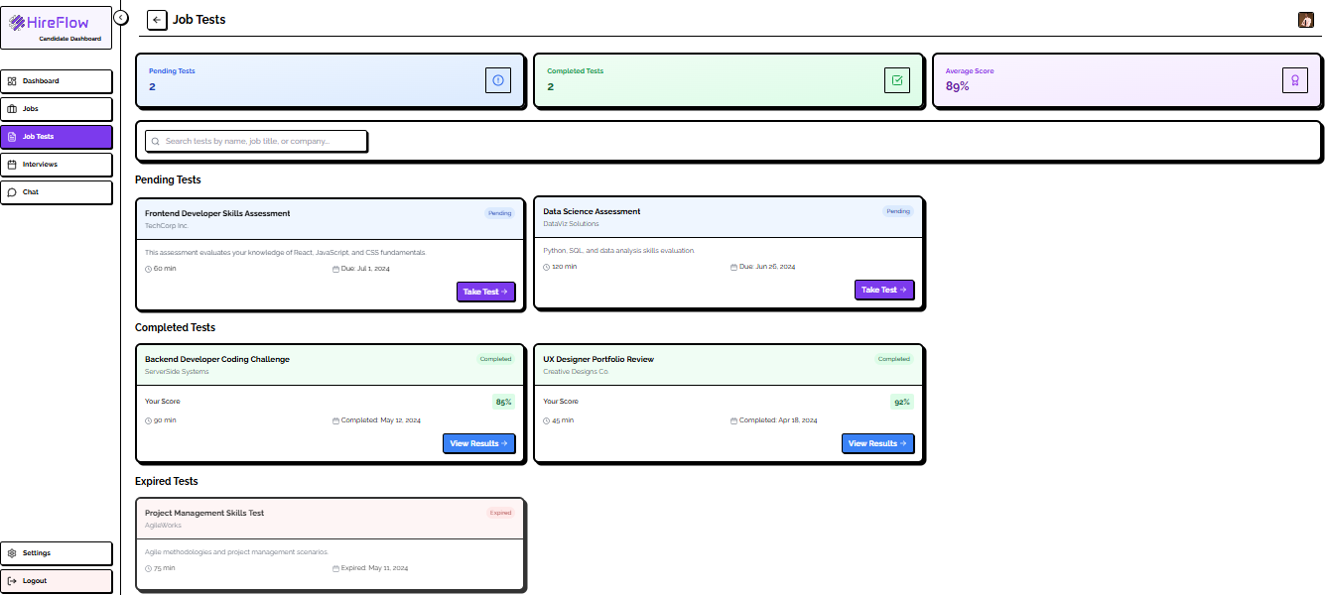
Candidate Assessment Module

Interview Management Module
This module is responsible for scheduling and managing interviews. Admins and companies can set up interview slots and assign panelists. Job seekers receive notifications and can attend scheduled interviews. The system also tracks interview results and integrates feedback from panelists.
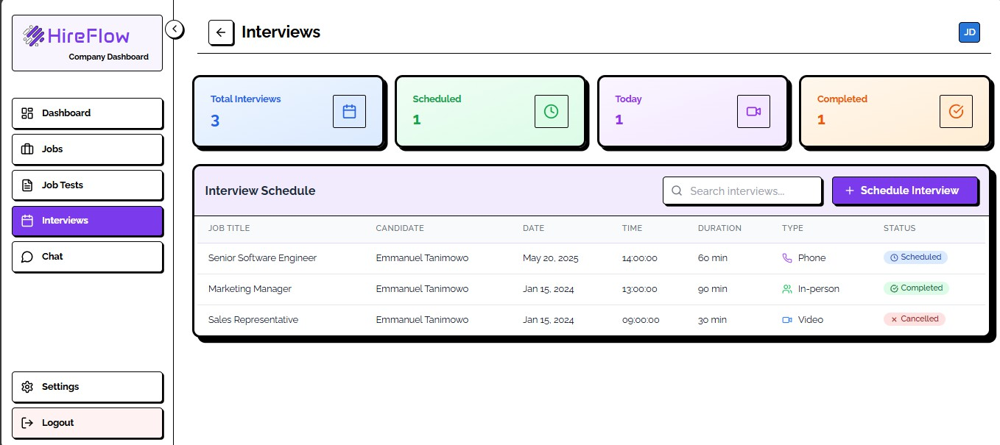
Company Interview Management Module

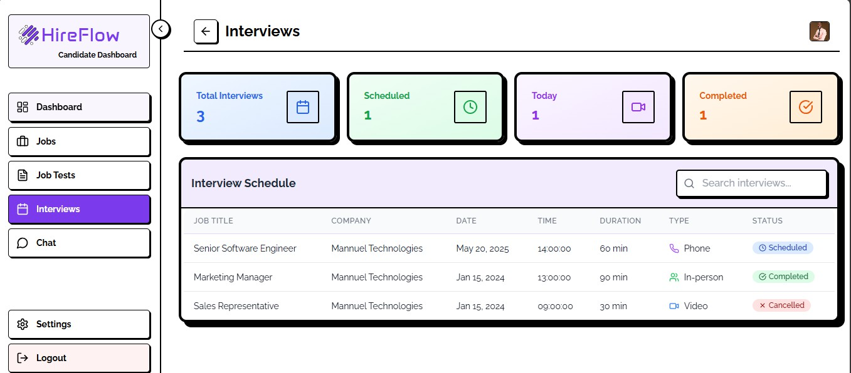
Candidate Interview Management Module

Chat Module and Personalized Chatbot
This module enables real-time messaging between users, including job seekers, companies, panelists, and admins. It supports text, emoji reactions, and file sharing to facilitate seamless communication. The integrated AI Chatbot assists users by answering FAQs, guiding them through platform features, and providing personalized job recommendations. The chatbot uses natural language processing to understand queries and improve responses over time.

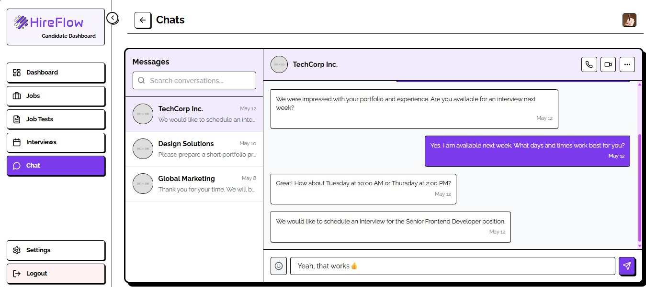
Company and Candidate Chat Module

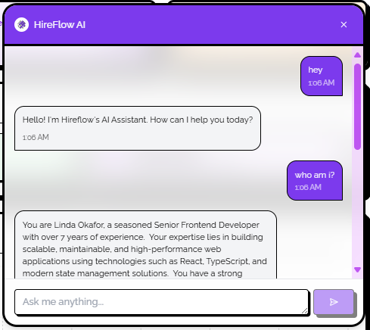
Personalized Chatbot (Candidate)

Multi-Factor Authentication (MFA) Module
This module strengthens platform security by implementing a layered authentication process. Beyond the standard username and password, users are required to complete an additional verification step, such as a one-time password sent via email, or generated through an authenticator app. MFA settings are role-aware and can be customized based on user sensitivity levels. The system enforces MFA during critical operations like login, password resets, and administrative functions, significantly reducing the risk of unauthorized access and enhancing overall account security.

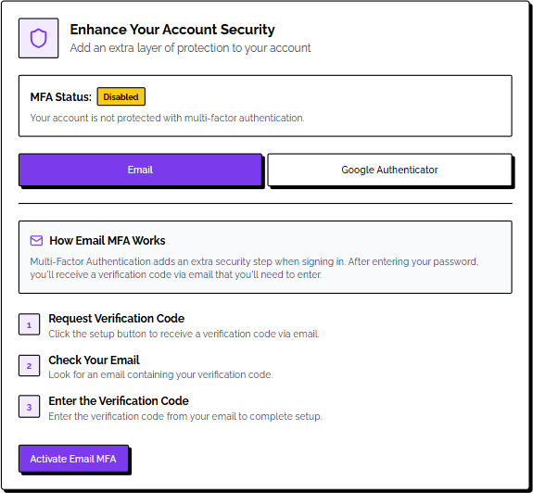
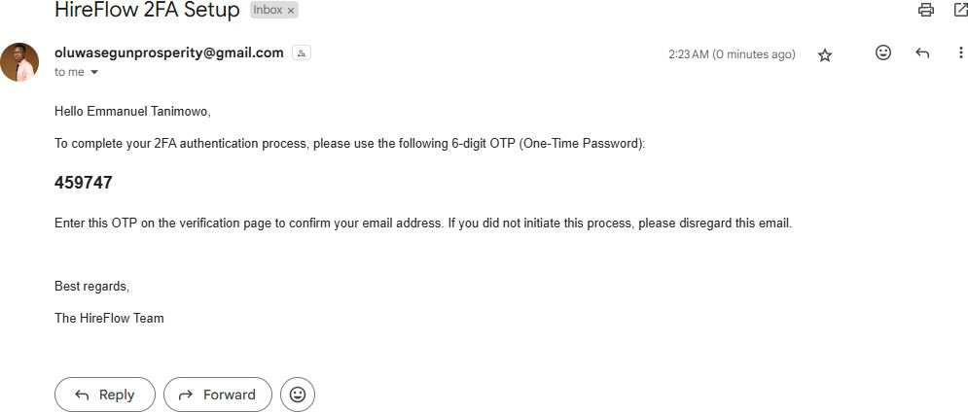
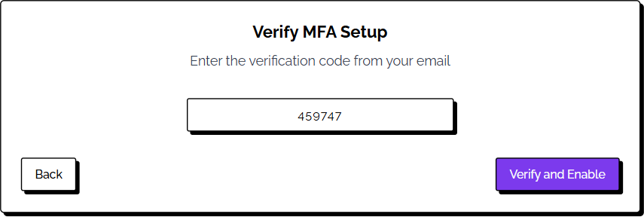

Email Multi-Factor Authentication Setup

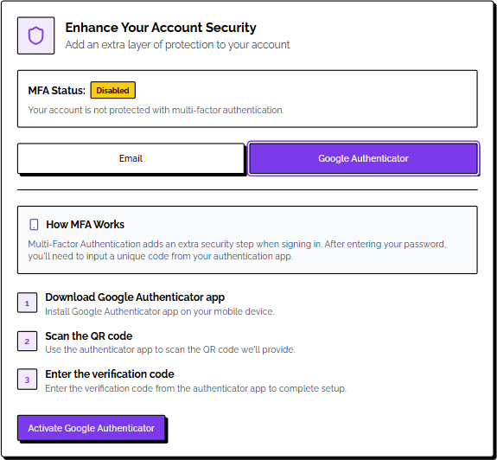
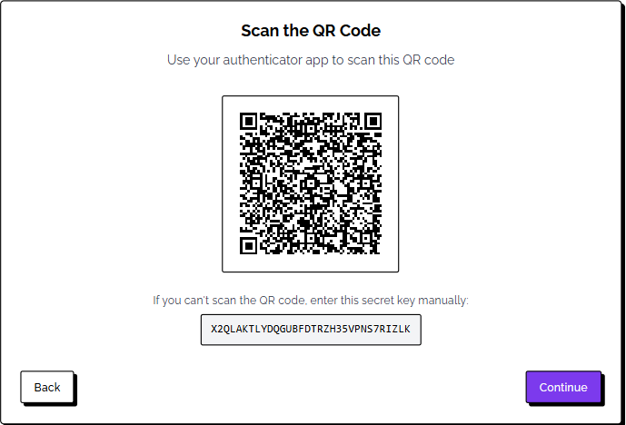
Google Authenticator App Multi-Factor Authentication Setup

Performance Metrics
To assess the reliability, responsiveness, and intelligence of the AI-Enhanced Job Matching and Recommendation Platform, a range of performance metrics was used. These metrics evaluate the efficiency of the system, the accuracy of AI predictions, and the overall user experience. Performance testing was conducted after the integration of major modules such as user management, resume parsing, job matching, interview scheduling, and application tracking.

Recommendation Accuracy Metrics

Match Quality Distribution
Match Quality Range | Percentage | Description
High-Quality Matches  (>75%) | 24.2% | Strong candidate-job  alignment
Medium-Quality  Matches (50-75%) | 51.9% | Good potential matches
Low-Quality Matches  (<50%) | 23.9% | Basic compatibility

Precision Metrics at Different Thresholds
Threshold | Precision Rate | Reliability Level
Precision@50% | 76.11% | Basic matches
Precision@60% | 54.14% | Good matches
Precision@70% | 33.44% | Strong matches
Precision@80% | 14.33% | Excellent matches
Precision@90% | 7.32% | Perfect matches

Recall Performance Analysis
Threshold | Recall Rate | Retrieved Relevant Items
Recall@50% | 227.62% | High sensitivity to relevant matches
Recall@60% | 161.90% | Strong retrieval performance
Recall@70% | 100.00% | Complete relevant item retrieval
Recall@80% | 42.86% | Selective high-quality retrieval
Recall@90% | 21.90% | Ultra-selective matching

F1 Score Performance
Threshold | F1 Score | Balance Assessment
F1@50% | 114.08% | Exceptional precision-recall balance
F1@60% | 81.15% | Strong balanced performance
F1@70% | 50.12% | Moderate balance
F1@80% | 21.48% | Precision-focused performance
F1@90% | 10.98% | High-threshold selectivity

Performance Distribution Analysis
Match Percentage Distribution Insights
The system shows a normal distribution pattern with peak performance in the 40-60% match range, indicating:
      - Balanced matching algorithm that avoids extreme bias
      - Realistic expectation setting for job-candidate alignment
      - Effective filtering that prevents over-optimistic matching

Precision-Recall Trade-off Analysis
Performance Aspect | Observation | Implication
High Recall at Lower  Thresholds | 227% recall at 50%  threshold | System captures most relevant  matches
Balanced F1 Performance | Peak F1 score of 114% at  50% threshold | Optimal balance between precision  and recall
Precision Decline | Gradual decrease from 76%  to 7% | Expected selectivity increase with  higher standards
Perfect Ranking | 100% MRR and NDCG  scores | Excellent recommendation ordering
Performance Aspect | Observation | Implication

System Performance Insights
      - Optimal Operating Threshold: Based on F1 score analysis, the system performs optimally at the 50-60% threshold range, balancing precision and recall effectively while maintaining practical usability.
      - Ranking Excellence: Perfect MRR (100%) and NDCG scores indicate that the system consistently ranks the most relevant recommendations at the top, demonstrating superior recommendation ordering capabilities.
      - Coverage vs. Quality Balance: Job coverage of 57.33% with high skill diversity (73.25%)

shows the system successfully balances broad coverage with quality matching, avoiding the common trade-off between reach and precision.
      - Matching Effectiveness: The system demonstrates strong performance in identifying relevant candidates, with 76.11% of recommendations showing at least 50% match relevance. The precision-threshold curve shows a balanced trade-off between match quality and quantity.
      - Skill Recognition and Matching: The system effectively identifies both technical and soft skills with high skill diversity (73.25%) indicating comprehensive coverage. Consistent recognition of modern technology stack requirements demonstrates robust parsing capabilities.
      - Distribution Balance: The normal distribution of match scores (centered around 60%) indicates a well-calibrated matching algorithm. Even distribution across match quality ranges suggests robust matching criteria.

Comparative Performance Benchmarks

Metric Category | System Performance | Industry Benchmark | Performance Assessment
Precision@50% | 76.11% | 60-70% | Above Average
F1 Score (Optimal) | 114.08% | 70-85% | Exceptional
Mean Reciprocal  Rank | 100% | 75-90% | Outstanding
Skill Diversity | 73.25% | 50-65% | Superior
System Coverage | 57.33% | 40-60% | Good

CHAPTER FIVE

SUMMARY, RECOMMENDATION AND CONCLUSION

Summary of the Study
This project focused on the design and development of an Artificial Intelligence Enhanced Job Platform to streamline job matching and recruitment processes using modern machine learning technologies. Built using Django, PostgreSQL, and integrated with AI models such as Gemini for resume parsing and job fit analysis, the system supports four distinct user types: Job Seekers (Candidates), Employers (Companies), Panelists, and Admins. Key functionalities include resume parsing, personalized job recommendations, candidate comparison feature, enabling detailed analysis of applicants’ strengths, gaps, and best-fit recommendations, automated test and interview management, panelist evaluation, and a personalized chatbot assistant for user engagement and support.
The study aimed to address limitations in traditional recruitment processes such as manual screening, inefficient job matching, and lack of candidate insight. By automating resume comparison against job descriptions and enabling real-time job fit scoring, the platform enhances hiring precision and user experience. The system architecture was carefully structured into frontend, backend, and AI microservices to ensure scalability, maintainability, and security. The project also emphasized modular design and RESTful APIs for seamless communication between components.

Contribution to Knowledge
This work advances the field of intelligent recruitment systems and job platforms in several notable ways:
    - AI-Driven Resume Parsing and Job Matching: By integrating Gemini AI for semantic analysis, the system provides real-time resume parsing and calculates job fit percentages to assist both applicants and recruiters in decision-making.
    - Multi-User Architecture: The inclusion of four user roles (Job Seeker, Company, Panelist, Admin) offers a holistic recruitment ecosystem, reflecting real-world HR workflows.
    - Automated Testing and Interview Management: Companies can create custom assessments linked to job posts, while panelists can grade interviews through an organized evaluation interface.
    - Dynamic Job Application Management: Job seekers can view, apply, and track job applications with real-time feedback on matching scores and status updates.
    - Use of Modern Web Technologies: Built on Django with PostgreSQL, and employing RESTful APIs, the system offers a secure, scalable, and maintainable architecture.

    - Data-Driven Analytics: The inclusion of dashboards provides actionable insights to users, such as application success rates, test performance, and job match trends.

Recommendations for Further Study
While the system successfully addresses key pain points in traditional hiring processes, further enhancements can be explored to increase its capabilities and impact:
- Enhanced Natural Language Understanding: Future work can involve integrating more advanced NLP models (like GPT-4 or domain-specific LLMs) for deeper understanding of resumes and job descriptions.
- Mobile Application Development: A dedicated mobile app would improve accessibility for job seekers and employers, particularly in regions with high mobile usage.
- Liveness Detection and Anti-Fraud Mechanisms: In tests and interviews, biometric verification can be added to validate candidate identity and prevent cheating.
- Integration with External Job Boards: To expand reach, the platform could integrate with LinkedIn, Indeed, or local job boards for automated job imports and exports.
- AI Feedback for Skill Development: Provide personalized feedback to job seekers on how to improve their resumes or skill sets based on AI analysis.

Conclusion
The Artificial Intelligence Enhanced Job Platform offers a robust and scalable solution to the inefficiencies of traditional recruitment by leveraging intelligent automation, structured data analysis, and personalized matching. Unlike conventional systems that rely on keyword filtering, this platform uses advanced AI, powered by Gemini for parsing resumes and comparing them against job criteria such as skills, experience, education, and location. This significantly increases match accuracy and relevance.
Additionally, the platform includes automated test assessments and structured interview evaluations through a panelist grading system, which minimizes human bias and ensures objective candidate evaluations. The multi-role architecture (Job Seeker, Employer, Admin, Panelist) allows seamless management of complex recruitment workflows and enhances user engagement across different touchpoints. User-specific dashboards, automated match percentages, and personalized job recommendations provide real-time feedback, increasing transparency and decision-making speed for both job seekers and recruiters.
While the current implementation achieves strong performance in core recruitment functions, future improvements such as biometric verification and integrations with external job databases (e.g., LinkedIn, Indeed) could further expand its capabilities. Nonetheless, this project demonstrates the feasibility and impact of Artificial Intelligence in transforming job platforms into intelligent, user-centric systems that address both recruiter and candidate needs effectively.

REFERENCES
Ahmed, K., Tasnim, Z., Shamrat, J. M., Allayear, S. M., & Nobel, N. I. (2020). Implementation of an intelligent online job portal using machine learning algorithms. Proceedings of the 2nd International Conference on Emerging Technologies in Data Mining and Information Security (IEMIS 2020), 234-241.
Aithal, P. S., & Prabhu, V. V. (2024). New job opportunities due to integration of AI-driven GPTs across four industry sectors: A futuristic analysis. Poornaprajna International Journal of Emerging Technologies, 1(1), 63–89.
Albassam, W. A. (2023). The power of artificial intelligence in recruitment: An analytical review of current AI-based recruitment strategies. International Journal of Professional Business Review, 8(6), 1-24.
Avery, M., Leibbrandt, A., & Vecci, J. (2023). Does artificial intelligence help or hurt gender diversity? Evidence from two field experiments on recruitment in tech. Monash Economics Working Papers, 2023-09.
Chen, L., Wang, R., & Martinez, S. (2024). Deep learning approaches for automated candidate screening: A comparative study. Journal of Artificial Intelligence in Human Resources, 12(3), 45-62.
Edwin, E. I., Obeta, R. U., & Ituma, O. A. (2024). Intersection between human resource management and artificial intelligence. Arabian Journal of Business and Management Review (Nigerian Chapter), 9(1), 12-28.
Garcia, M., Thompson, K., & Lee, H. (2024). Ethical implications of AI-driven recruitment: Bias detection and mitigation strategies. International Review of Human Resource Management Ethics, 15(2), 78-95.
Gong, Q., Fan, D., & Bartram, T. (2024). Integrating artificial intelligence and human resource management: A review and future research agenda. The International Journal of Human Resource Management, 36(1), 103–141.
Jackson, P., & Wilson, D. (2024). Natural language processing in resume parsing: Recent advances and applications. Computational Linguistics in HR Technology, 8(4), 112-128.
Johnson, A., Smith, B., & Brown, C. (2023). Machine learning algorithms for job-candidate matching: Performance evaluation and optimization. IEEE Transactions on Human-Computer Interaction, 19(5), 234-247.
Kindermann, M. T. (2023). Artificial intelligence-driven recruitment in the gig economy: Pricing, roll-out strategy, and financial insights on the example of Job Match [Doctoral dissertation, Universidade NOVA de Lisboa]. ProQuest Dissertations & Theses Global.
Kim, S., & Patel, R. (2024). Conversational AI in recruitment: Chatbot effectiveness and user experience analysis. Journal of Interactive HR Systems, 11(1), 23-39.
Koman, G., Boršoš, P., & Kubina, M. (2024). The possibilities of using artificial intelligence as a key technology in the current employee recruitment process. Administrative Sciences, 14(7), 157-172.
Kumar, R., Gupta, S., & Patel, A. (2022). Social media in recruitment: Building talent pipelines

in a candidate-centric era. Journal of Digital Recruitment and Human Resource Management, 11(2), 145–160.
Leah, G. R., & Chavez, E. P. (2021). Feature selection for job matching application using profile matching model. International Conference on Computer Science and Engineering, 156-162.
Liu, X., & Anderson, M. (2024). Predictive analytics in talent acquisition: Forecasting candidate success and retention. HR Analytics Quarterly, 7(2), 89-104.
Lomax, D., & Furlong, M. (2021). Machine learning in candidate screening: Enhancing efficiency and reducing bias in recruitment processes. International Journal of Recruitment and Technology, 7(3), 78–92.
Madanchian, M. (2024). From recruitment to retention: AI tools for human resource decision-making. Applied Sciences, 14(24), 11750-11768.
Mendez, J. S., & Bulanadi, J. D. (2022). Job matcher: A web application job placement using collaborative filtering recommender system. Proceedings of the Philippine Computing Science Congress, Holy Angel University, Angeles City, Philippines.
Nguyen, T., & Patel, K. (2024). AI-based placement partner: Enhancing career preparation through advanced learning technologies. International Journal of Advanced Research in Innovative Ideas in Education, 10(6), 63–70.
Nikolaos, D. A., Tsihrintzis, G. A., Karagiannis, N., & Strati, A. D. (2023). FoDRA. A new content-based job recommendation algorithm for job seeking and recruiting. Expert Systems with Applications, 201, 117-134.
Nwamaghinna, B. (2022). Design and implementation of web-based recruitment portal: A case study of Nigeria Civil Service Commission Enugu. African Journal of Information Systems, 14(3), 234-251.
O'Connor, J., & Davis, L. (2024). Automated resume parsing using transformer models: A comprehensive evaluation. Natural Language Processing in Business Applications, 6(2), 67-83.
Perera, V. (2024). Applications of AI in talent acquisition and recruitment. Strategic Human Resource Management Review, 18(4), 145-162.
Pillai, R., & Sivathanu, B. (2020). Adoption of artificial intelligence (AI) for talent acquisition in IT/ITeS organizations. Benchmarking: An International Journal, 27(9), 2599-2629.
Rai, A., Kumar, R., & Singh, S. (2022). Online job boards in the digital age: Revolutionizing recruitment processes. Journal of Digital Recruitment and Employment Studies, 15(3), 215–230.
Rathore, S. P. S. (2023). The impact of AI on recruitment and selection processes: Analyzing the role of AI in automating and enhancing recruitment and selection procedures. International Journal for Global Academic & Scientific Research, 2(2), 78–93.
Rodriguez, L. G., & Chavez, E. P. (2021). Feature selection for job matching application using profile matching model. International Conference on Intelligent Systems and Applications, 178-185.
Satheesh, K., Jahnavi, A., Iswarya, L., Ayesha, K., Bhanusekhar, G., & Hanisha, K. (2020). Resume ranking based on job description using SpaCy NER model. Proceedings of the International Conference on Emerging Technologies in Data Mining and Information Security

(IEMIS 2020), 445-453.
Sathish, A. S., Rajkumar, V. S., Vijay, V., & Kathiravan, C. (2024). The significance of artificial intelligence in career progression and career pathway development. Routledge.
Singh, A., & Kumar, V. (2024). Blockchain-based secure resume verification system for recruitment platforms. Journal of Cybersecurity in HR Technology, 9(1), 34-48.
Soares, M. E., & Rocha, Á. (2024). Recruitment and selection process using artificial intelligence. Administrative Sciences, 14(7), 155-171.
Soni, Y., Oza, K., Shah, K., & Patil, S. (2024). AI-based job portal. International Journal of Creative Research Thoughts (IJCRT), 12(4), 429–436.
Sridevi, G. M., & Suganthi, S. K. (2022). AI-based suitability measurement and prediction between job description and job seeker profiles. International Journal of Information Management Data Insights, 2(2), 100109.
Sutherland, A., Thompson, B., & Li, Y. (2021). Enhancing recruitment through artificial intelligence: Predictive analytics, candidate matching, and bias reduction. Journal of Human Resource Innovation, 9(3), 154–169.
Taylor, R., & Williams, S. (2024). Voice analytics in video interviews: Emotion recognition and personality assessment. AI in Human Assessment, 5(3), 156-172.
Vani, B., & Kumar, C. N. (2022). Design and implementation of job recommendation application 'Jobs-3600' for job seekers and employers using Flutter. International Journal of Mobile Application Development, 15(2), 89-104.
Verma, A., Lamsal, K., & Verma, P. (2021). An investigation of skill requirements in artificial intelligence and machine learning job advertisements. Journal of Career Development, 36(1), 78-95.
Wang, H., & Brown, T. (2024). Real-time job matching using graph neural networks: Architecture and performance evaluation. ACM Transactions on Intelligent Systems and Technology, 15(4), 1-23.
Zhang, Y., Mitchell, K., & Roberts, J. (2023). Federated learning for privacy-preserving candidate recommendation systems. Privacy-Enhancing Technologies in HR, 4(2), 112-128.

