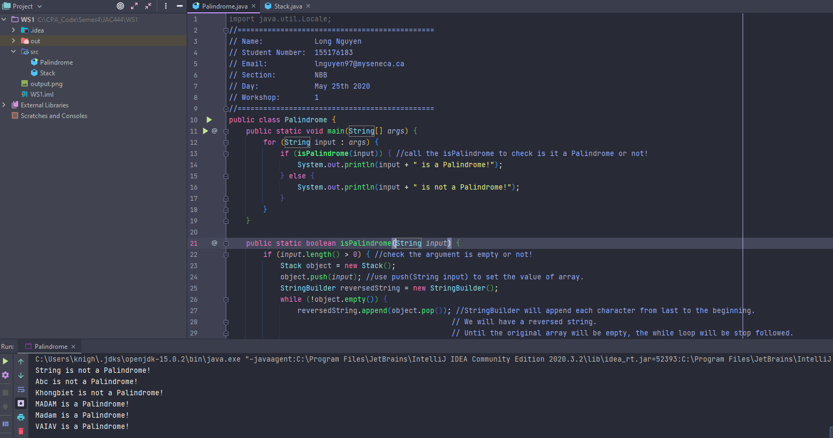

My input arguments are: "String, Abc, Khongbiet, MADAM, Madam, VAIAV"

take a look into the main function, I will call the isPalindrome(input) function to check this string is a Palindrome or not.

Inside the Palindrome function, it will check if the string pass into it is empty or not. Then it will create a new object type Stack. then push the String into Stack object (that will convert String to Array of Characters). Then I create reversedString type StringBuilder (to easy use append function). I append each character into the reversedString until the stack empty (exit while loop). Then I will check the input string and reversedString (I use equalsIgnoreCase to ignore the case of character). then return true, or false base on the process.

After all, I have the output:

String is not a Palindrome!

Abc is not a Palindrome!

Khongbiet is not a Palindrome!

MADAM is a Palindrome!

Madam is a Palindrome!

VAIAV is a Palindrome!