1. Create a class diagram to support the above case study and Systems Use Case Specifications  
   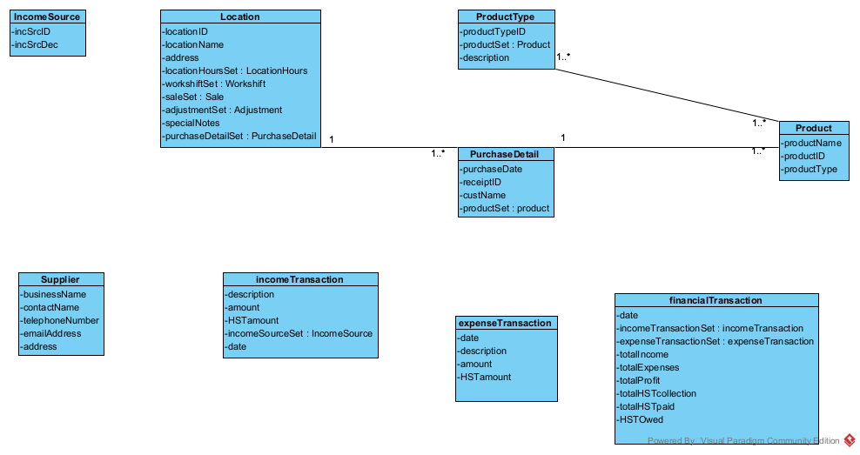
2. Create an object level sequence diagram, detailing the Create Income Transaction systems use case specification

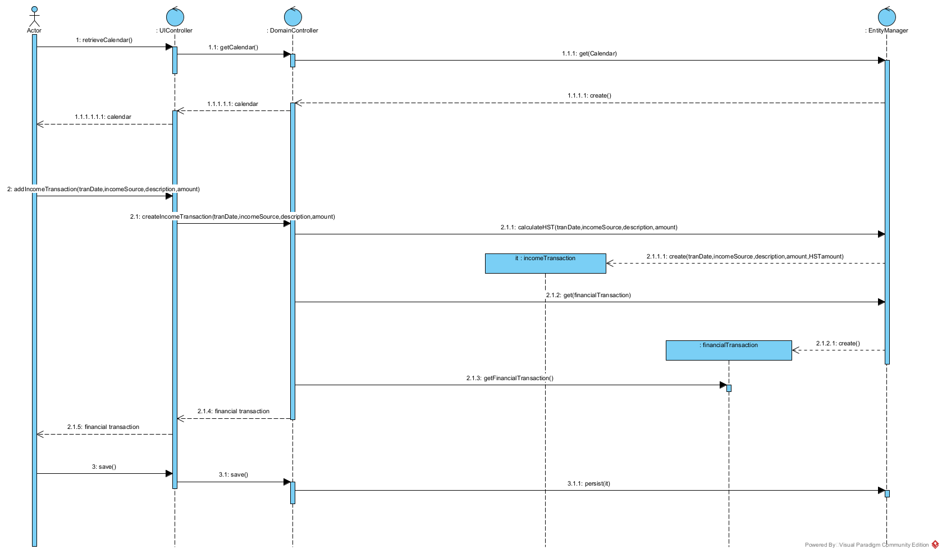

1. Create an object level sequence diagram, detailing the Create Expense Transaction systems use case specification

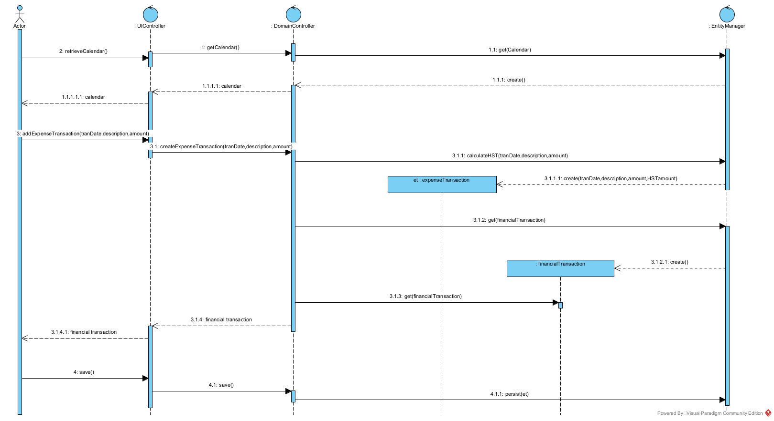

1. Create an object level sequence diagram, detailing the Query Financial Transaction system use case specification.

