SYD366 Money Test Summer 2021

Please read the case study and answer the questions below.

This test is a take-home assessment, that must be completed individually.

Test starts on Thursday June 17, 2021 at 9:00 AM  
Test is **due** Friday June 18, 2021 at 11:59 AM (**noon**).

***Work not properly referenced will be passed to the Academic Integrity Committee for review.***

**Submission notes:**

* Submission will be via Blackboard
* Submit one Word document with UML diagrams included as screenshots in the document. The pictures must be legible. Your professor will not grade any work that is not easy to read.
* Submit one Visual Paradigm file (.vpp) with all your UML diagrams included as well.
* Please note that submitted work, in any other format will not be graded and will received a grade of zero (0).

**Marks will be deducted for any of the following:**

* Files cannot be opened.
* Models and formatting do not follow course conventions.
* Missing screenshots, source files, or other required elements.
* Spelling or grammar errors, or unclear text content.
* PDF, ZIP, RAR, and other file formats will not be opened and will receive a mark of 0.

**Case Study**

Donald runs a small Medical Cleaning Productdistribution company that supplies various cleaning products to various hospitals and clinics.

Donald employs a small team, including some office, sales, and warehouse staff. A few times a year, Donald attends trade shows and visits manufacturers to learn about new products. Donald uses an outside delivery service to deliver orders to his customers.

Your team has been hired to document Donald’s requirements and recommend software for Donald to purchase.

Your team has started looking at Donald’s financial records and found that Donald allows for different payment methods and would like to categorize his company’s income and expense transactions accordingly.

Your team leader has written the following scenarios to capture Donald’s requirements.

|  |  |
| --- | --- |
| **Use Case Name** | **Record Income Transaction** |
| Triggering Event | Customer pays for work done |
| Brief Description | Allows the Owner to record an income transaction |
| Actors | Owner |
| Related Use Cases |  |
| Preconditions | Owner has opened the Main Menu. |

|  |  |  |  |  |  |
| --- | --- | --- | --- | --- | --- |
| Post Conditions | Income transaction is recorded | | | | |
| Flow of activities | Actor | | | | System |
|  | 1. | | Requests to record an income transaction | | Displays a list of payment methods and prompts for selection. Prompts for amount of transaction and transaction date (defaults to the system date) |
|  | 2. | | Selects a payment method, enters date and amount | | Displays the transaction and prompts for confirmation |
|  | 3 | | Chooses to confirm | | Saves the transaction. |
| Exception Conditions | • Owner chooses to cancel recording income transaction. | | | | |
|  |  | | | | |
| **Use Case Name** | **Query Expense transactions** | | | | |
| Triggering Event | Owner requires a list of expenses | | | | |
| Brief  Description | Allows the Owner to review expense transactions | | | | |
| Actors | Owner | | | | |
| Related Use Cases |  | | | | |
| Preconditions | Owner has opened the Main Menu. | | | | |
| Post Conditions | Expense transactions retrieved | | | | |
| Flow of activities | Actor | | | System | |
|  | 1. | Requests to query expense transactions | | Prompts for start and end date | |
|  | 2. | Enters a start and end date | | Retrieves expense transactions | |
|  |  |  | | that meet the date  requirements. Displays the list | |
| Exception Conditions | • | Owner chooses to cancel querying expense transactions. | | | |

**Question 1 (worth 10 marks)**

Complete a **Class diagram** to support what your team has learned so far about Donald’s Medical Cleaning Productdistribution business*.*

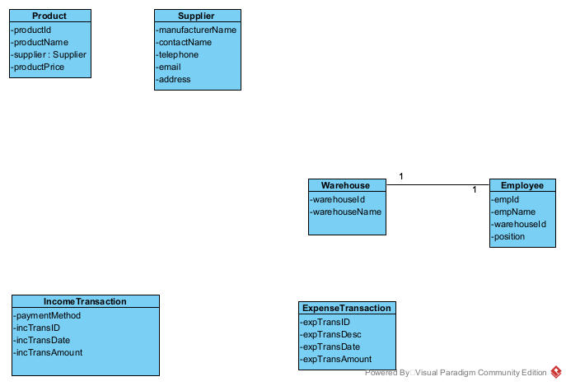

**Question 2 (worth 20 marks)**

Complete **Object Level Sequence** diagrams to support the above scenarios.

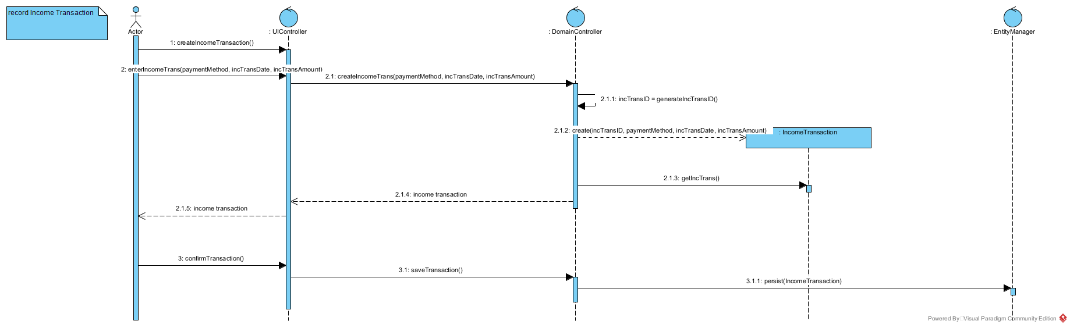

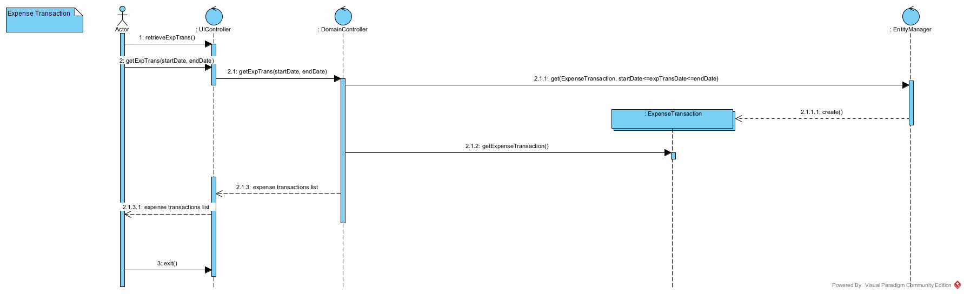

**Question 3 (worth 3 marks)**

Donald’s been approached to provide medical cleaning products for a client that is on Georgina Island Reserve. This client has tax exempt status as part of belonging to Indigenous people. What are tax implications? Does this affect your model? Please describe in English.

* Tax implication: Any property not acquired under the agreement but required by the purchaser to continue in business must be within the remaining 10% of the Fair Market Value of all acquired assets.
* If there is an amount without tax in my model. I will separate it into 2 categories, one applies HST, one is not. We will check if the transaction is included HST. If there is HST, we will process normally as others. In contrast, we no need to calculate the HST.

**Question 4 (worth 3 marks)**

Should Donald use his debit card or his credit card for purchases? Why? Please describe in English.

I will recommend he use a credit card. As far as I know, Business credit cards can offer important benefits to your company, including rewards you can use to travel virtually for free, manage expenses and credit to grow your business. your career. While you can make money in your personal life with a debit card or cash if you really want to, there are many benefits to getting the right credit card for your small business. That the reason why I recommend him to use the credit card.

**Question 5 (worth 3 marks)**

One of Donald’s customer pays him in USD. What should Donald do? How could you change your model to support this? Please describe in English.

* He should need a new function in his app. This function can convert the exchange rate at the time the customer purchase the product. Also, the app will show the customer the amount in USD they need to pay after converting the rate.
* To support this case, I will add the new function to my app. This function (method) will be called each time we have the customer outside the country or their provider bank outside the country. This function will detect their currency and convert it by exchange rate right away.

**Question 6 (worth 3 marks)**

How long are businesses required to keep records of financial transactions for taxation purposes? Why is it important to Donald’s company? Please describe in English.

* In Canada, they require the keep all the taxation purpose records and the supporting document in 6 years since the end of the last tax year relate to.
* He needs to keep records because it relates to the acquisitions and disposal of property, the share registry, or other historical information that would have an effect on the sale, liquidation or wind‑up of the business.

**Question 7 (worth 3 marks)**

Donald’s Medical Cleaning Productdistribution company is documenting the business’s requirements for a new system. We’ve looked at Agile and Waterfall (Predictive) Project Management methodologies. You are a team of 3 analysts and a Project Manager. If you were the Project Manager, what Project Management Methodology would you use for this project? And why? Please describe in English.

* I will use Agile Methodology because Agile is a flexible software development methodology that is a specific approach to software project management. It includes an integrated and interactive workflow to get the product into the hands of the user as quickly as possible. The Agile methodology will let the project has qualified members, willing to work together, it will bring success to the project. This methodology also allows focusing on each step carefully to avoid any errors, as everything is checked at the end.