Please read the case study and answer the questions below.

This test is a take-home assessment, that must be completed individually.

Test starts on Thursday July 8, 2021 at 9:00 AM  
Test is **due** Friday July 9, 2021 at 11:59 AM (**noon**).

***Work not properly referenced will be passed to the Academic Integrity Committee for review.***

**Submission notes:**

* Submission will be via Blackboard
* **Submit one Word document** with UML diagrams included as screenshots in the document. The pictures must be legible. Your professor will not grade any work that is not easy to read.
* **Submit one Visual Paradigm file (.vpp)** with all your UML diagrams included as well.
* Please note that submitted work, in any other format will not be graded and will received a grade of zero (0).

**Marks will be deducted for any of the following:**

* Files cannot be opened.
* Models and formatting do not follow course conventions.
* Missing screenshots, source files, or other required elements.
* Spelling or grammar errors, or unclear text content.
* PDF, ZIP, RAR, and other file formats will not be opened and will receive a mark of 0.

Case Study

Allan Bronner runs *Bronner Movers*, a small company that offers moving services to residential and commercial clients.

Allan employs a small team, including some office movers and drivers as staff. A few times a year, Allan attends trade shows and visits manufacturers to learn about new packing supply products and moving equipment.

Your team has started looking at Allan’s inventory records and found that Allan records measurements for each of the products that he stocks, for proper placement in his warehouse. Allan orders product from various suppliers through their online ordering portals and must record his purchases so that he knows what he has purchased and what is about to arrive at his warehouse.

Your team leader has written the following scenarios to capture Allan’s requirements.

|  |  |  |  |  |
| --- | --- | --- | --- | --- |
| Use Case Name | Create Product Information | | | |
| Triggering Event | A new product of interest to the business | | | |
| Brief Description | Allows the Owner to record a new product. | | | |
| Actors | Owner | | | |
| Related Use Cases |  | | | |
| Preconditions | Owner has opened the Main Menu. | | | |
| Post Conditions | Product is saved to the database and now can be purchased or used in a service. | | | |
| Flow of activities | Actor | | System | |
|  |  | Requests to add a new product | | Displays a list of products currently recorded in the system and prompts to add a new product. | |
|  |  | Enters the product name, description, height, width, and depth of the new product. | | Verifies that all of the data is entered. Displays the newly created product and requests to save. | |
|  |  | Request to save | | Saves the product and returns to the main menu | |
| Exception Conditions | * Owner chooses to cancel adding the product | | | |

|  |  |  |  |
| --- | --- | --- | --- |
| Use Case Name | Create Purchase | | |
| Triggering Event | Purchase of a product. | | |
| Brief Description | Allows the Owner to record a new purchase. | | |
| Actors | Owner | | |
| Related Use Cases |  | | |
| Preconditions | Owner has opened the Main Menu. | | |
| Post Conditions | Purchase is saved to the database and now can be queried. | | |
| Flow of activities | Actor | | System |
|  | 1. | Requests to add a new purchase | Displays a list of suppliers and prompts for selection. |
|  | 2. | Selects a supplier. | Verifies that a supplier was selected. Displays a calendar and prompts for purchase date and expected delivery date. |
|  | 3. | Selects purchase date and expected delivery date | Verifies that purchase date and delivery date were selected.  Creates a unique identifier for the purchase. Prompts to enter product details. |
|  | loop | Chooses new detail | Displays a list of products and prompts for selection. Prompts for price, quantity ordered, and quantity received |
|  | 4. | Selects a product and enters price and quantity. | Product must be selected.  Price and quantity must be entered  Data is valid  Dollar value of the detail is calculated and added to the total dollar value of the purchase  Dollar value of purchase and purchase detail are displayed  Prompts to add another product |
|  | End | When all products selected | Displays purchase including totals, date and list of products.  Verifies that at least one product has been selected.  Prompts to save purchase |
|  | 5. | Chooses to save | Saves the purchase and returns to the main menu |
| Exception Conditions | * Owner chooses to cancel adding the purchase | | |

**Question 1 (worth 15 marks)**

Complete a class diagram to support what your team has learned so far about *Bronner Movers.*

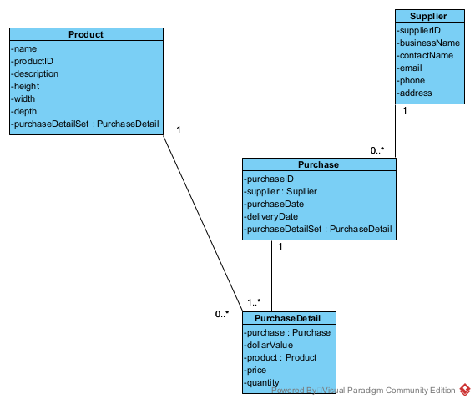

**Question 2 (worth 20 marks)**

Complete an Object Level Sequence Diagrams to support the above scenarios.

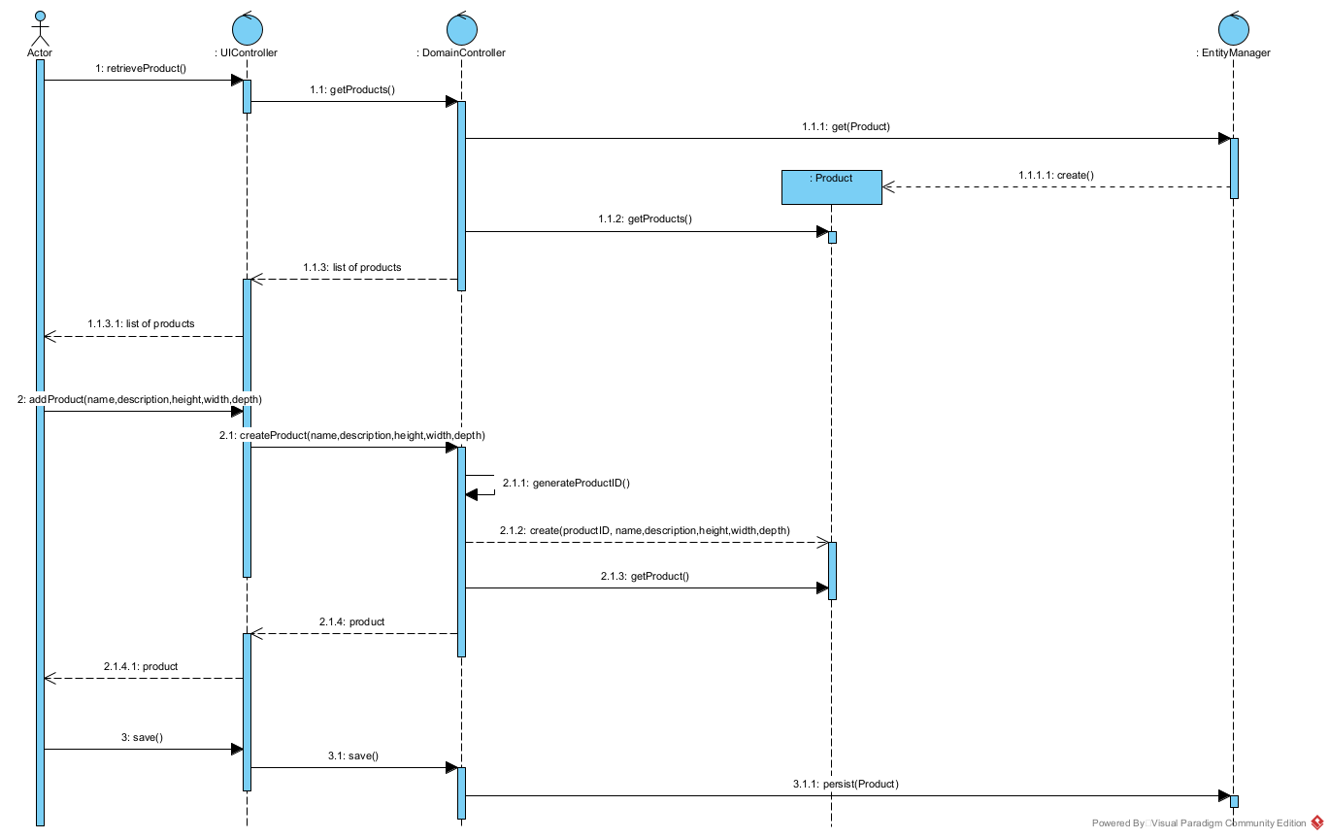

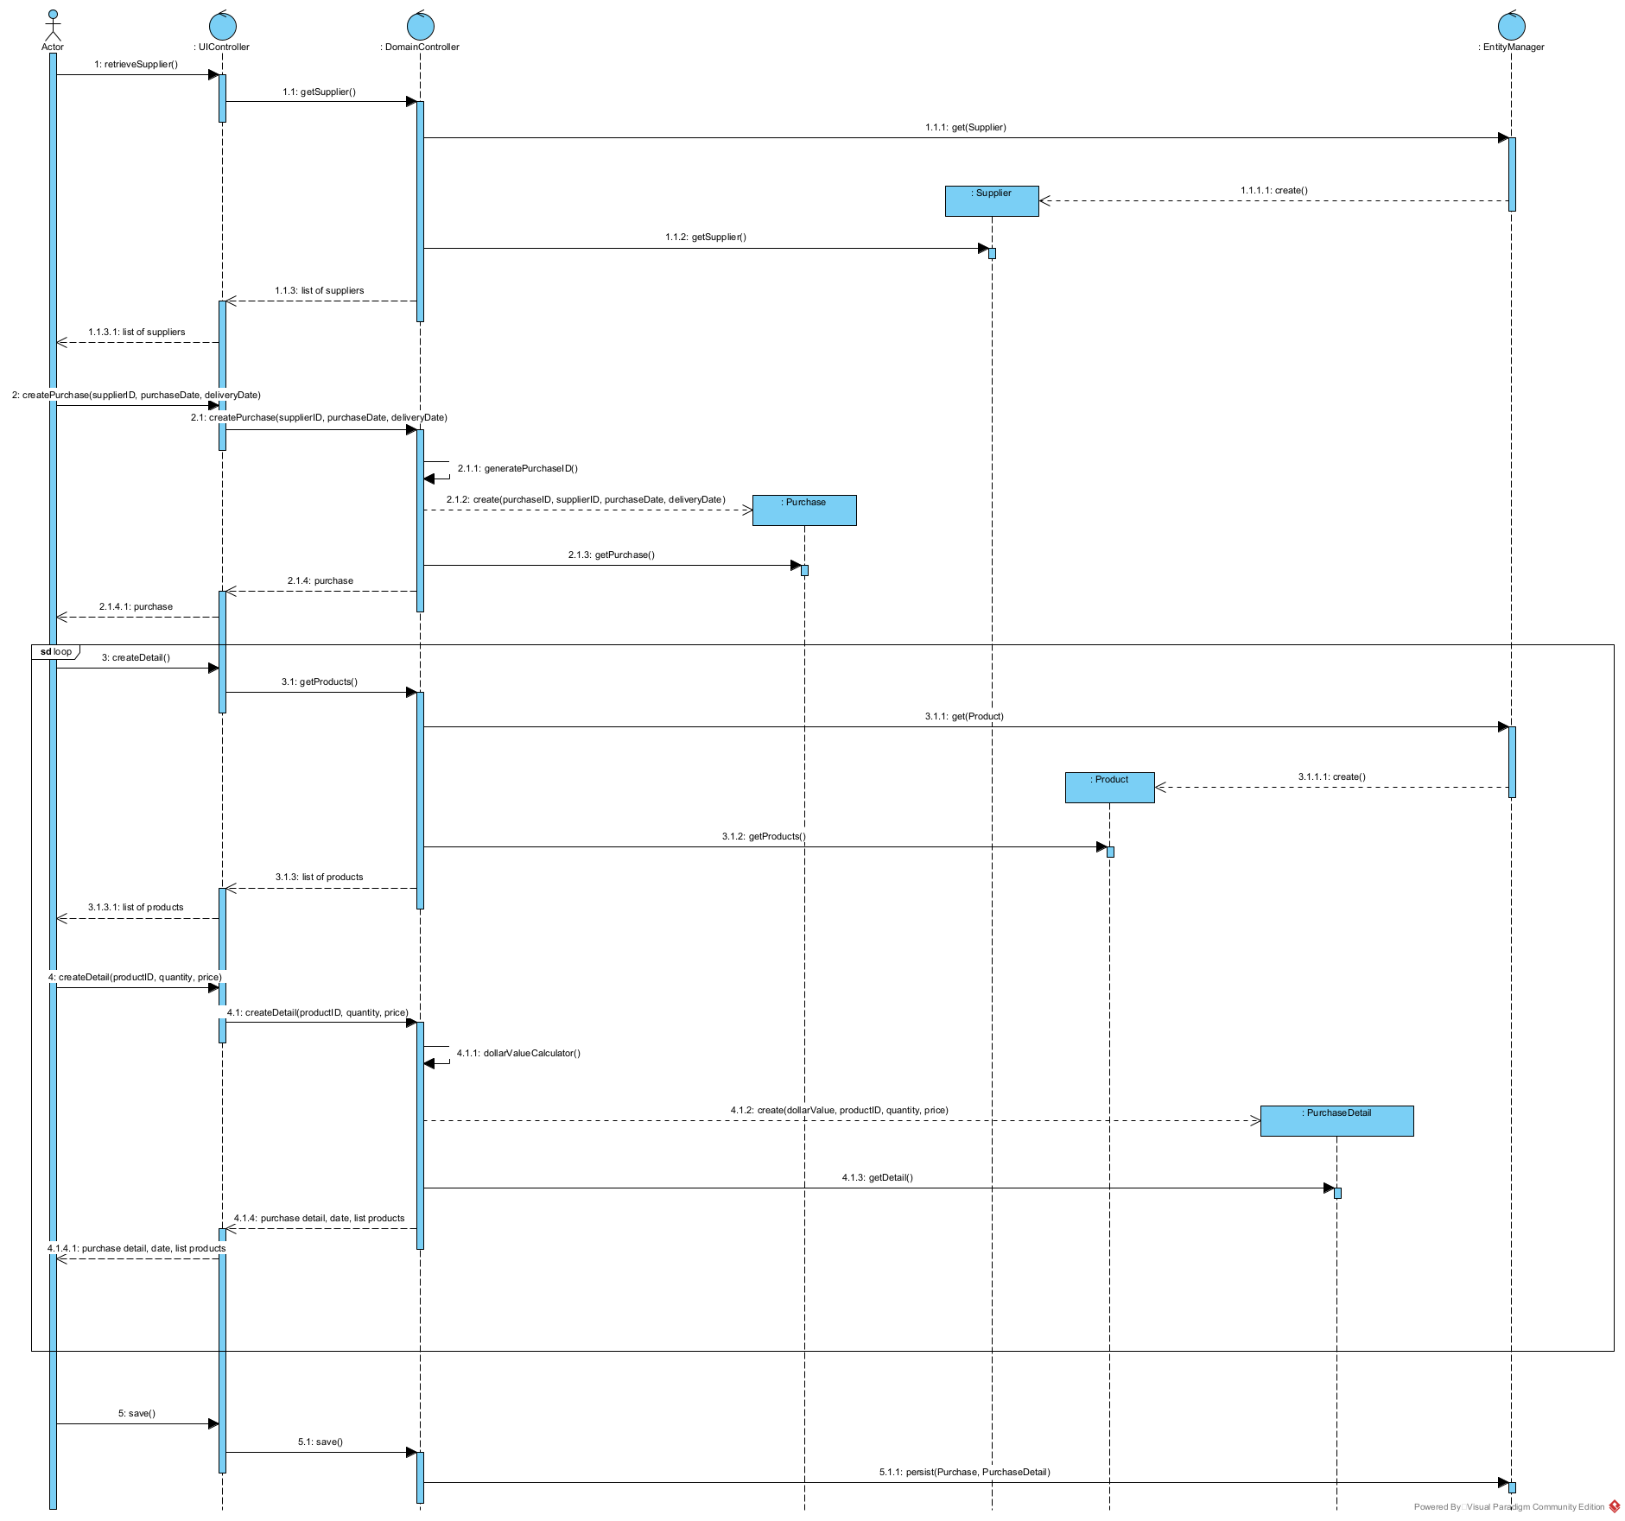

**Question 3 (worth 2 marks)**

Allan would like the system to suggest how much he should expect delivery to cost. To do that, he needs to know how much the purchase will weigh. How would you change your model to support this request?

To solve this problem, first, we need to specify the weight of each product to calculate the total weight before delivery. Then, base on the total weight of the purchase to calculate the delivery, including the delivery price into the bill for the customer.

**Question 4 (worth 2 marks)**

What is WHMIS? Is this important to Allan?

WHMIS is Workplace Hazardous Materials Information System. I think it is not too necessary for Allan company. However, few orders we need to deliver Hazardous Material. Facing this kind of order, we need the customer to declare to us. And to ready for it, we need the small number employees was trained for it, label for this order.

**Question 5 (worth 2 marks)**

Allan finds a sale on packing tape and would like to buy six months’ worth of product. How would he use your model to figure out how many to buy?

He can use the purchase date to predict the amount of orders base on the holiday (like Christmas, easter, thanksgiving, etc). To prepare for the huge amount of orders, he can buy the packing tape and worth for the business.