|  |
| --- |
| Mobile Student Lookup  Milestone 3  1/13/2012  Brandon Knight, Mark Vitale, Ann Say, Chris Gropp  Campus Mail: 1200 |

Contents

System Sequence Diagrams 3

Operations Contracts 5

Sequence Diagrams 5

Package Diagram 7

Class Diagram 8

The Who Done What Table: 8

# System Sequence Diagrams

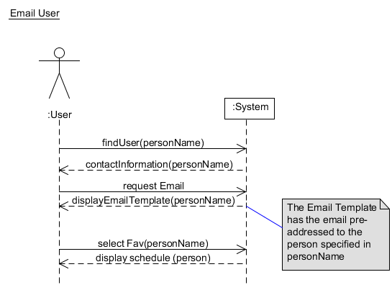

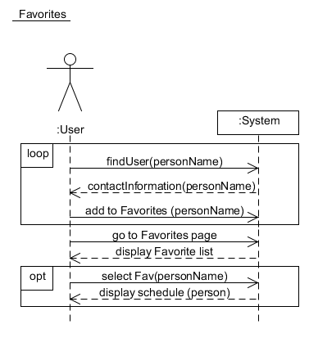

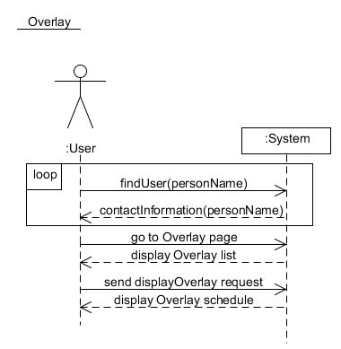

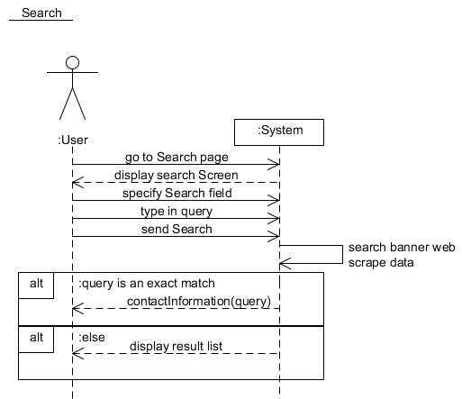

# Operations Contracts

|  |  |
| --- | --- |
| Operation: | findUser(personName) |
| Cross References: | Favorites, Overlay, Email User |
| Preconditions: | User is on a page that displays a clickable link of a person’s name. Ways to reach this page include searching via the Search use case, or viewing a class roster. |
| Postconditions: | -Display became a page that shows a person’s name, their username, their campus mail box number, their advisor, their email address, and a link to view their schedule. |

|  |  |
| --- | --- |
| Operation: | Sends Search |
| Cross References: | Search |
| Preconditions: | User is on search page |
| Postconditions: | -Display became a page with a list of results, which contain multiple people.  -If there was only one match, display shows contact information of queried person |

# Sequence Diagrams

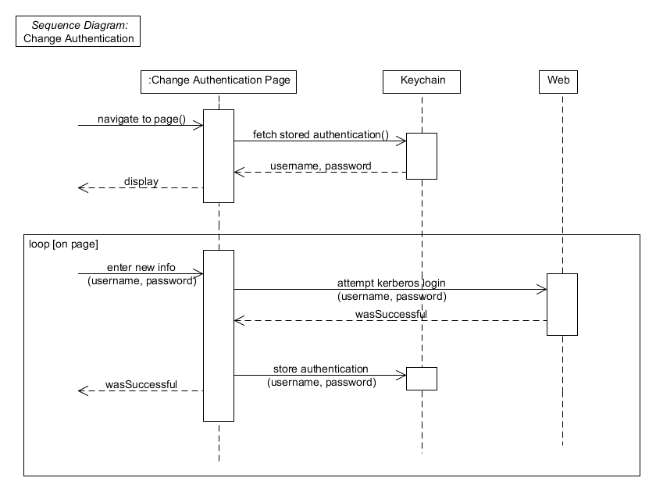

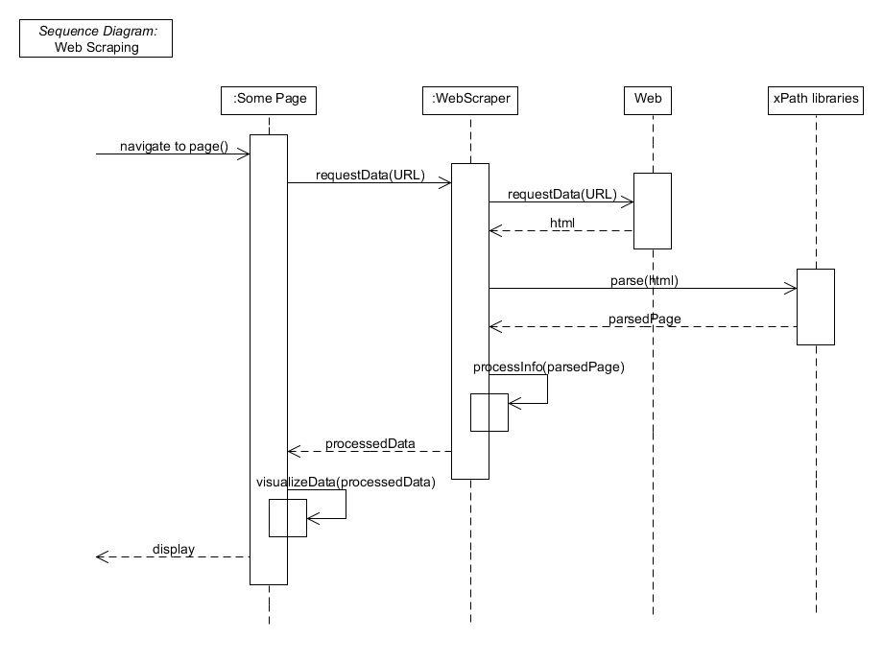

# Package Diagram

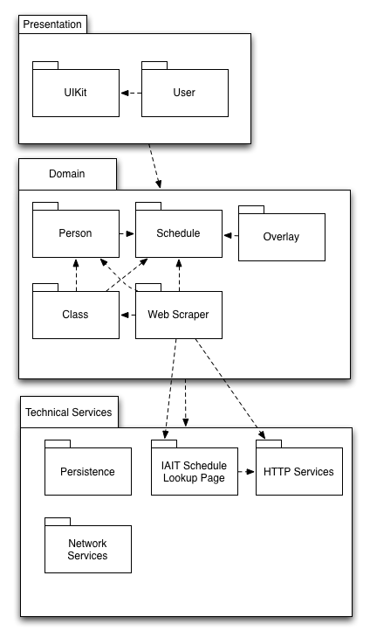

# Class Diagram

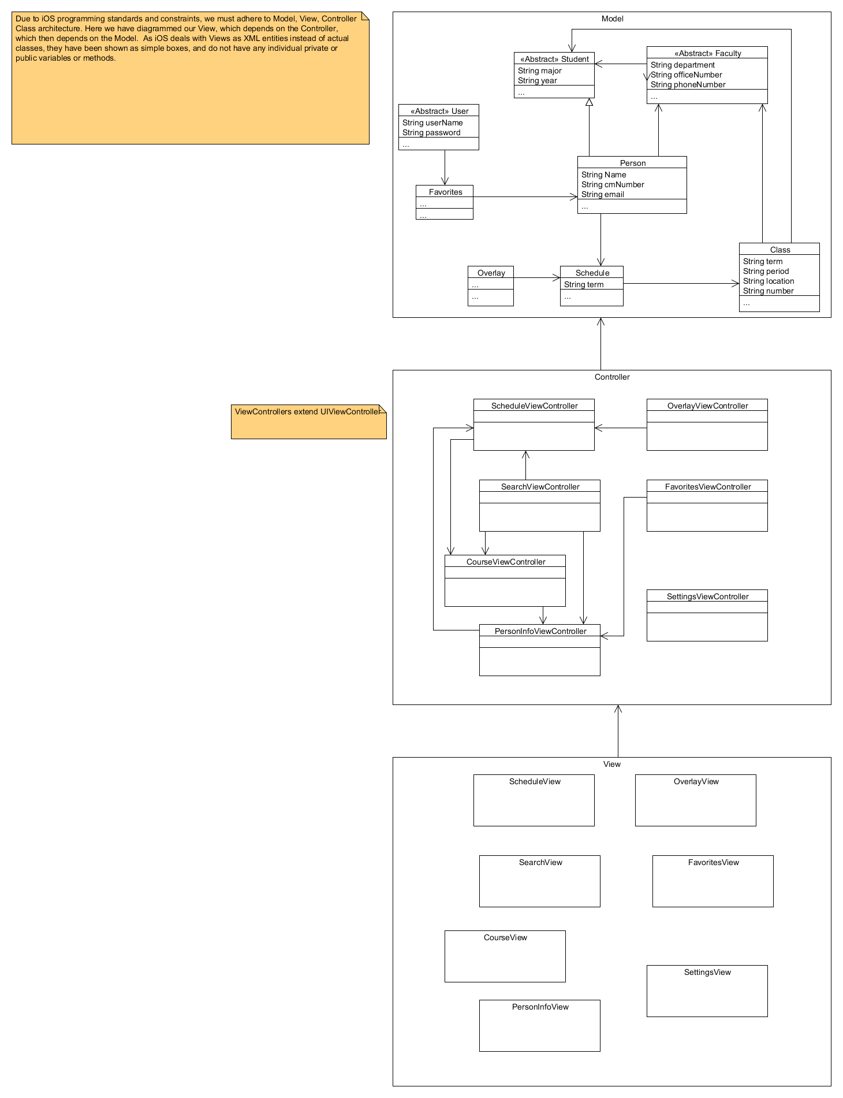

# The Who Done What Table:

|  |  |  |  |
| --- | --- | --- | --- |
| Who Done It:  Team Member Names | Section/Part Completed | Task/Comments | # of hours effort |
| Brandon Knight | Class Diagram, color slider tutorial | Created Class Diagram in UMLet | 3 hours |
| Ann Say | Operations Contracts | Completed operations contract. | 2-3 hours |
| Mark | Compiled Milestone. Kerberos Code Spike | Completed the Kerberos code spike. Compiled Milestone. Package diagrams | 5 hours |
| Chris Gropp | SDs | Created the SDs, updated engineering journal. | 2-3 hours |