GeoKnight GIS
Jacksonville Utility Network
A start-to-finish overview of a water, sewer, and electric GIS portfolio project
Christopher Knight · GeoKnight GIS · knightchrism.github.io
Links: Interactive map: web/index.html · GitHub repository: https://github.com/knightchrism/jax-utility-network · Portfolio: https://knightchrism.github.io
At a glance
Utilities run on maps. Every pipe, valve, wire, and fuse a utility owns has to be recorded in a geographic information system (GIS), connected correctly, and kept accurate so crews and planners can answer urgent questions quickly. This project shows that work end to end: I built connected water, sewer, and electric network models for two Jacksonville, Florida neighborhoods, checked them for data errors, and used them to answer the questions a utility asks every day.
- Where: Avondale/Riverside and Northside, Jacksonville, FL.
- What: water, sewer, and electric networks laid on real streets and real property parcels.
- How: an open-source Python workflow that downloads public data, builds the networks, runs quality checks, and produces maps and reports.
- Result: a working demonstration of data quality control, outage and shutoff tracing, sewer drainage tracing, and fire hydrant coverage analysis.
The problem utilities face
Water, sewer, and electric systems are large, buried or overhead, and built up over decades. When a main breaks or a fuse operates, the utility has to know right away which valves to close, which customers are affected, and where the problem sits. Those answers are only as good as the GIS data behind them.
In practice, utility GIS data carries everyday errors: pipes that do not actually connect, short stray line segments left from digitizing, missing pipe sizes, duplicated features, and equipment drawn slightly off the line it belongs to. Each error can send a crew to the wrong valve or give a customer the wrong outage message. Finding and fixing these problems, and using the network to support operations, is the core of a utility GIS role.
What was built
For the Avondale/Riverside study area (2,789 parcels), I built three connected utility networks:
Network | What it contains
Water | 1,418 main segments, 848 valves, and 2,789 service lines and meters (one per parcel), with the real fire hydrants connected to the mains
Electric | A substation tied to a real transmission line, 416 primary line segments split into 3 feeders, 82 fuses, 629 transformers, and 2,789 service drops
Sewer | 611 gravity mains, 616 manholes, 3 lift stations, and 2,789 service laterals, with manhole elevations taken from real USGS ground elevation data

The design follows real engineering conventions: valves near every intersection, electric trunk lines that are three-phase with single-phase branches protected by fuses, and sewer pipes that slope downhill with minimum cover and minimum slope standards. A second study area, Northside (2,671 parcels), was added to test fire hydrant coverage using real hydrants and real parcels.
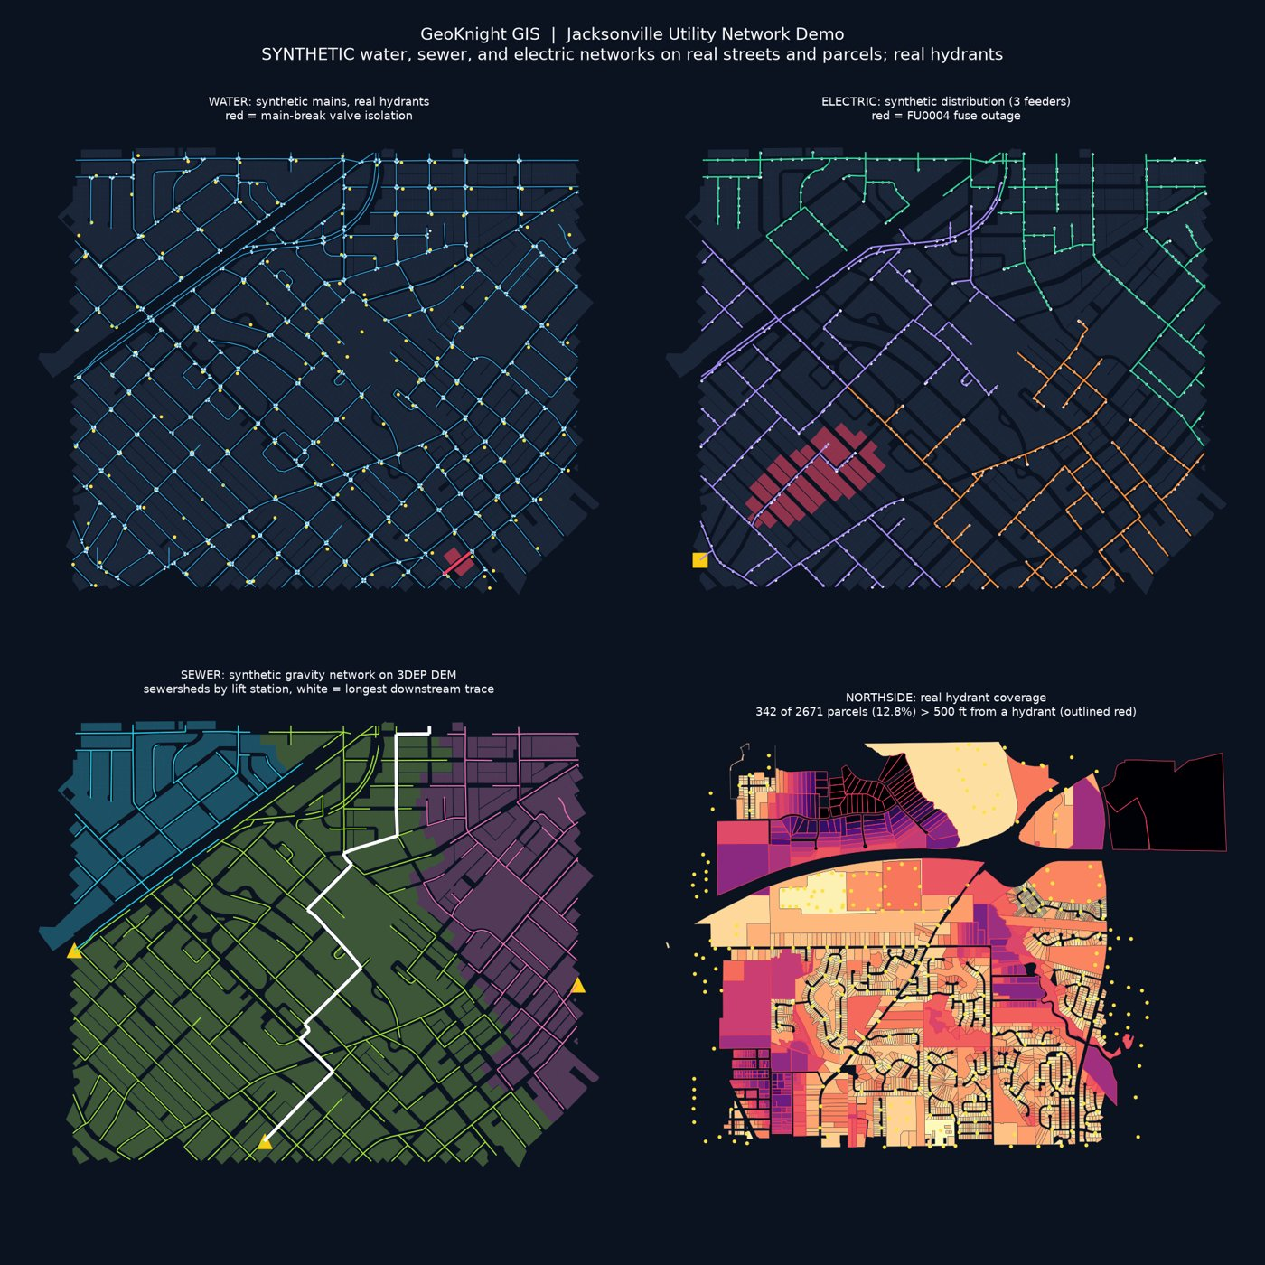
Figure 1. The four views of the project. Top left: water network, with the main-break shutoff area in red. Top right: electric distribution by feeder, with the fuse outage area in red. Bottom left: sewer drainage areas by lift station, with the longest downstream trace in white. Bottom right: Northside hydrant coverage, with parcels more than 500 ft from a hydrant outlined in red.
Real data versus synthetic data
Being clear about data sources is part of doing GIS responsibly, so every layer is labeled as real or synthetic in its file and layer name.
Real, public data used:
- Street centerlines from the US Census Bureau (TIGER)
- Property parcels from the Florida Department of Revenue
- Fire hydrants from the City of Jacksonville / JEA public hydrant service (206 in the Avondale/Riverside study area; 32,697 countywide)
- High-voltage transmission lines from HIFLD Open (132 in the Duval County area)
- Power lines, substations, and poles from OpenStreetMap (1,712 lines, 117 substations, and 11,122 poles, towers, and transformers in Duval County; © OpenStreetMap contributors)
- Ground elevation from the USGS 3D Elevation Program
- Septic tank phase-out areas from the City of Jacksonville (4 areas)
Synthetic data, and why: JEA does not publish its water, sewer, or electric distribution networks. That information is treated as critical infrastructure, which is appropriate. So I generated realistic networks along the real streets and parcels, and every one of those layers is clearly labeled synthetic. I also planted some data errors on purpose, flagged in the data, to prove that the quality checks catch them.
What each analysis does, and what it found
1. Data quality checks
These checks scan each network for the kinds of errors that break real utility operations. Results for the Avondale/Riverside networks:
Network | Issues found
Water | 6 disconnected mains, 17 short dangling segments (under 60 ft), 6 mains missing a pipe size, 2 duplicate mains, 3 valves not sitting on a main
Electric | 2 transformers not connected to a line; missing phase on 2 transformers and 3 line segments; 2 transformers missing voltage; every line segment reachable from the substation
Sewer | 5 pipes sloping the wrong way, 1 flow loop, 3 manholes with no connected pipe; 41 steep pipes and 139 manholes deeper than 20 ft flagged for engineering review

Each finding is listed by feature ID in the QC report, so a technician could go straight to it and fix it.
2. Water main break: which valves to close
When a water main breaks, crews need to close the fewest valves that stop the flow. The model starts at the break and walks outward along the pipes until it reaches valves. For a break on main WM00645, the answer is close 4 valves, which takes 5 mains out of service and leaves 5 parcels without water. That is the list a dispatcher would hand a crew and the customer list for notices.
3. Electric fuse outage: who loses power
When a fuse operates, everything downstream of it loses power. The model follows the feeder downstream from the fuse. When fuse FU0004 on feeder FDR-101 operates, 25 transformers and 139 customers are out. For comparison, a full feeder outage would affect 1,110 customers on FDR-101, 937 on FDR-102, or 742 on FDR-103, which shows why fuses limit the size of an outage.
4. Sewer drainage to lift stations
Sewage flows downhill by gravity to lift stations, which pump it onward. The model traces which parcels drain to each lift station: LS-1 serves 337 parcels, LS-2 serves 1,823, and LS-3 serves 629. The longest downstream path runs through 33 manholes and 7,543 ft to LS-2. This tells a utility how much load each station carries and which areas are affected if a station fails.
5. Fire hydrant coverage
This analysis measures how far each parcel is from the nearest real fire hydrant and flags those more than 500 ft away. Hydrants just outside each study area are included so edge parcels are not unfairly flagged.
- Avondale/Riverside: 0 of 2,789 parcels are more than 500 ft from a hydrant, reflecting a dense, older street grid.
- Northside: 342 of 2,671 parcels (12.8%) are more than 500 ft from a hydrant; 107 are more than 1,000 ft; the farthest is 2,380 ft.
These are straight-line distances, and large undeveloped parcels push the Northside numbers up. The flagged parcels are best read as candidates for field review, not confirmed deficiencies.
Deliverables
- Interactive web map: every layer can be switched on and off, including the trace results.
- GeoPackage: a single portable GIS database holding all layers and results, ready to open in ArcGIS Pro or QGIS.
- QC report: every data quality finding with counts and feature IDs, plus the trace and coverage results.
- README and data source log: documentation of the sources, methods, results, and how to rerun the full workflow.
Why this matters to a utility employer
- Network thinking: I model utilities as connected systems, not just lines on a map, which is what valve isolation, outage tracing, and drainage tracing depend on.
- Data quality discipline: I find and document the errors that undermine field operations, and I prove the checks work.
- Multi-utility range: water, sewer, and electric in one project, using the conventions each one follows.
- Honest, documented data: real public sources are credited, and synthetic data is clearly labeled.
- Repeatable workflow: the whole project reruns from scripts, so updates are fast and consistent, a good fit for remote GIS teams.
Next steps
- Load the networks into a PostGIS spatial database so traces can run directly in the database.
- Add a reclaimed water network.
- Measure hydrant coverage along streets rather than in a straight line, which better matches how hoses are laid.
Glossary
Term | Meaning
GIS | Geographic information system: software and data that store where things are and how they relate.
Topology | The rules for how features connect, such as pipes meeting at junctions. Good topology lets the map behave like a real network.
Valve isolation | Finding the smallest set of valves to close to shut off water to a broken main.
Feeder / fuse | A feeder is an electric line leaving a substation. A fuse protects a branch of it and limits how many customers lose power.
Lift station | A pump station that lifts sewage to a higher point so it can keep flowing by gravity.
Sewershed | The area whose sewage drains to one point, such as a lift station.
Parcel | A single property lot as recorded by the county or state.
GeoPackage | An open, single-file GIS database format that holds many map layers together.
Synthetic data | Realistic data generated for demonstration where the real data is not public.
QC | Quality control: systematic checks that find errors in the data.

