**Amrita School of Engineering, Coimbatore Department of Computer Science and Engineering**

**BTech / IV Year CSE / VII Semester**

**MOBILE APPLICATION DEVELOPMENT**

**Project Title: FRUITS CLASSIFICATION**

**Team Number: 24**

**Team Members:**

|  |  |  |
| --- | --- | --- |
| **Sl. No** | **Name** | **Register Number** |
| **1.** | **Abinesh T** | **CB.EN.U4CSE21302** |
| **2.** | **Shreeya Asawa** | **CB.EN.U4CSE21357** |

**Date : 14/08/2024**

**Problem Statement and its Significance:**

Identifying Fruitts Using Deep Learning

The goal is to create an automated system that can classify different types of fruits using machine learning and deep learning models. The system should be able to analyze images of fruits and accurately identify them based on their characteristics, like shape, color, and texture. This involves training models on a dataset of labeled fruit images to distinguish between various types of fruits, such as apples, bananas, oranges, and more.

Significance

This problem is important because it has the potential to make a big difference in industries like agriculture, food production, and retail. Right now, sorting and classifying fruits is often done manually, which takes a lot of time and effort. By automating this process using machine learning and deep learning, companies can save time, cut costs, and improve accuracy. For example, instead of relying on people to sort fruits by hand, an automated system could quickly and reliably identify and categorize different types of fruits, ensuring consistent quality and reducing mistakes.

This kind of system could also push technology forward. Building a reliable fruit classification model requires using advanced techniques in AI, which can lead to new discoveries in image recognition and other areas. It's a project that can help expand our understanding of AI and how to apply it to real-world problems.

On top of that, automation could help reduce food waste. By accurately sorting fruits, it’s easier to separate fresh produce from damaged or spoiled items, ensuring only the best fruits make it to market. This could lead to more sustainable practices, which is increasingly important in today’s world. So, the significance of this project extends far beyond just sorting fruits—it's about creating smarter, more efficient systems that benefit both businesses and the environment.

**Reference Papers:**

1. Title:Automatic Fruit Classification Using Deep Learning for Industrial Applications

DOI: 10.1109/TII.2018.2875149

2. Title: :Recognition of fruits using hybrid features and machine learning

DOI: 10.1109/CAST.2016.7915033

3. Title: Fruit recognition from images using deep learning

DOI: 10.2478/ausi-2018-0002

**DATASET:**

Link : [Dataset](https://bitbucket.org/ishaanjav/code-and-deploy-custom-tensorflow-lite-model/raw/a4febbfee178324b2083e322cdead7465d6fdf95/fruits.zip)

**Technology relevant with project:**

|  |  |  |  |
| --- | --- | --- | --- |
| S.NO. | Paper Title | Existing model in Paper | Model Accuracy |
| 1. | Fruit recognition from images using deep learning | CNN | 96.3 % |
| 2. | Recognition of Fruits Using Hybrid Features and Machine Learning | 1) Support Vector Machine (SVM)  2) K-Nearest Neighbours (K-NN) (value of k was set to 2) | 86.96%   91.30% |
| 3. | Automatic Fruit Classification Using Deep Learning for Industrial Applications. | 1)Light CNN Model    2) VGG-16 Fine-Tuned Model | 99.49% on dataset 1 and 85.43% on dataset 2   99.49% on dataset 1 and 85.43% on dataset 2 |

**Existing Model:**

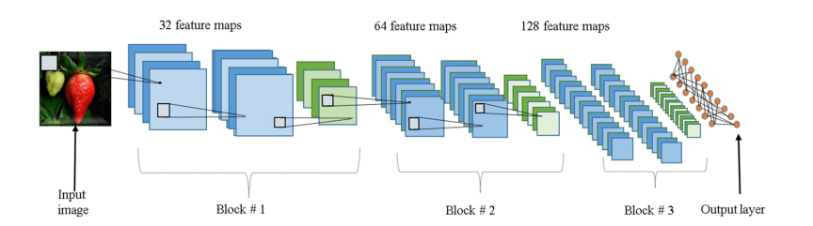

Fig. 1. Block diagram of the proposed light architecture. The blue layers represent CNN layers, the green layers represent max pooling layers, and the orange nodes represent a hidden fully connected layer and the output layer.

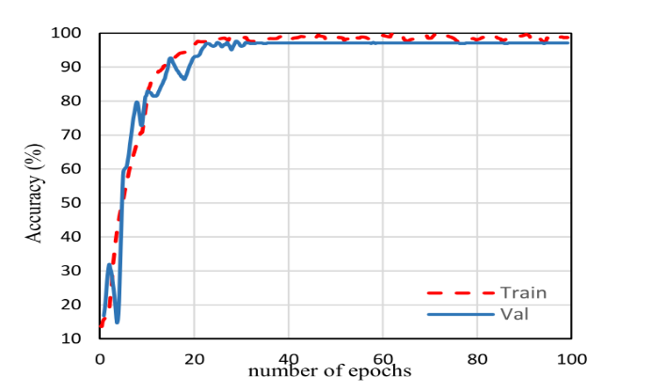

Fig. 2. Training versus validation accuracy for dataset

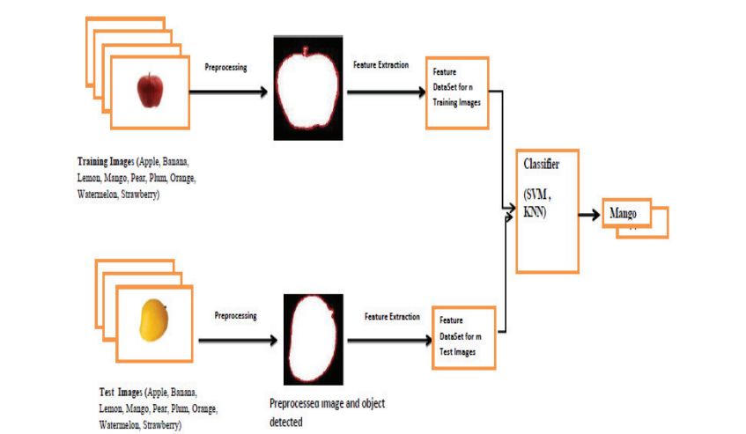

Fig:3 Methodology of Recognition Process

**Experiment :  
  
Model1 (CNN) :**

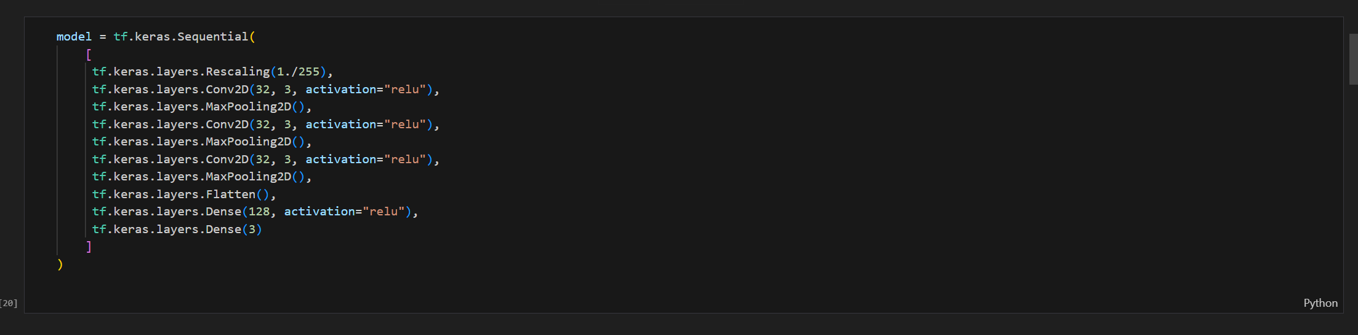

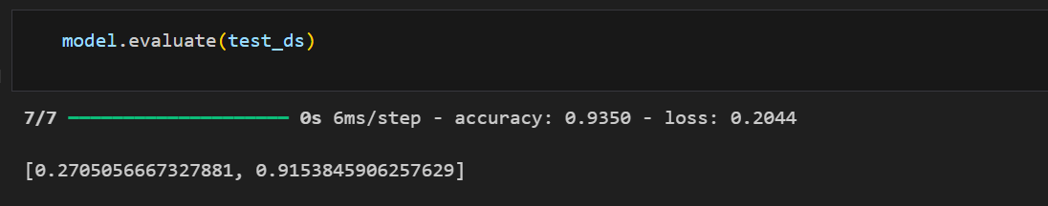

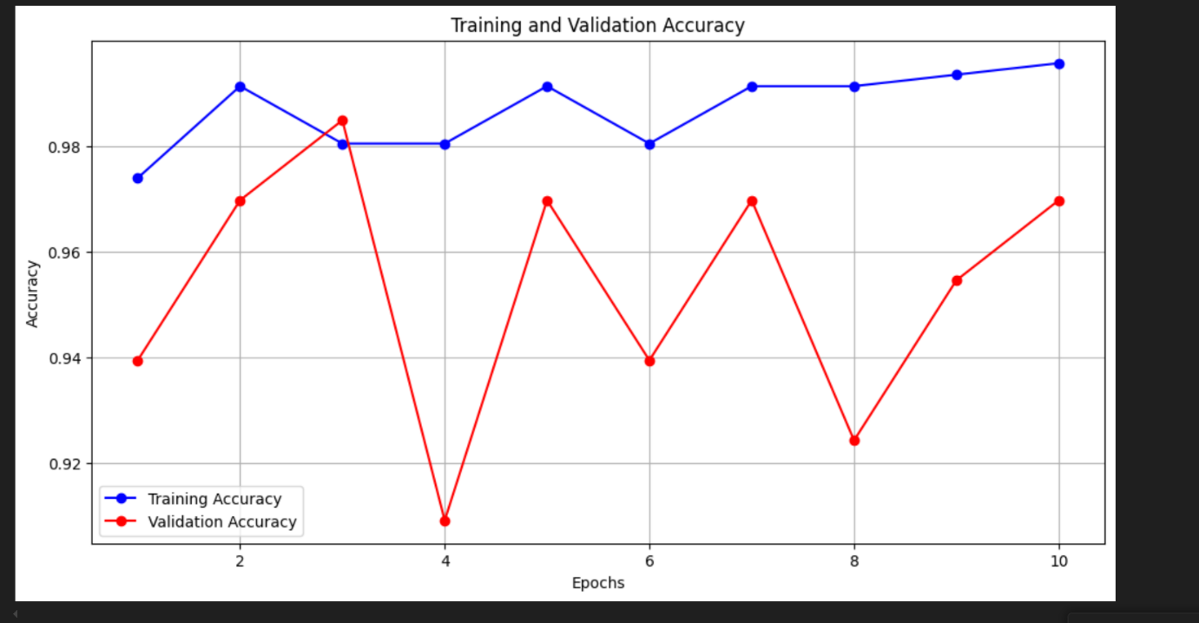

Fig. 4. CNN MODEL – Training and Testing

**Model2 (Mobile net V2) :**

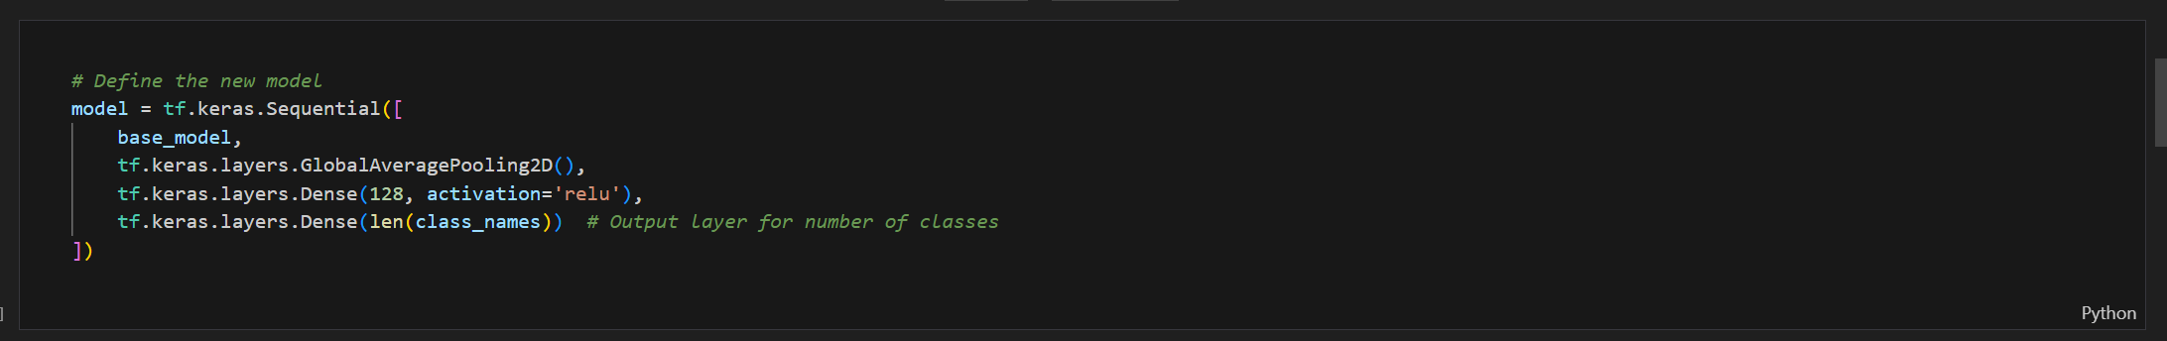

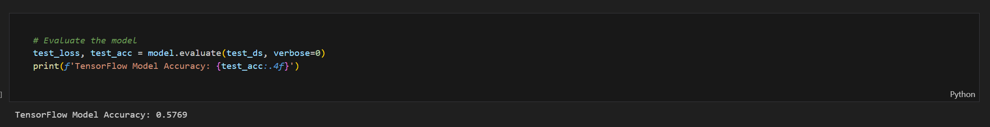

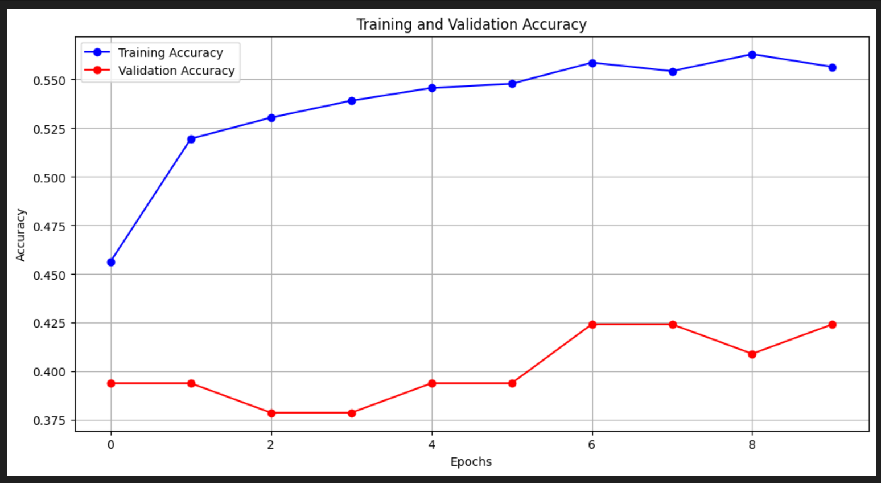

Fig. 6. MobilenetV2 MODEL – Training and Testing

**Results:**

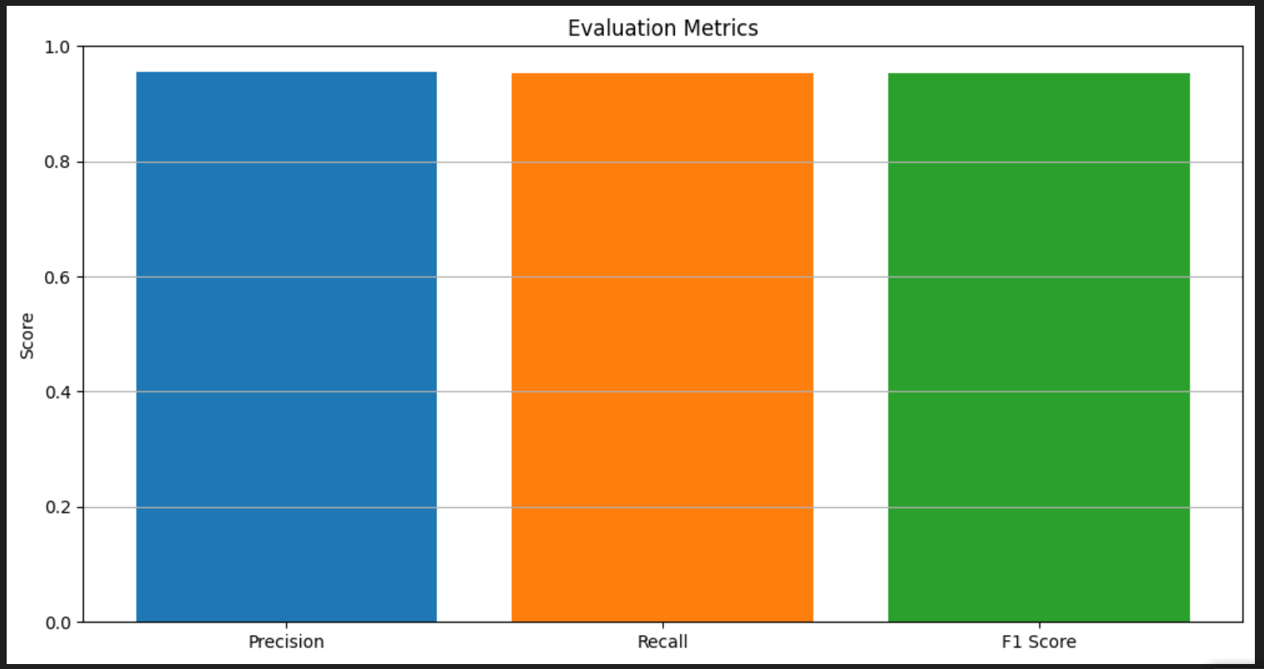

Fig. 5. CNN MODEL – Metrics

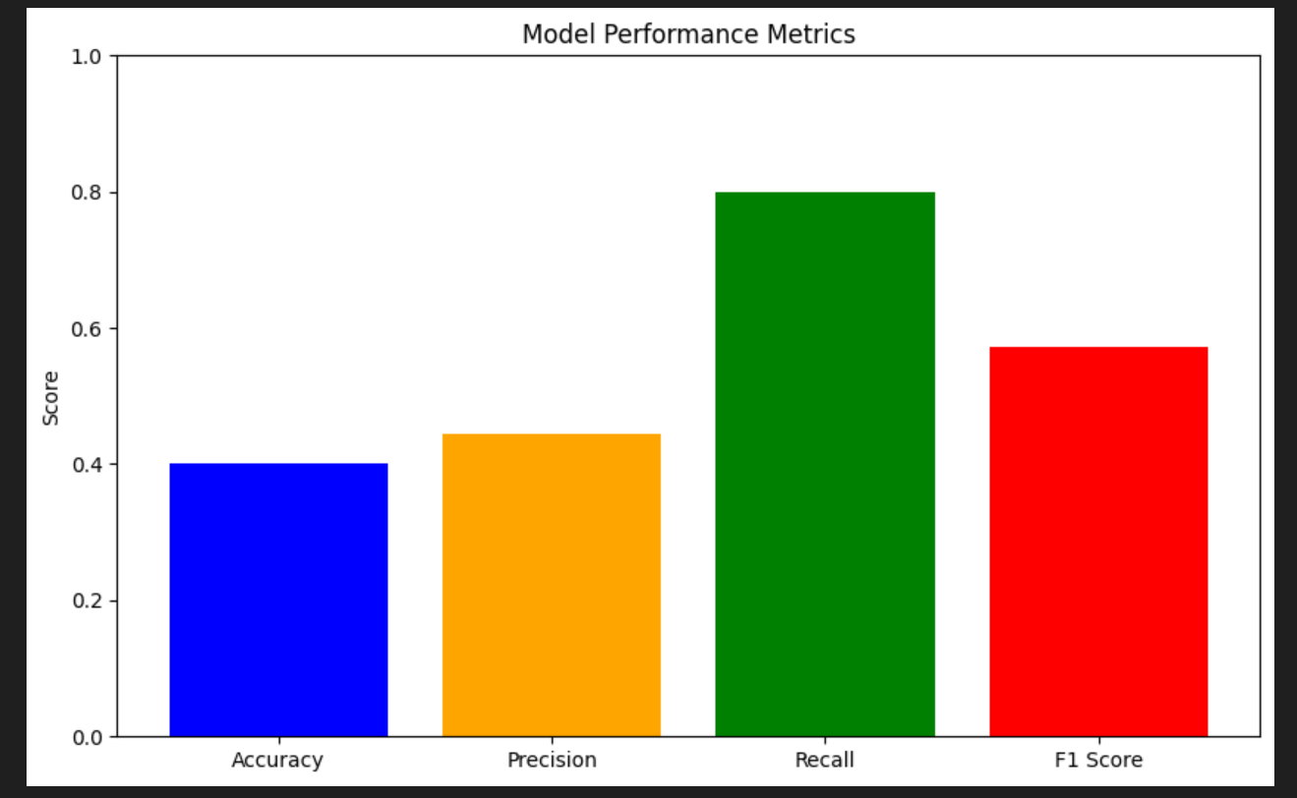

Fig. 7. MobilenetV2 – Metrics

Application UI :

