|  |
| --- |
| S.B.O.A School and Junior College |
| A C++ Project: Periodic Table |
| //Using Files and Graphics |

|  |
| --- |
| //M.Abu Bakr, K.K. Yaswant Narayan and G.Nitish  //2015-2016 |

CONTENTS

* ACKNOWLEDGEMENT
* SYNOPSIS
* INTRODUCTION
* AIM
* COMPONENTS
* ALGORITHM
* SOURCE CODE
* WORKING / DISPLAY
* APPLICATION
* RESULT
* BIBLIOGRAPHY

ACKNOWLEDGEMENT

I would like to thank all my classmates involved in this project with me for their fullest co-operation and kind help. I would like to express my sincere gratitude to Mrs. Geetha

our C.S. teacher for helping me in the successful completion of my project and demonstration.

I also thank our principal

MRS. RADHIKA UNNI

and the school for the lab facilities.

SYNOPSIS

We chose this project for the betterment of understanding the concept of Computer and Science. I hope it would be of great help to everybody who uses it.

This project is purely based on what we have derived from understanding the concept thought to us by our teachers.

Our project – The Periodic Table is widely used by all Science enthusiasts and other people; the best part – we added a few bits to all the elements chosen.

We have made it interactive in a graphical manner, completely user friendly and what everybody calls it – pretty printed with comment lines for better understanding of the source code.

Use the arrow keys to navigate between S, P, D and F blocks in the menu with the table in the beginning. Once chosen, it will lead you to a screen with the specific elements of the block, now you are free to move a box enclosing an element to your desired element and choose it. Now you will get the details of the element – the name (obvious!), symbol, atomic mass with number and its electronic configuration of orbitals. Enjoy…

INTRODUCTION

We were actually discussing about how to make a game – well let’s not go into it. It all started with the thought on how to make something useful for a student’s studies instead of playing games all day long. This one, our project, well; uses the graphics technology built in C++ - not that amusing but worth for 8-bit games and Periodic Tables (ha!).

It started as a simple interface of elements and viewing it but we wanted more and more and…well led to this stage of its improvement. Our project, now you move around to choose your element which you want to view the details with.

Okay the projects source code’s a bit lengthy, around 1000 to 1500 lines, but is extremely understandable for developers (i.e.) if you want to make your own version, just change it – we did not want to make it a fixed one. So ultimately, for all’s benefit stands this project for your fascination!

AIM OF THIS PROJECT

Well it has to be mentioned, doesn’t it?

To make a fully understandable, educating, satisfying, enjoying and a working condition of a Periodic Table using C++ as a programming language in a computer using the concepts of Files and Graphics present in-built in it.

Well in short – to give you a Periodic Table which is intractable using C++ loaded with goods.

COMPONENTS REQUIRED

This also has to be mentioned?! Well just in case…

Hardware (min):

1. Monitor
2. CPU
3. Mouse
4. Keyboard
5. AC Power supply

Software (min):

1. Any OS that supports C++ Compiler
2. C++ Compiler
3. Our Project files (yup!)

ALGORITHM

This one is COMPULSORY!!

START

struct element:

Public:

atno (int) - For storing atomic number of all elements

sym (char) - For storing symbols of all elements

ele_name (char[20]) - For storing names of all elements

atwt (float) - For storing atomic weight of all elements

at_con (char[150]) - For storing orbital configuration of all elements

Start ():

1. border() is initiated for border.
2. atno() is called for the initial chart.
3. Initialize char ‘a’ for storing in after the user types.
4. If the char is ‘s’ given by user – sblock() is called.
5. Else if the given char is ‘p’ – pblock() is called.
6. Else if the given char is ‘d’ – dblock() is called.
7. Else if the given char is ‘f’ – fblock() is called.
8. Else if the user wants to quit ESC key is pressed.

Output():

//The last page of this program.

1. Temporary object of ‘element’ is created for storing data.
2. File is opened by constructor using object in *.dat mode.
3. eof() checks if the file reaches end point.
4. File is read record by record and checked if the record at_no matches the parameter at_no.
5. If it matches display() is called using the same object.
6. The file is closed.
7. A key is pressed to start the whole process again.

atno():

//The first page of this program

1. All the required variables are declared.
2. For loop is initialized for making a grid appearance to show the atomic numbers.
3. The text shape, size and font is adjusted to the required values and the heading is printed on top.
4. All the atomic numbers are given according to the Periodic Table with appropriate colours for each group.

Border():

1. Variables m1 and m2 are declared for storing mid values of x and y co-ordinates.
2. 2 rectangle functions are used to make outline of the screen
3. The text “Periodic Table” is shown at the top of the screen.

Sblock():

1. The text style, shape and size are set to the appropriate values.
2. Heading “S-Block” is displayed at a location.
3. Required variables are declared for for-loops.
4. For loops are initialized and all the boxes and letters appear at the respective locations.
5. A legend is displayed at an appropriate location on the same page.
6. A navigation box is created for moving and choosing the desired element on the screen by the user.
7. Switch-Case is used for the movement and the selection of the required elements.
8. For loop is used till this point and is exited when the user presses ESC button.
9. A key is pressed and the function exits.

Pblock():

1. The text style, shape and size are set to the appropriate values.
2. Heading “P-Block” is displayed at a location.
3. Required variables are declared for for-loops.
4. For loops are initialized and all the boxes and letters appear at the respective locations.
5. A legend is displayed at an appropriate location on the same page.
6. A navigation box is created for moving and choosing the desired element on the screen by the user.
7. Switch-Case is used for the movement and the selection of the required elements.
8. For loop is used till this point and is exited when the user presses ESC button.
9. A key is pressed and the function exits.

Dblock():

1. The text style, shape and size are set to the appropriate values.
2. Heading “D-Block” is displayed at a location.
3. Required variables are declared for for-loops.
4. For loops are initialized and all the boxes and letters appear at the respective locations.
5. A legend is displayed at an appropriate location on the same page.
6. A navigation box is created for moving and choosing the desired element on the screen by the user.
7. Switch-Case is used for the movement and the selection of the required elements.
8. For loop is used till this point and is exited when the user presses ESC button.
9. A key is pressed and the function exits.

Fblock():

1. The text style, shape and size are set to the appropriate values.
2. Heading “F-Block” is displayed at a location.
3. Required variables are declared for for-loops.
4. For loops are initialized and all the boxes and letters appear at the respective locations.
5. A legend is displayed at an appropriate location on the same page.
6. A navigation box is created for moving and choosing the desired element on the screen by the user.
7. Switch-Case is used for the movement and the selection of the required elements.
8. For loop is used till this point and is exited when the user presses ESC button.
9. A key is pressed and the function exits.

Main():

1. Graphics is initialized legally.
2. Border() is called for displaying the border on screen.
3. The text style, shape and size are set to the appropriate values.
4. Start() is called for viewing all the contents and options.

STOP

SOURCE CODE

//Periodic Table – Source Code

//defining required headers

#include<fstream.h>

#include<iostream.h>

#include<conio.h>

#include<graphics.h>

#include<stdio.h>

#include<dos.h>

#include<stdlib.h>

#include<string.h>

#include<process.h>

//defining commonly used variables

#define up 72

#define down 80

#define right 77

#define left 75

#define esc 27

#define enter 13

//defining prototypes

void start();

void output(int a);

void atno();

void border();

void sblock();

void pblock();

void dblock();

void fblock();

//---------------------------------------------------------------------------

struct element

{

int at_no;

char sym[3];

char ele_name[20];

float at_wt;

char at_con[150];

void display()

{

cout<<'\n'<<'\n'<<'\n'<<'\n'<<'\n'<<'\n'<<'\n';

cout<<"\n\tAtomic number: "<<at_no;

cout<<"\n\n\tSymbol: "<<sym;

cout<<"\n\n\tName: "<<ele_name;

cout<<"\n\n\tAtomic weight: "<<at_wt;

cout<<"\n\n\tElectronic Configuration: "<<at_con;

border();

}

}e[118]={{1,"H","Hydrogen",1.008,"1s-1"},

{2,"He","Helium",4.003,"1s-2"},

{3,"Li","Lithium",6.941,"1s-2 2s-1"},

{4,"Be","Beryllium",9.012,"1s-2 2s-2"},

{5,"B","Boron",10.811,"1s-2 2s-2 2p-1"},

{6,"C","Carbon",12.011,"1s-2 2s-2 2p-2"},

{7,"N","Nitrogen",14.007,"1s-2 2s-2 2p-3"},

{8,"O","Oxygen",15.999,"1s-2 2s-2 2p-4"},

{9,"F","Flourine",18.998,"1s-2 2s-2 2p-5"},

{10,"Ne","Neon",20.180,"1s-2 2s-2 2p-6"},

{11,"Na","Sodium",22.990,"1s-2 2s-2 2p-6 3s-1"},

{12,"Mg","Magnesium",24.305,"1s-2 2s-2 2p-6 3s-2"},

{13,"Al","Aluminium",25.982,"1s-2 2s-2 2p-6 3s-2 3p-1"},

{14,"Si","Silicon",28.086,"1s-2 2s-2 2p-6 3s-2 3p-2"},

{15,"P","Phosphorous",30.974,"1s-2 2s-2 2p-6 3s-2 3p-3"},

{16,"S","Sulphur",32.066,"1s-2 2s-2 2p-6 3s-2 3p-4"},

{17,"Cl","Chlorine",35.453,"1s-2 2s-2 2p-6 3s-2 3p-5"},

{18,"Ar","Argon",39.948,"1s-2 2s-2 2p-6 3s-2 3p-6"},

{19,"K","Potassium",39.098,"1s-2 2s-2 2p-6 3s-2 3p-6 4s-1"},

{20,"Ca","Calcium",40.078,"1s-2 2s-2 2p-6 3s-2 3p-6 4s-2"},

{21,"Sc","Scandium",44.956,"1s-2 2s-2 2p-6 3s-2 3p-6 3d-1 4s-2"},

{22,"Ti","Titanium",47.880,"1s-2 2s-2 2p-6 3s-2 3p-6 3d-2 4s-2"},

{23,"V","Vanadium",50.942,"1s-2 2s-2 2p-6 3s-2 3p-6 3d-3 4s-2"},

{24,"Cr","Chromium",51.996,"1s-2 2s-2 2p-6 3s-2 3p-6 3d-5 4s-1"},

{25,"Mn","Manganese",54.938,"1s-2 2s-2 2p-6 3s-2 3p-6 3d-5 4s-2"},

{26,"Fe","Iron",55.993,"1s-2 2s-2 2p-6 3s-2 3p-6 3d-6 4s-2"},

{27,"Co","Cobalt",58.933,"1s-2 2s-2 2p-6 3s-2 3p-6 3d-7 4s-2"},

{28,"Ni","Nickel",58.693,"1s-2 2s-2 2p-6 3s-2 3p-6 3d-8 4s-2"},

{29,"Cu","Copper",63.546,"1s-2 2s-2 2p-6 3s-2 3p-6 3d-10 4s-1"},

{30,"Zn","Zinc",65.390,"1s-2 2s-2 2p-6 3s-2 3p-6 3d-10 4s-2"},

{31,"Ga","Gallium",69.732,"1s-2 2s-2 2p-6 3s-2 3p-6 3d-10 4s-2 4p-1"},

{32,"Ge","Germanium",72.610,"1s-2 2s-2 2p-6 3s-2 3p-6 3d-10 4s-2 4p-2"},

{33,"As","Arsenic",74.922,"1s-2 2s-2 2p-6 3s-2 3p-6 3d-10 4s-2 4p-3"},

{34,"Se","Selenium",78.090,"1s-2 2s-2 2p-6 3s-2 3p-6 3d-10 4s-2 4p-4"},

{35,"Br","Bromine",79.904,"1s-2 2s-2 2p-6 3s-2 3p-6 3d-10 4s-2 4p-5"},

{36,"Kr","Krypton",84.800,"1s-2 2s-2 2p-6 3s-2 3p-6 3d-10 4s-2 4p-6"},

{37,"Rb","Rubidium",84.468,"1s-2 2s-2 2p-6 3s-2 3p-6 3d-10 4s-2 4p-6 5s-1"},

{38,"Sr","Strontium",87.620,"1s-2 2s-2 2p-6 3s-2 3p-6 3d-10 4s-2 4p-6 5s-2"},

{39,"Y","Yttrium",88.906,"1s-2 2s-2 2p-6 3s-2 3p-6 3d-10 4s-2 4p-6 5s-2 4d-1"},

{40,"Zr","Zirconium",91.224,"1s-2 2s-2 2p-6 3s-2 3p-6 3d-10 4s-2 4p-6 5s-2 4d-2"},

{41,"Nb","Niobium",92.906,"1s-2 2s-2 2p-6 3s-2 3p-6 3d-10 4s-2 4p-6 5s-1 4d-4"},

{42,"Mo","Molybdenum",95.940,"1s-2 2s-2 2p-6 3s-2 3p-6 3d-10 4s-2 4p-6 5s-1 4d-5"},

{43,"Tc","Technetium",98.907,"1s-2 2s-2 2p-6 3s-2 3p-6 3d-10 4s-2 4p-6 5s-1 4d-6"},

{44,"Ru","Ruthenium",101.070,"1s-2 2s-2 2p-6 3s-2 3p-6 3d-10 4s-2 4p-6 5s-1 4d-7"},

{45,"Rh","Rhodium",102.906,"1s-2 2s-2 2p-6 3s-2 3p-6 3d-10 4s-2 4p-6 5s-1 4d-8"},

{46,"Pd","Palladium",106.42,"1s-2 2s-2 2p-6 3s-2 3p-6 3d-10 4s-2 4p-6 4d-10"},

{47,"Ag","Silver",107.868,"1s-2 2s-2 2p-6 3s-2 3p-6 3d-10 4s-2 4p-6 4d-10 5s-1"},

{48,"Cd","Cadmium",112.411,"1s-2 2s-2 2p-6 3s-2 3p-6 3d-10 4s-2 4p-6 4d-10 5s-2"},

{49,"In","Indium",114.818,"1s-2 2s-2 2p-6 3s-2 3p-6 3d-10 4s-2 4p-6 4d-10 5s-2 5p-1"},

{50,"Sn","Tin",118.710,"1s-2 2s-2 2p-6 3s-2 3p-6 3d-10 4s-2 4p-6 4d-10 5s-2 5p-2"},

{51,"Sb","Antimony",121.750,"1s-2 2s-2 2p-6 3s-2 3p-6 3d-10 4s-2 4p-6 4d-10 5s-2 5p-3"},

{52,"Te","Tellurium",127.600,"1s-2 2s-2 2p-6 3s-2 3p-6 3d-10 4s-2 4p-6 4d-10 5s-2 5p-4"},

{53,"I","Iodine",126.904,"1s-2 2s-2 2p-6 3s-2 3p-6 3d-10 4s-2 4p-6 4d-10 5s-2 5p-5"},

{54,"Xe","Xenon",131.290,"1s-2 2s-2 2p-6 3s-2 3p-6 3d-10 4s-2 4p-6 4d-10 5s-2 5p-6"},

{55,"Cs","Caesium",132.105,"1s-2 2s-2 2p-6 3s-2 3p-6 3d-10 4s-2 4p-6 4d-10 5s-2 5p-6 6s-1"},

{56,"Ba","Barium",137.327,"1s-2 2s-2 2p-6 3s-2 3p-6 3d-10 4s-2 4p-6 4d-10 5s-2 5p-6 6s-2"},

{57,"La","Lanthanum",138.906,"1s-2 2s-2 2p-6 3s-2 3p-6 3d-10 4s-2 4p-6 4d-10 5s-2 5p-6 6s-2 5d-1"},

{58,"Ce","Cerium",140.115,"1s-2 2s-2 2p-6 3s-2 3p-6 3d-10 4s-2 4p-6 4d-10 5s-2 5p-6 6s-2 4f-2"},

{59,"Pr","Praseodymium",140.908,"1s-2 2s-2 2p-6 3s-2 3p-6 3d-10 4s-2 4p-6 4d-10 5s-2 5p-6 6s-2 4f-3"},

{60,"Nd","Neodymium",144.240,"1s-2 2s-2 2p-6 3s-2 3p-6 3d-10 4s-2 4p-6 4d-10 5s-2 5p-6 6s-2 4f-4"},

{61,"Pm","Promethium",144.193,"1s-2 2s-2 2p-6 3s-2 3p-6 3d-10 4s-2 4p-6 4d-10 5s-2 5p-6 6s-2 4f-5"},

{62,"Sm","Samarium",150.360,"1s-2 2s-2 2p-6 3s-2 3p-6 3d-10 4s-2 4p-6 4d-10 5s-2 5p-6 6s-2 4f-6"},

{63,"Eu","Europium",151.966,"1s-2 2s-2 2p-6 3s-2 3p-6 3d-10 4s-2 4p-6 4d-10 5s-2 5p-6 6s-2 4f-7"},

{64,"Gd","Gadolinium",157.250,"1s-2 2s-2 2p-6 3s-2 3p-6 3d-10 4s-2 4p-6 4d-10 5s-2 5p-6 6s-2 4f-7 5d-1"},

{65,"Tb","Terbium",158.925,"1s-2 2s-2 2p-6 3s-2 3p-6 3d-10 4s-2 4p-6 4d-10 5s-2 5p-6 6s-2 4f-9"},

{66,"Dy","Dysprosium",162.50,"1s-2 2s-2 2p-6 3s-2 3p-6 3d-10 4s-2 4p-6 4d-10 5s-2 5p-6 6s-2 4f-10"},

{67,"Ho","Holmium",164.930,"1s-2 2s-2 2p-6 3s-2 3p-6 3d-10 4s-2 4p-6 4d-10 5s-2 5p-6 6s-2 4f-11"},

{68,"Er","Erbium",167.26,"1s-2 2s-2 2p-6 3s-2 3p-6 3d-10 4s-2 4p-6 4d-10 5s-2 5p-6 6s-2 4f-12"},

{69,"Tm","Thulium",168.934,"1s-2 2s-2 2p-6 3s-2 3p-6 3d-10 4s-2 4p-6 4d-10 5s-2 5p-6 6s-2 4f-13"},

{70,"Yb","Yttrbium",173.040,"1s-2 2s-2 2p-6 3s-2 3p-6 3d-10 4s-2 4p-6 4d-10 5s-2 5p-6 6s-2 4f-14"},

{71,"Lu","Lutetium",174.957,"1s-2 2s-2 2p-6 3s-2 3p-6 3d-10 4s-2 4p-6 4d-10 5s-2 5p-6 6s-2 4f-14 5d-1"},

{72,"Hf","Hafnium",178.490,"1s-2 2s-2 2p-6 3s-2 3p-6 3d-10 4s-2 4p-6 4d-10 5s-2 5p-6 6s-2 4f-14 5d-2"},

{73,"Ta","Tantalum",180.948,"1s-2 2s-2 2p-6 3s-2 3p-6 3d-10 4s-2 4p-6 4d-10 5s-2 5p-6 6s-2 4f-14 5d-3"},

{74,"W","Tungsten",183.850,"1s-2 2s-2 2p-6 3s-2 3p-6 3d-10 4s-2 4p-6 4d-10 5s-2 5p-6 6s-2 4f-14 5d-4"},

{75,"Re","Rhenium",186.207,"1s-2 2s-2 2p-6 3s-2 3p-6 3d-10 4s-2 4p-6 4d-10 5s-2 5p-6 6s-2 4f-14 5d-5"},

{76,"Os","Osmium",190.23,"1s-2 2s-2 2p-6 3s-2 3p-6 3d-10 4s-2 4p-6 4d-10 5s-2 5p-6 6s-2 4f-14 5d-6"},

{77,"Ir","Iridium",192.220,"1s-2 2s-2 2p-6 3s-2 3p-6 3d-10 4s-2 4p-6 4d-10 5s-2 5p-6 4f-14 5d-9"},

{78,"Pt","Platinum",195.080,"1s-2 2s-2 2p-6 3s-2 3p-6 3d-10 4s-2 4p-6 4d-10 5s-2 5p-6 4f-14 5d-9 6s-1"},

{79,"Au","Gold",196.967,"1s-2 2s-2 2p-6 3s-2 3p-6 3d-10 4s-2 4p-6 4d-10 5s-2 5p-6 4f-14 5d-10 6s-1"},

{80,"Hg","Mercury",200.590,"1s-2 2s-2 2p-6 3s-2 3p-6 3d-10 4s-2 4p-6 4d-10 5s-2 5p-6 4f-14 5d-10 6s-2"},

{81,"Tl","Thallium",204.383,"1s-2 2s-2 2p-6 3s-2 3p-6 3d-10 4s-2 4p-6 4d-10 5s-2 5p-6 4f-14 5d-10 6s-2 6p-1"},

{82,"Pb","Lead",207.200,"1s-2 2s-2 2p-6 3s-2 3p-6 3d-10 4s-2 4p-6 4d-10 5s-2 5p-6 4f-14 5d-10 6s-2 6p-2"},

{83,"Bi","Bismuth",208.980,"1s-2 2s-2 2p-6 3s-2 3p-6 3d-10 4s-2 4p-6 4d-10 5s-2 5p-6 4f-14 5d-10 6s-2 6p-3"},

{84,"Po","Polonium",208.982,"1s-2 2s-2 2p-6 3s-2 3p-6 3d-10 4s-2 4p-6 4d-10 5s-2 5p-6 4f-14 5d-10 6s-2 6p-4"},

{85,"At","Astatine",209.987,"1s-2 2s-2 2p-6 3s-2 3p-6 3d-10 4s-2 4p-6 4d-10 5s-2 5p-6 4f-14 5d-10 6s-2 6p-5"},

{86,"Rn","Radon",222.018,"1s-2 2s-2 2p-6 3s-2 3p-6 3d-10 4s-2 4p-6 4d-10 5s-2 5p-6 4f-14 5d-10 6s-2 6p-6"},

{87,"Fr","Francium",223.020,"1s-2 2s-2 2p-6 3s-2 3p-6 3d-10 4s-2 4p-6 4d-10 5s-2 5p-6 4f-14 5d-10 6s-2 6p-6 7s-1"},

{88,"Ra","Radium",226.025,"1s-2 2s-2 2p-6 3s-2 3p-6 3d-10 4s-2 4p-6 4d-10 5s-2 5p-6 4f-14 5d-10 6s-2 6p-6 7s-2"},

{89,"Ac","Actinium",227.028,"1s-2 2s-2 2p-6 3s-2 3p-6 3d-10 4s-2 4p-6 4d-10 5s-2 5p-6 4f-14 5d-10 6s-2 6p-6 7s-2 6d-1"},

{90,"Th","Thorium",251.080,"1s-2 2s-2 2p-6 3s-2 3p-6 3d-10 4s-2 4p-6 4d-10 5s-2 5p-6 4f-14 5d-10 6s-2 6p-6 7s-2 6d-2"},

{91,"Pa","Proactinium",231.036,"1s-2 2s-2 2p-6 3s-2 3p-6 3d-10 4s-2 4p-6 4d-10 5s-2 5p-6 4f-14 5d-10 6s-2 6p-6 6d-1 5f-2"},

{92,"U","Uranium",238.029,"1s-2 2s-2 2p-6 3s-2 3p-6 3d-10 4s-2 4p-6 4d-10 5s-2 5p-6 4f-14 5d-10 6s-2 6p-6 6d-1 5f-3"},

{93,"Np","Neptunium",237.048,"NA"},

{94,"Pu","Plutonium",244.064,"NA"},

{95,"Am","Americium",243.061,"NA"},

{96,"Cm","Curium",247.070,"NA"},

{97,"Bk","Berkelium",247.070,"NA"},

{98,"Cf","Californium",251.080,"NA"},

{99,"Es","Einsteinium",254.0,"NA"},

{100,"Fm","Fermium",257.095,"NA"},

{101,"Md","Mendelivium",258.100,"NA"},

{102,"No","Nobelium",259.101,"NA"},

{103,"Lr","Lawrencium",262.0,"NA"},

{104,"Rf","Rutherfordium",261.0,"NA"},

{105,"Db","Dubnium",262.0,"NA"},

{106,"Sg","Seaborghium",256.0,"NA"},

{107,"Bh","Bhorium",264.0,"NA"},

{108,"Hs","Hassium",269.0,"NA"},

{109,"Mt","Meitnerium",268.0,"NA"},

{110,"Ds","Darmstadtium",269.0,"NA"},

{111,"Rg","Roentgenium",272.0,"NA"},

{112,"Cn","Coppernicium",277.0,"NA"},

{113,"Uut","Ununtrium",0,"NA"},

{114,"Fl","Flevorium",289.0,"NA"},

{115,"Uup","Ununpentium",0,"NA"},

{116,"Lv","Livermorium",298.0,"NA"},

{117,"Uus","Ununseptium",0,"NA"},

{118,"Uuo","Ununoctium",0,"NA"}

};

//---------------------------------------------------------------------------

void start()

{

clrscr();

cleardevice();

border();

atno();

char c;

loop :

{

c=getch();

if(c=='s')

sblock();

else if(c=='p')

pblock();

else if(c=='d')

dblock();

else if(c=='f')

fblock();

else if(c==esc)

{

cleardevice();

setcolor(15);

settextstyle(8,0,3);

border();

settextstyle(0,0,2);

outtextxy(230,100,"THANK YOU !!");

delay(1000);

exit(0);

}

else { sound(100);

delay(50);

nosound();

goto loop;

}

}

}

//-------------------------------------------------------------------------

void output(int a)

{

cleardevice();

element ee;

ifstream f("ele.dat",ios::in|ios::binary);

while(!f.eof())

{

if(f)

{

f.read((char*)&ee,sizeof(ee));

if(a==ee.at_no)

ee.display();

}

}

f.close();

gotoxy(15,20);

cout<<"Please press ENTER key to continue...";

getch();

start();

}

//---------------------------------------------------------------------------

void atno()

{

int b=0,c=0,d=0,e=0,f=0,g=0,h=0,i=0,j=0,k=0,l=0,m=0,n=0,o=0,p=0,q=0,r=0;

for(int ii=0;ii<9;ii++)

{

rectangle(51,110+b,111,150+b); b+=40;

rectangle(81,110+c,141,150+c); c+=40;

rectangle(111,110+d,171,150+d); d+=40;

rectangle(141,110+e,204,150+e); e+=40;

rectangle(171,110+f,231,150+f); f+=40;

rectangle(204,110+g,261,150+g); g+=40;

rectangle(231,110+h,291,150+h); h+=40;

rectangle(261,110+i,321,150+i); i+=40;

rectangle(291,110+j,351,150+j); j+=40;

rectangle(321,110+k,381,150+k); k+=40;

rectangle(351,110+l,411,150+l); l+=40;

rectangle(381,110+m,441,150+m); m+=40;

rectangle(411,110+n,471,150+n); n+=40;

rectangle(441,110+o,504,150+o); o+=40;

rectangle(471,110+p,531,150+p); p+=40;

rectangle(504,110+q,561,150+q); q+=40;

rectangle(531,110+r,591,150+r); r+=40;

}

settextstyle(0,0,0);

outtextxy(246,60,"Atomic Number Chart");

line(245,75,396,75);

//numbering

//p1

setcolor(12);

outtextxy(64,127,"1");

setcolor(7);

outtextxy(573,127,"2");

//p2

setcolor(4);

outtextxy(64,166,"3");

setcolor(10);

outtextxy(94,166,"4");

setcolor(1);

outtextxy(424,166,"5");

setcolor(9);

outtextxy(454,166,"6");

outtextxy(484,166,"7");

outtextxy(514,166,"8");

setcolor(6);

outtextxy(544,166,"9");

setcolor(7);

outtextxy(570,166,"10");

//p3

setcolor(4);

outtextxy(60,206,"11");

setcolor(10);

outtextxy(90,206,"12");

setcolor(2);

outtextxy(420,206,"13");

setcolor(1);

outtextxy(450,206,"14");

setcolor(9);

outtextxy(480,206,"15");

outtextxy(510,206,"16");

setcolor(6);

outtextxy(540,206,"17");

setcolor(7);

outtextxy(570,206,"18");

//p4

setcolor(4);

outtextxy(60,246,"19");

setcolor(10);

outtextxy(90,246,"20");

setcolor(14);

outtextxy(120,246,"21");

outtextxy(150,246,"22");

outtextxy(180,246,"23");

outtextxy(210,246,"24");

outtextxy(240,246,"25");

outtextxy(270,246,"26");

outtextxy(300,246,"27");

outtextxy(330,246,"28");

outtextxy(360,246,"29");

outtextxy(390,246,"30");

setcolor(2);

outtextxy(420,246,"31");

setcolor(1);

outtextxy(450,246,"32");

outtextxy(480,246,"33");

setcolor(9);

outtextxy(510,246,"34");

setcolor(6);

outtextxy(540,246,"35");

setcolor(7);

outtextxy(570,246,"36");

//p5

setcolor(4);

outtextxy(60,286,"37");

setcolor(10);

outtextxy(90,286,"38");

setcolor(14);

outtextxy(120,286,"39");

outtextxy(150,286,"40");

outtextxy(180,286,"41");

outtextxy(210,286,"42");

outtextxy(240,286,"43");

outtextxy(270,286,"44");

outtextxy(300,286,"45");

outtextxy(330,286,"46");

outtextxy(360,286,"47");

outtextxy(390,286,"48");

setcolor(2);

outtextxy(420,286,"49");

outtextxy(450,286,"50");

setcolor(1);

outtextxy(480,286,"51");

outtextxy(510,286,"52");

setcolor(6);

outtextxy(540,286,"53");

setcolor(7);

outtextxy(570,286,"54");

//p6

setcolor(4);

outtextxy(60,326,"55");

setcolor(10);

outtextxy(90,326,"56");

setcolor(7);

outtextxy(120,326,"Ln");

setcolor(14);

outtextxy(150,326,"72");

outtextxy(180,326,"73");

outtextxy(210,326,"74");

outtextxy(240,326,"75");

outtextxy(270,326,"76");

outtextxy(300,326,"77");

outtextxy(330,326,"78");

outtextxy(360,326,"79");

outtextxy(390,326,"80");

setcolor(2);

outtextxy(420,326,"81");

outtextxy(450,326,"82");

outtextxy(480,326,"83");

setcolor(1);

outtextxy(510,326,"84");

setcolor(6);

outtextxy(540,326,"85");

setcolor(7);

outtextxy(570,326,"86");

//p7

setcolor(4);

outtextxy(60,365,"87");

setcolor(10);

outtextxy(90,365,"88");

setcolor(7);

outtextxy(120,365,"Ac");

setcolor(14);

outtextxy(146,365,"104");

outtextxy(176,365,"105");

outtextxy(206,365,"106");

outtextxy(236,365,"107");

outtextxy(266,365,"108");

outtextxy(296,365,"109");

outtextxy(326,365,"110");

outtextxy(356,365,"111");

outtextxy(386,365,"112");

setcolor(2);

outtextxy(416,365,"113");

outtextxy(446,365,"114");

outtextxy(476,365,"115");

outtextxy(506,365,"116");

setcolor(6);

outtextxy(536,365,"117");

setcolor(7);

outtextxy(566,365,"118");

//Ln-S

setcolor(13);

outtextxy(90,405,"57");

outtextxy(120,405,"58");

outtextxy(150,405,"59");

outtextxy(180,405,"60");

outtextxy(210,405,"61");

outtextxy(240,405,"62");

outtextxy(270,405,"63");

outtextxy(300,405,"64");

outtextxy(330,405,"65");

outtextxy(360,405,"66");

outtextxy(390,405,"67");

outtextxy(420,405,"68");

outtextxy(450,405,"69");

outtextxy(480,405,"70");

outtextxy(510,405,"71");

//Ac-S

setcolor(13);

outtextxy(90,443,"89");

outtextxy(120,443,"90");

outtextxy(150,443,"91");

outtextxy(180,443,"92");

outtextxy(210,443,"93");

outtextxy(240,443,"94");

outtextxy(270,443,"95");

outtextxy(300,443,"96");

outtextxy(330,443,"97");

outtextxy(360,443,"98");

outtextxy(388,443,"99");

outtextxy(418,443,"100");

outtextxy(448,443,"101");

outtextxy(478,443,"102");

outtextxy(508,443,"103");

//mapping

//prds

setcolor(11);

outtextxy(30,125,"A");

outtextxy(30,165,"B");

outtextxy(30,205,"C");

outtextxy(30,245,"D");

outtextxy(30,285,"E");

outtextxy(30,325,"F");

outtextxy(30,365,"G");

outtextxy(30,405,"H");

outtextxy(30,445,"I");

//gps

outtextxy(64,90,"1");

outtextxy(94,90,"2");

outtextxy(124,90,"3");

outtextxy(154,90,"4");

outtextxy(184,90,"5");

outtextxy(214,90,"6");

outtextxy(244,90,"7");

outtextxy(274,90,"8");

outtextxy(304,90,"9");

outtextxy(330,90,"10");

outtextxy(360,90,"11");

outtextxy(390,90,"12");

outtextxy(420,90,"13");

outtextxy(450,90,"14");

outtextxy(480,90,"15");

outtextxy(510,90,"16");

outtextxy(540,90,"17");

outtextxy(570,90,"18");

}

//------------------------------------------------------------------------

void border()

{

settextstyle(0,0,0);

int mi1,mi2;

rectangle(10,10,getmaxx(),getmaxy());

rectangle(12,12,getmaxx()-2,getmaxy()-2);

mi1=getmaxx()/2;

outtextxy(mi1-50,20,"Periodic Table");

}

//------------------------------------------------------------------------

void sblock()

{

cleardevice();

settextstyle(8,0,5);

setcolor(10);

outtextxy(300,100,"S-BLOCK");

int n=0,i=0; // n-no of blocks and i for coordinates

setcolor(BLACK);

for(n=0;n<7;n++)

{

if(n==0)

{

setfillstyle(1,11); //color of first box

}

else

{

setfillstyle(1,12);

}

bar(20,20+i,50,50+i);

delay(50); //inc y coordinates oy 60

i+=60; //60 is standard spacing between two coordinates

} //of consequtive boxes

delay(100);

i=0;

for(n=0;n<6;n++)

{

setfillstyle(1,13);

bar(80,80+i,110,110+i);

delay(50);

i+=60;

}

delay(100);

// for some reason I need to add a dummy string {"."}

char ch1[][7]={{"."},{"H"},{"Li"},{"Na"},{"K"},{"Rb"},{"Cs"},{"Fr"}};

char ch2[][6]={{"."},{"Be"},{"Mg"},{"Ca"},{"Sr"},{"Ba"},{"Ra"}};

settextstyle(0,0,1); // declaring 2d string

for(i=0,n=0;i<=420,n<7;i+=60,n++)

{

outtextxy(30,30+i,&ch1[n][7]);

delay(50);

}

delay(100); // arranging string in their respective boxes

for(i=0,n=0;i<=360,n<6;i+=60,n++)

{

outtextxy(90,90+i,&ch2[n][6]);

delay(50);

}

delay(100);

n=10;

for(i=0;i<180;i+=60) // this is for key

{

n++;

setfillstyle(1,n);

bar(290,260+i,310,280+i);

delay(50);

}

delay(100);

settextstyle(2,0,4); // writing key

setcolor(WHITE);

outtextxy(320,260,"Special element");

outtextxy(320,320,"Alkali metals");

outtextxy(320,380,"Alkaline Earth metals");

getch();

//---------------------------------------------------------------------------

//navigation box (nav_box) starts here

int x1=18,y1=18,x2=52,y2=52;

rectangle(x1,y1,x2,y2); //reference nav_box

rectangle(x1-1,y1-1,x2+1,y2+1);

char ch;

do

{ // accepting ch in loop

ch=getch();

switch(ch)

{

case down : if(y1<=320) //(last coordinate of y1)

{

setcolor(BLACK); //dissapearing before rect

rectangle(x1,y1,x2,y2);

rectangle(x1-1,y1-1,x2+1,y2+1);

y1+=60;

y2+=60; //inc coord

setcolor(WHITE);

rectangle(x1,y1,x2,y2); //drawing new rect

rectangle(x1-1,y1-1,x2+1,y2+1);

}

else

{

sound(100);

delay(50); //warning

nosound();

}

break;

case up : if(y1>=70)

{

setcolor(BLACK);

rectangle(x1,y1,x2,y2);

rectangle(x1-1,y1-1,x2+1,y2+1);

y1-=60;

y2-=60;

setcolor(WHITE);

rectangle(x1,y1,x2,y2);

rectangle(x1-1,y1-1,x2+1,y2+1);

}

else

{

sound(100);

delay(50);

nosound();

}

break;

case right : if(x1<=20)

{

setcolor(BLACK);

rectangle(x1,y1,x2,y2);

rectangle(x1-1,y1-1,x2+1,y2+1);

x1+=60;

x2+=60;

setcolor(WHITE);

rectangle(x1,y1,x2,y2);

rectangle(x1-1,y1-1,x2+1,y2+1);

}

else

{

sound(100);

delay(50);

nosound();

}

break;

case left : if(x1>=20)

{

setcolor(BLACK);

rectangle(x1,y1,x2,y2);

rectangle(x1-1,y1-1,x2+1,y2+1);

x1-=60;

x2-=60;

setcolor(WHITE);

rectangle(x1,y1,x2,y2);

rectangle(x1-1,y1-1,x2+1,y2+1);

}

else

{

sound(100);

delay(50);

nosound();

}

break;

case enter :

if(x1==18&&y1==18)

output(1);

else if(x1==18&&y1==78)

output(3);

else if(x1==18&&y1==138)

output(11);

else if(x1==18&&y1==198)

output(19);

else if(x1==18&&y1==258)

output(37);

else if(x1==18&&y1==318)

output(55);

else if(x1==18&&y1==378)

output(87);

else if(x1==78&&y1==78)

output(4);

else if(x1==78&&y1==138)

output(12);

else if(x1==78&&y1==198)

output(20);

else if(x1==78&&y1==253)

output(38);

else if(x1==78&&y1==318)

output(56);

else if(x1==78&&y1==378)

output(88);

else if(x1==78&&y1==78)

output(4);

else if(x1==78&&y1==138)

output(12);

else if(x1==78&&y1==198)

output(20);

else if(x1==78&&y1==258)

output(38);

else if(x1==78&&y1==318)

output(56);

else if(x1==78&&y1==378)

output(88);

break;

case esc : start();

break;

}

}

while(ch!=esc); //loop till esc is pressed

getch();

}

//---------------------------------------------------------------------------

void pblock()

{

cleardevice();

settextstyle(8,0,5);

outtextxy(50,100,"P-BLOCK");

int n=0,i=0,j,ele=5;

//1

for(n=0;n<6;n++)

{

setfillstyle(1,11);

bar(580,20+i,610,50+i);

delay(50);

i+=60;

}

//2

delay(100);

i=0;

for(n=0;n<5;n++)

{

if(n==4)

{

setfillstyle(1,YELLOW);

}

else

{

setfillstyle(1,12);

}

bar(520,80+i,550,110+i);

delay(50);

i+=60;

}

//3

delay(100);

i=0;

for(n=0;n<5;n++)

{

if(n<3)

{

setfillstyle(1,MAGENTA);

}

else if(n>=3&&n<=5)

{

setfillstyle(1,LIGHTBLUE);

}

bar(460,80+i,490,110+i);

delay(50);

i+=60;

}

//4

delay(100);

i=0;

for(n=0;n<5;n++)

{

if(n<2)

{

setfillstyle(1,MAGENTA);

}

else if(n<4)

{

setfillstyle(1,LIGHTBLUE);

}

else

{

setfillstyle(1,GREEN);

}

bar(400,80+i,430,110+i);

delay(50);

i+=60;

}

//5

delay(100);

i=0;

for(n=0;n<5;n++)

{

if(n==0)

{

setfillstyle(1,MAGENTA);

}

else if(n>0&&n<3)

{

setfillstyle(1,LIGHTBLUE);

}

else

{

setfillstyle(1,GREEN);

}

bar(340,80+i,370,110+i);

delay(50);

i+=60;

}

//6

delay(100);

i=0;

for(n=0;n<5;n++)

{

if(n==0)

{

setfillstyle(1,LIGHTBLUE);

}

else

{

setfillstyle(1,GREEN);

}

bar(280,80+i,310,110+i);

delay(50);

i+=60;

}

//last

delay(100);

i=0;

for(n=0;n<7;n++)

{

setfillstyle(1,7);

bar(280+i,380,310+i,410);

delay(50);

i+=60;

}

delay(100);

setcolor(WHITE);

settextstyle(2,0,4);

setfillstyle(1,CYAN);

bar(50,200,60,210);

outtextxy(70,200,"Noble Gases");

setfillstyle(1,LIGHTRED);

bar(50,250,60,260);

outtextxy(70,250,"Halogens");

setfillstyle(1,LIGHTBLUE);

bar(50,300,60,310);

outtextxy(70,300,"Metalloids");

setfillstyle(1,GREEN);

bar(50,350,60,360);

outtextxy(70,350,"Metals");

setfillstyle(1,7);

bar(50,400,60,410);

outtextxy(70,400,"Man-made elements");

delay(100);

char ch18[][5]={{"."},{"He"},{"Ne"},{"Ar"},{"Kr"},{"xe"},{"Rn"},{"Uuo"}};

char ch17[][5]={{"."},{"F"},{"Cl"},{"Br"},{"I"},{"At"},{"Uus"}};

char ch16[][5]={{"."},{"O"},{"S"},{"Se"},{"Te"},{"Po"},{"Uuh"}};

char ch15[][5]={{"."},{"N"},{"P"},{"As"},{"Sb"},{"Bi"},{"Uup"}};

char ch14[][5]={{"."},{"C"},{"Si"},{"Ge"},{"Sn"},{"Pb"},{"Uuq"}};

char ch13[][5]={{"."},{"B"},{"Al"},{"Ga"},{"In"},{"Tl"},{"Uut"}};

setcolor(BLACK);

settextstyle(0,0,1);

//1

for(i=0,n=0;i<=420,n<7;i+=60,n++)

{

outtextxy(585,30+i,&ch18[n][5]);

delay(50);

}

//2

for(i=0,n=0;i<=360,n<6;i+=60,n++)

{

outtextxy(525,90+i,&ch17[n][5]);

delay(50);

}

//3

for(i=0,n=0;i<=360,n<6;i+=60,n++)

{

outtextxy(465,90+i,&ch16[n][5]);

delay(50);

}

//4

for(i=0,n=0;i<=360,n<6;i+=60,n++)

{

outtextxy(405,90+i,&ch15[n][5]);

delay(50);

}

//5

for(i=0,n=0;i<=360,n<6;i+=60,n++)

{

outtextxy(345,90+i,&ch14[n][5]);

delay(50);

}

//6

for(i=0,n=0;i<=360,n<6;i+=60,n++)

{

outtextxy(285,90+i,&ch13[n][5]);

delay(50);

}

getch();

//navigation box ( nav_box ) starts here

int x1=578,y1=18,x2=612,y2=52;

rectangle(x1,y1,x2,y2); //reference nav_box

rectangle(x1-1,y1-1,x2+1,y2+1);

char ch;

do

{ // accepting ch in loop

ch=getch();

switch(ch)

{

case down : if(y1<=320)//(last coordinate of y1) - 60 ~ appr

{

setcolor(BLACK); //dissapearing before rect

rectangle(x1,y1,x2,y2);

rectangle(x1-1,y1-1,x2+1,y2+1);

y1+=60;

y2+=60; //inc coord

setcolor(WHITE);

rectangle(x1,y1,x2,y2); //drawing new rect

rectangle(x1-1,y1-1,x2+1,y2+1);

}

else

{

sound(100);

delay(50); //warning

nosound();

}

break;

case up : if(y1>=70)

{

setcolor(BLACK);

rectangle(x1,y1,x2,y2);

rectangle(x1-1,y1-1,x2+1,y2+1);

y1-=60;

y2-=60;

setcolor(WHITE);

rectangle(x1,y1,x2,y2);

rectangle(x1-1,y1-1,x2+1,y2+1);

}

else

{

sound(100);

delay(50);

nosound();

}

break;

case right : if(x1<=550)

{

setcolor(BLACK);

rectangle(x1,y1,x2,y2);

rectangle(x1-1,y1-1,x2+1,y2+1);

x1+=60;

x2+=60;

setcolor(WHITE);

rectangle(x1,y1,x2,y2);

rectangle(x1-1,y1-1,x2+1,y2+1);

}

else

{

sound(100);

delay(50);

nosound();

}

break;

case left : if(x1>=320)

{

setcolor(BLACK);

rectangle(x1,y1,x2,y2);

rectangle(x1-1,y1-1,x2+1,y2+1);

x1-=60;

x2-=60;

setcolor(WHITE);

rectangle(x1,y1,x2,y2);

rectangle(x1-1,y1-1,x2+1,y2+1);

}

else

{

sound(100);

delay(50);

nosound();

}

break;

case enter : if(x1==578&&y1==18)

{ output(2);

}

else

{

ele=5;

for(i=278,ele;i<=578,ele<=10;i+=60,ele++)

{

if(x1==i&&y1==78)

output(ele);

}

ele=13;

for(i=278,ele;i<=578,ele<=18;i+=60,ele++)

{

if(x1==i&&y1==138)

output(ele);

}

ele=31;

for(i=278,ele;i<=578,ele<=36;i+=60,ele++)

{

if(x1==i&&y1==198)

output(ele);

}

ele=49;

for(i=278,ele;i<=578,ele<=54;i+=60,ele++)

{

if(x1==i&&y1==258)

output(ele);

}

ele=81;

for(i=278,ele;i<=578,ele<=86;i+=60,ele++)

{

if(x1==i&&y1==318)

output(ele);

}

ele=113;

for(i=278,ele;i<=578,ele<=118;i+=60,ele++)

{

if(x1==i&&y1==378)

output(ele);

}

}

case esc : start();

break;

}

}

while(ch!=esc); //loop till esc is pressed

getch();

}

//------------------------------------------------------------------------

void dblock()

{

cleardevice();

settextstyle(8,0,5);

setcolor(10);

outtextxy(230,50,"D-BLOCK");

int n=0,i=0,ele=0;

int x1=40,y1=200,x2=70,y2=230;

int x11=50,y11=210;

setcolor(BLACK);

char ch3[][5]={{"."},{"Sc"},{"Y"},{"Lu"},{"Lr"}};

char ch4[][5]={{"."},{"Ti"},{"Zr"},{"Hf"},{"Rf"}};

char ch5[][5]={{"."},{"V"},{"Nb"},{"Ta"},{"Db"}};

char ch6[][5]={{"."},{"Cr"},{"Mo"},{"W"},{"Sg"}};

char ch7[][5]={{"."},{"Mn"},{"Tc"},{"Re"},{"Bh"}};

char ch8[][5]={{"."},{"Fe"},{"Ru"},{"Os"},{"Hs"}};

char ch9[][5]={{"."},{"Co"},{"Rh"},{"Ir"},{"Mt"}};

char ch10[][5]={{"."},{"Ni"},{"Pd"},{"Pt"},{"Ds"}};

char ch11[][5]={{"."},{"Cu"},{"Ag"},{"Au"},{"Rg"}};

char ch12[][5]={{"."},{"Zn"},{"Cd"},{"Hg"},{"Cn"}};

for(int j=0;j<10;j++)

{

for(n=0;n<4;n++)

{

if(j==0&&(n==2||n==3))

{

setfillstyle(1,CYAN);

}

else

{

setfillstyle(1,YELLOW);

}

bar(x1,y1+i,x2,y2+i);

i+=60;

delay(50);

}

x1+=60;

x2+=60;

y1=200;

y2=230;

i=0;

}

settextstyle(0,0,1);

for(i=0,n=0;i<=360,n<6;i+=60,n++)

{

outtextxy(x11,y11+i,&ch3[n][5]);

delay(50);

}

x11+=60;

for(i=0,n=0;i<=360,n<6;i+=60,n++)

{

outtextxy(x11,y11+i,&ch4[n][5]);

delay(50);

}

x11+=60;

for(i=0,n=0;i<=360,n<6;i+=60,n++)

{

outtextxy(x11,y11+i,&ch5[n][5]);

delay(50);

}

x11+=60;

for(i=0,n=0;i<=360,n<6;i+=60,n++)

{

outtextxy(x11,y11+i,&ch6[n][5]);

delay(50);

}

x11+=60;

for(i=0,n=0;i<=360,n<6;i+=60,n++)

{

outtextxy(x11,y11+i,&ch7[n][5]);

delay(50);

}

x11+=60;

for(i=0,n=0;i<=360,n<6;i+=60,n++)

{

outtextxy(x11,y11+i,&ch8[n][5]);

delay(50);

}

x11+=60;

for(i=0,n=0;i<=360,n<6;i+=60,n++)

{

outtextxy(x11,y11+i,&ch9[n][5]);

delay(50);

}

x11+=60;

for(i=0,n=0;i<=360,n<6;i+=60,n++)

{

outtextxy(x11,y11+i,&ch10[n][5]);

delay(50);

}

x11+=60;

for(i=0,n=0;i<=360,n<6;i+=60,n++)

{

outtextxy(x11,y11+i,&ch11[n][5]);

delay(50);

}

x11+=60;

for(i=0,n=0;i<=360,n<6;i+=60,n++)

{

outtextxy(x11,y11+i,&ch12[n][5]);

delay(50);

}

//nav_box

x11=38;

y11=198;

int x22=72,y22=232;

rectangle(x11,y11,x22,y22);

rectangle(x11-1,y11-1,x22+1,y22+1);

char ch;

do

{ // accepting ch in loop

ch=getch();

switch(ch)

{

case down : if(y11<=320)//(last coordinate of y1) - 60 ~ appr

{

setcolor(BLACK); //dissapearing before rect

rectangle(x11,y11,x22,y22);

rectangle(x11-1,y11-1,x22+1,y22+1);

y11+=60;

y22+=60; //inc coord

setcolor(WHITE);

rectangle(x11,y11,x22,y22); //drawing new rect

rectangle(x11-1,y11-1,x22+1,y22+1);

}

else

{

sound(100);

delay(50); //warning

nosound();

}

break;

case up : if(y11>=258)

{

setcolor(BLACK);

rectangle(x11,y11,x22,y22);

rectangle(x11-1,y11-1,x22+1,y22+1);

y11-=60;

y22-=60;

setcolor(WHITE);

rectangle(x11,y11,x22,y22);

rectangle(x11-1,y11-1,x22+1,y22+1);

}

else

{

sound(100);

delay(50);

nosound();

}

break;

case right : if(x11<=560)

{

setcolor(BLACK);

rectangle(x11,y11,x22,y22);

rectangle(x11-1,y11-1,x22+1,y22+1);

x11+=60;

x22+=60;

setcolor(WHITE);

rectangle(x11,y11,x22,y22);

rectangle(x11-1,y11-1,x22+1,y22+1);

}

else

{

sound(100);

delay(50);

nosound();

}

break;

case left : if(x11>=80)

{

setcolor(BLACK);

rectangle(x11,y11,x22,y22);

rectangle(x11-1,y11-1,x22+1,y22+1);

x11-=60;

x22-=60;

setcolor(WHITE);

rectangle(x11,y11,x22,y22);

rectangle(x11-1,y11-1,x22+1,y22+1);

}

else

{

sound(100);

delay(50);

nosound();

}

break;

case enter :

ele=21;

for(i=38,ele;i<=578,ele<=30;i+=60,ele++)

{

if(x11==i&&y11==198)

output(ele);

}

ele=39;

for(i=38,ele;i<=578,ele<=48;i+=60,ele++)

{

if(x11==i&&y11==258)

output(ele);

}

ele=71;

for(i=38,ele;i<=578,ele<=80;i+=60,ele++)

{

if(x11==i&&y11==318)

output(ele);

}

ele=103;

for(i=38,ele;i<=578,ele<=112;i+=60,ele++)

{

if(x11==i&&y11==378)

output(ele);

}

case esc : start();

break;

}

}

while(ch!=esc); //loop till esc is pressed

getch();

}

//---------------------------------------------------------------------------

void fblock()

{

cleardevice();

settextstyle(8,0,5);

setcolor(YELLOW);

outtextxy(230,50,"F-BLOCK");

int n=0,i=0,ele;

int x1=45,y1=270,x2=75,y2=300;

int x11=15,y11=280;

setcolor(WHITE);

for(int j=0;j<14;j++)

{

for(n=0;n<2;n++)

{

if(j==0)

setfillstyle(1,YELLOW);

else

{ setfillstyle(1,10);}

bar(x1,y1+i,x2,y2+i);

i+=80;

delay(50);

}

x1+=40;

x2+=40;

y1=270;

y2=300;

i=0;

}

settextstyle(2,0,5);

outtextxy(10,240,"-- LANTHANOIDS SERIES --");

outtextxy(10,320,"-- ACTENOIDS SERIES --");

setcolor(BLACK);

char la[][15]={{"."},{"La"},{"Ce"},{"Pr"},{"Nd"},{"Pm"},{"Sm"},{"Eu"},{"Gd"},

{"Tb"},{"Dy"},{"Ho"},{"Er"},{"Tm"},{"Yb"}};

char ac[][15]={{"."},{"Ac"},{"Th"},{"Pa"},{"U"},{"Np"},{"Pu"},{"Am"},{"Cm"},

{"Bk"},{"Cf"},{"Es"},{"Fm"},{"Md"},{"No"}};

for(i=0;i<15;i++)

{

outtextxy(x11+=40,y11,&la[i][15]);

delay(50);

}

y11+=80;

x11=15;

for(i=0;i<15;i++)

{

outtextxy(x11+=40,y11,&ac[i][15]);

delay(50);

}

//nav box

x11=43;

y11=268;

int x22=77,y22=302;

setcolor(WHITE);

rectangle(x11,y11,x22,y22);

rectangle(x11-1,y11-1,x22+1,y22+1);

char ch;

do

{ // accepting ch in loop

ch=getch();

switch(ch)

{

case down : if(y11<=320)//(last coordinate of y1) - 60 ~ appr

{

setcolor(BLACK); //dissapearing before rect

rectangle(x11,y11,x22,y22);

rectangle(x11-1,y11-1,x22+1,y22+1);

y11+=80;

y22+=80; //inc coord

setcolor(WHITE);

rectangle(x11,y11,x22,y22); //drawing new rect

rectangle(x11-1,y11-1,x22+1,y22+1);

}

else

{

sound(100);

delay(50); //warning

nosound();

}

break;

case up : if(y11>=338)

{

setcolor(BLACK);

rectangle(x11,y11,x22,y22);

rectangle(x11-1,y11-1,x22+1,y22+1);

y11-=80;

y22-=80;

setcolor(WHITE);

rectangle(x11,y11,x22,y22);

rectangle(x11-1,y11-1,x22+1,y22+1);

}

else

{

sound(100);

delay(50);

nosound();

}

break;

case right : if(x11<=560)

{

setcolor(BLACK);

rectangle(x11,y11,x22,y22);

rectangle(x11-1,y11-1,x22+1,y22+1);

x11+=40;

x22+=40;

setcolor(WHITE);

rectangle(x11,y11,x22,y22);

rectangle(x11-1,y11-1,x22+1,y22+1);

}

else

{

sound(100);

delay(50);

nosound();

}

break;

case left : if(x11>=80)

{

setcolor(BLACK);

rectangle(x11,y11,x22,y22);

rectangle(x11-1,y11-1,x22+1,y22+1);

x11-=40;

x22-=40;

setcolor(WHITE);

rectangle(x11,y11,x22,y22);

rectangle(x11-1,y11-1,x22+1,y22+1);

}

else

{

sound(100);

delay(50);

nosound();

}

break;

case enter :

ele=57;

for(i=43,ele;i<=563,ele<=70;i+=40,ele++)

{

if(x11==i&&y11==268)

output(ele);

}

ele=89;

for(i=43,ele;i<=563,ele<=102;i+=40,ele++)

{

if(x11==i&&y11==348)

output(ele);

}

case esc : start();

break;

}

}

while(ch!=esc); //loop till esc is pressed

getch();

}

//---------------------------------------------------------------------------

void main()

{

clrscr();

int gd=DETECT; int gm;

initgraph(&gd,&gm,"C:\\TC\\BGI");

setfillstyle(0,GREEN);

settextstyle(8,0,5);

setcolor(GREEN);

outtextxy(100,100,"THE PERIODIC TABLE");

delay(1500);

cleardevice();

setcolor(WHITE);

border();

settextstyle(2,0,4);

outtextxy(50,100,"INSTRUCTIONS : ");

outtextxy(50,200,"1. You can navigate to S,P,D and F block by pressing S,P,D,F keys respectively.");

outtextxy(50,300,"2. Press ESC to exit in any case.");

getch();

cleardevice();

start();

}

//---------------------------------------------------------------------------

WORKING/DISPLAY

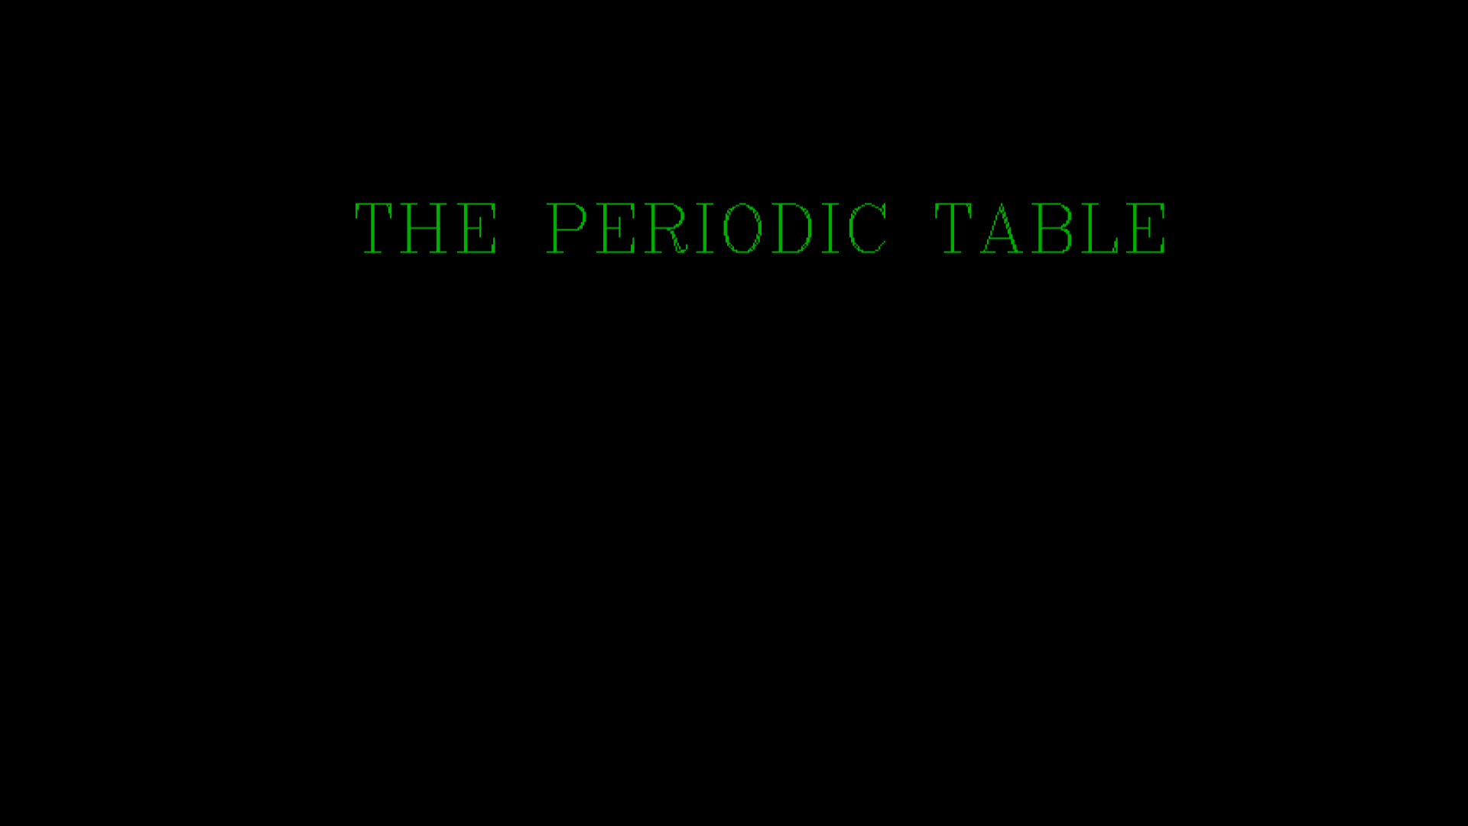

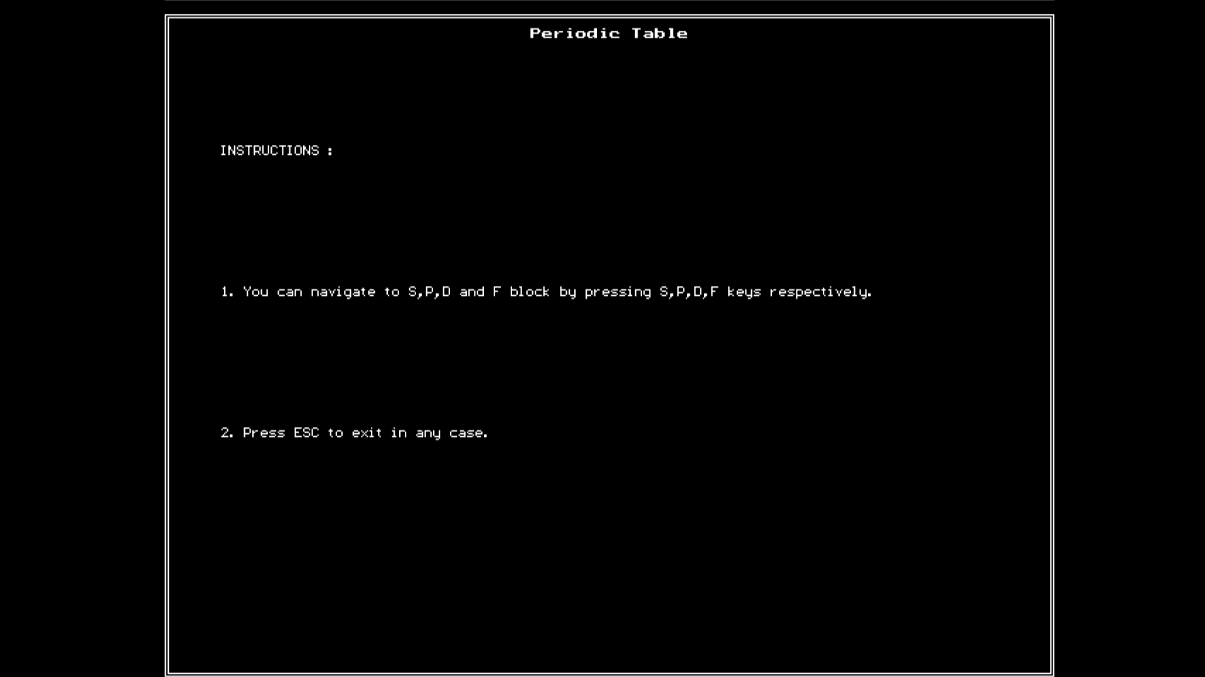

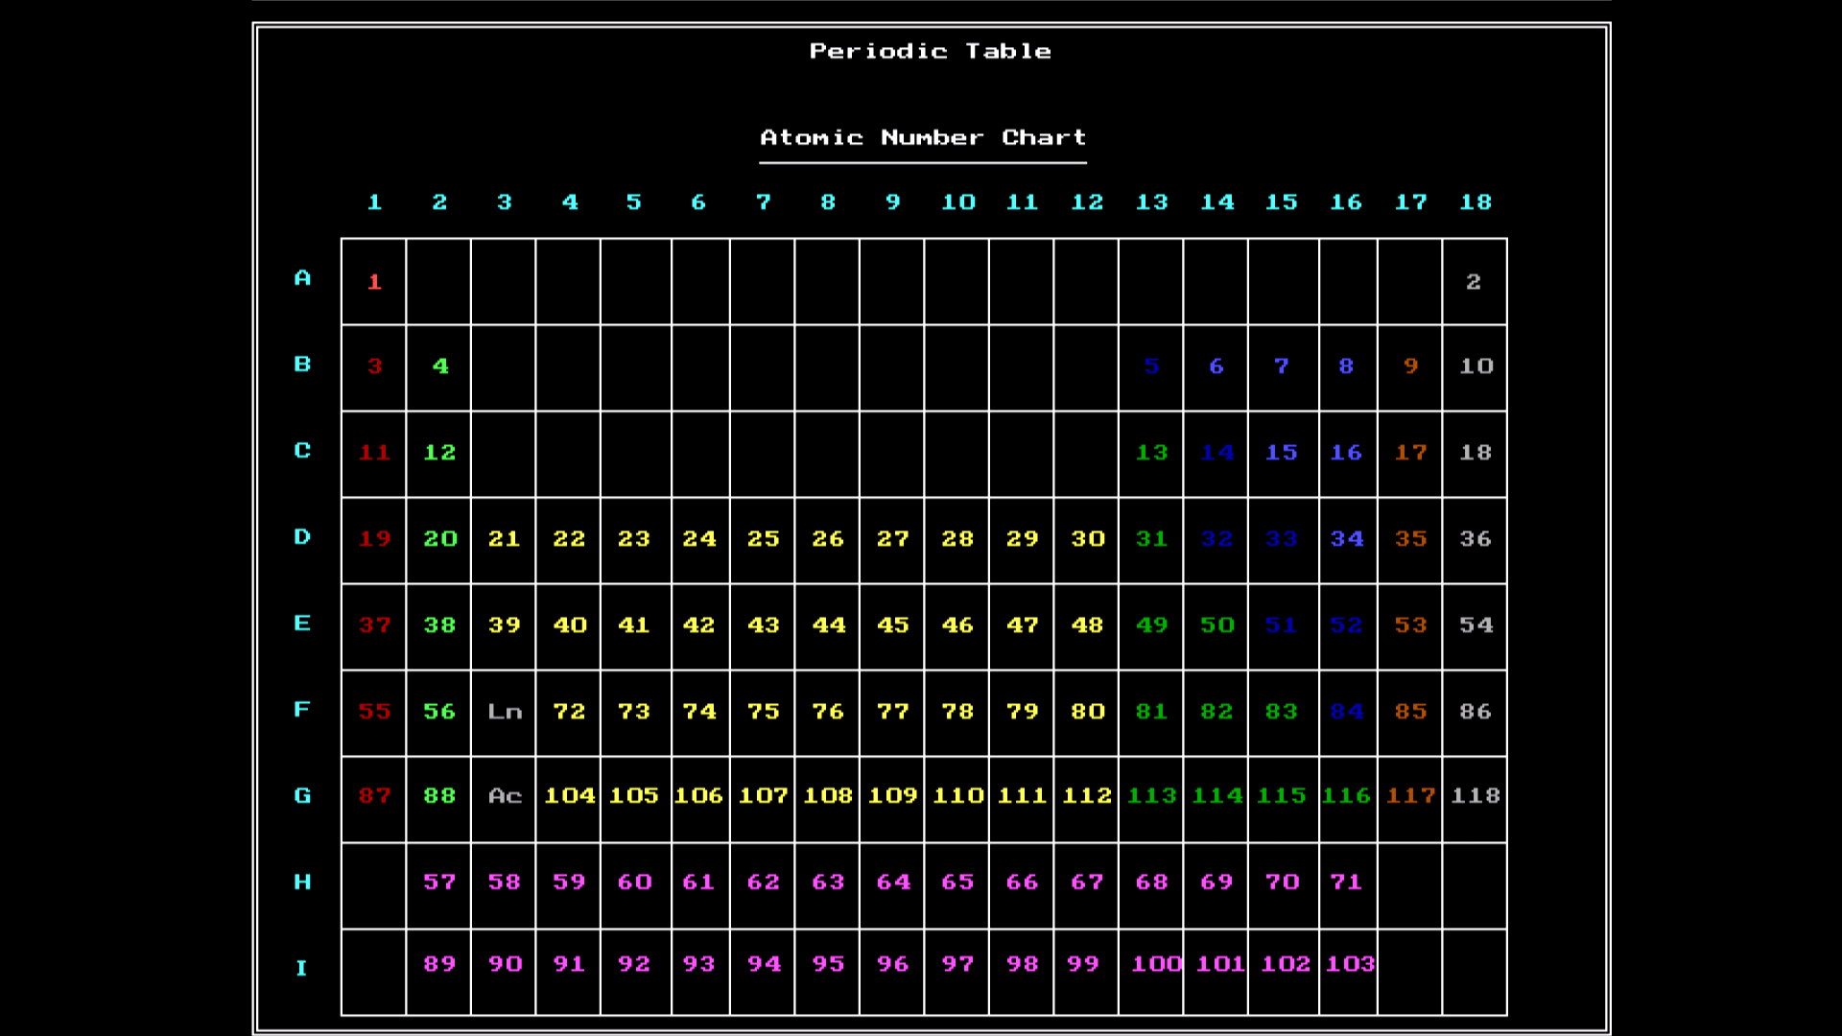

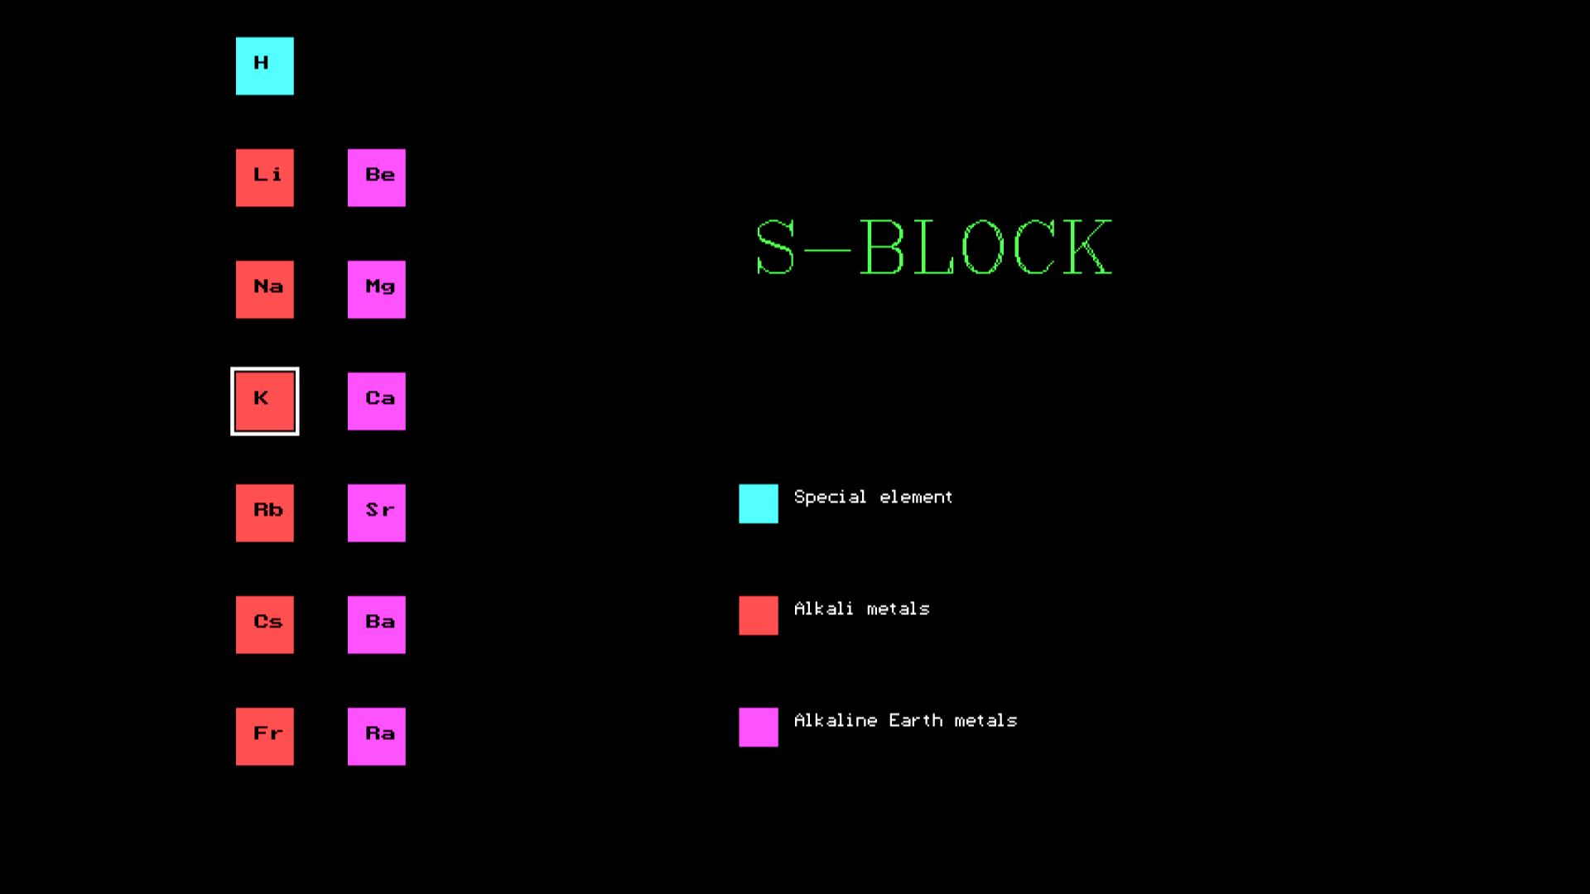

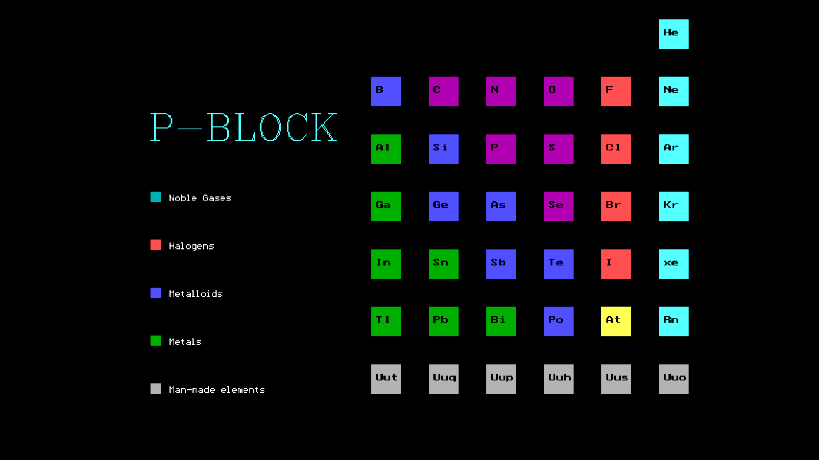

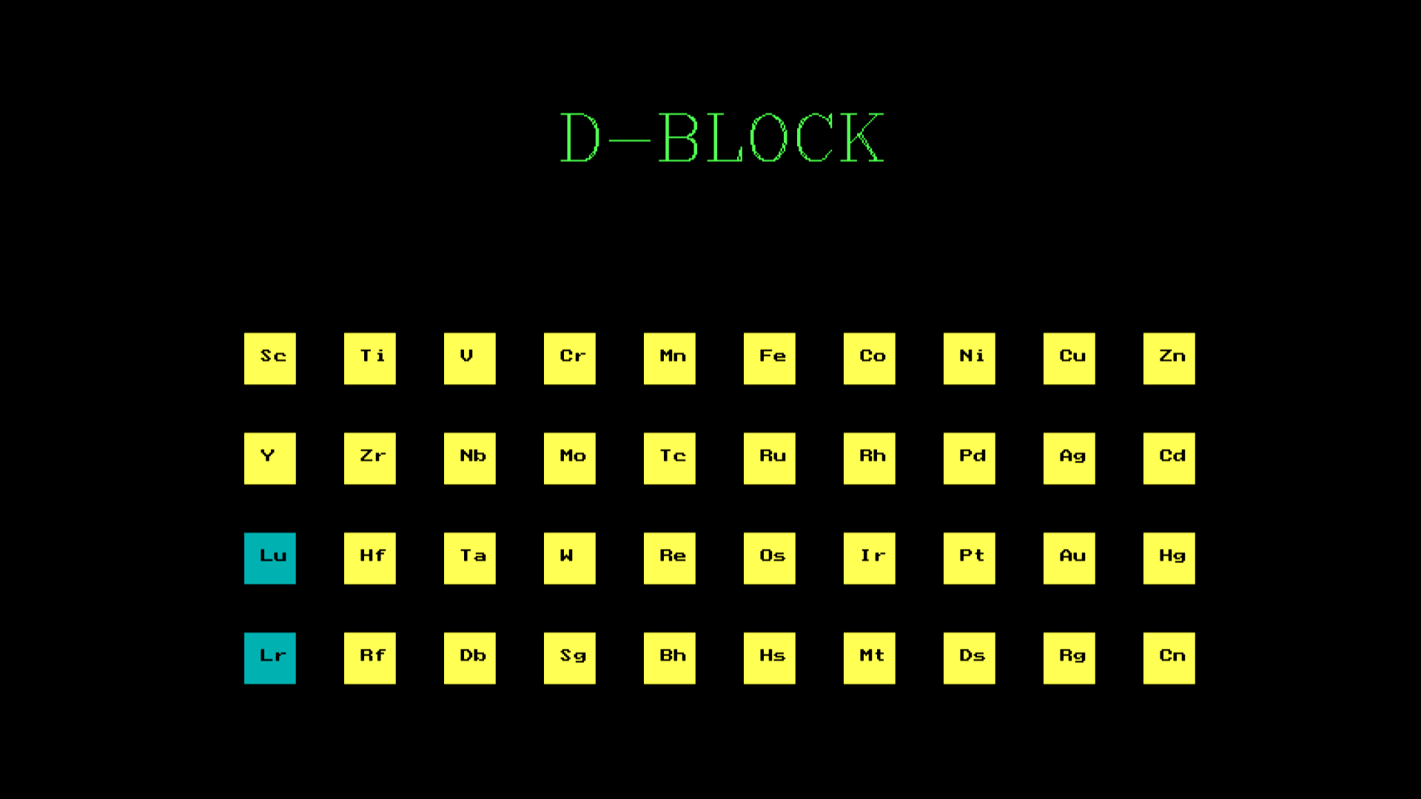

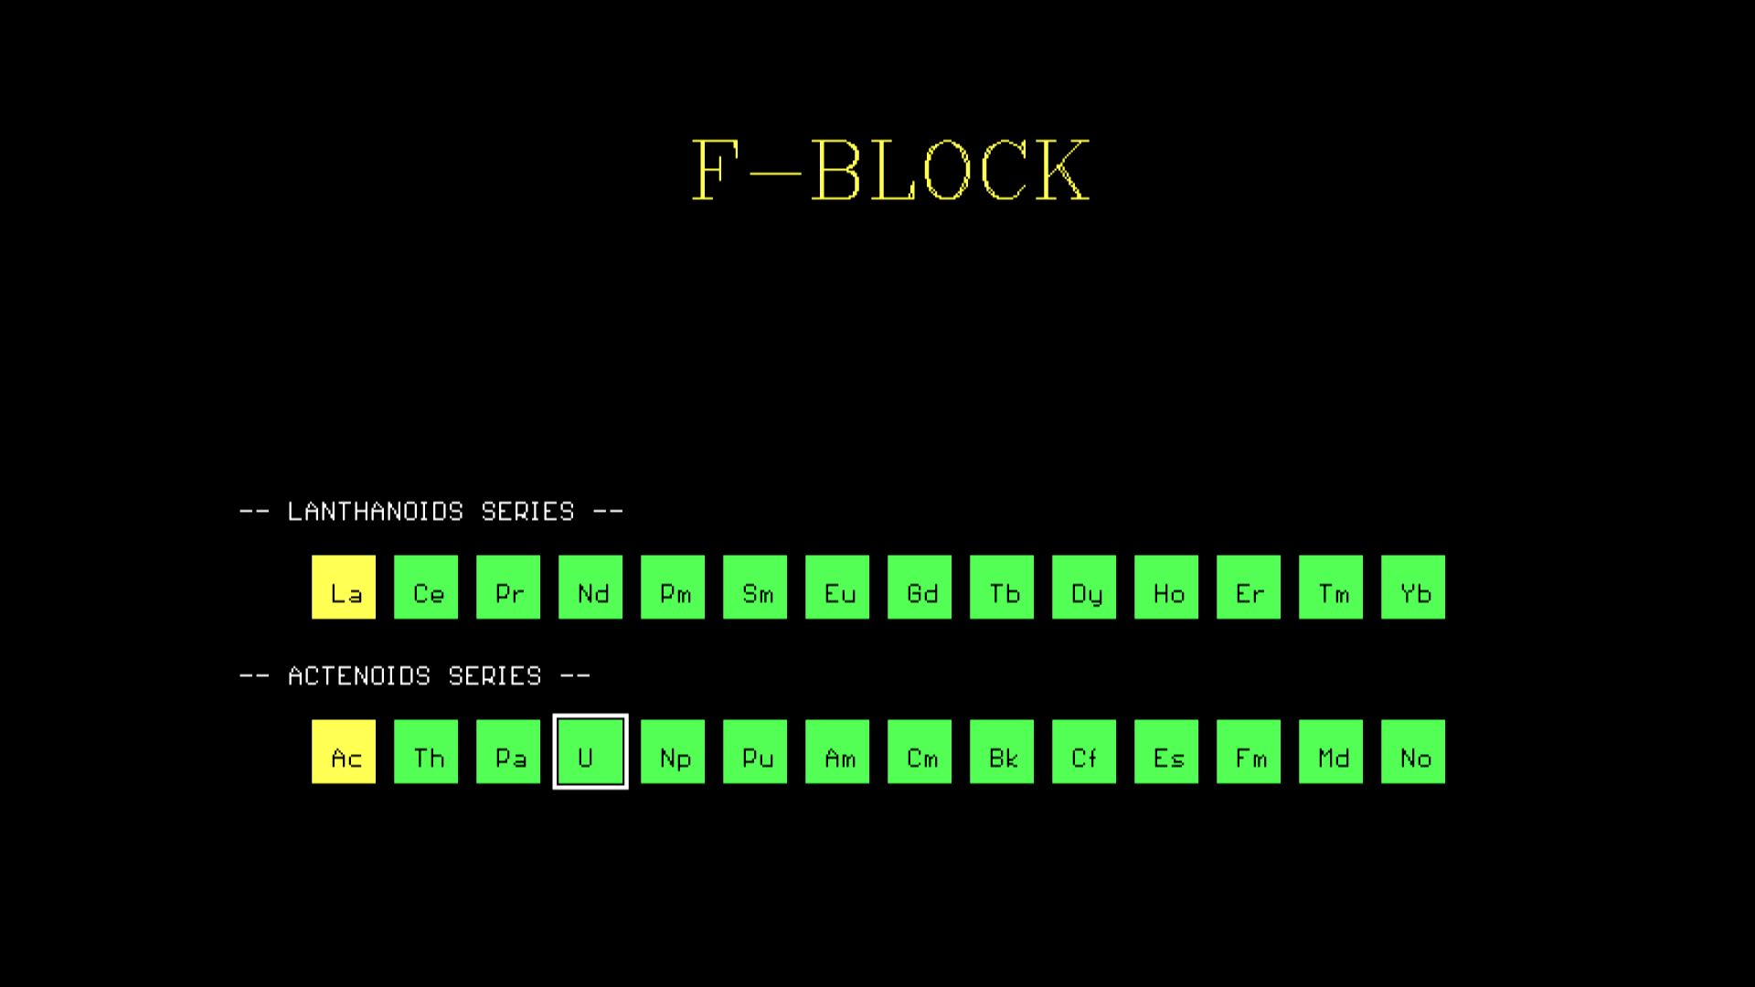

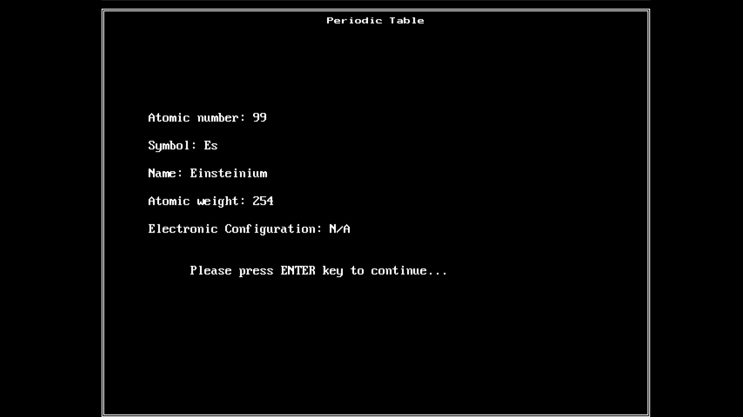

APPLICATION

“Where the hell to use this?” Pretty much for that!!

Our project can be used by any people (Umm… Discrimination is against the law, ha!), anywhere, any place, any time at any person’s ease.

Mostly by people who use only computers and specifically want to view a periodic table on a c++ compiler.

Coming to the point, on offices or industries, pharmacies, laboratories or any place which has a computer with c++ compiler and wants a periodic table with a few more bits of information.

RESULT

Well finally…

Thus an intractable version of the periodic table using concepts of Files and Graphics in C++ was prepared and made viewable for using according to your amazement and amusement.

Thank You all on our behalf.

BIBLIOGRAPHY

This is important though…

Books:

* Clark’s Tables
* Periodic Table
* Physics Class 12 – P. 1 & 2
* Chemistry Class 12 – P. 1 & 2
* C.S. 12 – Part 1 & 2

Websites:

* Google.com
* Wikipedia.org
* Iupac.com

//End of file script.