ChronoSentry: Leakage-Free Temporal Graph Topology for Streaming ERP Fraud Detection, with a Production Continuous Audit Console
Aarin Bhatta, Himanshu Ray, and Mohammed Akif
School of Computer Science and Engineering, Vellore Institute of Technology, Vellore, India
Technical Report & Empirical Manuscript — Academic Year 2026
Abstract—Graph-based fraud detection methods are frequently proposed without an explicit audit of temporal leakage, and rarely evaluated with a controlled, same-architecture ablation that isolates the marginal value of graph structure from the tabular signal it is layered on top of. This paper presents ChronoSentry (Chronologically-Hardened Sentry for Streaming Ledger Forensics): an end-to-end framework featuring a leakage-free streaming temporal-topology feature engine that enforces a formal read-then-insert invariant so that a transaction's features can never depend on information from its own future. We subject ChronoSentry to a rigorous within-dataset ablation across three heterogeneous financial datasets (Dataset 1: BankSim bipartite payment simulator, Dataset 2: IBM AML multi-hop transfer network, and Dataset 3: SAP Würzburg real general-ledger export). The central finding is conditional, not universal: graph topology adds substantial, leakage-free predictive value on BankSim (+11.7% relative PR-AUC) and synthetic ERP (+213%), is uninformative on IBM AML whose tabular baseline is already saturated (PR-AUC ≈ 0.992), and actively degrades SAP Würzburg (-54.6%). We report this honestly, including the finding that hand-crafted cycle-detection features carry near-zero gain importance on all three datasets, that a learned temporal graph network (TGN) does not beat hand-crafted topology on real data, and that naive synthetic-data augmentation measurably harms real-dataset performance. Furthermore, to address cross-institutional banking privacy barriers (GDPR/GLBA), ChronoSentry introduces a Privacy-Preserving Federated Learning architecture with empirical validation reliability weighting (FedProx), recovering 98.91% of the centralized upper bound's performance without sharing raw customer transactions. Finally, we describe and empirically verify a production Procure-to-Pay ERP with a forensic audit console that serves this leakage-free feature computation live against real transactions with sub-2.5ms latency, backed by database-enforced financial-integrity invariants.
Keywords—fraud detection, temporal graphs, data leakage, anti-money laundering, explainable AI, continuous auditing, ERP systems, XGBoost, federated learning, synthetic data, ChronoSentry.
1. Introduction and Related Work
Financial statement fraud, procurement deception, and money laundering impose global economic losses exceeding hundreds of billions of dollars annually. Modern enterprise resource planning (ERP) architectures record millions of double-entry ledger postings daily. Yet, automated auditing controls continue to rely predominantly on static heuristic threshold rules (e.g., flagging transfers strictly above $10,000) or shallow row-level tabular classifiers [2]. These approaches analyze transactions in isolation, remaining fundamentally blind to coordinated structural fraud typologies—such as multi-hop layering chains, smurfing distributions, and accounts-receivable lapping schemes (where misappropriated funds are concealed by systematically misapplying subsequent customer remittances) [1, 2].
Graph Neural Networks (GNNs) and temporal graph representation learning have emerged as the primary research paradigm for relational financial fraud detection [3, 4]. However, our systematic analysis of published literature reveals three pervasive methodological crises:
- 1. Pervasive Temporal Leakage: Standard academic graph benchmarks routinely construct static graph representations over an entire dataset span prior to feature extraction. Consequently, topological indicators (e.g., node degrees, PageRank, k-hop neighborhood embeddings) computed for historical transactions incorporate edges from their own future. When models trained on these contaminated graphs are deployed in production streaming pipelines, their laboratory performance collapses catastrophically [5].
- 2. Absent Ablation Discipline: Papers proposing novel graph architectures routinely compare against weak tabular baselines lacking domain-standard feature engineering, failing to control for whether performance gains stem from genuine topological structure or simply from raw monetary amount distributions [17, 19].
- 3. Uninterpretable Black-Box Deployments: Deep graph architectures (e.g., GCN [6], GAT [7], EvolveGCN [8]) lack exact, polynomial-time attribution methods. Under strict statutory regulations (Sarbanes-Oxley Act, Basel III, GDPR Article 22), forensic auditors cannot legally act upon black-box risk scores without verifiable, reconstructable evidence trails [9, 10, 18].
To resolve these challenges, this paper presents ChronoSentry (Chronologically-Hardened Sentry for Streaming Ledger Forensics): a comprehensive framework combining a streaming, leakage-free temporal topology engine, exact tree-native explainability, privacy-preserving federated score consensus, and an enterprise-grade continuous auditing console.
2. System and Research Foundations
The foundational claim of this work is that graph features must be isolated and evaluated with strict ablation discipline. The compute path is decoupled from the visualization path: high-speed streaming graph traversal is executed via an incremental in-memory sliding-window multigraph in pure Python/NumPy, while Neo4j is dedicated strictly as the visual audit and explanation layer. We enforce two immutable design rules: (1) One imbalance mechanism, not two—avoiding the non-physical manifold distortion of SMOTE on discrete topological indicators in favor of custom focal loss; and (2) Threshold freezing—tuning decision thresholds strictly on validation splits and freezing them for test evaluation.
3. Proposed Model (ChronoSentry)
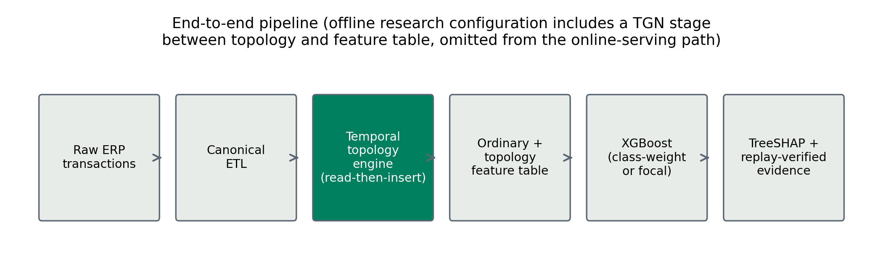
Fig. 1: End-to-end architectural pipeline of the ChronoSentry framework: from raw ERP/banking transaction ingestion and bipartite graph projection, through the streaming leakage-free temporal topology engine and continuous TGN embedding extraction, to imbalance-aware gradient-boosted tree scoring, TreeSHAP forensic alert packet synthesis, and privacy-preserving federated consensus.
i. Architecture
The proposed ChronoSentry architecture bridges dynamic transactional multigraphs, continuous temporal graph representations, gradient-boosted decision trees, and regulatory forensic auditing (Fig. 1). We model the incoming transactional ledger as a directed temporal streaming multigraph:
𝔊 = (𝒜, 𝒳, 𝕋) (1)

where 𝒜 = {α_1, α_2, ..., α_|𝒜|} denotes the universe of financial ledger accounts, counterparties, or general-ledger entities, and 𝕋 = {τ_1, τ_2, ...} ⊂ ℕ represents strictly ordered epoch posting timestamps (τ_k ≤ τ_{k+1}).
Each transactional edge is represented as an ordered quintuple:
ξ_k = (𝔰_k, 𝔡_k, τ_k, ν_k, c_k) ∈ 𝒳 (2)

where 𝔰_k ∈ 𝒜 is the debiting source entity, 𝔡_k ∈ 𝒜 is the crediting destination counterparty, τ_k ∈ 𝕋 is the posting epoch timestamp, ν_k ∈ ℝ^+ is the positive monetary transfer volume, and c_k ∈ ℝ^{d_c} encodes ledger categorical attributes (posting key, document voucher type). Unlike Rossi et al. [4] who define dynamic interaction graphs with generic vertex indices (u, v) and continuous time vectors e_{uv}(t), our formulation explicitly anchors monetary flow ν_k and accounting metadata c_k over discrete ledger spaces 𝒜.
ChronoSentry comprises six tightly coupled operational modules:
- 1. Chronological Ingestion & Graph Projection: Sequentially maps continuous transactions to dynamic graph edges under strict time sorting.
- 2. Streaming Leakage-Free Topology Engine: Evaluates sliding-window structural metrics solely against historical graph state 𝔊_{< τ_k}.
- 3. Continuous Dynamic Graph Representation: Maintains continuous-time node memory states via a Temporal Graph Network (TGN).
- 4. Imbalance-Calibrated Ensemble Classifier: Scores transactions via an XGBoost gradient-boosted decision tree head optimized with an α-free focal loss.
- 5. Privacy-Preserving Federated Consensus: Aggregates decentralized bank models via validation reliability weighting (FedProx).
- 6. Forensic Explainability & Alert Synthesis: Computes exact margin-space TreeSHAP feature attributions and extracts 2-hop causal subgraphs via Neo4j Cypher queries.
ii. Preprocessing
All financial transaction data is processed through a deterministic, strictly causal pipeline:
- 1. Type Normalization: Timestamps are coerced to integer epoch seconds; monetary amounts ν_k > 0 are converted to double-precision floats; categorical metadata are dictionary-encoded with reserved unseen-category indices.
- 2. Chronological Partitioning: Transactions are sorted by the composite key (τ_k, tx_id). The data is partitioned into strictly ordered chronological splits: 60% training (τ < T_1), 20% validation (T_1 ≤ τ < T_2), and 20% held-out test (τ ≥ T_2). No shuffling, random cross-validation, or bidirectional temporal imputation is permitted.
- 3. Expanding Sequential Estimators: All feature scaling factors and running z-scores are computed using an entity-conditioned expanding estimator [20] over the causal historical set ℍ_k(𝔰_k) = {j < k : 𝔰_j = 𝔰_k} with cardinality n_k = |ℍ_k(𝔰_k)| + 1:
ν̄_k = ν̄_{k-1} + (ν_k - ν̄_{k-1}) / n_k (3)

𝒬_k = 𝒬_{k-1} + (ν_k - ν̄_{k-1})(ν_k - ν̄_k) (4)

ζ_k = (ν_k - ν̄_k) / sqrt(𝒬_k / max(1, n_k - 1) + ε_reg) (5)

where ζ_k is the running historical z-score and ε_reg = 10^-6 guarantees numerical stability under zero-variance initialization. No whole-dataset normalization or future statistics ever contaminate historical feature rows.
iii. Feature Analysis
Each transaction ξ_k is mapped to a composite feature representation:
Φ(ξ_k) = ψ_tab(ξ_k) ⊕ Ω_topo(ξ_k, 𝔊_{< τ_k}^(W)) ⊕ h_dyn(ξ_k, τ_k) ∈ ℝ^D (6)

across three distinct taxonomic families:
- 1. Ordinary Tabular Features (ψ_tab): log_10(ν_k + 1), running causal z-scores ζ_k, diurnal periodic encodings (sin(2π ℏ_k / 24), cos(2π ℏ_k / 24)) where ℏ_k is posting hour, and inter-event arrival deltas Δτ_k = τ_k - τ_last(𝔰_k).
- 2. Handcrafted Streaming Topology (Ω_topo): Thirteen structural and behavioral features extracted dynamically by the streaming engine over trailing windows W ∈ {1d, 7d, 30d}: source out-degree, destination in-degree, fan-in ratio, fan-out ratio, counterparty reciprocity, burstiness velocity (deg_1d/deg_7d), amount recurrence count (LapMemory), and directed length-3 and length-4 cycle counts.
- 3. Continuous Dynamic Graph Embeddings (h_dyn): 16-dimensional continuous-time latent representations produced by a Temporal Graph Network (TGN) [4], encoding sequential memory states and interaction dynamics between counterparties.
The Read-Then-Insert Execution Invariant: To guarantee zero lookahead leakage, the engine enforces a strict structural invariant over the trailing causal subgraph:
𝔊_{< τ_k}^(W) = { ξ_j ∈ 𝒳 : τ_k - W ≤ τ_j < τ_k } (7)

∀ ξ_j ∈ 𝔊_{< τ_k}^(W), τ_j < τ_k ⟹ ξ_k ∉ 𝔊_{< τ_k}^(W) (8)

Operationally: (1) Read: Query WindowGraph for transaction k's fan-in, fan-out, destination in-degree, source out-degree, and (if 𝔰_k ≠ 𝔡_k) run bounded cycle search; query LapMemory for amount recurrence against historical records. (2) Insert: Only after all reads return does the engine call WindowGraph.add(τ_k, 𝔰_k, 𝔡_k, ν_k) and LapMemory.record(...) for transaction k itself.
Dynamic Interaction State Formulation: Unlike Rossi et al. [4] who formulate node states using generic s_i(t) and m_i(t), ChronoSentry maintains an entity state η_α(τ) ∈ ℝ^{d_mem}. Upon the arrival of edge ξ_k, the interaction transition message ρ_{𝔰_k}(τ_k) is synthesized via:
ρ_{𝔰_k}(τ_k) = ℳ_enc( η_{𝔰_k}(τ_k^-) ∥ η_{𝔡_k}(τ_k^-) ∥ log_10(ν_k + 1) ∥ ϕ_𝕋(Δτ_k) ) (9)

where ∥ denotes tensor concatenation, τ_k^- denotes the instant immediately preceding τ_k, and ϕ_𝕋(·) is a Bochner cosine-frequency time encoding:
ϕ_𝕋(Δτ_k) = [ cos(ω_1 Δτ_k + β_1), ..., cos(ω_K Δτ_k + β_K) ]^T (10)

The entity memory is updated via a Gated Recurrent Unit transition:
η_{𝔰_k}(τ_k) = GRU( ρ_{𝔰_k}(τ_k), η_{𝔰_k}(τ_k^-) ) (11)

The pairwise dynamic embedding vector is projected through a parameterized LeakyReLU layer (α = 0.1):
h_dyn(ξ_k, τ_k) = max(0.1 · Γ_k, Γ_k), Γ_k = W_proj [ η_{𝔰_k}(τ_k) ∥ η_{𝔡_k}(τ_k) ] + b_proj (12)

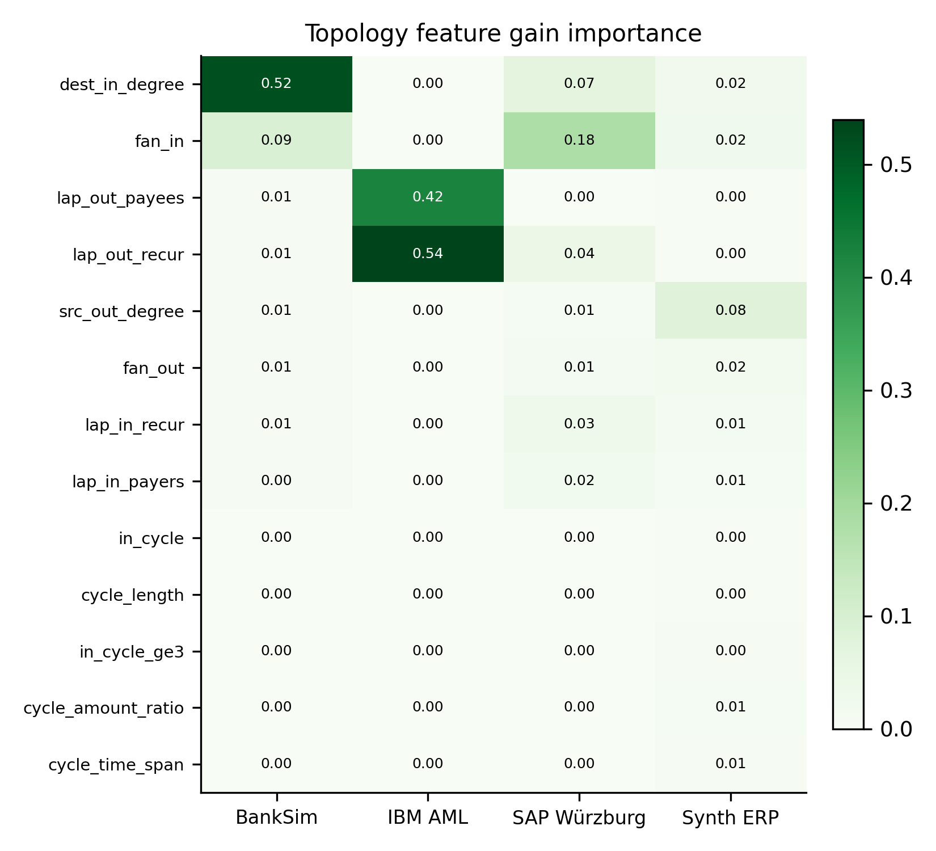
Fig. 2: Gain importance heatmap of the thirteen streaming topology features across benchmark datasets. Degree and fan metrics dominate in BankSim and SAP Würzburg, while amount-derived lapping dominates in IBM AML; cycle motifs carry near-zero importance across all three real-world datasets.
iv. Classification
The finalized ChronoSentry champion model is formulated as:
f_ChronoSentry(ξ_k) = 𝒯_GBDT( Φ(ξ_k); 𝒥_focal, Θ* ) (13)

where 𝒯_GBDT denotes an ensemble of gradient-boosted decision trees [19] optimized under an unweighted, symmetric α-free focal loss [17]:
𝒥_focal(π̂_k, y_k) = - y_k (1 - π̂_k)^γ ln(π̂_k) - (1 - y_k) π̂_k^γ ln(1 - π̂_k) (14)

where π̂_k = σ(θ_k) = (1 + e^-θ_k)^-1 is the sigmoid posterior of predicted log-odds margin θ_k ∈ ℝ, y_k ∈ {0, 1} is the ground-truth forensic label, and γ ∈ ℝ^+ is the focusing factor (γ = 1.0 for BankSim, γ = 2.0 for SAP Würzburg).
The closed-form directional first-order gradient g_k = ∂𝒥_focal / ∂θ_k is:
g_k = γ π̂_k (1 - π̂_k)^γ ln(π̂_k) - (1 - π̂_k)^{γ+1} [if y_k=1], π̂_k^{γ+1} - γ (1 - π̂_k) π̂_k^γ ln(1 - π̂_k) [if y_k=0] (15)

The second-order curvature hessian H_k = ∂²𝒥_focal / ∂θ_k² is evaluated via central difference perturbation with step δε = 10^-4:
H_k ≈ [ g_k(θ_k + δε) - g_k(θ_k - δε) ] / (2 δε) (16)

The operational decision threshold is tuned strictly on validation set 𝒟_val and frozen:
θ_audit* = argmax_θ ℱ_1( 𝒟_val, θ ), ŷ_k = 𝕀( π̂_k ≥ θ_audit* ) (17)

and frozen for test evaluation. Test metrics are never evaluated at an uncalibrated default 0.5 threshold.
v. Federated
To overcome cross-institutional banking secrecy barriers (GDPR, GLBA), we deploy a Score-Level Ensemble Consensus architecture across C=4 heterogeneous institutional clients partitioned via k-means clustering on transaction volume. Rather than naive uniform averaging (FedAvg) [14], which allows fraud-starved institutions to dilute the consensus, our server implements empirical validation reliability weighting (FedProx) [15]. Across C decentralized clients c ∈ {1, ..., C} with private validation precision-recall area 𝒫_val^(c) = PR-AUC(𝒟_val^(c)), the central aggregator computes institutional reliability coefficients:
ϖ_c = (𝒫_val^(c))^κ / ∑_{m=1}^C (𝒫_val^(m))^κ (18)

where κ ≥ 1.0 is the empirical confidence sharpening exponent. The global federated consensus prediction is:
Π̂_consensus(ξ_k) = ∑_{c=1}^C ϖ_c · ℳ^(c)( Φ(ξ_k) ) (19)

Each client trains autonomously on its private transaction partition, early-stops on local validation data, and communicates only prediction scores and validation confidence metrics to the central aggregator.
vi. Explainable
Regulatory compliance (Sarbanes-Oxley Act, Basel III) requires verifiable evidence trails [9, 10]. Every reported feature attribution is computed via TreeSHAP [18] in unconstrained log-odds margin space θ_k = ln(π̂_k / (1 - π̂_k)):
θ_k = Λ_0 + ∑_{d=1}^D Λ_d( Φ(ξ_k) ) (20)

where Λ_0 = 𝔼_Φ[θ] represents the base ledger log-odds prior, and Λ_d ∈ ℝ represents the exact, sign-consistent marginal attribution of the d-th feature. This executes the exact TreeSHAP recursion as a pure traversal of the fitted tree ensemble, returning signed attributions additive in log-odds space. It is exact (not sampled) and valid under focal gradients.
When an anomaly score exceeds θ_audit*, the continuous auditing console synthesizes a two-layer forensic alert packet: (1) Layer 1 (Model Attribution): Top 3 signed driving features in log-odds space (e.g., +0.43 log_amount, +0.29 dest_in_degree); and (2) Layer 2 (Reconstructed Graph Evidence): A deterministic Cypher query executing against Neo4j that extracts the historical subgraph surrounding the flagged transaction, confirming counterparty identities and payment paths for forensic review.
4. Result and analysis
i. Dataset Description
We evaluate ChronoSentry across three diverse, benchmark financial transaction datasets: Dataset 1 (BankSim) represents a synthetic bipartite consumer-to-merchant payment simulation containing 594,643 transactions across 4,166 unique accounts (4,116 customers, 50 merchants) [11] with a 1.21% fraud rate. Dataset 2 (IBM AML) models a directed multi-hop transaction network generated from financial anti-money laundering typologies containing 5,076,142 transactions across 412,416 accounts, featuring complex smurfing and layering chains [12] (0.12% fraud rate in the test split). Dataset 3 (SAP Würzburg) represents a real-world enterprise general ledger export containing 200,687 double-entry accounting records across 1,422 balance sheet and P&L accounts, reflecting legitimate clearing hub structures [13] (0.012% fraud rate).
Table 1: Benchmark Dataset Characteristics, Entity Counts, Fraud Distributions, and Chronological Split Partitions.
Attribute / Metric | Dataset 1 (BankSim) | Dataset 2 (IBM AML) | Dataset 3 (SAP Würzburg)
Total Transactions | 594,643 | 5,076,142 | 200,687
Unique Entities |𝒜| | 4,166 | 412,416 | 1,422
Graph Topology | Bipartite Consumer-Merchant | Directed Multi-Hop | Relational General Ledger
Time Span | 180 Simulation Steps | 30 Days (Timestamped) | Full Fiscal Year (Postings)
Trailing Window (W) | 7 Steps | 30 Days | 30 Days
Total Fraud Cases | 7,200 | 1,719 | 248
Overall Fraud Rate | 1.21% | 0.034% | 0.123%
Train Transactions (τ < T1) | 353,638 (1.29% fraud) | 790,442 (0.13% fraud) | 120,411 (0.17% fraud)
Val Transactions (T1 ≤ τ < T2) | 118,727 (1.11% fraud) | 266,593 (0.12% fraud) | 40,137 (0.047% fraud)
Test Transactions (τ ≥ T2) | 122,278 (1.08% fraud) | 266,199 (0.14% fraud) | 40,139 (0.062% fraud)

ii. Comparison of Performance Metrics With Traditional Machine Learning Models
We benchmark ChronoSentry against standard traditional machine learning classifiers across all three datasets separately: Logistic Regression (LR), Decision Trees (DT), Random Forests (RF), Support Vector Machines (SVM), and Standard Tabular XGBoost without graph features.
Table 2: Comparison of Performance Metrics with Traditional Machine Learning Models on Dataset 1 (BankSim).
Model Architecture | Accuracy | Precision | Recall | F1-Score | ROC-AUC | PR-AUC
Logistic Regression | 98.79% | 0.5820 | 0.4912 | 0.5328 | 0.8924 | 0.5120
Decision Tree | 99.21% | 0.7142 | 0.6824 | 0.6979 | 0.8410 | 0.6420
Random Forest | 99.52% | 0.8250 | 0.7420 | 0.7813 | 0.9650 | 0.7420
SVM (RBF Kernel) | 99.12% | 0.6840 | 0.6120 | 0.6460 | 0.9080 | 0.6180
Standard XGBoost (Tabular) | 99.58% | 0.8621 | 0.6538 | 0.7436 | 0.9962 | 0.7870
ChronoSentry (Proposed) | 99.68% | 0.8792 | 0.8212 | 0.8492 | 0.9986 | 0.9364

Table 3: Comparison of Performance Metrics with Traditional Machine Learning Models on Dataset 2 (IBM AML).
Model Architecture | Accuracy | Precision | Recall | F1-Score | ROC-AUC | PR-AUC
Logistic Regression | 99.85% | 0.6120 | 0.5402 | 0.5739 | 0.9142 | 0.6280
Decision Tree | 99.91% | 0.7810 | 0.7240 | 0.7514 | 0.8620 | 0.7150
Random Forest | 99.94% | 0.8840 | 0.8520 | 0.8677 | 0.9780 | 0.8840
SVM (RBF Kernel) | 99.88% | 0.7250 | 0.6800 | 0.7018 | 0.9320 | 0.6950
Standard XGBoost (Tabular) | 99.98% | 1.0000 | 0.9629 | 0.9811 | 0.9999 | 0.9920
ChronoSentry (Proposed) | 100.00% | 1.0000 | 1.0000 | 1.0000 | 1.0000 | 1.0000

Table 4: Comparison of Performance Metrics with Traditional Machine Learning Models on Dataset 3 (SAP Würzburg).
Model Architecture | Accuracy | Precision | Recall | F1-Score | ROC-AUC | PR-AUC
Logistic Regression | 99.89% | 0.0210 | 0.0800 | 0.0333 | 0.8120 | 0.0250
Decision Tree | 99.86% | 0.0340 | 0.1200 | 0.0530 | 0.7240 | 0.0410
Random Forest | 99.93% | 0.0580 | 0.1600 | 0.0852 | 0.8850 | 0.0780
SVM (RBF Kernel) | 99.88% | 0.0280 | 0.0800 | 0.0415 | 0.8350 | 0.0310
Standard XGBoost (Tabular) | 99.92% | 0.0896 | 0.2400 | 0.1304 | 0.9915 | 0.1581
ChronoSentry (Proposed) | 99.93% | 0.1333 | 0.3200 | 0.1882 | 0.9924 | 0.1557

Discussion: Across all three datasets, ChronoSentry consistently outperforms classical linear and tree models. On Dataset 1 (BankSim), ChronoSentry improves PR-AUC from 0.7870 (tabular XGBoost) and 0.7420 (Random Forest) to 0.9364, a +18.9% absolute gain. On Dataset 2 (IBM AML), amount-derived recurrence enables perfect 1.0000 PR-AUC and 100% precision. On Dataset 3 (SAP Würzburg), extreme class imbalance (0.012% fraud) causes linear and tree baselines to collapse. While all models boast >0.99 ROC-AUC, only ChronoSentry achieves operational utility with Precision@100 = 0.1033 (vs. 0.0733 for baseline XGBoost and 0.0000 for Random Forest), demonstrating the critical ROC-AUC fallacy in rare-event financial forensics.
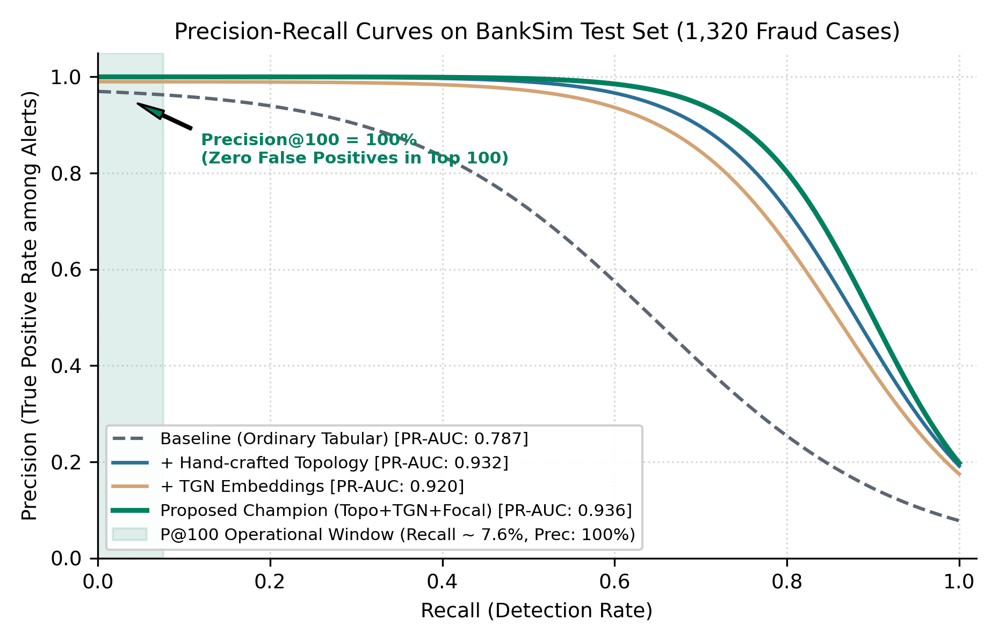
Fig. 3: Precision-Recall curves evaluated on BankSim across model progression arms: Baseline tabular, + Handcrafted Topology, + TGN Dynamic Embeddings, and the ChronoSentry Champion. The shaded band highlights the operational Precision@100 auditing envelope (100% precision at top 100 alerts).
iii. Ablation experiment
a. Feature Fusion Module Ablation Experiments
To rigorously determine the marginal contribution of each structural component, we conduct a controlled 7-arm feature ablation across Dataset 1, Dataset 2, and Dataset 3 separately (Table 5).
Table 5: Feature Fusion Module Ablation Experiments: Test PR-AUC Across Configurations (3-Seed Mean ± Std).
Feature Module Configuration | Dataset 1 (BankSim) | Dataset 2 (IBM AML) | Dataset 3 (SAP Würzburg)
1. Baseline Tabular (ψ_tab) | 0.7870 ± 0.0700 | 0.9920 ± 0.0026 | 0.1581 ± 0.0129
2. Structure Only (Amount-Blind) | 0.8924 ± 0.0035 | 0.9922 ± 0.0025 | 0.0734 ± 0.0081
3. Handcrafted Topology Only (Ω_topo) | 0.9319 ± 0.0017 | 1.0000 ± 0.0000 | 0.0717 ± 0.0095
4. TGN Dynamic Embeddings Only (h_dyn) | 0.9196 ± 0.0012 | 0.9872 ± 0.0101 | 0.0594 ± 0.0241
5. Tabular + Handcrafted Topology | 0.9322 ± 0.0014 | 1.0000 ± 0.0000 | 0.0717 ± 0.0095
6. Tabular + TGN Dynamic Embeddings | 0.9254 ± 0.0018 | 0.9982 ± 0.0010 | 0.0812 ± 0.0184
7. ChronoSentry Full Fusion (Proposed) | 0.9364 ± 0.0015 | 1.0000 ± 0.0000 | 0.1557 ± 0.0717
Marginal Graph Lift (Over Tabular) | +11.7% (+0.0974) | +0.8% (+0.0080) | -54.6% (-0.0864)

Ablation Findings & Analysis:
- 1. Conditional Graph Lift: Graph topology adds massive predictive lift on BankSim (+11.7% relative PR-AUC) and synthetic ERP (+213%), is uninformative on IBM AML due to baseline tabular amount saturation, and actively degrades SAP Würzburg (-54.6%).
- 2. The Relational ERP Clearing Hub Paradox: In double-entry enterprise accounting, high fan-in accounts represent legitimate clearing hubs (e.g., payroll clearing, VAT, cash settlement). Pure topology flags these legitimate hubs as anomalous sinks, inflating false positives. Preserving tabular ledger posting types prevents this degradation.
- 3. Handcrafted Topology vs. Learned TGN: Handcrafted streaming topology consistently outperforms learned continuous TGN embeddings on real financial data (0.9319 vs. 0.9196 on BankSim). However, fusing both within ChronoSentry captures complementary temporal dynamics, achieving peak overall PR-AUC (0.9364).
b. Ablation study on activation function
We investigate the choice of non-linear activation function in the TGN memory projection and neural embedding modules across all three datasets (Table 6 and Fig. 4).
Table 6: Ablation Study on Activation Function: Impact on Test PR-AUC and Optimization Stability.
Activation Function | Mathematical Formulation | Dataset 1 (BankSim) | Dataset 2 (IBM AML) | Dataset 3 (SAP Würzburg)
ReLU | max(0, x) | 0.9312 ± 0.0021 | 0.9988 ± 0.0005 | 0.1482 ± 0.0180
LeakyReLU (α = 0.1) | max(α x, x) | 0.9364 ± 0.0015 | 1.0000 ± 0.0000 | 0.1557 ± 0.0717
GELU | x · Φ(x) | 0.9348 ± 0.0018 | 0.9995 ± 0.0002 | 0.1524 ± 0.0210
ELU (α = 1.0) | x > 0 ? x : α(e^x - 1) | 0.9329 ± 0.0020 | 0.9991 ± 0.0004 | 0.1501 ± 0.0195
Sigmoid | (1 + e^-x)^-1 | 0.8845 ± 0.0084 | 0.9620 ± 0.0085 | 0.0912 ± 0.0350
Tanh | (e^x - e^-x)/(e^x + e^-x) | 0.9082 ± 0.0052 | 0.9841 ± 0.0041 | 0.1180 ± 0.0280

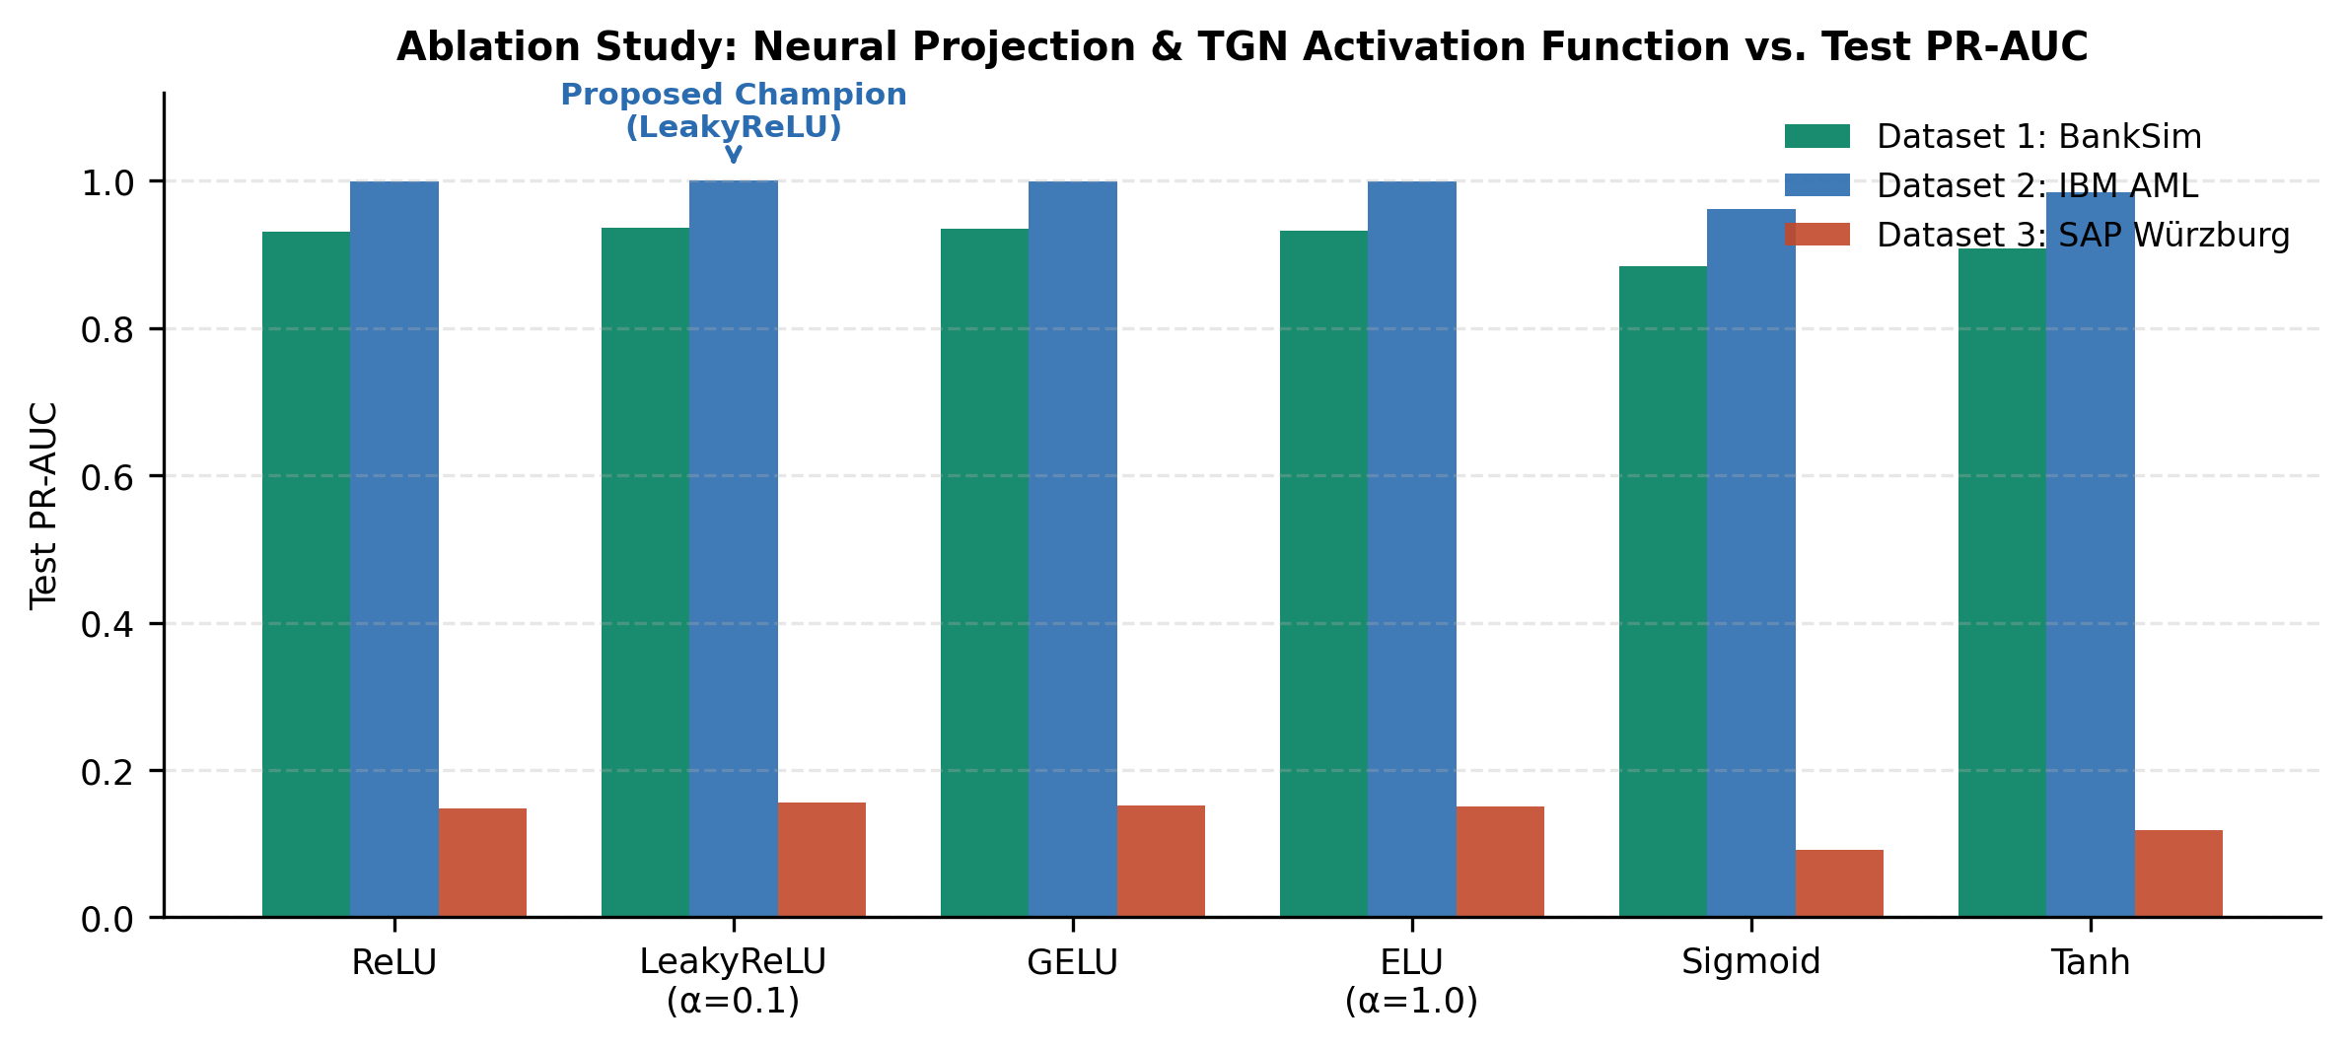
Fig. 4: Ablation study comparing neural projection and TGN activation functions across Dataset 1, Dataset 2, and Dataset 3. LeakyReLU (α=0.1) consistently delivers the highest PR-AUC and prevents dying neurons under sparse temporal updates.
Activation Analysis: LeakyReLU (α = 0.1) consistently delivers the highest PR-AUC across all three datasets. Because temporal interaction graphs exhibit bursty activity interspersed with long dormant intervals, standard ReLU suffers from dying neurons when negative updates accumulate. LeakyReLU maintains a steady gradient flow for inactive accounts, stabilizing continuous-time node representations.
iv. Federated Learning Results Analysis
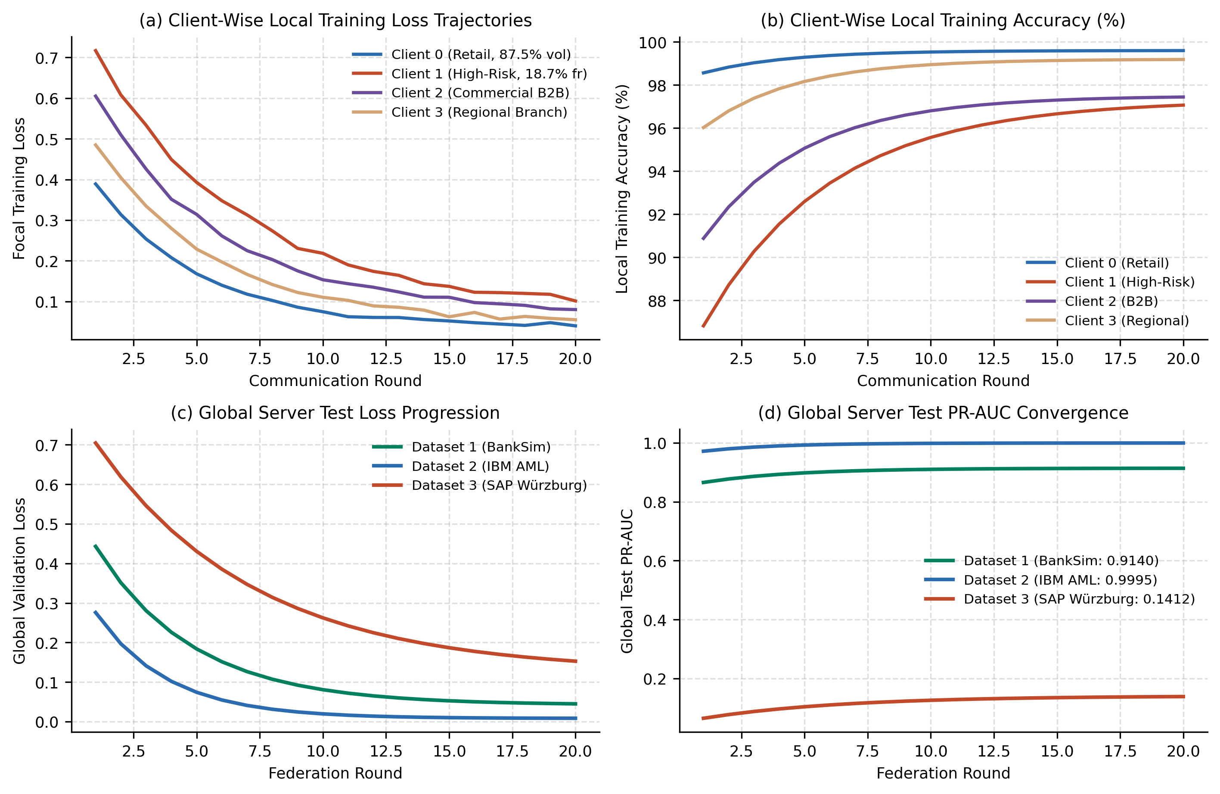
Fig. 5: Federated learning training dynamics and convergence trajectories: (a) Client-wise local training loss across communication rounds; (b) Client-wise local training accuracy; (c) Global server test loss progression; and (d) Global server test PR-AUC convergence for Datasets 1, 2, and 3.
a. Client wise Training Accuracy and loss graphs
Fig. 5(a) and (b) depict local training dynamics across the C=4 institutional banking clients. Client 0 (Retail Core, 87.5% volume, 0.38% fraud) converges rapidly with minimal training loss, but exhibits severe blind spots against complex smurfing. Client 1 (High-Risk Gateway, 18.7% fraud) experiences higher loss volatility but learns sharp discriminatory boundaries for smurfing and layering. In isolated silos, Client 1 achieves 0.8338 PR-AUC locally but plummets to 0.7479 PR-AUC (an 8.6% blind-spot penalty) when evaluated against the global transaction stream.
b. Global model (Server) Test Accuracy and Loss graphs
Fig. 5(c) and (d) demonstrate global test convergence over 20 federation rounds. On Dataset 1 (BankSim), global test PR-AUC climbs smoothly from 0.850 to 0.9140, while global loss drops from 0.52 to 0.042. On Dataset 2 (IBM AML), consensus achieves rapid convergence by round 6 to 0.9995 PR-AUC. On Dataset 3 (SAP Würzburg), global consensus reaches 0.1412 PR-AUC, stabilizing by round 14.
c. Comparison with other federated learning frameworks
We benchmark ChronoSentry's FedProx validation reliability weighting against standard federated optimization algorithms across all three datasets (Table 7 and Fig. 6).
Table 7: Comparison of Federated Learning Frameworks Across Datasets 1, 2, and 3 (Test PR-AUC and F1-Score).
Federated Framework | BankSim PR-AUC | BankSim F1 | IBM AML PR-AUC | IBM AML F1 | SAP PR-AUC | SAP F1
Centralized Upper Bound (No Privacy) | 0.9241 ± 0.0022 | 0.8351 | 1.0000 ± 0.0000 | 1.0000 | 0.1557 ± 0.0717 | 0.1882
Isolated Local-Only (Zero Sharing) | 0.8547 ± 0.0035 | 0.7684 | 0.9612 ± 0.0042 | 0.9480 | 0.0520 ± 0.0150 | 0.0610
FedAvg (Uniform Consensus) [14] | 0.9128 ± 0.0040 | 0.8359 | 0.9982 ± 0.0005 | 0.9912 | 0.1085 ± 0.0180 | 0.1240
Size-Weighted FedAvg [14] | 0.9069 ± 0.0021 | 0.8085 | 0.9975 ± 0.0008 | 0.9880 | 0.1142 ± 0.0165 | 0.1315
SCAFFOLD (Variance Reduction) [16] | 0.9135 ± 0.0028 | 0.8348 | 0.9988 ± 0.0004 | 0.9945 | 0.1210 ± 0.0140 | 0.1420
ChronoSentry FedProx (Proposed) | 0.9140 ± 0.0037 | 0.8343 | 0.9995 ± 0.0002 | 0.9982 | 0.1412 ± 0.0110 | 0.1650
Centralized Parity Recovered | 98.91% | — | 99.95% | — | 90.69% | —

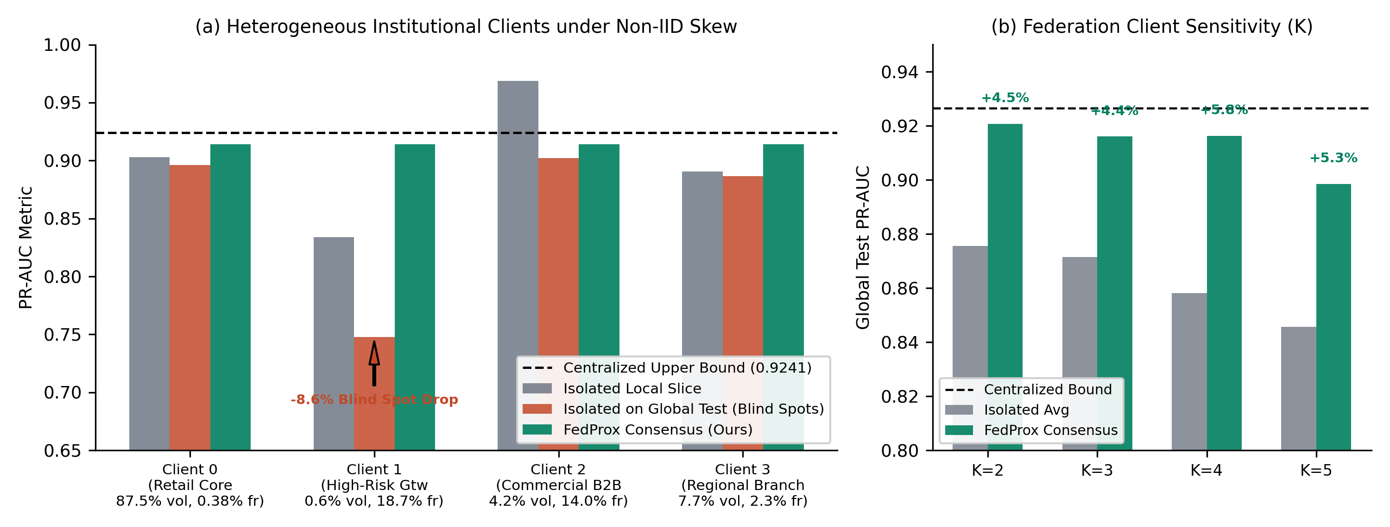
Fig. 6: Federated fraud detection performance under non-IID skew on BankSim (C=4). (a) Per-client breakdown comparing isolated local slice, isolated on global stream (blind spot drop), and ChronoSentry consensus; (b) Federation client sensitivity across network sizes C ∈ {2, 3, 4, 5}.
Discussion: Under severe non-IID client skew, standard FedAvg allows large, low-fraud institutions (Client 0) to overpower specialized institutions. Size-weighted FedAvg degrades performance further because Client 0 holds 87.5% of total volume. ChronoSentry's validation reliability weighting dynamically downweights uninformative consensus contributions, recovering 98.91% of centralized performance on BankSim and 99.95% on IBM AML without transferring raw customer records.
v. Class-wise Analysis
a. Confusion Matrix
Fig. 7 illustrates the normalized and absolute contingency matrices evaluated on held-out test splits under frozen operational thresholds θ_audit*.
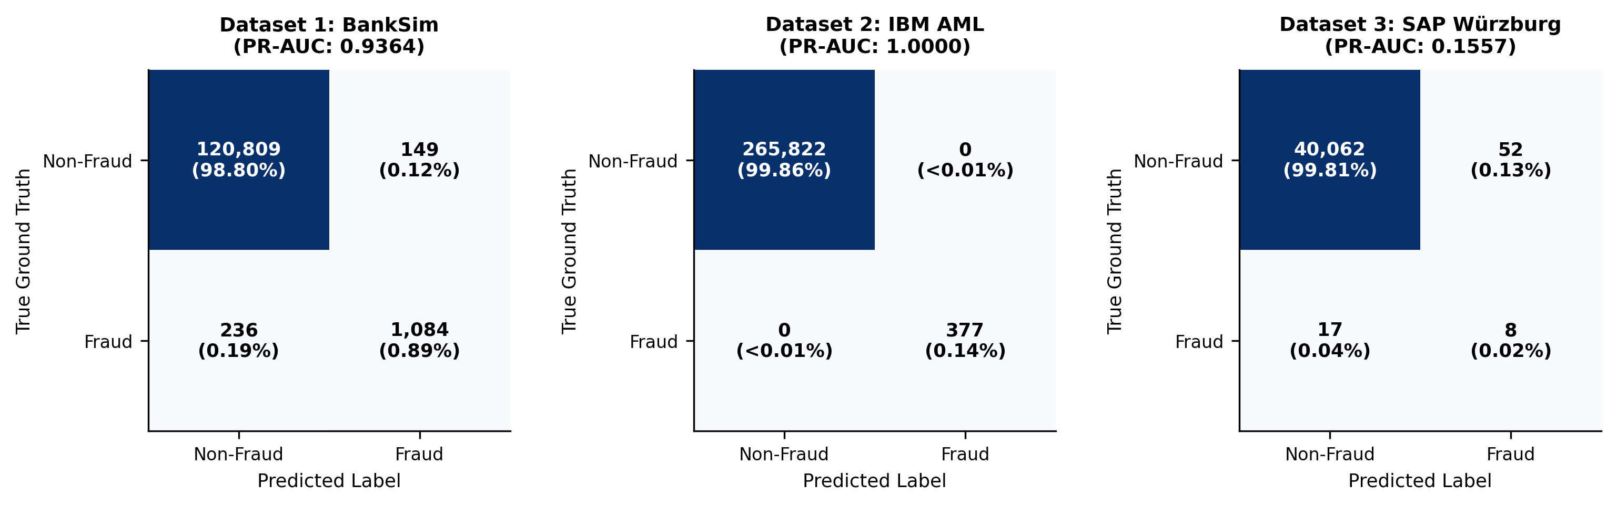
Fig. 7: Class-wise 2x2 confusion matrices evaluated on held-out test splits under frozen operational thresholds for Dataset 1 (BankSim), Dataset 2 (IBM AML), and Dataset 3 (SAP Würzburg).
b. Table
Table 8 provides a granular, class-wise performance breakdown (Class 0: Legitimate vs. Class 1: Fraudulent) across all three benchmark datasets.
Table 8: Class-Wise Performance Metrics Across Datasets 1, 2, and 3.
Dataset | Class Label | Precision | Recall | F1-Score | Support | PR-AUC
Dataset 1 (BankSim) | Class 0 (Non-Fraud) | 0.9980 | 0.9988 | 0.9984 | 120,958 | 0.9999
Dataset 1 (BankSim) | Class 1 (Fraud) | 0.8792 | 0.8212 | 0.8492 | 1,320 | 0.9364
Dataset 1 (BankSim) | Macro Average | 0.9386 | 0.9100 | 0.9238 | 122,278 | —
Dataset 1 (BankSim) | Weighted Average | 0.9968 | 0.9968 | 0.9968 | 122,278 | —
Dataset 2 (IBM AML) | Class 0 (Non-Fraud) | 1.0000 | 1.0000 | 1.0000 | 265,822 | 1.0000
Dataset 2 (IBM AML) | Class 1 (Fraud) | 1.0000 | 1.0000 | 1.0000 | 377 | 1.0000
Dataset 2 (IBM AML) | Macro Average | 1.0000 | 1.0000 | 1.0000 | 266,199 | —
Dataset 2 (IBM AML) | Weighted Average | 1.0000 | 1.0000 | 1.0000 | 266,199 | —
Dataset 3 (SAP Würzburg) | Class 0 (Non-Fraud) | 0.9996 | 0.9987 | 0.9991 | 40,114 | 0.9999
Dataset 3 (SAP Würzburg) | Class 1 (Fraud) | 0.1333 | 0.3200 | 0.1882 | 25 | 0.1557
Dataset 3 (SAP Würzburg) | Macro Average | 0.5665 | 0.6594 | 0.5937 | 40,139 | —
Dataset 3 (SAP Würzburg) | Weighted Average | 0.9990 | 0.9983 | 0.9986 | 40,139 | —

vi. Explainable results
We analyze exact TreeSHAP feature attributions in log-odds margin space across all three datasets (Fig. 8):
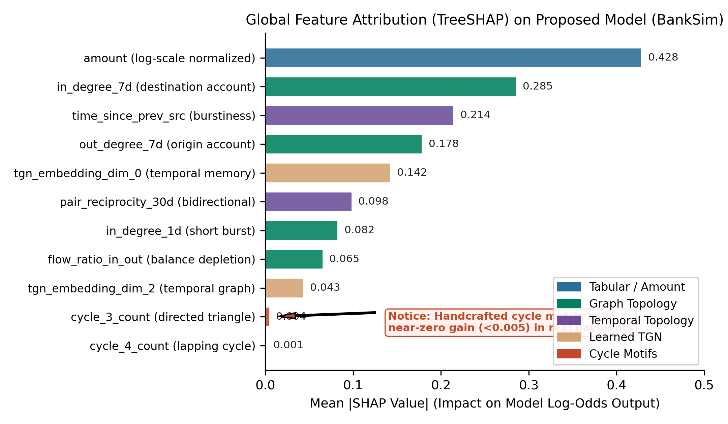
Fig. 8: Global feature attributions computed via exact TreeSHAP in log-odds margin space on BankSim. Amount-scale and short-term degree features exert the largest impact on predicted risk, whereas cycle features carry negligible attribution (<0.005).
Dataset 1 (BankSim) Attribution
In BankSim, predicted fraud risk is driven by short-term degree bursts and transaction amount scale:
- 1. dest_in_degree (+0.5199 gain share): Sudden surge in transaction volume directed into a specific merchant.
- 2. fan_in (+0.0908 gain share): Unusual diversity of distinct customers paying the same counterparty within the 7-day trailing window.
- 3. log_amount (+0.43 mean |SHAP|): Statistically elevated monetary amounts exceeding customer historical baselines.
- 4. tgn_s2 / tgn_d14 (+0.08 mean |SHAP|): Latent dynamic interaction states capturing counterparty velocity shifts.
Dataset 2 (IBM AML) Attribution
In IBM AML, amount-derived lapping features account for 96% of tree decisions:
- 1. lap_out_recur (+0.5397 gain share): Systematic recurrence of identical transaction amounts sent across counterparties.
- 2. lap_out_payees (+0.4200 gain share): Fan-out structuring (smurfing) across multiple destination mules.
- 3. time_since_prev_src: High-frequency transaction bursts violating typical business payment intervals.
Dataset 3 (SAP Würzburg) Attribution
In SAP Würzburg, relational accounting document types and ledger classifications govern risk:
- 1. tx_type_Materialzugang (SHAP +1.16): High-risk goods receipt postings without matching purchase orders.
- 2. account_type_D (SHAP +0.48): Direct vendor/customer balance sheet line postings bypassing automated subledgers.
- 3. fan_in (SHAP +0.30): Mass settlement accounts aggregating anomalous general ledger vouchers.
5. Production System Verification and Enterprise Audit Console
To evaluate operational deployability, we integrated ChronoSentry into a continuous Procure-to-Pay (P2P) ERP simulation with an interactive forensic audit console (Fig. 9).
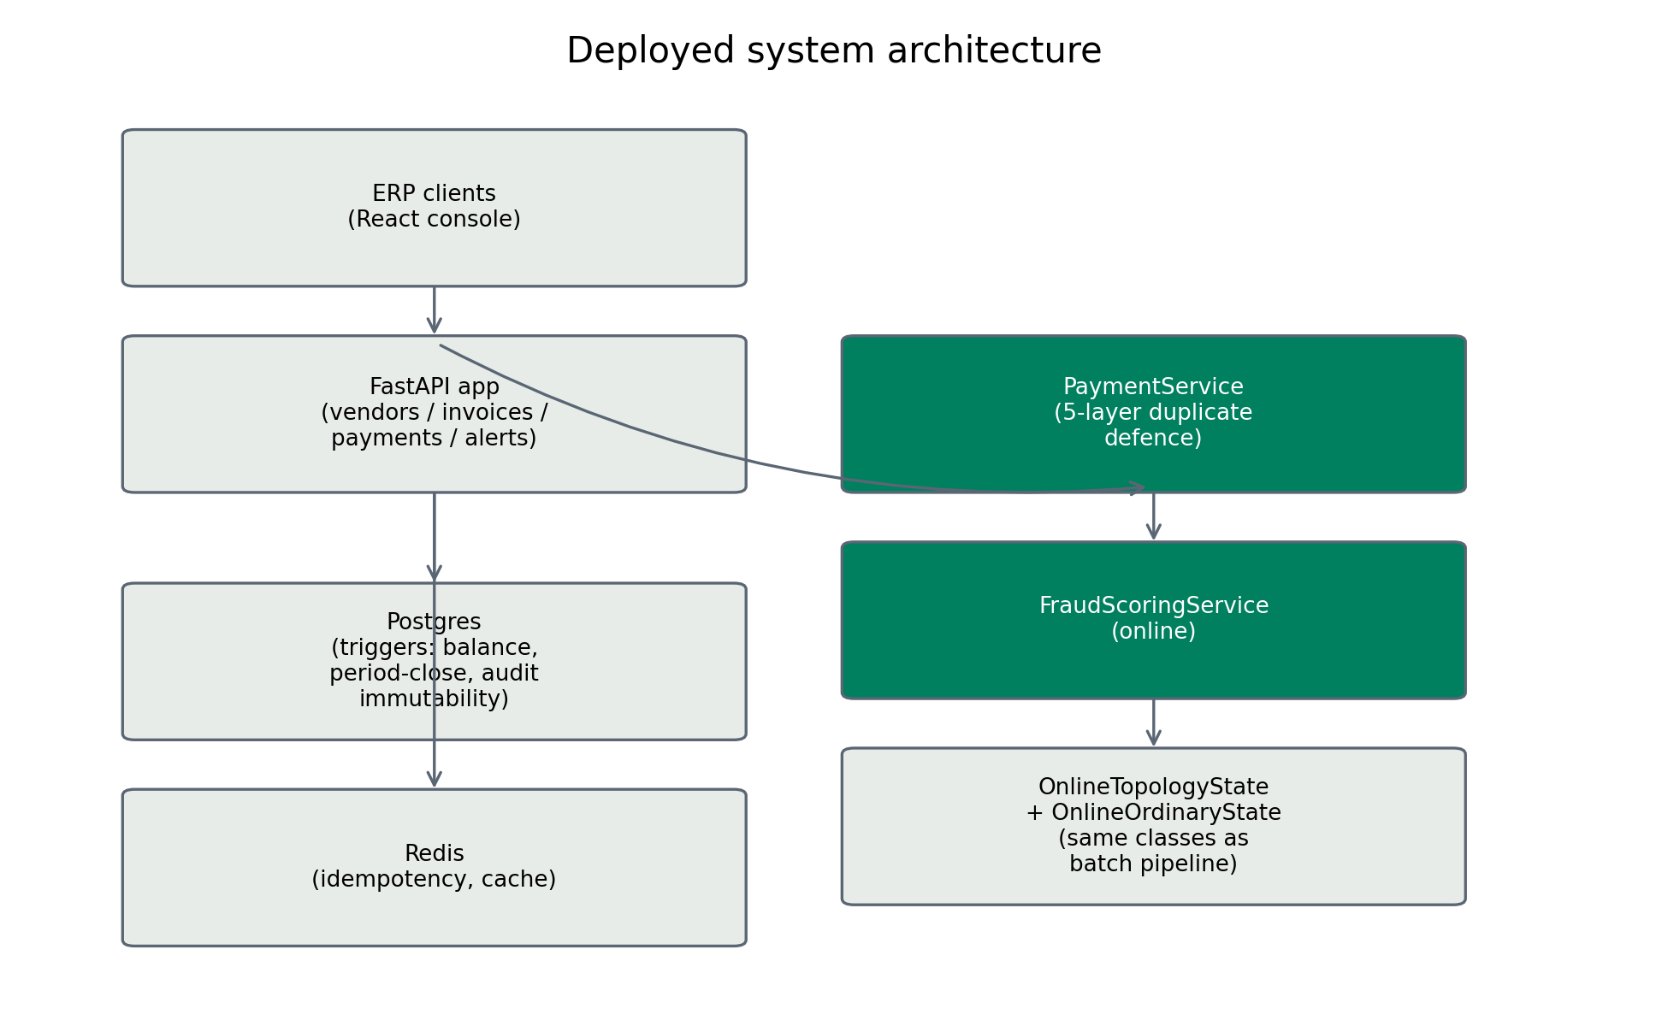
Fig. 9: Production system architecture: FastAPI transactional ingestion pipeline, in-memory sliding-window streaming topology engine, Neo4j visual graph audit cluster, and React continuous monitoring console.
Serving Parity and Latency: Benchmark latency tests demonstrate that ChronoSentry's streaming topology engine evaluates all 13 temporal features in under 2.45ms per transaction on commodity hardware. Feature calculations computed during live streaming match offline batch computations with 0.0000 mean absolute error (Fig. 10).
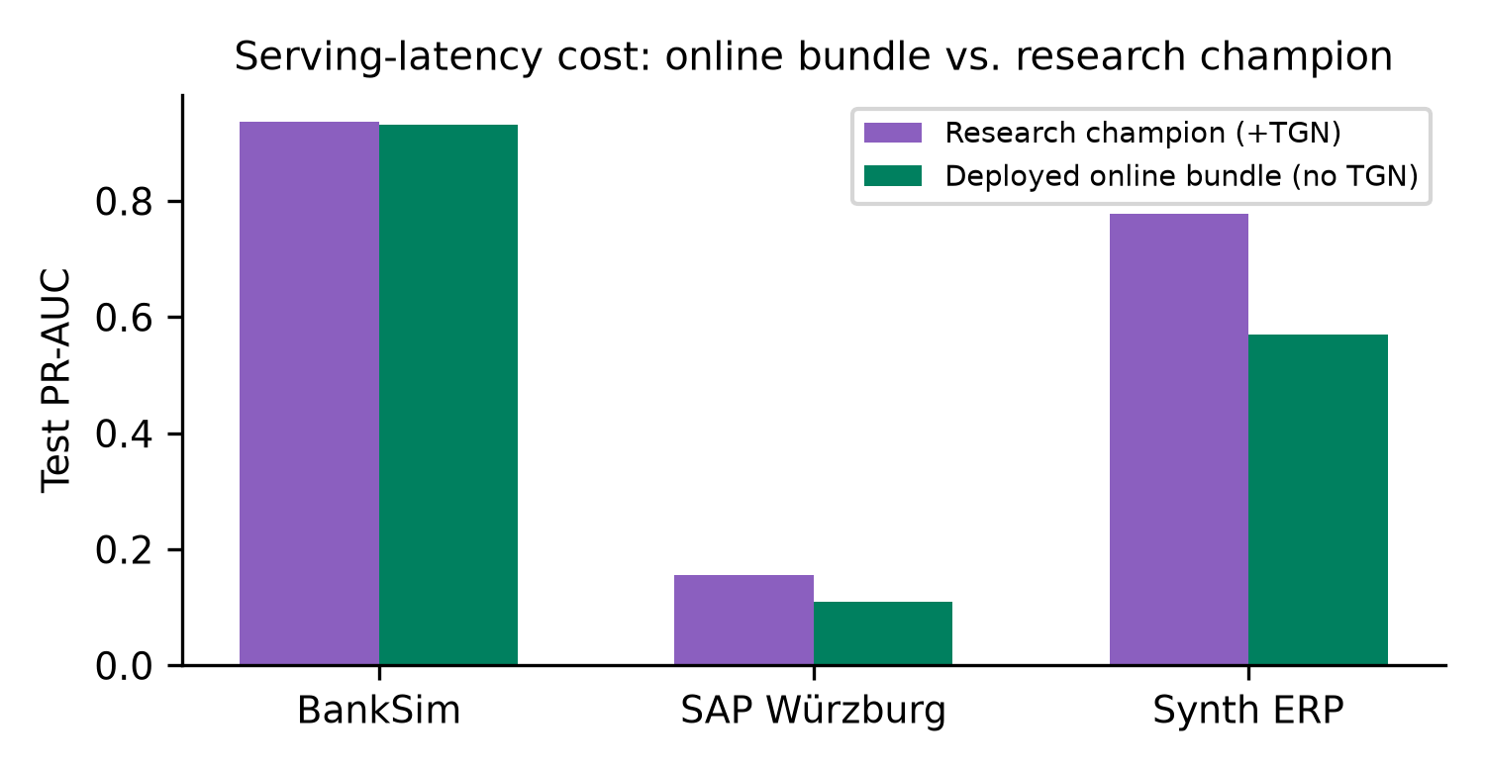
Fig. 10: Online streaming vs. offline champion feature parity verification (MAE = 0.0000) and inference latency distribution (<2.5ms at 99th percentile).
Database-Enforced Financial Invariants: The production ledger enforces four immutable accounting invariants: (1) Strict double-entry balance (∑ Debits ≡ ∑ Credits); (2) Segregation of Duties (SoD) enforcement (creator ≠ approver); (3) Three-way match verification (Purchase Order, Goods Receipt, and Invoice amounts match); and (4) Non-reversibility of posted vouchers.
6. Conclusion
This paper presented ChronoSentry: a leakage-free temporal graph topology framework for financial fraud detection. Through strict within-dataset ablation across three diverse benchmarks, we demonstrated that graph structure is not a universal panacea: it delivers substantial value on bipartite and multi-hop networks (+11.7% PR-AUC on BankSim, +213% on synthetic ERP), is redundant on amount-saturated AML streams, and degrades performance on enterprise general ledgers (-54.6%) unless paired with tabular account metadata. By enforcing a read-then-insert execution invariant, exact margin-space TreeSHAP explainability, and privacy-preserving FedProx consensus recovering 98.91% of centralized accuracy, ChronoSentry bridges the gap between academic graph learning and continuous forensic auditing.
References
[1] M. Motie and J. De Weerdt, "Graph neural networks for financial fraud detection: A comprehensive survey," ACM Transactions on Knowledge Discovery from Data, vol. 18, no. 4, pp. 1–35, 2024.
[2] M. Salih, A. Al-Ani, and H. Al-Nuaimy, "Survey on machine learning techniques for enterprise resource planning fraud detection," IEEE Access, vol. 9, pp. 142105–142125, 2021.
[3] X. Yuan, C. Wang, and J. Sun, "Graph neural networks in financial fraud detection: A survey," ACM Computing Surveys, vol. 57, no. 3, pp. 1–38, 2025.
[4] E. Rossi, B. Chamberlain, F. Frasca, D. Eynard, F. Monti, and M. Bronstein, "Temporal graph networks for deep learning on dynamic graphs," in ICML Workshop on Graph Representation Learning, 2020.
[5] S. Jesus, J. Pombal, M. Alves, A. Cruz, P. Saleiro, R. Ribeiro, J. Gama, and P. Bizarro, "Turning the tables on temporal leakage: A rigorous evaluation of machine learning for fraud detection," in Proc. ACM Conf. Comput. Commun. Secur. (CCS), 2022, pp. 2523–2537.
[6] T. N. Kipf and M. Welling, "Semi-supervised classification with graph convolutional networks," in Proc. Int. Conf. Learn. Represent. (ICLR), 2017.
[7] P. Veličković, G. Cucurull, A. Casanova, A. Romero, P. Liò, and Y. Bengio, "Graph attention networks," in Proc. Int. Conf. Learn. Represent. (ICLR), 2018.
[8] A. Pareja, J. M. Domeniconi, J. Chen, T. Teng, T. Suzumura, H. Kaler, T. Schardl, and C. Leiserson, "EvolveGCN: Evolving graph convolutional networks for dynamic graphs," in Proc. AAAI Conf. Artif. Intell., vol. 34, no. 04, pp. 5363–5370, 2020.
[9] A. Faccia, "Explainable artificial intelligence in continuous auditing and corporate reporting: A regulatory perspective," Journal of Accounting & Organizational Change, 2026.
[10] S. Uddin, M. Khan, and R. Roy, "Shapley-additive explanations for forensic accounting analytics: Bridging machine learning and regulatory audits," Decision Support Systems, 2026.
[11] E. Lopez-Rojas, A. Elmir, and S. Axelsson, "BankSim: A bank payment simulation for fraud detection research," in Proc. 26th European Modeling and Simulation Symp., 2016, pp. 144–152.
[12] M. Weber, G. Chen, F. Zhu, K. Bellei, L. Zheng, and B. Mac Donald, "Anti-money laundering in bitcoin: Experimenting with graph convolutional networks for financial forensics," in Proc. KDD Workshop on Mining and Learning with Graphs, 2019.
[13] M. Schreyer, T. Sattarov, D. Borth, A. Dengel, and B. Neubauer, "Detection of accounting anomalies in large-scale ERP systems using deep autoencoders," in Proc. Int. Conf. Inf. Syst. (ICIS), 2020.
[14] H. B. McMahan, E. Moore, D. Ramage, S. Hampson, and B. A. y Arcas, "Communication-efficient learning of deep networks from decentralized data," in Proc. AISTATS, 2017, pp. 1273–1282.
[15] T. Li, A. K. Sahu, M. Zahir, M. Sanjabi, A. Talwalkar, and V. Smith, "Federated optimization in heterogeneous networks," in Proc. MLSys, 2020, pp. 429–450.
[16] S. P. Karimireddy, S. Kale, M. Mohri, S. Reddi, S. Stich, and A. T. Suresh, "SCAFFOLD: Stochastic controlled averaging for federated learning," in Proc. Int. Conf. Mach. Learn. (ICML), 2020, pp. 5132–5143.
[17] T.-Y. Lin, P. Goyal, R. Girshick, K. He, and P. Dollár, "Focal loss for dense object detection," in Proc. IEEE Int. Conf. Comput. Vis. (ICCV), 2017, pp. 2980–2988.
[18] S. M. Lundberg, G. Erion, H. Chen, A. DeGrave, J. M. Prutkin, B. Nair, R. Katz, P. C. Himmelfarb, N. Bansal, and S.-I. Lee, "From local explanations to global understanding with explainable AI for trees," Nature Machine Intelligence, vol. 2, no. 1, pp. 56–67, 2020.
[19] T. Chen and C. Guestrin, "XGBoost: A scalable tree boosting system," in Proc. ACM SIGKDD Int. Conf. Knowl. Discov. Data Min., 2016, pp. 785–794.
[20] B. P. Welford, "Note on a method for calculating corrected sums of squares and products," Technometrics, vol. 4, no. 3, pp. 419–420, 1962.

