[](http://www.stakeholdermap.com/project-templates/project-management-templates.html)

*<COMPANY OR PROJECT LOGO>*

## <PROPOSED PROJECT NAME>

# project charter

### Version <1.0>

### <dd/mm/yyyy>

## Revision History

|  |  |  |  |
| --- | --- | --- | --- |
| **Date** | **Version** | **Description** | **Author** |
| *<MM/DD/YYYY>* | *<0.00>* | *<Type brief description here>* | *<First Initial & Last Name>* |
|  |  |  |  |

## Distribution list

|  |  |  |
| --- | --- | --- |
| **Name** | **Role** | **Date of distribution** |
|  |  |  |
|  |  |  |
|  |  |  |
|  |  |  |

## Approvals

|  |  |  |
| --- | --- | --- |
| **Name** | **Role** | **signature** |
|  |  |  |
|  |  |  |
|  |  |  |
|  |  |  |

***Notes to the Author***

*[The Project Charter is issued by the project initiator or sponsor. It formally authorizes the existence of a project, and provides the project manager with the authority to apply organizational resources to project activities.*

*Instructional text in this document is bracketed. Other text may be used in your actual plan. Please remove the instructions when the document is finalized.*

*The project initiator or sponsor create the charter or delegate the duty to the Project Manager. Typically the Project Sponsor, and Project Board/Steering Group authorize the Project Charter’s contents. The signed Project Charter authorizes the project.]*

Contents

<PROPOSED PROJECT NAME> 1

project charter 1

Version <1.0> 1

<dd/mm/yyyy> 1

Revision History 2

Distribution list 2

Approvals 2

Purpose/Project Justification 6

Objectives and success criteria 6

Requirements 6

Project Assumptions and/Or Constraints 6

Preliminary Risk Statement 6

Summary Milestone Schedule 6

Summary Estimated Budget 7

Project Governance Requirements 7

Project Manager ReResponsibilities 7

Project OrganiZation 8

Project Organization Chart 8

Roles and Responsibilities 8

Appendices 9

DOWNLOAD MORE PROJECT TEMPLATES 9

# Purpose/Project Justification

[Describe the purpose of the project and the [requirements](https://www.stakeholdermap.com/project-dictionary/requirement-meaning.html) the [project](https://www.stakeholdermap.com/prince2/prince2-glossary-P-performance.html#project) should to address. Describe the justification for conducting this [project](https://www.stakeholdermap.com/prince2/prince2-glossary-P-performance.html#project).]

# Objectives and success criteria

[Briefly discuss the intended goals and expected outcomes of the [project](https://www.stakeholdermap.com/prince2/prince2-glossary-P-performance.html#project). If possible, relate these objectives strategic business plans, the table below may help. Describe each objective using measureable success criteria, such as anticipated productivity improvements, cost reduction, improvements in business processes, revenue enhancements, technical efficiencies, etc. The stated objectives will become the basis for the [acceptance criteria](https://www.stakeholdermap.com/prince2/prince2-glossary.html#acceptance-criteria).]

|  |  |
| --- | --- |
| **Business Strategy objective** | **Project objective** |
| [Reference the goal or objective from the Strategic Business Plan. See [Strategic Business Planning](https://www.stakeholdermap.com/business/strategic-business-planning.html).] | [Describe the project objective using measureable success criteria if possible.] |
|  |  |
|  |  |

# Requirements

[Briefly describe the high level [requirements](https://www.stakeholdermap.com/project-dictionary/requirement-meaning.html). This might be a summary with the detail in an appendix.]

# Project Assumptions and/Or Constraints

[Describe any [constraints](https://www.stakeholdermap.com/prince2/prince2-glossary-C-COE.html#constraints) and [assumption](https://www.stakeholdermap.com/project-dictionary/assumptions-meaning.html)s that are currently known about the proposed project. These [constraints](https://www.stakeholdermap.com/prince2/prince2-glossary-C-COE.html#constraints) and [assumption](https://www.stakeholdermap.com/project-dictionary/assumptions-meaning.html)s may include regulatory or legislative [requirements](https://www.stakeholdermap.com/project-dictionary/requirement-meaning.html), funding limitations, sunset dates, etc. [Assumption](https://www.stakeholdermap.com/project-dictionary/assumptions-meaning.html)s are statements taken for granted or accepted as true without proof. [Assumption](https://www.stakeholdermap.com/project-dictionary/assumptions-meaning.html)s are made in the absence of fact.]

# Preliminary Risk Statement

[List and describe any [risk](https://www.stakeholdermap.com/risk/risk-dictionary-R.html#risk)s that can be identified. Consider the project [constraints](https://www.stakeholdermap.com/prince2/prince2-glossary-C-COE.html#constraints) and [assumptions](https://www.stakeholdermap.com/project-dictionary/assumptions-meaning.html) to help identify potential [risk](https://www.stakeholdermap.com/risk/risk-dictionary-R.html#risk)s. Include known [risk mitigation strategies](https://www.stakeholdermap.com/risk/risk-mitigation.html). Risks and [mitigations strategies](https://www.stakeholdermap.com/risk/risk-mitigation.html) may be in bulleted lists.]

* [Risk]
* [Risk]

[Get a [risk register template](https://www.stakeholdermap.com/risk/risk-register.html).]

# Summary Milestone Schedule

[List projected [project milestones](https://www.stakeholdermap.com/project-management/project-milestones.html) and their forecasted completion dates. This schedule is of preliminary nature only. Once the project has been approved to move forward a comprehensive Microsoft Project Plan will be developed.]

[The table below can be used or a high level [Gantt Chart](https://www.stakeholdermap.com/plan-project/gantt-charts.html). Get an [Excel Gantt Chart template](https://www.stakeholdermap.com/project-templates/excel-project-plan.html).]

|  |  |  |
| --- | --- | --- |
| [**Project Milestone**](https://www.stakeholdermap.com/project-management/project-milestones.html) | **Forecast Date** | **Owner** |
| [Initiation] |  |  |
| [Concept Development] |  |  |
| [Planning] |  |  |
| [Requirements Analysis] |  |  |
| [Design] |  |  |
| [Development] |  |  |

# Summary Estimated Budget

[Detail the current estimated costs to conduct the project and identify the source of funding. Add any additional categories to the table below as needed.]

The forecasted budget for the <Project Name> project is $<amount>. It is to be funded through <funding source/budget>. This forecasted amount will be adjusted during the Concept Development, Planning, and [Requirements](https://www.stakeholdermap.com/project-dictionary/requirement-meaning.html) Analysis Phases to derive a more precise budget.

|  |  |
| --- | --- |
| **Rough Order of Magnitude Item** | **ROM Estimate** |
| [Software] | $ |
| [Internal Resources] | $ |
| [Contractor Resources] | $ |
| [Total ROM Budget Estimate] | $ |

# Project Governance Requirements

[Describe how the project will be managed and overseen, who decides the project is successful, and who signs off on project progress, changes, and completion. It is not necessary to provide named resources at this point. Sample project governance [requirements](https://www.stakeholdermap.com/project-dictionary/requirement-meaning.html) are provided in the paragraph below.]

This project shall be internally managed by the [Project Manager](https://www.stakeholdermap.com/project-dictionary/project-manager-meaning-definition.html) with direct oversight from the Steering Committee. The Steering Committee is chaired by the Project Sponsor and comprises selected stakeholders. The [Project Manager](https://www.stakeholdermap.com/project-dictionary/project-manager-meaning-definition.html) will report the project status to the Steering Committee and present issues, options, and recommendations to the Steering Committee for authorization.

# Project Manager ReResponsibilities

[Describe project management responsibilities and the authority granted to the [Project Manager](https://www.stakeholdermap.com/project-dictionary/project-manager-meaning-definition.html). Sample project management responsibilities are provided in the paragraph below.]

The [Project Manager](https://www.stakeholdermap.com/project-dictionary/project-manager-meaning-definition.html) <Project Manager Name> is hereby authorized to interface with the Project Sponsor, Executive Sponsor, and Steering Committee as required, negotiate for resources, delegate responsibilities within the scope of the project, and to communicate, as required, with all team members, contractors, and management to ensure timely and successful completion of the project. The Project Manager is responsible for developing the Microsoft Project Plan, managing the schedule, cost, and scope of the project, measuring performance, and taking corrective action.

# Project OrganiZation

## Project Organization Chart

[Provide an Organization chart of the project team. It will typically begin with the project sponsor and include the project team and other stakeholders. An example is below:]

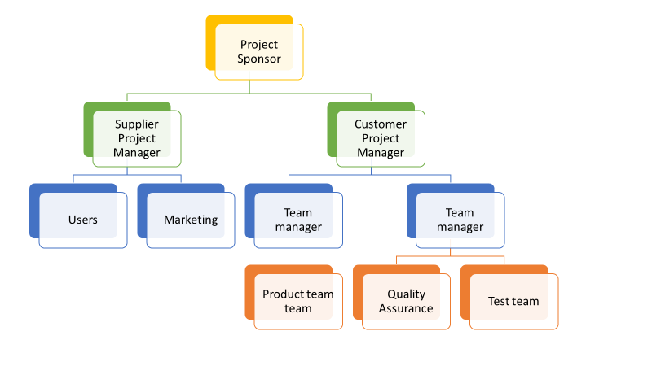

## Roles and Responsibilities

[Describe the Roles and Responsibilities of the project team and include key stakeholders.]

[It can be useful to include a [RACI](https://www.stakeholdermap.com/project-templates/raci-template.html) chart in this section. An example is below:

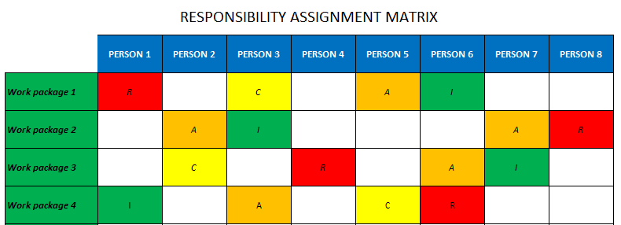

[RACI Chart - a how to guide to using RACI](https://www.stakeholdermap.com/business/raci-chart.html)

# Appendices

[Use the appendices to include detailed documentation that has been summarized in the main body of the charter. For example, project schedules, estimates, [project team job descriptions](https://www.stakeholdermap.com/project-templates/job-description-project-manager.html) etc.]

## DOWNLOAD MORE PROJECT TEMPLATES

[Microsoft Project Plans](https://www.stakeholdermap.com/project-templates/ms-project-templates.html) – real world project plans in Microsoft Project.

[Project Management Templates](https://www.stakeholdermap.com/project-templates/project-management-templates.html) – FREE project management templates in Word and Excel

[Stakeholder Management Templates](https://www.stakeholdermap.com/stakeholder-management-templates.html)

[Flowcharts to download](https://www.stakeholdermap.com/business-analysis/flow-charts.html) in Visio and PDF

[Risk Register in Excel –](https://www.stakeholdermap.com/risk/risk-register.html) download immediately

[Work Breakdown Structure Excel template](https://www.stakeholdermap.com/project-templates/WBS-excel-template.html)

[Work Breakdown Structure (WBS)](https://www.stakeholdermap.com/plan-project/example-work-breakdown-structures.html) FREE examples to download immediately.