**Prerequisite:**

System should have Java Installed and Set the path.

Refer <https://docs.oracle.com/javase/tutorial/essential/environment/paths.html> to set the path

***Instructions to execute the programme.***

1. Create a folder in C drive with any name. e.g. FindShortestPaths.

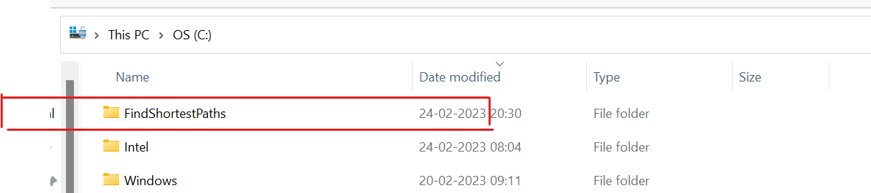

1. Download all 3 files from git repo “XXXX” into FindShortestPaths folder.

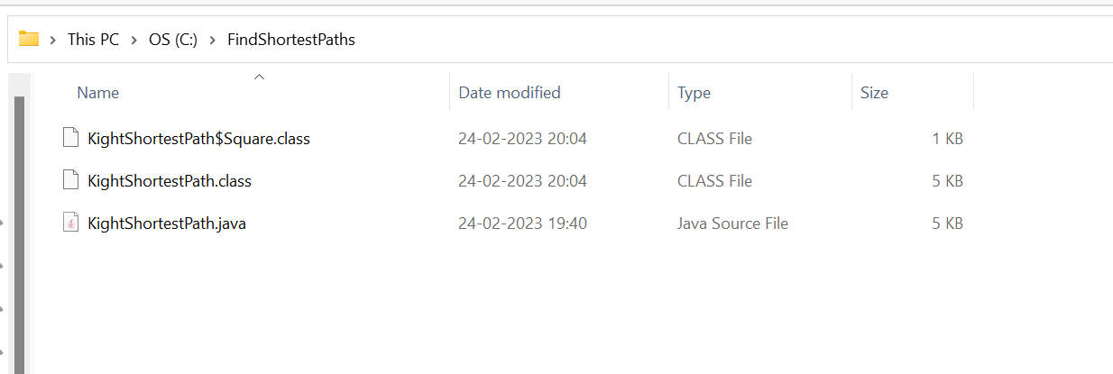

1. Open the command prompt and move to directory created in step 1 (i.e. FindShortestPaths)

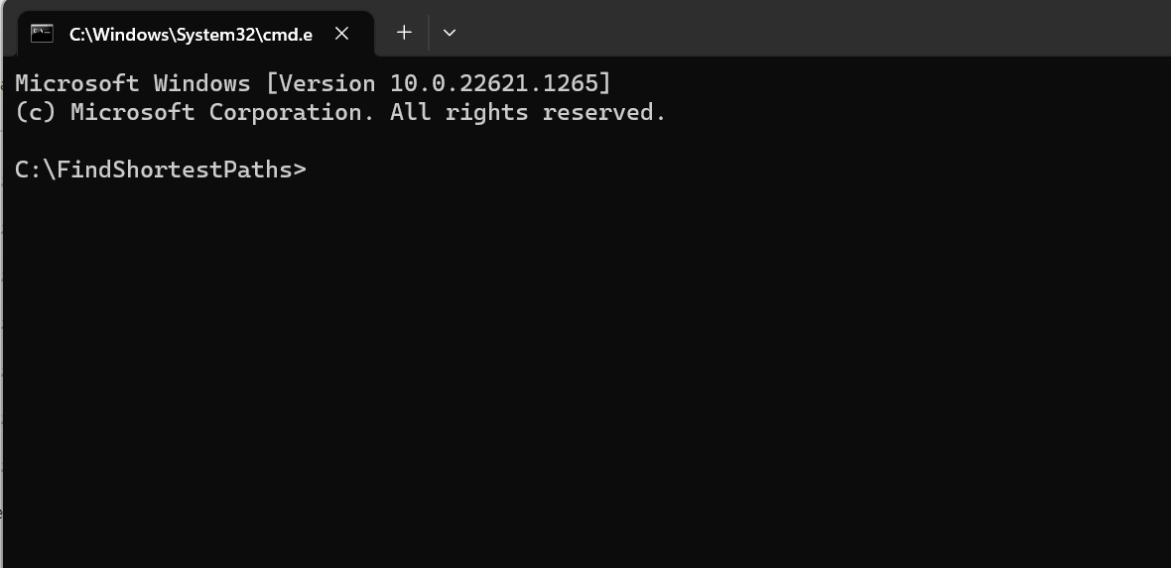

1. Run below command

java KightShortestPath

and press enter, it will wait for the input instructions as shown below,

java KightShortestPath

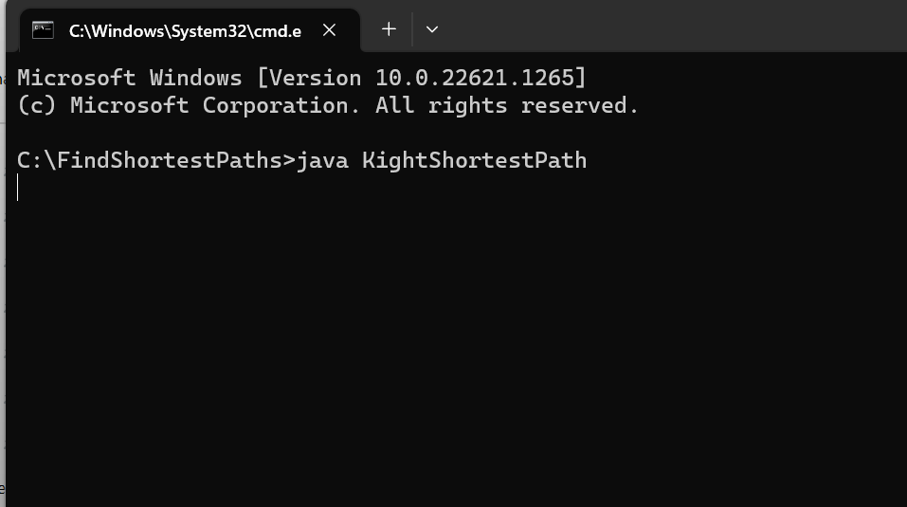

5. Enter the lines in the below format (We can enter any number of lines)

D4 G7

D4 D5

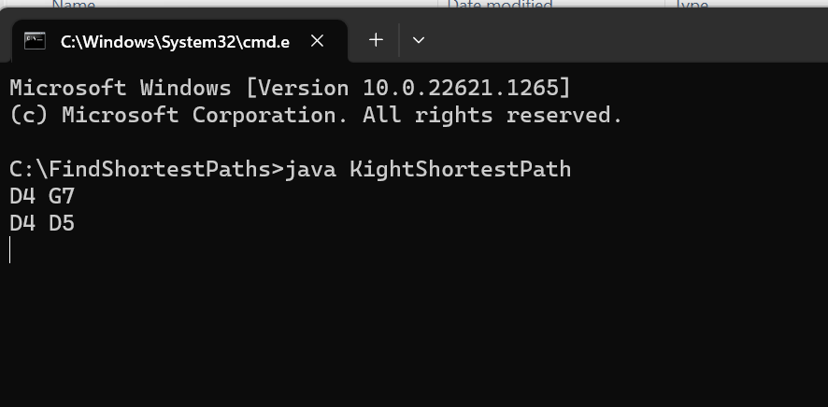

6. In order to get the output type Letter R and press Enter in new line. example

D4 G7

D4 D5

R

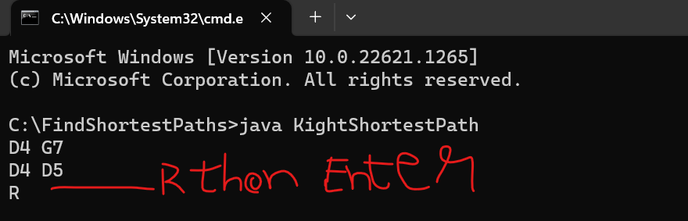

7. You will see the result as shown below

