**Prerequisite:**

You should have a development salesforce org.

***Section 1: Installing the package***

1. Open browser and access URL <https://login.salesforce.com/packaging/installPackage.apexp?p0=04t2w000009C6jf>
2. Login using your development org user name and password. Once logged in it shows below installation page.

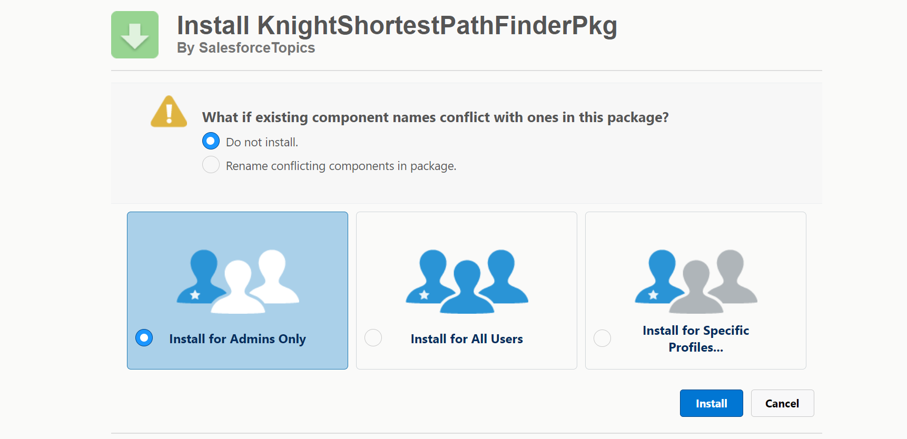

1. Select Install for Admins Only and click on Install button.

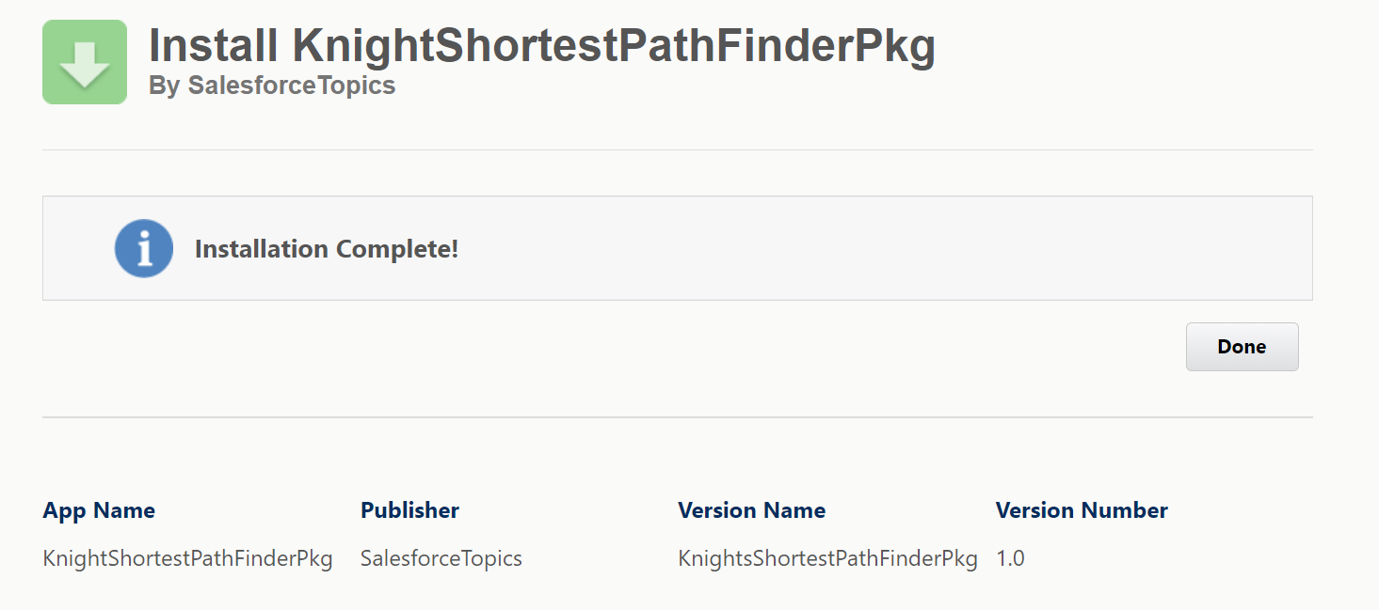

1. Click on Done.
2. Click App Launcher and Search for an App with name “Knight’s Moves”

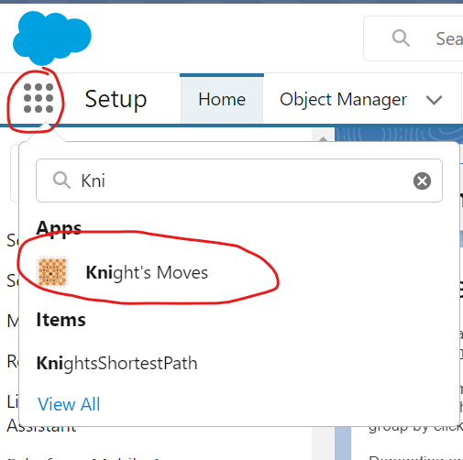

1. You will be landing on to the Knight’s Moves app.

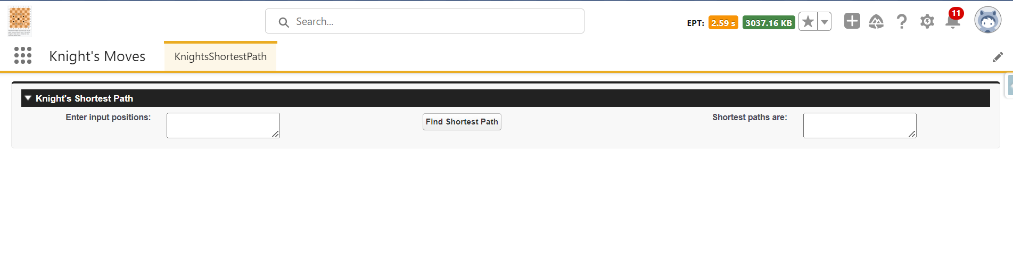

1. Enter the input possitions in the below format (We can enter any number of lines)

D4 G7

D4 D5

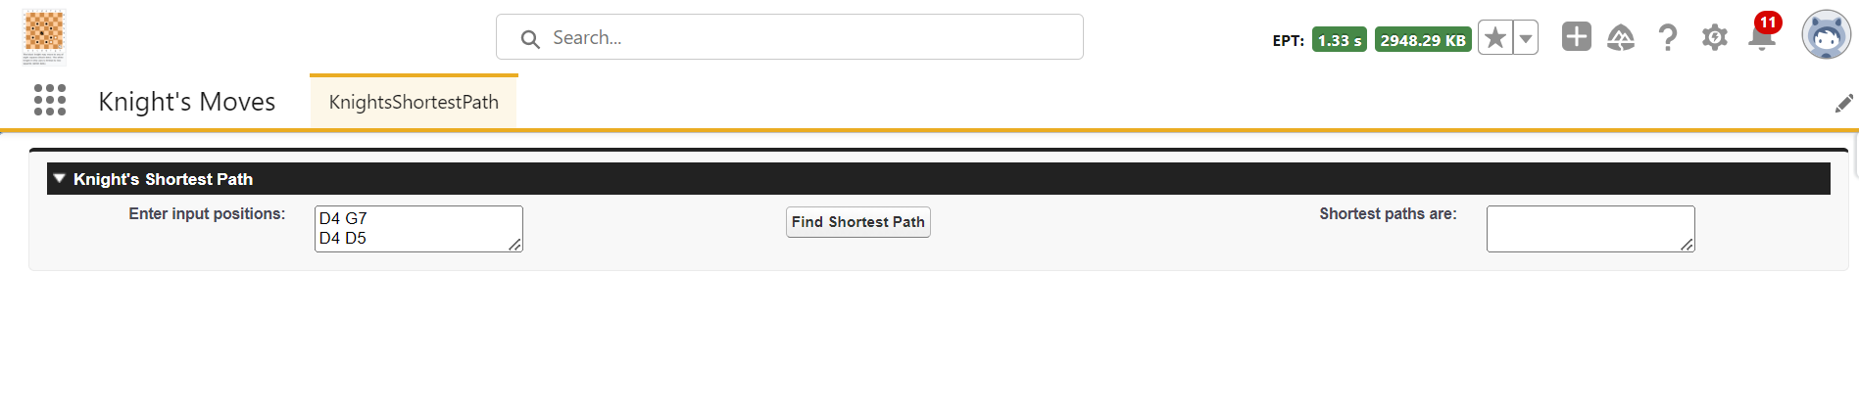

6. In order to get the output click on “Find Shortest Path” button

7. You will see the result as shown below (highlighted in red box)

