{{client}}

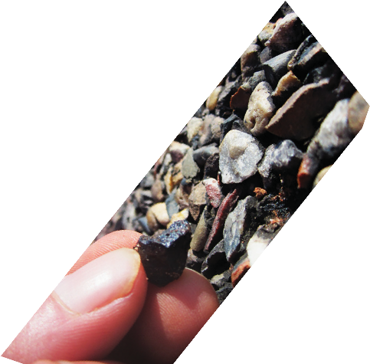
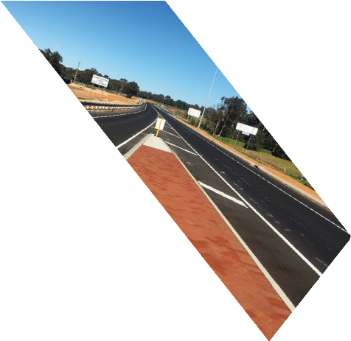
{{report_number}}

{{cover_title}}
{{report_date_long}}


Document History and Status
Revision | Prepared By |  | Reviewed By | Purpose of Issue | Date
{{revision}} | {{prepared_by}} |  | {{reviewed_by}} | {{purpose}} | {{report_date_short}}
Issued to: |  | {{issued_to}}
WML Project Number: |  | {{project_number}}
Document Name: |  | {{document_name}}

WML Consultants Pty Ltd

{{prepared_by}} | {{reviewed_by}}
{{author_qualifications}} | {{reviewer_qualifications}}
{{author_title}} | {{reviewer_title}}
Author | Reviewer
For and on behalf of WML Consultants Pty Ltd

Contents

1 INTRODUCTION
2 EXTERNAL BUILDING OBSERVATIONS
3 RECOMMENDED REMEDIAL WORKS
4 CONCLUSION
5 COST ESTIMATE

Introduction

external building Observations
ELEMENT
CONDITION RATING
LIKELIHOOD
SEVERITY
PRIORITY

recommended remedial works

Conclusion

Cost estimate
COST ESTIMATE
Item | Description | Quantity | Unit | Rate | Cost | Priority

