**Normalization results for pairs 1_0.ppm_1_4.ppm from subset HPatches_mikolajczyk_set10_Pairs50\v_blueprint**

**1_0.ppm: 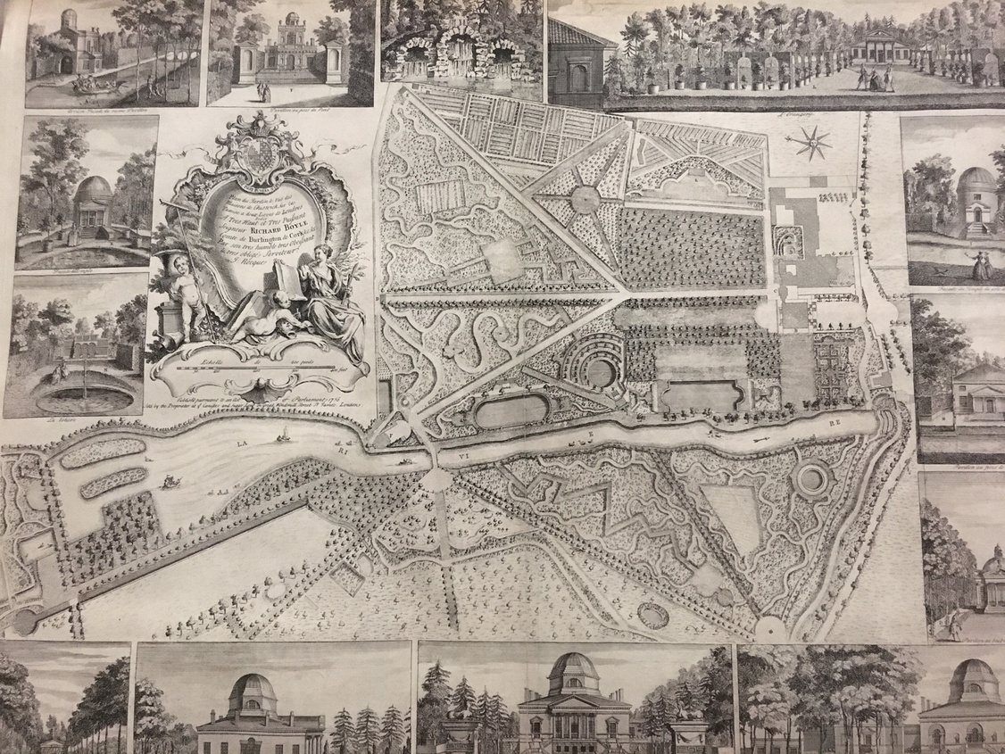1_4.ppm:** 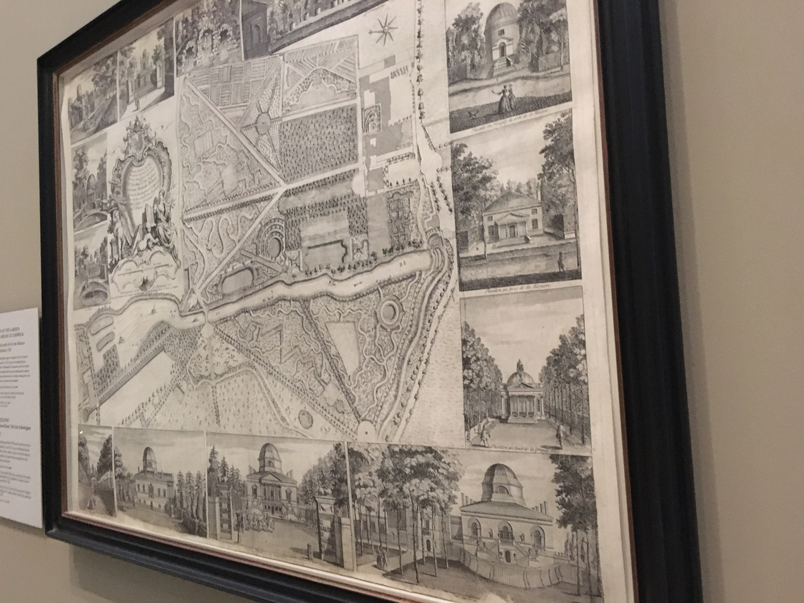

**Table 1 - Found homography parameters and normalization accuracy assessment**

|  |  |  |  |  |  |  |  |  |  |  |  |  |  |  |  |
| --- | --- | --- | --- | --- | --- | --- | --- | --- | --- | --- | --- | --- | --- | --- | --- |
| Original:  img1: 94,129 img2: 47,064 | h11 | h12 | h13 | h21 | h22 | h23 | h31 | h32 | h33 | avg ErrPar (param) | avg ErrIM (pixel) | max ErrIM | avg ErrCPM (corner) | max ErrCPM | Expert rate |
| SIFT | 0,275 | 0,042 | 84,232 | -0,228 | 0,691 | 123,548 | -0 | 0 | 1 | 0,21 | 1,013 | 3,217 | 1,788 | 2,714 |  |
| SURF128 | 0,263 | 0,036 | 93,381 | -0,232 | 0,676 | 130,765 | -0 | 0 | 1 | 0,591 | 1,275 | 3,533 | 12,142 | 31,35 |  |
| SURF64 | 0,281 | 0,043 | 81,425 | -0,227 | 0,697 | 121,242 | -0 | 0 | 1 | 0,41 | 1,297 | 3,442 | 6,861 | 12,523 |  |
| ORB | 0,283 | 0,043 | 79,2 | -0,228 | 0,697 | 122,75 | -0 | 0 | 1 | 0,398 | 1,162 | 5,686 | 10,009 | 18,512 |  |
| ORB1000 | 0,269 | 0,045 | 84,725 | -0,229 | 0,682 | 125,164 | -0 | 0 | 1 | 0,33 | 1,174 | 1,923 | 5,871 | 15,107 |  |
| BRISK | 0,277 | 0,041 | 83,582 | -0,227 | 0,693 | 122,412 | -0 | 0 | 1 | 0,276 | 1,025 | 3,084 | 3,789 | 6,228 |  |
| KAZE | 0,266 | 0,04 | 91,363 | -0,229 | 0,685 | 125,44 | -0 | 0 | 1 | 0,298 | 1,103 | 4,344 | 10,709 | 21,658 |  |
| AKAZE | 0,279 | 0,045 | 80,493 | -0,23 | 0,693 | 124,27 | -0 | 0 | 1 | 0,333 | 1,14 | 3,911 | 6,41 | 14,174 |  |
| Original matrix | 0,273 | 0,041 | 84,951 | -0,229 | 0,687 | 124,47 | -0 | 0 | 1 |  |  |  |  |  |  |

where h11, h12, h13, h21, h22, h23, h31, h32, h33 - parameters of found homography matrix H* or of original one H;   
avgErrPar - average error of found parameters, the accuracy of found homography matrix parameters with a preliminary minimax normalization of found and original matrices;  
avgErrIM - average error of inlier coordinate matching;  
inliers - correct matches; outliers - false matches;  
maxErrIM – maximum error of inlier coordinate matching;  
avgErrCPM - average error of corner point matching;  
maxErrCPM - maximum error of corner point matching;  
expert rate - experts assessment of normalization accuracy with a 5-point scale: 0 - normalization failed, 1 - insufficient, 2 - satisfactory, 3 - good, 4 – excellent.

**Table 2 - Quantitative evaluation of descriptors, precision and recall estimation (with found overlap)**

|  |  |  |  |  |  |  |  |  |  |  |  |  |  |  |  |  |
| --- | --- | --- | --- | --- | --- | --- | --- | --- | --- | --- | --- | --- | --- | --- | --- | --- |
| Name | NP1 | NP2 | NM | NI | DP1 | DP2 | OP1 | OP2 | NPO1 | NPO2 | NMO | DPO1 | DPO2 | Precision | RecallO1 | Comments |
| SIFT | 13974 | 7959 | 1322 | 1191 | 0,0147 | 0,0084 | 94,094 | 47,0728 | 13043 | 6126 | 1319 | 0,0146 | 0,0137 | 0,9009 | 0,0913 |  |
| SURF128 | 14804 | 8633 | 435 | 275 | 0,0156 | 0,0091 | 94,3155 | 46,4347 | 14122 | 5718 | 434 | 0,0157 | 0,0129 | 0,6322 | 0,0195 |  |
| SURF64 | 14804 | 8633 | 710 | 484 | 0,0156 | 0,0091 | 94,052 | 47,2499 | 14082 | 5822 | 702 | 0,0157 | 0,013 | 0,6817 | 0,0344 |  |
| ORB | 64986 | 28642 | 1780 | 1225 | 0,0683 | 0,0301 | 94,0837 | 47,4303 | 62665 | 23760 | 1778 | 0,07 | 0,0526 | 0,6882 | 0,0195 |  |
| ORB1000 | 1000 | 1000 | 28 | 21 | 0,0011 | 0,0011 | 94,1289 | 47,0056 | 973 | 749 | 28 | 0,0011 | 0,0017 | 0,75 | 0,0216 |  |
| BRISK | 27221 | 8520 | 1057 | 821 | 0,0286 | 0,009 | 94,0799 | 47,1309 | 25972 | 7082 | 1055 | 0,029 | 0,0158 | 0,7767 | 0,0316 |  |
| KAZE | 4180 | 1634 | 402 | 259 | 0,0044 | 0,0017 | 94,1357 | 46,5485 | 3885 | 1190 | 399 | 0,0043 | 0,0027 | 0,6443 | 0,0667 |  |
| AKAZE | 5089 | 1722 | 272 | 206 | 0,0053 | 0,0018 | 94,0861 | 47,2834 | 4819 | 1328 | 270 | 0,0054 | 0,003 | 0,7574 | 0,0427 |  |

where NP - number of found key points; NP1, NP2 - number of found key points for image1 and image2 respectively;  
NM - number of matches found with NNDR method, NM=NI+NO;  
NI - number of inliers found with RANSAC method;  
NO - number of outliers discarded with RANSAC method;   
DP - density of key points (per cent), DP= NP/(height x width) , height, width - vertical and horizontal image sizes respectively (pixels)  
DP1, DP2 - density of key points points for image1 and image2 respectively;  
OP1, OP2 - overlap percentage for image1 and image2 respectively;  
NPO1, NPO2 - number of found key points on overlap for image1 and image2 respectivelyy;  
NMO - number of matches on overlap found with NNDR method;  
DPO1, DPO2 - density of key points points on overlap for image1 and image2 respectively;   
OA - overlap area (pixels), OA1, OA2 - overlap area for image1 and image2 respectively;  
DPO1= NPO1/OA1; DPO2= NPO2/OA2;  
Precision = NI/ NM - the rate to evaluate the part of inliers to all found matches with NNDR method;  
RecallO1 = NI/ NPO1 - completeness of inlier retrieval relative to the number of all key points on overlap for image1. The rate illustrates usefulness of the found key points for normalization.

**Table 3 - Estimation of time costs**

|  |  |  |  |  |  |  |  |  |  |  |
| --- | --- | --- | --- | --- | --- | --- | --- | --- | --- | --- |
| Name | NP1 | NP2 | DesT1, sec | DesT2, sec | MatchT, sec | InlierT, sec | AvgDesT, ms | AvgMatchT, ms | AvgInlierT, ms | TotalNormT, sec |
| SIFT | 13974 | 7959 | 0,288618 | 0,237889 | 1,215858 | 0,00091 | 0,025271 | 0,91971 | 0,000764 | 1,743275 |
| SURF128 | 14804 | 8633 | 0,536297 | 0,418438 | 1,565575 | 0,001358 | 0,042347 | 3,599023 | 0,004937 | 2,521667 |
| SURF64 | 14804 | 8633 | 0,576644 | 0,58252 | 0,95001 | 0,001035 | 0,053213 | 1,338042 | 0,002138 | 2,110209 |
| ORB | 64986 | 28642 | 0,132565 | 0,068537 | 5,915814 | 0,001403 | 0,002215 | 3,32349 | 0,001145 | 6,118319 |
| ORB1000 | 1000 | 1000 | 0,040658 | 0,031087 | 0,004084 | 0,000545 | 0,035872 | 0,145871 | 0,025941 | 0,076374 |
| BRISK | 27221 | 8520 | 0,449841 | 0,134054 | 0,84206 | 0,001121 | 0,016129 | 0,79665 | 0,001365 | 1,427076 |
| KAZE | 4180 | 1634 | 1,222454 | 0,794925 | 0,143359 | 0,001 | 0,389471 | 0,356615 | 0,003862 | 2,161738 |
| AKAZE | 5089 | 1722 | 0,122581 | 0,108388 | 0,029097 | 0,000597 | 0,043514 | 0,106975 | 0,002898 | 0,260663 |

where DesT – descriptor creation time (time for key point detection and descriptor computation), DesT1, DesT2 – creation time of descriptors for image1 and image2 respectively;  
MatchT - retrieval time of matching found with NNDR method for the pair;  
InlierT – inlier retrieval time found with RANSAC method for the pair;  
AvgDesT – average time for one descriptor creation;  
AvgMatchT - average time for one match retrieval with NNDR method;  
AvgInlierT – average time for one inlier retrieval with RANSAC method;  
TotalNormT – total normalization time for the pair.