**Normalization results for pairs 11_0.png_11_1.png from subset png\building**

**11_0.png: 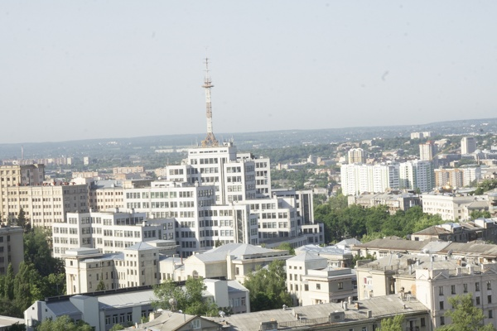11_1.png:** 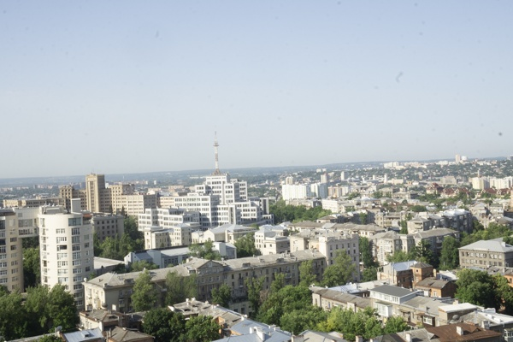

**Table 1 - Found homography parameters and normalization accuracy assessment**

|  |  |  |  |  |  |  |  |  |  |  |  |  |  |  |  |
| --- | --- | --- | --- | --- | --- | --- | --- | --- | --- | --- | --- | --- | --- | --- | --- |
| Original:  img1: 0 img2: 0 | h11 | h12 | h13 | h21 | h22 | h23 | h31 | h32 | h33 | avg ErrPar (param) | avg ErrIM (pixel) | max ErrIM | avg ErrCPM (corner) | max ErrCPM | Expert rate |
| SIFT | 0,491 | -0,001 | 130,935 | 0,006 | 0,486 | 118,776 | 0 | 0 | 1 | 0 | 0,24 | 2,549 | ~ | ~ |  |
| SURF128 | 0,489 | -0,003 | 130,96 | 0,006 | 0,483 | 119,014 | 0 | -0 | 1 | 0 | 0,589 | 2,588 | ~ | ~ |  |
| SURF64 | 0,489 | -0,003 | 131,018 | 0,006 | 0,483 | 118,846 | 0 | -0 | 1 | 0 | 0,634 | 3,035 | ~ | ~ |  |
| ORB | 0,492 | -0,005 | 131,602 | 0,007 | 0,485 | 118,496 | 0 | -0 | 1 | 0 | 0,729 | 3,794 | ~ | ~ |  |
| ORB1000 | 0,503 | 0,014 | 128,413 | 0,008 | 0,507 | 116,665 | 0 | 0 | 1 | 0 | 0,689 | 2,518 | ~ | ~ |  |
| BRISK | 0,491 | -0,001 | 130,77 | 0,006 | 0,49 | 117,834 | 0 | 0 | 1 | 0 | 0,615 | 3,014 | ~ | ~ |  |
| KAZE | 0,485 | -0,003 | 131,792 | 0,001 | 0,485 | 119,676 | 0 | 0 | 1 | 0 | 0,811 | 2,736 | ~ | ~ |  |
| AKAZE | 0,492 | -0,004 | 130,875 | 0,008 | 0,484 | 118,446 | 0 | -0 | 1 | 0 | 0,453 | 2,682 | ~ | ~ |  |
| Original matrix |  |  |  |  |  |  |  |  |  |  |  |  |  |  |  |

where h11, h12, h13, h21, h22, h23, h31, h32, h33 - parameters of found homography matrix H* or of original one H;   
avgErrPar - average error of found parameters, the accuracy of found homography matrix parameters with a preliminary minimax normalization of found and original matrices;  
avgErrIM - average error of inlier coordinate matching;  
inliers - correct matches; outliers - false matches;  
maxErrIM – maximum error of inlier coordinate matching;  
avgErrCPM - average error of corner point matching;  
maxErrCPM - maximum error of corner point matching;  
expert rate - experts assessment of normalization accuracy with a 5-point scale: 0 - normalization failed, 1 - insufficient, 2 - satisfactory, 3 - good, 4 – excellent.

**Table 2 - Quantitative evaluation of descriptors, precision and recall estimation (with found overlap)**

|  |  |  |  |  |  |  |  |  |  |  |  |  |  |  |  |  |
| --- | --- | --- | --- | --- | --- | --- | --- | --- | --- | --- | --- | --- | --- | --- | --- | --- |
| Name | NP1 | NP2 | NM | NI | DP1 | DP2 | OP1 | OP2 | NPO1 | NPO2 | NMO | DPO1 | DPO2 | Precision | RecallO1 | Comments |
| SIFT | 2478 | 2378 | 536 | 511 | 0,0103 | 0,0099 | 100 | 23,265 | 2478 | 799 | 536 | 0,0103 | 0,0143 | 0,9534 | 0,2062 |  |
| SURF128 | 1896 | 1559 | 266 | 254 | 0,0079 | 0,0065 | 100 | 23,2763 | 1896 | 538 | 266 | 0,0079 | 0,0096 | 0,9549 | 0,134 |  |
| SURF64 | 1896 | 1559 | 310 | 300 | 0,0079 | 0,0065 | 100 | 23,2933 | 1896 | 538 | 310 | 0,0079 | 0,0096 | 0,9677 | 0,1582 |  |
| ORB | 9584 | 9369 | 1096 | 1055 | 0,0399 | 0,039 | 100 | 23,4467 | 9584 | 4038 | 1096 | 0,0399 | 0,0718 | 0,9626 | 0,1101 |  |
| ORB1000 | 1000 | 1000 | 149 | 126 | 0,0042 | 0,0042 | 100 | 23,6879 | 1000 | 557 | 149 | 0,0042 | 0,0098 | 0,8456 | 0,126 |  |
| BRISK | 4031 | 3950 | 510 | 486 | 0,0168 | 0,0165 | 100 | 23,5442 | 4031 | 1493 | 510 | 0,0168 | 0,0264 | 0,9529 | 0,1206 |  |
| KAZE | 1117 | 986 | 109 | 78 | 0,0047 | 0,0041 | 100 | 23,3904 | 1117 | 315 | 109 | 0,0047 | 0,0056 | 0,7156 | 0,0698 |  |
| AKAZE | 1000 | 894 | 104 | 90 | 0,0042 | 0,0037 | 100 | 23,3 | 1000 | 375 | 104 | 0,0042 | 0,0067 | 0,8654 | 0,09 |  |

where NP - number of found key points; NP1, NP2 - number of found key points for image1 and image2 respectively;  
NM - number of matches found with NNDR method, NM=NI+NO;  
NI - number of inliers found with RANSAC method;  
NO - number of outliers discarded with RANSAC method;   
DP - density of key points (per cent), DP= NP/(height x width) , height, width - vertical and horizontal image sizes respectively (pixels)  
DP1, DP2 - density of key points points for image1 and image2 respectively;  
OP1, OP2 - overlap percentage for image1 and image2 respectively;  
NPO1, NPO2 - number of found key points on overlap for image1 and image2 respectivelyy;  
NMO - number of matches on overlap found with NNDR method;  
DPO1, DPO2 - density of key points points on overlap for image1 and image2 respectively;   
OA - overlap area (pixels), OA1, OA2 - overlap area for image1 and image2 respectively;  
DPO1= NPO1/OA1; DPO2= NPO2/OA2;  
Precision = NI/ NM - the rate to evaluate the part of inliers to all found matches with NNDR method;  
RecallO1 = NI/ NPO1 - completeness of inlier retrieval relative to the number of all key points on overlap for image1. The rate illustrates usefulness of the found key points for normalization.

**Table 3 - Estimation of time costs**

|  |  |  |  |  |  |  |  |  |  |  |
| --- | --- | --- | --- | --- | --- | --- | --- | --- | --- | --- |
| Name | NP1 | NP2 | DesT1, sec | DesT2, sec | MatchT, sec | InlierT, sec | AvgDesT, ms | AvgMatchT, ms | AvgInlierT, ms | TotalNormT, sec |
| SIFT | 2478 | 2378 | 0,058261 | 0,062497 | 0,058374 | 0,000504 | 0,024896 | 0,108907 | 0,000986 | 0,179636 |
| SURF128 | 1896 | 1559 | 0,057065 | 0,052448 | 0,023786 | 0,000364 | 0,031869 | 0,089421 | 0,001431 | 0,133662 |
| SURF64 | 1896 | 1559 | 0,056898 | 0,053231 | 0,014251 | 0,000391 | 0,032076 | 0,045971 | 0,001303 | 0,124771 |
| ORB | 9584 | 9369 | 0,022266 | 0,021516 | 0,212082 | 0,000839 | 0,002309 | 0,193505 | 0,000795 | 0,256703 |
| ORB1000 | 1000 | 1000 | 0,01041 | 0,01001 | 0,003436 | 0,000415 | 0,010209 | 0,023057 | 0,003296 | 0,024271 |
| BRISK | 4031 | 3950 | 0,058188 | 0,056803 | 0,040594 | 0,000492 | 0,014407 | 0,079595 | 0,001011 | 0,156076 |
| KAZE | 1117 | 986 | 0,181445 | 0,131949 | 0,01215 | 0,000613 | 0,14813 | 0,111471 | 0,007863 | 0,326158 |
| AKAZE | 1000 | 894 | 0,019895 | 0,018841 | 0,003739 | 0,000338 | 0,020484 | 0,035954 | 0,00375 | 0,042813 |

where DesT – descriptor creation time (time for key point detection and descriptor computation), DesT1, DesT2 – creation time of descriptors for image1 and image2 respectively;  
MatchT - retrieval time of matching found with NNDR method for the pair;  
InlierT – inlier retrieval time found with RANSAC method for the pair;  
AvgDesT – average time for one descriptor creation;  
AvgMatchT - average time for one match retrieval with NNDR method;  
AvgInlierT – average time for one inlier retrieval with RANSAC method;  
TotalNormT – total normalization time for the pair.