**Normalization results for pairs 12_0.png_12_1.png from subset 07_27\building\retest**

**12_0.png: 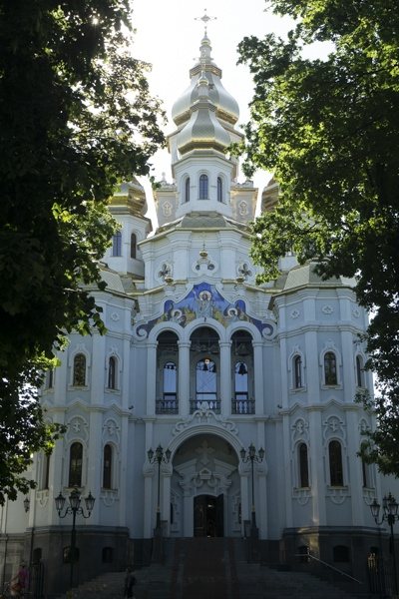12_1.png:** 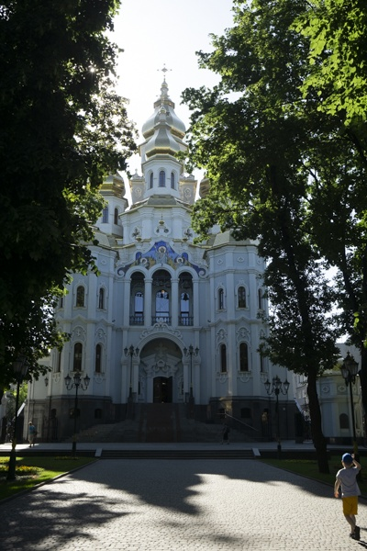

**Table 1 - Found homography parameters and normalization accuracy assessment**

|  |  |  |  |  |  |  |  |  |  |  |  |  |
| --- | --- | --- | --- | --- | --- | --- | --- | --- | --- | --- | --- | --- |
| Original:  img1: 0 img2: 0 | h11 | h12 | h13 | h21 | h22 | h23 | h31 | h32 | h33 | avg ErrIM (pixel) | max ErrIM | Expert rate |
| SIFT | 0,722 | -0,001 | 32,372 | 0,023 | 0,724 | 58,253 | 0 | 0 | 1 | 0,547 | 3,251 |  |
| SURF128 | 0,718 | -0,003 | 32,927 | 0,021 | 0,718 | 58,858 | 0 | 0 | 1 | 0,794 | 4,241 |  |
| SURF64 | 0,721 | -0,001 | 32,106 | 0,025 | 0,721 | 58,548 | 0 | 0 | 1 | 0,909 | 5,814 |  |
| ORB | 0,726 | -0,003 | 32,169 | 0,026 | 0,723 | 58,201 | 0 | 0 | 1 | 0,973 | 3,742 |  |
| ORB1000 | 0,739 | -0,016 | 32,71 | 0,046 | 0,703 | 58,877 | 0 | -0 | 1 | 1,002 | 2,632 |  |
| BRISK | 0,72 | -0,001 | 32,268 | 0,02 | 0,723 | 58,673 | 0 | 0 | 1 | 0,938 | 3,3 |  |
| KAZE | 0,708 | -0,006 | 33,975 | 0,017 | 0,708 | 59,818 | 0 | 0 | 1 | 0,881 | 3,615 |  |
| AKAZE | 0,701 | -0,006 | 33,785 | 0,014 | 0,7 | 59,946 | -0 | -0 | 1 | 0,749 | 3,65 |  |
|  |  |  |  |  |  |  |  |  |  |  |  |  |

where h11, h12, h13, h21, h22, h23, h31, h32, h33 - parameters of found homography matrix H* or of original one H;   
avgErrPar - average error of found parameters, the accuracy of found homography matrix parameters with a preliminary minimax normalization of found and original matrices;  
avgErrIM - average error of inlier coordinate matching;  
inliers - correct matches; outliers - false matches;  
maxErrIM – maximum error of inlier coordinate matching;  
avgErrCPM - average error of corner point matching;  
maxErrCPM - maximum error of corner point matching;  
expert rate - experts assessment of normalization accuracy with a 5-point scale: 0 - normalization failed, 1 - insufficient, 2 - satisfactory, 3 - good, 4 – excellent.

**Table 2 - Quantitative evaluation of descriptors, precision and recall estimation (with found overlap)**

|  |  |  |  |  |  |  |  |  |  |  |  |  |  |  |  |  |
| --- | --- | --- | --- | --- | --- | --- | --- | --- | --- | --- | --- | --- | --- | --- | --- | --- |
| Name | NP1 | NP2 | NM | NI | DP1 | DP2 | OP1 | OP2 | NPO1 | NPO2 | NMO | DPO1 | DPO2 | Precision | RecallO1 | Comments |
| SIFT | 2290 | 2247 | 501 | 460 | 0,0095 | 0,0094 | 100 | 49,0325 | 2290 | 1250 | 501 | 0,0095 | 0,0106 | 0,9182 | 0,2009 |  |
| SURF128 | 2347 | 2249 | 484 | 411 | 0,0098 | 0,0094 | 100 | 49,1246 | 2347 | 1381 | 484 | 0,0098 | 0,0117 | 0,8492 | 0,1751 |  |
| SURF64 | 2347 | 2249 | 588 | 503 | 0,0098 | 0,0094 | 100 | 48,9458 | 2347 | 1377 | 588 | 0,0098 | 0,0117 | 0,8554 | 0,2143 |  |
| ORB | 11488 | 11165 | 1931 | 1753 | 0,0479 | 0,0465 | 100 | 49,1967 | 11488 | 8028 | 1931 | 0,0479 | 0,068 | 0,9078 | 0,1526 |  |
| ORB1000 | 1000 | 1000 | 163 | 142 | 0,0042 | 0,0042 | 100 | 48,6783 | 1000 | 737 | 163 | 0,0042 | 0,0063 | 0,8712 | 0,142 |  |
| BRISK | 5019 | 4985 | 576 | 528 | 0,0209 | 0,0208 | 100 | 49,0975 | 5019 | 3069 | 576 | 0,0209 | 0,026 | 0,9167 | 0,1052 |  |
| KAZE | 1140 | 1137 | 211 | 158 | 0,0047 | 0,0047 | 100 | 49,2342 | 1140 | 586 | 211 | 0,0047 | 0,005 | 0,7488 | 0,1386 |  |
| AKAZE | 1107 | 1050 | 171 | 121 | 0,0046 | 0,0044 | 100 | 50,0908 | 1107 | 693 | 171 | 0,0046 | 0,0058 | 0,7076 | 0,1093 |  |

where NP - number of found key points; NP1, NP2 - number of found key points for image1 and image2 respectively;  
NM - number of matches found with NNDR method, NM=NI+NO;  
NI - number of inliers found with RANSAC method;  
NO - number of outliers discarded with RANSAC method;   
DP - density of key points (per cent), DP= NP/(height x width) , height, width - vertical and horizontal image sizes respectively (pixels)  
DP1, DP2 - density of key points points for image1 and image2 respectively;  
OP1, OP2 - overlap percentage for image1 and image2 respectively;  
NPO1, NPO2 - number of found key points on overlap for image1 and image2 respectivelyy;  
NMO - number of matches on overlap found with NNDR method;  
DPO1, DPO2 - density of key points points on overlap for image1 and image2 respectively;   
OA - overlap area (pixels), OA1, OA2 - overlap area for image1 and image2 respectively;  
DPO1= NPO1/OA1; DPO2= NPO2/OA2;  
Precision = NI/ NM - the rate to evaluate the part of inliers to all found matches with NNDR method;  
RecallO1 = NI/ NPO1 - completeness of inlier retrieval relative to the number of all key points on overlap for image1. The rate illustrates usefulness of the found key points for normalization.

**Table 3 - Estimation of time costs**

|  |  |  |  |  |  |  |  |  |  |  |
| --- | --- | --- | --- | --- | --- | --- | --- | --- | --- | --- |
| Name | NP1 | NP2 | DesT1, sec | DesT2, sec | MatchT, sec | InlierT, sec | AvgDesT, ms | AvgMatchT, ms | AvgInlierT, ms | TotalNormT, sec |
| SIFT | 2290 | 2247 | 0,306762 | 0,054638 | 0,135678 | 0,071585 | 0,079136 | 0,270815 | 0,155619 | 0,568664 |
| SURF128 | 2347 | 2249 | 0,32435 | 0,066499 | 0,042297 | 0,00076 | 0,083882 | 0,08739 | 0,001849 | 0,433907 |
| SURF64 | 2347 | 2249 | 0,076948 | 0,06727 | 0,024489 | 0,000804 | 0,031348 | 0,041648 | 0,001598 | 0,169511 |
| ORB | 11488 | 11165 | 0,06865 | 0,027671 | 0,294892 | 0,001214 | 0,004226 | 0,152714 | 0,000692 | 0,392428 |
| ORB1000 | 1000 | 1000 | 0,011378 | 0,011504 | 0,003515 | 0,000567 | 0,01144 | 0,021566 | 0,003992 | 0,026964 |
| BRISK | 5019 | 4985 | 0,076249 | 0,078094 | 0,06504 | 0,000554 | 0,015428 | 0,112916 | 0,001048 | 0,219937 |
| KAZE | 1140 | 1137 | 0,143421 | 0,117989 | 0,013526 | 0,000694 | 0,114789 | 0,064102 | 0,004391 | 0,27563 |
| AKAZE | 1107 | 1050 | 0,022198 | 0,021892 | 0,004764 | 0,00065 | 0,02045 | 0,027857 | 0,005368 | 0,049503 |

where DesT – descriptor creation time (time for key point detection and descriptor computation), DesT1, DesT2 – creation time of descriptors for image1 and image2 respectively;  
MatchT - retrieval time of matching found with NNDR method for the pair;  
InlierT – inlier retrieval time found with RANSAC method for the pair;  
AvgDesT – average time for one descriptor creation;  
AvgMatchT - average time for one match retrieval with NNDR method;  
AvgInlierT – average time for one inlier retrieval with RANSAC method;  
TotalNormT – total normalization time for the pair.