**Normalization results for pairs 13_0.png_13_1.png from subset png\building**

**13_0.png: 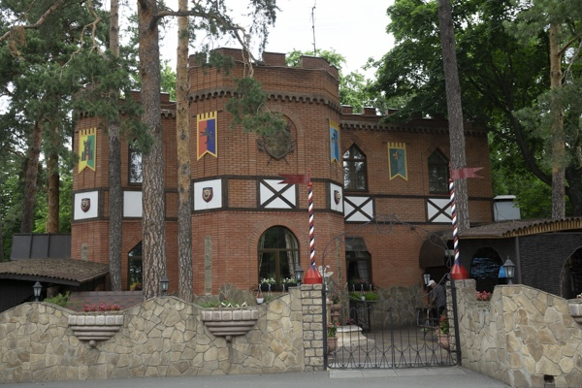13_1.png:** 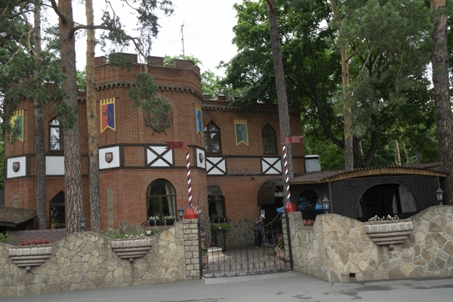

**Table 1 - Found homography parameters and normalization accuracy assessment**

|  |  |  |  |  |  |  |  |  |  |  |  |  |  |  |  |
| --- | --- | --- | --- | --- | --- | --- | --- | --- | --- | --- | --- | --- | --- | --- | --- |
| Original:  img1: 0 img2: 0 | h11 | h12 | h13 | h21 | h22 | h23 | h31 | h32 | h33 | avg ErrPar (param) | avg ErrIM (pixel) | max ErrIM | avg ErrCPM (corner) | max ErrCPM | Expert rate |
| SIFT | 0,991 | 0,017 | -63,051 | 0,026 | 0,959 | 19,602 | 0 | -0 | 1 | 0 | 0,961 | 3,752 | ~ | ~ |  |
| SURF128 | 1,025 | 0,055 | -79,312 | 0,024 | 0,957 | 20,474 | 0 | -0 | 1 | 0 | 1,304 | 3,263 | ~ | ~ |  |
| SURF64 | 1,003 | 0,055 | -74,85 | 0,011 | 0,953 | 23,562 | 0 | 0 | 1 | 0 | 1,293 | 3,54 | ~ | ~ |  |
| ORB | 0,992 | 0,041 | -69,211 | 0,02 | 0,938 | 22,588 | 0 | -0 | 1 | 0 | 1,316 | 3,464 | ~ | ~ |  |
| ORB1000 | 1,002 | 0,015 | -67,41 | 0,03 | 0,95 | 19,662 | 0 | -0 | 1 | 0 | 1,072 | 3,455 | ~ | ~ |  |
| BRISK | 1,056 | 0,069 | -84,101 | 0,042 | 1,005 | 12,828 | 0 | 0 | 1 | 0 | 1,346 | 3,343 | ~ | ~ |  |
| KAZE | 1,036 | 0,056 | -80,484 | 0,031 | 0,968 | 18,365 | 0 | 0 | 1 | 0 | 1,135 | 3,141 | ~ | ~ |  |
| AKAZE | 1,007 | 0,046 | -74,22 | 0,019 | 0,94 | 22,948 | 0 | -0 | 1 | 0 | 1,209 | 2,879 | ~ | ~ |  |
| Original matrix |  |  |  |  |  |  |  |  |  |  |  |  |  |  |  |

where h11, h12, h13, h21, h22, h23, h31, h32, h33 - parameters of found homography matrix H* or of original one H;   
avgErrPar - average error of found parameters, the accuracy of found homography matrix parameters with a preliminary minimax normalization of found and original matrices;  
avgErrIM - average error of inlier coordinate matching;  
inliers - correct matches; outliers - false matches;  
maxErrIM – maximum error of inlier coordinate matching;  
avgErrCPM - average error of corner point matching;  
maxErrCPM - maximum error of corner point matching;  
expert rate - experts assessment of normalization accuracy with a 5-point scale: 0 - normalization failed, 1 - insufficient, 2 - satisfactory, 3 - good, 4 – excellent.

**Table 2 - Quantitative evaluation of descriptors, precision and recall estimation (with found overlap)**

|  |  |  |  |  |  |  |  |  |  |  |  |  |  |  |  |  |
| --- | --- | --- | --- | --- | --- | --- | --- | --- | --- | --- | --- | --- | --- | --- | --- | --- |
| Name | NP1 | NP2 | NM | NI | DP1 | DP2 | OP1 | OP2 | NPO1 | NPO2 | NMO | DPO1 | DPO2 | Precision | RecallO1 | Comments |
| SIFT | 2058 | 2074 | 539 | 279 | 0,0086 | 0,0086 | 90,0475 | 72,1554 | 1830 | 1576 | 539 | 0,0085 | 0,0091 | 0,5176 | 0,1525 |  |
| SURF128 | 2576 | 2611 | 500 | 331 | 0,0107 | 0,0109 | 88,9533 | 73,3825 | 2335 | 2084 | 500 | 0,0109 | 0,0118 | 0,662 | 0,1418 |  |
| SURF64 | 2576 | 2611 | 667 | 344 | 0,0107 | 0,0109 | 89,4733 | 73,8175 | 2340 | 2097 | 664 | 0,0109 | 0,0118 | 0,5157 | 0,147 |  |
| ORB | 8039 | 8437 | 1325 | 865 | 0,0335 | 0,0352 | 89,8271 | 73,1083 | 7639 | 7253 | 1323 | 0,0354 | 0,0413 | 0,6528 | 0,1132 |  |
| ORB1000 | 1000 | 1000 | 198 | 140 | 0,0042 | 0,0042 | 89,3312 | 72,3375 | 986 | 952 | 198 | 0,0046 | 0,0055 | 0,7071 | 0,142 |  |
| BRISK | 2973 | 3013 | 510 | 295 | 0,0124 | 0,0126 | 88,9858 | 72,5842 | 2712 | 2525 | 510 | 0,0127 | 0,0145 | 0,5784 | 0,1088 |  |
| KAZE | 751 | 719 | 221 | 126 | 0,0031 | 0,003 | 88,9317 | 73,2383 | 684 | 599 | 220 | 0,0032 | 0,0034 | 0,5701 | 0,1842 |  |
| AKAZE | 636 | 634 | 160 | 91 | 0,0027 | 0,0026 | 89,3038 | 73,5512 | 601 | 577 | 159 | 0,0028 | 0,0033 | 0,5687 | 0,1514 |  |

where NP - number of found key points; NP1, NP2 - number of found key points for image1 and image2 respectively;  
NM - number of matches found with NNDR method, NM=NI+NO;  
NI - number of inliers found with RANSAC method;  
NO - number of outliers discarded with RANSAC method;   
DP - density of key points (per cent), DP= NP/(height x width) , height, width - vertical and horizontal image sizes respectively (pixels)  
DP1, DP2 - density of key points points for image1 and image2 respectively;  
OP1, OP2 - overlap percentage for image1 and image2 respectively;  
NPO1, NPO2 - number of found key points on overlap for image1 and image2 respectivelyy;  
NMO - number of matches on overlap found with NNDR method;  
DPO1, DPO2 - density of key points points on overlap for image1 and image2 respectively;   
OA - overlap area (pixels), OA1, OA2 - overlap area for image1 and image2 respectively;  
DPO1= NPO1/OA1; DPO2= NPO2/OA2;  
Precision = NI/ NM - the rate to evaluate the part of inliers to all found matches with NNDR method;  
RecallO1 = NI/ NPO1 - completeness of inlier retrieval relative to the number of all key points on overlap for image1. The rate illustrates usefulness of the found key points for normalization.

**Table 3 - Estimation of time costs**

|  |  |  |  |  |  |  |  |  |  |  |
| --- | --- | --- | --- | --- | --- | --- | --- | --- | --- | --- |
| Name | NP1 | NP2 | DesT1, sec | DesT2, sec | MatchT, sec | InlierT, sec | AvgDesT, ms | AvgMatchT, ms | AvgInlierT, ms | TotalNormT, sec |
| SIFT | 2058 | 2074 | 0,057714 | 0,057362 | 0,035807 | 0,002122 | 0,02785 | 0,066432 | 0,007605 | 0,153005 |
| SURF128 | 2576 | 2611 | 0,070751 | 0,061628 | 0,063638 | 0,000988 | 0,025534 | 0,127275 | 0,002984 | 0,197005 |
| SURF64 | 2576 | 2611 | 0,067705 | 0,066694 | 0,031133 | 0,002284 | 0,025913 | 0,046675 | 0,006639 | 0,167816 |
| ORB | 8039 | 8437 | 0,020127 | 0,019949 | 0,160838 | 0,00137 | 0,002433 | 0,121387 | 0,001583 | 0,202284 |
| ORB1000 | 1000 | 1000 | 0,009939 | 0,010722 | 0,003706 | 0,000723 | 0,01033 | 0,018716 | 0,005166 | 0,02509 |
| BRISK | 2973 | 3013 | 0,046482 | 0,045294 | 0,023139 | 0,001748 | 0,015333 | 0,045369 | 0,005924 | 0,116662 |
| KAZE | 751 | 719 | 0,183531 | 0,176084 | 0,004833 | 0,001371 | 0,244641 | 0,02187 | 0,010879 | 0,365819 |
| AKAZE | 636 | 634 | 0,018293 | 0,018192 | 0,001882 | 0,001358 | 0,028727 | 0,011765 | 0,014921 | 0,039725 |

where DesT – descriptor creation time (time for key point detection and descriptor computation), DesT1, DesT2 – creation time of descriptors for image1 and image2 respectively;  
MatchT - retrieval time of matching found with NNDR method for the pair;  
InlierT – inlier retrieval time found with RANSAC method for the pair;  
AvgDesT – average time for one descriptor creation;  
AvgMatchT - average time for one match retrieval with NNDR method;  
AvgInlierT – average time for one inlier retrieval with RANSAC method;  
TotalNormT – total normalization time for the pair.