**Normalization results for pairs 14_0.png_14_1.png from subset png\building**

**14_0.png: 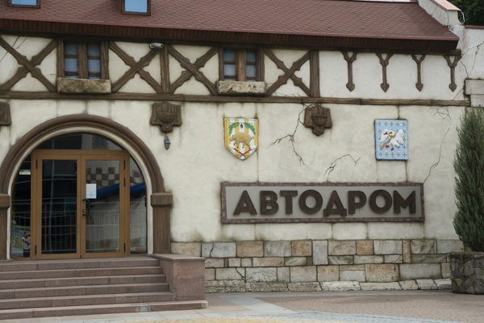14_1.png:** 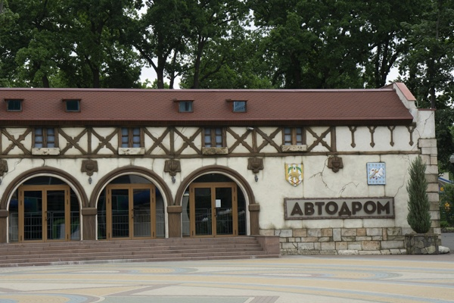

**Table 1 - Found homography parameters and normalization accuracy assessment**

|  |  |  |  |  |  |  |  |  |  |  |  |  |  |  |  |
| --- | --- | --- | --- | --- | --- | --- | --- | --- | --- | --- | --- | --- | --- | --- | --- |
| Original:  img1: 0 img2: 0 | h11 | h12 | h13 | h21 | h22 | h23 | h31 | h32 | h33 | avg ErrPar (param) | avg ErrIM (pixel) | max ErrIM | avg ErrCPM (corner) | max ErrCPM | Expert rate |
| SIFT | 0,458 | 0,023 | 229,183 | -0,057 | 0,544 | 143,387 | -0 | 0 | 1 | 0 | 0,367 | 2,456 | ~ | ~ |  |
| SURF128 | 0,464 | 0,027 | 228,202 | -0,055 | 0,549 | 142,944 | -0 | 0 | 1 | 0 | 0,731 | 3,408 | ~ | ~ |  |
| SURF64 | 0,464 | 0,029 | 228,229 | -0,056 | 0,551 | 142,975 | -0 | 0 | 1 | 0 | 0,739 | 2,581 | ~ | ~ |  |
| ORB | 0,473 | 0,03 | 226,559 | -0,052 | 0,554 | 142,022 | -0 | 0 | 1 | 0 | 0,745 | 2,652 | ~ | ~ |  |
| ORB1000 | 0,418 | 0,03 | 231,869 | -0,071 | 0,528 | 144,919 | -0 | 0 | 1 | 0 | 0,762 | 1,603 | ~ | ~ |  |
| BRISK | 0,455 | 0,028 | 228,951 | -0,059 | 0,548 | 143,217 | -0 | 0 | 1 | 0 | 0,615 | 2,623 | ~ | ~ |  |
| KAZE | 0,453 | 0,039 | 228,672 | -0,061 | 0,556 | 143,004 | -0 | 0 | 1 | 0 | 0,672 | 2,91 | ~ | ~ |  |
| AKAZE | 0,46 | 0,032 | 228,208 | -0,058 | 0,553 | 142,786 | -0 | 0 | 1 | 0 | 0,528 | 2,889 | ~ | ~ |  |
| Original matrix |  |  |  |  |  |  |  |  |  |  |  |  |  |  |  |

where h11, h12, h13, h21, h22, h23, h31, h32, h33 - parameters of found homography matrix H* or of original one H;   
avgErrPar - average error of found parameters, the accuracy of found homography matrix parameters with a preliminary minimax normalization of found and original matrices;  
avgErrIM - average error of inlier coordinate matching;  
inliers - correct matches; outliers - false matches;  
maxErrIM – maximum error of inlier coordinate matching;  
avgErrCPM - average error of corner point matching;  
maxErrCPM - maximum error of corner point matching;  
expert rate - experts assessment of normalization accuracy with a 5-point scale: 0 - normalization failed, 1 - insufficient, 2 - satisfactory, 3 - good, 4 – excellent.

**Table 2 - Quantitative evaluation of descriptors, precision and recall estimation (with found overlap)**

|  |  |  |  |  |  |  |  |  |  |  |  |  |  |  |  |  |
| --- | --- | --- | --- | --- | --- | --- | --- | --- | --- | --- | --- | --- | --- | --- | --- | --- |
| Name | NP1 | NP2 | NM | NI | DP1 | DP2 | OP1 | OP2 | NPO1 | NPO2 | NMO | DPO1 | DPO2 | Precision | RecallO1 | Comments |
| SIFT | 1488 | 1895 | 453 | 400 | 0,0062 | 0,0079 | 100 | 31,5446 | 1488 | 749 | 453 | 0,0062 | 0,0099 | 0,883 | 0,2688 |  |
| SURF128 | 2133 | 2325 | 336 | 276 | 0,0089 | 0,0097 | 100 | 31,5654 | 2133 | 830 | 336 | 0,0089 | 0,011 | 0,8214 | 0,1294 |  |
| SURF64 | 2133 | 2325 | 375 | 306 | 0,0089 | 0,0097 | 100 | 31,6004 | 2133 | 831 | 375 | 0,0089 | 0,011 | 0,816 | 0,1435 |  |
| ORB | 4635 | 7656 | 867 | 680 | 0,0193 | 0,0319 | 100 | 31,8492 | 4635 | 3197 | 867 | 0,0193 | 0,0418 | 0,7843 | 0,1467 |  |
| ORB1000 | 1000 | 1000 | 39 | 21 | 0,0042 | 0,0042 | 100 | 31,1887 | 1000 | 186 | 39 | 0,0042 | 0,0025 | 0,5385 | 0,021 |  |
| BRISK | 1559 | 3129 | 279 | 233 | 0,0065 | 0,013 | 100 | 31,6317 | 1559 | 1130 | 279 | 0,0065 | 0,0149 | 0,8351 | 0,1495 |  |
| KAZE | 810 | 1065 | 139 | 108 | 0,0034 | 0,0044 | 100 | 31,5792 | 810 | 415 | 139 | 0,0034 | 0,0055 | 0,777 | 0,1333 |  |
| AKAZE | 743 | 1038 | 173 | 144 | 0,0031 | 0,0043 | 100 | 31,7163 | 743 | 466 | 173 | 0,0031 | 0,0061 | 0,8324 | 0,1938 |  |

where NP - number of found key points; NP1, NP2 - number of found key points for image1 and image2 respectively;  
NM - number of matches found with NNDR method, NM=NI+NO;  
NI - number of inliers found with RANSAC method;  
NO - number of outliers discarded with RANSAC method;   
DP - density of key points (per cent), DP= NP/(height x width) , height, width - vertical and horizontal image sizes respectively (pixels)  
DP1, DP2 - density of key points points for image1 and image2 respectively;  
OP1, OP2 - overlap percentage for image1 and image2 respectively;  
NPO1, NPO2 - number of found key points on overlap for image1 and image2 respectivelyy;  
NMO - number of matches on overlap found with NNDR method;  
DPO1, DPO2 - density of key points points on overlap for image1 and image2 respectively;   
OA - overlap area (pixels), OA1, OA2 - overlap area for image1 and image2 respectively;  
DPO1= NPO1/OA1; DPO2= NPO2/OA2;  
Precision = NI/ NM - the rate to evaluate the part of inliers to all found matches with NNDR method;  
RecallO1 = NI/ NPO1 - completeness of inlier retrieval relative to the number of all key points on overlap for image1. The rate illustrates usefulness of the found key points for normalization.

**Table 3 - Estimation of time costs**

|  |  |  |  |  |  |  |  |  |  |  |
| --- | --- | --- | --- | --- | --- | --- | --- | --- | --- | --- |
| Name | NP1 | NP2 | DesT1, sec | DesT2, sec | MatchT, sec | InlierT, sec | AvgDesT, ms | AvgMatchT, ms | AvgInlierT, ms | TotalNormT, sec |
| SIFT | 1488 | 1895 | 0,050535 | 0,049905 | 0,021942 | 0,000524 | 0,030148 | 0,048436 | 0,001309 | 0,122905 |
| SURF128 | 2133 | 2325 | 0,071505 | 0,072659 | 0,048886 | 0,000596 | 0,032387 | 0,145495 | 0,002158 | 0,193646 |
| SURF64 | 2133 | 2325 | 0,071603 | 0,072399 | 0,023496 | 0,000663 | 0,032353 | 0,062656 | 0,002165 | 0,168161 |
| ORB | 4635 | 7656 | 0,014531 | 0,019409 | 0,091606 | 0,000734 | 0,002835 | 0,105659 | 0,001079 | 0,12628 |
| ORB1000 | 1000 | 1000 | 0,009427 | 0,010303 | 0,003493 | 0,001662 | 0,009864 | 0,08956 | 0,079124 | 0,024884 |
| BRISK | 1559 | 3129 | 0,023679 | 0,046297 | 0,012747 | 0,00048 | 0,014992 | 0,045687 | 0,002061 | 0,083204 |
| KAZE | 810 | 1065 | 0,13659 | 0,125476 | 0,010309 | 0,000574 | 0,143223 | 0,074162 | 0,005312 | 0,272948 |
| AKAZE | 743 | 1038 | 0,018909 | 0,022238 | 0,003404 | 0,000416 | 0,023436 | 0,019675 | 0,002887 | 0,044966 |

where DesT – descriptor creation time (time for key point detection and descriptor computation), DesT1, DesT2 – creation time of descriptors for image1 and image2 respectively;  
MatchT - retrieval time of matching found with NNDR method for the pair;  
InlierT – inlier retrieval time found with RANSAC method for the pair;  
AvgDesT – average time for one descriptor creation;  
AvgMatchT - average time for one match retrieval with NNDR method;  
AvgInlierT – average time for one inlier retrieval with RANSAC method;  
TotalNormT – total normalization time for the pair.