**Normalization results for pairs 15_0.png_15_1.png from subset png\building**

**15_0.png: 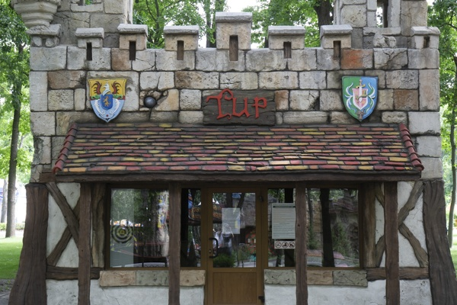15_1.png:** 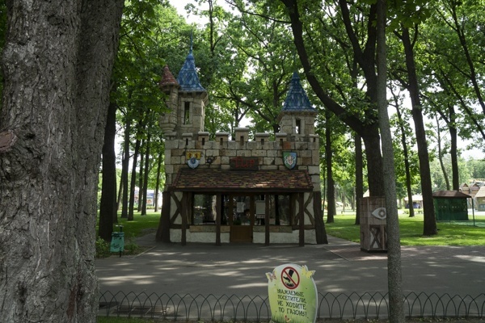

**Table 1 - Found homography parameters and normalization accuracy assessment**

|  |  |  |  |  |  |  |  |  |  |  |  |  |  |  |  |
| --- | --- | --- | --- | --- | --- | --- | --- | --- | --- | --- | --- | --- | --- | --- | --- |
| Original:  img1: 0 img2: 0 | h11 | h12 | h13 | h21 | h22 | h23 | h31 | h32 | h33 | avg ErrPar (param) | avg ErrIM (pixel) | max ErrIM | avg ErrCPM (corner) | max ErrCPM | Expert rate |
| SIFT | 0,361 | -0,015 | 189,698 | 0,006 | 0,35 | 150,865 | 0 | -0 | 1 | 0 | 0,412 | 2,25 | ~ | ~ |  |
| SURF128 | 0,364 | -0,012 | 189,19 | 0,007 | 0,355 | 150,409 | 0 | -0 | 1 | 0 | 0,645 | 2,282 | ~ | ~ |  |
| SURF64 | 0,363 | -0,012 | 189,152 | 0,006 | 0,354 | 150,623 | 0 | -0 | 1 | 0 | 0,667 | 3,031 | ~ | ~ |  |
| ORB | 0,367 | -0,006 | 188,497 | 0,006 | 0,36 | 150,401 | 0 | -0 | 1 | 0 | 0,61 | 1,946 | ~ | ~ |  |
| ORB1000 | -0,732 | -4,827 | 426,968 | -0,265 | -2,135 | 185,083 | -0,002 | -0,011 | 1 | 0 | 0 | 0 | ~ | ~ |  |
| BRISK | 0,362 | -0,012 | 188,773 | 0,006 | 0,353 | 150,48 | 0 | -0 | 1 | 0 | 0,639 | 2,533 | ~ | ~ |  |
| KAZE | 0,354 | -0,007 | 189,342 | -0,001 | 0,361 | 150,005 | -0 | -0 | 1 | 0 | 0,594 | 1,32 | ~ | ~ |  |
| AKAZE | 0,326 | -0,064 | 191,306 | -0,007 | 0,285 | 153,36 | -0 | -0 | 1 | 0 | 0,057 | 0,13 | ~ | ~ |  |
| Original matrix |  |  |  |  |  |  |  |  |  |  |  |  |  |  |  |

where h11, h12, h13, h21, h22, h23, h31, h32, h33 - parameters of found homography matrix H* or of original one H;   
avgErrPar - average error of found parameters, the accuracy of found homography matrix parameters with a preliminary minimax normalization of found and original matrices;  
avgErrIM - average error of inlier coordinate matching;  
inliers - correct matches; outliers - false matches;  
maxErrIM – maximum error of inlier coordinate matching;  
avgErrCPM - average error of corner point matching;  
maxErrCPM - maximum error of corner point matching;  
expert rate - experts assessment of normalization accuracy with a 5-point scale: 0 - normalization failed, 1 - insufficient, 2 - satisfactory, 3 - good, 4 – excellent.

**Table 2 - Quantitative evaluation of descriptors, precision and recall estimation (with found overlap)**

|  |  |  |  |  |  |  |  |  |  |  |  |  |  |  |  |  |
| --- | --- | --- | --- | --- | --- | --- | --- | --- | --- | --- | --- | --- | --- | --- | --- | --- |
| Name | NP1 | NP2 | NM | NI | DP1 | DP2 | OP1 | OP2 | NPO1 | NPO2 | NMO | DPO1 | DPO2 | Precision | RecallO1 | Comments |
| SIFT | 2643 | 2734 | 245 | 216 | 0,011 | 0,0114 | 100 | 12,9812 | 2643 | 437 | 245 | 0,011 | 0,014 | 0,8816 | 0,0817 |  |
| SURF128 | 2735 | 2719 | 137 | 122 | 0,0114 | 0,0113 | 100 | 13,0071 | 2735 | 415 | 137 | 0,0114 | 0,0133 | 0,8905 | 0,0446 |  |
| SURF64 | 2735 | 2719 | 178 | 147 | 0,0114 | 0,0113 | 100 | 13,0067 | 2735 | 415 | 178 | 0,0114 | 0,0133 | 0,8258 | 0,0537 |  |
| ORB | 8932 | 12487 | 236 | 184 | 0,0372 | 0,052 | 100 | 13,1025 | 8932 | 2250 | 236 | 0,0372 | 0,0716 | 0,7797 | 0,0206 |  |
| ORB1000 | 1000 | 1000 | 5 | 4 | 0,0042 | 0,0042 | 96,7138 | 86,5108 | 936 | 899 | 5 | 0,004 | 0,0043 | 0,8 | 0,0043 |  |
| BRISK | 3400 | 5069 | 93 | 83 | 0,0142 | 0,0211 | 100 | 13,0746 | 3400 | 723 | 93 | 0,0142 | 0,023 | 0,8925 | 0,0244 |  |
| KAZE | 1076 | 1082 | 15 | 12 | 0,0045 | 0,0045 | 100 | 13,1658 | 1076 | 152 | 15 | 0,0045 | 0,0048 | 0,8 | 0,0112 |  |
| AKAZE | 910 | 1026 | 13 | 6 | 0,0038 | 0,0043 | 100 | 13,68 | 910 | 183 | 13 | 0,0038 | 0,0056 | 0,4615 | 0,0066 |  |

where NP - number of found key points; NP1, NP2 - number of found key points for image1 and image2 respectively;  
NM - number of matches found with NNDR method, NM=NI+NO;  
NI - number of inliers found with RANSAC method;  
NO - number of outliers discarded with RANSAC method;   
DP - density of key points (per cent), DP= NP/(height x width) , height, width - vertical and horizontal image sizes respectively (pixels)  
DP1, DP2 - density of key points points for image1 and image2 respectively;  
OP1, OP2 - overlap percentage for image1 and image2 respectively;  
NPO1, NPO2 - number of found key points on overlap for image1 and image2 respectivelyy;  
NMO - number of matches on overlap found with NNDR method;  
DPO1, DPO2 - density of key points points on overlap for image1 and image2 respectively;   
OA - overlap area (pixels), OA1, OA2 - overlap area for image1 and image2 respectively;  
DPO1= NPO1/OA1; DPO2= NPO2/OA2;  
Precision = NI/ NM - the rate to evaluate the part of inliers to all found matches with NNDR method;  
RecallO1 = NI/ NPO1 - completeness of inlier retrieval relative to the number of all key points on overlap for image1. The rate illustrates usefulness of the found key points for normalization.

**Table 3 - Estimation of time costs**

|  |  |  |  |  |  |  |  |  |  |  |
| --- | --- | --- | --- | --- | --- | --- | --- | --- | --- | --- |
| Name | NP1 | NP2 | DesT1, sec | DesT2, sec | MatchT, sec | InlierT, sec | AvgDesT, ms | AvgMatchT, ms | AvgInlierT, ms | TotalNormT, sec |
| SIFT | 2643 | 2734 | 0,058541 | 0,058811 | 0,064971 | 0,000398 | 0,02183 | 0,265186 | 0,001844 | 0,182722 |
| SURF128 | 2735 | 2719 | 0,08905 | 0,079379 | 0,062841 | 0,000499 | 0,030876 | 0,458694 | 0,00409 | 0,23177 |
| SURF64 | 2735 | 2719 | 0,246614 | 0,151317 | 0,077957 | 0,000451 | 0,07291 | 0,437961 | 0,003065 | 0,476339 |
| ORB | 8932 | 12487 | 0,022062 | 0,057861 | 0,366173 | 0,000535 | 0,003551 | 1,55158 | 0,002906 | 0,446631 |
| ORB1000 | 1000 | 1000 | 0,011272 | 0,011416 | 0,004214 | 0,000268 | 0,011343 | 0,842888 | 0,066901 | 0,027169 |
| BRISK | 3400 | 5069 | 0,056547 | 0,078374 | 0,06025 | 0,00032 | 0,016046 | 0,647847 | 0,003853 | 0,19549 |
| KAZE | 1076 | 1082 | 0,125157 | 0,128862 | 0,011821 | 0,000409 | 0,117705 | 0,78807 | 0,034104 | 0,266249 |
| AKAZE | 910 | 1026 | 0,037377 | 0,030763 | 0,008017 | 0,003397 | 0,035528 | 0,616658 | 0,566158 | 0,079554 |

where DesT – descriptor creation time (time for key point detection and descriptor computation), DesT1, DesT2 – creation time of descriptors for image1 and image2 respectively;  
MatchT - retrieval time of matching found with NNDR method for the pair;  
InlierT – inlier retrieval time found with RANSAC method for the pair;  
AvgDesT – average time for one descriptor creation;  
AvgMatchT - average time for one match retrieval with NNDR method;  
AvgInlierT – average time for one inlier retrieval with RANSAC method;  
TotalNormT – total normalization time for the pair.