**Normalization results for pairs 16_0.png_16_1.png from subset png\building**

**16_0.png: 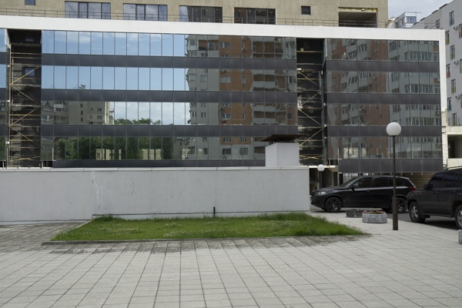16_1.png:** 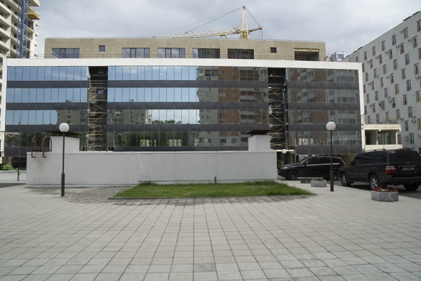

**Table 1 - Found homography parameters and normalization accuracy assessment**

|  |  |  |  |  |  |  |  |  |  |  |  |  |  |  |  |
| --- | --- | --- | --- | --- | --- | --- | --- | --- | --- | --- | --- | --- | --- | --- | --- |
| Original:  img1: 0 img2: 0 | h11 | h12 | h13 | h21 | h22 | h23 | h31 | h32 | h33 | avg ErrPar (param) | avg ErrIM (pixel) | max ErrIM | avg ErrCPM (corner) | max ErrCPM | Expert rate |
| SIFT | 0,661 | -0,01 | 117,508 | -0,014 | 0,675 | 66,718 | -0 | -0 | 1 | 0 | 0,865 | 2,967 | ~ | ~ |  |
| SURF128 | 0,665 | -0,008 | 116,737 | -0,013 | 0,679 | 66,24 | -0 | -0 | 1 | 0 | 0,975 | 3,299 | ~ | ~ |  |
| SURF64 | 0,663 | -0,006 | 116,543 | -0,015 | 0,679 | 66,46 | -0 | -0 | 1 | 0 | 0,999 | 3,105 | ~ | ~ |  |
| ORB | 0,667 | -0,001 | 115,641 | -0,015 | 0,686 | 65,789 | -0 | -0 | 1 | 0 | 0,938 | 3,326 | ~ | ~ |  |
| ORB1000 | 0,665 | 0,009 | 115,349 | -0,016 | 0,692 | 65,67 | -0 | 0 | 1 | 0 | 1,106 | 2,926 | ~ | ~ |  |
| BRISK | 0,682 | -0,002 | 113,873 | -0,008 | 0,69 | 64,348 | -0 | -0 | 1 | 0 | 0,908 | 2,86 | ~ | ~ |  |
| KAZE | 0,708 | -0,005 | 110,707 | 0 | 0,7 | 62,422 | 0 | -0 | 1 | 0 | 1,001 | 3,062 | ~ | ~ |  |
| AKAZE | 0,68 | -0,004 | 113,882 | -0,011 | 0,691 | 64,797 | -0 | -0 | 1 | 0 | 0,647 | 2,382 | ~ | ~ |  |
| Original matrix |  |  |  |  |  |  |  |  |  |  |  |  |  |  |  |

where h11, h12, h13, h21, h22, h23, h31, h32, h33 - parameters of found homography matrix H* or of original one H;   
avgErrPar - average error of found parameters, the accuracy of found homography matrix parameters with a preliminary minimax normalization of found and original matrices;  
avgErrIM - average error of inlier coordinate matching;  
inliers - correct matches; outliers - false matches;  
maxErrIM – maximum error of inlier coordinate matching;  
avgErrCPM - average error of corner point matching;  
maxErrCPM - maximum error of corner point matching;  
expert rate - experts assessment of normalization accuracy with a 5-point scale: 0 - normalization failed, 1 - insufficient, 2 - satisfactory, 3 - good, 4 – excellent.

**Table 2 - Quantitative evaluation of descriptors, precision and recall estimation (with found overlap)**

|  |  |  |  |  |  |  |  |  |  |  |  |  |  |  |  |  |
| --- | --- | --- | --- | --- | --- | --- | --- | --- | --- | --- | --- | --- | --- | --- | --- | --- |
| Name | NP1 | NP2 | NM | NI | DP1 | DP2 | OP1 | OP2 | NPO1 | NPO2 | NMO | DPO1 | DPO2 | Precision | RecallO1 | Comments |
| SIFT | 1181 | 1193 | 497 | 446 | 0,0049 | 0,005 | 100 | 49,1513 | 1181 | 724 | 497 | 0,0049 | 0,0061 | 0,8974 | 0,3776 |  |
| SURF128 | 2138 | 1968 | 615 | 559 | 0,0089 | 0,0082 | 100 | 49,1729 | 2138 | 1284 | 615 | 0,0089 | 0,0109 | 0,9089 | 0,2615 |  |
| SURF64 | 2138 | 1968 | 761 | 655 | 0,0089 | 0,0082 | 100 | 49,26 | 2138 | 1285 | 761 | 0,0089 | 0,0109 | 0,8607 | 0,3064 |  |
| ORB | 4197 | 4560 | 1338 | 1197 | 0,0175 | 0,019 | 100 | 49,5712 | 4197 | 3544 | 1338 | 0,0175 | 0,0298 | 0,8946 | 0,2852 |  |
| ORB1000 | 1000 | 1000 | 313 | 248 | 0,0042 | 0,0042 | 100 | 49,2579 | 1000 | 786 | 313 | 0,0042 | 0,0066 | 0,7923 | 0,248 |  |
| BRISK | 1394 | 1613 | 326 | 292 | 0,0058 | 0,0067 | 100 | 49,4542 | 1394 | 1082 | 326 | 0,0058 | 0,0091 | 0,8957 | 0,2095 |  |
| KAZE | 500 | 580 | 144 | 113 | 0,0021 | 0,0024 | 100 | 49,9546 | 500 | 360 | 144 | 0,0021 | 0,003 | 0,7847 | 0,226 |  |
| AKAZE | 367 | 474 | 105 | 87 | 0,0015 | 0,002 | 100 | 49,7875 | 367 | 353 | 105 | 0,0015 | 0,003 | 0,8286 | 0,2371 |  |

where NP - number of found key points; NP1, NP2 - number of found key points for image1 and image2 respectively;  
NM - number of matches found with NNDR method, NM=NI+NO;  
NI - number of inliers found with RANSAC method;  
NO - number of outliers discarded with RANSAC method;   
DP - density of key points (per cent), DP= NP/(height x width) , height, width - vertical and horizontal image sizes respectively (pixels)  
DP1, DP2 - density of key points points for image1 and image2 respectively;  
OP1, OP2 - overlap percentage for image1 and image2 respectively;  
NPO1, NPO2 - number of found key points on overlap for image1 and image2 respectivelyy;  
NMO - number of matches on overlap found with NNDR method;  
DPO1, DPO2 - density of key points points on overlap for image1 and image2 respectively;   
OA - overlap area (pixels), OA1, OA2 - overlap area for image1 and image2 respectively;  
DPO1= NPO1/OA1; DPO2= NPO2/OA2;  
Precision = NI/ NM - the rate to evaluate the part of inliers to all found matches with NNDR method;  
RecallO1 = NI/ NPO1 - completeness of inlier retrieval relative to the number of all key points on overlap for image1. The rate illustrates usefulness of the found key points for normalization.

**Table 3 - Estimation of time costs**

|  |  |  |  |  |  |  |  |  |  |  |
| --- | --- | --- | --- | --- | --- | --- | --- | --- | --- | --- |
| Name | NP1 | NP2 | DesT1, sec | DesT2, sec | MatchT, sec | InlierT, sec | AvgDesT, ms | AvgMatchT, ms | AvgInlierT, ms | TotalNormT, sec |
| SIFT | 1181 | 1193 | 0,112707 | 0,070646 | 0,035563 | 0,000545 | 0,077325 | 0,071555 | 0,001222 | 0,219462 |
| SURF128 | 2138 | 1968 | 0,167077 | 0,150514 | 0,046808 | 0,000682 | 0,077313 | 0,07611 | 0,00122 | 0,365081 |
| SURF64 | 2138 | 1968 | 0,085129 | 0,070595 | 0,03316 | 0,000715 | 0,037843 | 0,043573 | 0,001092 | 0,189599 |
| ORB | 4197 | 4560 | 0,01381 | 0,014491 | 0,067441 | 0,000987 | 0,003233 | 0,050404 | 0,000824 | 0,096728 |
| ORB1000 | 1000 | 1000 | 0,010442 | 0,00899 | 0,009892 | 0,00096 | 0,009716 | 0,031602 | 0,00387 | 0,030283 |
| BRISK | 1394 | 1613 | 0,021806 | 0,025153 | 0,008172 | 0,000842 | 0,015618 | 0,025067 | 0,002884 | 0,055973 |
| KAZE | 500 | 580 | 0,295834 | 0,134742 | 0,004218 | 0,000586 | 0,41199 | 0,029288 | 0,005186 | 0,43538 |
| AKAZE | 367 | 474 | 0,019047 | 0,021198 | 0,001598 | 0,000392 | 0,04831 | 0,01522 | 0,004507 | 0,042236 |

where DesT – descriptor creation time (time for key point detection and descriptor computation), DesT1, DesT2 – creation time of descriptors for image1 and image2 respectively;  
MatchT - retrieval time of matching found with NNDR method for the pair;  
InlierT – inlier retrieval time found with RANSAC method for the pair;  
AvgDesT – average time for one descriptor creation;  
AvgMatchT - average time for one match retrieval with NNDR method;  
AvgInlierT – average time for one inlier retrieval with RANSAC method;  
TotalNormT – total normalization time for the pair.