**Normalization results for pairs 18_0.png_18_1.png from subset 07_27\building\retest**

**18_0.png: 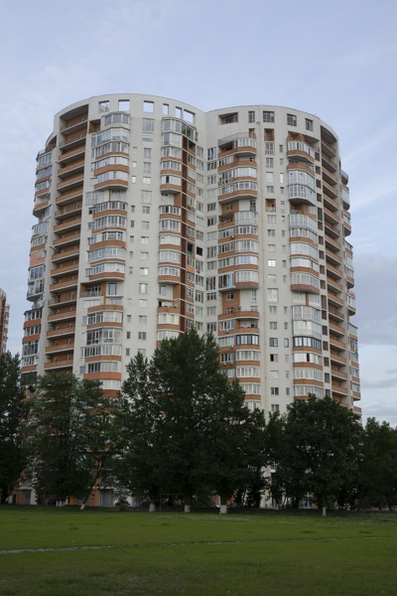18_1.png:** 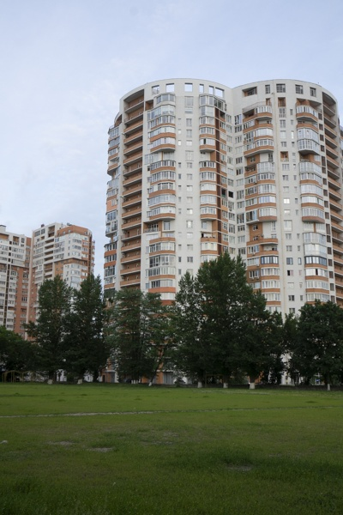

**Table 1 - Found homography parameters and normalization accuracy assessment**

|  |  |  |  |  |  |  |  |  |  |  |  |  |
| --- | --- | --- | --- | --- | --- | --- | --- | --- | --- | --- | --- | --- |
| Original:  img1: 0 img2: 0 | h11 | h12 | h13 | h21 | h22 | h23 | h31 | h32 | h33 | avg ErrIM (pixel) | max ErrIM | Expert rate |
| SIFT | 0,806 | 0,042 | 90,119 | -0,085 | 0,867 | 18,927 | -0 | 0 | 1 | 0,367 | 3,161 |  |
| SURF128 | 0,809 | 0,044 | 89,985 | -0,085 | 0,874 | 18,214 | -0 | 0 | 1 | 0,886 | 3,272 |  |
| SURF64 | 0,814 | 0,042 | 89,845 | -0,082 | 0,873 | 18,093 | -0 | 0 | 1 | 0,878 | 3,717 |  |
| ORB | 0,813 | 0,041 | 90,608 | -0,082 | 0,877 | 17,774 | -0 | 0 | 1 | 0,912 | 4,538 |  |
| ORB1000 | 0,812 | 0,04 | 90,378 | -0,08 | 0,873 | 17,988 | -0 | 0 | 1 | 1,003 | 3,09 |  |
| BRISK | 0,805 | 0,041 | 90,621 | -0,086 | 0,872 | 18,629 | -0 | 0 | 1 | 0,812 | 3,682 |  |
| KAZE | 0,806 | 0,043 | 90,332 | -0,085 | 0,873 | 18,308 | -0 | 0 | 1 | 0,738 | 3,284 |  |
| AKAZE | 0,809 | 0,043 | 90,008 | -0,084 | 0,875 | 18,033 | -0 | 0 | 1 | 0,729 | 3,123 |  |
|  |  |  |  |  |  |  |  |  |  |  |  |  |

where h11, h12, h13, h21, h22, h23, h31, h32, h33 - parameters of found homography matrix H* or of original one H;   
avgErrPar - average error of found parameters, the accuracy of found homography matrix parameters with a preliminary minimax normalization of found and original matrices;  
avgErrIM - average error of inlier coordinate matching;  
inliers - correct matches; outliers - false matches;  
maxErrIM – maximum error of inlier coordinate matching;  
avgErrCPM - average error of corner point matching;  
maxErrCPM - maximum error of corner point matching;  
expert rate - experts assessment of normalization accuracy with a 5-point scale: 0 - normalization failed, 1 - insufficient, 2 - satisfactory, 3 - good, 4 – excellent.

**Table 2 - Quantitative evaluation of descriptors, precision and recall estimation (with found overlap)**

|  |  |  |  |  |  |  |  |  |  |  |  |  |  |  |  |  |
| --- | --- | --- | --- | --- | --- | --- | --- | --- | --- | --- | --- | --- | --- | --- | --- | --- |
| Name | NP1 | NP2 | NM | NI | DP1 | DP2 | OP1 | OP2 | NPO1 | NPO2 | NMO | DPO1 | DPO2 | Precision | RecallO1 | Comments |
| SIFT | 1604 | 1680 | 810 | 731 | 0,0067 | 0,007 | 86,1058 | 64,7379 | 1529 | 1342 | 808 | 0,0074 | 0,0086 | 0,9025 | 0,4781 |  |
| SURF128 | 2061 | 1732 | 568 | 505 | 0,0086 | 0,0072 | 86,1767 | 64,5763 | 1971 | 1493 | 568 | 0,0095 | 0,0096 | 0,8891 | 0,2562 |  |
| SURF64 | 2061 | 1732 | 700 | 575 | 0,0086 | 0,0072 | 86,2971 | 64,7758 | 1974 | 1495 | 699 | 0,0095 | 0,0096 | 0,8214 | 0,2913 |  |
| ORB | 9806 | 8633 | 3418 | 2910 | 0,0409 | 0,036 | 86,4567 | 64,6912 | 9506 | 7692 | 3417 | 0,0458 | 0,0495 | 0,8514 | 0,3061 |  |
| ORB1000 | 1000 | 1000 | 387 | 346 | 0,0042 | 0,0042 | 86,5537 | 64,7563 | 962 | 920 | 387 | 0,0046 | 0,0059 | 0,8941 | 0,3597 |  |
| BRISK | 3712 | 3380 | 1250 | 1163 | 0,0155 | 0,0141 | 86,2071 | 64,6458 | 3545 | 2962 | 1250 | 0,0171 | 0,0191 | 0,9304 | 0,3281 |  |
| KAZE | 885 | 872 | 441 | 421 | 0,0037 | 0,0036 | 86,2071 | 64,6246 | 843 | 767 | 441 | 0,0041 | 0,0049 | 0,9546 | 0,4994 |  |
| AKAZE | 818 | 755 | 296 | 267 | 0,0034 | 0,0031 | 86,2321 | 64,6671 | 794 | 667 | 296 | 0,0038 | 0,0043 | 0,902 | 0,3363 |  |

where NP - number of found key points; NP1, NP2 - number of found key points for image1 and image2 respectively;  
NM - number of matches found with NNDR method, NM=NI+NO;  
NI - number of inliers found with RANSAC method;  
NO - number of outliers discarded with RANSAC method;   
DP - density of key points (per cent), DP= NP/(height x width) , height, width - vertical and horizontal image sizes respectively (pixels)  
DP1, DP2 - density of key points points for image1 and image2 respectively;  
OP1, OP2 - overlap percentage for image1 and image2 respectively;  
NPO1, NPO2 - number of found key points on overlap for image1 and image2 respectivelyy;  
NMO - number of matches on overlap found with NNDR method;  
DPO1, DPO2 - density of key points points on overlap for image1 and image2 respectively;   
OA - overlap area (pixels), OA1, OA2 - overlap area for image1 and image2 respectively;  
DPO1= NPO1/OA1; DPO2= NPO2/OA2;  
Precision = NI/ NM - the rate to evaluate the part of inliers to all found matches with NNDR method;  
RecallO1 = NI/ NPO1 - completeness of inlier retrieval relative to the number of all key points on overlap for image1. The rate illustrates usefulness of the found key points for normalization.

**Table 3 - Estimation of time costs**

|  |  |  |  |  |  |  |  |  |  |  |
| --- | --- | --- | --- | --- | --- | --- | --- | --- | --- | --- |
| Name | NP1 | NP2 | DesT1, sec | DesT2, sec | MatchT, sec | InlierT, sec | AvgDesT, ms | AvgMatchT, ms | AvgInlierT, ms | TotalNormT, sec |
| SIFT | 1604 | 1680 | 0,05049 | 0,051127 | 0,02122 | 0,00063 | 0,030954 | 0,026197 | 0,000861 | 0,123466 |
| SURF128 | 2061 | 1732 | 0,063238 | 0,057693 | 0,035116 | 0,000532 | 0,031996 | 0,061823 | 0,001053 | 0,156579 |
| SURF64 | 2061 | 1732 | 0,072663 | 0,055037 | 0,016311 | 0,000764 | 0,033516 | 0,023301 | 0,001328 | 0,144775 |
| ORB | 9806 | 8633 | 0,022586 | 0,020878 | 0,19355 | 0,002187 | 0,00236 | 0,056626 | 0,000751 | 0,239201 |
| ORB1000 | 1000 | 1000 | 0,01016 | 0,010151 | 0,003407 | 0,000456 | 0,010155 | 0,008803 | 0,001318 | 0,024175 |
| BRISK | 3712 | 3380 | 0,051329 | 0,047665 | 0,032386 | 0,000818 | 0,013964 | 0,025908 | 0,000703 | 0,132198 |
| KAZE | 885 | 872 | 0,132622 | 0,121958 | 0,00854 | 0,000591 | 0,144857 | 0,019365 | 0,001404 | 0,263711 |
| AKAZE | 818 | 755 | 0,020246 | 0,018732 | 0,002938 | 0,000414 | 0,02478 | 0,009925 | 0,00155 | 0,04233 |

where DesT – descriptor creation time (time for key point detection and descriptor computation), DesT1, DesT2 – creation time of descriptors for image1 and image2 respectively;  
MatchT - retrieval time of matching found with NNDR method for the pair;  
InlierT – inlier retrieval time found with RANSAC method for the pair;  
AvgDesT – average time for one descriptor creation;  
AvgMatchT - average time for one match retrieval with NNDR method;  
AvgInlierT – average time for one inlier retrieval with RANSAC method;  
TotalNormT – total normalization time for the pair.