**Normalization results for pairs 19_0.png_19_1.png from subset png\building**

**19_0.png: 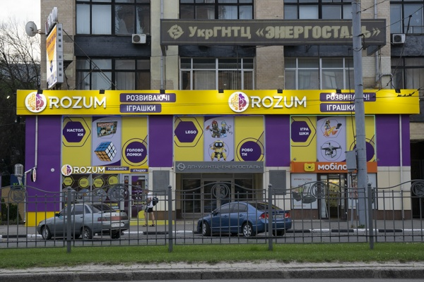19_1.png:** 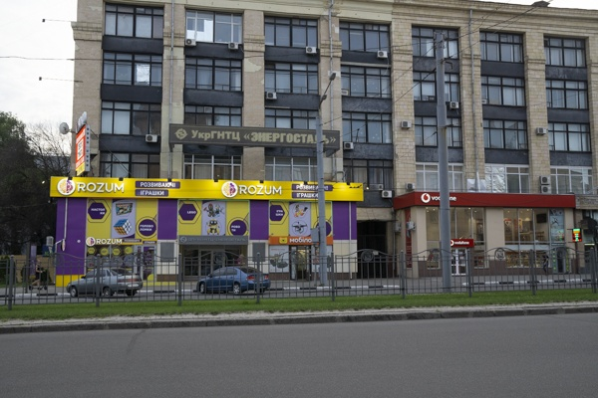

**Table 1 - Found homography parameters and normalization accuracy assessment**

|  |  |  |  |  |  |  |  |  |  |  |  |  |  |  |  |
| --- | --- | --- | --- | --- | --- | --- | --- | --- | --- | --- | --- | --- | --- | --- | --- |
| Original:  img1: 0 img2: 0 | h11 | h12 | h13 | h21 | h22 | h23 | h31 | h32 | h33 | avg ErrPar (param) | avg ErrIM (pixel) | max ErrIM | avg ErrCPM (corner) | max ErrCPM | Expert rate |
| SIFT | 0,605 | -0,018 | 38,042 | 0,039 | 0,558 | 104,434 | 0 | -0 | 1 | 0 | 0,418 | 2,927 | ~ | ~ |  |
| SURF128 | 0,603 | -0,018 | 37,97 | 0,037 | 0,558 | 104,462 | 0 | -0 | 1 | 0 | 0,787 | 3,105 | ~ | ~ |  |
| SURF64 | 0,614 | 0,003 | 35,309 | 0,04 | 0,585 | 103,139 | 0 | 0 | 1 | 0 | 0,917 | 5,393 | ~ | ~ |  |
| ORB | 0,616 | -0,004 | 35 | 0,041 | 0,576 | 103,407 | 0 | 0 | 1 | 0 | 0,849 | 3,81 | ~ | ~ |  |
| ORB1000 | 0,606 | -0,013 | 37,159 | 0,038 | 0,564 | 103,844 | 0 | -0 | 1 | 0 | 0,716 | 2,323 | ~ | ~ |  |
| BRISK | 0,607 | -0,019 | 37,653 | 0,039 | 0,559 | 104,327 | 0 | -0 | 1 | 0 | 0,744 | 3,076 | ~ | ~ |  |
| KAZE | 0,611 | -0,018 | 36,914 | 0,042 | 0,56 | 103,975 | 0 | -0 | 1 | 0 | 0,734 | 2,063 | ~ | ~ |  |
| AKAZE | 0,599 | -0,013 | 38 | 0,03 | 0,566 | 104,702 | 0 | -0 | 1 | 0 | 0,717 | 3,322 | ~ | ~ |  |
| Original matrix |  |  |  |  |  |  |  |  |  |  |  |  |  |  |  |

where h11, h12, h13, h21, h22, h23, h31, h32, h33 - parameters of found homography matrix H* or of original one H;   
avgErrPar - average error of found parameters, the accuracy of found homography matrix parameters with a preliminary minimax normalization of found and original matrices;  
avgErrIM - average error of inlier coordinate matching;  
inliers - correct matches; outliers - false matches;  
maxErrIM – maximum error of inlier coordinate matching;  
avgErrCPM - average error of corner point matching;  
maxErrCPM - maximum error of corner point matching;  
expert rate - experts assessment of normalization accuracy with a 5-point scale: 0 - normalization failed, 1 - insufficient, 2 - satisfactory, 3 - good, 4 – excellent.

**Table 2 - Quantitative evaluation of descriptors, precision and recall estimation (with found overlap)**

|  |  |  |  |  |  |  |  |  |  |  |  |  |  |  |  |  |
| --- | --- | --- | --- | --- | --- | --- | --- | --- | --- | --- | --- | --- | --- | --- | --- | --- |
| Name | NP1 | NP2 | NM | NI | DP1 | DP2 | OP1 | OP2 | NPO1 | NPO2 | NMO | DPO1 | DPO2 | Precision | RecallO1 | Comments |
| SIFT | 2616 | 2496 | 505 | 376 | 0,0109 | 0,0104 | 100 | 30,9475 | 2616 | 1061 | 505 | 0,0109 | 0,0143 | 0,7446 | 0,1437 |  |
| SURF128 | 2900 | 2483 | 384 | 324 | 0,0121 | 0,0103 | 100 | 30,9246 | 2900 | 1039 | 384 | 0,0121 | 0,014 | 0,8438 | 0,1117 |  |
| SURF64 | 2900 | 2483 | 519 | 391 | 0,0121 | 0,0103 | 100 | 30,5646 | 2900 | 1039 | 519 | 0,0121 | 0,0142 | 0,7534 | 0,1348 |  |
| ORB | 9783 | 9464 | 1219 | 1018 | 0,0408 | 0,0394 | 100 | 30,9279 | 9783 | 5469 | 1219 | 0,0408 | 0,0737 | 0,8351 | 0,1041 |  |
| ORB1000 | 1000 | 1000 | 227 | 195 | 0,0042 | 0,0042 | 100 | 31,1346 | 1000 | 681 | 227 | 0,0042 | 0,0091 | 0,859 | 0,195 |  |
| BRISK | 3909 | 3516 | 439 | 379 | 0,0163 | 0,0146 | 100 | 30,9475 | 3909 | 1973 | 439 | 0,0163 | 0,0266 | 0,8633 | 0,097 |  |
| KAZE | 1066 | 1013 | 135 | 102 | 0,0044 | 0,0042 | 100 | 31,0312 | 1066 | 434 | 135 | 0,0044 | 0,0058 | 0,7556 | 0,0957 |  |
| AKAZE | 1022 | 1022 | 128 | 107 | 0,0043 | 0,0043 | 100 | 31,1029 | 1022 | 520 | 128 | 0,0043 | 0,007 | 0,8359 | 0,1047 |  |

where NP - number of found key points; NP1, NP2 - number of found key points for image1 and image2 respectively;  
NM - number of matches found with NNDR method, NM=NI+NO;  
NI - number of inliers found with RANSAC method;  
NO - number of outliers discarded with RANSAC method;   
DP - density of key points (per cent), DP= NP/(height x width) , height, width - vertical and horizontal image sizes respectively (pixels)  
DP1, DP2 - density of key points points for image1 and image2 respectively;  
OP1, OP2 - overlap percentage for image1 and image2 respectively;  
NPO1, NPO2 - number of found key points on overlap for image1 and image2 respectivelyy;  
NMO - number of matches on overlap found with NNDR method;  
DPO1, DPO2 - density of key points points on overlap for image1 and image2 respectively;   
OA - overlap area (pixels), OA1, OA2 - overlap area for image1 and image2 respectively;  
DPO1= NPO1/OA1; DPO2= NPO2/OA2;  
Precision = NI/ NM - the rate to evaluate the part of inliers to all found matches with NNDR method;  
RecallO1 = NI/ NPO1 - completeness of inlier retrieval relative to the number of all key points on overlap for image1. The rate illustrates usefulness of the found key points for normalization.

**Table 3 - Estimation of time costs**

|  |  |  |  |  |  |  |  |  |  |  |
| --- | --- | --- | --- | --- | --- | --- | --- | --- | --- | --- |
| Name | NP1 | NP2 | DesT1, sec | DesT2, sec | MatchT, sec | InlierT, sec | AvgDesT, ms | AvgMatchT, ms | AvgInlierT, ms | TotalNormT, sec |
| SIFT | 2616 | 2496 | 0,098216 | 0,076938 | 0,094783 | 0,000729 | 0,034184 | 0,187689 | 0,001939 | 0,270666 |
| SURF128 | 2900 | 2483 | 0,1796 | 0,185527 | 0,105694 | 0,000506 | 0,068324 | 0,275245 | 0,001562 | 0,471327 |
| SURF64 | 2900 | 2483 | 0,121997 | 0,115963 | 0,048931 | 0,000829 | 0,044385 | 0,094279 | 0,002119 | 0,28772 |
| ORB | 9783 | 9464 | 0,024957 | 0,022842 | 0,334195 | 0,000997 | 0,002482 | 0,274154 | 0,000979 | 0,38299 |
| ORB1000 | 1000 | 1000 | 0,010349 | 0,010291 | 0,003806 | 0,000449 | 0,010319 | 0,016767 | 0,002301 | 0,024895 |
| BRISK | 3909 | 3516 | 0,056125 | 0,049508 | 0,042379 | 0,00052 | 0,014219 | 0,096535 | 0,00137 | 0,148532 |
| KAZE | 1066 | 1013 | 0,149439 | 0,150599 | 0,010274 | 0,000643 | 0,144426 | 0,076107 | 0,006307 | 0,310956 |
| AKAZE | 1022 | 1022 | 0,020507 | 0,017309 | 0,005144 | 0,000392 | 0,0185 | 0,040189 | 0,003665 | 0,043353 |

where DesT – descriptor creation time (time for key point detection and descriptor computation), DesT1, DesT2 – creation time of descriptors for image1 and image2 respectively;  
MatchT - retrieval time of matching found with NNDR method for the pair;  
InlierT – inlier retrieval time found with RANSAC method for the pair;  
AvgDesT – average time for one descriptor creation;  
AvgMatchT - average time for one match retrieval with NNDR method;  
AvgInlierT – average time for one inlier retrieval with RANSAC method;  
TotalNormT – total normalization time for the pair.