**Normalization results for pairs 20_0.png_20_1.png from subset png\building**

**20_0.png: 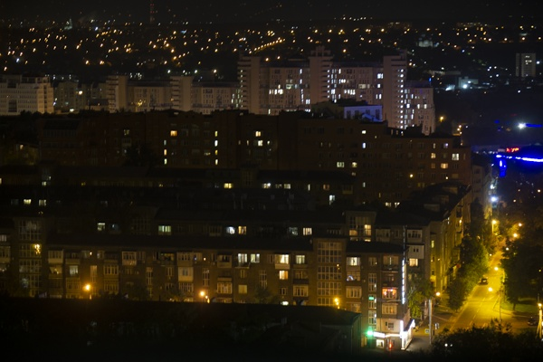20_1.png:** 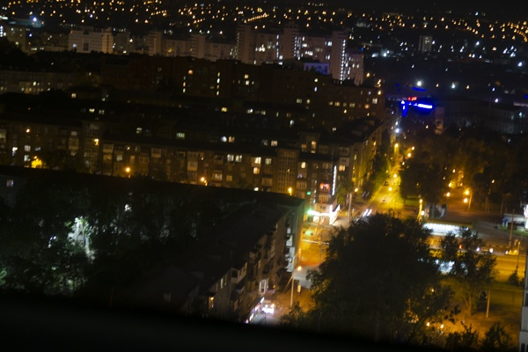

**Table 1 - Found homography parameters and normalization accuracy assessment**

|  |  |  |  |  |  |  |  |  |  |  |  |  |  |  |  |
| --- | --- | --- | --- | --- | --- | --- | --- | --- | --- | --- | --- | --- | --- | --- | --- |
| Original:  img1: 0 img2: 0 | h11 | h12 | h13 | h21 | h22 | h23 | h31 | h32 | h33 | avg ErrPar (param) | avg ErrIM (pixel) | max ErrIM | avg ErrCPM (corner) | max ErrCPM | Expert rate |
| SIFT | 0,691 | -0,032 | 91,555 | 0,051 | 0,697 | -29,408 | 0 | 0 | 1 | 0 | 0,403 | 2,709 | ~ | ~ |  |
| SURF128 | 0,69 | -0,034 | 91,882 | 0,051 | 0,695 | -28,947 | 0 | 0 | 1 | 0 | 0,765 | 3,211 | ~ | ~ |  |
| SURF64 | 0,688 | -0,035 | 92,224 | 0,051 | 0,694 | -29,05 | 0 | 0 | 1 | 0 | 0,816 | 3,496 | ~ | ~ |  |
| ORB | 0,69 | -0,035 | 91,944 | 0,05 | 0,695 | -28,927 | 0 | 0 | 1 | 0 | 0,75 | 3,253 | ~ | ~ |  |
| ORB1000 | 0,689 | -0,033 | 91,897 | 0,051 | 0,697 | -29,418 | 0 | 0 | 1 | 0 | 0,816 | 3,018 | ~ | ~ |  |
| BRISK | 0,688 | -0,035 | 91,99 | 0,049 | 0,694 | -28,821 | 0 | 0 | 1 | 0 | 0,573 | 1,956 | ~ | ~ |  |
| KAZE | 0,694 | -0,037 | 91,322 | 0,051 | 0,696 | -29,322 | 0 | 0 | 1 | 0 | 0,56 | 2,099 | ~ | ~ |  |
| AKAZE | 0,696 | -0,028 | 89,86 | 0,051 | 0,703 | -30,16 | 0 | 0 | 1 | 0 | 0,485 | 1,871 | ~ | ~ |  |
| Original matrix |  |  |  |  |  |  |  |  |  |  |  |  |  |  |  |

where h11, h12, h13, h21, h22, h23, h31, h32, h33 - parameters of found homography matrix H* or of original one H;   
avgErrPar - average error of found parameters, the accuracy of found homography matrix parameters with a preliminary minimax normalization of found and original matrices;  
avgErrIM - average error of inlier coordinate matching;  
inliers - correct matches; outliers - false matches;  
maxErrIM – maximum error of inlier coordinate matching;  
avgErrCPM - average error of corner point matching;  
maxErrCPM - maximum error of corner point matching;  
expert rate - experts assessment of normalization accuracy with a 5-point scale: 0 - normalization failed, 1 - insufficient, 2 - satisfactory, 3 - good, 4 – excellent.

**Table 2 - Quantitative evaluation of descriptors, precision and recall estimation (with found overlap)**

|  |  |  |  |  |  |  |  |  |  |  |  |  |  |  |  |  |
| --- | --- | --- | --- | --- | --- | --- | --- | --- | --- | --- | --- | --- | --- | --- | --- | --- |
| Name | NP1 | NP2 | NM | NI | DP1 | DP2 | OP1 | OP2 | NPO1 | NPO2 | NMO | DPO1 | DPO2 | Precision | RecallO1 | Comments |
| SIFT | 887 | 1087 | 191 | 166 | 0,0037 | 0,0045 | 95,1154 | 43,7754 | 883 | 554 | 191 | 0,0039 | 0,0053 | 0,8691 | 0,188 |  |
| SURF128 | 1713 | 1591 | 232 | 220 | 0,0071 | 0,0066 | 95,2442 | 43,7179 | 1695 | 962 | 232 | 0,0074 | 0,0092 | 0,9483 | 0,1298 |  |
| SURF64 | 1713 | 1591 | 315 | 279 | 0,0071 | 0,0066 | 95,2008 | 43,7013 | 1695 | 963 | 315 | 0,0074 | 0,0092 | 0,8857 | 0,1646 |  |
| ORB | 4353 | 4771 | 785 | 697 | 0,0181 | 0,0199 | 95,215 | 43,8263 | 4340 | 2722 | 785 | 0,019 | 0,0259 | 0,8879 | 0,1606 |  |
| ORB1000 | 994 | 1000 | 218 | 211 | 0,0041 | 0,0042 | 95,0983 | 43,7971 | 993 | 680 | 218 | 0,0044 | 0,0065 | 0,9679 | 0,2125 |  |
| BRISK | 1642 | 1698 | 149 | 138 | 0,0068 | 0,0071 | 95,1617 | 43,8075 | 1613 | 895 | 149 | 0,0071 | 0,0085 | 0,9262 | 0,0856 |  |
| KAZE | 549 | 630 | 78 | 73 | 0,0023 | 0,0026 | 95,1292 | 43,9225 | 544 | 345 | 78 | 0,0024 | 0,0033 | 0,9359 | 0,1342 |  |
| AKAZE | 447 | 503 | 51 | 48 | 0,0019 | 0,0021 | 94,9183 | 43,8396 | 444 | 297 | 51 | 0,0019 | 0,0028 | 0,9412 | 0,1081 |  |

where NP - number of found key points; NP1, NP2 - number of found key points for image1 and image2 respectively;  
NM - number of matches found with NNDR method, NM=NI+NO;  
NI - number of inliers found with RANSAC method;  
NO - number of outliers discarded with RANSAC method;   
DP - density of key points (per cent), DP= NP/(height x width) , height, width - vertical and horizontal image sizes respectively (pixels)  
DP1, DP2 - density of key points points for image1 and image2 respectively;  
OP1, OP2 - overlap percentage for image1 and image2 respectively;  
NPO1, NPO2 - number of found key points on overlap for image1 and image2 respectivelyy;  
NMO - number of matches on overlap found with NNDR method;  
DPO1, DPO2 - density of key points points on overlap for image1 and image2 respectively;   
OA - overlap area (pixels), OA1, OA2 - overlap area for image1 and image2 respectively;  
DPO1= NPO1/OA1; DPO2= NPO2/OA2;  
Precision = NI/ NM - the rate to evaluate the part of inliers to all found matches with NNDR method;  
RecallO1 = NI/ NPO1 - completeness of inlier retrieval relative to the number of all key points on overlap for image1. The rate illustrates usefulness of the found key points for normalization.

**Table 3 - Estimation of time costs**

|  |  |  |  |  |  |  |  |  |  |  |
| --- | --- | --- | --- | --- | --- | --- | --- | --- | --- | --- |
| Name | NP1 | NP2 | DesT1, sec | DesT2, sec | MatchT, sec | InlierT, sec | AvgDesT, ms | AvgMatchT, ms | AvgInlierT, ms | TotalNormT, sec |
| SIFT | 887 | 1087 | 0,054332 | 0,053423 | 0,010483 | 0,000389 | 0,0552 | 0,054886 | 0,002344 | 0,118628 |
| SURF128 | 1713 | 1591 | 0,076003 | 0,142618 | 0,040805 | 0,000403 | 0,067004 | 0,175882 | 0,00183 | 0,259828 |
| SURF64 | 1713 | 1591 | 0,07864 | 0,072556 | 0,015924 | 0,000441 | 0,045755 | 0,050552 | 0,001581 | 0,167561 |
| ORB | 4353 | 4771 | 0,015069 | 0,049579 | 0,245668 | 0,000634 | 0,006926 | 0,312952 | 0,000909 | 0,310949 |
| ORB1000 | 994 | 1000 | 0,009208 | 0,009433 | 0,003647 | 0,000333 | 0,009348 | 0,01673 | 0,00158 | 0,022622 |
| BRISK | 1642 | 1698 | 0,026295 | 0,027819 | 0,01278 | 0,000386 | 0,016198 | 0,085773 | 0,002794 | 0,06728 |
| KAZE | 549 | 630 | 0,131181 | 0,127594 | 0,004087 | 0,000277 | 0,220736 | 0,052399 | 0,003792 | 0,263138 |
| AKAZE | 447 | 503 | 0,020031 | 0,019629 | 0,001315 | 0,000321 | 0,041917 | 0,025794 | 0,006691 | 0,041297 |

where DesT – descriptor creation time (time for key point detection and descriptor computation), DesT1, DesT2 – creation time of descriptors for image1 and image2 respectively;  
MatchT - retrieval time of matching found with NNDR method for the pair;  
InlierT – inlier retrieval time found with RANSAC method for the pair;  
AvgDesT – average time for one descriptor creation;  
AvgMatchT - average time for one match retrieval with NNDR method;  
AvgInlierT – average time for one inlier retrieval with RANSAC method;  
TotalNormT – total normalization time for the pair.