**Normalization results for pairs 2_0.png_2_1.png from subset png\building**

**2_0.png: 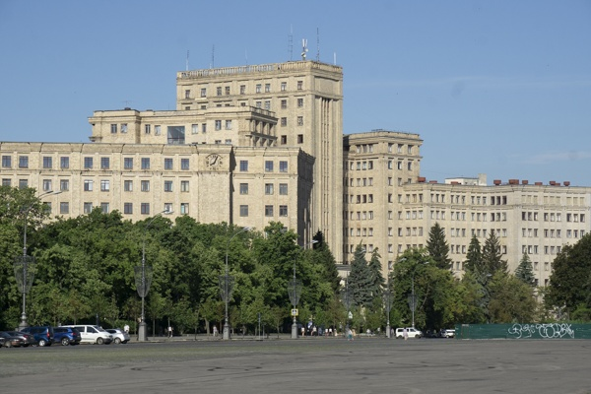2_1.png:** 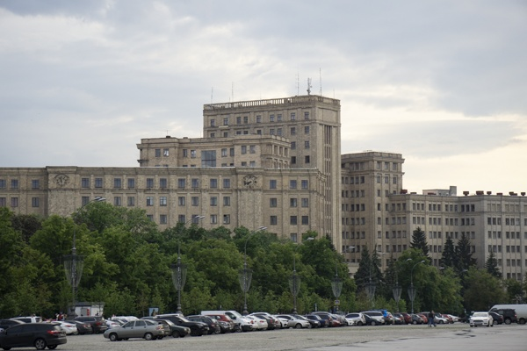

**Table 1 - Found homography parameters and normalization accuracy assessment**

|  |  |  |  |  |  |  |  |  |  |  |  |  |  |  |  |
| --- | --- | --- | --- | --- | --- | --- | --- | --- | --- | --- | --- | --- | --- | --- | --- |
| Original:  img1: 0 img2: 0 | h11 | h12 | h13 | h21 | h22 | h23 | h31 | h32 | h33 | avg ErrPar (param) | avg ErrIM (pixel) | max ErrIM | avg ErrCPM (corner) | max ErrCPM | Expert rate |
| SIFT | 0,817 | 0,126 | 79,079 | -0,044 | 0,96 | 57,779 | -0 | 0 | 1 | 0 | 0,919 | 2,563 | ~ | ~ |  |
| SURF128 | -1,823 | 1,465 | 475,563 | -0,738 | 0,643 | 188,753 | -0,003 | 0,002 | 1 | 0 | 0 | 0 | ~ | ~ |  |
| SURF64 | 0,931 | 0,024 | 92,663 | -0,015 | 1,034 | 50,211 | -0 | 0 | 1 | 0 | 0,785 | 1,749 | ~ | ~ |  |
| ORB | 1,02 | 0,449 | 27,108 | 0,006 | 1,243 | 32,188 | 0 | 0,001 | 1 | 0 | 1,268 | 3,418 | ~ | ~ |  |
| ORB1000 | -0,356 | 0,072 | 245,886 | -0,371 | 0,076 | 209,662 | -0,001 | -0,001 | 1 | 0 | 0 | 0 | ~ | ~ |  |
| BRISK | 0,986 | 0,38 | 33,954 | -0,005 | 1,168 | 38,564 | 0 | 0,001 | 1 | 0 | 0,967 | 2,103 | ~ | ~ |  |
| KAZE | 0,518 | -0,932 | 256,346 | 0,012 | -0,057 | 157,926 | 0 | -0,002 | 1 | 0 | 0,377 | 0,531 | ~ | ~ |  |
| AKAZE | 0,788 | 0,24 | 69,767 | -0,058 | 1,007 | 55,67 | -0 | 0 | 1 | 0 | 0,68 | 0,974 | ~ | ~ |  |
| Original matrix |  |  |  |  |  |  |  |  |  |  |  |  |  |  |  |

where h11, h12, h13, h21, h22, h23, h31, h32, h33 - parameters of found homography matrix H* or of original one H;   
avgErrPar - average error of found parameters, the accuracy of found homography matrix parameters with a preliminary minimax normalization of found and original matrices;  
avgErrIM - average error of inlier coordinate matching;  
inliers - correct matches; outliers - false matches;  
maxErrIM – maximum error of inlier coordinate matching;  
avgErrCPM - average error of corner point matching;  
maxErrCPM - maximum error of corner point matching;  
expert rate - experts assessment of normalization accuracy with a 5-point scale: 0 - normalization failed, 1 - insufficient, 2 - satisfactory, 3 - good, 4 – excellent.

**Table 2 - Quantitative evaluation of descriptors, precision and recall estimation (with found overlap)**

|  |  |  |  |  |  |  |  |  |  |  |  |  |  |  |  |  |
| --- | --- | --- | --- | --- | --- | --- | --- | --- | --- | --- | --- | --- | --- | --- | --- | --- |
| Name | NP1 | NP2 | NM | NI | DP1 | DP2 | OP1 | OP2 | NPO1 | NPO2 | NMO | DPO1 | DPO2 | Precision | RecallO1 | Comments |
| SIFT | 2330 | 1665 | 80 | 37 | 0,0097 | 0,0069 | 93,1763 | 74,085 | 2279 | 1494 | 80 | 0,0102 | 0,0084 | 0,4625 | 0,0162 |  |
| SURF128 | 2072 | 1810 | 13 | 4 | 0,0086 | 0,0075 | 78,3904 | 82,7121 | 1802 | 1705 | 12 | 0,0096 | 0,0086 | 0,3077 | 0,0022 |  |
| SURF64 | 2072 | 1810 | 26 | 9 | 0,0086 | 0,0075 | 93,4996 | 74,9679 | 2069 | 1626 | 26 | 0,0092 | 0,009 | 0,3462 | 0,0043 |  |
| ORB | 10869 | 5416 | 112 | 45 | 0,0453 | 0,0226 | 98,5213 | 76,5487 | 10869 | 4977 | 112 | 0,046 | 0,0271 | 0,4018 | 0,0041 |  |
| ORB1000 | 1000 | 1000 | 9 | 4 | 0,0042 | 0,0042 | 0 | 49,21 | 948 | 598 | 9 | ∞ | 0,0051 | 0,4444 | 0,0042 |  |
| BRISK | 3832 | 1878 | 48 | 19 | 0,016 | 0,0078 | 96,8204 | 77,2154 | 3831 | 1713 | 48 | 0,0165 | 0,0092 | 0,3958 | 0,005 |  |
| KAZE | 823 | 538 | 6 | 5 | 0,0034 | 0,0022 | 81,2808 | 51,5012 | 747 | 434 | 6 | 0,0038 | 0,0035 | 0,8333 | 0,0067 |  |
| AKAZE | 828 | 419 | 16 | 6 | 0,0034 | 0,0017 | 94,1467 | 74,2779 | 828 | 385 | 16 | 0,0037 | 0,0022 | 0,375 | 0,0072 |  |

where NP - number of found key points; NP1, NP2 - number of found key points for image1 and image2 respectively;  
NM - number of matches found with NNDR method, NM=NI+NO;  
NI - number of inliers found with RANSAC method;  
NO - number of outliers discarded with RANSAC method;   
DP - density of key points (per cent), DP= NP/(height x width) , height, width - vertical and horizontal image sizes respectively (pixels)  
DP1, DP2 - density of key points points for image1 and image2 respectively;  
OP1, OP2 - overlap percentage for image1 and image2 respectively;  
NPO1, NPO2 - number of found key points on overlap for image1 and image2 respectivelyy;  
NMO - number of matches on overlap found with NNDR method;  
DPO1, DPO2 - density of key points points on overlap for image1 and image2 respectively;   
OA - overlap area (pixels), OA1, OA2 - overlap area for image1 and image2 respectively;  
DPO1= NPO1/OA1; DPO2= NPO2/OA2;  
Precision = NI/ NM - the rate to evaluate the part of inliers to all found matches with NNDR method;  
RecallO1 = NI/ NPO1 - completeness of inlier retrieval relative to the number of all key points on overlap for image1. The rate illustrates usefulness of the found key points for normalization.

**Table 3 - Estimation of time costs**

|  |  |  |  |  |  |  |  |  |  |  |
| --- | --- | --- | --- | --- | --- | --- | --- | --- | --- | --- |
| Name | NP1 | NP2 | DesT1, sec | DesT2, sec | MatchT, sec | InlierT, sec | AvgDesT, ms | AvgMatchT, ms | AvgInlierT, ms | TotalNormT, sec |
| SIFT | 2330 | 1665 | 0,062477 | 0,059522 | 0,042011 | 0,002942 | 0,031281 | 0,525132 | 0,079521 | 0,166952 |
| SURF128 | 2072 | 1810 | 0,078898 | 0,058151 | 0,03378 | 0,014438 | 0,035102 | 2,598492 | 3,60943 | 0,185267 |
| SURF64 | 2072 | 1810 | 0,090988 | 0,10956 | 0,04393 | 0,011181 | 0,052221 | 1,689626 | 1,242339 | 0,255659 |
| ORB | 10869 | 5416 | 0,025961 | 0,01658 | 0,209776 | 0,005206 | 0,002724 | 1,872996 | 0,115689 | 0,257522 |
| ORB1000 | 1000 | 1000 | 0,010483 | 0,009566 | 0,005922 | 0,00336 | 0,010023 | 0,657976 | 0,840021 | 0,02933 |
| BRISK | 3832 | 1878 | 0,052699 | 0,027497 | 0,024589 | 0,005438 | 0,014196 | 0,512277 | 0,286217 | 0,110223 |
| KAZE | 823 | 538 | 0,20164 | 0,17312 | 0,006719 | 0,000338 | 0,283394 | 1,119801 | 0,067584 | 0,381816 |
| AKAZE | 828 | 419 | 0,021853 | 0,019576 | 0,001798 | 0,006846 | 0,036555 | 0,112362 | 1,14102 | 0,050072 |

where DesT – descriptor creation time (time for key point detection and descriptor computation), DesT1, DesT2 – creation time of descriptors for image1 and image2 respectively;  
MatchT - retrieval time of matching found with NNDR method for the pair;  
InlierT – inlier retrieval time found with RANSAC method for the pair;  
AvgDesT – average time for one descriptor creation;  
AvgMatchT - average time for one match retrieval with NNDR method;  
AvgInlierT – average time for one inlier retrieval with RANSAC method;  
TotalNormT – total normalization time for the pair.