**Normalization results for pairs 4_0.png_4_1.png from subset png\building**

**4_0.png: 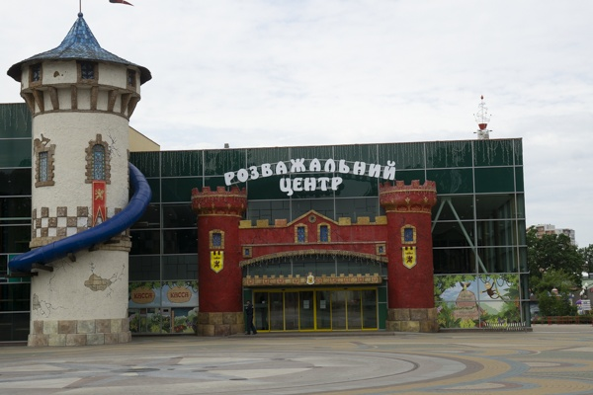4_1.png:** 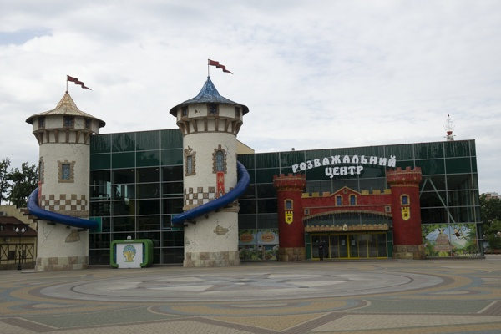

**Table 1 - Found homography parameters and normalization accuracy assessment**

|  |  |  |  |  |  |  |  |  |  |  |  |  |  |  |  |
| --- | --- | --- | --- | --- | --- | --- | --- | --- | --- | --- | --- | --- | --- | --- | --- |
| Original:  img1: 0 img2: 0 | h11 | h12 | h13 | h21 | h22 | h23 | h31 | h32 | h33 | avg ErrPar (param) | avg ErrIM (pixel) | max ErrIM | avg ErrCPM (corner) | max ErrCPM | Expert rate |
| SIFT | 0,608 | 0,008 | 196,346 | -0,049 | 0,662 | 85,121 | -0 | -0 | 1 | 0 | 0,308 | 3,773 | ~ | ~ |  |
| SURF128 | 0,61 | 0,006 | 196,126 | -0,047 | 0,659 | 85,189 | -0 | -0 | 1 | 0 | 0,723 | 3,149 | ~ | ~ |  |
| SURF64 | 0,61 | 0,007 | 196,066 | -0,048 | 0,66 | 85,333 | -0 | -0 | 1 | 0 | 0,767 | 3,185 | ~ | ~ |  |
| ORB | 0,612 | 0,006 | 196,179 | -0,047 | 0,662 | 84,848 | -0 | -0 | 1 | 0 | 0,82 | 3,992 | ~ | ~ |  |
| ORB1000 | 0,619 | -0,005 | 195,974 | -0,044 | 0,656 | 84,918 | -0 | -0 | 1 | 0 | 0,853 | 2,466 | ~ | ~ |  |
| BRISK | 0,613 | 0,013 | 195,137 | -0,047 | 0,667 | 84,355 | -0 | -0 | 1 | 0 | 0,678 | 3,373 | ~ | ~ |  |
| KAZE | 0,62 | 0,007 | 195,295 | -0,043 | 0,663 | 84,281 | -0 | -0 | 1 | 0 | 0,82 | 3,642 | ~ | ~ |  |
| AKAZE | 0,623 | 0,029 | 192,819 | -0,046 | 0,682 | 82,981 | -0 | 0 | 1 | 0 | 0,518 | 2,806 | ~ | ~ |  |
| Original matrix |  |  |  |  |  |  |  |  |  |  |  |  |  |  |  |

where h11, h12, h13, h21, h22, h23, h31, h32, h33 - parameters of found homography matrix H* or of original one H;   
avgErrPar - average error of found parameters, the accuracy of found homography matrix parameters with a preliminary minimax normalization of found and original matrices;  
avgErrIM - average error of inlier coordinate matching;  
inliers - correct matches; outliers - false matches;  
maxErrIM – maximum error of inlier coordinate matching;  
avgErrCPM - average error of corner point matching;  
maxErrCPM - maximum error of corner point matching;  
expert rate - experts assessment of normalization accuracy with a 5-point scale: 0 - normalization failed, 1 - insufficient, 2 - satisfactory, 3 - good, 4 – excellent.

**Table 2 - Quantitative evaluation of descriptors, precision and recall estimation (with found overlap)**

|  |  |  |  |  |  |  |  |  |  |  |  |  |  |  |  |  |
| --- | --- | --- | --- | --- | --- | --- | --- | --- | --- | --- | --- | --- | --- | --- | --- | --- |
| Name | NP1 | NP2 | NM | NI | DP1 | DP2 | OP1 | OP2 | NPO1 | NPO2 | NMO | DPO1 | DPO2 | Precision | RecallO1 | Comments |
| SIFT | 1230 | 1054 | 494 | 445 | 0,0051 | 0,0044 | 94,4287 | 47,1813 | 1179 | 660 | 494 | 0,0052 | 0,0058 | 0,9008 | 0,3774 |  |
| SURF128 | 1753 | 1539 | 472 | 432 | 0,0073 | 0,0064 | 94,5087 | 47,1554 | 1734 | 986 | 470 | 0,0076 | 0,0087 | 0,9153 | 0,2491 |  |
| SURF64 | 1753 | 1539 | 580 | 521 | 0,0073 | 0,0064 | 94,4929 | 47,1475 | 1734 | 985 | 580 | 0,0076 | 0,0087 | 0,8983 | 0,3005 |  |
| ORB | 4530 | 3872 | 1249 | 1207 | 0,0189 | 0,0161 | 94,4808 | 47,2196 | 4520 | 2555 | 1249 | 0,0199 | 0,0225 | 0,9664 | 0,267 |  |
| ORB1000 | 997 | 1000 | 337 | 305 | 0,0042 | 0,0042 | 94,5058 | 47,3717 | 997 | 747 | 337 | 0,0044 | 0,0066 | 0,905 | 0,3059 |  |
| BRISK | 1598 | 1360 | 389 | 330 | 0,0067 | 0,0057 | 94,525 | 47,3038 | 1577 | 884 | 389 | 0,007 | 0,0078 | 0,8483 | 0,2093 |  |
| KAZE | 551 | 536 | 164 | 127 | 0,0023 | 0,0022 | 94,7083 | 47,2454 | 541 | 330 | 164 | 0,0024 | 0,0029 | 0,7744 | 0,2348 |  |
| AKAZE | 502 | 476 | 131 | 106 | 0,0021 | 0,002 | 94,5996 | 47,3712 | 500 | 310 | 130 | 0,0022 | 0,0027 | 0,8092 | 0,212 |  |

where NP - number of found key points; NP1, NP2 - number of found key points for image1 and image2 respectively;  
NM - number of matches found with NNDR method, NM=NI+NO;  
NI - number of inliers found with RANSAC method;  
NO - number of outliers discarded with RANSAC method;   
DP - density of key points (per cent), DP= NP/(height x width) , height, width - vertical and horizontal image sizes respectively (pixels)  
DP1, DP2 - density of key points points for image1 and image2 respectively;  
OP1, OP2 - overlap percentage for image1 and image2 respectively;  
NPO1, NPO2 - number of found key points on overlap for image1 and image2 respectivelyy;  
NMO - number of matches on overlap found with NNDR method;  
DPO1, DPO2 - density of key points points on overlap for image1 and image2 respectively;   
OA - overlap area (pixels), OA1, OA2 - overlap area for image1 and image2 respectively;  
DPO1= NPO1/OA1; DPO2= NPO2/OA2;  
Precision = NI/ NM - the rate to evaluate the part of inliers to all found matches with NNDR method;  
RecallO1 = NI/ NPO1 - completeness of inlier retrieval relative to the number of all key points on overlap for image1. The rate illustrates usefulness of the found key points for normalization.

**Table 3 - Estimation of time costs**

|  |  |  |  |  |  |  |  |  |  |  |
| --- | --- | --- | --- | --- | --- | --- | --- | --- | --- | --- |
| Name | NP1 | NP2 | DesT1, sec | DesT2, sec | MatchT, sec | InlierT, sec | AvgDesT, ms | AvgMatchT, ms | AvgInlierT, ms | TotalNormT, sec |
| SIFT | 1230 | 1054 | 0,062868 | 0,055742 | 0,01448 | 0,000494 | 0,051998 | 0,029311 | 0,001109 | 0,133583 |
| SURF128 | 1753 | 1539 | 0,088458 | 0,066619 | 0,021969 | 0,000468 | 0,046873 | 0,046544 | 0,001083 | 0,177514 |
| SURF64 | 1753 | 1539 | 0,062397 | 0,057081 | 0,015217 | 0,000548 | 0,036341 | 0,026236 | 0,001052 | 0,135243 |
| ORB | 4530 | 3872 | 0,01432 | 0,012738 | 0,050203 | 0,000994 | 0,003225 | 0,040194 | 0,000823 | 0,078255 |
| ORB1000 | 997 | 1000 | 0,009131 | 0,008607 | 0,003724 | 0,000606 | 0,008882 | 0,01105 | 0,001985 | 0,022068 |
| BRISK | 1598 | 1360 | 0,024496 | 0,020941 | 0,010144 | 0,000607 | 0,015363 | 0,026077 | 0,001839 | 0,056188 |
| KAZE | 551 | 536 | 0,167752 | 0,152691 | 0,00331 | 0,00061 | 0,29466 | 0,020182 | 0,004802 | 0,324363 |
| AKAZE | 502 | 476 | 0,020127 | 0,028696 | 0,022222 | 0,000444 | 0,050189 | 0,169632 | 0,004189 | 0,071489 |

where DesT – descriptor creation time (time for key point detection and descriptor computation), DesT1, DesT2 – creation time of descriptors for image1 and image2 respectively;  
MatchT - retrieval time of matching found with NNDR method for the pair;  
InlierT – inlier retrieval time found with RANSAC method for the pair;  
AvgDesT – average time for one descriptor creation;  
AvgMatchT - average time for one match retrieval with NNDR method;  
AvgInlierT – average time for one inlier retrieval with RANSAC method;  
TotalNormT – total normalization time for the pair.