**Normalization results for pairs 5_0.png_5_1.png from subset png\building**

**5_0.png: 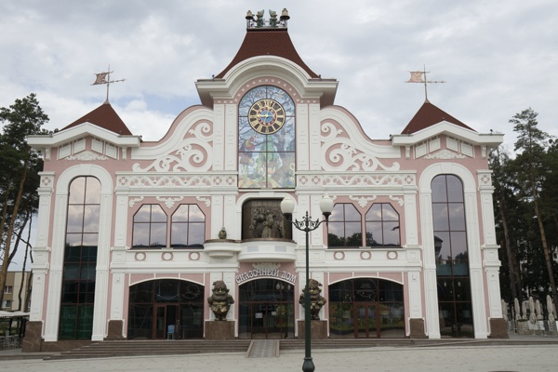5_1.png:** 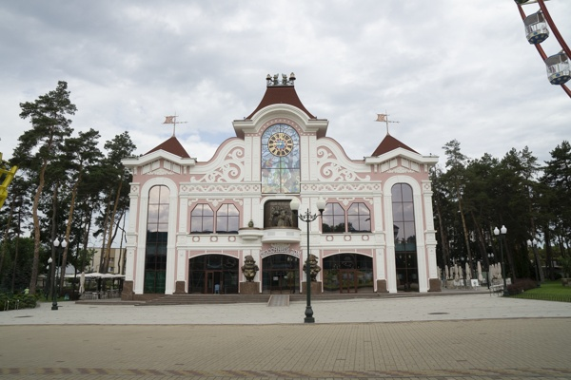

**Table 1 - Found homography parameters and normalization accuracy assessment**

|  |  |  |  |  |  |  |  |  |  |  |  |  |  |  |  |
| --- | --- | --- | --- | --- | --- | --- | --- | --- | --- | --- | --- | --- | --- | --- | --- |
| Original:  img1: 0 img2: 0 | h11 | h12 | h13 | h21 | h22 | h23 | h31 | h32 | h33 | avg ErrPar (param) | avg ErrIM (pixel) | max ErrIM | avg ErrCPM (corner) | max ErrCPM | Expert rate |
| SIFT | 0,667 | 0,009 | 104,977 | 0,002 | 0,668 | 69,429 | 0 | 0 | 1 | 0 | 0,592 | 1,753 | ~ | ~ |  |
| SURF128 | 0,652 | 0,017 | 105,877 | -0,006 | 0,67 | 70,077 | -0 | 0 | 1 | 0 | 0,969 | 3,751 | ~ | ~ |  |
| SURF64 | 0,641 | 0,009 | 107,648 | -0,009 | 0,658 | 71,559 | -0 | 0 | 1 | 0 | 1,047 | 4,333 | ~ | ~ |  |
| ORB | 0,659 | -0,006 | 106,55 | 0 | 0,651 | 70,638 | 0 | -0 | 1 | 0 | 0,778 | 3,932 | ~ | ~ |  |
| ORB1000 | 0,652 | 0,005 | 106,928 | -0,004 | 0,658 | 70,895 | -0 | 0 | 1 | 0 | 0,901 | 2,517 | ~ | ~ |  |
| BRISK | 0,648 | 0,008 | 107,583 | -0,005 | 0,661 | 70,924 | -0 | 0 | 1 | 0 | 0,991 | 3,629 | ~ | ~ |  |
| KAZE | 0,659 | 0,019 | 104,417 | -0,003 | 0,671 | 69,876 | -0 | 0 | 1 | 0 | 0,984 | 3,173 | ~ | ~ |  |
| AKAZE | 0,652 | 0,006 | 106,625 | -0,004 | 0,66 | 70,805 | -0 | 0 | 1 | 0 | 0,699 | 3,422 | ~ | ~ |  |
| Original matrix |  |  |  |  |  |  |  |  |  |  |  |  |  |  |  |

where h11, h12, h13, h21, h22, h23, h31, h32, h33 - parameters of found homography matrix H* or of original one H;   
avgErrPar - average error of found parameters, the accuracy of found homography matrix parameters with a preliminary minimax normalization of found and original matrices;  
avgErrIM - average error of inlier coordinate matching;  
inliers - correct matches; outliers - false matches;  
maxErrIM – maximum error of inlier coordinate matching;  
avgErrCPM - average error of corner point matching;  
maxErrCPM - maximum error of corner point matching;  
expert rate - experts assessment of normalization accuracy with a 5-point scale: 0 - normalization failed, 1 - insufficient, 2 - satisfactory, 3 - good, 4 – excellent.

**Table 2 - Quantitative evaluation of descriptors, precision and recall estimation (with found overlap)**

|  |  |  |  |  |  |  |  |  |  |  |  |  |  |  |  |  |
| --- | --- | --- | --- | --- | --- | --- | --- | --- | --- | --- | --- | --- | --- | --- | --- | --- |
| Name | NP1 | NP2 | NM | NI | DP1 | DP2 | OP1 | OP2 | NPO1 | NPO2 | NMO | DPO1 | DPO2 | Precision | RecallO1 | Comments |
| SIFT | 1651 | 1477 | 596 | 479 | 0,0069 | 0,0062 | 100 | 43,115 | 1651 | 825 | 596 | 0,0069 | 0,008 | 0,8037 | 0,2901 |  |
| SURF128 | 2492 | 1806 | 660 | 548 | 0,0104 | 0,0075 | 100 | 43,1604 | 2492 | 1236 | 660 | 0,0104 | 0,0119 | 0,8303 | 0,2199 |  |
| SURF64 | 2492 | 1806 | 752 | 647 | 0,0104 | 0,0075 | 100 | 43,0192 | 2492 | 1241 | 752 | 0,0104 | 0,012 | 0,8604 | 0,2596 |  |
| ORB | 6534 | 7227 | 1513 | 1308 | 0,0272 | 0,0301 | 100 | 43,4721 | 6534 | 5022 | 1513 | 0,0272 | 0,0481 | 0,8645 | 0,2002 |  |
| ORB1000 | 1000 | 1000 | 170 | 135 | 0,0042 | 0,0042 | 100 | 43,1542 | 1000 | 556 | 170 | 0,0042 | 0,0054 | 0,7941 | 0,135 |  |
| BRISK | 2638 | 2903 | 569 | 522 | 0,011 | 0,0121 | 100 | 42,9354 | 2638 | 1775 | 569 | 0,011 | 0,0172 | 0,9174 | 0,1979 |  |
| KAZE | 844 | 882 | 214 | 155 | 0,0035 | 0,0037 | 100 | 43,1704 | 844 | 500 | 214 | 0,0035 | 0,0048 | 0,7243 | 0,1836 |  |
| AKAZE | 707 | 799 | 179 | 160 | 0,0029 | 0,0033 | 100 | 43,2108 | 707 | 525 | 179 | 0,0029 | 0,0051 | 0,8939 | 0,2263 |  |

where NP - number of found key points; NP1, NP2 - number of found key points for image1 and image2 respectively;  
NM - number of matches found with NNDR method, NM=NI+NO;  
NI - number of inliers found with RANSAC method;  
NO - number of outliers discarded with RANSAC method;   
DP - density of key points (per cent), DP= NP/(height x width) , height, width - vertical and horizontal image sizes respectively (pixels)  
DP1, DP2 - density of key points points for image1 and image2 respectively;  
OP1, OP2 - overlap percentage for image1 and image2 respectively;  
NPO1, NPO2 - number of found key points on overlap for image1 and image2 respectivelyy;  
NMO - number of matches on overlap found with NNDR method;  
DPO1, DPO2 - density of key points points on overlap for image1 and image2 respectively;   
OA - overlap area (pixels), OA1, OA2 - overlap area for image1 and image2 respectively;  
DPO1= NPO1/OA1; DPO2= NPO2/OA2;  
Precision = NI/ NM - the rate to evaluate the part of inliers to all found matches with NNDR method;  
RecallO1 = NI/ NPO1 - completeness of inlier retrieval relative to the number of all key points on overlap for image1. The rate illustrates usefulness of the found key points for normalization.

**Table 3 - Estimation of time costs**

|  |  |  |  |  |  |  |  |  |  |  |
| --- | --- | --- | --- | --- | --- | --- | --- | --- | --- | --- |
| Name | NP1 | NP2 | DesT1, sec | DesT2, sec | MatchT, sec | InlierT, sec | AvgDesT, ms | AvgMatchT, ms | AvgInlierT, ms | TotalNormT, sec |
| SIFT | 1651 | 1477 | 0,057516 | 0,059881 | 0,026801 | 0,000656 | 0,037689 | 0,044968 | 0,001369 | 0,144854 |
| SURF128 | 2492 | 1806 | 0,080766 | 0,068478 | 0,049987 | 0,000635 | 0,035163 | 0,075737 | 0,001159 | 0,199866 |
| SURF64 | 2492 | 1806 | 0,082471 | 0,064727 | 0,026202 | 0,000707 | 0,034467 | 0,034843 | 0,001093 | 0,174108 |
| ORB | 6534 | 7227 | 0,017254 | 0,019494 | 0,164115 | 0,000934 | 0,002668 | 0,10847 | 0,000713 | 0,201797 |
| ORB1000 | 1000 | 1000 | 0,010115 | 0,00963 | 0,005358 | 0,000467 | 0,009872 | 0,031515 | 0,003456 | 0,02557 |
| BRISK | 2638 | 2903 | 0,039527 | 0,041803 | 0,027462 | 0,000669 | 0,014691 | 0,048264 | 0,00128 | 0,109461 |
| KAZE | 844 | 882 | 0,137761 | 0,137883 | 0,006314 | 0,000723 | 0,159776 | 0,029504 | 0,004666 | 0,282681 |
| AKAZE | 707 | 799 | 0,019496 | 0,015161 | 0,002319 | 0,0004 | 0,023275 | 0,012953 | 0,002502 | 0,037377 |

where DesT – descriptor creation time (time for key point detection and descriptor computation), DesT1, DesT2 – creation time of descriptors for image1 and image2 respectively;  
MatchT - retrieval time of matching found with NNDR method for the pair;  
InlierT – inlier retrieval time found with RANSAC method for the pair;  
AvgDesT – average time for one descriptor creation;  
AvgMatchT - average time for one match retrieval with NNDR method;  
AvgInlierT – average time for one inlier retrieval with RANSAC method;  
TotalNormT – total normalization time for the pair.