**Normalization results for pairs 6_0.png_6_1.png from subset png\building**

**6_0.png: 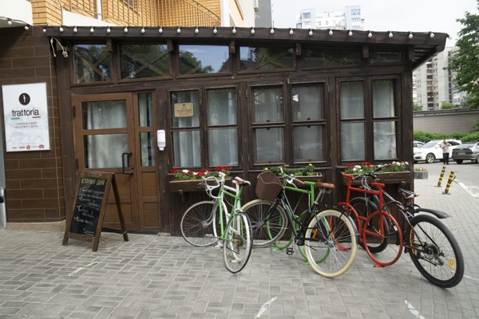6_1.png:** 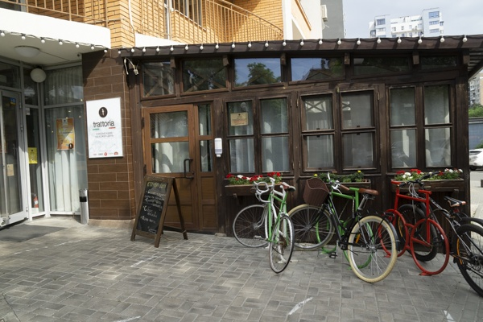

**Table 1 - Found homography parameters and normalization accuracy assessment**

|  |  |  |  |  |  |  |  |  |  |  |  |  |  |  |  |
| --- | --- | --- | --- | --- | --- | --- | --- | --- | --- | --- | --- | --- | --- | --- | --- |
| Original:  img1: 0 img2: 0 | h11 | h12 | h13 | h21 | h22 | h23 | h31 | h32 | h33 | avg ErrPar (param) | avg ErrIM (pixel) | max ErrIM | avg ErrCPM (corner) | max ErrCPM | Expert rate |
| SIFT | 0,749 | -0,012 | 105,946 | -0,06 | 0,865 | 33,301 | -0 | 0 | 1 | 0 | 1,171 | 2,86 | ~ | ~ |  |
| SURF128 | 0,749 | -0,028 | 107,893 | -0,055 | 0,854 | 32,962 | -0 | -0 | 1 | 0 | 1,305 | 4,287 | ~ | ~ |  |
| SURF64 | 0,739 | -0,006 | 106,054 | -0,066 | 0,876 | 32,746 | -0 | 0 | 1 | 0 | 1,52 | 3,44 | ~ | ~ |  |
| ORB | 0,711 | -0,026 | 114,645 | -0,071 | 0,851 | 36,363 | -0 | 0 | 1 | 0 | 1,402 | 3,582 | ~ | ~ |  |
| ORB1000 | 0,741 | 0,043 | 104,108 | -0,079 | 0,942 | 28,207 | -0 | 0 | 1 | 0 | 1,353 | 3,14 | ~ | ~ |  |
| BRISK | 0,74 | -0,003 | 105,113 | -0,06 | 0,863 | 33,502 | -0 | 0 | 1 | 0 | 1,441 | 3,163 | ~ | ~ |  |
| KAZE | 0,712 | -0,036 | 116,79 | -0,068 | 0,856 | 34,587 | -0 | 0 | 1 | 0 | 1,394 | 4,866 | ~ | ~ |  |
| AKAZE | 0,744 | 0,016 | 104,08 | -0,073 | 0,898 | 33,891 | -0 | 0 | 1 | 0 | 1,467 | 3,277 | ~ | ~ |  |
| Original matrix |  |  |  |  |  |  |  |  |  |  |  |  |  |  |  |

where h11, h12, h13, h21, h22, h23, h31, h32, h33 - parameters of found homography matrix H* or of original one H;   
avgErrPar - average error of found parameters, the accuracy of found homography matrix parameters with a preliminary minimax normalization of found and original matrices;  
avgErrIM - average error of inlier coordinate matching;  
inliers - correct matches; outliers - false matches;  
maxErrIM – maximum error of inlier coordinate matching;  
avgErrCPM - average error of corner point matching;  
maxErrCPM - maximum error of corner point matching;  
expert rate - experts assessment of normalization accuracy with a 5-point scale: 0 - normalization failed, 1 - insufficient, 2 - satisfactory, 3 - good, 4 – excellent.

**Table 2 - Quantitative evaluation of descriptors, precision and recall estimation (with found overlap)**

|  |  |  |  |  |  |  |  |  |  |  |  |  |  |  |  |  |
| --- | --- | --- | --- | --- | --- | --- | --- | --- | --- | --- | --- | --- | --- | --- | --- | --- |
| Name | NP1 | NP2 | NM | NI | DP1 | DP2 | OP1 | OP2 | NPO1 | NPO2 | NMO | DPO1 | DPO2 | Precision | RecallO1 | Comments |
| SIFT | 1668 | 1659 | 332 | 165 | 0,0069 | 0,0069 | 88,83 | 77,5117 | 1406 | 1350 | 331 | 0,0066 | 0,0073 | 0,497 | 0,1174 |  |
| SURF128 | 2515 | 2626 | 337 | 167 | 0,0105 | 0,0109 | 89,0662 | 77,6404 | 2314 | 2209 | 334 | 0,0108 | 0,0119 | 0,4955 | 0,0722 |  |
| SURF64 | 2515 | 2626 | 446 | 252 | 0,0105 | 0,0109 | 88,7683 | 77,7662 | 2301 | 2222 | 443 | 0,0108 | 0,0119 | 0,565 | 0,1095 |  |
| ORB | 7369 | 6847 | 761 | 497 | 0,0307 | 0,0285 | 88,7721 | 76,5221 | 6818 | 6311 | 756 | 0,032 | 0,0344 | 0,6531 | 0,0729 |  |
| ORB1000 | 1000 | 1000 | 115 | 78 | 0,0042 | 0,0042 | 88,3975 | 77,8933 | 885 | 910 | 114 | 0,0042 | 0,0049 | 0,6783 | 0,0881 |  |
| BRISK | 2981 | 2578 | 389 | 234 | 0,0124 | 0,0107 | 89,2537 | 77,3458 | 2614 | 2298 | 389 | 0,0122 | 0,0124 | 0,6015 | 0,0895 |  |
| KAZE | 968 | 811 | 212 | 116 | 0,004 | 0,0034 | 88,8537 | 76,7633 | 795 | 672 | 212 | 0,0037 | 0,0036 | 0,5472 | 0,1459 |  |
| AKAZE | 819 | 680 | 141 | 88 | 0,0034 | 0,0028 | 89,1842 | 77,485 | 718 | 605 | 141 | 0,0034 | 0,0033 | 0,6241 | 0,1226 |  |

where NP - number of found key points; NP1, NP2 - number of found key points for image1 and image2 respectively;  
NM - number of matches found with NNDR method, NM=NI+NO;  
NI - number of inliers found with RANSAC method;  
NO - number of outliers discarded with RANSAC method;   
DP - density of key points (per cent), DP= NP/(height x width) , height, width - vertical and horizontal image sizes respectively (pixels)  
DP1, DP2 - density of key points points for image1 and image2 respectively;  
OP1, OP2 - overlap percentage for image1 and image2 respectively;  
NPO1, NPO2 - number of found key points on overlap for image1 and image2 respectivelyy;  
NMO - number of matches on overlap found with NNDR method;  
DPO1, DPO2 - density of key points points on overlap for image1 and image2 respectively;   
OA - overlap area (pixels), OA1, OA2 - overlap area for image1 and image2 respectively;  
DPO1= NPO1/OA1; DPO2= NPO2/OA2;  
Precision = NI/ NM - the rate to evaluate the part of inliers to all found matches with NNDR method;  
RecallO1 = NI/ NPO1 - completeness of inlier retrieval relative to the number of all key points on overlap for image1. The rate illustrates usefulness of the found key points for normalization.

**Table 3 - Estimation of time costs**

|  |  |  |  |  |  |  |  |  |  |  |
| --- | --- | --- | --- | --- | --- | --- | --- | --- | --- | --- |
| Name | NP1 | NP2 | DesT1, sec | DesT2, sec | MatchT, sec | InlierT, sec | AvgDesT, ms | AvgMatchT, ms | AvgInlierT, ms | TotalNormT, sec |
| SIFT | 1668 | 1659 | 0,060658 | 0,056537 | 0,02802 | 0,002415 | 0,035222 | 0,084398 | 0,014635 | 0,147631 |
| SURF128 | 2515 | 2626 | 0,087809 | 0,09836 | 0,068144 | 0,002441 | 0,036185 | 0,202208 | 0,014613 | 0,256754 |
| SURF64 | 2515 | 2626 | 0,064877 | 0,079103 | 0,029719 | 0,00171 | 0,027959 | 0,066633 | 0,006786 | 0,175408 |
| ORB | 7369 | 6847 | 0,023164 | 0,018599 | 0,140215 | 0,001322 | 0,002929 | 0,18425 | 0,002659 | 0,183299 |
| ORB1000 | 1000 | 1000 | 0,010055 | 0,009771 | 0,003496 | 0,000828 | 0,009912 | 0,030399 | 0,01062 | 0,02415 |
| BRISK | 2981 | 2578 | 0,045729 | 0,03967 | 0,028567 | 0,001261 | 0,015364 | 0,073437 | 0,005388 | 0,115227 |
| KAZE | 968 | 811 | 0,123534 | 0,124866 | 0,009573 | 0,001994 | 0,140791 | 0,045155 | 0,017193 | 0,259968 |
| AKAZE | 819 | 680 | 0,018218 | 0,014139 | 0,003419 | 0,001062 | 0,021517 | 0,024251 | 0,012066 | 0,036838 |

where DesT – descriptor creation time (time for key point detection and descriptor computation), DesT1, DesT2 – creation time of descriptors for image1 and image2 respectively;  
MatchT - retrieval time of matching found with NNDR method for the pair;  
InlierT – inlier retrieval time found with RANSAC method for the pair;  
AvgDesT – average time for one descriptor creation;  
AvgMatchT - average time for one match retrieval with NNDR method;  
AvgInlierT – average time for one inlier retrieval with RANSAC method;  
TotalNormT – total normalization time for the pair.