**Normalization results for pairs 7_0.png_7_1.png from subset png\building**

**7_0.png: 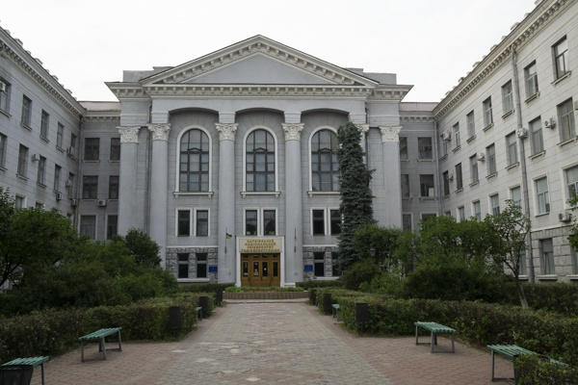7_1.png:** 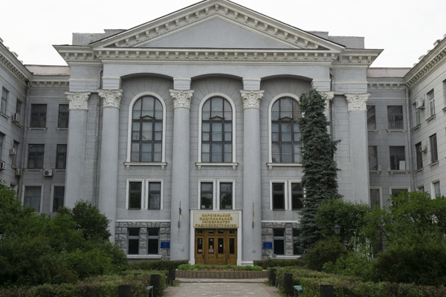

**Table 1 - Found homography parameters and normalization accuracy assessment**

|  |  |  |  |  |  |  |  |  |  |  |  |  |  |  |  |
| --- | --- | --- | --- | --- | --- | --- | --- | --- | --- | --- | --- | --- | --- | --- | --- |
| Original:  img1: 0 img2: 0 | h11 | h12 | h13 | h21 | h22 | h23 | h31 | h32 | h33 | avg ErrPar (param) | avg ErrIM (pixel) | max ErrIM | avg ErrCPM (corner) | max ErrCPM | Expert rate |
| SIFT | 1,325 | -0,027 | -70,028 | -0,003 | 1,335 | -52,432 | -0 | -0 | 1 | 0 | 0,592 | 2,597 | ~ | ~ |  |
| SURF128 | 1,334 | -0,022 | -72,318 | -0,001 | 1,344 | -53,662 | -0 | -0 | 1 | 0 | 0,909 | 3,717 | ~ | ~ |  |
| SURF64 | 1,323 | -0,029 | -69,916 | -0,002 | 1,327 | -51,538 | -0 | -0 | 1 | 0 | 0,995 | 5,002 | ~ | ~ |  |
| ORB | 1,329 | -0,027 | -70,128 | -0,001 | 1,338 | -52,673 | -0 | -0 | 1 | 0 | 1,086 | 3,759 | ~ | ~ |  |
| ORB1000 | 1,34 | -0,015 | -73,142 | -0 | 1,358 | -55,075 | -0 | -0 | 1 | 0 | 1,206 | 3,281 | ~ | ~ |  |
| BRISK | 1,333 | -0,025 | -71,521 | -0,001 | 1,34 | -53,187 | -0 | -0 | 1 | 0 | 0,985 | 3,118 | ~ | ~ |  |
| KAZE | 1,342 | -0,017 | -73,135 | 0,001 | 1,36 | -55,569 | -0 | -0 | 1 | 0 | 0,939 | 3,148 | ~ | ~ |  |
| AKAZE | 1,343 | -0,024 | -72,402 | 0,004 | 1,347 | -54,346 | -0 | -0 | 1 | 0 | 0,57 | 2,562 | ~ | ~ |  |
| Original matrix |  |  |  |  |  |  |  |  |  |  |  |  |  |  |  |

where h11, h12, h13, h21, h22, h23, h31, h32, h33 - parameters of found homography matrix H* or of original one H;   
avgErrPar - average error of found parameters, the accuracy of found homography matrix parameters with a preliminary minimax normalization of found and original matrices;  
avgErrIM - average error of inlier coordinate matching;  
inliers - correct matches; outliers - false matches;  
maxErrIM – maximum error of inlier coordinate matching;  
avgErrCPM - average error of corner point matching;  
maxErrCPM - maximum error of corner point matching;  
expert rate - experts assessment of normalization accuracy with a 5-point scale: 0 - normalization failed, 1 - insufficient, 2 - satisfactory, 3 - good, 4 – excellent.

**Table 2 - Quantitative evaluation of descriptors, precision and recall estimation (with found overlap)**

|  |  |  |  |  |  |  |  |  |  |  |  |  |  |  |  |  |
| --- | --- | --- | --- | --- | --- | --- | --- | --- | --- | --- | --- | --- | --- | --- | --- | --- |
| Name | NP1 | NP2 | NM | NI | DP1 | DP2 | OP1 | OP2 | NPO1 | NPO2 | NMO | DPO1 | DPO2 | Precision | RecallO1 | Comments |
| SIFT | 1675 | 1638 | 683 | 583 | 0,007 | 0,0068 | 52,1708 | 100 | 1026 | 1638 | 661 | 0,0082 | 0,0068 | 0,8536 | 0,5682 |  |
| SURF128 | 2181 | 2515 | 586 | 502 | 0,0091 | 0,0105 | 52,0629 | 100 | 1488 | 2515 | 580 | 0,0119 | 0,0105 | 0,8567 | 0,3374 |  |
| SURF64 | 2181 | 2515 | 694 | 569 | 0,0091 | 0,0105 | 52,1883 | 100 | 1483 | 2515 | 687 | 0,0118 | 0,0105 | 0,8199 | 0,3837 |  |
| ORB | 6114 | 5656 | 1610 | 1324 | 0,0255 | 0,0236 | 52,4179 | 100 | 4548 | 5656 | 1608 | 0,0362 | 0,0236 | 0,8224 | 0,2911 |  |
| ORB1000 | 1000 | 1000 | 266 | 234 | 0,0042 | 0,0042 | 52,4121 | 100 | 736 | 1000 | 265 | 0,0059 | 0,0042 | 0,8797 | 0,3179 |  |
| BRISK | 2118 | 1901 | 458 | 367 | 0,0088 | 0,0079 | 52,1604 | 100 | 1392 | 1901 | 444 | 0,0111 | 0,0079 | 0,8013 | 0,2636 |  |
| KAZE | 685 | 641 | 199 | 164 | 0,0029 | 0,0027 | 52,1971 | 100 | 420 | 641 | 196 | 0,0034 | 0,0027 | 0,8241 | 0,3905 |  |
| AKAZE | 598 | 572 | 146 | 127 | 0,0025 | 0,0024 | 52,475 | 100 | 445 | 572 | 145 | 0,0035 | 0,0024 | 0,8699 | 0,2854 |  |

where NP - number of found key points; NP1, NP2 - number of found key points for image1 and image2 respectively;  
NM - number of matches found with NNDR method, NM=NI+NO;  
NI - number of inliers found with RANSAC method;  
NO - number of outliers discarded with RANSAC method;   
DP - density of key points (per cent), DP= NP/(height x width) , height, width - vertical and horizontal image sizes respectively (pixels)  
DP1, DP2 - density of key points points for image1 and image2 respectively;  
OP1, OP2 - overlap percentage for image1 and image2 respectively;  
NPO1, NPO2 - number of found key points on overlap for image1 and image2 respectivelyy;  
NMO - number of matches on overlap found with NNDR method;  
DPO1, DPO2 - density of key points points on overlap for image1 and image2 respectively;   
OA - overlap area (pixels), OA1, OA2 - overlap area for image1 and image2 respectively;  
DPO1= NPO1/OA1; DPO2= NPO2/OA2;  
Precision = NI/ NM - the rate to evaluate the part of inliers to all found matches with NNDR method;  
RecallO1 = NI/ NPO1 - completeness of inlier retrieval relative to the number of all key points on overlap for image1. The rate illustrates usefulness of the found key points for normalization.

**Table 3 - Estimation of time costs**

|  |  |  |  |  |  |  |  |  |  |  |
| --- | --- | --- | --- | --- | --- | --- | --- | --- | --- | --- |
| Name | NP1 | NP2 | DesT1, sec | DesT2, sec | MatchT, sec | InlierT, sec | AvgDesT, ms | AvgMatchT, ms | AvgInlierT, ms | TotalNormT, sec |
| SIFT | 1675 | 1638 | 0,056981 | 0,054097 | 0,025084 | 0,000694 | 0,033522 | 0,036726 | 0,001189 | 0,136856 |
| SURF128 | 2181 | 2515 | 0,074082 | 0,077466 | 0,053422 | 0,00086 | 0,032384 | 0,091163 | 0,001712 | 0,20583 |
| SURF64 | 2181 | 2515 | 0,062323 | 0,080572 | 0,037919 | 0,000736 | 0,030305 | 0,054637 | 0,001292 | 0,18155 |
| ORB | 6114 | 5656 | 0,016683 | 0,018576 | 0,100455 | 0,001237 | 0,003006 | 0,062394 | 0,000934 | 0,136951 |
| ORB1000 | 1000 | 1000 | 0,009464 | 0,011332 | 0,018599 | 0,000413 | 0,010397 | 0,069922 | 0,001766 | 0,039808 |
| BRISK | 2118 | 1901 | 0,031869 | 0,028338 | 0,013697 | 0,000632 | 0,014976 | 0,029905 | 0,001722 | 0,074535 |
| KAZE | 685 | 641 | 0,112428 | 0,092372 | 0,00454 | 0,00048 | 0,154117 | 0,022812 | 0,002924 | 0,209819 |
| AKAZE | 598 | 572 | 0,017655 | 0,013826 | 0,00227 | 0,000373 | 0,026847 | 0,015547 | 0,002934 | 0,034124 |

where DesT – descriptor creation time (time for key point detection and descriptor computation), DesT1, DesT2 – creation time of descriptors for image1 and image2 respectively;  
MatchT - retrieval time of matching found with NNDR method for the pair;  
InlierT – inlier retrieval time found with RANSAC method for the pair;  
AvgDesT – average time for one descriptor creation;  
AvgMatchT - average time for one match retrieval with NNDR method;  
AvgInlierT – average time for one inlier retrieval with RANSAC method;  
TotalNormT – total normalization time for the pair.