**Normalization results for pairs 9_0.png_9_1.png from subset png\building**

**9_0.png: 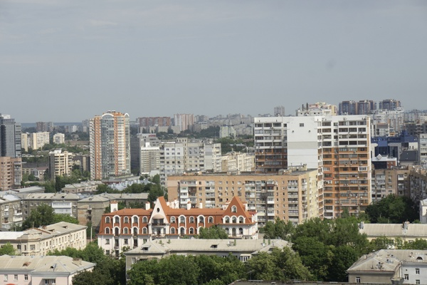9_1.png:** 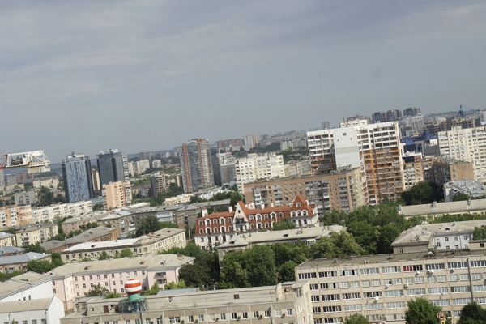

**Table 1 - Found homography parameters and normalization accuracy assessment**

|  |  |  |  |  |  |  |  |  |  |  |  |  |  |  |  |
| --- | --- | --- | --- | --- | --- | --- | --- | --- | --- | --- | --- | --- | --- | --- | --- |
| Original:  img1: 0 img2: 0 | h11 | h12 | h13 | h21 | h22 | h23 | h31 | h32 | h33 | avg ErrPar (param) | avg ErrIM (pixel) | max ErrIM | avg ErrCPM (corner) | max ErrCPM | Expert rate |
| SIFT | 0,672 | 0,076 | 122,997 | -0,073 | 0,684 | 75,352 | -0 | 0 | 1 | 0 | 0,306 | 2,993 | ~ | ~ |  |
| SURF128 | 0,675 | 0,073 | 122,926 | -0,073 | 0,683 | 75,39 | -0 | 0 | 1 | 0 | 0,659 | 2,63 | ~ | ~ |  |
| SURF64 | 0,679 | 0,081 | 121,03 | -0,072 | 0,691 | 74,193 | -0 | 0 | 1 | 0 | 0,788 | 4,056 | ~ | ~ |  |
| ORB | 0,676 | 0,077 | 122,486 | -0,072 | 0,687 | 74,564 | -0 | 0 | 1 | 0 | 0,807 | 3,514 | ~ | ~ |  |
| ORB1000 | 0,648 | 0,05 | 129,131 | -0,079 | 0,648 | 80,928 | -0 | -0 | 1 | 0 | 0,802 | 2,449 | ~ | ~ |  |
| BRISK | 0,67 | 0,072 | 123,585 | -0,073 | 0,68 | 75,795 | -0 | 0 | 1 | 0 | 0,641 | 3,145 | ~ | ~ |  |
| KAZE | 0,677 | 0,085 | 120,925 | -0,073 | 0,695 | 73,512 | -0 | 0 | 1 | 0 | 0,637 | 2,637 | ~ | ~ |  |
| AKAZE | 0,673 | 0,072 | 123,404 | -0,072 | 0,683 | 74,777 | -0 | 0 | 1 | 0 | 0,45 | 2,383 | ~ | ~ |  |
| Original matrix |  |  |  |  |  |  |  |  |  |  |  |  |  |  |  |

where h11, h12, h13, h21, h22, h23, h31, h32, h33 - parameters of found homography matrix H* or of original one H;   
avgErrPar - average error of found parameters, the accuracy of found homography matrix parameters with a preliminary minimax normalization of found and original matrices;  
avgErrIM - average error of inlier coordinate matching;  
inliers - correct matches; outliers - false matches;  
maxErrIM – maximum error of inlier coordinate matching;  
avgErrCPM - average error of corner point matching;  
maxErrCPM - maximum error of corner point matching;  
expert rate - experts assessment of normalization accuracy with a 5-point scale: 0 - normalization failed, 1 - insufficient, 2 - satisfactory, 3 - good, 4 – excellent.

**Table 2 - Quantitative evaluation of descriptors, precision and recall estimation (with found overlap)**

|  |  |  |  |  |  |  |  |  |  |  |  |  |  |  |  |  |
| --- | --- | --- | --- | --- | --- | --- | --- | --- | --- | --- | --- | --- | --- | --- | --- | --- |
| Name | NP1 | NP2 | NM | NI | DP1 | DP2 | OP1 | OP2 | NPO1 | NPO2 | NMO | DPO1 | DPO2 | Precision | RecallO1 | Comments |
| SIFT | 2447 | 2513 | 694 | 672 | 0,0102 | 0,0105 | 100 | 47,5771 | 2447 | 1358 | 694 | 0,0102 | 0,0119 | 0,9683 | 0,2746 |  |
| SURF128 | 2168 | 2154 | 271 | 229 | 0,009 | 0,009 | 100 | 47,6308 | 2168 | 1196 | 271 | 0,009 | 0,0105 | 0,845 | 0,1056 |  |
| SURF64 | 2168 | 2154 | 354 | 313 | 0,009 | 0,009 | 100 | 47,8396 | 2168 | 1195 | 354 | 0,009 | 0,0104 | 0,8842 | 0,1444 |  |
| ORB | 11601 | 11067 | 1145 | 1088 | 0,0483 | 0,0461 | 100 | 47,7229 | 11601 | 7891 | 1145 | 0,0483 | 0,0689 | 0,9502 | 0,0938 |  |
| ORB1000 | 1000 | 1000 | 121 | 101 | 0,0042 | 0,0042 | 100 | 46,6763 | 1000 | 746 | 121 | 0,0042 | 0,0067 | 0,8347 | 0,101 |  |
| BRISK | 4836 | 4756 | 440 | 408 | 0,0202 | 0,0198 | 100 | 47,5083 | 4836 | 2975 | 440 | 0,0202 | 0,0261 | 0,9273 | 0,0844 |  |
| KAZE | 1047 | 1081 | 167 | 137 | 0,0044 | 0,0045 | 100 | 47,9846 | 1047 | 565 | 167 | 0,0044 | 0,0049 | 0,8204 | 0,1309 |  |
| AKAZE | 1078 | 1037 | 148 | 144 | 0,0045 | 0,0043 | 100 | 47,6538 | 1078 | 676 | 148 | 0,0045 | 0,0059 | 0,973 | 0,1336 |  |

where NP - number of found key points; NP1, NP2 - number of found key points for image1 and image2 respectively;  
NM - number of matches found with NNDR method, NM=NI+NO;  
NI - number of inliers found with RANSAC method;  
NO - number of outliers discarded with RANSAC method;   
DP - density of key points (per cent), DP= NP/(height x width) , height, width - vertical and horizontal image sizes respectively (pixels)  
DP1, DP2 - density of key points points for image1 and image2 respectively;  
OP1, OP2 - overlap percentage for image1 and image2 respectively;  
NPO1, NPO2 - number of found key points on overlap for image1 and image2 respectivelyy;  
NMO - number of matches on overlap found with NNDR method;  
DPO1, DPO2 - density of key points points on overlap for image1 and image2 respectively;   
OA - overlap area (pixels), OA1, OA2 - overlap area for image1 and image2 respectively;  
DPO1= NPO1/OA1; DPO2= NPO2/OA2;  
Precision = NI/ NM - the rate to evaluate the part of inliers to all found matches with NNDR method;  
RecallO1 = NI/ NPO1 - completeness of inlier retrieval relative to the number of all key points on overlap for image1. The rate illustrates usefulness of the found key points for normalization.

**Table 3 - Estimation of time costs**

|  |  |  |  |  |  |  |  |  |  |  |
| --- | --- | --- | --- | --- | --- | --- | --- | --- | --- | --- |
| Name | NP1 | NP2 | DesT1, sec | DesT2, sec | MatchT, sec | InlierT, sec | AvgDesT, ms | AvgMatchT, ms | AvgInlierT, ms | TotalNormT, sec |
| SIFT | 2447 | 2513 | 0,088951 | 0,067613 | 0,074745 | 0,000559 | 0,031628 | 0,107701 | 0,000832 | 0,231868 |
| SURF128 | 2168 | 2154 | 0,072279 | 0,076105 | 0,04425 | 0,000451 | 0,034335 | 0,163285 | 0,001969 | 0,193085 |
| SURF64 | 2168 | 2154 | 0,070351 | 0,072907 | 0,022233 | 0,000482 | 0,033148 | 0,062804 | 0,001539 | 0,165972 |
| ORB | 11601 | 11067 | 0,025681 | 0,024605 | 0,397812 | 0,00088 | 0,002218 | 0,347434 | 0,000808 | 0,448978 |
| ORB1000 | 1000 | 1000 | 0,010552 | 0,010235 | 0,003171 | 0,000435 | 0,010392 | 0,026203 | 0,004305 | 0,024392 |
| BRISK | 4836 | 4756 | 0,067454 | 0,067816 | 0,086451 | 0,000461 | 0,014103 | 0,19648 | 0,00113 | 0,222183 |
| KAZE | 1047 | 1081 | 0,140426 | 0,140978 | 0,014203 | 0,000498 | 0,132268 | 0,085047 | 0,003632 | 0,296104 |
| AKAZE | 1078 | 1037 | 0,022101 | 0,020573 | 0,004255 | 0,000271 | 0,02017 | 0,02875 | 0,001884 | 0,0472 |

where DesT – descriptor creation time (time for key point detection and descriptor computation), DesT1, DesT2 – creation time of descriptors for image1 and image2 respectively;  
MatchT - retrieval time of matching found with NNDR method for the pair;  
InlierT – inlier retrieval time found with RANSAC method for the pair;  
AvgDesT – average time for one descriptor creation;  
AvgMatchT - average time for one match retrieval with NNDR method;  
AvgInlierT – average time for one inlier retrieval with RANSAC method;  
TotalNormT – total normalization time for the pair.