**Normalization results for pairs 11_0.png_11_1.png from subset png\graffiti_picture_outside**

**11_0.png: 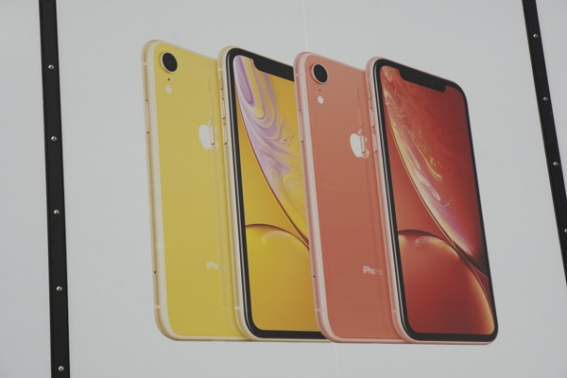11_1.png:** 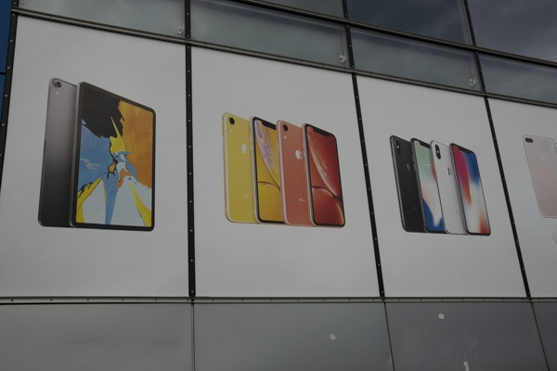

**Table 1 - Found homography parameters and normalization accuracy assessment**

|  |  |  |  |  |  |  |  |  |  |  |  |  |
| --- | --- | --- | --- | --- | --- | --- | --- | --- | --- | --- | --- | --- |
| Original:  img1: 0 img2: 0 | h11 | h12 | h13 | h21 | h22 | h23 | h31 | h32 | h33 | avg ErrIM (pixel) | max ErrIM | Expert rate |
| SIFT | 0,39 | -0,006 | 183,287 | 0,031 | 0,379 | 101,334 | 0 | 0 | 1 | 0,221 | 0,571 |  |
| SURF128 | 0,416 | 0,003 | 180,138 | 0,037 | 0,392 | 101,454 | 0 | 0 | 1 | 1,292 | 3,851 |  |
| SURF64 | 0,376 | -0,021 | 185,199 | 0,024 | 0,364 | 102,793 | 0 | -0 | 1 | 1,065 | 3,267 |  |
| ORB | 0,337 | -0,021 | 189,776 | 0,008 | 0,35 | 106,27 | -0 | -0 | 1 | 1,002 | 2,295 |  |
| ORB1000 | 0,352 | -0,14 | 197,902 | 0,045 | 0,253 | 104,951 | 0 | -0 | 1 | 0,916 | 1,824 |  |
| BRISK | 0,346 | -0,011 | 186,827 | 0,013 | 0,361 | 103,574 | -0 | -0 | 1 | 0,884 | 2,823 |  |
| KAZE | 0,386 | -0,012 | 183,057 | 0,023 | 0,377 | 102,744 | 0 | 0 | 1 | 0,746 | 1,176 |  |
| AKAZE | 0 | 0 | 0 | 0 | 0 | 0 | 0 | 0 | 0 | -1 | ~ |  |
|  |  |  |  |  |  |  |  |  |  |  |  |  |

where h11, h12, h13, h21, h22, h23, h31, h32, h33 - parameters of found homography matrix H* or of original one H;   
avgErrPar - average error of found parameters, the accuracy of found homography matrix parameters with a preliminary minimax normalization of found and original matrices;  
avgErrIM - average error of inlier coordinate matching;  
inliers - correct matches; outliers - false matches;  
maxErrIM – maximum error of inlier coordinate matching;  
avgErrCPM - average error of corner point matching;  
maxErrCPM - maximum error of corner point matching;  
expert rate - experts assessment of normalization accuracy with a 5-point scale: 0 - normalization failed, 1 - insufficient, 2 - satisfactory, 3 - good, 4 – excellent.

**Table 2 - Quantitative evaluation of descriptors, precision and recall estimation (with found overlap)**

|  |  |  |  |  |  |  |  |  |  |  |  |  |  |  |  |  |
| --- | --- | --- | --- | --- | --- | --- | --- | --- | --- | --- | --- | --- | --- | --- | --- | --- |
| Name | NP1 | NP2 | NM | NI | DP1 | DP2 | OP1 | OP2 | NPO1 | NPO2 | NMO | DPO1 | DPO2 | Precision | RecallO1 | Comments |
| SIFT | 100 | 260 | 39 | 30 | 0,0004 | 0,0011 | 100 | 13,4092 | 100 | 47 | 39 | 0,0004 | 0,0015 | 0,7692 | 0,3 |  |
| SURF128 | 1414 | 1787 | 131 | 61 | 0,0059 | 0,0074 | 100 | 13,4921 | 1414 | 375 | 131 | 0,0059 | 0,0116 | 0,4656 | 0,0431 |  |
| SURF64 | 1414 | 1787 | 167 | 79 | 0,0059 | 0,0074 | 100 | 13,4367 | 1414 | 386 | 167 | 0,0059 | 0,012 | 0,4731 | 0,0559 |  |
| ORB | 847 | 1184 | 39 | 26 | 0,0035 | 0,0049 | 100 | 13,0112 | 847 | 292 | 39 | 0,0035 | 0,0094 | 0,6667 | 0,0307 |  |
| ORB1000 | 744 | 943 | 26 | 13 | 0,0031 | 0,0039 | 100 | 12,6067 | 744 | 236 | 26 | 0,0031 | 0,0078 | 0,5 | 0,0175 |  |
| BRISK | 289 | 408 | 31 | 21 | 0,0012 | 0,0017 | 100 | 13,2371 | 289 | 103 | 31 | 0,0012 | 0,0032 | 0,6774 | 0,0727 |  |
| KAZE | 243 | 297 | 20 | 8 | 0,001 | 0,0012 | 100 | 13,5929 | 243 | 57 | 20 | 0,001 | 0,0017 | 0,4 | 0,0329 |  |
| AKAZE | 85 | 171 | 0 | 0 | 0,0004 | 0,0007 | 0 | 0 | 0 | 0 | 0 | � | � | � | � |  |

where NP - number of found key points; NP1, NP2 - number of found key points for image1 and image2 respectively;  
NM - number of matches found with NNDR method, NM=NI+NO;  
NI - number of inliers found with RANSAC method;  
NO - number of outliers discarded with RANSAC method;   
DP - density of key points (per cent), DP= NP/(height x width) , height, width - vertical and horizontal image sizes respectively (pixels)  
DP1, DP2 - density of key points points for image1 and image2 respectively;  
OP1, OP2 - overlap percentage for image1 and image2 respectively;  
NPO1, NPO2 - number of found key points on overlap for image1 and image2 respectivelyy;  
NMO - number of matches on overlap found with NNDR method;  
DPO1, DPO2 - density of key points points on overlap for image1 and image2 respectively;   
OA - overlap area (pixels), OA1, OA2 - overlap area for image1 and image2 respectively;  
DPO1= NPO1/OA1; DPO2= NPO2/OA2;  
Precision = NI/ NM - the rate to evaluate the part of inliers to all found matches with NNDR method;  
RecallO1 = NI/ NPO1 - completeness of inlier retrieval relative to the number of all key points on overlap for image1. The rate illustrates usefulness of the found key points for normalization.

**Table 3 - Estimation of time costs**

|  |  |  |  |  |  |  |  |  |  |  |
| --- | --- | --- | --- | --- | --- | --- | --- | --- | --- | --- |
| Name | NP1 | NP2 | DesT1, sec | DesT2, sec | MatchT, sec | InlierT, sec | AvgDesT, ms | AvgMatchT, ms | AvgInlierT, ms | TotalNormT, sec |
| SIFT | 100 | 260 | 0,040615 | 0,03904 | 0,000423 | 0,000468 | 0,278149 | 0,010835 | 0,015587 | 0,080545 |
| SURF128 | 1414 | 1787 | 0,056423 | 0,056737 | 0,020411 | 0,002896 | 0,035826 | 0,155812 | 0,047478 | 0,136468 |
| SURF64 | 1414 | 1787 | 0,067116 | 0,062889 | 0,010923 | 0,002733 | 0,041328 | 0,065409 | 0,034599 | 0,143662 |
| ORB | 847 | 1184 | 0,00754 | 0,008009 | 0,002956 | 0,00078 | 0,007833 | 0,075784 | 0,029984 | 0,019285 |
| ORB1000 | 744 | 943 | 0,007336 | 0,007689 | 0,00245 | 0,00221 | 0,009006 | 0,094234 | 0,17001 | 0,019685 |
| BRISK | 289 | 408 | 0,006204 | 0,007543 | 0,000675 | 0,000724 | 0,019977 | 0,021779 | 0,03449 | 0,015146 |
| KAZE | 243 | 297 | 0,105898 | 0,106806 | 0,000828 | 0,005147 | 0,397706 | 0,041403 | 0,643328 | 0,218679 |
| AKAZE | 85 | 171 | 0,0149 | 0,012779 | 0,00026 | 0 | 0,125012 | 0 | 0 | 0,027939 |

where DesT – descriptor creation time (time for key point detection and descriptor computation), DesT1, DesT2 – creation time of descriptors for image1 and image2 respectively;  
MatchT - retrieval time of matching found with NNDR method for the pair;  
InlierT – inlier retrieval time found with RANSAC method for the pair;  
AvgDesT – average time for one descriptor creation;  
AvgMatchT - average time for one match retrieval with NNDR method;  
AvgInlierT – average time for one inlier retrieval with RANSAC method;  
TotalNormT – total normalization time for the pair.