**Normalization results for pairs 12_0.png_12_1.png from subset png\graffiti_picture_outside**

**12_0.png: 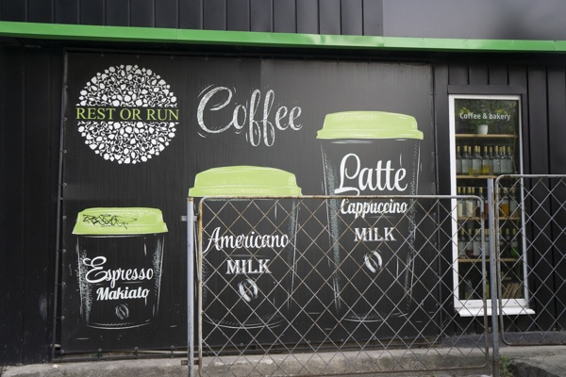12_1.png:** 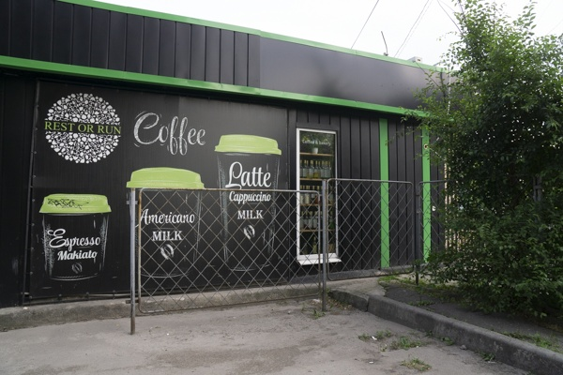

**Table 1 - Found homography parameters and normalization accuracy assessment**

|  |  |  |  |  |  |  |  |  |  |  |  |  |
| --- | --- | --- | --- | --- | --- | --- | --- | --- | --- | --- | --- | --- |
| Original:  img1: 0 img2: 0 | h11 | h12 | h13 | h21 | h22 | h23 | h31 | h32 | h33 | avg ErrIM (pixel) | max ErrIM | Expert rate |
| SIFT | 0,837 | -0,014 | -17,133 | 0,101 | 0,751 | 39,913 | 0 | 0 | 1 | 0,65 | 3,77 |  |
| SURF128 | 0,838 | -0,017 | -16,454 | 0,101 | 0,753 | 39,825 | 0 | 0 | 1 | 0,975 | 4,669 |  |
| SURF64 | 0,822 | -0,015 | -15,711 | 0,096 | 0,749 | 39,897 | 0 | 0 | 1 | 0,914 | 3,455 |  |
| ORB | 0,814 | -0,019 | -14,607 | 0,093 | 0,734 | 41,316 | 0 | -0 | 1 | 0,869 | 4,987 |  |
| ORB1000 | 0,825 | -0,015 | -15,88 | 0,095 | 0,751 | 40,103 | 0 | 0 | 1 | 0,868 | 2,895 |  |
| BRISK | 0,822 | -0,017 | -15,682 | 0,096 | 0,743 | 40,426 | 0 | -0 | 1 | 0,817 | 3,644 |  |
| KAZE | 0,841 | -0,015 | -17,345 | 0,103 | 0,759 | 38,725 | 0 | 0 | 1 | 0,926 | 2,829 |  |
| AKAZE | 0,826 | -0,016 | -16,25 | 0,096 | 0,746 | 40,34 | 0 | -0 | 1 | 0,669 | 3,087 |  |
|  |  |  |  |  |  |  |  |  |  |  |  |  |

where h11, h12, h13, h21, h22, h23, h31, h32, h33 - parameters of found homography matrix H* or of original one H;   
avgErrPar - average error of found parameters, the accuracy of found homography matrix parameters with a preliminary minimax normalization of found and original matrices;  
avgErrIM - average error of inlier coordinate matching;  
inliers - correct matches; outliers - false matches;  
maxErrIM – maximum error of inlier coordinate matching;  
avgErrCPM - average error of corner point matching;  
maxErrCPM - maximum error of corner point matching;  
expert rate - experts assessment of normalization accuracy with a 5-point scale: 0 - normalization failed, 1 - insufficient, 2 - satisfactory, 3 - good, 4 – excellent.

**Table 2 - Quantitative evaluation of descriptors, precision and recall estimation (with found overlap)**

|  |  |  |  |  |  |  |  |  |  |  |  |  |  |  |  |  |
| --- | --- | --- | --- | --- | --- | --- | --- | --- | --- | --- | --- | --- | --- | --- | --- | --- |
| Name | NP1 | NP2 | NM | NI | DP1 | DP2 | OP1 | OP2 | NPO1 | NPO2 | NMO | DPO1 | DPO2 | Precision | RecallO1 | Comments |
| SIFT | 1664 | 1393 | 362 | 246 | 0,0069 | 0,0058 | 96,1375 | 43,1371 | 1662 | 760 | 362 | 0,0072 | 0,0073 | 0,6796 | 0,148 |  |
| SURF128 | 2888 | 2772 | 373 | 252 | 0,012 | 0,0115 | 96,1662 | 43,0742 | 2883 | 1586 | 372 | 0,0125 | 0,0153 | 0,6756 | 0,0874 |  |
| SURF64 | 2888 | 2772 | 524 | 322 | 0,012 | 0,0115 | 96,3242 | 43,6571 | 2884 | 1610 | 524 | 0,0125 | 0,0154 | 0,6145 | 0,1117 |  |
| ORB | 9932 | 7868 | 1360 | 1134 | 0,0414 | 0,0328 | 96,3563 | 43,7283 | 9932 | 4995 | 1360 | 0,0429 | 0,0476 | 0,8338 | 0,1142 |  |
| ORB1000 | 1000 | 1000 | 266 | 232 | 0,0042 | 0,0042 | 96,3083 | 43,5192 | 1000 | 928 | 266 | 0,0043 | 0,0089 | 0,8722 | 0,232 |  |
| BRISK | 3933 | 3010 | 459 | 375 | 0,0164 | 0,0125 | 96,2683 | 43,5529 | 3933 | 1849 | 459 | 0,017 | 0,0177 | 0,817 | 0,0953 |  |
| KAZE | 941 | 539 | 170 | 120 | 0,0039 | 0,0022 | 96,0933 | 43,2546 | 941 | 385 | 170 | 0,0041 | 0,0037 | 0,7059 | 0,1275 |  |
| AKAZE | 1058 | 575 | 138 | 110 | 0,0044 | 0,0024 | 96,1883 | 43,4417 | 1058 | 449 | 138 | 0,0046 | 0,0043 | 0,7971 | 0,104 |  |

where NP - number of found key points; NP1, NP2 - number of found key points for image1 and image2 respectively;  
NM - number of matches found with NNDR method, NM=NI+NO;  
NI - number of inliers found with RANSAC method;  
NO - number of outliers discarded with RANSAC method;   
DP - density of key points (per cent), DP= NP/(height x width) , height, width - vertical and horizontal image sizes respectively (pixels)  
DP1, DP2 - density of key points points for image1 and image2 respectively;  
OP1, OP2 - overlap percentage for image1 and image2 respectively;  
NPO1, NPO2 - number of found key points on overlap for image1 and image2 respectivelyy;  
NMO - number of matches on overlap found with NNDR method;  
DPO1, DPO2 - density of key points points on overlap for image1 and image2 respectively;   
OA - overlap area (pixels), OA1, OA2 - overlap area for image1 and image2 respectively;  
DPO1= NPO1/OA1; DPO2= NPO2/OA2;  
Precision = NI/ NM - the rate to evaluate the part of inliers to all found matches with NNDR method;  
RecallO1 = NI/ NPO1 - completeness of inlier retrieval relative to the number of all key points on overlap for image1. The rate illustrates usefulness of the found key points for normalization.

**Table 3 - Estimation of time costs**

|  |  |  |  |  |  |  |  |  |  |  |
| --- | --- | --- | --- | --- | --- | --- | --- | --- | --- | --- |
| Name | NP1 | NP2 | DesT1, sec | DesT2, sec | MatchT, sec | InlierT, sec | AvgDesT, ms | AvgMatchT, ms | AvgInlierT, ms | TotalNormT, sec |
| SIFT | 1664 | 1393 | 0,049623 | 0,047819 | 0,018724 | 0,000877 | 0,032074 | 0,051723 | 0,003565 | 0,117044 |
| SURF128 | 2888 | 2772 | 0,077899 | 0,075529 | 0,061635 | 0,000899 | 0,02711 | 0,16524 | 0,003569 | 0,215962 |
| SURF64 | 2888 | 2772 | 0,077006 | 0,074409 | 0,034309 | 0,001283 | 0,026753 | 0,065474 | 0,003984 | 0,187006 |
| ORB | 9932 | 7868 | 0,02198 | 0,01937 | 0,175743 | 0,000965 | 0,002337 | 0,129222 | 0,000851 | 0,218058 |
| ORB1000 | 1000 | 1000 | 0,00964 | 0,009174 | 0,003252 | 0,000501 | 0,009406 | 0,012223 | 0,002158 | 0,022567 |
| BRISK | 3933 | 3010 | 0,053424 | 0,042007 | 0,03091 | 0,000699 | 0,013769 | 0,067342 | 0,001863 | 0,127041 |
| KAZE | 941 | 539 | 0,177531 | 0,1131 | 0,004999 | 0,000727 | 0,199246 | 0,029406 | 0,006061 | 0,296357 |
| AKAZE | 1058 | 575 | 0,019962 | 0,017617 | 0,002911 | 0,000459 | 0,024752 | 0,021095 | 0,004176 | 0,040949 |

where DesT – descriptor creation time (time for key point detection and descriptor computation), DesT1, DesT2 – creation time of descriptors for image1 and image2 respectively;  
MatchT - retrieval time of matching found with NNDR method for the pair;  
InlierT – inlier retrieval time found with RANSAC method for the pair;  
AvgDesT – average time for one descriptor creation;  
AvgMatchT - average time for one match retrieval with NNDR method;  
AvgInlierT – average time for one inlier retrieval with RANSAC method;  
TotalNormT – total normalization time for the pair.