**Normalization results for pairs 13_0.png_13_1.png from subset png\graffiti_picture_outside**

**13_0.png: 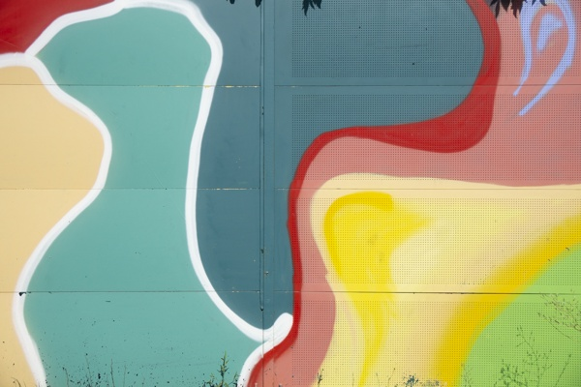13_1.png:** 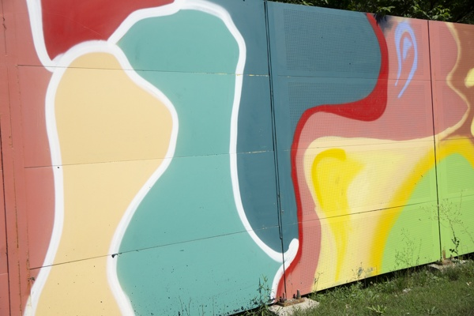

**Table 1 - Found homography parameters and normalization accuracy assessment**

|  |  |  |  |  |  |  |  |  |  |  |  |  |
| --- | --- | --- | --- | --- | --- | --- | --- | --- | --- | --- | --- | --- |
| Original:  img1: 0 img2: 0 | h11 | h12 | h13 | h21 | h22 | h23 | h31 | h32 | h33 | avg ErrIM (pixel) | max ErrIM | Expert rate |
| SIFT | 1,193 | 0,062 | 103,031 | 0,116 | 1,123 | -11,62 | 0,001 | 0 | 1 | 1,212 | 3,281 |  |
| SURF128 | 1,173 | 0,038 | 105,13 | 0,125 | 1,079 | -10,046 | 0,001 | -0 | 1 | 1,408 | 2,928 |  |
| SURF64 | 1,174 | 0,068 | 101,02 | 0,096 | 1,114 | -9,466 | 0,001 | 0 | 1 | 1,399 | 3,459 |  |
| ORB | 1,198 | 0,052 | 105,554 | 0,107 | 1,125 | -10,778 | 0,001 | 0 | 1 | 0,892 | 2,309 |  |
| ORB1000 | 1,268 | 0,116 | 87,869 | 0,131 | 1,183 | -17,585 | 0,001 | 0 | 1 | 0,886 | 1,786 |  |
| BRISK | 1,132 | 0,061 | 105,312 | 0,064 | 1,116 | -8,301 | 0,001 | 0 | 1 | 0,833 | 2,093 |  |
| KAZE | 1,157 | 0,021 | 107,84 | 0,122 | 1,058 | -9,195 | 0,001 | -0 | 1 | 1,074 | 2,378 |  |
| AKAZE | 1,367 | 0,137 | 79,644 | 0,089 | 1,272 | -12,404 | 0,001 | 0 | 1 | 0,823 | 1,431 |  |
|  |  |  |  |  |  |  |  |  |  |  |  |  |

where h11, h12, h13, h21, h22, h23, h31, h32, h33 - parameters of found homography matrix H* or of original one H;   
avgErrPar - average error of found parameters, the accuracy of found homography matrix parameters with a preliminary minimax normalization of found and original matrices;  
avgErrIM - average error of inlier coordinate matching;  
inliers - correct matches; outliers - false matches;  
maxErrIM – maximum error of inlier coordinate matching;  
avgErrCPM - average error of corner point matching;  
maxErrCPM - maximum error of corner point matching;  
expert rate - experts assessment of normalization accuracy with a 5-point scale: 0 - normalization failed, 1 - insufficient, 2 - satisfactory, 3 - good, 4 – excellent.

**Table 2 - Quantitative evaluation of descriptors, precision and recall estimation (with found overlap)**

|  |  |  |  |  |  |  |  |  |  |  |  |  |  |  |  |  |
| --- | --- | --- | --- | --- | --- | --- | --- | --- | --- | --- | --- | --- | --- | --- | --- | --- |
| Name | NP1 | NP2 | NM | NI | DP1 | DP2 | OP1 | OP2 | NPO1 | NPO2 | NMO | DPO1 | DPO2 | Precision | RecallO1 | Comments |
| SIFT | 107 | 306 | 30 | 21 | 0,0004 | 0,0013 | 98,9546 | 63,6537 | 104 | 85 | 30 | 0,0004 | 0,0006 | 0,7 | 0,2019 |  |
| SURF128 | 375 | 845 | 99 | 53 | 0,0016 | 0,0035 | 98,7329 | 62,6608 | 375 | 516 | 99 | 0,0016 | 0,0034 | 0,5354 | 0,1413 |  |
| SURF64 | 375 | 845 | 89 | 43 | 0,0016 | 0,0035 | 99,0104 | 64,7042 | 375 | 524 | 89 | 0,0016 | 0,0034 | 0,4831 | 0,1147 |  |
| ORB | 699 | 745 | 30 | 19 | 0,0029 | 0,0031 | 98,9846 | 64,1208 | 699 | 337 | 30 | 0,0029 | 0,0022 | 0,6333 | 0,0272 |  |
| ORB1000 | 358 | 545 | 24 | 16 | 0,0015 | 0,0023 | 98,8483 | 64,5442 | 358 | 224 | 24 | 0,0015 | 0,0014 | 0,6667 | 0,0447 |  |
| BRISK | 152 | 420 | 21 | 13 | 0,0006 | 0,0018 | 98,9442 | 66,62 | 152 | 175 | 21 | 0,0006 | 0,0011 | 0,619 | 0,0855 |  |
| KAZE | 108 | 252 | 28 | 15 | 0,0004 | 0,001 | 98,8183 | 62,3338 | 108 | 113 | 28 | 0,0005 | 0,0008 | 0,5357 | 0,1389 |  |
| AKAZE | 29 | 95 | 10 | 6 | 0,0001 | 0,0004 | 97,8371 | 65,8683 | 29 | 46 | 10 | 0,0001 | 0,0003 | 0,6 | 0,2069 |  |

where NP - number of found key points; NP1, NP2 - number of found key points for image1 and image2 respectively;  
NM - number of matches found with NNDR method, NM=NI+NO;  
NI - number of inliers found with RANSAC method;  
NO - number of outliers discarded with RANSAC method;   
DP - density of key points (per cent), DP= NP/(height x width) , height, width - vertical and horizontal image sizes respectively (pixels)  
DP1, DP2 - density of key points points for image1 and image2 respectively;  
OP1, OP2 - overlap percentage for image1 and image2 respectively;  
NPO1, NPO2 - number of found key points on overlap for image1 and image2 respectivelyy;  
NMO - number of matches on overlap found with NNDR method;  
DPO1, DPO2 - density of key points points on overlap for image1 and image2 respectively;   
OA - overlap area (pixels), OA1, OA2 - overlap area for image1 and image2 respectively;  
DPO1= NPO1/OA1; DPO2= NPO2/OA2;  
Precision = NI/ NM - the rate to evaluate the part of inliers to all found matches with NNDR method;  
RecallO1 = NI/ NPO1 - completeness of inlier retrieval relative to the number of all key points on overlap for image1. The rate illustrates usefulness of the found key points for normalization.

**Table 3 - Estimation of time costs**

|  |  |  |  |  |  |  |  |  |  |  |
| --- | --- | --- | --- | --- | --- | --- | --- | --- | --- | --- |
| Name | NP1 | NP2 | DesT1, sec | DesT2, sec | MatchT, sec | InlierT, sec | AvgDesT, ms | AvgMatchT, ms | AvgInlierT, ms | TotalNormT, sec |
| SIFT | 107 | 306 | 0,039748 | 0,040066 | 0,000571 | 0,000654 | 0,251203 | 0,019023 | 0,031142 | 0,081038 |
| SURF128 | 375 | 845 | 0,03521 | 0,04067 | 0,002946 | 0,002338 | 0,071011 | 0,029754 | 0,044122 | 0,081164 |
| SURF64 | 375 | 845 | 0,036168 | 0,040173 | 0,001719 | 0,002503 | 0,071995 | 0,019317 | 0,058201 | 0,080564 |
| ORB | 699 | 745 | 0,007292 | 0,007504 | 0,001939 | 0,000924 | 0,010251 | 0,064648 | 0,048631 | 0,01766 |
| ORB1000 | 358 | 545 | 0,0067 | 0,007102 | 0,000967 | 0,000782 | 0,015872 | 0,040277 | 0,048896 | 0,01555 |
| BRISK | 152 | 420 | 0,004809 | 0,008982 | 0,000447 | 0,000982 | 0,026512 | 0,021276 | 0,075513 | 0,015219 |
| KAZE | 108 | 252 | 0,169844 | 0,124856 | 0,000414 | 0,001661 | 1,034045 | 0,014799 | 0,110705 | 0,296775 |
| AKAZE | 29 | 95 | 0,016745 | 0,017044 | 0,000146 | 0,001103 | 0,378421 | 0,014609 | 0,183865 | 0,035039 |

where DesT – descriptor creation time (time for key point detection and descriptor computation), DesT1, DesT2 – creation time of descriptors for image1 and image2 respectively;  
MatchT - retrieval time of matching found with NNDR method for the pair;  
InlierT – inlier retrieval time found with RANSAC method for the pair;  
AvgDesT – average time for one descriptor creation;  
AvgMatchT - average time for one match retrieval with NNDR method;  
AvgInlierT – average time for one inlier retrieval with RANSAC method;  
TotalNormT – total normalization time for the pair.